Nonsubstantive change request: EIA would like to add a response option to Form EIA-457F, Residential Energy Consumption Survey (RECS) Natural Gas Usage
Background: EIA Form 457F collects customer natural gas billing (usage and cost) information from natural gas providers for respondents to the Residential Energy Consumption Survey (RECS) Household Survey (Form EIA 457A.) The form asks provider respondents to indicate the units in which the natural gas usage on the bills is reported. As collected on the prior RECS form as part of the 2020 RECS, and currently approved for collection on the 2024 RECS, provider respondents are offered five response options: therms, cubic feet (cf), hundred cubic feet (ccf), thousands of cubic feet (MCF), and other (specify). EIA analysis of the 2020 RECS data indicates that nearly all the “other” responses are dekatherms, accounting for more than 3% of reported bills. EIA has determined that a sixth option - dekatherms - should be added for the unit item options.
Following is a comparison of the currently approved unit item options and the revised unit item options:
Current Version:
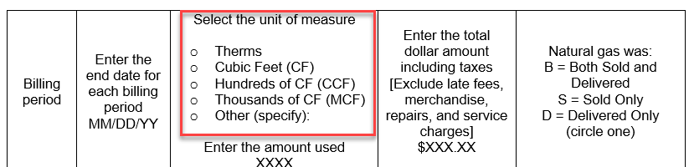

Revised Version:
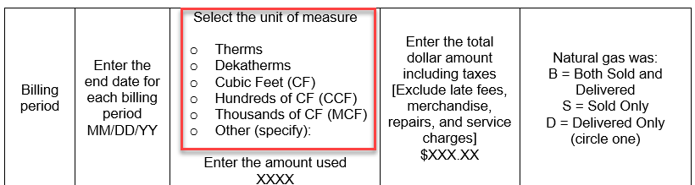

Benefits: This revised form will be beneficial by:
- allowing more respondents to report natural gas usage in the units in which they retain their records for company purposes, which will reduce reporting error
- facilitating more efficient data processing for EIA staff by decreasing manual review of write-in responses
- improving EIA’s estimation of natural gas usage for residential energy stakeholders

