SUPPORTING STATEMENT FOR
FERC-545 [(Gas Pipeline Rates: Rate Change (Non-Formal)]

The Federal Energy Regulatory Commission (Commission or FERC) requests that the Office of Management and Budget (OMB) review/approve the extension of the FERC-545 information collection [(Gas Pipeline Rates: Rate Change (Non-Formal)].

- CIRCUMSTANCES THAT MAKE THE COLLECTION OF INFORMATION NECESSARY

FERC-545 is required to implement sections 4, 5, and 16 of the Natural Gas Act (NGA), (15 USC 717c, 717d, and 717o). NGA Sections 4, 5, and 16 authorize the Commission to inquire into rate structures and methodologies and to set rates at a just and reasonable level. Specifically, a natural gas company must obtain Commission authorization for all rates and charges made, demanded, or received in connection with the transportation or sale of natural gas in interstate commerce.

Under the NGA, a natural gas company’s rates must be just and reasonable and not unduly discriminatory or preferential. The Commission may act under different sections of the NGA to effect a change in a natural gas company’s rates. When the Commission reviews rate increases that a natural gas company has proposed, it is subject to the requirement of section 4(e) of the NGA. These types of filings are referred to as general section 4 rate cases. In the proceedings, the Commission reviews a pipeline’s rates and services. A pipeline can file a general section 4 rate case anytime it wishes, provided the pipeline did not agree otherwise in a settlement. A pipeline must demonstrate that the new rates it proposes to charge are just and reasonable. When a rate increase filing is made pursuant to section 4, the application is typically suspended and set for hearing by a Commission Order. On the other hand, when the Commission seeks to impose its own rate determination, it must do so in compliance with section 5(a) of the NGA. Under section 5, the Commission must first establish and demonstrate that a pipeline’s existing rate is no longer just and reasonable. Under section 4(e), the natural gas company bears the burden of proving that its proposed rates are just and reasonable. On the other hand, when the Commission seeks to impose its own rate determination, it must do so in compliance with section 5(a) of the NGA. Under section 5, the Commission must first establish that its alternative rate proposal is both just and reasonable.

Section 16 of the NGA states that the Commission “shall have the power to perform any and all acts, and to prescribe, issue, make, amend, and rescind such orders, rules, and regulations as it may find necessary or appropriate to carry out provisions of [the NGA].” In other words, section 16 of the NGA grants the Commission the power to define accounting, technical and trade terms, prescribe forms, statements, declarations or reports and to prescribe rules and regulations.

Pipelines adjust their tariffs to meet market and customer needs. Commission review of these proposed changes is required to ensure rates remain just and reasonable and that services are not provided in an unduly or preferential manner. The Commission’s regulation in 18 C.F.R. Part 154 specifies what changes are allowed and the procedures for requesting Commission approval.

Since 1996, the Commission has adopted regulations to standardize the business practices and communication methodologies of interstate natural gas pipelines to create a more integrated and efficient pipeline grid. These regulations have been promulgated in the Order No. 587 series of orders, wherein the Commission has incorporated by reference standards for interstate natural gas pipeline business practices and electronic communications that were developed and adopted by the Wholesale Gas Quadrant (WGQ) of the North American Energy Standards Board (NAESB). Upon incorporation by reference, version 4.0 of the standards (Version 4.0) will replace the currently incorporated version (Version 3.2) of those business practice standards.

On October 2, 2023, NAESB reported to the Commission (Informational Report) that it had approved WGQ Version 4.0 to replace the currently incorporated version (Version 3.2) of those business practice standards Version 4.0 of the WGQ includes business practice standards developed and modified in response to industry requests and directives from the NAESB Board of Directors. This version also includes the standards developed in response to the recommendations of Sandia National Laboratories (Sandia), which in 2019 issued a DOE-sponsored cybersecurity surety assessment of the NAESB standards. =NAESB’s Informational Report identifies all the changes made to the WGQ Version 3.2 standards and summarizes the deliberations that led to the changes being made. It also identifies changes to the existing standards that were considered but not adopted due to a lack of consensus or other reasons.

NAESB’s revisions in WGQ Version 4.0 are designed to promote greater efficiency and reliability of the natural gas industry’s operations and strengthen the cybersecurity protections provided within the standards.

The new WGQ Cybersecurity Related Standards Manual consolidates existing NAESB cybersecurity-related standards from various NAESB standards manuals into a single manual. This consolidation should make the NAESB and Commission processes for revising NAESB cybersecurity standards easier and faster to help match the fast pace of changes in cybersecurity practices. These standards focus on strengthening the cybersecurity practices used by the industry through the mitigation of potential
vulnerabilities and the use of secure communication and encryption methodologies.

In response to industry request, WGQ Version 4.0 adds new data elements to the WGQ Additional Standards and the WGQ Capacity Release Related Standards and modifies existing data elements in the WGQ Flowing Gas Related Standards and the WGQ Invoicing Related Standards to improve efficiencies of business processes for
transportation service providers and parties interacting with these entities.

NAESB’s revisions in WGQ Version 4.0 upgrade current business practices and communication standards by specifically: (1) adding a new data element, “Cycle Indicator,” to the data set for the Storage Information standard to address technical details for the reporting of storage balances and the activities that affect storage balances; (2) revising the data element “Service Requester Contract” contained in the data set for the Flowing Gas Related Allocation standard to identify the applicable contract and to support the communication of the results of processes used to allocate the actual flow of gas quantities to parties involved in a transaction; (3) modifying the “Charge Type Rate” data element contained in the data set for the Transportation/Sales Invoice standard that allows for the identification of multiple rates that may be applicable for a single transaction or service; (4) adding a new sender’s option data element, “Location Indicator Data,” to the Transactional Reporting – Capacity Release standard to improve efficiencies by providing a mechanism for a transportation service provider to communicate the locations at which a discounted rate is offered as well as if the rate is associated with a single location, multiple locations, or all locations; (5) adding code values for five data elements to the EDI X12 Mapping Guidelines in the Transportation/Sales Invoice standard to ensure the hierarchal structure of the dataset complied with the Accredited Standards Institute X12 Transaction Set 811 Consolidated Invoice/Statement. In addition, the Commission’s Office of Enforcement will
use the data for general industry oversight.

The Commission has established a more efficient and integrated pipeline grid. These requirements conform to our plan for efficient information collection, communication, and management within the natural gas pipeline industries. We determined through our internal review, that there is specific, objective support for the burden estimates associated with the information requirements.

- HOW, BY WHOM, AND FOR WHAT PURPOSE THE INFORMATION IS TO BE USED AND THE CONSEQUENCES OF NOT COLLECTING THE INFORMATION

The following information is the subject of the FERC-545 consists of: 1) Tariff Filings which are filings regarding proposed changes to a pipeline’s tariff and any related compliance filings; 2) Rate Filings which are rate-related filings under NGA sections 4 and 5 and any related compliance filings and settlements; 3) Informational Reports, for example, annual reconciliation reports.; 4) Negotiated Rates and Non-Conforming Agreement Filings; 5) NAESB WGQ Filings and any related compliance filings; 6) Market-Based Rates for Storage Filings; and 6) the Labor-Wage Policy which allows jurisdictional entities to include wages consistent with project-area standards in cost-of-service rates filed with the Commission where the record supports that outcome. In summary, the Commission uses the FERC-545 information to (1) ensure there are adequate customer protections under section 4 of the NGA; (2) review rates and terms and conditions of service changes by natural gas companies for the transportation and storage of natural gas; (3) provide general industry oversight; and (4) supplement documentation during FERC’s audits process.

The Commission reviews the FERC-545 materials to determine whether proposed transportation and sales rates and terms and conditions of service are just and reasonable. The Commission uses the information to monitor rates and terms and conditions of service related to jurisdictional transportation, natural gas storage, and unbundled sales activities of jurisdictional companies. In addition to fulfilling the Commission’s obligations under the NGA, the information enables the Commission to monitor the activities and evaluate transactions of the natural gas industry to ensure competitiveness and improved efficiency of the industry’s operations.

Consistent with the Commission’s practice since Order No. 587-V each interstate natural gas pipeline must designate a single tariff section under which every NAESB WGQ Standard incorporated by reference by the Commission is listed. For each NAESB standard, the pipeline must specifically list in that tariff section:

- whether the standard is incorporated by reference;

- for those standards not incorporated by reference, the tariff provision that complies with the standard; or

- for those standards with which the pipeline does not comply, an indication in the tariff section of whether the pipeline has been granted a waiver, extension of time, or other variance with respect to compliance with the standard.

Likewise, consistent with past practice, the Commission posted on its eLibrary website (under Docket No. RM96-1-043) a sample tariff format to provide filers with an illustrative example to aid them in preparing their compliance filings. Consistent with the Commission’s policy since Order No. 587-V, entities may request waivers under the requirements set forth in Order No. 587-V and the Commission will then evaluate those requests. If the pipeline is requesting a continuation of an existing waiver or extension of time, it must include a table in its transmittal letter that identifies the standard for which the Commission granted the waiver or extension of time, and the docket number or order citation to the proceeding in which the Commission granted the waiver or extension of time. The pipeline also must present an explanation for why such waiver or extension of time should remain in force with regard to the WGQ Version 4.0 Standards. This continues the Commission’s practice of having pipelines include in their tariffs a common location that identifies the way in which the pipeline is incorporating all the NAESB WGQ Standards and the standards with which it is required to comply.

- DESCRIBE ANY CONSIDERATION FOR THE USE OF IMPROVED INFORMATION TECHNOLOGY TO REDUCE BURDEN AND TECHNICAL OR LEGAL OBSTACLES TO REDUCING BURDEN

The Commission improved the security for submitting electronic tariff filings. In addition, the Commission improved the pipelines’ on-line process of appointing and modifying agents with the authority to make an electronic tariff filing on the pipeline’s behalf.

- DESCRIBE EFFORTS TO IDENTIFY DUPLICATION AND SHOW SPECIFICALLY WHY ANY SIMILAR INFORMATION ALREADY AVAILABLE CANNOT BE USED OR MODIFIED FOR USE FOR THE PURPOSE(S) DESCRIBED IN INSTRUCTION NO. 2.
Commission filings and data requirements are periodically reviewed in conjunction with OMB clearance expiration dates. No duplication of the information collection requirements has been found.
- METHODS USED TO MINIMIZE BURDEN IN COLLECTION OF INFORMATION INVOLVING SMALL ENTITIES

The FERC-545 are filing requirements related to pipeline rate filing obligations for the transportation and storage of natural gas. The filings collect data from both large and small respondent companies. The data required were designed to impose the least possible burden for companies, while collecting the information required for processing the filings. Use of the Internet to file documents electronically is the primary method the Commission uses to minimize the filing burden.

- CONSEQUENCE TO FEDERAL PROGRAM IF COLLECTION WERE CONDUCTED LESS FREQUENTLY

The FERC-545 is a one-time compliance filing. Failure to collect the information would prohibit the Commission from properly monitoring and evaluating pipeline transactions and meeting statutory obligations under the Natural Gas Policy Act and Natural Gas Act.

- EXPLAIN ANY SPECIAL CIRCUMSTANCES RELATING TO THE INFORMATION COLLECTION

The FERC-545 presents no special circumstances.

- DESCRIBE EFFORTS TO CONSULT OUTSIDE THE AGENCY: SUMMARIZE PUBLIC COMMENTS AND AGENCY'S RESPONSE TO THESE COMMENTS

The 60-day notice published on January 8, 2025 (90 FR 1476) and no comments were received. The 30-day notice published on March 26, 2025 (90 FR 13745). There is no anticipation of receiving comments at the end of the 30-day comment period.

9. EXPLAIN ANY PAYMENT OR GIFTS TO RESPONDENTS

There are no payments or gifts made or given to respondents associated with collections FERC-545.

- DESCRIBE ANY ASSURANCE OF CONFIDENTIALITY PROVIDED TO RESPONDENTS

The new WGQ Cybersecurity Related Standards focus on strengthening the
cybersecurity practices used by the industry through the mitigation of potential
vulnerabilities and the use of secure communication and encryption methodologies. In general, for submittals to the Commission, filers may submit specific requests for confidential treatment to the extent permitted by law; details are available in 18 C.F.R. Section 388.112.

- PROVIDE ADDITIONAL JUSTIFICATION FOR ANY QUESTIONS OF A SENSITIVE NATURE, SUCH AS SEXUAL BEHAVIOR AND ATTITUDES, RELIGIOUS BELIEFS, AND OTHER MATTERS THAT ARE COMMONLY CONSIDERED PRIVATE.

There are no questions of a sensitive nature in the reporting requirements.

- ESTIMATED BURDEN OF COLLECTION OF INFORMATION

The Commission estimates the annual public reporting burden and cost for the information collection as follows:

FERC-545: Gas Pipeline Rates: Rate Change (Non-Formal) (No change)
 | Number of Respondents  (1) | Average Number of Responses per Respondent  (2) | Total Number of Responses (1)*(2)=(3) | Average Burden & Cost Per Response²  (4) | Total Annual Burden Hours & Total Annual Cost  (3)*(4)=(5) | Cost per Respondent ($) (5)÷(1)
Tariff Filings | 141 | 3 | 423 | 211 hrs.;  $22,999 | 89,253 hrs.;  $9,728,577 | $68,997
Rate Filings | 19 | 2 | 38 | 354 hrs.;  $38,586 | 13,452 hrs.;  $1,466,268 | $77,172
Informational Reports | 80 | 2 | 160 | 235 hrs.;  $25,615 | 37,600 hrs.;  $4,098,400 | $51,230
Negotiated Rates & Non-Conforming Agreement Filings | 75 | 8 | 600 | 233 hrs.;  $25,397 | 139,800 hrs.;  $15,238,200 | $203,176
Market-Base Rates for Storage Filings | 2 | 1 | 2 | 230 hrs.;  $25,070 | 460 hrs.;  $50,140 | $25,070
Section 4 Rate Cases | 8 | 1 | 8 | 100 hrs.  $10,900 | 800 hrs.  $87,200 | $10,900
NAESB (version 4.0) carried over from RM96-1-042 | 193 | 1 | 193 | 10 hrs.;  $1,110 | 1,930 hrs.; $214,230 | $1,110
Labor-Wage Policy | 11 | 1 | 11 | 15 hrs.;  $1,635 | 165 hrs.;  $17,985 | $1,635
TOTAL |  |  | 1,427 (rounded) |  | 282,660 hrs. (rounded);  $30,813,800

- ESTIMATE OF THE TOTAL ANNUAL COST BURDEN TO RESPONDENTS

There are no capital or start-up costs for FERC-545. All the costs are related to burden hours and are detailed in Questions #12 and #15.

- ESTIMATED ANNUALIZED COST TO FEDERAL GOVERNMENT

 | Number of Hours or FTE’s | Estimated Annual Federal Cost ($)
PRA Administration Cost | - | $8,396
Data Processing and Analysis, Sub-Total | 0.75 | $155,839.50
FERC Total for FERC-545 |  | $164,235.50

- REASONS FOR CHANGES IN BURDEN INCLUDING THE NEED FOR ANY INCREASE

The decrease in burden is due to a change in estimate because of normal changes in the industry. The Commission has received less filings than what was previously approved under the last renewal and is revising its estimates based on more current numbers.

 | Total Request | Previously Approved | Change due to Adjustment in Estimate | Change Due to Agency Discretion
FERC-545
Annual Number of Responses | 1,306 | 1,387 | -81 | 0
Annual Time Burden (Hr.) | 282,173 | 306,827 | -24,654 | 0
Annual Cost Burden ($) | $0 | $0 | $0 | $0

- TIME SCHEDULE FOR PUBLICATION OF DATA

Despite the fact that FERC-545 data are publicly available, there are no tabulating, statistical or publication plans.

- DISPLAY OF EXPIRATION DATE

The expiration date is displayed in a table posted on ferc.gov at https://www.ferc.gov/information-collections

- EXCEPTIONS TO THE CERTIFICATION STATEMENT

There are no exceptions.

Appendix A.

Screenshot for eFilings, including Tariff Filings
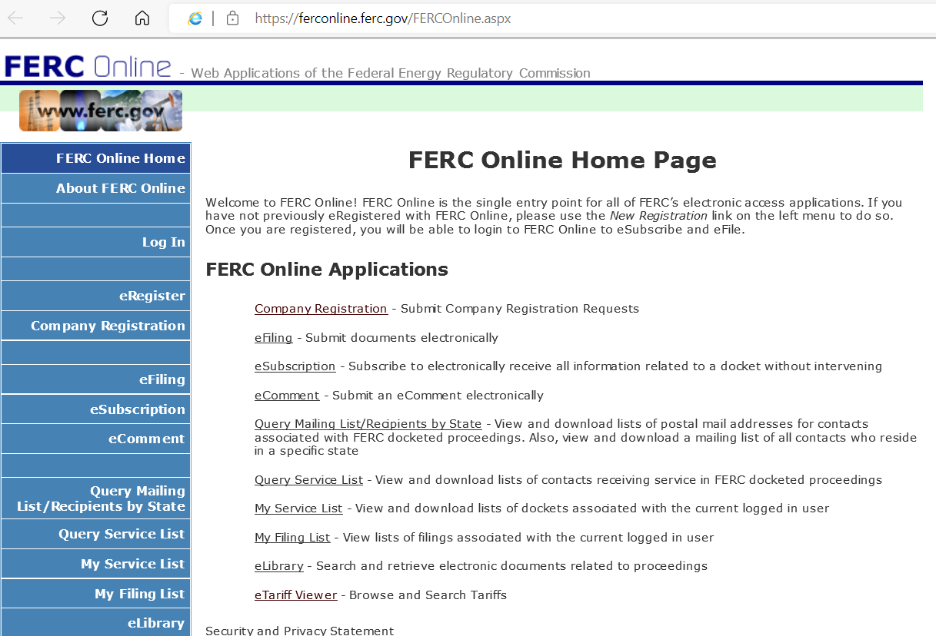
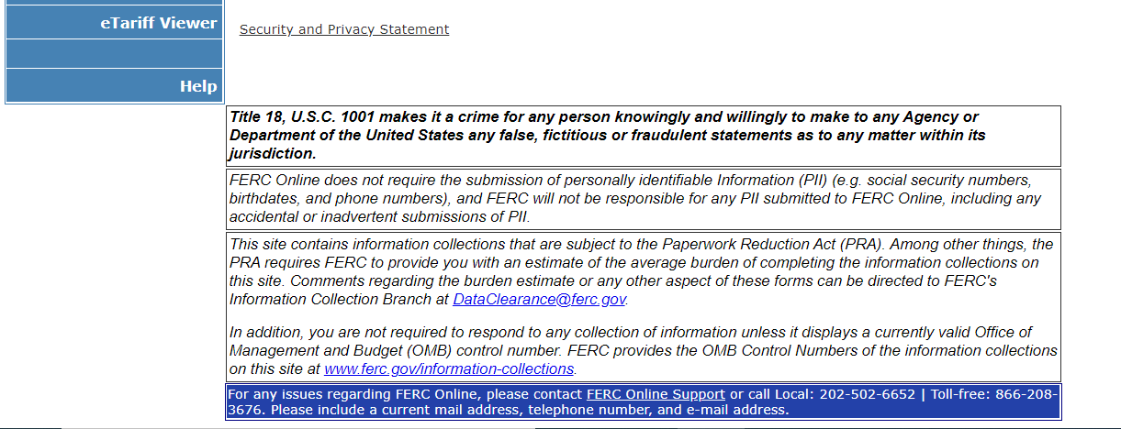

This series of orders began with the Commission’s issuance of Standards for Bus. Pracs. of Interstate Nat. Gas Pipelines, Order. No. 587, 61 FR 39053 (July 26, 1996), FERC Stats. & Regs. ¶ 31,038 (1996) (cross-referenced at 76 FERC ¶ 61,042).
Standards for Bus. Pracs. of Interstate Nat. Gas Pipelines, Order No. 587-AA, 89 FR 97518 (Dec. 9, 2024), 189 FERC ¶ 61,135 (2024).
Sandia is a multidisciplinary national laboratory and federally funded research and development center for the U.S. Department of Energy’s (DOE) National Nuclear Security Administration that supports numerous federal, state, and local government agencies, companies, and organizations.
In April 2017, NAESB announced that Sandia, through funding provided by DOE, would be performing a surety assessment of the NAESB standards. As determined by Sandia and DOE, the purpose of the surety assessment was to analyze cybersecurity elements within the standards, focusing on four areas: (1) the NAESB Certification Program for Accredited Certification Authorities, including the Wholesale Electric Quadrant (WEQ)-012 Public Key Infrastructure Business Practice Standards, the NAESB Accreditation Requirements for Authorized Certificate Authorities, and the Authorized Certification Authority Process; (2) the WEQ Open Access Same-Time Information Systems suite of standards; (3) the WGQ and Retail Markets Quadrant Internet Electronic Transport and Quadrant Electronic Delivery Mechanism (EDM) Related Standards Manual; and (4) a high-level dependency analysis between the gas and electric markets to evaluate the different security paradigms the markets employ.
Natural gas transportation service is provided by interstate pipelines, intrastate pipelines, natural gas gathering pipelines, and local distribution companies; all are referred to as “transportation service providers.”
Standards for Bus. Pracs. of Interstate Nat. Gas Pipelines, Order No. 587-V, 77 FR 43711 (Jul. 26, 2012), 140 FERC ¶ 61,036 (2012).
Standards for Bus. Pracs. of Interstate Nat. Gas Pipelines, 174 FERC ¶ 61,103, at P 21 (2021).
Shippers can use the Commission’s electronic tariff system to locate the tariff record containing the NAESB standards, which will indicate the docket in which any waiver or extension of time was granted.
Order No. 587-V, 140 FERC ¶ 61,036.
Order No. 587-V Compliance Order, 141 FERC ¶ 61,167 at PP 4, 38 (a pipeline does not need to seek a waiver for standards that address business practices that the pipeline does not offer).
Please refer to Appendix A on last page of the Supporting Statement or refer to the link https://ferconline.ferc.gov/FERCOnline.aspx
The estimated hourly cost (salary plus benefits) provided in this section is based on the salary figures for May 2023 posted by the Bureau of Labor Statistics for the Utilities sector (available at https://www.bls.gov/oes/current/naics3_221000.htm) and scaled to reflect benefits using the relative importance of employer costs for employee compensation from March 2023 available at https://www.bls.gov/news.release/ecec.nr0.htm). The hourly estimates for salary plus benefits are: Computer and Information Systems Manager (Occupation Code: 11-3021), $115.47; Computer and Information Analysts (Occupation Code: 15-1210), $80.10; Electrical Engineer (Occupation Code: 17-2071), $79.31; Legal (Occupation Code: 23-0000), $162.66. The average hourly cost (salary plus benefits) weighting all of the above skill sets evenly, is $109.38. We round it to $109/hour.
This estimate was most recently updated in RM96-1-043, which was approved by OMB on March 25, 2025 (ICR 202501-1902-009). However, due to the rulemaking, FERC issued notices citing the existing burden under RM96-1-042. This estimate in ROCIS is averaged over three years, which totals 64.33 responses.
Project-Area Wage Standards in the Labor Cost Component of Cost-of-Service Rates under Docket No. PL24-1-000 was issued on March 21, 2024, which allows jurisdictional entities to include wages consistent with project-area standards in cost-of-service rates filed with the Commission where the record supports that outcome.
Based on FERC’s Fiscal Year 2021 average cost per FTE (salary plus benefits) of $207,786 per year, rounded to $100.00 per hour.
Paperwork Reduction Act of 1995 (PRA)
The PRA Administration Cost is $ 8,396, and includes preparing supporting statements, notices, and other activities associated with PRA compliance.

