Saguaro National Park
Natural Soundscapes Study

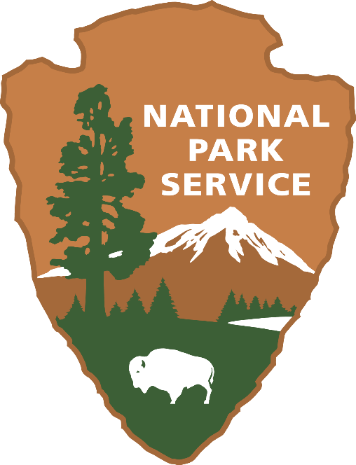

PAPERWORK REDUCTION ACT STATEMENT: The National Park Service is authorized by the NPS Research Mandate (54 USC 100702) to collect this information. This information will be used by park managers to understand visitors’ perceptions of sounds in Saguaro National Park. Responses to this request are voluntary and anonymous. Your name will never be associated with your answers, and all contact information will be destroyed when the data collection is concluded. No action may be taken against you for refusing to supply the information requested. An agency may not conduct or sponsor, and a person is not required to respond to, a collection of information unless it displays a currently valid OMB control number and expiration date.

BURDEN ESTIMATE statement: Public reporting burden for this form is estimated to average 14 minutes per response. Direct comments regarding the burden estimate or any other aspect of this form to: Adam Springer, Saguaro National Park Resource Management Specialist, adam_springer@nps.gov; 520-733-5171

The focus of this study is to better understand visitors’ experiences and management preferences regarding natural soundscapes in Saguaro National Park. These data will be used to inform park managers about the current visitor experiences and management preferences regarding natural soundscapes.

Your participation in the study is voluntary, and your answers will remain anonymous. Our results will be summarized so that the answers you provide cannot be associated with you or anyone in your group or household. The survey will take approximately 14 minutes to complete.

TOPIC AREA 5: ACT11

- Below is a list of activities available at Saguaro National Park. Please indicate your primary activity today (choose one):
Primary Activity
(Check only one)
Hiking | £
Picnicking | £
Camping | £
Nature/wildlife observation | £
Cycling | £
Viewing Saguaro cacti | £
Attend a ranger talk | £
Backpacking | £
Through hiking the Arizona Trail | £
Horseback riding/equestrian activities | £
Dark sky viewing | £
Other Specify:_____________ | £

TOPIC AREA 3: CVIS1
- Are you a first-time visitor to Saguaro National Park?
  - YES
  - NO (Skip to Question #3)

TOPIC AREA 3: CVIS1
- Over the past twelve months, how many visits have you made to Saguaro National Park? ___Number of Visits

TOPIC AREA 5: SOUND7, (Variation: specified wording to focus on specific park needs.)
- Please rate the quality of the sounds your heard on your visit today. Please select Q only one response for each item.

Hearing… | Not applicable | Extremely Unpleasant | Moderately Unpleasant | Neutral | Moderately Pleasant | Extremely Pleasant
Traffic Noise |  | 1 | 2 | 3 | 4 | 5
Bird song/calls |  | 1 | 2 | 3 | 4 | 5
People shouting or speaking loudly |  | 1 | 2 | 3 | 4 | 5
Wildlife (non-birds) |  | 1 | 2 | 3 | 4 | 5
Loud music |  | 1 | 2 | 3 | 4 | 5
Wind |  | 1 | 2 | 3 | 4 | 5
Someone’s ringing cell phone |  | 1 | 2 | 3 | 4 | 5
Running/falling water |  | 1 | 2 | 3 | 4 | 5
Large groups of people speaking |  | 1 | 2 | 3 | 4 | 5
Other electronic equipment (camera, drone, etc.) |  | 1 | 2 | 3 | 4 | 5
Aircraft noise |  | 1 | 2 | 3 | 4 | 5
Train sounds |  | 1 | 2 | 3 | 4 | 5
Blasting (from a mine) |  | 1 | 2 | 3 | 4 | 5
Unknown mechanical noise |  | 1 | 2 | 3 | 4 | 5
Other _____________________ |  | 1 | 2 | 3 | 4 | 5

TOPIC AREA 5: SOUND16
- Please rate the PLEASANTNESS or UNPLEASANTNESS of the overall sound that you heard along this last segment of the trail. Mark your single choice with an X.
Very  pleasant | Moderately  pleasant | A little  pleasant | Neutral | A little  unpleasant | Moderately unpleasant | Very  unpleasant
! | ! | ! | ! | ! | ! | !

TOPIC AREA 5: SOUND8
- Did you make a conscious effort to limit the amount of noise you made in the park today? (Choose one and explain why)
- YES. Explain why? ______________________________________________

- NO. Explain why? _______________________________________________

TOPIC AREA 5: SOUND15 (Variation: Simplified wording to focus on single aspect.)

- How much did human-made sounds interfere with your enjoyment during your time in Saguaro? (Please select one)

Much less than I expected | Less than I expected | About as much as I expected | More than I expected | Much more than I expected
1 | 2 | 3 | 4 | 5

TOPIC AREA 5: SOUND4, variation
- What was the primary human-made sound that interfered with the enjoyment of your time in Saguaro National Park? Select one.
Not applicable (human-made sounds did not interfere with my enjoyment) | £
Traffic Noise
People shouting or speaking loudly | £
Loud music | £
Someone’s ringing cell phone | £
Large groups of people speaking | £
Other electronic equipment (camera, drone, etc.) | £
Aircraft noise | £
Train sounds | £
Blasting (from a mine) | £
Unknown mechanical noise | £
Other _____________________ | £

TOPIC AREA 5: NSKIES16, SOUND1, SOUND3 (Variation: Modified items to focus on sounds.)
- Please indicate the degree to which you agree or disagree with the following statements. (Select one number for each statement.)
 | Strongly disagree | Disagree | Neither | Agree | Strongly agree
Hearing natural soundscapes is important to me. | -2 | -1 | 0 | 1 | 2
Hearing natural soundscapes is an important part of my experience in Saguaro National Park | -2 | -1 | 0 | 1 | 2
Protection of the natural soundscape is important in preserving this park for future generations. | -2 | -1 | 0 | 1 | 2
Preserving the natural soundscape is as important as protecting other resources in this park. | -2 | -1 | 0 | 1 | 2
The natural soundscape in this park is pristine (i.e., free of noise). | -2 | -1 | 0 | 1 | 2
TOPIC AREA 7: LNT8 (Variation: modified response items to focus on sounds/noise.)

- Please indicate how INAPPROPRIATE or APPROPRIATE you think each of the following activities is for a visitor to do in Saguaro. Select the number of your response for each statement.

 | Very Inappropriate | Inappropriate | Neutral | Appropriate | Very  Appropriate
Playing music loudly | 1 | 2 | 3 | 4 | 5
Reducing your noise that may impact wildlife | 1 | 2 | 3 | 4 | 5
Listening to music with headphones/earbuds | 1 | 2 | 3 | 4 | 5
Muting your phone and other electronics | 1 | 2 | 3 | 4 | 5
Carpooling whenever possible | 1 | 2 | 3 | 4 | 5
Reducing noise that may impact other visitors | 1 | 2 | 3 | 4 | 5
Playing music at a level that only you, or your immediate group can hear | 1 | 2 | 3 | 4 | 5
Reducing your driving speed to reduce noise | 1 | 2 | 3 | 4 | 5

TOPIC AREA 5: SOUND20
- How desirable would it be IF you were to experience the following during your visit? (Select one number which best describes how unacceptable or acceptable the experience would be).

Sounds | Very  undesirable | Slightly undesirable | Neutral | Slightly  desirable | Very  desirable
Sign(s) informing you about the park’s concerns with human-caused noise | -2 | -1 | 0 | 1 | 2
Sign(s) encouraging you to listen to natural soundscapes | -2 | -1 | 0 | 1 | 2
Sign(s) informing you which natural sounds you should be listening for | -2 | -1 | 0 | 1 | 2
Designating a quiet area within the park | -2 | -1 | 0 | 1 | 2
Lowered speed limits to reduce vehicle noise | -2 | -1 | 0 | 1 | 2
Sign(s) informing you what this area might have sounded like 500 years ago | -2 | -1 | 0 | 1 | 2
Sign(s) asking you to limit human-caused noise in the park | -2 | -1 | 0 | 1 | 2
Park rangers stationed along the trail quieting visitors. | -2 | -1 | 0 | 1 | 2
Park rangers stationed along the trail to educate visitors about natural soundscapes | -2 | -1 | 0 | 1 | 2
Park interpreters conducting ‘listening’ walks | -2 | -1 | 0 | 1 | 2

TOPIC AREA 8: LNT18 (Variation: modified to answer questions about Leave No Trace Behaviors)
- Please indicate the degree to which you agree or disagree that participating in the following [ACTIVITIES] would reduce negative impacts on wildlife and improve visitor experiences in the Park. (Select the number of your response for each statement)

Participating in the following activities in Saguaro would reduce negative impacts on wildlife and improve visitor experiences | Strong disagree | Disagree | Neither | Agree | Strongly agree
Muting your phone and other electronics | -2 | -1 | 0 | 1 | 2
Playing music at a level that only you, or your immediate group can hear it | -2 | -1 | 0 | 1 | 2
Using headphones or ear buds while listening to music or talking on the phone | -2 | -1 | 0 | 1 | 2
Carpooling whenever possible | -2 | -1 | 0 | 1 | 2
Speaking quietly | -2 | -1 | 0 | 1 | 2
Reducing your driving speeds | -2 | -1 | 0 | 1 | 2
Being mindful of your car alarm and horn | -2 | -1 | 0 | 1 | 2
Recreating in smaller group sizes | -2 | -1 | 0 | 1 | 2

TOPIC AREA 7: SOUND21 (Variation: Modified response options to fit study needs.)
NOTE TO REVIEWER:
The questions in this section will be used to investigate spatially, where within the park visitors find specific visitor-caused noise sources acceptable or unacceptable. Using a map provided in the survey, they will draw polygons around the areas of the park where the following noise sources are acceptable. They will do the same for noise sources rated as unacceptable. They will be limited to drawing 6 polygons for each noise source (3 for acceptability and 3 for unacceptability). Here we provided an example of what the map will look like.
- Using the map(provided), please identify the locations within the park you find each sound source acceptable. You can choose multiple locations.

Sound Source -Acceptable | Specify Locations | Acceptable in all locations
Music playing on a phone or speaker
People talking loudly
Electronics like phones, cameras, etc.
Vehicle noise
Aircraft noise

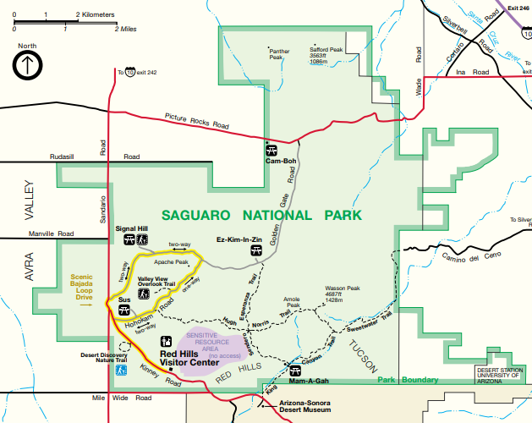
- Using the map(provided), please identify the locations within the park you find each sound source unacceptable. You can choose multiple locations.

Sound Source -Unacceptable | Specify Locations | Unacceptable in all locations
Music playing on a phone or speaker
People talking loudly
Electronics like phones, cameras, etc.
Vehicle noise
Aircraft noise

TOPIC AREA 8: LNT16 (Variation: Modified response options to fit study needs.)
- Leave No Trace is an educational partner of the National Park Service and they work to help teach the public about how to recreate sustainably, including how to respect wildlife in parks. Please indicate the extent to which you disagree or agree with the following statements[MM1] regarding your involvement with Leave No Trace.
 | Strongly Disagree | Disagree | Neither Agree or Disagree | Agree | Strongly Agree | Do Not Know
I have regularly used Leave No Trace techniques when recreating outdoors in the past. | 1 | 2 | 3 | 4 | 5 | 6
I have taken time to educate others about using Leave No Trace techniques when recreating outdoors. | 1 | 2 | 3 | 4 | 5 | 6
When recreating outdoors previously, I have planned ahead and prepared beyond the basic necessities. | 1 | 2 | 3 | 4 | 5 | 6
I spend time regularly learning how to better Leave No Trace when recreating outdoors | 1 | 2 | 3 | 4 | 5 | 6
I believe my knowledge of Leave No Trace techniques is more advanced than that of most other outdoor recreationists. | 1 | 2 | 3 | 4 | 5 | 6
I understand how to use Leave No Trace techniques in a variety of outdoor settings. | 1 | 2 | 3 | 4 | 5 | 6
I am confident in my ability to effectively Leave No Trace when participating in a variety of outdoor recreation activities. | 1 | 2 | 3 | 4 | 5 | 6
I have invested in outdoor equipment to help me better Leave No Trace when recreating outdoors. | 1 | 2 | 3 | 4 | 5 | 6
Using Leave No Trace techniques when recreating outdoors says a lot about who I am. | 1 | 2 | 3 | 4 | 5 | 6
Many people I surround myself with use Leave No Trace techniques when recreating outdoors. | 1 | 2 | 3 | 4 | 5 | 6
I identify with the general image associated with Leave No Trace. | 1 | 2 | 3 | 4 | 5 | 6

TOPIC AREA 1: RES1
- Are you a permanent resident or citizen of the United States? (Please respond “yes” or “no”)
NO - What is your country of origin? _______________________
YES - What is your primary zip code
Zip code ______________

TOPIC AREA 1: GROUP5
- How many people were in your personal group today, including you?
____ Number of people

TOPIC AREA 1: GROUP3
- Which one of the following best describes the group you are traveling with?
Myself/alone
Myself with family
Myself with friends
Commercial guided tour group
Outfitter/guide
Club/organization
Other: _________________________

TOPIC AREA 1: GEND1
- What is your gender? (Please select one.)
- Male
- Female
- Transgender, non-binary, or another gender
- Prefer not to answer

TOPIC AREA 1: AGE 1
- In what year were you born? ________

Topic Area 1: RACE/ETH1
- What is your race and/or ethnicity?
Select all that apply and enter additional details in the spaces below.
- American Indian or Alaska Native—Enter, for example, Navajo Nation, Blackfeet Tribe of the Blackfeet Indian Reservation of Montana, Native Village of Barrow Inupiat Traditional Government, Nome Eskimo Community, Aztec, Maya, etc.

- Asian—Provide details below.
- Chinese | - Asian Indian | - Filipino
- Vietnamese | - Korean | - Japanese
Enter, for example, Pakistani, Hmong, Afghan, etc.

- Black or African American—Provide details below.
- African American | - Jamaican | - Haitian
- Nigerian | - Ethiopian | - Somali
Enter, for example, Trinidadian and Tobagonian, Ghanaian, Congolese, etc.

- Hispanic or Latino—Provide details below.
- Mexican | - Puerto Rican | - Salvadoran
- Cuban | - Dominican | - Guatemalan
Enter, for example, Colombian, Honduran, Spaniard, etc.

- Middle Eastern or North African—Provide details below.
- Lebanese | - Iranian | - Egyptian
- Syrian | - Iraqi | - Israeli
Enter, for example, Moroccan, Yemeni, Kurdish, etc.

- Native Hawaiian or Pacific Islander—Provide details below.
- Native Hawaiian | - Samoan | - Chamorro
- Tongan | - Fijian | - Marshallese
Enter, for example, Chuukese, Palauan, Tahitian, etc.

- White—Provide details below.
- English | - German | - Irish
- Italian | - Polish | - Scottish
Enter, for example, French, Swedish, Norwegian, etc.

Saguaro National Park and the University of New Hampshire
thank you for your assistance.

