Attachment 3. Injury Control Research Centers (ICRC) Cooperative Agreement Management Platform (CAMP) Platform Screenshots

Injury Control Research Centers (ICRC) Grant Platform Homepage
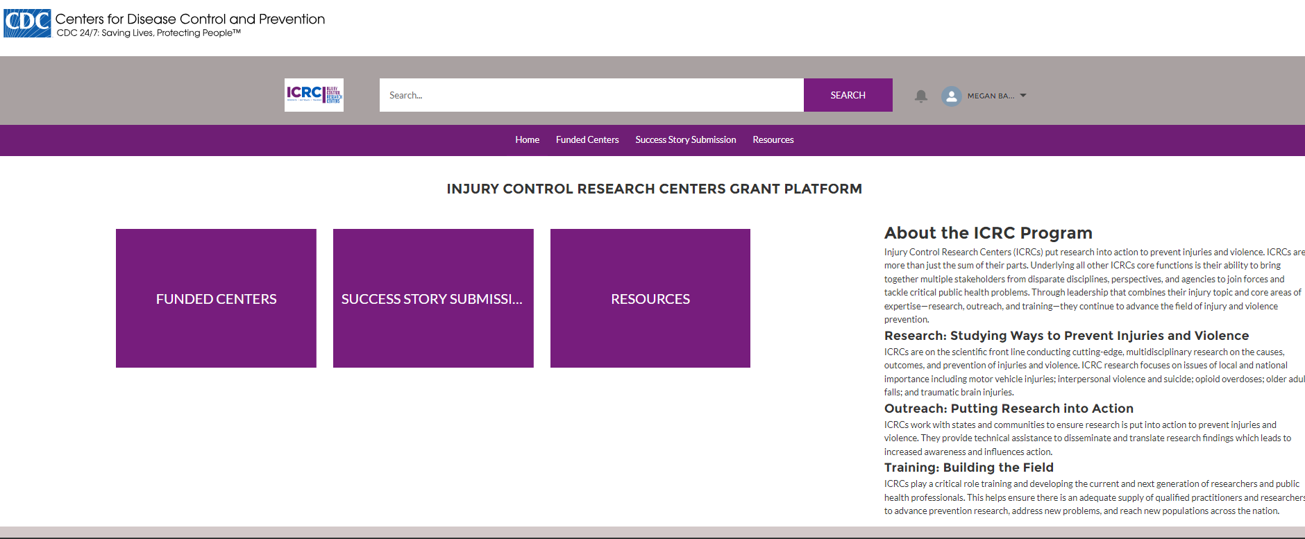

ICRC Funded Centers list view
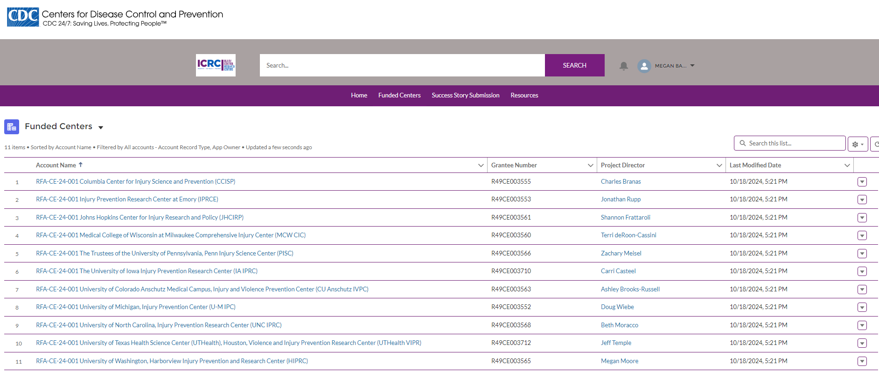

ICRC work products page (with OMB form approval at top right, and public reporting burden time estimate at the bottom of the page) 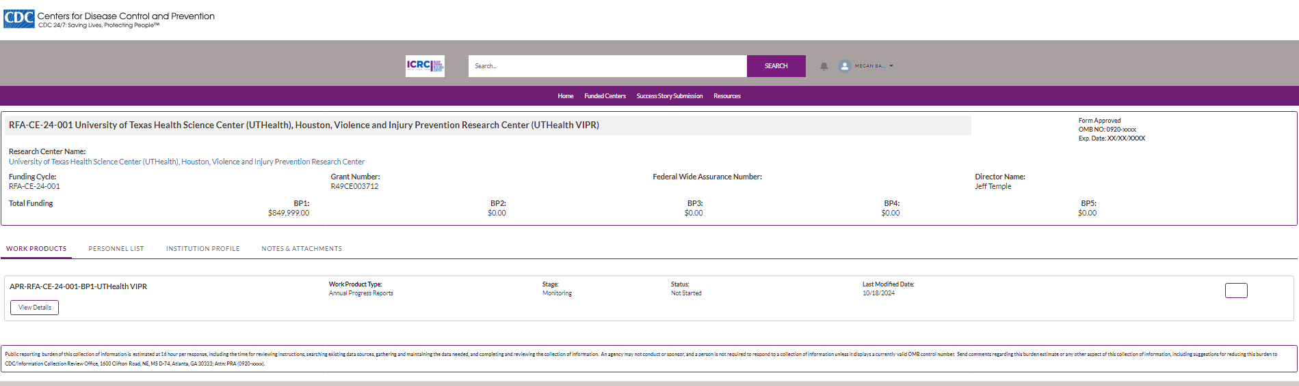

ICRC work products detailed page (with OMB form approval at top right, and public reporting burden time estimate at the bottom of the page) 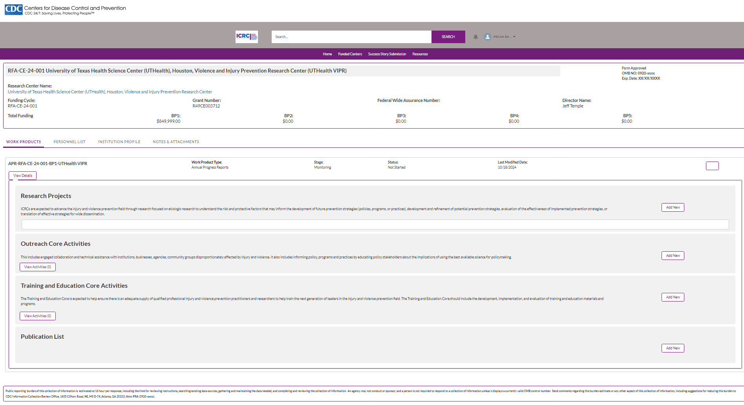

ICRC add a research project details page 1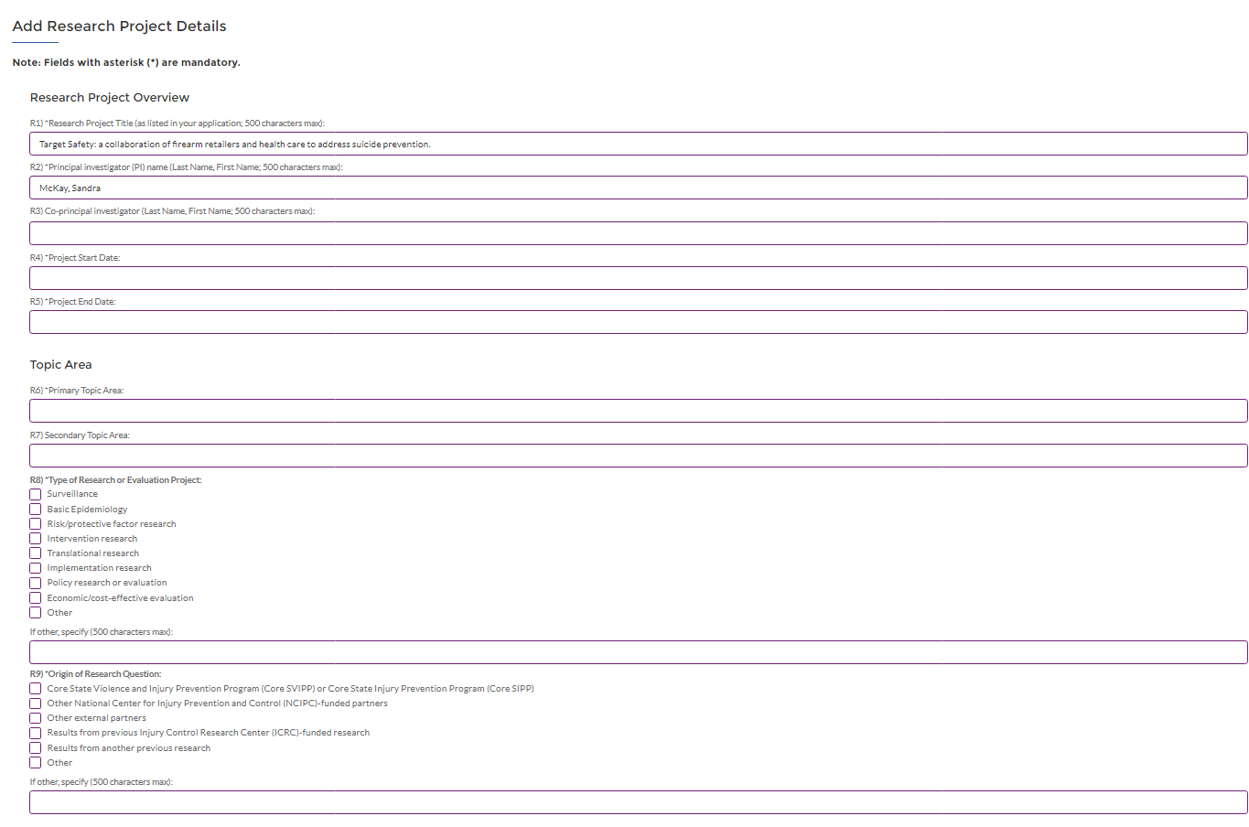
ICRC add a research project details page 2
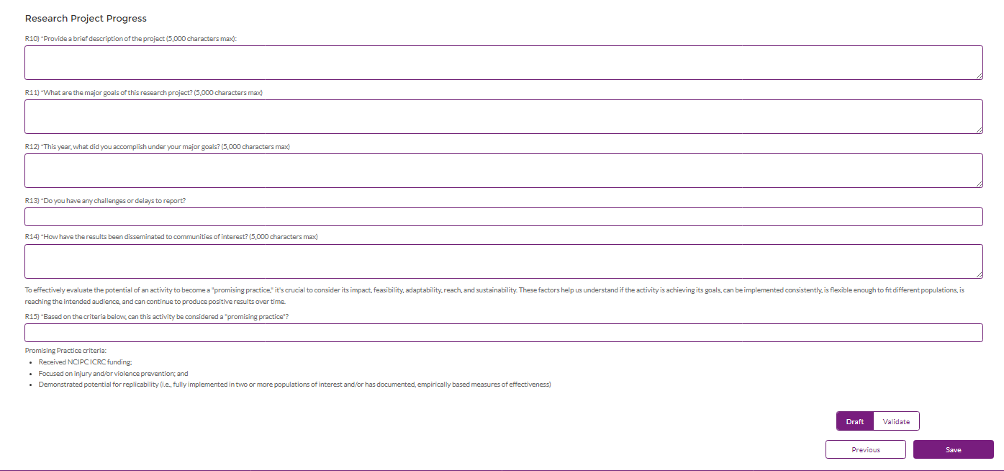

ICRC add an outreach activity page
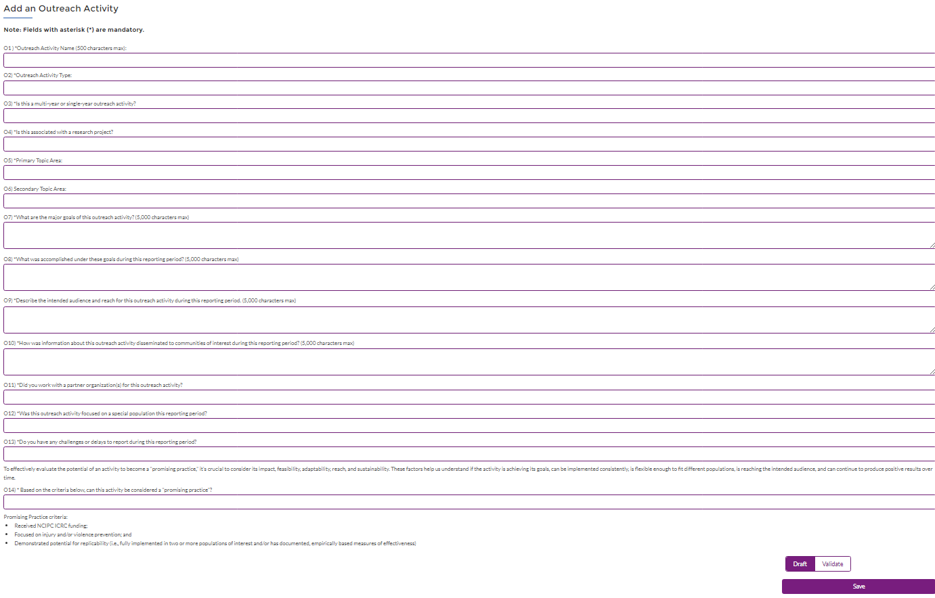

ICRC add an Injury & Violence Prevention course page
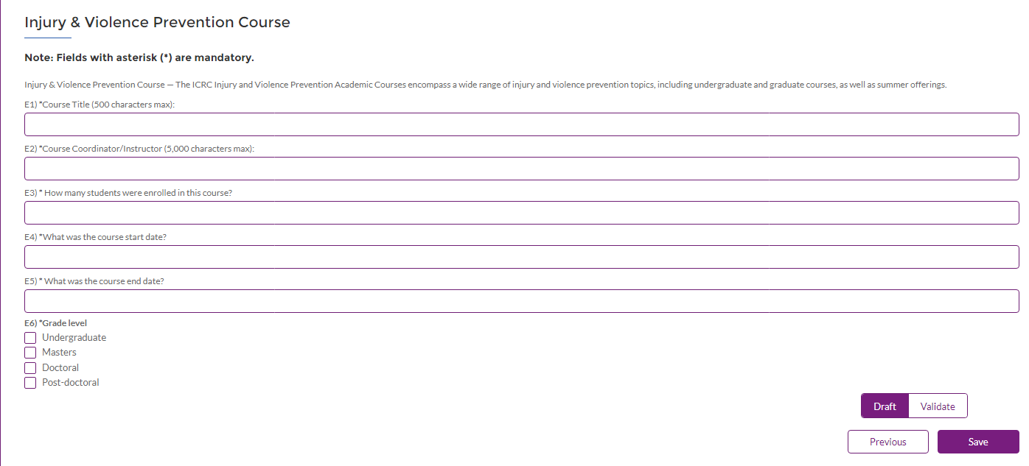

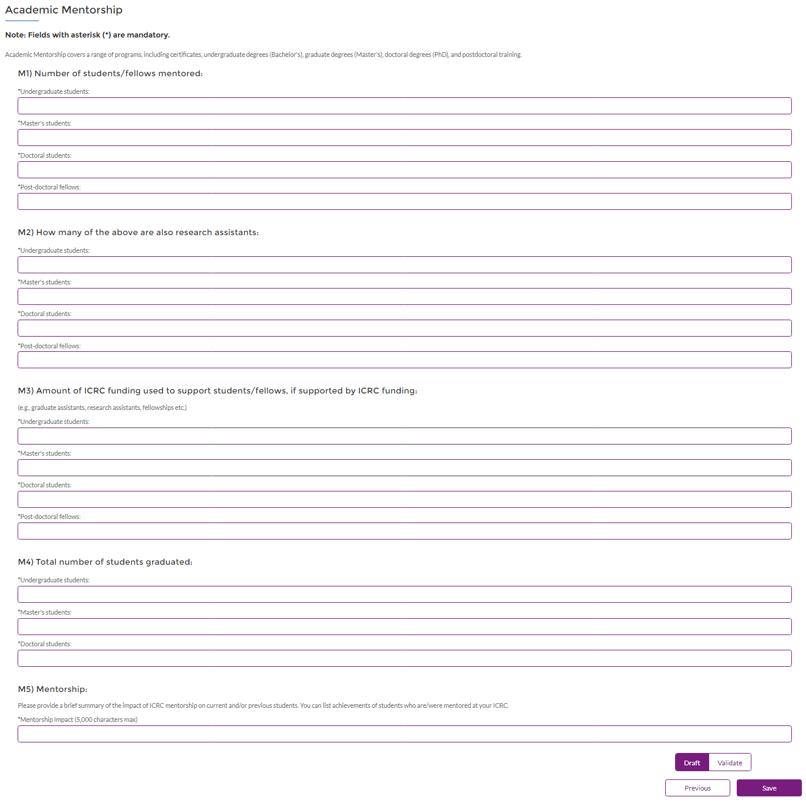
ICRC add Academic Mentorship page

ICRC add Other Training & Education Activities page
