Attachment A: Online study protocol
Welcome! Thank you for your interest in our research to improve survey questions for the Bureau of Labor Statistics.
The study should take about 10 minutes. Please only start the study when you will be able to complete the whole study without interruption. Please do your best to respond to the questions accurately.
Please do not use your browser's back button.
This voluntary study is being collected by the Bureau of Labor Statistics under OMB No. 1220-0141 (Expiration Date: July 31, 2027). Without this currently approved number, we could not conduct this survey. This survey will take approximately 10 minutes to complete. If you have any comments regarding this estimate or any other aspect of this study, send them to BLS_PRA_Public@bls.gov. The BLS cannot guarantee the protection of survey responses and advises against the inclusion of sensitive personal information in any response. This survey is being administered by Qualtrics and resides on a server outside of the BLS Domain. Your participation is voluntary, and you have the right to stop at any time.
---page break---

What is your CloudResearch Connect ID/Amazon Mechanical Turk ID number?
[open entry]

For accuracy, please re-enter your CloudResearch Connect ID/Amazon Mechanical Turk ID number?
[open entry]

---page break---

Next, we have some questions about your past experiences, attitudes, and behaviors.

Behavioral question 1

<Random assignment to Select All (SA) vs. Forced Choice (FC)>
Think back to the last time you looked for work.

In what year did you last look for work? (YYYY)

---page break---

SA:What are all of the things you did to find work? Select all that apply.
FC: Indicate whether or not you did each of the following things to find work. Yes/No
- Interviewed for a job
- Applied for a job or answered a job ad
- Checked a union/professional register (such as, construction register or nurse’s register)
- Submit a resume or an ad/listing online or in-person
- Contacted employment agency/school employment center/job fair
- Asked friends, relatives, network about job leads
- Looked at job ads online, in print, or in-person
- Participated in a job training course or other activity to improve job skills
- Worked on resume
- Other (please specify)
- None of the above (only for the Select All condition)

---page break---

Did you do anything else to look for work?
- Yes
- No

(If yes) Please describe what else you did.
[open-end]

---page break---

Behavioral question 2

SA: Which of the following apps have you used in the past 12 months to purchase goods or services? Select all that apply.
FC: Indicate whether or not you have used each of the following apps in the past 12 months to purchase goods or services? Yes/No
[randomize select all vs. forced choice; randomize list order]

- Uber
- Instacart
- Task Rabbit
- Doordash
- Lyft
- Airbnb
- Rover
- Swimply
- Vrbo
- Ksmt
- None of the above (only for the Select All condition)

---page break---

Behavioral question 3

SA: Which of the following privacy related behaviors do you engage in while online? Select all that apply.
FC: Indicate whether or not you engage in the following privacy related behaviors while online. Yes/No
[randomize select all vs. forced choice; randomize list order]

- I shred/burn personal documents when disposing of them.
- I hide my pin bank card number when using cashing machines or making purchases
- I only register for websites that have a privacy policy
- I read a website’s privacy policy before registering my information
- I look for a privacy certification on a website before registering my information
- I read license agreements fully before agreeing to them
- I verify that online organizations are who they claim to be
- I do not register for websites that ask for too much personal information
- I take measures to protect myself from identity theft
- I encrypt email messages when sending private information online
- None of the above (only for the Select All condition)

---page break---

Factual question 1

SA: Which of the following appliances or equipment were included in your home or rental? Select all that apply.
FC: Indicate whether or not the following appliances or equipment were included in your home or rental. Yes/No
[randomize select all vs. forced choice; randomize list order]

- Built-in coffee or espresso maker
- Microwave oven
- Wine cellar
- Built-in dishwasher
- Portable dishwasher
- Garbage disposal
- Clothes washer or dryer
- Smoke alarms and detectors
- Window air conditioner
- Central air
- None of the above (only for the Select All condition)

---page break---

Factual question 2

SA: What types of insurance do you have? Select all that apply.
FC: Indicate whether or not you have each the following types of insurance. Yes/No

[randomize select all vs. forced choice; randomize list order]

1. Life insurance or other policies which provide benefits in case of death or disability
2. Homeowners' insurance
3. Renters' insurance
4. Automobile or other vehicle insurance
6. Veterinary insurance
7. Health insurance
8. Dental insurance
9. Vision insurance
10. Umbrella insurance
11. None of the above (only for the Select All condition)

---page break---

Attitude question 1

SA: Which of the following statements [reflect how you feel about surveys / do NOT reflect how you feel about surveys]? Select all that apply.
FC: Indicate whether or not each of statements below reflects how you feel about surveys. Yes/No
[randomize select all vs. forced choice]

- I really enjoy responding to questionnaires through mail or Internet.
- I really enjoy being interviewed for a survey.
- Surveys are interesting in themselves.
- Surveys are important for society.
- A lot can be learned from information collected through surveys.
- Completing surveys is a waste of time.
- I receive far too many requests to participate in surveys.
- Opinion polls are an invasion of privacy.
- It is exhausting to answer so many questions in a survey.
- Election polls are a good prediction of election outcomes.
- None of the above (only for the Select All condition)

---page break---

Attitude question 2
SA: Which of the following privacy concerns do you have when online? Select all that apply. FC: Indicate whether or not you have the following privacy concerns while online. Yes/No
[randomize select all vs. forced choice; randomize list order]

- I am concerned about my privacy while using the internet
- I am concerned about online organizations not being who they claim they are
- I am concerned that I am asked for too much personal information when I register or make online purchases
- I am concerned about online identity theft
- I am concerned about people online not being who they say they are
- I am concerned about who might access my medical records electronically
- I am concerned about people I do not know obtaining personal information about me from my online activities
- I am concerned are that if I use a credit card to buy something on the internet my credit card number will obtained by someone else
- I am concerned that an email I send may be read by someone else besides the person I sent it to
- I am concerned about email I receive not being from whom they say they are
- None of the above (only for the Select All condition)

---page break---

Hypothetical question 1

SA: Over the next 4 weeks, do you plan to purchase or pay for any of the following? Select all that apply.
FC: From the list below, indicate whether or not you plan to purchase or pay for any of the following over the next 4 weeks. Yes/No

[randomize select all vs. forced choice; randomize list order]

- Ground coffee
- Pet food
- Clothing
- Lottery tickets
- New or used motor vehicle (car, truck, SUV, etc.)
- Concert tickets
- Rent or mortgage
- Books
- Dishwasher
- Airline travel
- None of the above (only for the Select All condition)

---page break---
Hypothetical question 2

Below are some ways people use the Internet. Some people have done these things, but other people have not. Over the next 4 weeks, do you plan to do any of the following while using the Internet? Select all that apply. / From the list below, indicate whether or not you plan to do each of these things while using the Internet over the next 4 weeks.

 | List 1: Only Low Probability Items | List 2: Including Higher Probability Items
 | Low probability items - Control | Low probability items - Control
 | Search for a job in the classifieds section of a newspaper website | Search for a job in the classifieds section of a newspaper website
 | Begin a new subscription for an online news magazine | Begin a new subscription for an online news magazine
 | Contribute to an online support forum for people with a similar health or medication issue | Contribute to an online support forum for people with a similar health or medication issue
 | Look for a health care provider using healthcare.gov | Look for a health care provider using healthcare.gov
 | Purchase a vehicle from an online retailer | Purchase a vehicle from an online retailer
 | Low probability items | Higher probability items
 | Buy travel-size medicine or vitamins online | Buy medicine, vitamins, or supplements online
 | Use an online journal to help you with your physical activity | Use a website or app to help you with your diet, weight, or physical activity
 | Use text messaging to communicate with a doctor or a doctor’s office | Use e-mail or the Internet to communicate with a doctor or a doctor’s office
 | Create a new profile for a social media website, such as Facebook or LinkedIn | Visit a social media website, such as Facebook or LinkedIn
 | Write a creative story using artificial intelligence applications, such as ChatGPT | Use artificial intelligence applications, such as ChatGPT
 | None of the above (only for the Select All condition) | None of the above (only for the Select All condition)

---page break---

And now we have a few questions about what it has been like to answer the questions in the survey so far.

How burdensome was it to answer these questions?

- Not at all burdensome
- Somewhat burdensome
- Moderately burdensome
- Very burdensome
- Extremely burdensome

How easy or difficult was it to answer these questions?
- Very easy
- Somewhat easy
- Neither easy nor difficult
- Somewhat difficult
- Very difficult

How accurate would you say your answers are to the questions in this survey?
- Very accurate
- Somewhat accurate
- You did the best you could

---page break---

What is your age?
[open numeric entry]

What is your gender?
- Male
- Female
- Transgender, non-binary, or another gender identity

What is the highest level of school you have completed or the highest degree you have received?
- Less than a high school diploma
- High school graduate, no college
- Some college or associate degree
- Bachelor's degree or higher

---page break---
Race/ethnicity questions will be placed here, participants will be randomly assigned to the following conditions:

Question Display | Examples Shown | Order
Unfolding format  -Participants select minimum categories, and then the detailed categories unfold in-page | Examples displayed on the page with the minimum categories | Alphabetical
2-page format  -Participants select the minimum categories that apply, and then they select the detailed categories on the next page | Examples are not displayed on the page with the minimum categories | Incidence

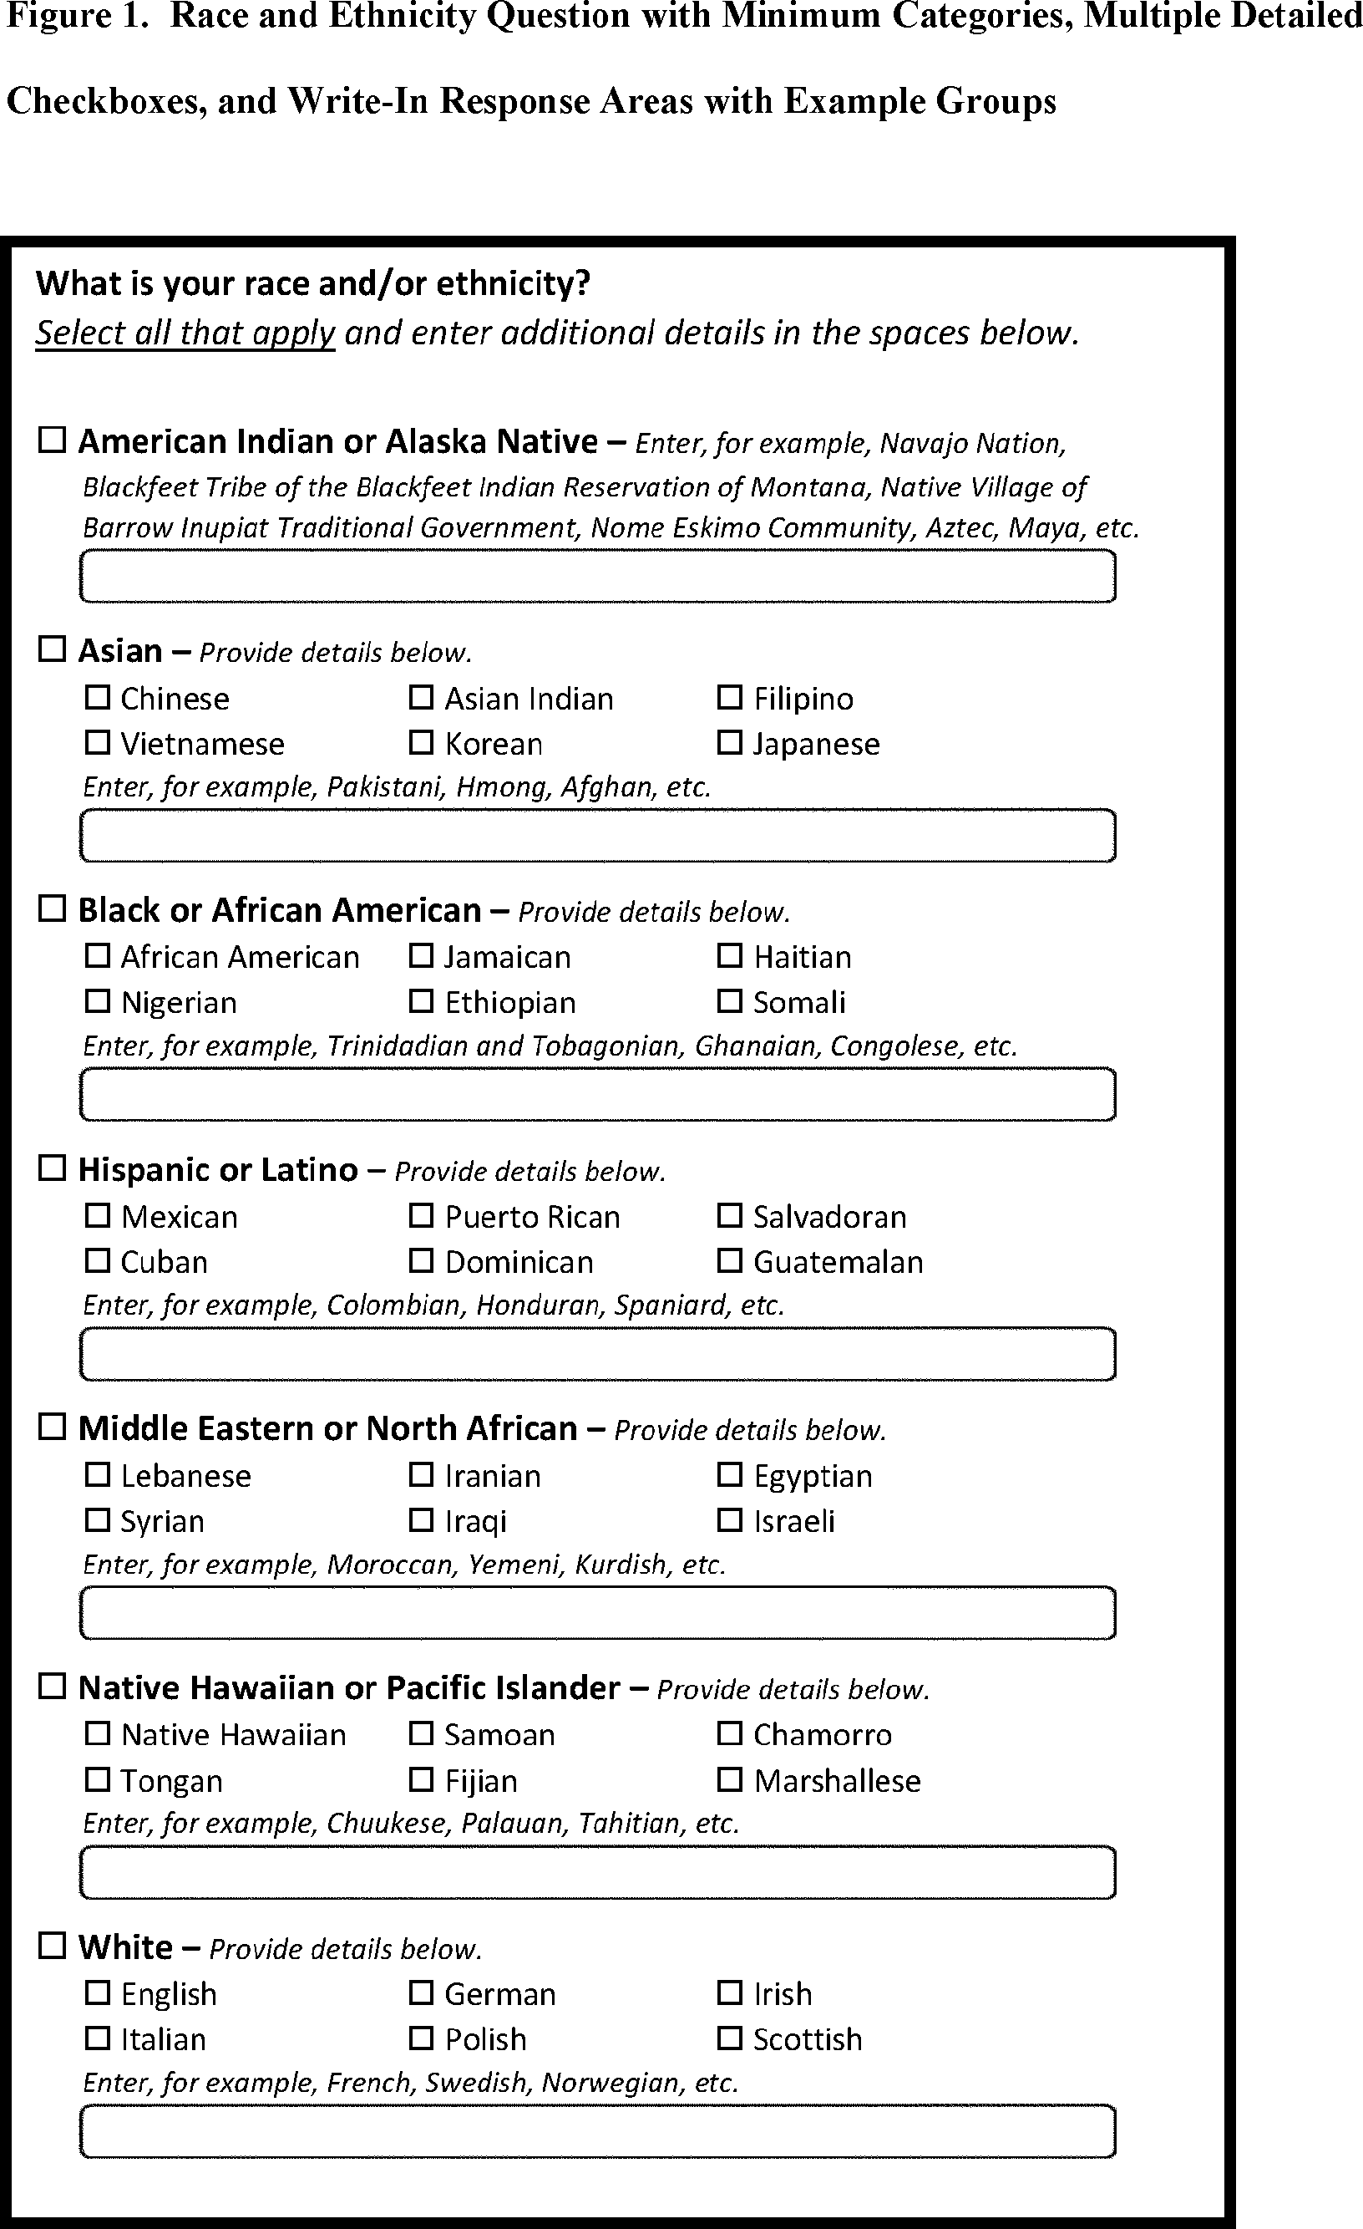

Last week, did you work at a job, or do any work for pay or profit?
- Yes
- No <skip to end>

---page break---

Please describe the type of work you do, that is, what is your occupation? For example: 4th grade teacher, plumber.
[open-end]

---page break---

From the list below, please select the option that best fits the kind of work do you do, that is, your occupation.
[autocomplete]

How well does this describe your occupation?
- Not well at all
- Somewhat well
- Moderately well
- Very well
- Extremely well

---page break---

What kind of business or industry do you work in?
[open-end]

---page break---

From the list below, please select the option that best fits the type of business or industry you work in.
[autocomplete]

How well does this describe your industry?
- Not well at all
- Somewhat well
- Moderately well
- Very well
- Extremely well

---page break---

Thank you for answering these questions.

Your completion code is: [insert code]

One decoy app name was included as a data quality check.

