Attachment A: Interview Protocols

Introduction (All Participants - 10 minutes)

Background and introductions (5 minutes)
Hello, my name is ______________ and I work at the Bureau of Labor Statistics. Thank you for taking the time to talk with me today. I’m joined by my colleague __________ today, who will be observing and taking notes.

BLS is currently working on a redesign of the current Classroom site to add new resources and to expand the audience to include adults who are learning about BLS data and concepts. In order to ensure that the site meets our users’ needs, we would like to talk about your work and how you might use resources on the BLS Classroom site. We would also like to get your feedback on some prototypes of new resources we are working on. Your input today will help us improve the content currently on the site as well as future content. There are no right or wrong answers; we’re looking for your reactions and honest feedback. Your name will not be included in the report, and nothing that you say will be attributed directly to you. Our goal today is to gather insight that can help us improve the resources on the BLS Classroom site.
Do you have any questions?

We would like to record the session today. It would only be shared with members of the team to help us as we work on the site. Is it ok with you if we record the session?
[If they say yes] OK, then I will start the recording.

Informed Consent (5 minutes)
[Share first informed consent card to participant]
Please read the slide I am sharing. Let me know when you are done.
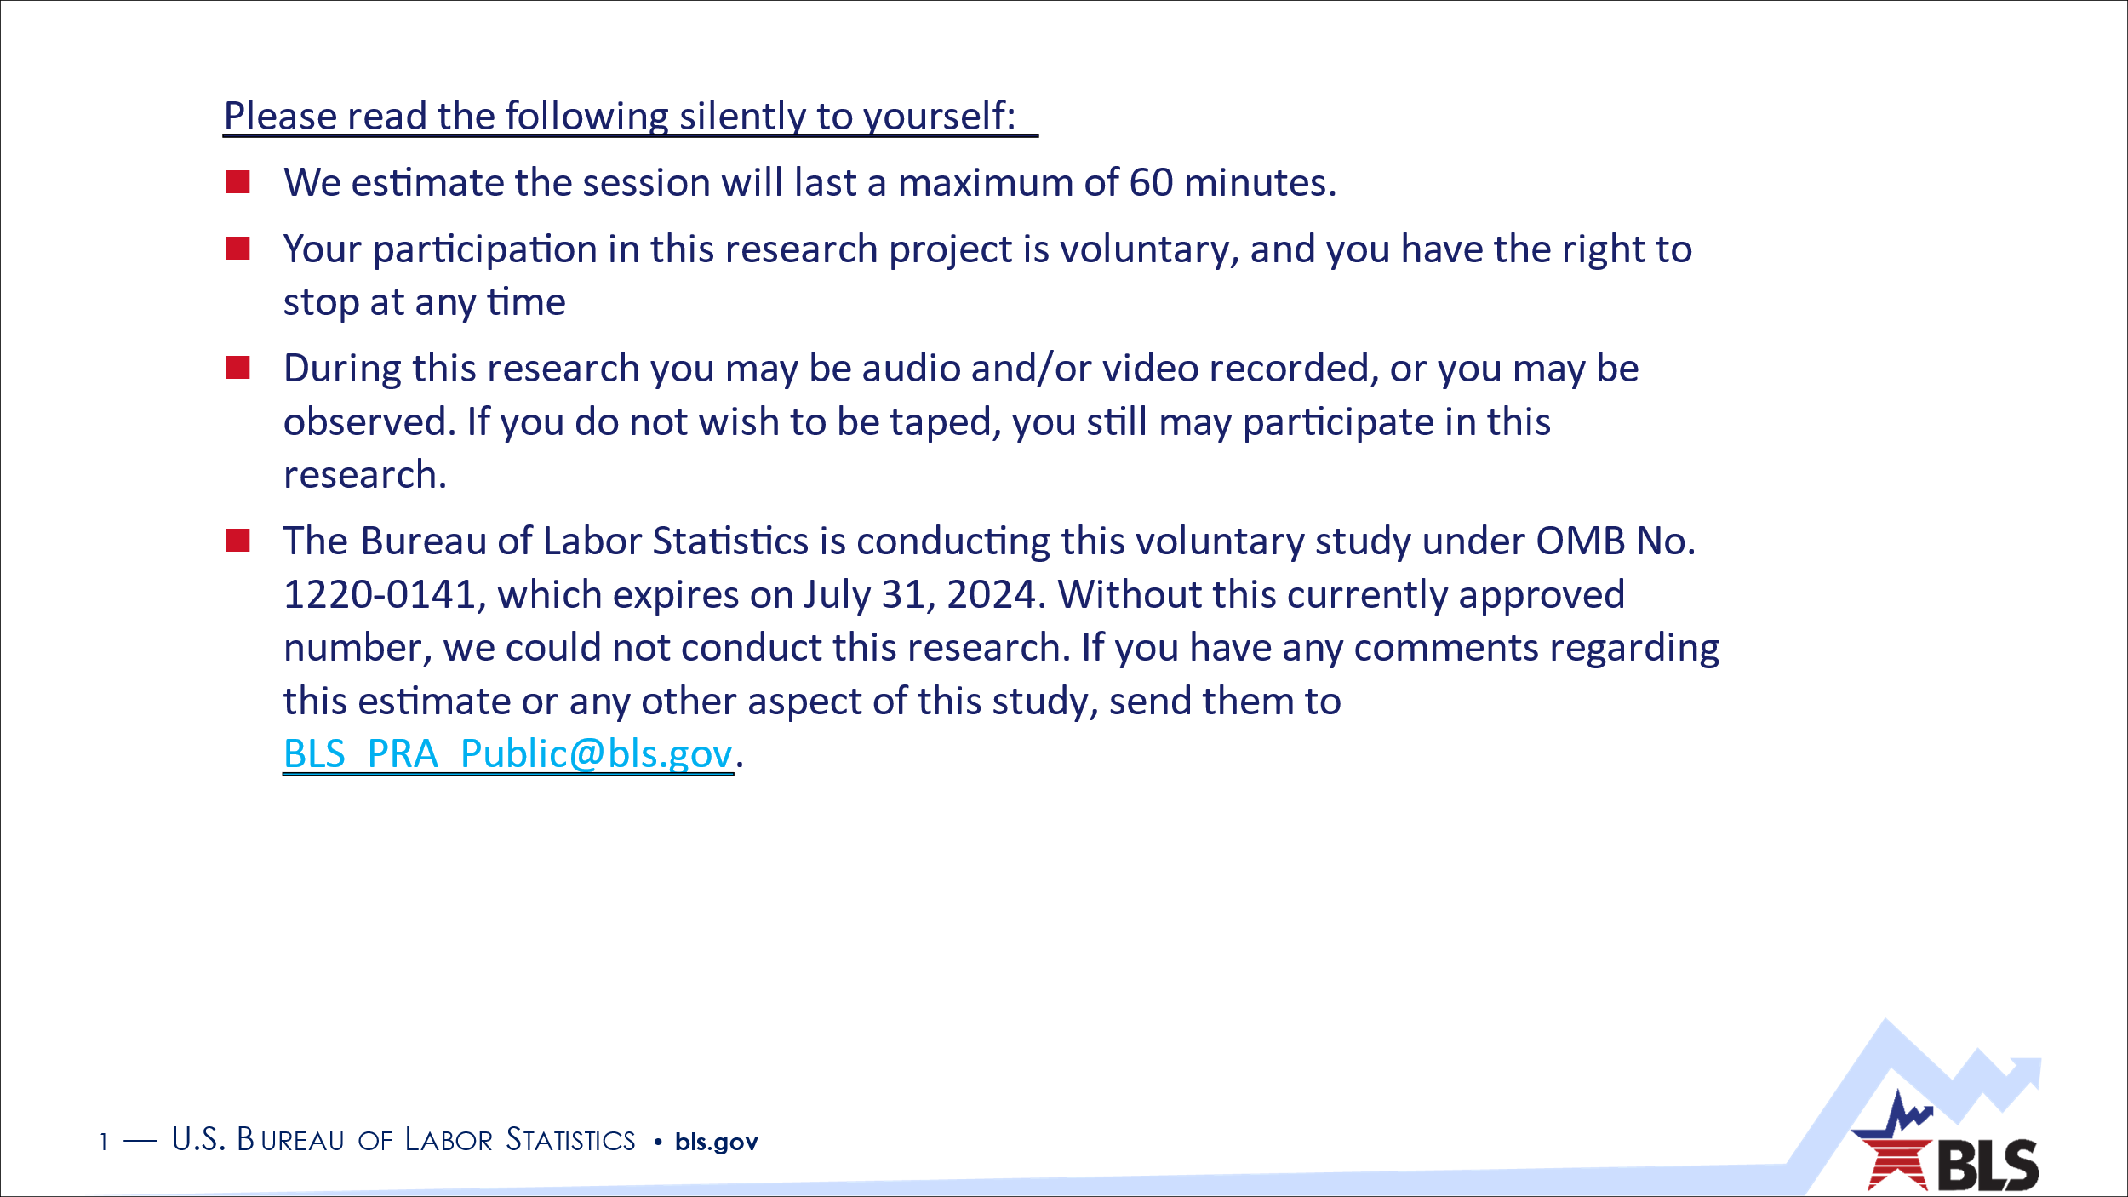
[Share second informed consent card to participant]
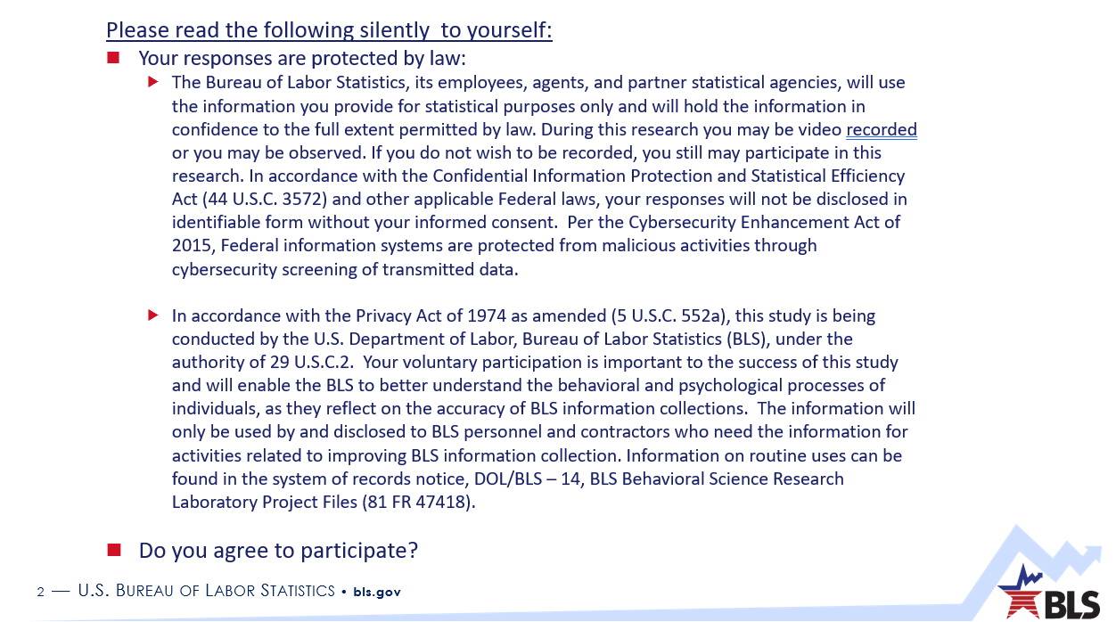

Do you have any questions before we proceed?
Do you agree to participate?
We will need to confirm your contact information in order to send you your gift card. Can you confirm your email and cell phone number? You should get your gift card within two business days.

Participants’ Background (All Participants, 10 minutes)
Could you describe your role and the kind of organization you work for?
[Teachers and Career Counselors only] Can you describe the students you work with?
[Teachers only] Can you tell me what educational standards, if any, are you using? For example, are you using your state or federal standards?
[Teachers Only] What are a couple of the resources you use to help explain the topics you teach?
[Career Counselors Only] What are the primary resources you use with your students to help them identify potential careers?
[Teachers and Career Counselors only] When reviewing new resources, what factors do you consider when deciding whether to use it or not?
[Media Only] In general, what topics do you cover?
[Media Only] What resources do you use to learn about labor economic concepts?
How long have you been doing this work?
In order to ensure that we are getting a good representation of participants, we’d like to get some demographic information about you.
  - What is your gender?
    - Male
    - Female
    - Transgender, non-binary, or another gender identity
    - Prefer not to answer
  - What is your race and/or ethnicity? Choose all that apply.
    - American Indian or Alaska native
    - Asian
    - Black or African American
    - Hispanic or Latino
    - Middle Eastern or North African
    - Native Hawaiian or Pacific Islander
    - White
    - Prefer not to answer

BLS and Classroom Resources Used (All Participants, 10 minutes)
Have you used or tried to use any of the resources on the BLS.gov website?
[If yes] Which resources have you used, and how did you use them?
What did you think of them?

Now let’s take a look at the Classroom site. I’d like to ask you to share your screen. Please be sure any confidential or sensitive files or applications are closed before you do. Once you’re ready, please navigate to the Classroom homepage. We will put a link in the chat.

Take a few moments to look around the homepage to see what’s on the site. What are your thoughts on the homepage and the site?
What do you like?
What don’t you like?

Feedback on Classroom Site Resources (Career Counselors Only, 10 minutes)
Now, let’s take a look at some resources on the site intended for career planning.

[Middle and High School Counselors only]

To start, please navigate to the Career Exploration page and take a few minutes to look around.
What do you think of this resource?
Do you think this content would be useful to you and the students you work with?
What age group would you say this was targeted towards?
The site links to the BLS Occupational Outlook Handbook. Is the information in the OOH useful to you?
Do you have any recommendations to improve the site?

[All Counselors]

Please navigate to the Career Resource Guide and take a few minutes to look around.
What do you think of this resource?
Do you think this content would be useful to you and the students you work with?
What age group would you say this was targeted towards?
Do you have any recommendations to improve the site?

Feedback on Classroom Site Resources (Elementary School Teachers Only, 10 minutes)

Activities

Now, let’s take a look at some resources on the site.

To start, please navigate to the Classroom Activities page.
What do you think of this page?
When you want to find resources like these, how would you like to sort or filter the options?
How would you interpret the links for “Requirements” and “Activity”?
What formats for the activities would you use? Would you like a format like PDF that is intended for printing?
Are there activities or topics that you’d like to see here that you think are missing?

Next, please select one of the activities that you think might be useful in your classroom.
What do you think of the Requirements?

What do you think of the Activity?
Would you use an activity like this or one of the others in your class? [If no] Why not?
What age group would you say this was targeted towards?
What could we do to improve the Activity, including the Requirements?

Games and Quizzes
Next, please navigate to the Games and Quizzes page.

What do you think of the games and quizzes available on this page?
Would you use activities like this in your class? Why or why not?
What age group would you say these resources were targeted towards?

Feedback on Classroom Site Resources (Middle School Teachers Only, 10 minutes)

Activities

Now, let’s take a look at some resources on the site.

To start, please navigate to the Classroom Activities page.

What do you think of this page?
When you want to find resources like these, how would you like to sort or filter the options?
How would you interpret the links for “Requirements” and “Activity”?
What formats for the activities would you use? Would you like a format like PDF that is intended for printing?
Are there activities or topics that you’d like to see here that you think are missing?

Next, please select one of the activities that you think might be useful in your classroom.
What do you think of the Requirements?

What do you think of the Activity?
Would you use an activity like this or one of the others in your class? [If no] Why not?
What age group would you say this was targeted towards?
What could we do to improve the Activity, including the Requirements?

Economics Made Easy
Next, we’ll look at our Economics Made Easy handouts. Please navigate to the Economics Made Easy landing page.
What do you think of this page?
Do any of the handouts look useful?
What formats would you use? Would you like a format like PDF that is intended for printing?
When you want to find resources like these, how would you like to sort or filter the options?
Are there activities or topics that you’d like to see here that you think are missing?

Next, please select one of the topics that you think might be useful in your classroom.
What do you think of this handout?
Would you use a handout like this or one of the others in your class? [If no] Why not?
What age group would you say this was targeted towards?
What could we do to improve the handout?

Feedback on Classroom Site Resources (High School Civics/Social Studies Teachers, 10 minutes)
Next, we’ll look at a few BLS resources.

Economics Made Easy
Now please navigate to the Economics Made Easy landing page.
What do you think of this page?
Do any of the handouts look useful?
What formats would you use? Would you like a format like PDF that is intended for printing?
When you want to find resources like these, how would you like to sort or filter the options?
Are there activities or topics that you’d like to see here that you think are missing?

Next, please select one of the topics that you think might be useful in your classroom.
What do you think of this handout?
Would you use a handout like this or one of the others in your class? [If no] Why not?
What age group would you say this was targeted towards?
What could we do to improve the handout?

Maps
Now we’ll look at some maps with BLS data. Please navigate to the Maps page. Take a look around.
What do you think of this resource?
Would you use this in your class? [If no] Why not?
What age group would you say this was targeted towards?
What could we do to improve the resources here?

Feedback on Classroom Site Resources (High School Math/Statistics Teachers, High School Economics Teachers, College Economics Professors, 10 minutes)
Next, we’ll look at a few BLS resources.

Economics Made Easy
We’ll look at with our Economics Made Easy handouts. Please navigate to the Economics Made Easy landing page.
What do you think of this page?
Do any of the handouts look useful?
What formats would you use? Would you want a format like PDF that is intended for printing?
When you want to find resources like these, how would you like to sort or filter the options?
Are there activities or topics that you’d like to see here that you think are missing?

Next, please select one of the topics that you think might be useful in your classroom.
What do you think of this handout?
Would you use a handout like this or one of the others in your class? [If no] Why not?
What age group would you say this was targeted towards?
What could we do to improve the handout?

Economy at a Glance
Next, we’ll look at a resource for exploring BLS data. Please navigate to the Economy at a Glance page. Take a look around.
What do you think of this resource?
Would you use this in your class? [If no] Why not?
What age group would you say this was targeted towards?
What could we do to improve the resources here?

Feedback on Classroom Site Resources (Media, 10 minutes)

Economy at a Glance
Next, we’ll look at a resource for exploring BLS data. Please navigate to the Economy at a Glance page. Take a look around.
What do you think of this resource?
Is this something you might find useful?
What could we do to improve the resources here?

Economics Made Easy
Next, we’ll look at our Economics Made Easy handouts. Please navigate to the Economics Made Easy landing page.
What do you think of this page?
Do any of the handouts look useful?
Are there topics that you’d like to see here that you think are missing?

Please select one of the topics that you think might be useful in your work.
What do you think of this handout?
What age group would you say this was targeted towards?
What could we do to improve the handout?

New Ideas for the Site (All Participants, 15 minutes)

Discussion of prototypes (5 minutes)
Next, we’ll spend some time talking about ideas for the redesigned site. Please stop sharing your screen, and I’ll share mine. We have been thinking about how to organize the sections of the site. I’m going to show you three options to get your input.

In the first option, we’ve got three sections: one for “Educator Resources,” one for “Games and Videos,” and one for “Other Resources.”

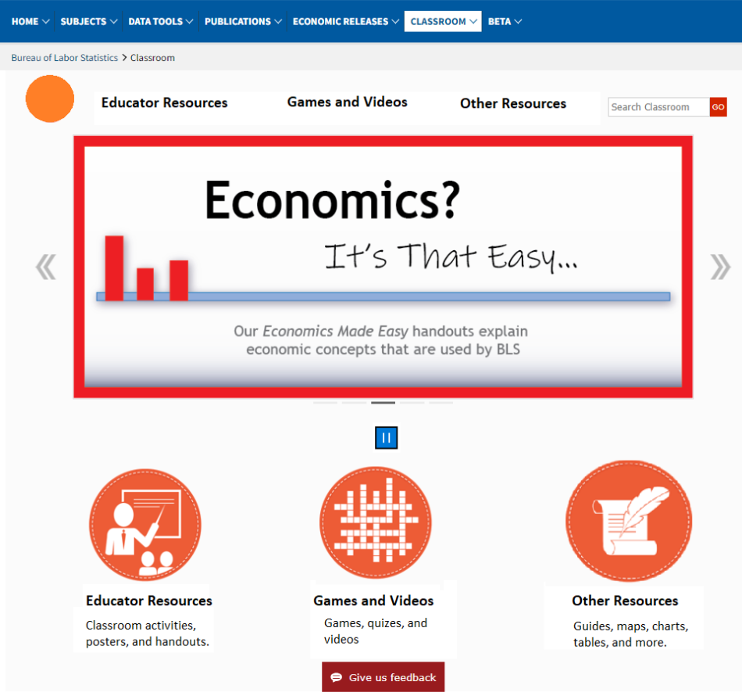

In the second option, we’ve got “Games and Videos,” “BLS Basics,” “For Educators,” and “Career Resources.”
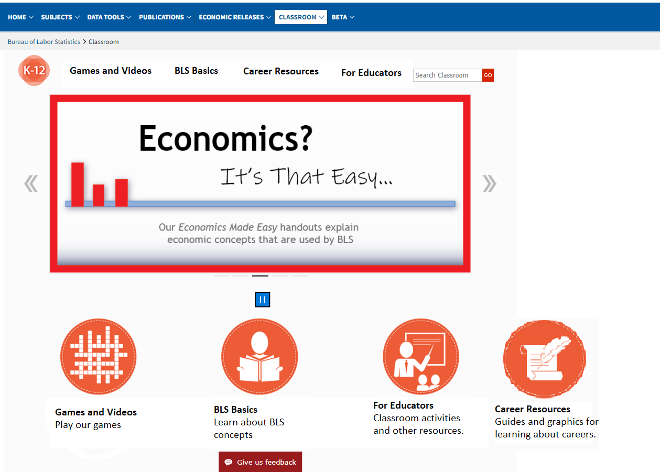

In the third option, we’ve got “Games and Quizzes,” “Activities,” and “About BLS.”
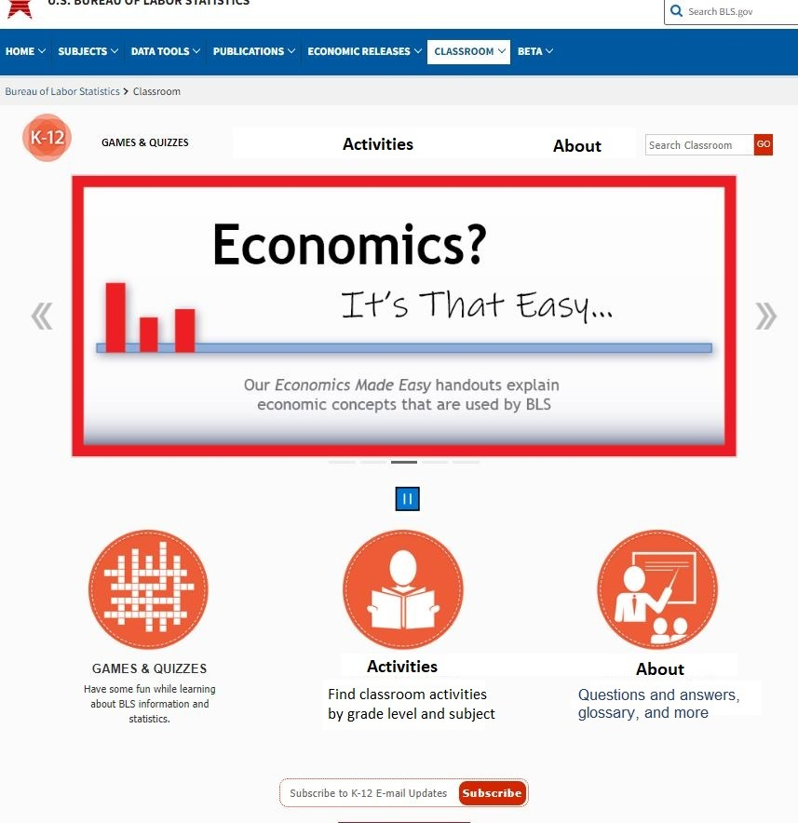

Let me show you all three groupings at once:

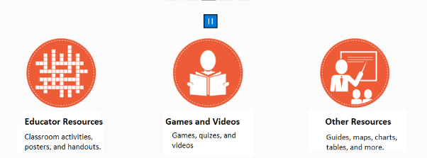
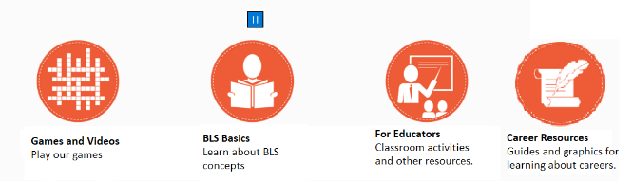
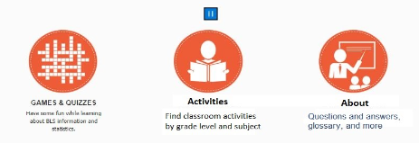

What are your thoughts on each option?
What do you like and dislike about them?
What do you think of the icons?
What materials would you expect to find under each category?

Other ideas (10 minutes)
What kinds of resources would be most useful to you? (e.g., videos, activities, etc.)
What other resources would you like to see on the BLS Classroom site?
[Teachers only] What could BLS provide that would make it easier for you to meet the standards you use?
How else could we improve the site?

Conclusion (All Participants, 5 minutes)
Is there anything else about the BLS Classroom site that you’d like to share?

