UNITED STATES FOOD & DRUG ADMINISTRATION

Prescription Drug Marketing – OMB Control No. 0910-0435

Request for Non-substantive, non-material change to an approved Collection of Information:
As administrative transitioning continues, FDA is requesting approval of Form FDA 3911 – Drug Notification, and its accompanying instructions, available for download at https://www.fda.gov/about-fda/reports-manuals-forms/forms. Form FDA 3911 is currently approved for use in OMB control no. 0910-0806 and can be submitted utilizing the Center for Drug Evaluation and Research (CDER) Platform “CDER NextGen Portal.” If a respondent would like to submit Form FDA 3911 through the Portal, they may visit https://cdernextgenportal.fda.gov/Login_CDER?ec=302&startURL=%2Fs%2F and proceed through prompts to the form. Upon selecting the Form FDA 3911 tab, the form is generated, completed by respondent, and submitted to FDA; an electronic copy may be retained by respondents. Although Form FDA 3911, “Drug Notification,” is primarily intended to report “suspect products” as statutorily defined in section 581 of the Federal Food, Drug, and Cosmetic Act (FFDCA) and statutorily required in section 582, we encourage respondents to report problems when there is a concern about the quality, authenticity, performance or safety of any medication or device, as solicited on our website at https://www.fda.gov/drugs/drug-safety-and-availability/drug-supply-chain-integrity#reporting:
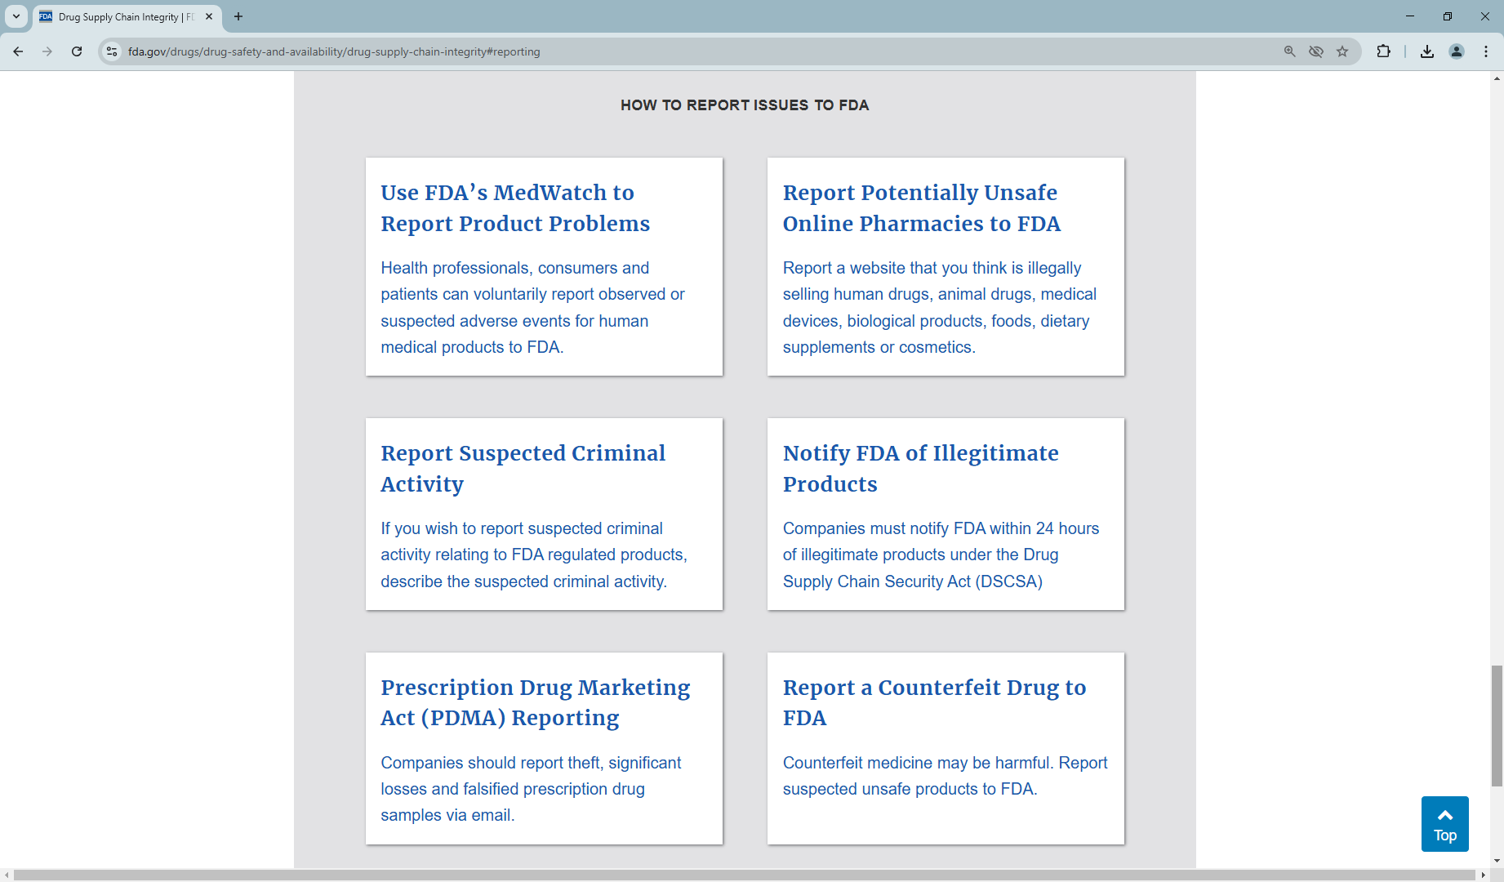

We note in 21 CFR 203, subpart D - Samples, related information collection activities with regard to reports and records. We have added the form and its instructions to the reporting IC element and requesting use of Form FDA 3911 under OMB control no. 0910-0435 for continuity of agency operations.

Submitted: February 2025

