Appendix N1. IDI Reminder Call Script (English)

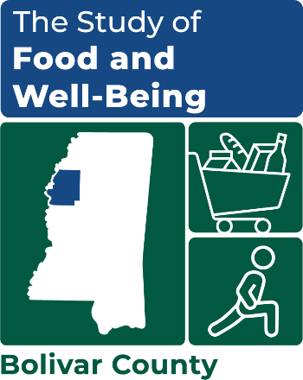

STUDY OF FOOD AND WELL-BEING
OMB Number: 0584-XXXX
Expiration Date: XX/XX/20XX
In-depth interview (IDI) reminder call script

Voicemail script, if leaving a message:
Hello [MR./MS. FIRST NAME, LAST NAME]. My name is [NAME] and I am calling to remind you of your upcoming appointment for an [in-person] discussion for the Study of Food and Well-Being.
You told us that you would be available for an [in-person] discussion [at [LOCATION]] on [MM/DD from HH:MM – HH:MM]. [The [LOCATION] is located at [ADDRESS]. I will be there to greet you a few minutes before [INTERVIEW START TIME]. ]
If your schedule has changed [or if cannot find me at [LOCATION]], please don’t hesitate to call me at [PHONE NUMBER]. At the end of the discussion, we will provide you with a $50 gift card as a token of our appreciation. Thanks and see you soon! END

Hello, my name is ____________. I’m calling from Mathematica. May I please speak with [MR./MS. FIRST NAME, LAST NAME]?
[INTERVIEWER: If the recruited respondent is not in, ask about a good time to reach her/him. Leave a message (with the person who answers or on a voice message) with your name and contact information. say you are calling to remind her/him of her/his appointment for aN IN-PERSON discussion FOR THE STUDY OF FOOD AND WELL-BEING, scheduled for [INTERVIEW DATE].
Hi [MR./MS. FIRST NAME, LAST NAME]. I am calling to remind you of your upcoming appointment for an [in-person] discussion for the Study of Food and Well-Being.
You told us that you would be available for an [in-person] interview [at [LOCATION]] on [MM/DD from HH:MM – HH:MM].
Are you still available for the discussion during that time [and at that location]?
This information is being collected to assist the Food and Nutrition Service (FNS) in understanding the interrelated factors that affect food insecurity and poverty. This is a voluntary collection and FNS will use the information to aid in the administration of the Supplemental Nutrition Assistance Program. This collection does request personally identifiable information under the Privacy Act of 1974. According to the Paperwork Reduction Act of 1995, an agency may not conduct or sponsor, and a person is not required to respond to, a collection of information unless it displays a valid OMB control number. The valid OMB control number for this information collection is 0584-[xxxx]. The time required to complete this information collection is estimated to average 2 minutes (0.0334 hours) per response, including the time for reviewing instructions, searching existing data sources, gathering and maintaining the data needed, and completing and reviewing the collection of information. Send comments regarding this burden estimate or any other aspect of this collection of information, including suggestions for reducing this burden, to: U.S. Department of Agriculture, Food and Nutrition Service, Office of Policy Support, 1320 Braddock Place, 5th Floor, Alexandria, VA 22306 ATTN: PRA (0584-xxxx). Do not return the completed form to this address.
IF YES, SAY: Great, thank you for agreeing to participate. My name is [NAME] and I will be leading the discussion and I look forward to speaking with you. [Again, our interview will be at the [LOCATION].]
IF NO, SAY: I’m sorry you won’t be able to attend. Is there another time that might work better for you?
[INTERVIEWER: ATTEMPT TO FIND AND SCHEDULE A MORE CONVENIENT APPOINTMENT ON [AVAILABLE DATES]. REMIND THEM THAT THEY WILL BE PROVIDED WITH A $50 GIFT CARD AS A TOKEN OF OUR APPRECIATION FOR THEIR PARTICIPATION.]
Do you know where it is?
[IF NO, SAY:] It’s located at [ADDRESS].
I will be there to greet you a few minutes before [INTERVIEW START TIME].
Do you have any questions for me about the discussion that I can answer now?
[INTERVIEWER: FIELD ANY QUESTIONS OR CONCERNS THAT THEY HAVE.]
Okay, I think we are all set then. If your schedule changes [or if cannot find me], please feel free to call me at [PHONE NUMBER]. At the end of the interview, we will provide you with a $50 gift card as a token of our appreciation. Thank you so much and I look forward to talking with you on [INTERVIEW DATE]. END

