Lenders Login to VA’s Loan Guaranty system:
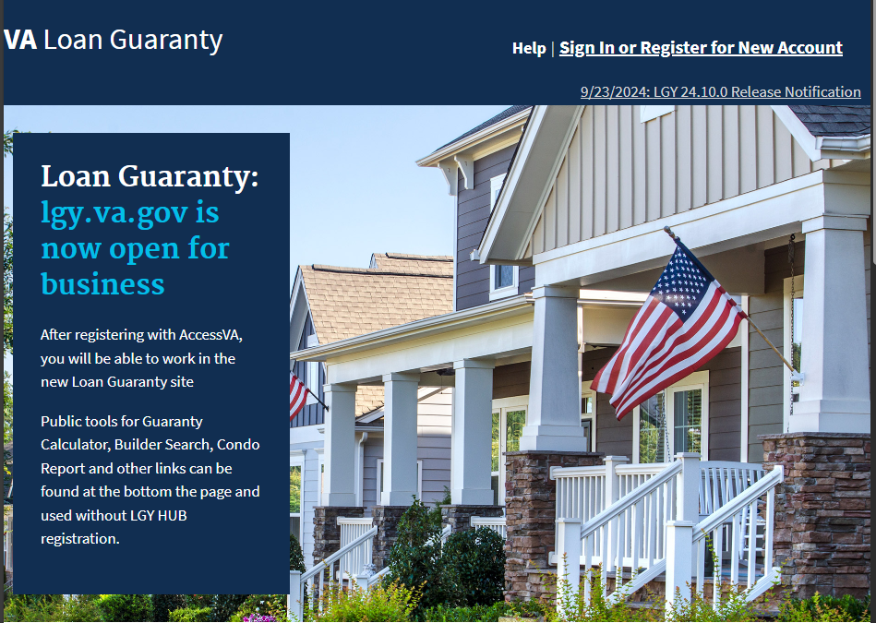
And navigate to WebLGY
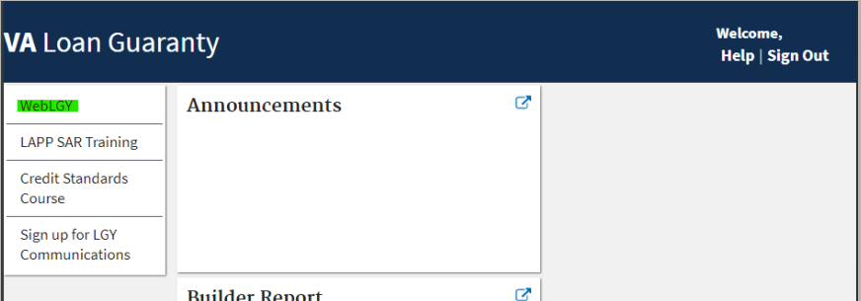

Using the top navigation the lender selects Loan > Enter New Loan
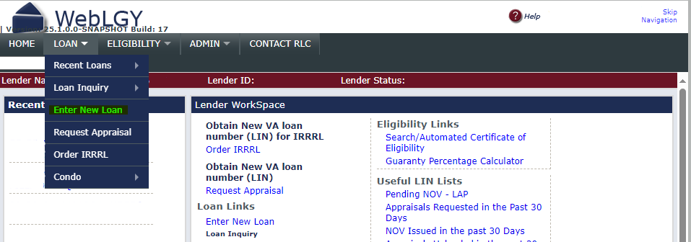
The lender will use the Loan Procedure drop down to select Prior-Approval, enter the LIN and click Submit.
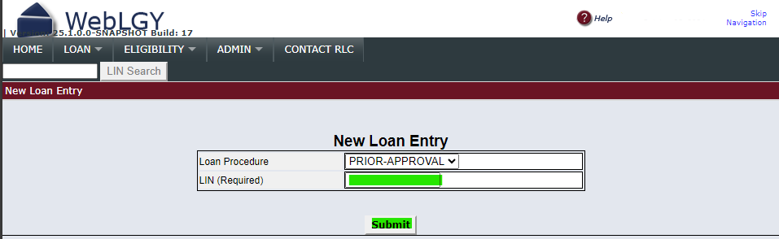
The lender will enter the requested information and then click Add New Veteran, they will click Add New Veteran for each Veteran using entitlement on the loan.
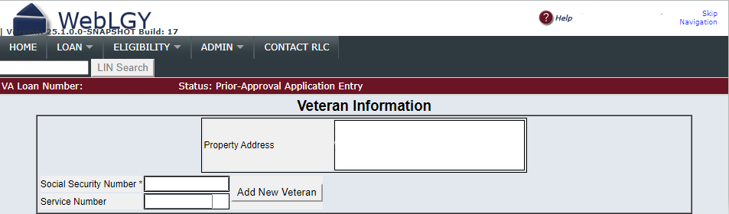

The lender will review the information returned, complete the necessary fields, and click Loan Analysis.
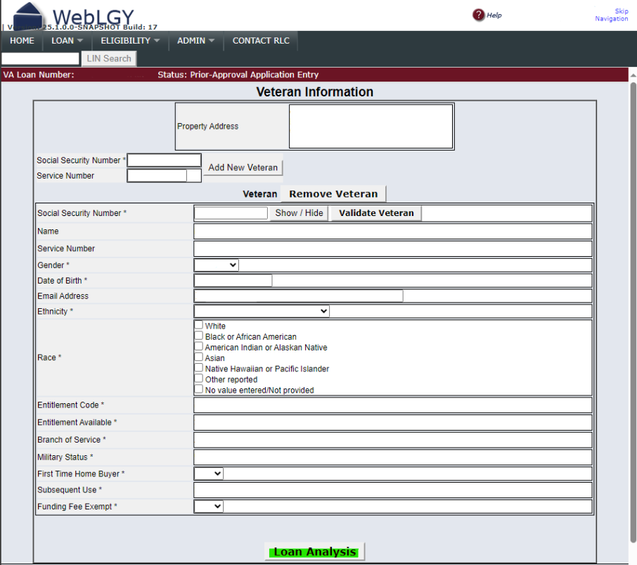

The lender will then fill in the Loan Analysis
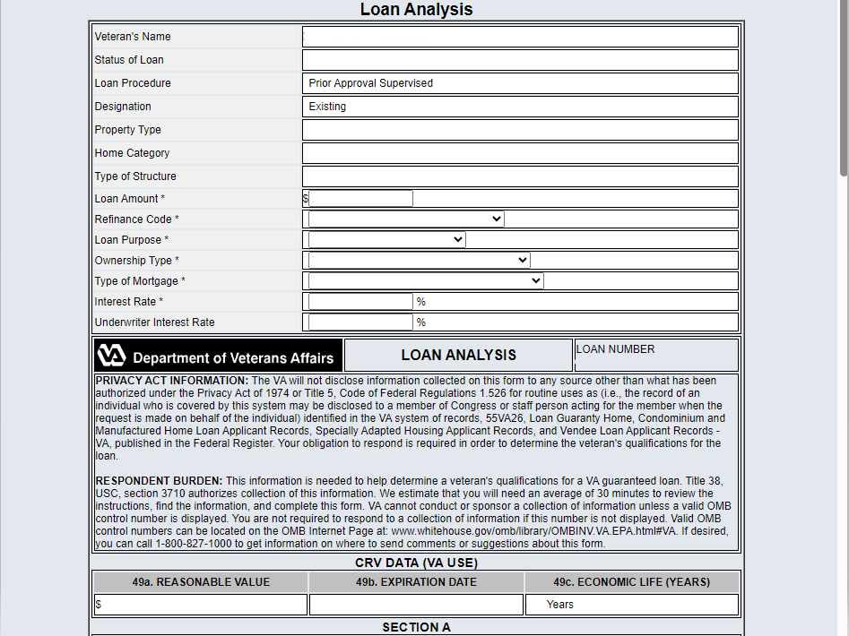

Loan Analysis, continued
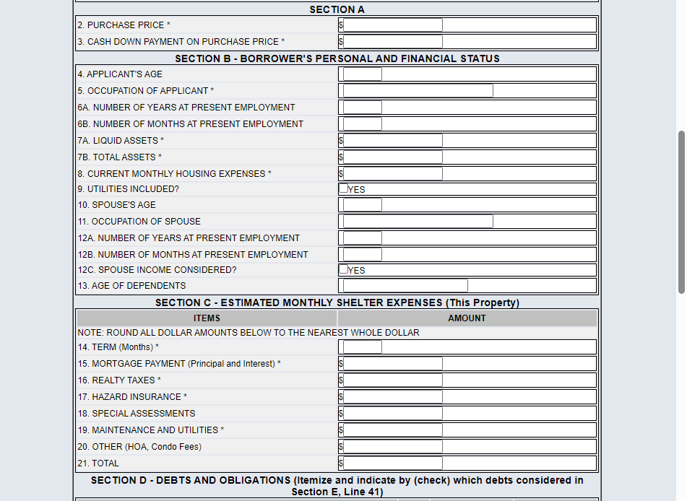
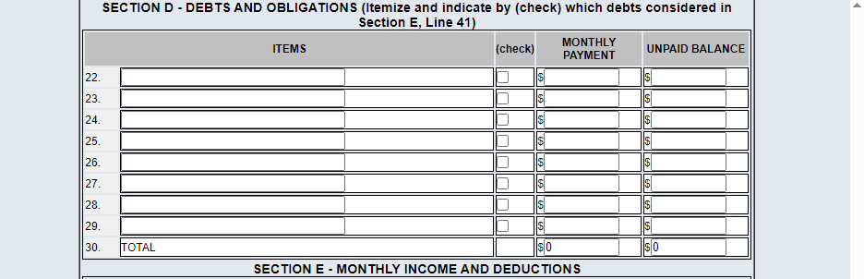

Loan Analysis, continued
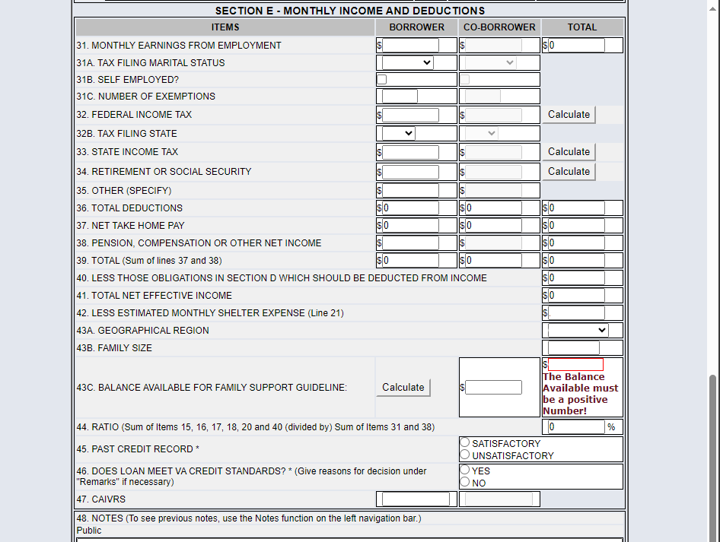
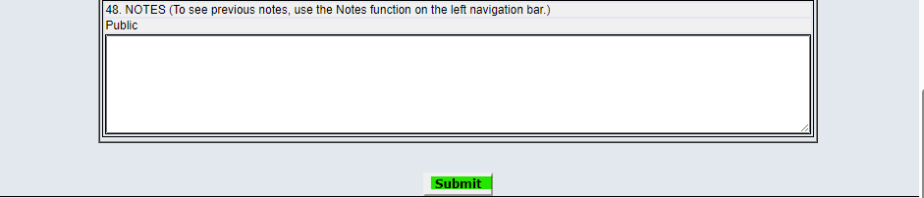

After clicking Submit, the lender will upload the Prior Approval Loan Package outlined in the Stacking Order by selecting the ‘Correspondence’ link on the left navigation panel.
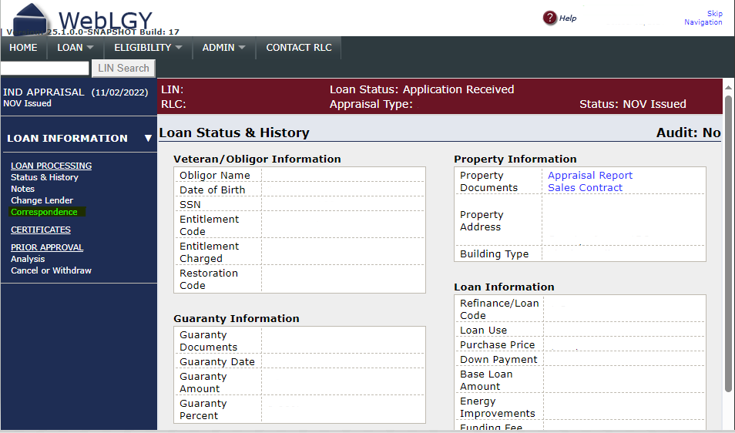
The lender will then Select the document for upload. There is a place for an optional note as well.
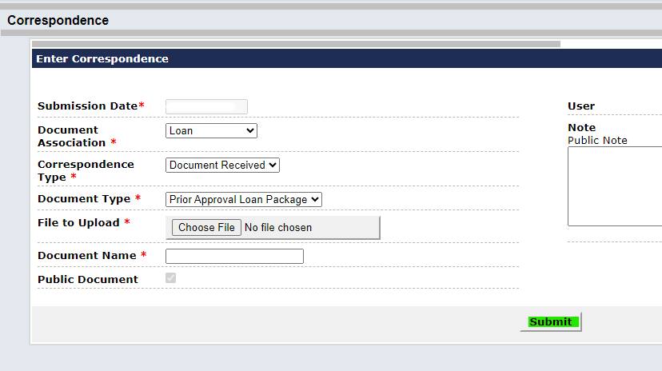
Once the lender hits submit, the loan is routed to VA for prior approval review.

