Digital Website Feedback Survey Screenshots
OMB control no. 1601-0029
Exp.: 12/31/2026

- First Page

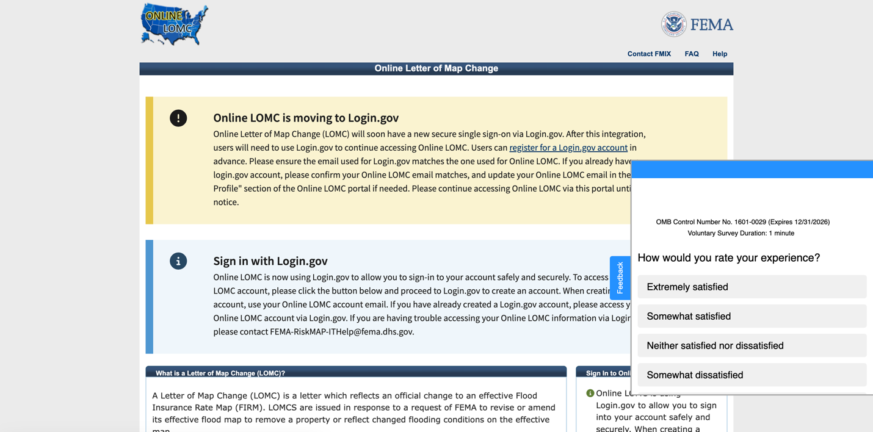

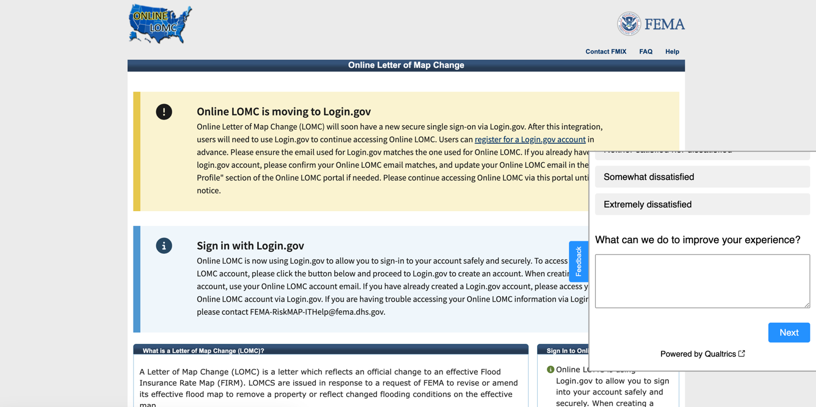

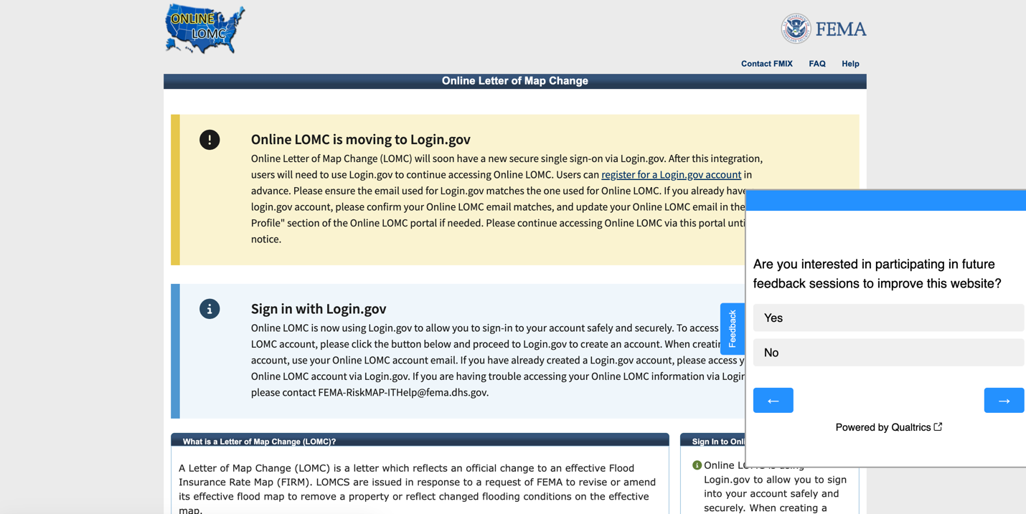
- Second Page

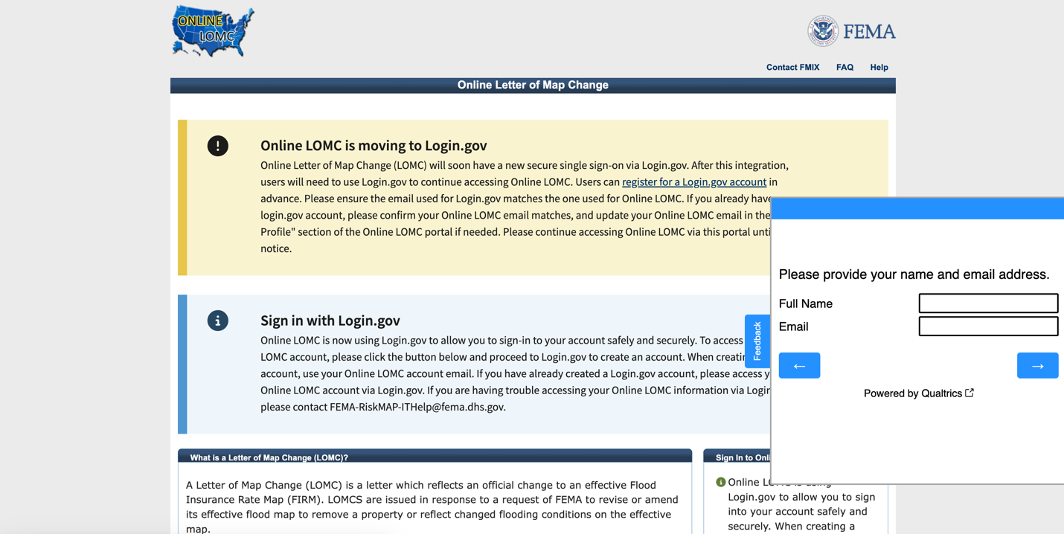
- Third Page

- End of Survey
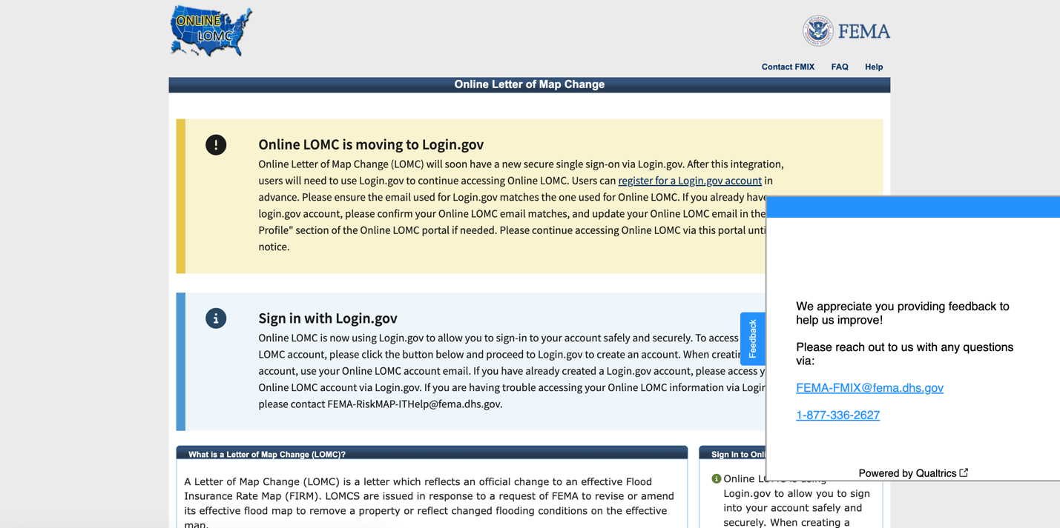
PRA Statement:
DHS will use the information to collect feedback about current FEMA websites. This is a voluntary collection. It is estimated that it will take no more than 1 minute to complete this form. An agency may not conduct or sponsor, and a person is not required to respond to a collection of information unless it displays a valid OMB control number. The control number assigned to this collection is OMB 1601-0029, which expires 12/31/2026. Send comments regarding this burden estimate or any other aspect of this collection of information including suggestions for reducing this burden to DHS/FEMA, FEMA-FMIX@fema.dhs.gov. Attn: PRA 1601-0029 FEMA Risk MAP IT and Data Management Map Service Center (MSC) and Online Letter of Map Change (OLOMC)Website Feedback.

