NASA Earth and Space Science Fellowship Survey Welcome! As a past NESSF proposer, you have been selected to take part in a brief questionnaire about your experiences.

Privacy Act Notification:
The information you provide via this form is protected from unauthorized disclosure in accordance with the Privacy Act of 1974. It will be used by NASA for the specific purpose of implementing and evaluating STEM engagement investments. Collection of the information is authorized by the National Aeronautics and Space Act of 1958 § 403(a)(b), 42 U.S.C. § 2473 (c)(1). Provision of the requested information is strictly voluntary. NASA may disclose information to NASA administrators and managers, Office of Management and Budget officials, and members of Congress for the purposes of accountability and tracking of program and project efficiency and effectiveness. Any information released (such as statistical summaries) will be in a form that does not personally identify you.
Elaboration and conditions of information disclosure may be found under “Routine Uses” of the full System of Records Notice at https://www.govinfo.gov/content/pkg/PAI-2013-NASA/xml/PAI-2013-NASA.xml#10euda and in Appendix B at https://www.govinfo.gov/content/pkg/PAI-2013-NASA/xml/PAI-2013-NASA.xml#appb.

Paperwork Reduction Act Statement:
This information collection meets the requirements of 44 U.S.C. §3507, as amended by section 2 of the Paperwork Reduction Act of 1995. You do not need to answer these questions unless we display a
valid Office of Management and Budget (OMB) control number. The OMB control number for this collection is 2700-0159 and expires 09/30/2024.

Practical Information:
- On average, it will take about 25 minutes to complete the questionnaire. Actual time may vary depending on your circumstances.
- Your response is voluntary and failure to provide some or all of the requested information will not in any way adversely affect you.
- Your response will help NASA improve opportunities and programming for future generations of graduate students.
- We welcome you to contact amy.p.chen@nasa.gov if you have any comments or questions.
- Thank you for your participation!

Section I: NESSF Status

How many times did you apply for the NASA Earth and Space Science Fellowship (NESSF)?
1
2
3
4
5
more than 5

Did you receive a NASA Earth and Space Science Fellowship (NESSF) offer?
Yes (go to 3)
No (go to 5)

Did you accept your NESSF offer?
Yes (go to Section II)
No (go to 4)

Why did you not accept your NESSF offer? (go to 6)

Did you pursue a graduate degree?
Yes (go to 6)
No (go to 28)

What were the primary sources of financial support during your graduate education? (select one)
fellowship/scholarship (please type name below)
grant (please type name below)
teaching assistantship
research assistantship
other assistantship (please type name below)
internship
loans (from any source)
personal saving
personal earning during graduate school
spouse/partner or family earnings or savings
employer assistance or reimbursement
Type name of fellowship/scholarship, grant, assistantship, or sources not listed above.

Section II: NESSF Proposal & Dissertation Research Characteristics

How did you learn about the NESSF opportunity? (select all that apply)
from my academic advisor
from a mentor
from a faculty member who was not my advisor or mentor
from a friend or acquaintance
from an ad at a conference
NASA NSPIRES notification
Other (please specify):

At the time you submitted your NESSF proposal, your academic advisor listed on your NESSF proposal...
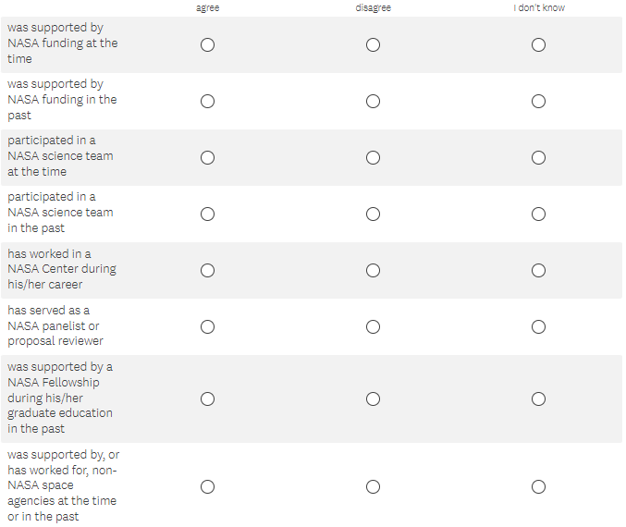

To what extent do you agree with the following statements?
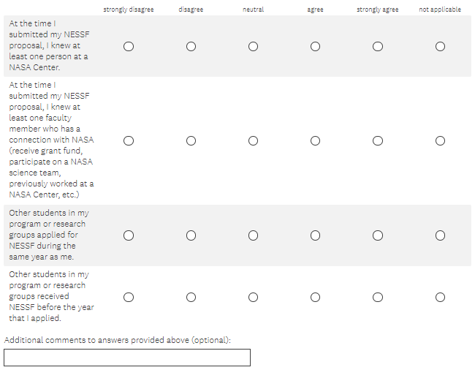

To what extent do you agree with the following statements about the feedbacks you received on your NESSF proposal?
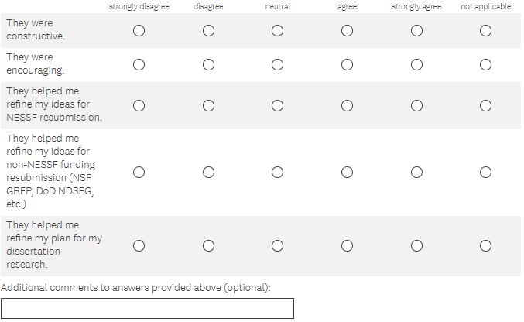

To what extent do you agree with the following statements?
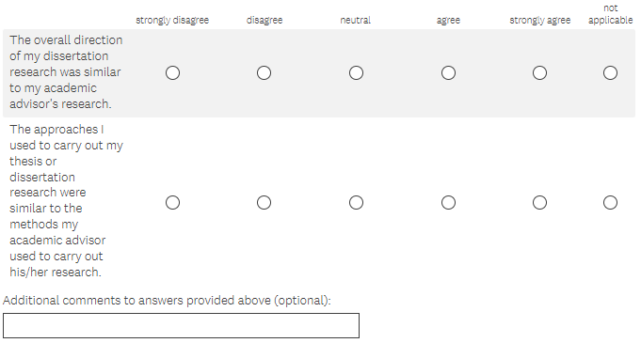

To what extent do you agree with the following statements?

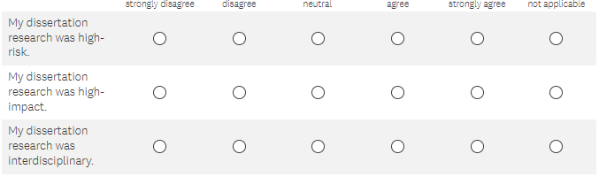

- Without NESSF funding, did you pursue the research you proposed in your NESSF proposal? (skip for those who answer yes to 2)
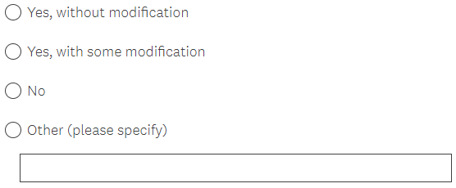

Section III: Graduate Education Experience

How would you rate your experience as a graduate student on each of the following?

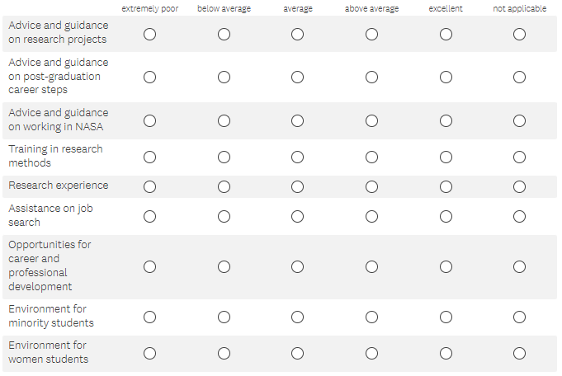

To what extent would you agree with the following statements about the faculty you interacted with while a graduate student
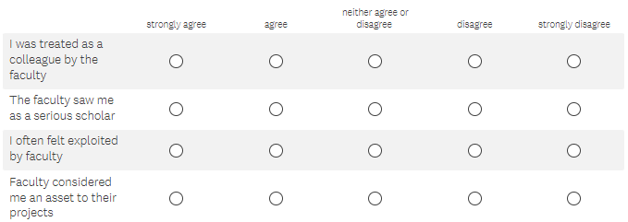

While in graduate school, were you required to...
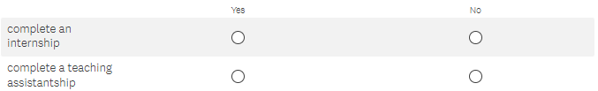

While in graduate school, did you...

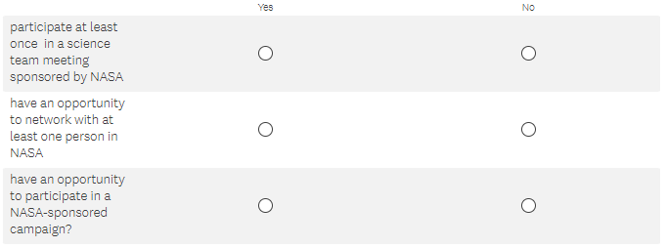

While in graduate school, how many papers did you present at national and international conferences?

 (drop down 0 – 100)

While in graduate school, how many of the following publications did you produce?
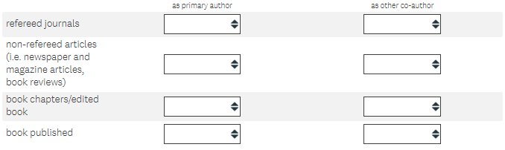
(drop down 0 – 20 for each) (drop down 0 – 20 for each)

While in graduate school...

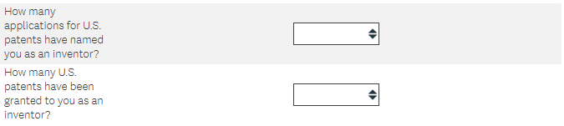
(drop down 0 – 20 for each)

Since leaving graduate school, how many papers have you presented at national and international conferences?
(drop down 0 – 100)

Since leaving graduate school, which of the following professional services/activities have you undertaken? (choose all that apply)

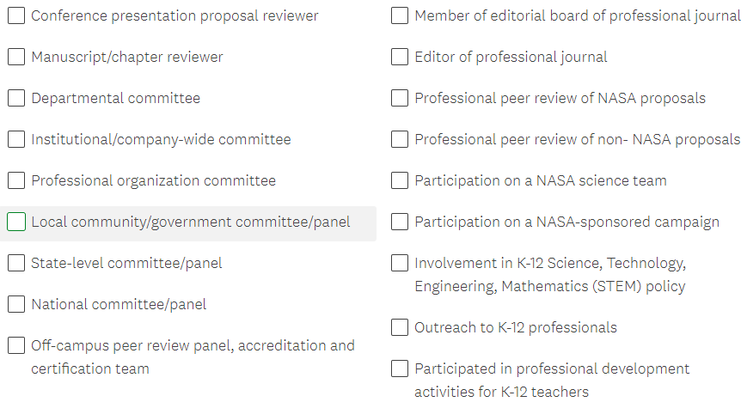

Since leaving graduate school, how many and what types of grants/contracts have you been awarded as a PI?
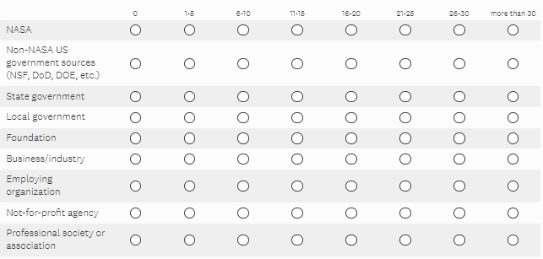

Since leaving graduate school...
(drop down 0 – 20 for each)

Since leaving graduate school, how many of the following publications did you produce?
(drop down 0 – 20 for each) (drop down 0 – 20 for each)

Since leaving graduate school, did you...

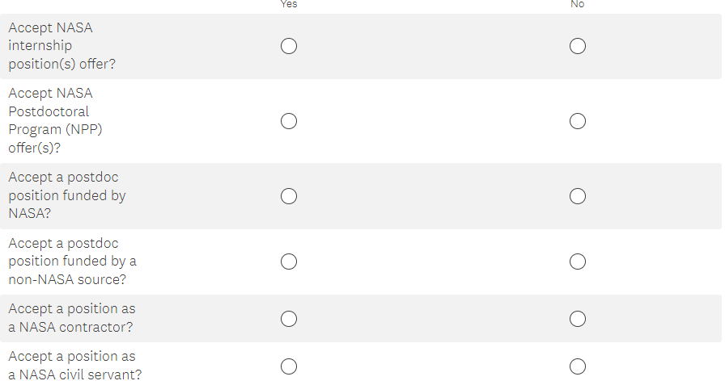

Since leaving graduate school, did you...

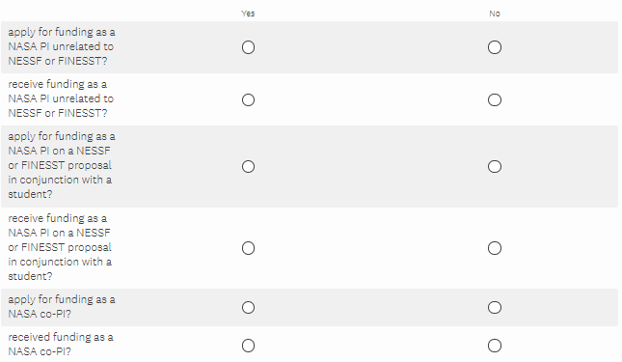

At the present time, which of the following best describes your employment status?
employed (including self-employment, postdoctoral appointment, or on a paid or unpaid leave, including vacation)
(go to 30)
not currently working for pay (go to 29)

What best describe your reason for not currently working? (select one)
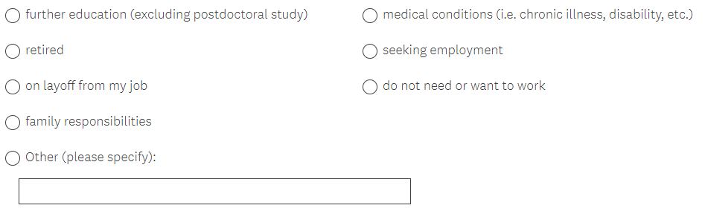

What type of employer are you currently working for?
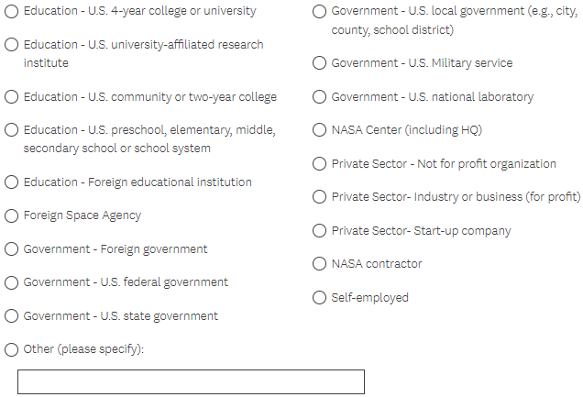

What type of employer have you worked for since leaving your graduate program? (select all that apply)
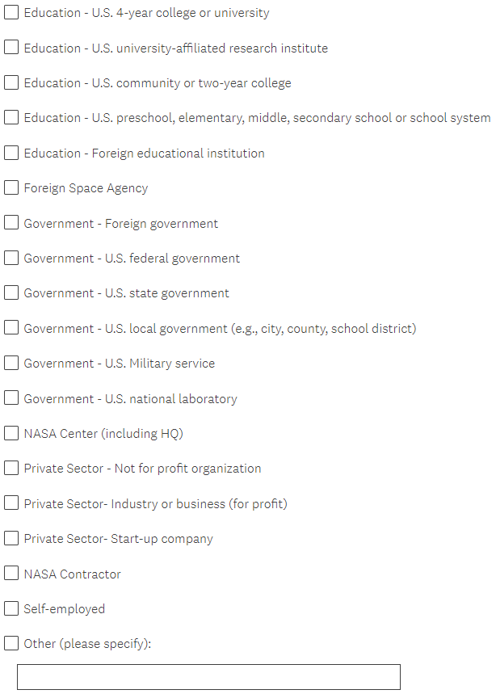

Is your current job an academic position?
Yes
No

What type of academic position(s) do you currently hold?
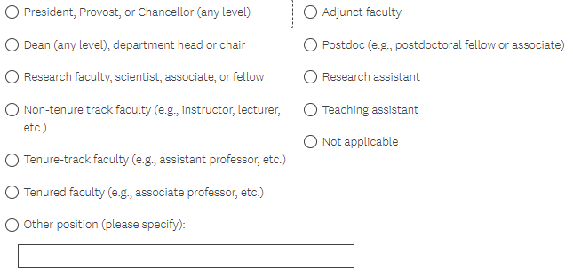

What is the name of your current employer or most recent employer if you are currently unemployed?

What is the title of your position at your current employer or most recent employer if you are currently unemployed?

Please indicate which category your current salary, or most recent salary if you are currently unemployed, fall into (before tax). Do not include bonuses or additional compensation for summertime teaching or research.

(drop down $30,000 or less to more than $200,001)

Is this salary based on a 52-week year or less than that?

52 week
less than 52-week
Please specify the number of weeks your salary is based on if less than 52-week.

What are your primary and secondary work activities at your current job, or most recent job if you are currently unemployed?
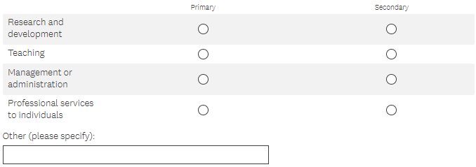

To what extent is your work on your current /most recent job related to your field of graduate studies?
Closely related
Somewhat related
Not related

How valuable was your NESSF with respect to the following: (skip for those who answer no to 3)

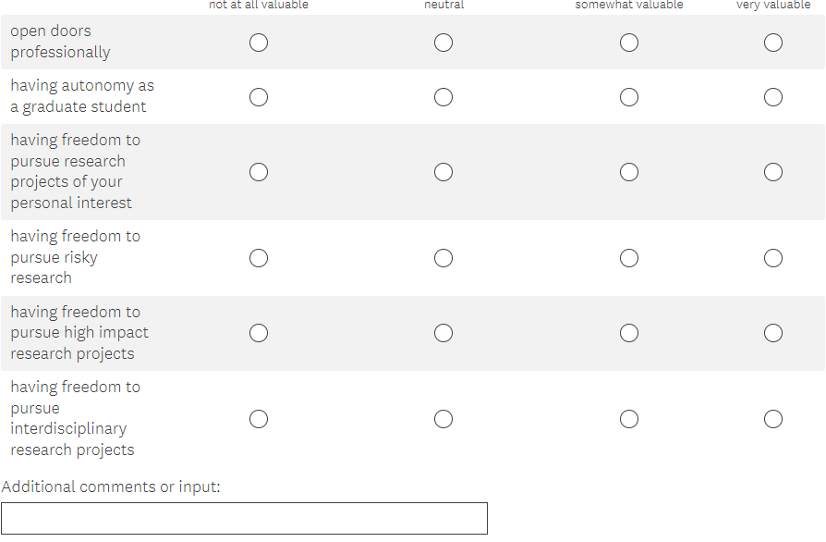

Are you willing to serve as a NASA proposal reviewer/panelist?
Yes
Maybe
No

Are you willing to be contacted for a 15 min. interview?
Yes
No

What is your gender?
Female
Male
Do not wish to provide

What is your ethnicity?
Hispanic or Latino
Not Hispanic or Latino
Do not wish to provide

What is your race? (Select as many as apply)
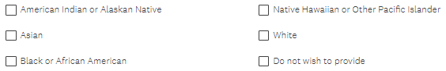

What is the highest degree that you have attained?
Bachelor’s Degree
Master’s degree (e.g., MA, MS, MBA, MSW, etc.)
Professional degree (e.g., MD, DDS, JD, D.Min., Psy.D., etc.)
Research doctoral degree or Ph.D.
Other (please specify):

What is the highest educational attainment of your mother and father?
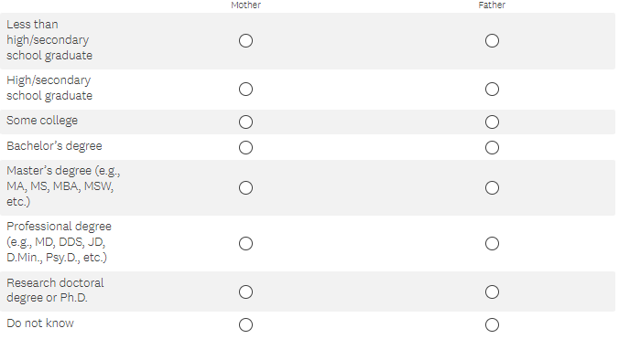

Do you have a disability?
Yes
No
Do not wish to provide

Is English your first/native language?
Yes
No
Do not wish to provide

What is your name?
first name
middle name
last name

Has your name changed since your NESSF application
yes
no

What is your best contact email address?

What is your best contact phone number?

Thank you for your participation! Do you have any additional input to any of the questions in this survey?

