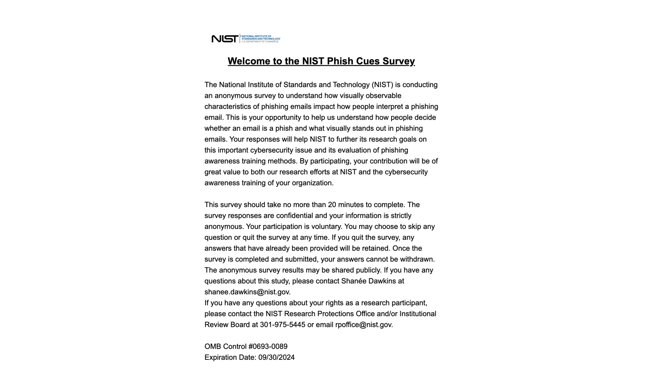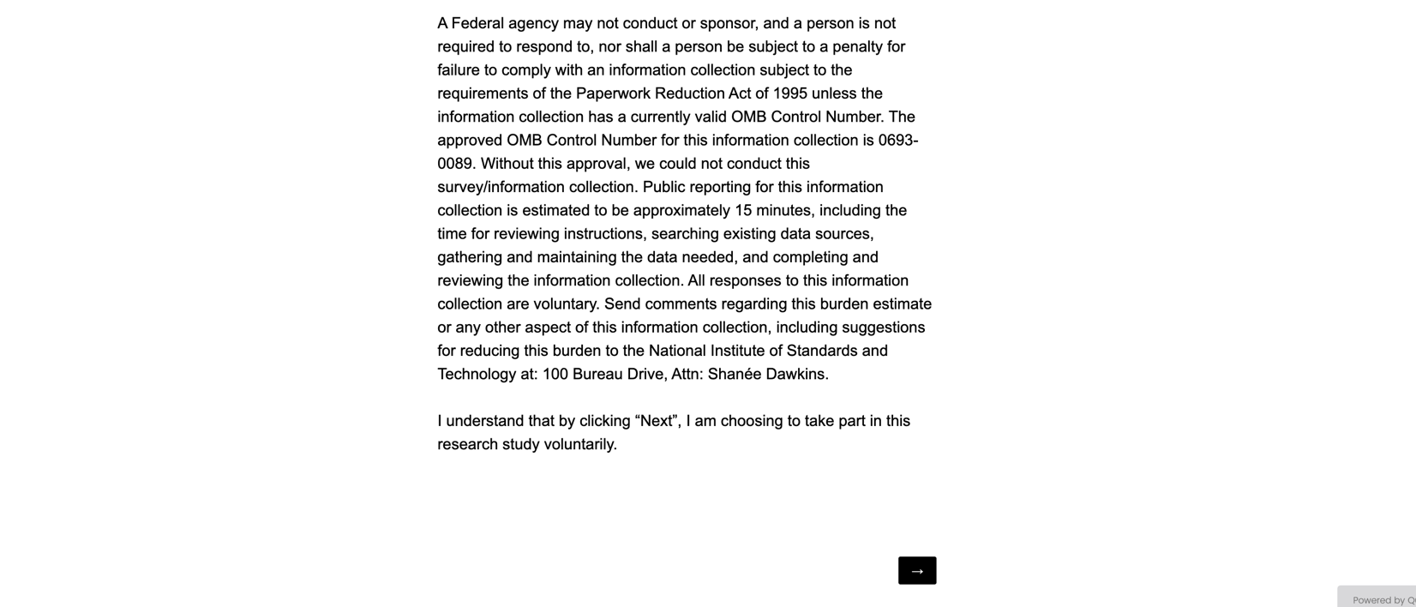
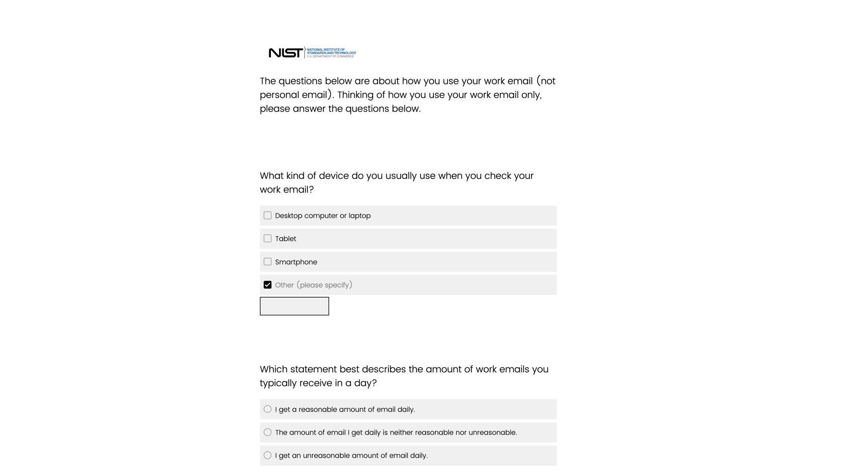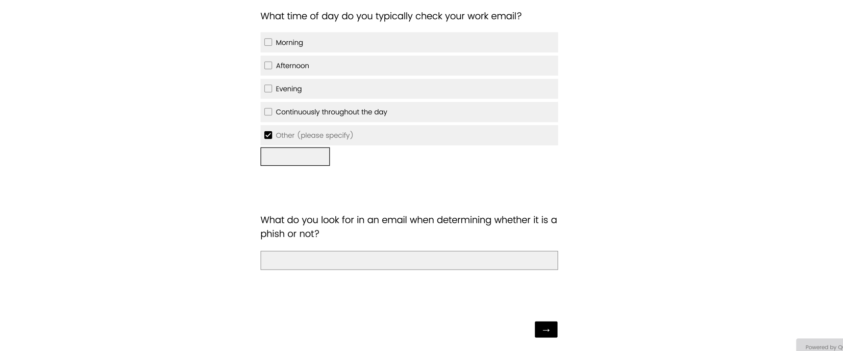
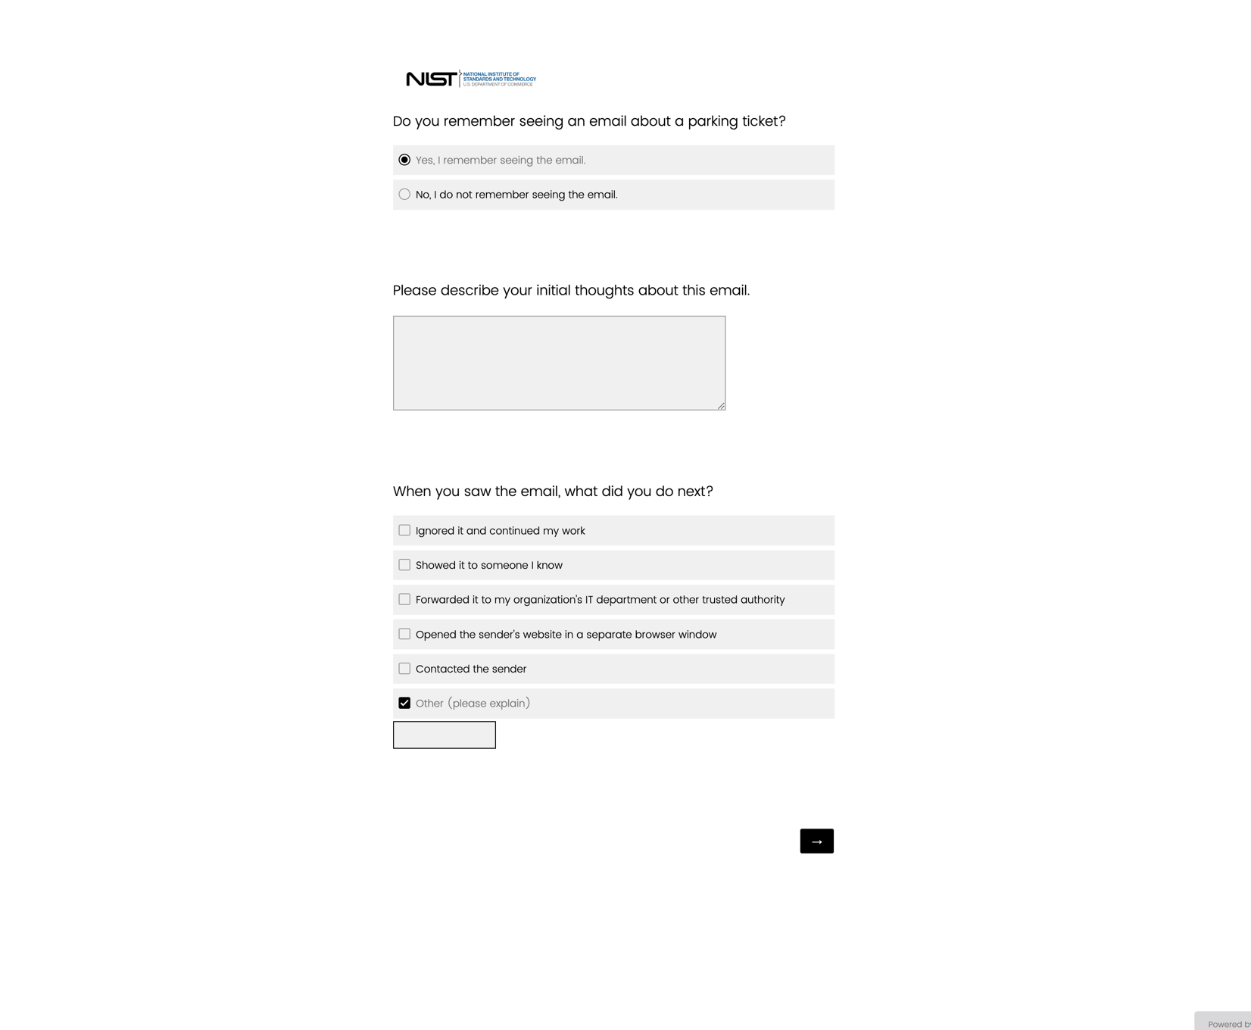
The wording of this question (“parking ticket”) is conditional. The subject of the email depends on the email template the participant receives.

These questions are conditional – whether participants are asked or not depends on the participant’s responses to earlier questions.

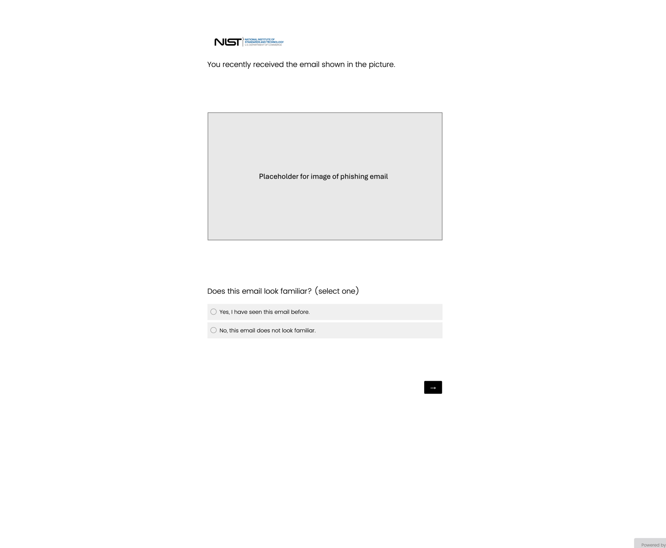
This page is conditional – whether participants are asked this question or not depends on the participant’s responses to earlier questions.
Placeholder images throughout this file are dependent on the email template the participant receives.

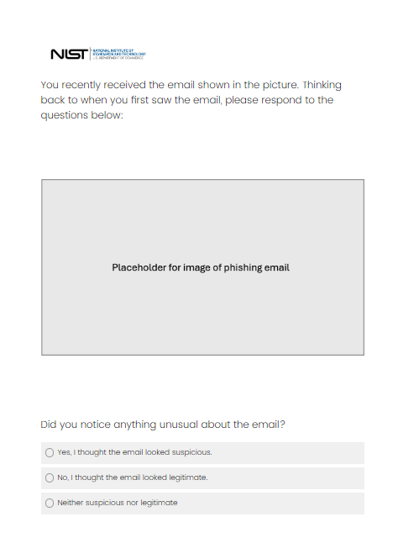

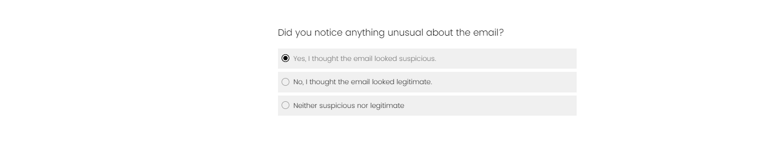
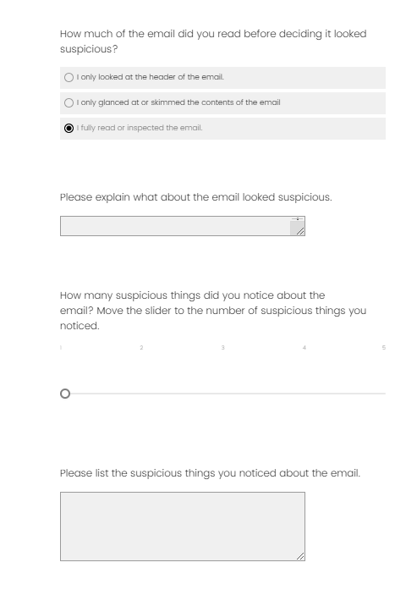
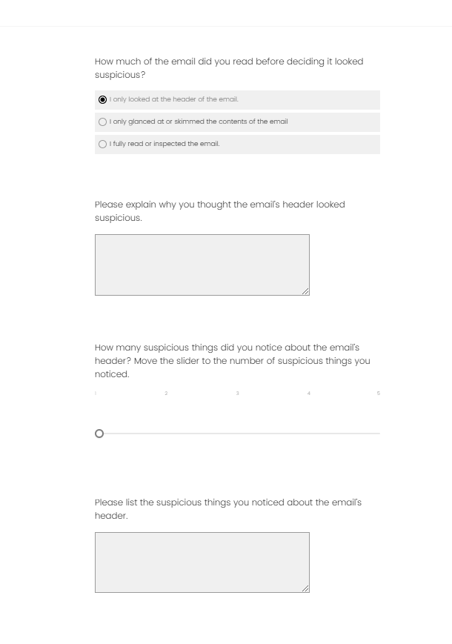
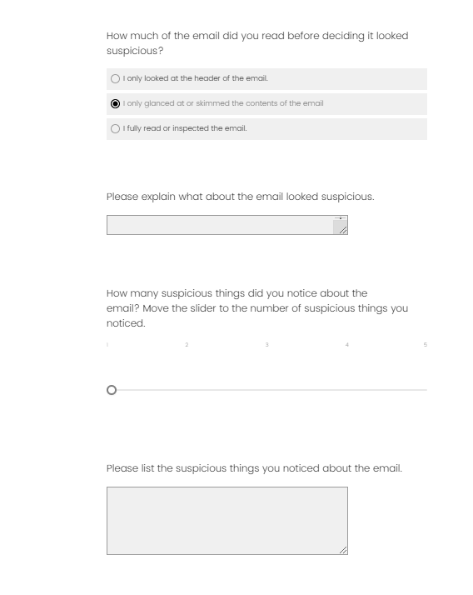
These questions are conditional – whether participants are asked these questions or not depends on the participant’s responses to earlier questions.

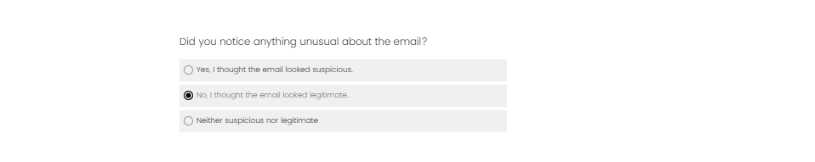
These questions are conditional – whether participants are asked these questions or not depends on the participant’s responses to earlier questions.

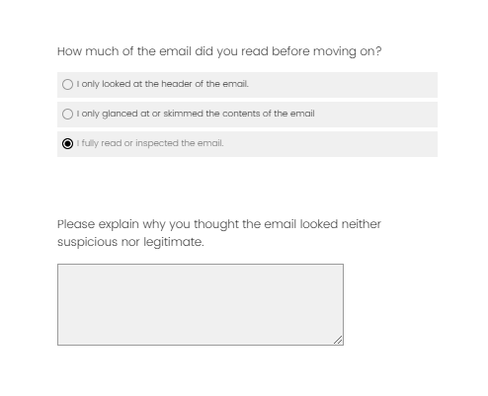
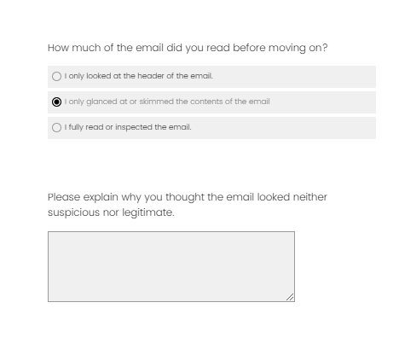
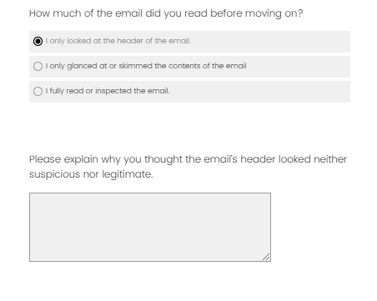
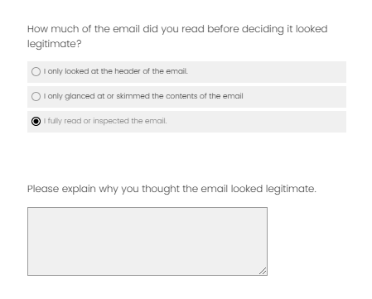
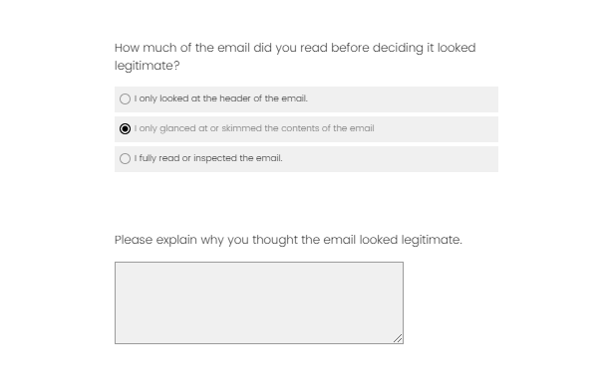
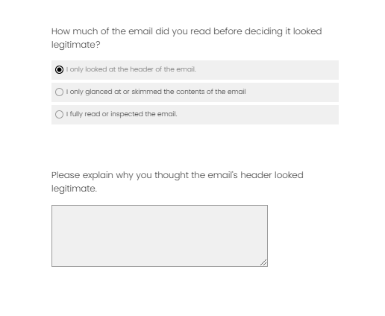
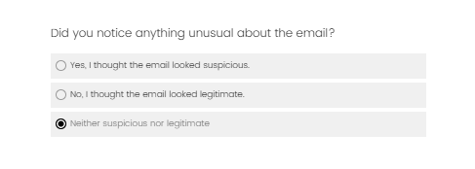
These questions are conditional – whether participants are asked these questions or not depends on the participant’s responses to earlier questions.

Page 5 OR Page 6 is asked to the participant, depending on their previous survey responses. All questions on pages 5 and 6 are conditional unless otherwise noted.

For pages 5 and 6, the grid questions below the placeholder image are conditional – whether they are asked or not depends on the email template the participant receives. Only one grid question will be asked per survey.

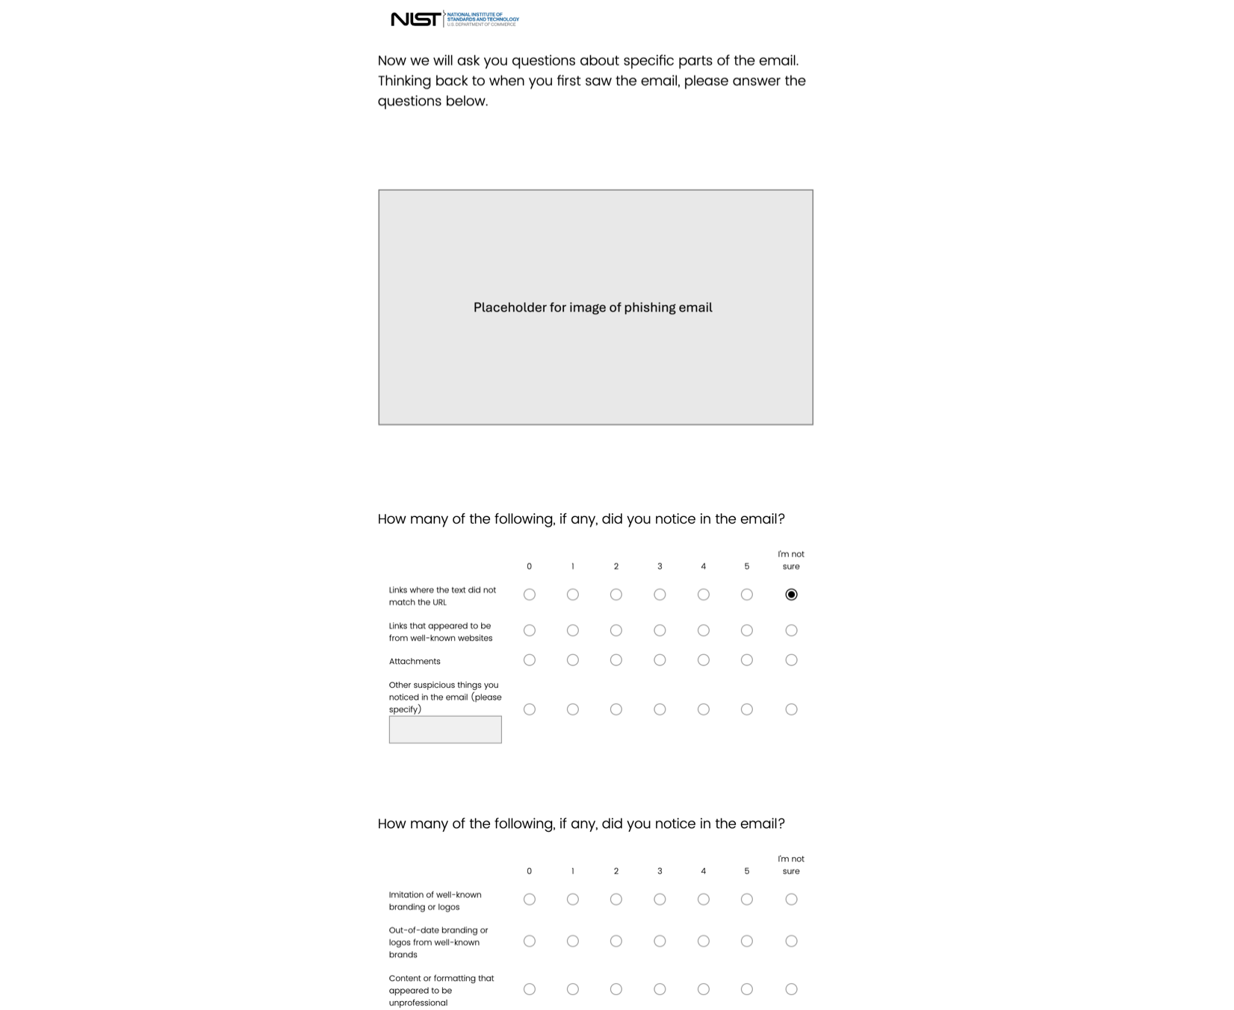
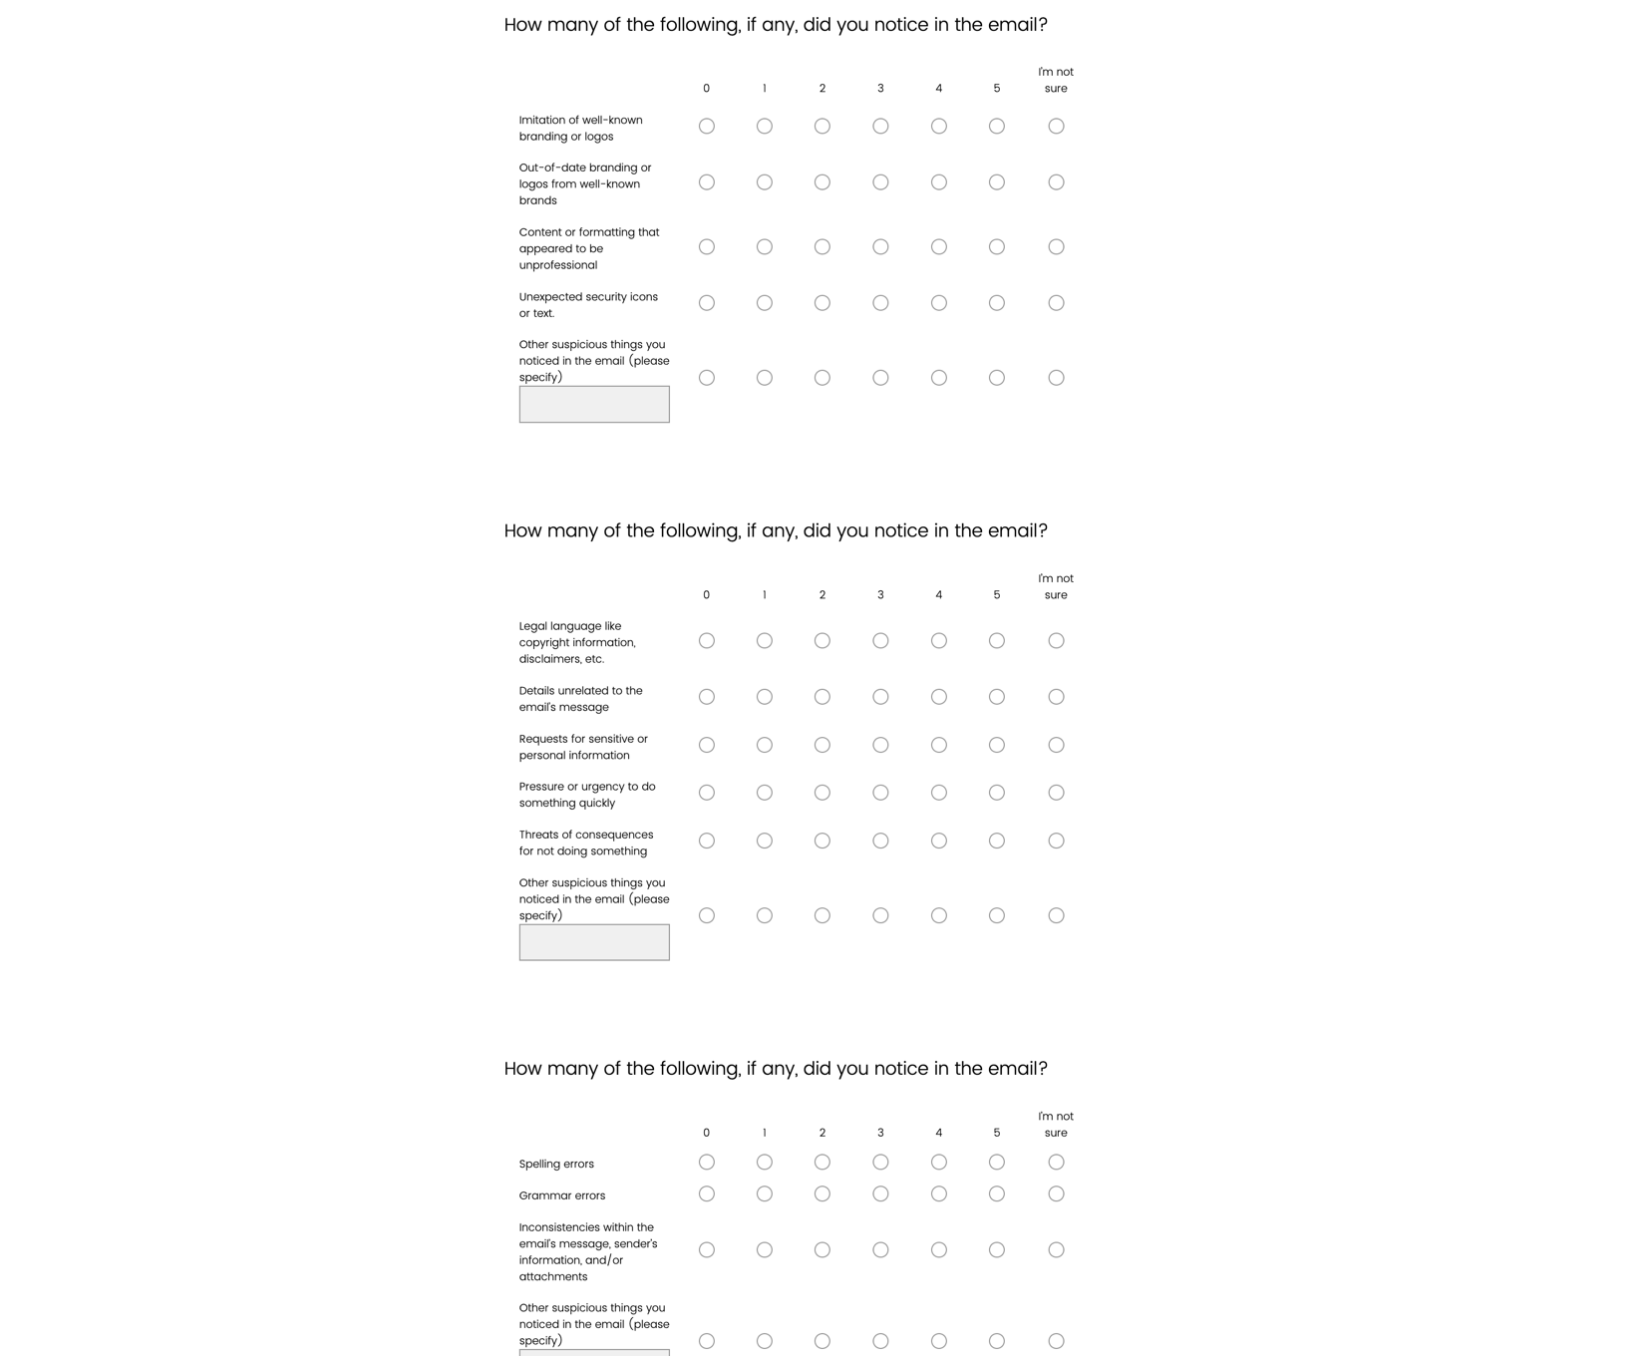
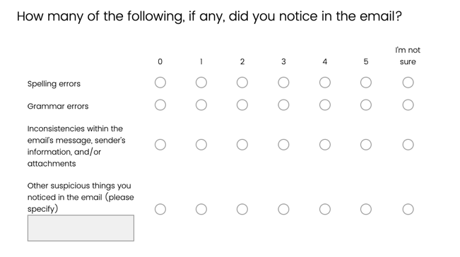
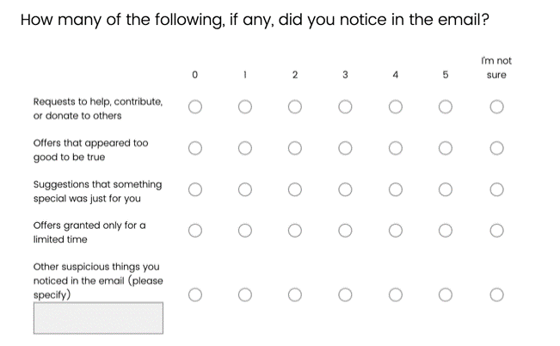

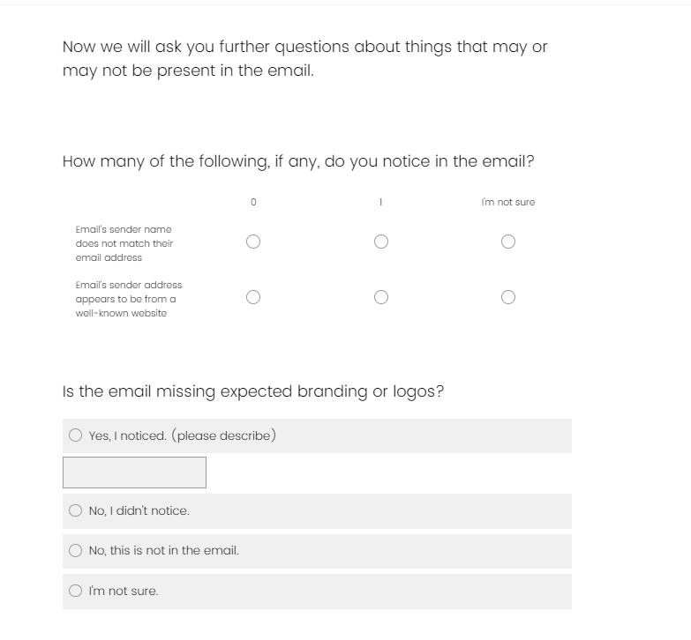

For pages 5 and 6, these questions are also conditional – whether they are asked or not depends on the email template the participant receives.

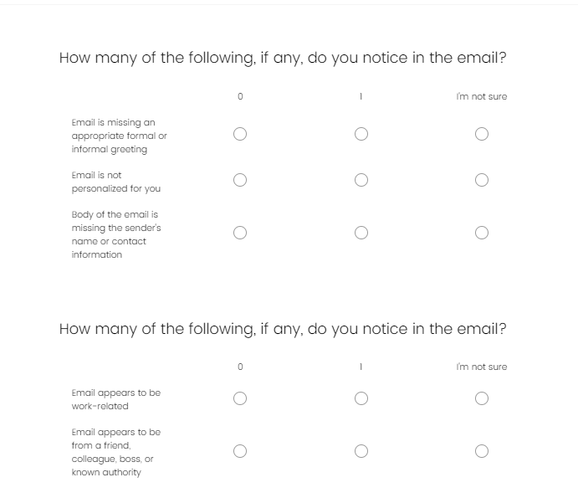

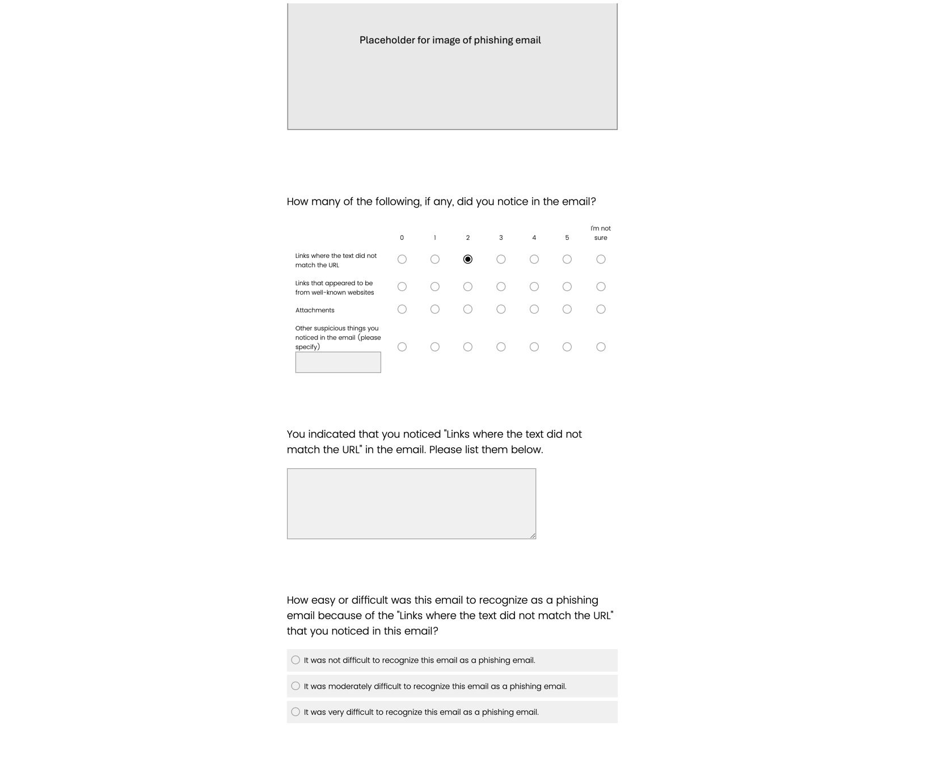

For pages 5 and 6, the wording of these questions is conditional. For each item in the first grid question, these questions are asked depending on participant responses.

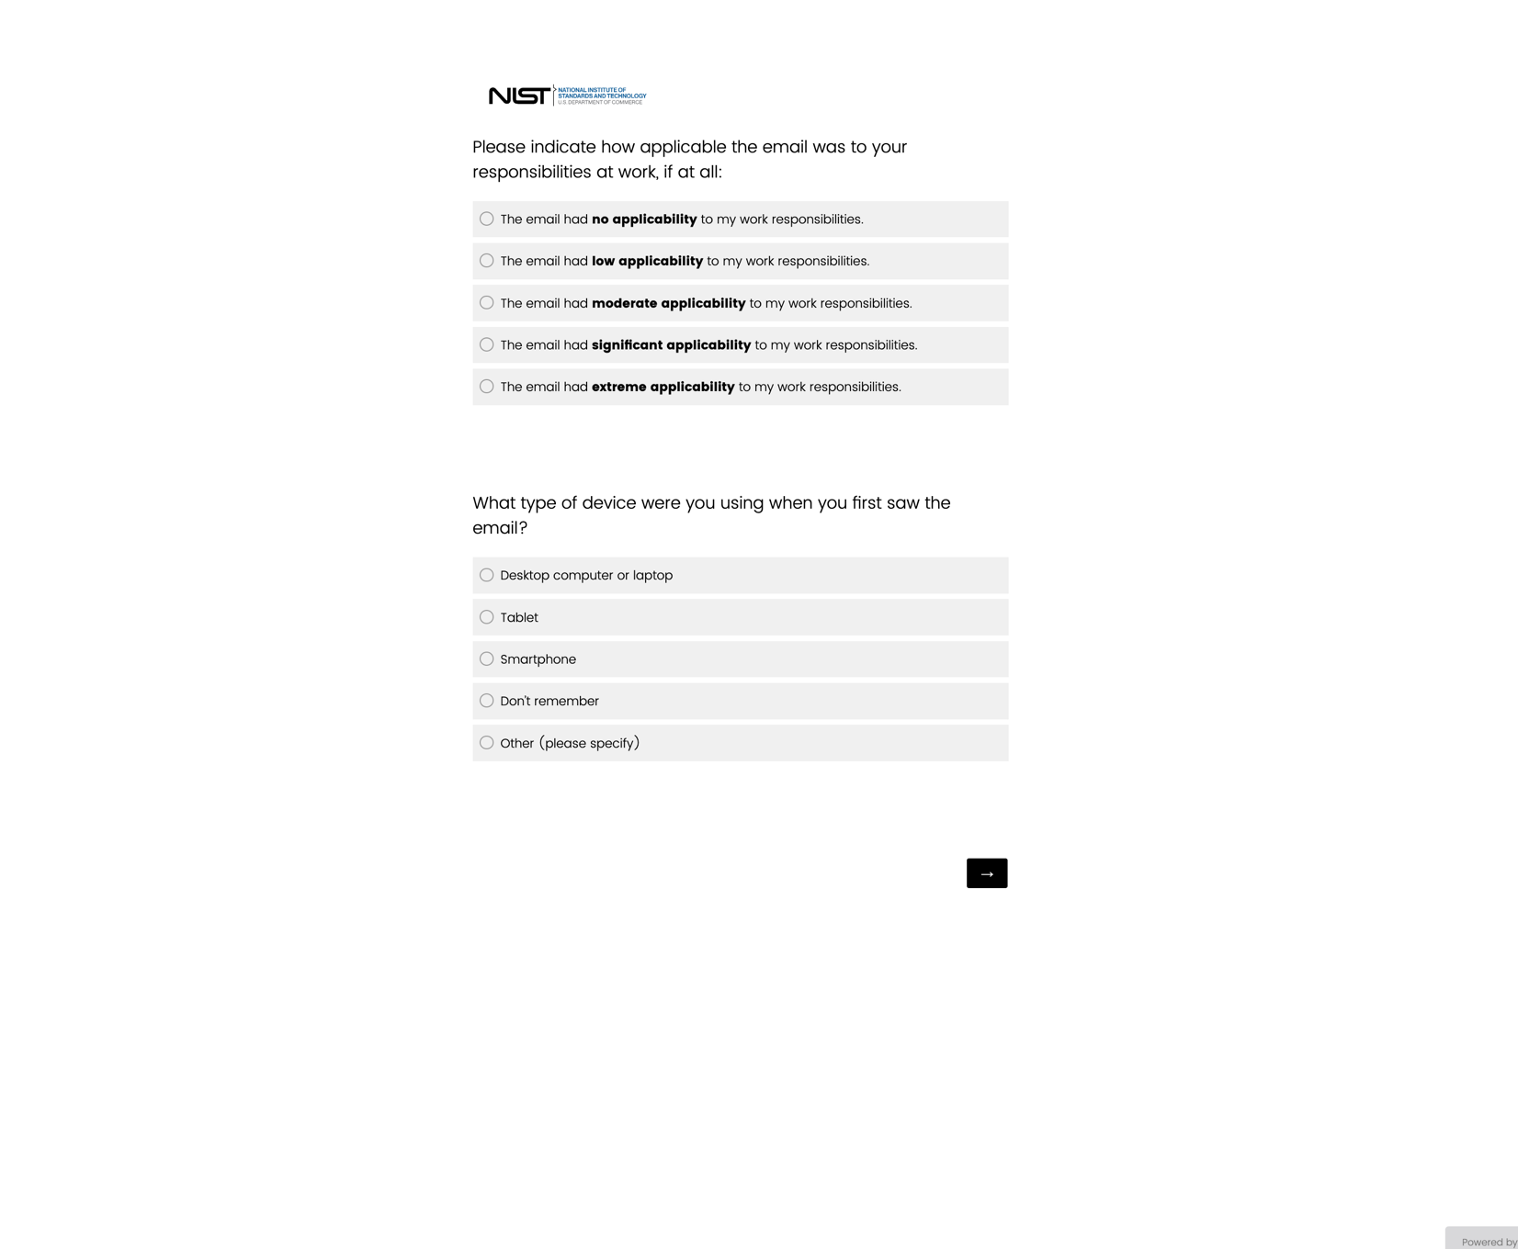
For pages 5 and 6, these questions are asked to all participants and are not conditional.
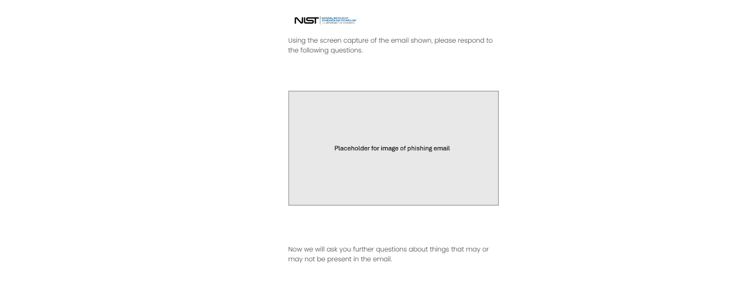
Page 5 OR Page 6 is asked to the participant, depending on their previous survey responses.

The skip logic and branching is identical to page 5. The only difference between page 5 and page 6 is the wording of certain questions.

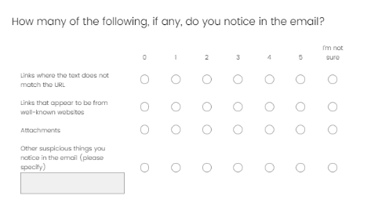
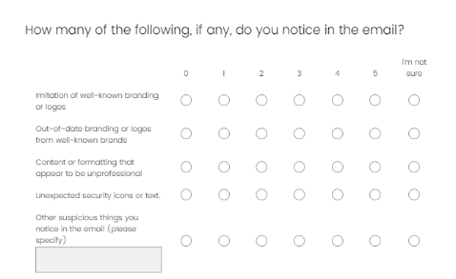
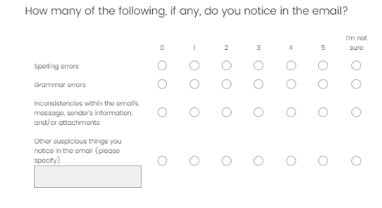
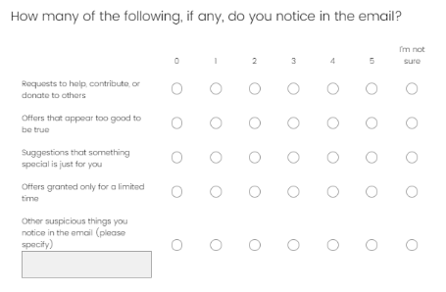
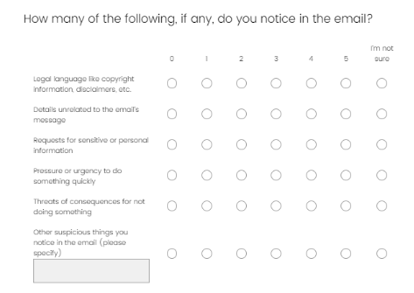

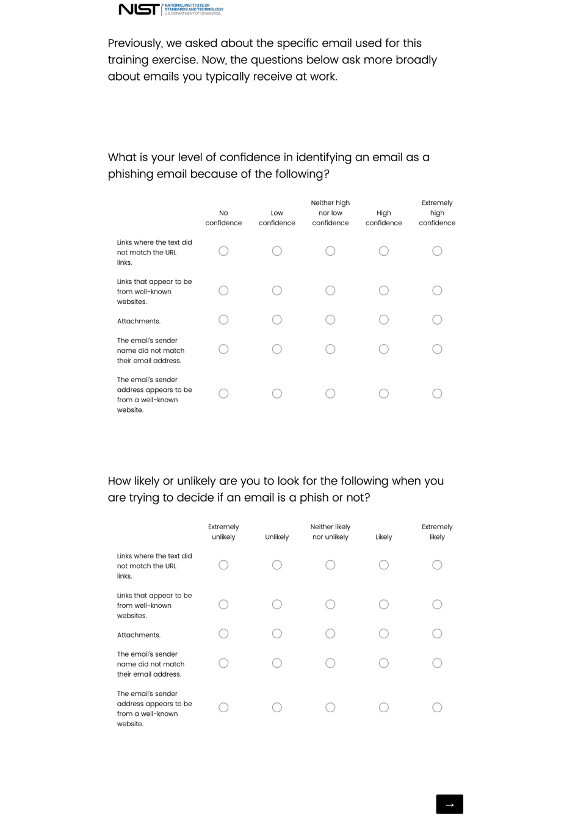
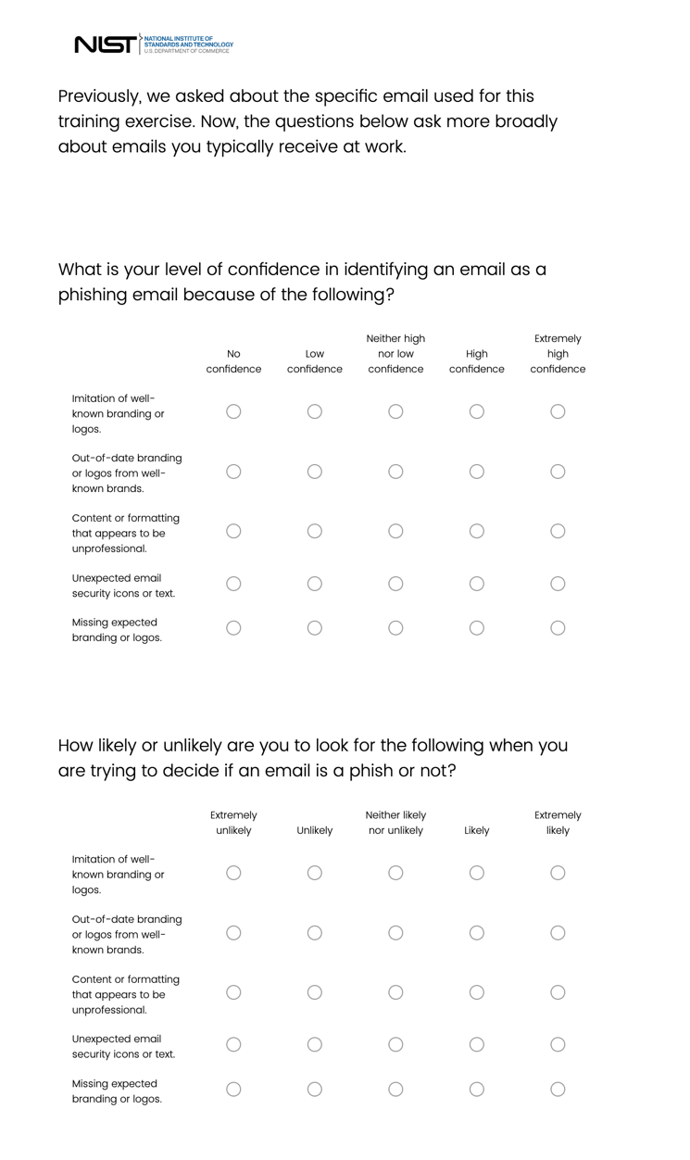

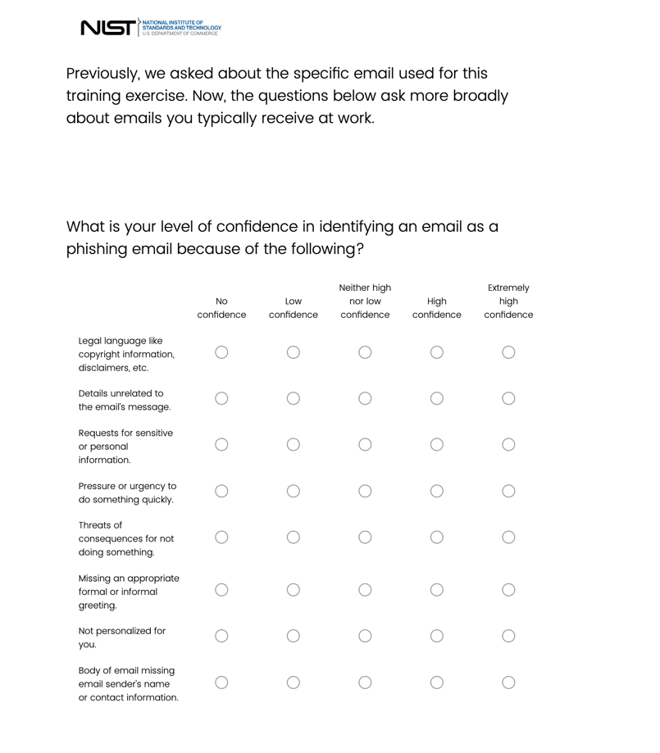
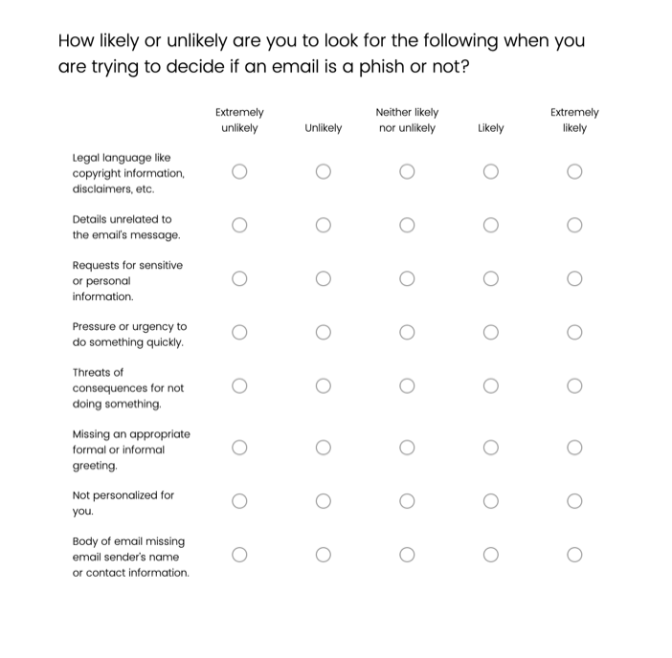

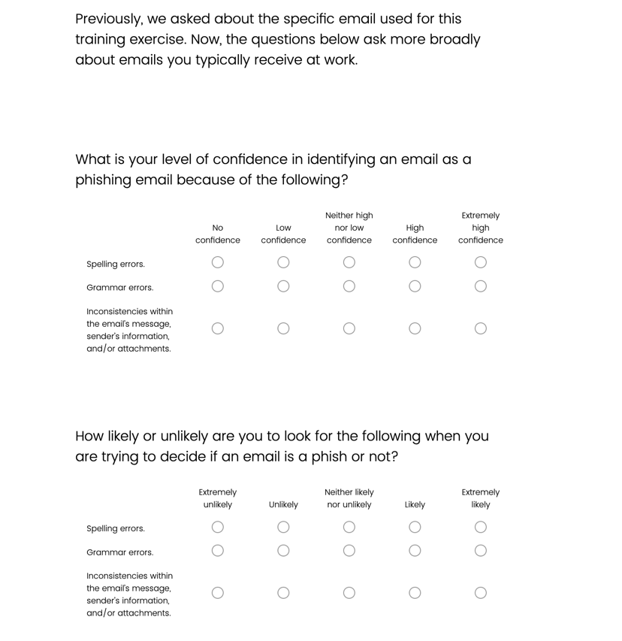
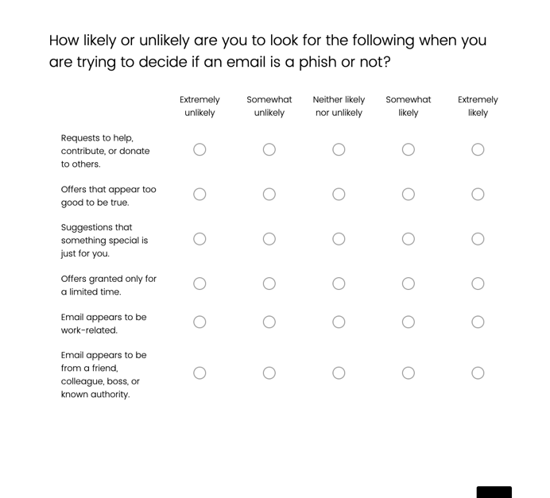
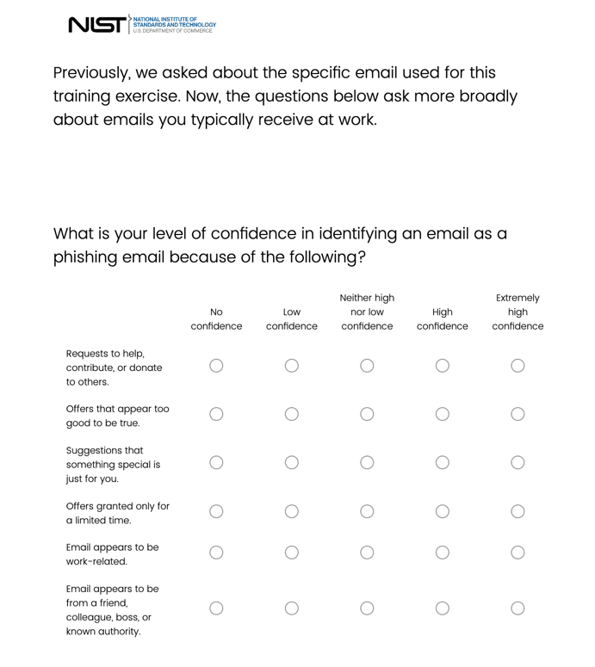
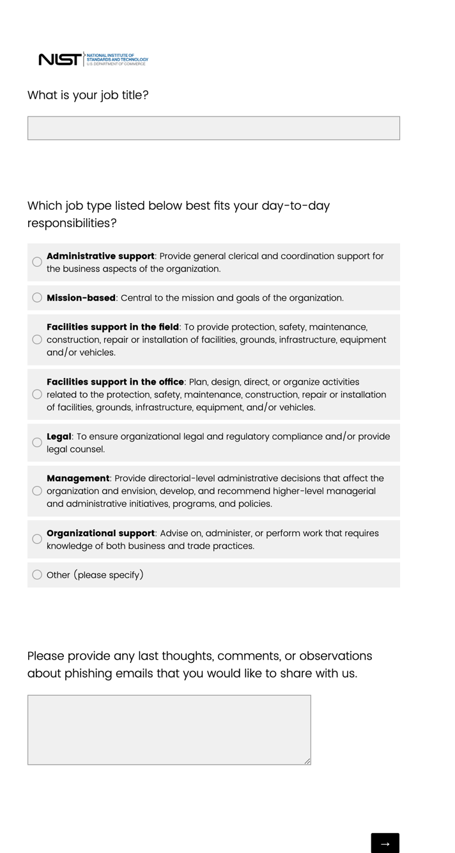
When a participant hovers over a response option, examples of the job type will be displayed:
- Administrative support-For example, timecard tracking, travel and expense report preparation, or meeting planning
- Mission-based-For example, an instructor, scientist, researcher, or salesperson
- Facilities support in the field-For example, security guard, janitorial staff or groundskeeper
- Facilities support in the office-For example, a facilities manager or security captain
- Legal-For example, general counsel
- Management-For example, Chief Executive Office, Director, or Department Chair
- Organizational support-For example, grants and contracts, employee relations, finance, public affairs, auditing, or information technology

