

I was satisfied with my experience interacting with HUD.



The interaction increased my trust in HUD.

How did you find this website?

0 | Search engine
0 | HUD.gov
0 | Landlord
0 | Lawyer
0 | HUD Employee
0 | Another Government Agency
0 | HUD or social media

I would describe myself primarily as:

0 | Civil Rights
0 | Housing provider
0 | Homelessness Group
0 | Climate Advocacy Group
0 | Language Access Group
0 | Disability Group
0 | Tenant Engagement Group
0 | Public Housing Industry Group
0 | Housing Finance Group
0 | Consumer Advocate
0 | Fair Housing Initiatives Program (FHIP) agency
0 | Fair Housing Assistance Program (FHAP) agency
0 | Tech Group
0 | Other

Where are you located?
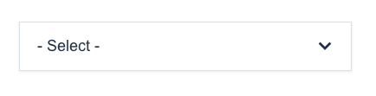

How can improve the experience on the website? (this question is not required for survey completion)



Disclaimer:
OMB Control Number: 2511-0001
Expiration Date: 09/30/2024
According to the Paperwork Reduction Act of 1995, no persons are required to respond to a collection of information unless such collection displays a valid OMB control number. The time required to complete this information collection is estimated to average 5 minutes. All responses to this collection of information are voluntary. If you have comments or concerns regarding this collection, please contact cx@hud.gov

