V1.0 – October 12, 2023

LMD Community Feedback Survey Online version
Survey links  (Identical surveys in separate links. This allows aggregated responses to be contrasted and provide a more comprehensive impression) | - Link for Civil Servants: https://forms.office.com/Pages/ResponsePage.aspx?id=WNQFcL5FrkiBQNQ9qW3Rezo6-byOb8FKnNYzKPeALthURVpHWEQ1QVFGRUhDMEkwMEs5SjVKN1pBTS4u  - Link for Contractors: https://forms.office.com/Pages/ResponsePage.aspx?id=WNQFcL5FrkiBQNQ9qW3Rezo6-byOb8FKnNYzKPeALthUOU1FVTI3VU1BVzg0RDczVjJTUktIV0xSTC4u

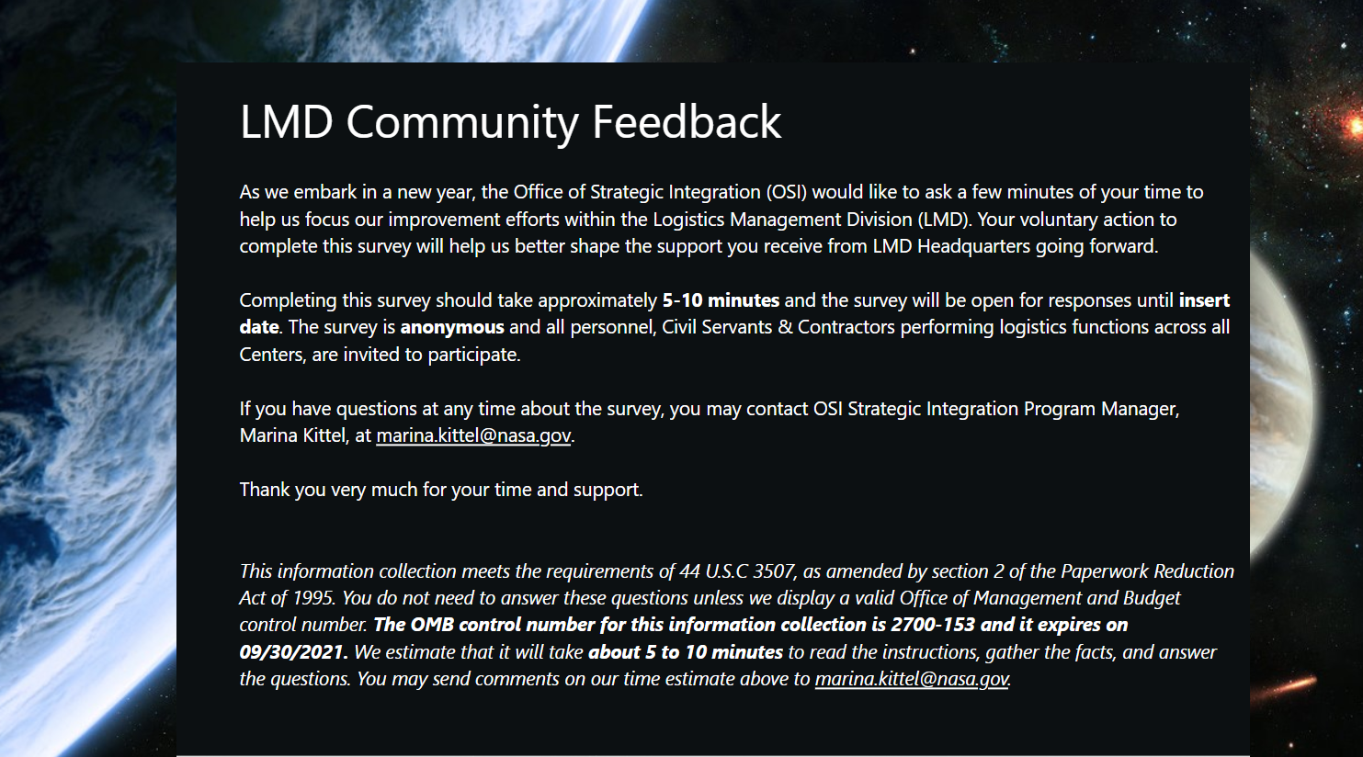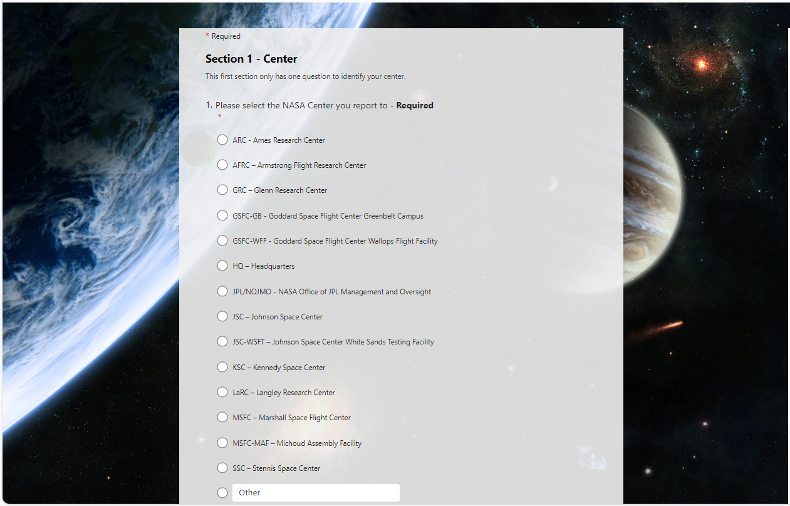

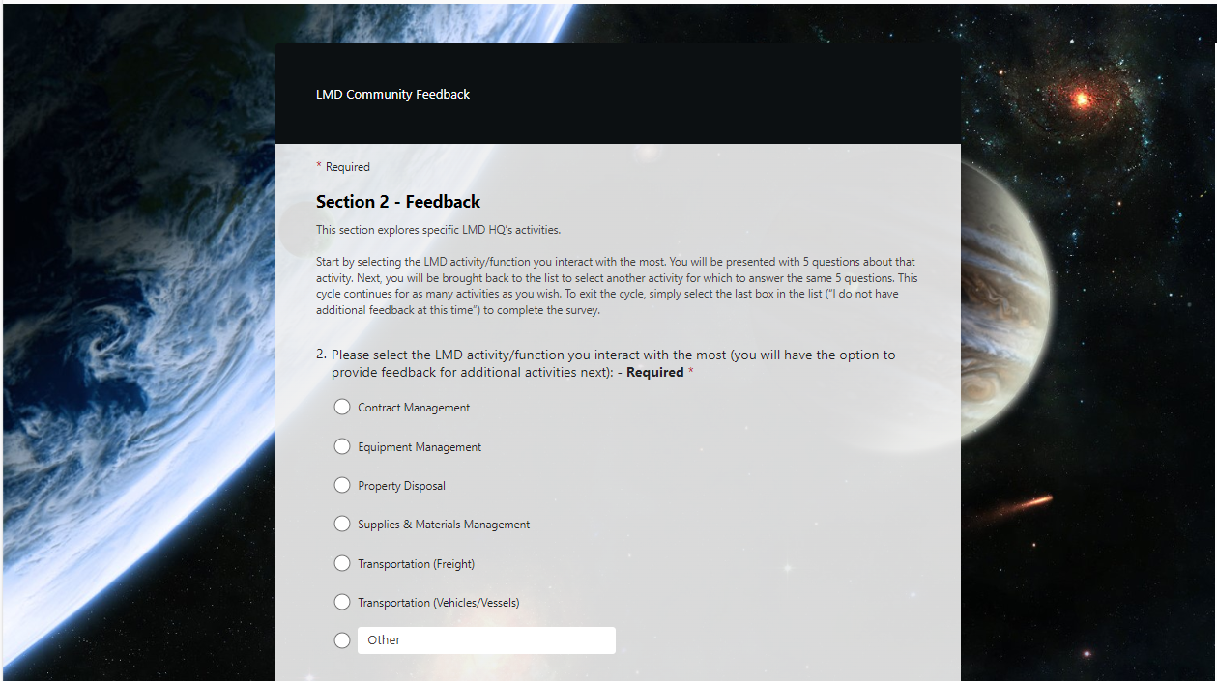

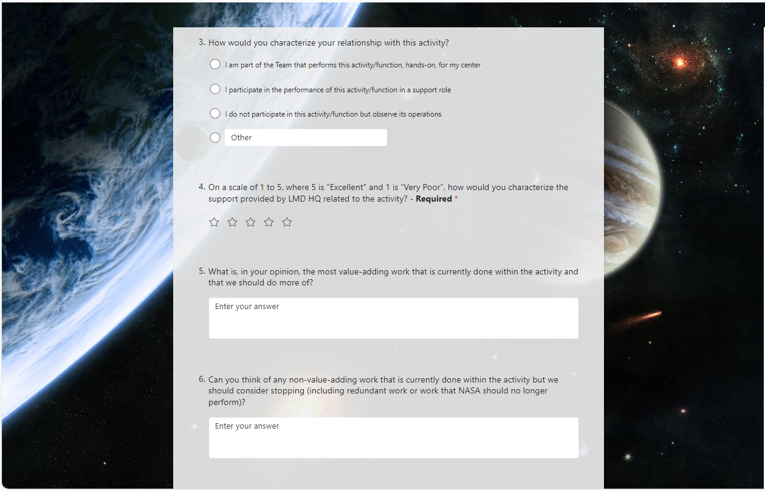

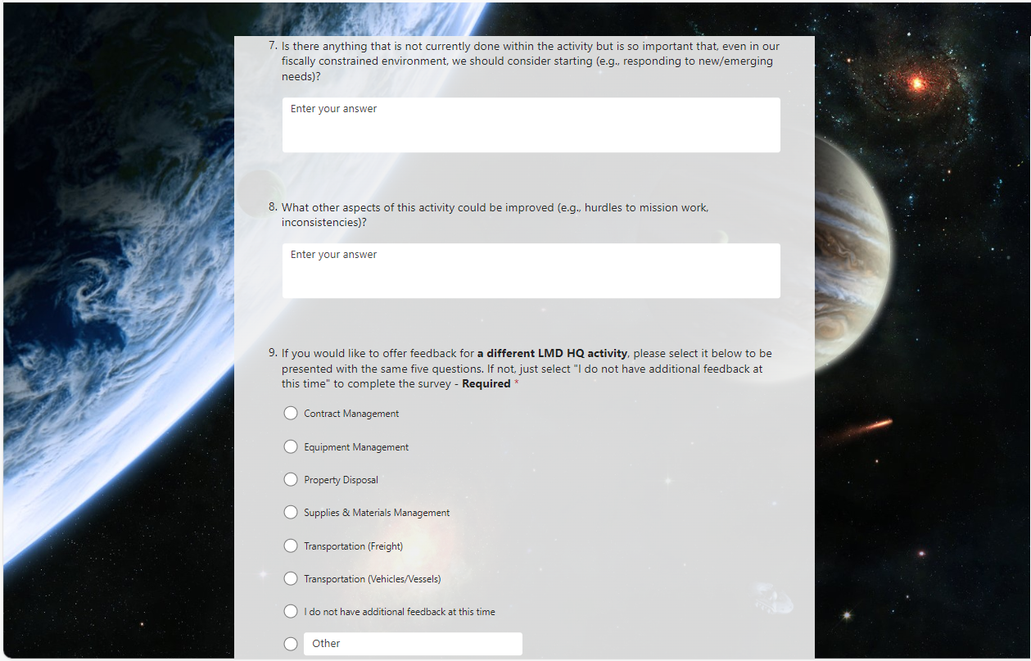

Repeat questions 3 to 9 up to 6 times, or until respondent selects “I do not have additional feedback”, then move to Section 3.
