NATIONAL CENTER FOR EDUCATION STATISTICS NATIONAL ASSESSMENT OF EDUCATIONAL PROGRESS

National Assessment of Educational Progress (NAEP)
2025 Long-Term Trend (LTT) Clearance Package

Appendix G

Long-Term Trend (LTT) 2025 Survey Questionnaires

OMB# 1850-0928 v.32



October 2023
revised February 2024

LTT Age 9 and Age 13 Core Math and Reading Survey Questionnaires were previously approved by OMB (OMB# 1850-0928 v.26). LTT Age 17 SQs were previously approved by OMB (OMB# 1850-0928 v.16).
This appendix includes all final LTT 2025 questionnaires.
Table of Contents
Sample NAEP Student Questionnaire Cover Page (LTT Age 9) 3
Appendix G-1: Operational LTT Age 9 Mathematics (Previously approved by OMB – OMB# 1850-0928 v.26) 4
Appendix G-2: Operational Age 9 Reading (Previously approved by OMB – OMB# 1850-0928 v.26) 7
Sample NAEP School Questionnaire Cover Page (LTT Age 9) 10
Appendix G-3: Summary of Changes Operational LTT Age 9 Core School Items 11
Appendix G-4: Operational LTT Age 9 Core School Items 12
Sample NAEP Student Questionnaire Cover Page (LTT Age 13) 24
Appendix G-5: Operational LTT Age 13 Mathematics (Previously approved by OMB – OMB# 1850-0928 v.26) 25
Appendix G-6: Operational LTT Age 13 Reading (Previously approved by OMB – OMB# 1850-0928 v.26) 28
Sample NAEP School Questionnaire Cover Page (LTT Age 13) 31
Appendix G-7: Summary of Changes Operational LTT Age 13 Core School Items 32
Appendix G-8: Operational LTT Age 13 Core School Items 34
Sample NAEP Student Questionnaire Cover Page (LTT Age 17) 46
Appendix G-9: Operational Age 17 Mathematics (Previously approved by OMB – OMB# 1850-0928 v.16) 47
Appendix G-10: Operational Age 17 Reading (Previously approved by OMB – OMB# 1850-0928 v.16) 51
Sample NAEP School Questionnaire Cover Page (LTT Age 17) 55
Appendix G-11: Summary of Changes Operational LTT Age 17 Core School Items 56
Appendix G-12: Operational LTT Age 17 Core School Items 57

Sample NAEP Student Questionnaire Cover Page (LTT Age 9)
Note: Sample cover pages will be updated in an upcoming Amendment.
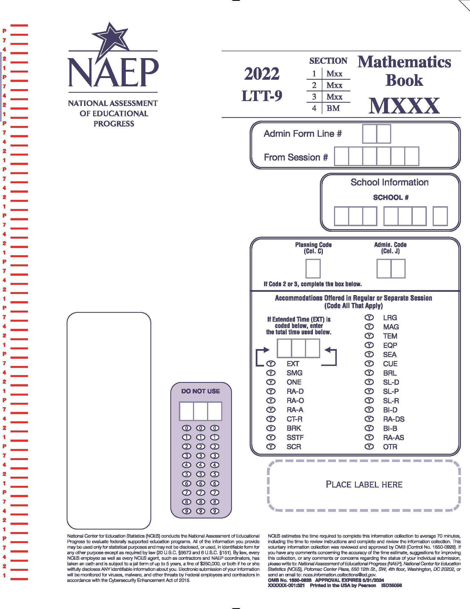

Appendix G-1: Operational LTT Age 9 Mathematics
(Previously approved by OMB – OMB# 1850-0928 v.26)

VB331330
- Are you Hispanic or Latino? Fill in one or more ovals.
  - No, I am not Hispanic or Latino.
  - Yes, I am Mexican, Mexican American, or Chicano.
  - Yes, I am Puerto Rican or Puerto Rican American.
  - Yes, I am Cuban or Cuban American.
  - Yes, I am from some other Hispanic or Latino background.
VB331331
- Which of the following best describes you? Fill in one or more ovals.
  - White
  - Black or African American
  - Asian
  - American Indian or Alaska Native
  - Native Hawaiian or other Pacific Islander
VB331335
- About how many books are there in your home?
  - Few (0–10)
  - Enough to fill one shelf (11–25)
  - Enough to fill one bookcase (26–100)
  - Enough to fill several bookcases (more than 100)
VB331336
- Is there a computer at home that you use?
  - Yes
  - No

TB001101
- About how many pages a day do you have to read in school and for homework?
  - 5 or fewer
  - 6–10
  - 11–15
  - 16–20
E More than 20
BO001200
- How much time did you spend on homework yesterday?
  - No homework was assigned.
  - I had homework but didn’t do it.
  - Less than 1 hour
  - 1 to 2 hours
  - More than 2 hours
VB331339
- How often do you talk about things you have studied in school with someone in your family?
  - Never or hardly ever
  - Once every few weeks
  - About once a week
  - Two or three times a week
  - Every day
VB331447
- How many days were you absent from school in the last month?
  - None
  - 1 or 2 days
  - 3 or 4 days
  - 5 to 10 days
  - More than 10 days

VB331451
- How often do people in your home talk to each other in a language other than English?
  - Never
  - Once in a while
  - About half of the time
  - All or most of the time

Appendix G-2: Operational Age 9 Reading
(Previously approved by OMB – OMB# 1850-0928 v.26)

VB331330
- Are you Hispanic or Latino? Fill in one or more ovals.
  - No, I am not Hispanic or Latino.
  - Yes, I am Mexican, Mexican American, or Chicano.
  - Yes, I am Puerto Rican or Puerto Rican American.
  - Yes, I am Cuban or Cuban American.
  - Yes, I am from some other Hispanic or Latino background.
VB331331
- Which of the following best describes you? Fill in one or more ovals.
  - White
  - Black or African American
  - Asian
  - American Indian or Alaska Native
  - Native Hawaiian or other Pacific Islander
VB331335
- About how many books are there in your home?
  - Few (0–10)
  - Enough to fill one shelf (11–25)
  - Enough to fill one bookcase (26–100)
  - Enough to fill several bookcases (more than 100)
VB331336
- Is there a computer at home that you use?
  - Yes
  - No

TB001101
- About how many pages a day do you have to read in school and for homework?
  - 5 or fewer
  - 6–10
  - 11–15
  - 16–20
  - More than 20
BO001200
- How much time did you spend on homework yesterday?
  - No homework was assigned.
  - I had homework but didn’t do it.
  - Less than 1 hour
  - 1 to 2 hours
  - More than 2 hours
VB331339
- How often do you talk about things you have studied in school with someone in your family?
  - Never or hardly ever
  - Once every few weeks
  - About once a week
  - Two or three times a week
  - Every day
VB331447
- How many days were you absent from school in the last month?
  - None
  - 1 or 2 days
  - 3 or 4 days
  - 5 to 10 days
  - More than 10 days

VB331451
- How often do people in your home talk to each other in a language other than English?
  - Never
  - Once in a while
  - About half of the time
  - All or most of the time
SO003500
- How often do you do each of the following things?
 | Almost every day | Once or twice a week | Once or twice a month | A few times a year | Never or hardly ever
a. Read for fun on your own time. | A | B | C | D | E | VC375071
b. Tell a friend about a good book. | A | B | C | D | E | VC375073

Sample NAEP School Questionnaire Cover Page (LTT Age 9)
Note: Sample cover pages will be updated in an upcoming Amendment.
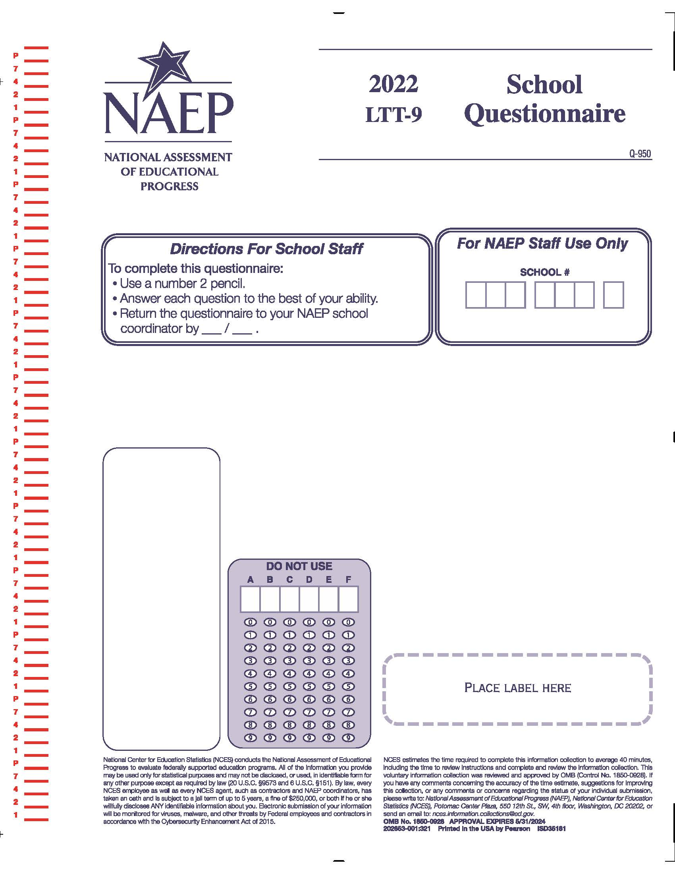

Appendix G-3: Summary of Changes Operational LTT Age 9 Core School Items
2024/2025 Operational Age 9 Long-Term Trend Core School Items

Previous Item | 2024/2025 LTT Item | D/A/R+ | Rationale
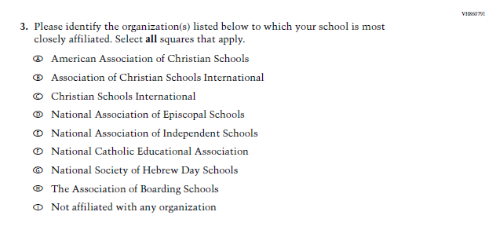  (2024 Grade 4, 8, and 12) | N/A | D | Dropped this item given the sample size of schools in LTT, and to reduce respondent burden.
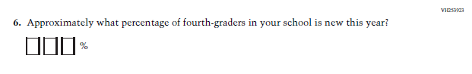  (2024 Grade 4) | N/A | D | Asking about fourth graders does not fit the LTT context as LTT is based on the age of students rather than the grade.
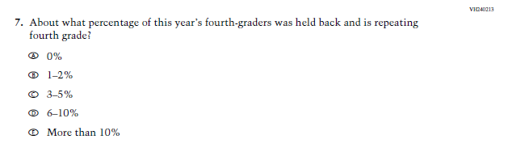  (2024 Grade 4) | N/A | D | Asking about fourth graders does not fit the LTT context as LTT is based on the age of students rather than the grade.

Appendix G-4: Operational LTT Age 9 Core School Items
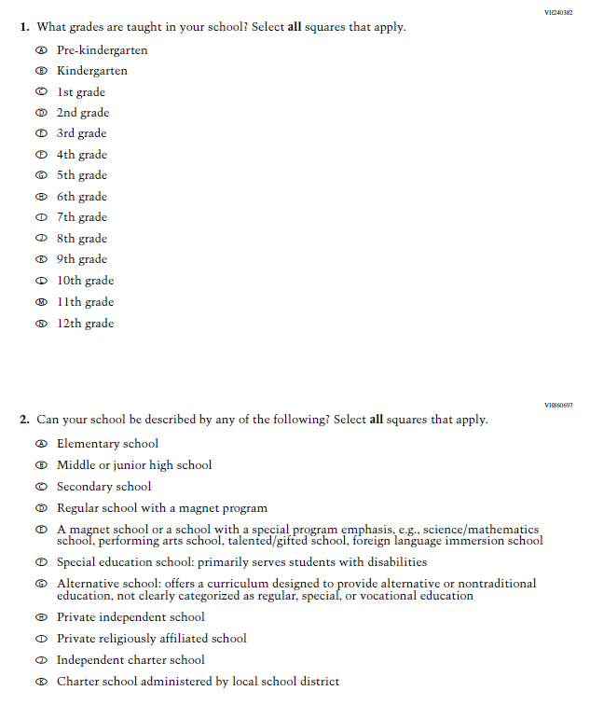
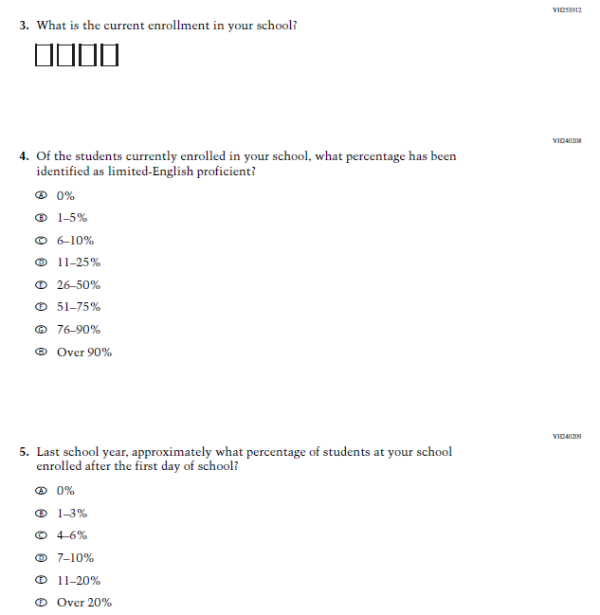
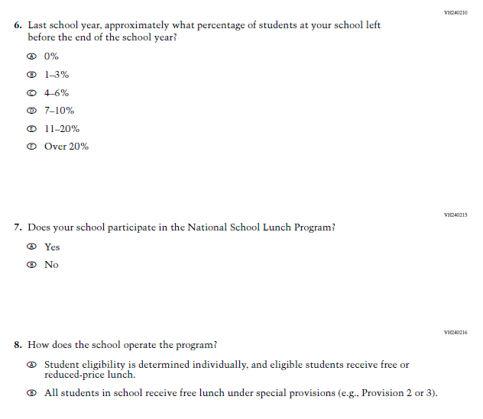
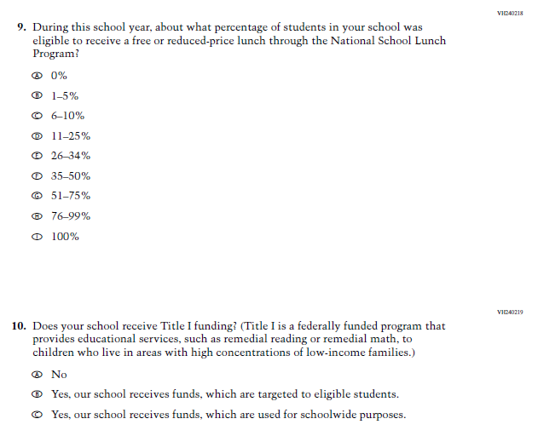
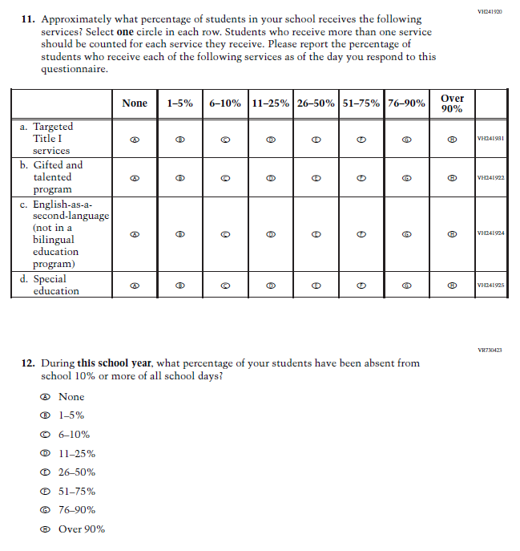
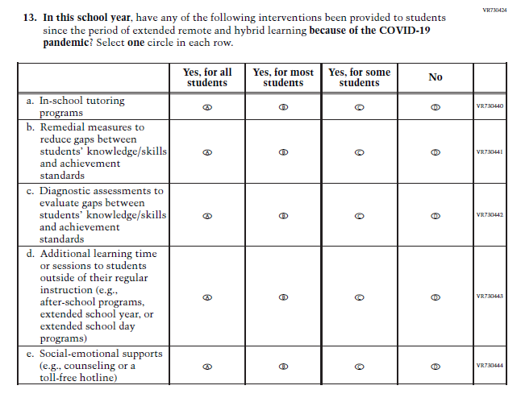
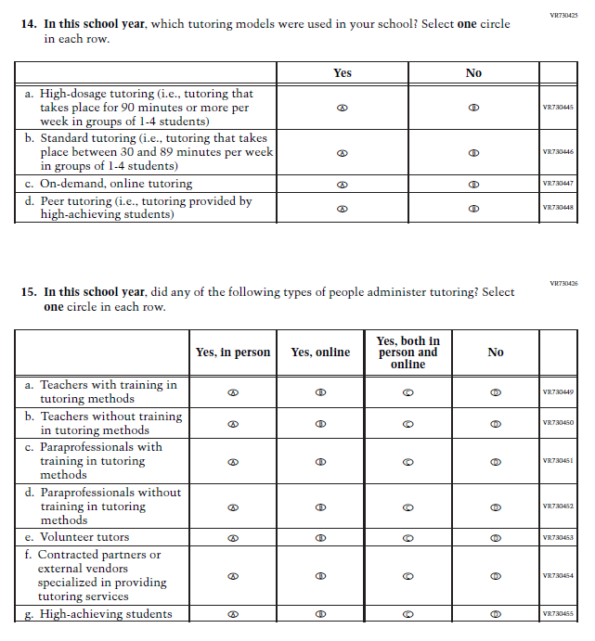
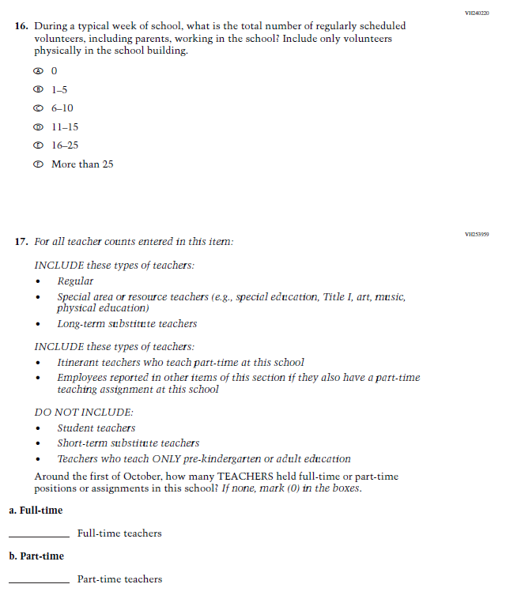
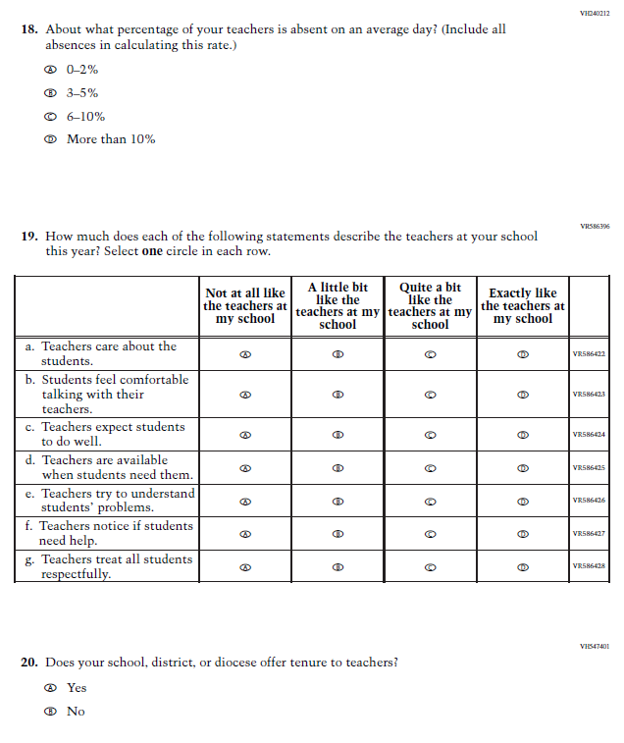
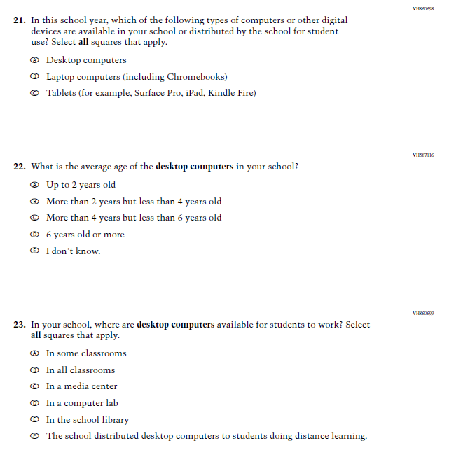
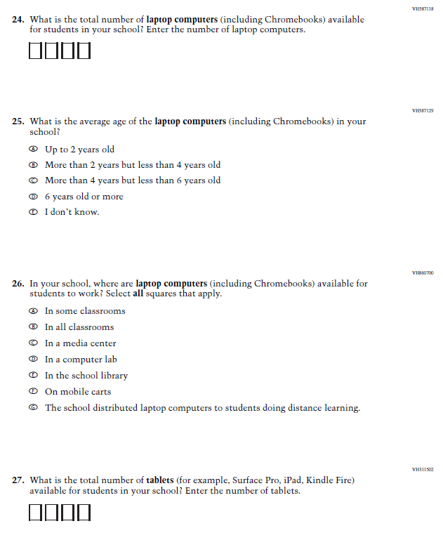
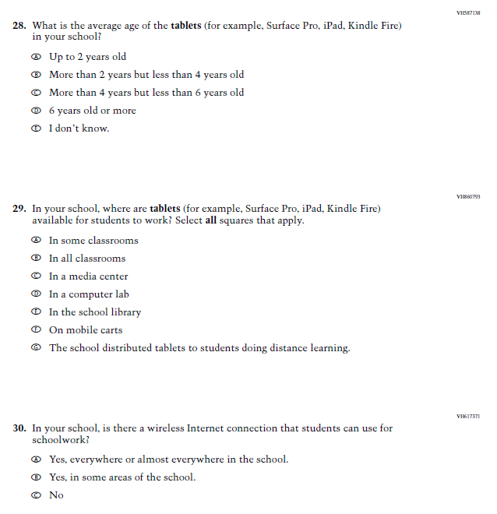

Sample NAEP Student Questionnaire Cover Page (LTT Age 13)
Note: Sample cover pages will be updated in an upcoming Amendment.
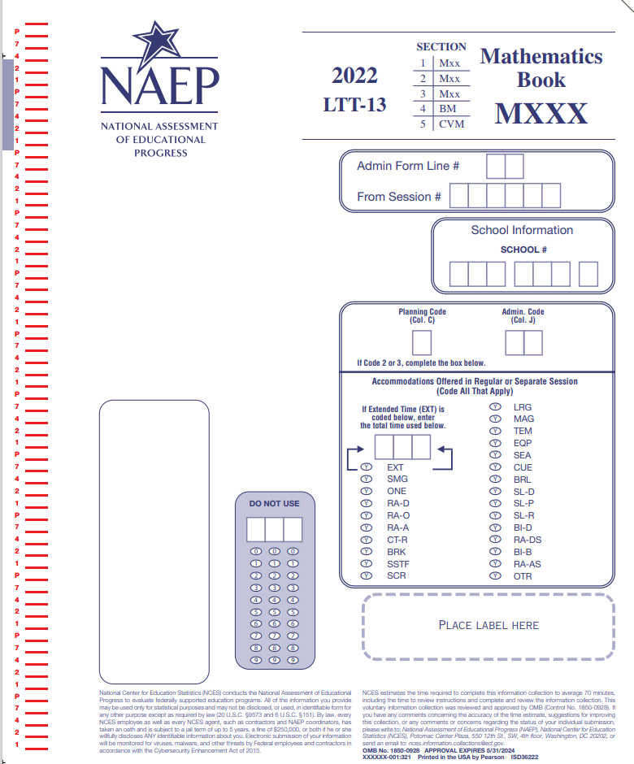

Appendix G-5: Operational LTT Age 13 Mathematics
(Previously approved by OMB – OMB# 1850-0928 v.26)
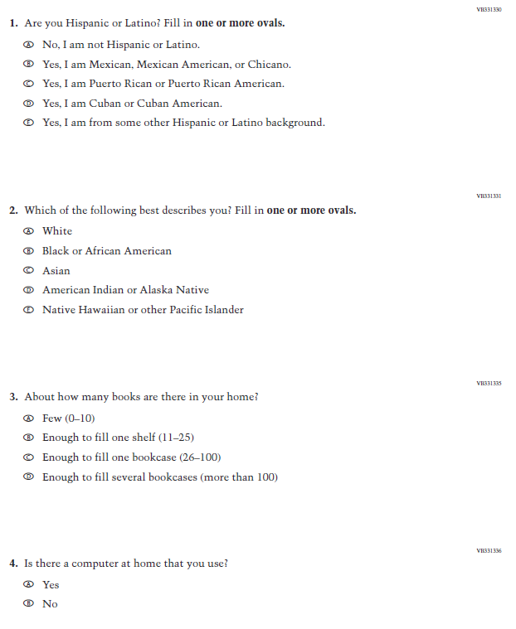
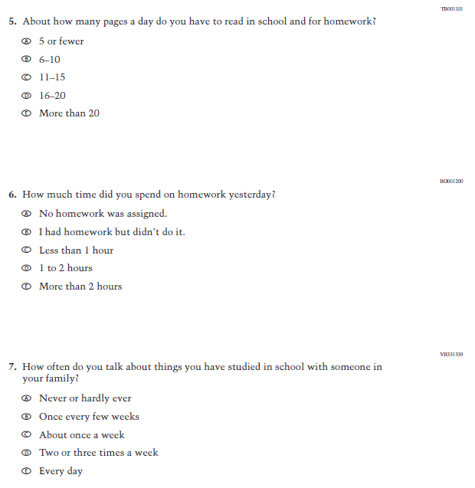

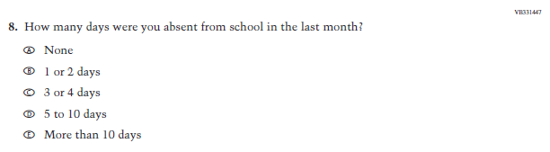
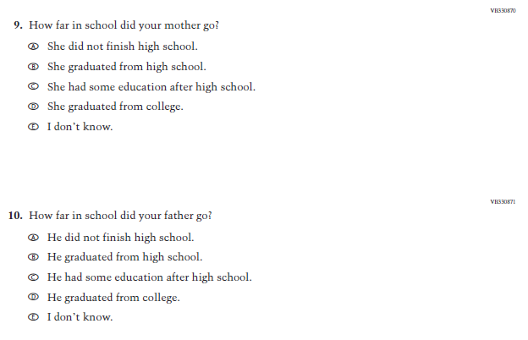

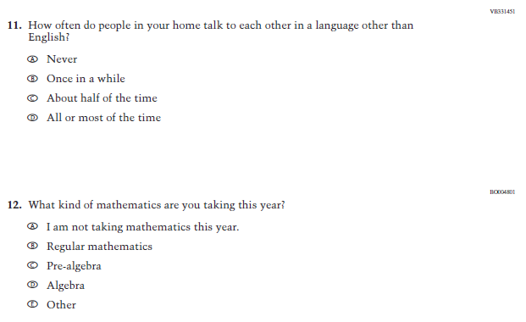

Appendix G-6: Operational LTT Age 13 Reading
(Previously approved by OMB – OMB# 1850-0928 v.26)
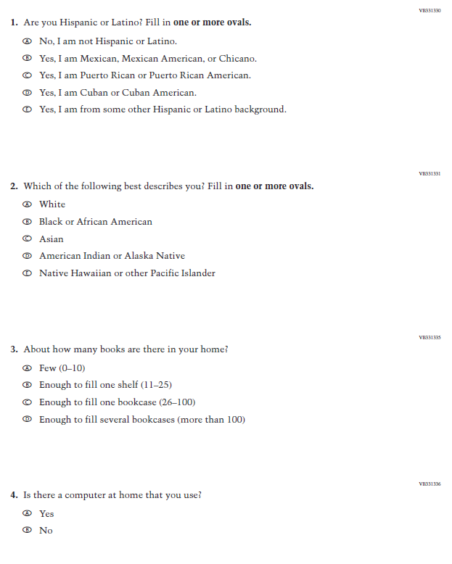
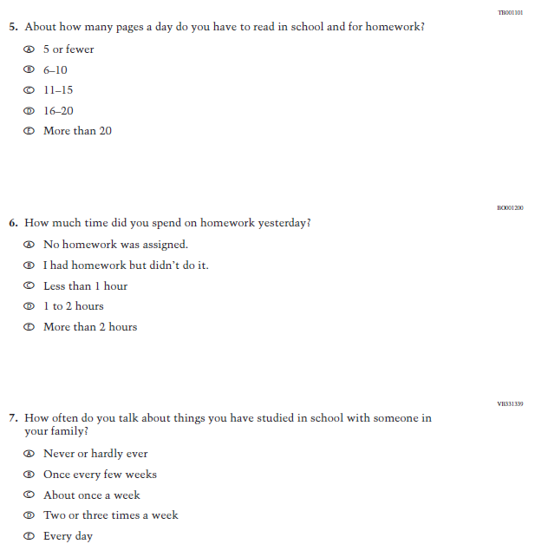

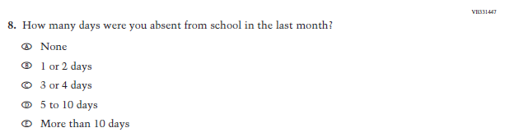
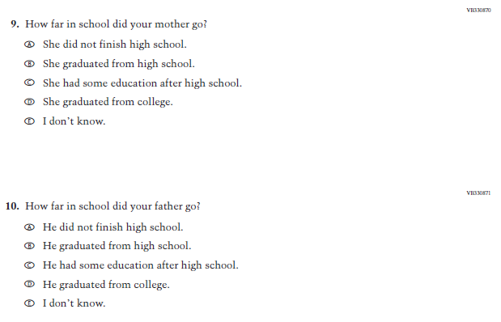

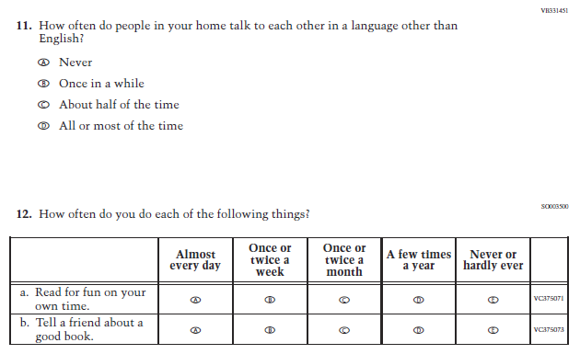

Sample NAEP School Questionnaire Cover Page (LTT Age 13)
Note: Sample cover pages will be updated in an upcoming Amendment.
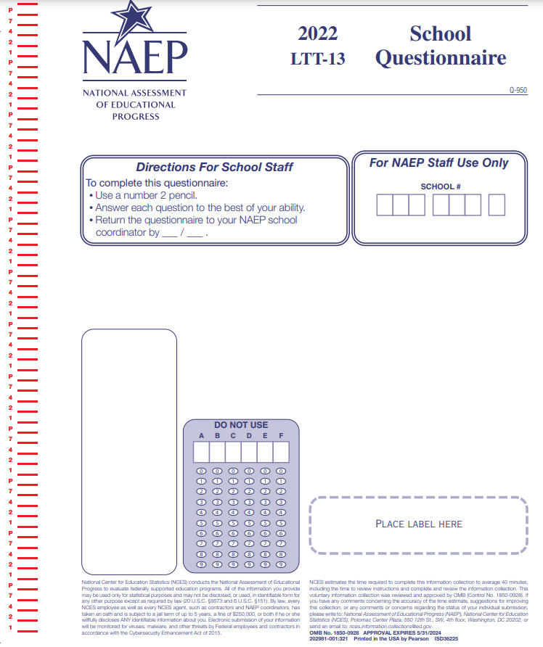

Appendix G-7: Summary of Changes Operational LTT Age 13 Core School Items

2024/2025 Operational Age 13 Long-Term Trend Core School Items

Previous Item | 2024/2025 LTT Item | D/A/R+ | Rationale
(2024 Grade 4, 8, and 12) | N/A | D | Dropped this item given the sample size of schools in LTT, and to reduce respondent burden.
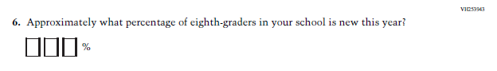  (2024 Grade 8) | N/A | D | Asking about eighth graders does not fit the LTT context as LTT is based on the age of students rather than the grade.
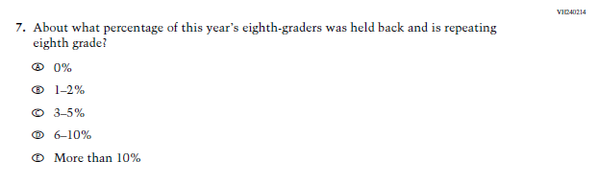  (2024 Grade 8) | N/A | D | Asking about eighth graders does not fit the LTT context as LTT is based on the age of students rather than the grade.
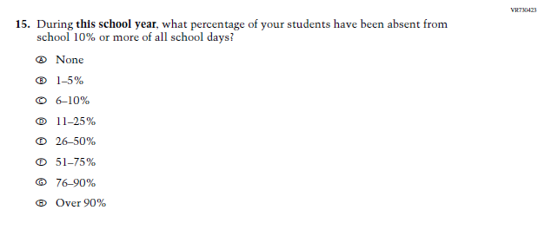  (2024 Grade 4, 8, and 12) | 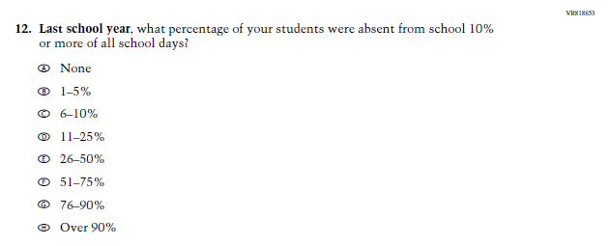Learning Recovery; School Attendance | R | Given the timeframe for the Administration of LTT at Age 13 (before or very close to the start of the Academic Year), the focus of this Item was changed from “this school year” to “last school year” for Age 13 only.

Appendix G-8: Operational LTT Age 13 Core School Items
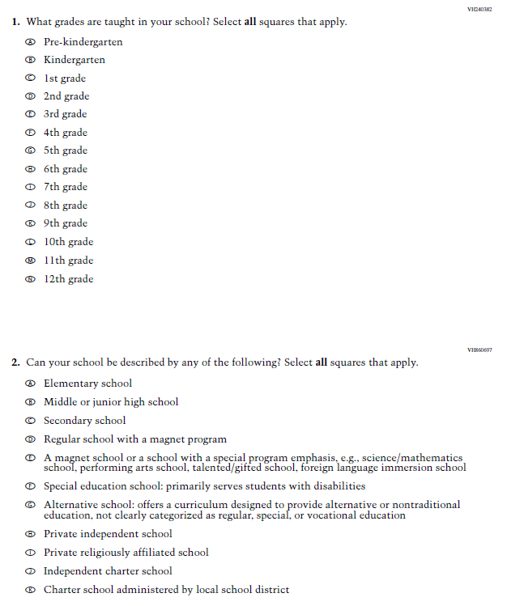
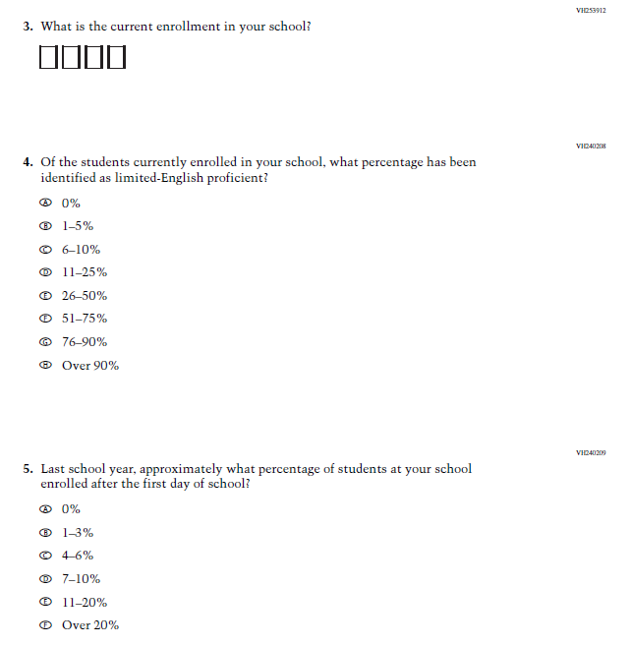
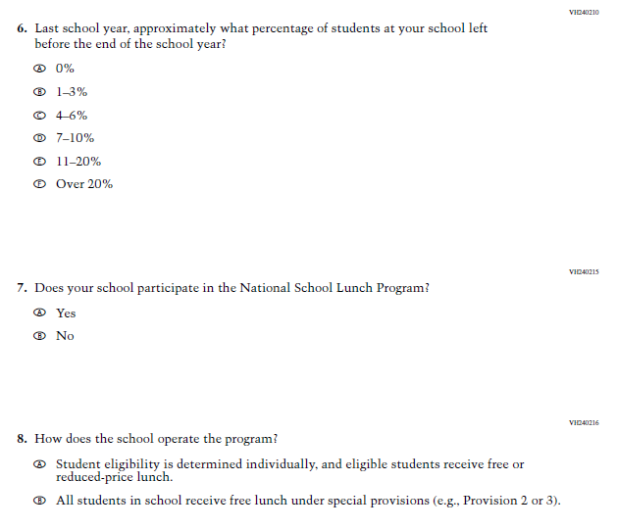
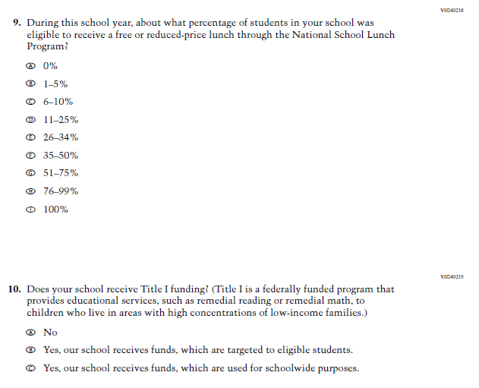
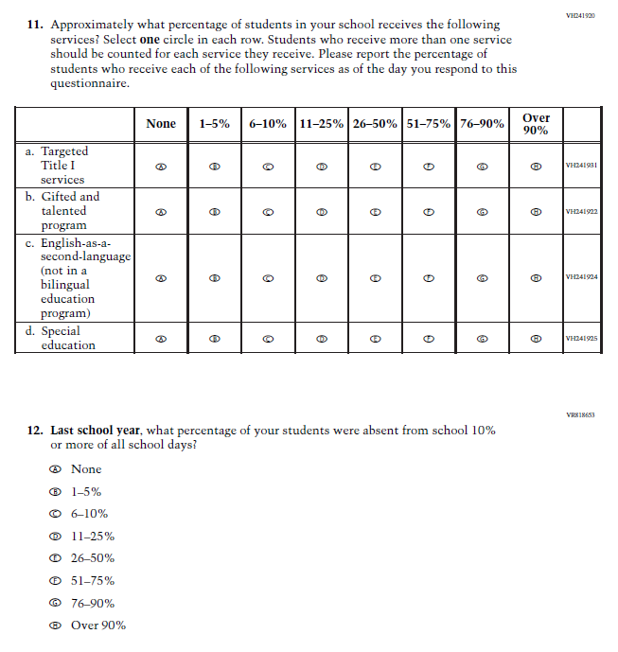
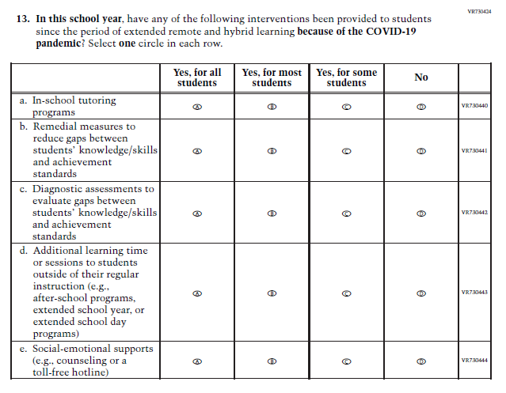
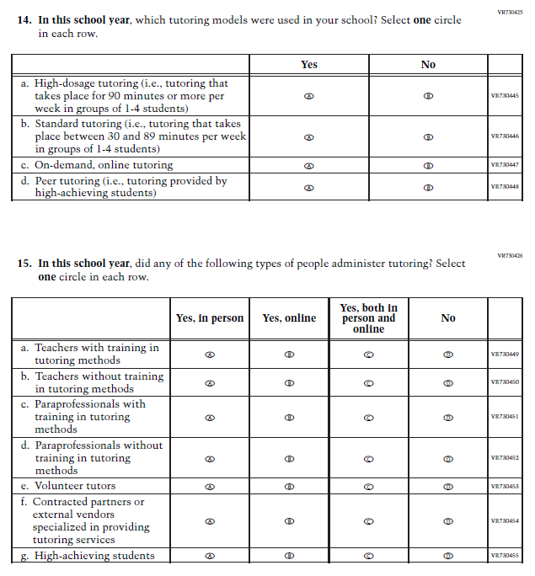
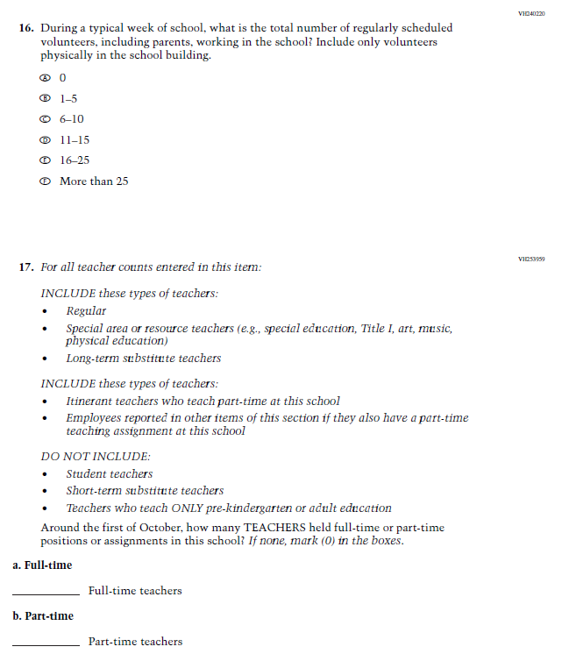
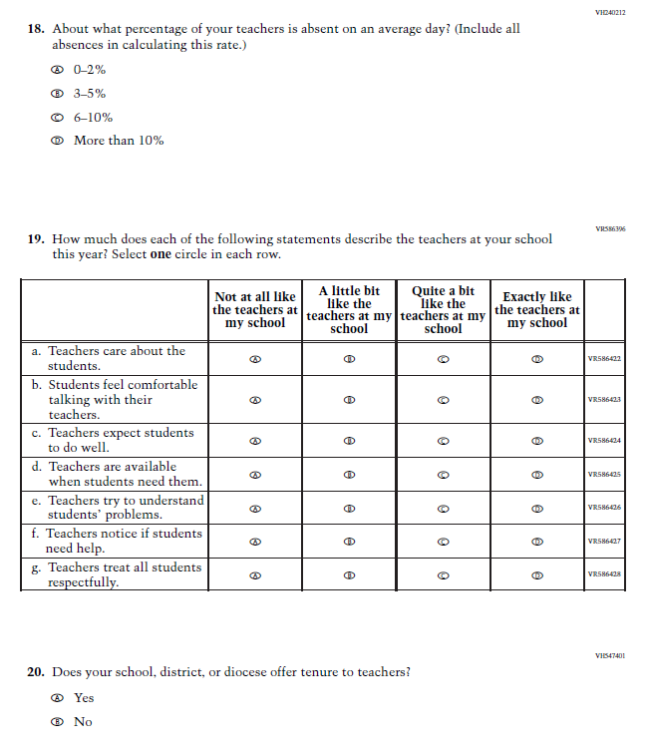
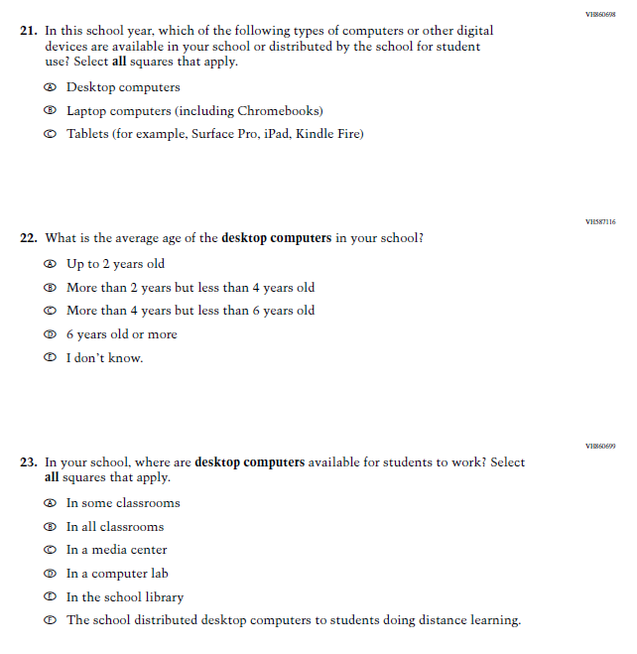
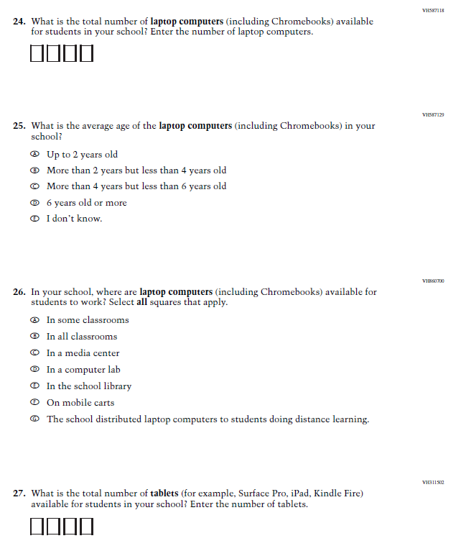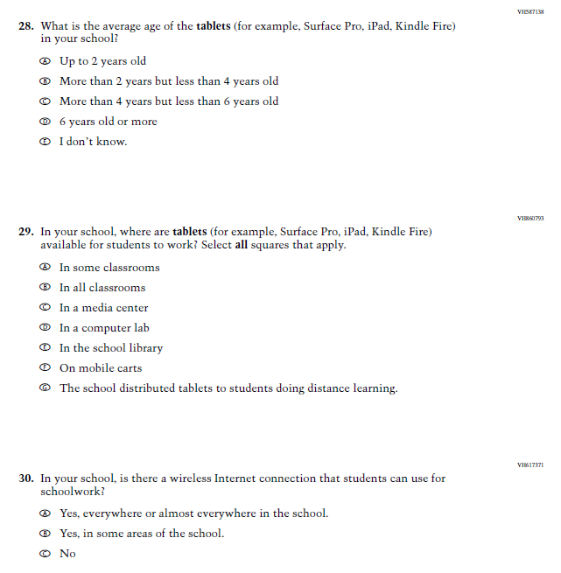

Sample NAEP Student Questionnaire Cover Page (LTT Age 17)
Note: Sample cover pages will be updated in an upcoming Amendment.
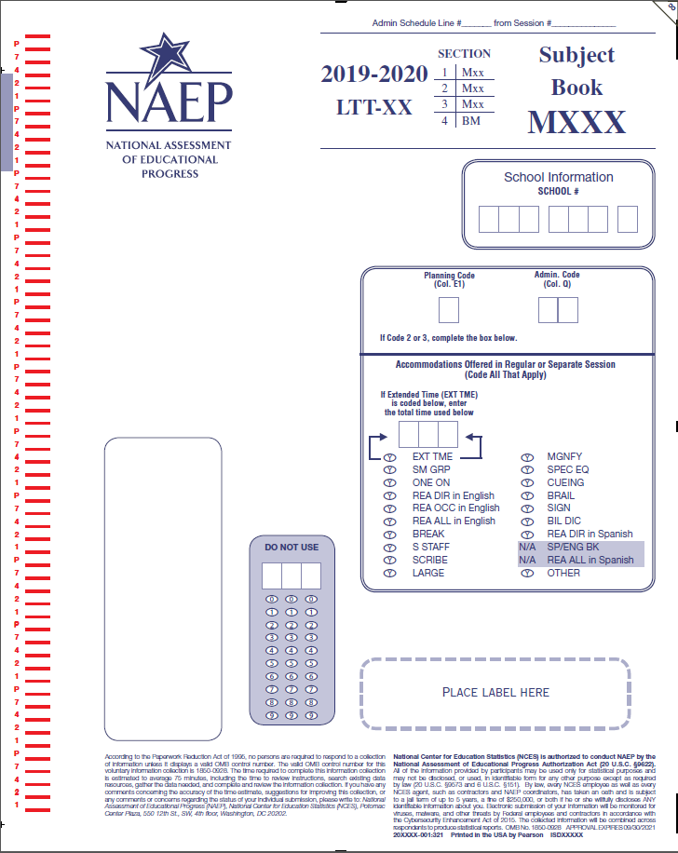

Appendix G-9: Operational Age 17 Mathematics
(Previously approved by OMB – OMB# 1850-0928 v.16)

VB331330
- Are you Hispanic or Latino? Fill in one or more ovals.
  - No, I am not Hispanic or Latino.
  - Yes, I am Mexican, Mexican American, or Chicano.
  - Yes, I am Puerto Rican or Puerto Rican American.
  - Yes, I am Cuban or Cuban American.
  - Yes, I am from some other Hispanic or Latino background.
VB331331
- Which of the following best describes you? Fill in one or more ovals.
  - White
  - Black or African American
  - Asian
  - American Indian or Alaska Native
  - Native Hawaiian or other Pacific Islander
VB331335
- About how many books are there in your home?
  - Few (0–10)
  - Enough to fill one shelf (11–25)
  - Enough to fill one bookcase (26–100)
  - Enough to fill several bookcases (more than 100)
VB331336
- Is there a computer at home that you use?
  - Yes
  - No

TB001101
- About how many pages a day do you have to read in school and for homework?
  - 5 or fewer
  - 6–10
  - 11–15
  - 16–20
  - More than 20
BO001200
- How much time did you spend on homework yesterday?
  - No homework was assigned.
  - I had homework but didn’t do it.
  - Less than 1 hour
  - 1 to 2 hours
  - More than 2 hours
VB331339
- How often do you talk about things you have studied in school with someone in your family?
  - Never or hardly ever
  - Once every few weeks
  - About once a week
  - Two or three times a week
  - Every day
VB331447
- How many days were you absent from school in the last month?
  - None
  - 1 or 2 days
  - 3 or 4 days
  - 5 to 10 days
  - More than 10 days
VB330870
- How far in school did your mother go?
  - She did not finish high school.
  - She graduated from high school.
  - She had some education after high school.
  - She graduated from college.
  - I don’t know.
VB330871
- How far in school did your father go?
  - He did not finish high school.
  - He graduated from high school.
  - He had some education after high school.
  - He graduated from college.
  - I don’t know.
VB331451
- How often do people in your home talk to each other in a language other than English?
  - Never
  - Once in a while
  - About half of the time
  - All or most of the time
HE002549
- Which of the following best describes your high school program?
  - General
  - Academic or college preparatory
  - Vocational or technical

BO005300
- Counting what you are taking now, have you ever taken any of the following mathematics courses? Fill in only one oval on each line.
 | Have taken | Have not taken
a. General, business, or consumer mathematics | A | B | VC373212
b. Pre-algebra or introduction to algebra | A | B | VC373213
c. First-year algebra | A | B | VC373217
d. Second-year algebra | A | B | VC373220
e. Geometry | A | B | VC373221
f. Trigonometry | A | B | VC373222
g. Pre-calculus or calculus | A | B | VC373224

Appendix G-10: Operational Age 17 Reading
(Previously approved by OMB – OMB# 1850-0928 v.16)
VB331330
- Are you Hispanic or Latino? Fill in one or more ovals.
  - No, I am not Hispanic or Latino.
  - Yes, I am Mexican, Mexican American, or Chicano.
  - Yes, I am Puerto Rican or Puerto Rican American.
  - Yes, I am Cuban or Cuban American.
  - Yes, I am from some other Hispanic or Latino background.
VB331331
- Which of the following best describes you? Fill in one or more ovals.
  - White
  - Black or African American
  - Asian
  - American Indian or Alaska Native
  - Native Hawaiian or other Pacific Islander
VB331335
- About how many books are there in your home?
  - Few (0–10)
  - Enough to fill one shelf (11–25)
  - Enough to fill one bookcase (26–100)
  - Enough to fill several bookcases (more than 100)

VB331336
- Is there a computer at home that you use?
  - Yes
  - No

TB001101
- About how many pages a day do you have to read in school and for homework?
  - 5 or fewer
  - 6–10
  - 11–15
  - 16–20
  - More than 20
BO001200
- How much time did you spend on homework yesterday?
  - No homework was assigned.
  - I had homework but didn’t do it.
  - Less than 1 hour
  - 1 to 2 hours
  - More than 2 hours
VB331339
- How often do you talk about things you have studied in school with someone in your family?
  - Never or hardly ever
  - Once every few weeks
  - About once a week
  - Two or three times a week
  - Every day
VB331447
- How many days were you absent from school in the last month?
  - None
  - 1 or 2 days
  - 3 or 4 days
  - 5 to 10 days
  - More than 10 days
VB330870
- How far in school did your mother go?
  - She did not finish high school.
  - She graduated from high school.
  - She had some education after high school.
  - She graduated from college.
  - I don’t know.
VB330871
- How far in school did your father go?
  - He did not finish high school.
  - He graduated from high school.
  - He had some education after high school.
  - He graduated from college.
  - I don’t know.
VB331451
- How often do people in your home talk to each other in a language other than English?
  - Never
  - Once in a while
  - About half of the time
  - All or most of the time
HE002549
- Which of the following best describes your high school program?
  - General
  - Academic or college preparatory
  - Vocational or technical

SO003500
- How often do you do each of the following things?
 | Almost every day | Once or twice a week | Once or twice a month | A few times a year | Never or hardly ever
a. Read for fun on your own time. | A | B | C | D | E | VC375071
b. Tell a friend about a good book. | A | B | C | D | E | VC375073

Sample NAEP School Questionnaire Cover Page (LTT Age 17)
Note: A sample LTT 17 School Questionnaire Cover Page will be included in an upcoming Amendment.

Appendix G-11: Summary of Changes Operational LTT Age 17 Core School Items
2024/2025 Operational Age 17 Long-Term Trend Core School Items

Previous Item | 2024/2025 LTT Item | D/A/R+ | Rationale
(2024 Grade 4, 8, and 12) | N/A | D | Dropped this item given the sample size of schools in LTT, and to reduce respondent burden.
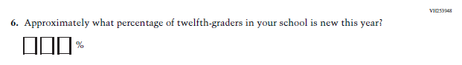  (2024 Grade 12) | N/A | D | Asking about twelfth graders does not fit the LTT context as LTT is based on the age of students rather than the grade.
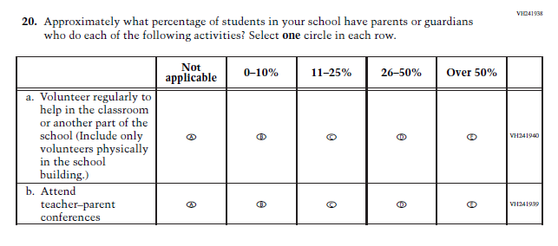  (2024 Grade 12) | N/A | D | Dropped this Item given the sample size of schools in LTT, and to reduce respondent burden.

Appendix G-12: Operational LTT Age 17 Core School Items
