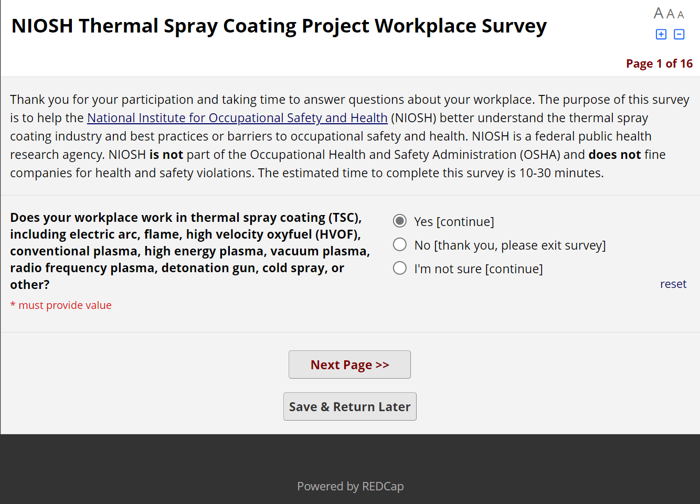
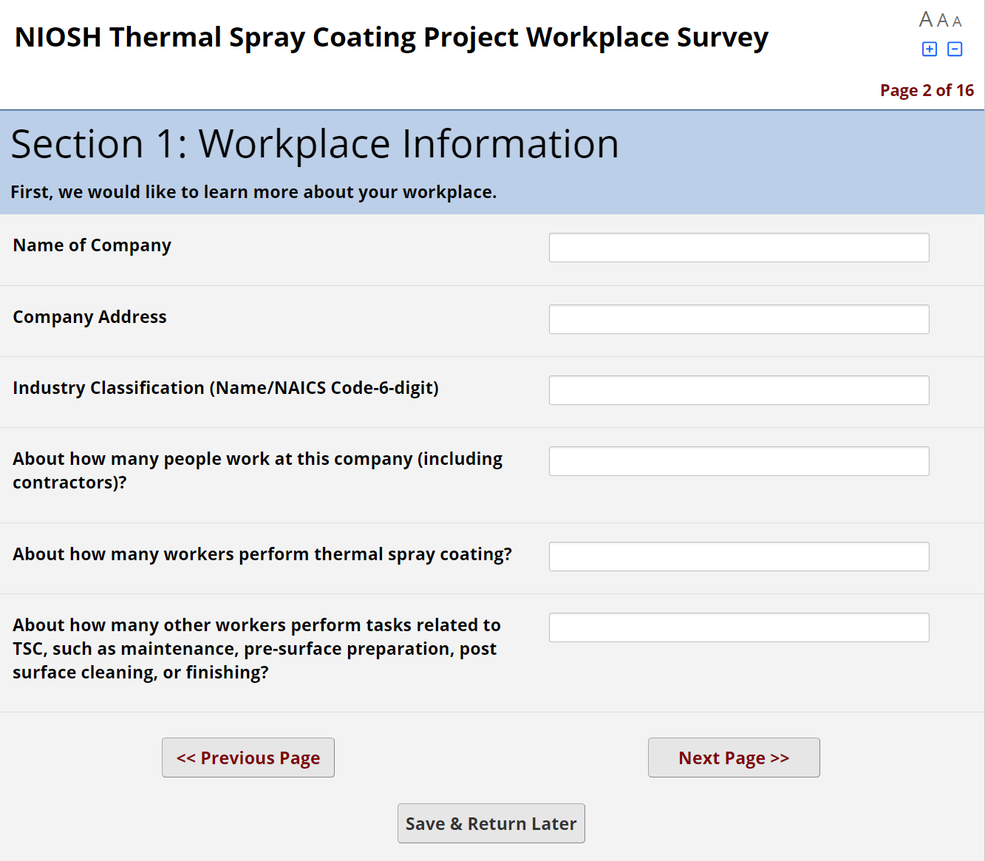
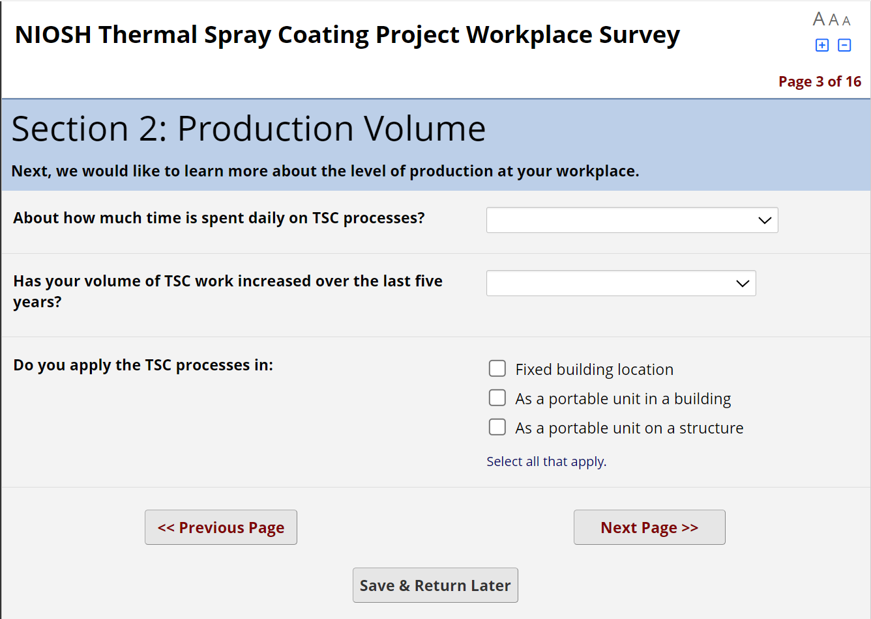

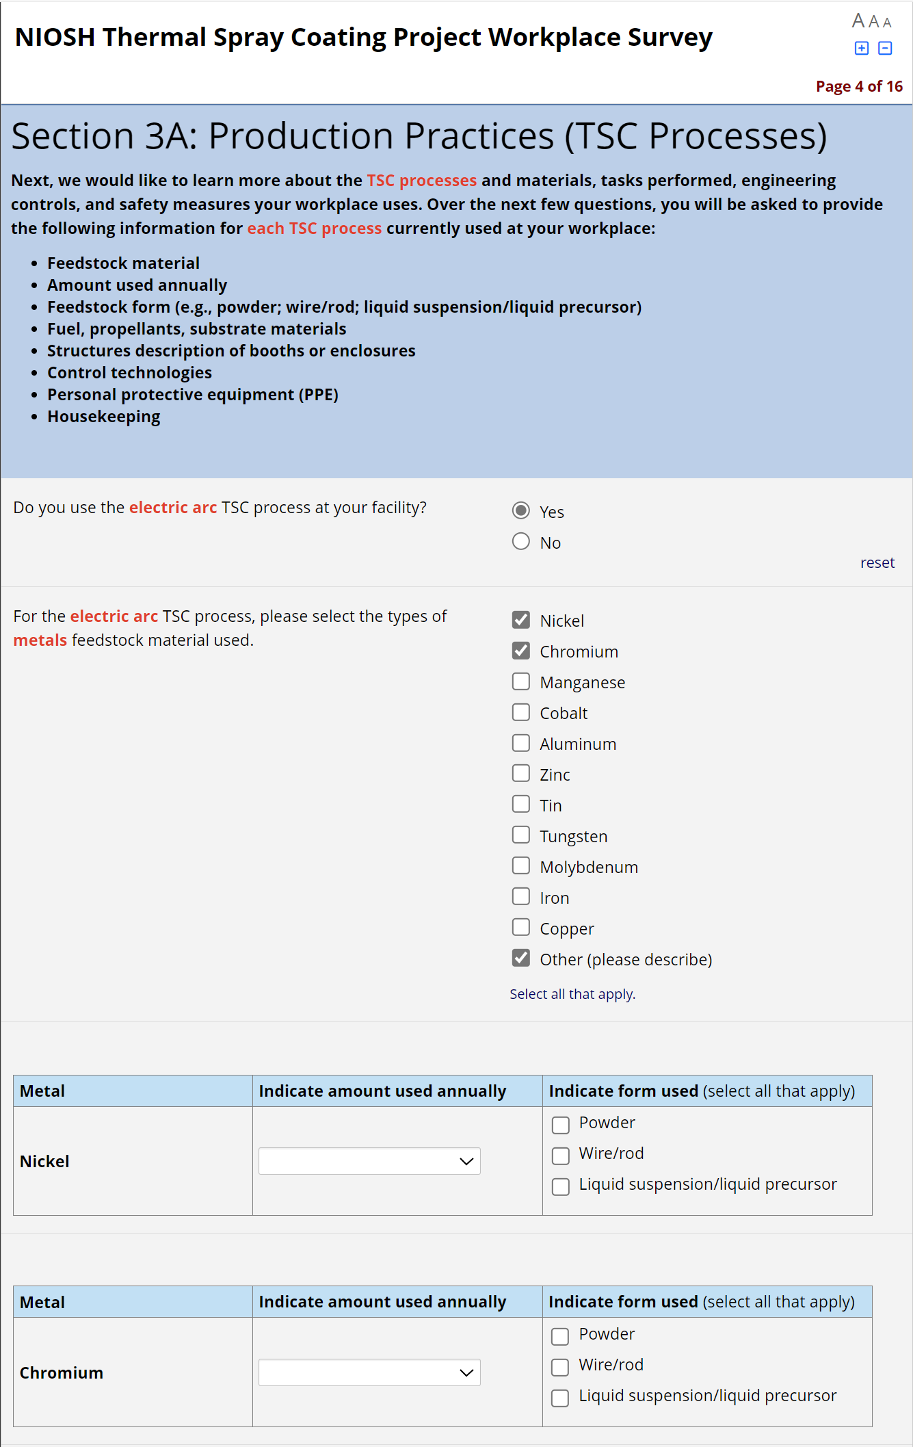
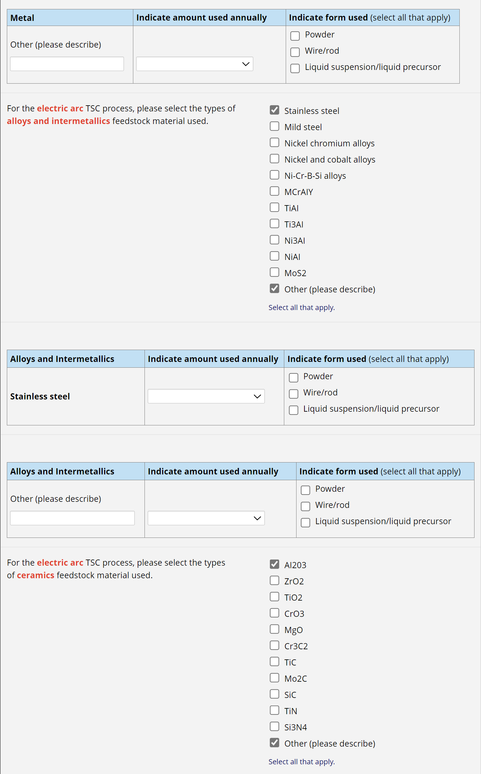
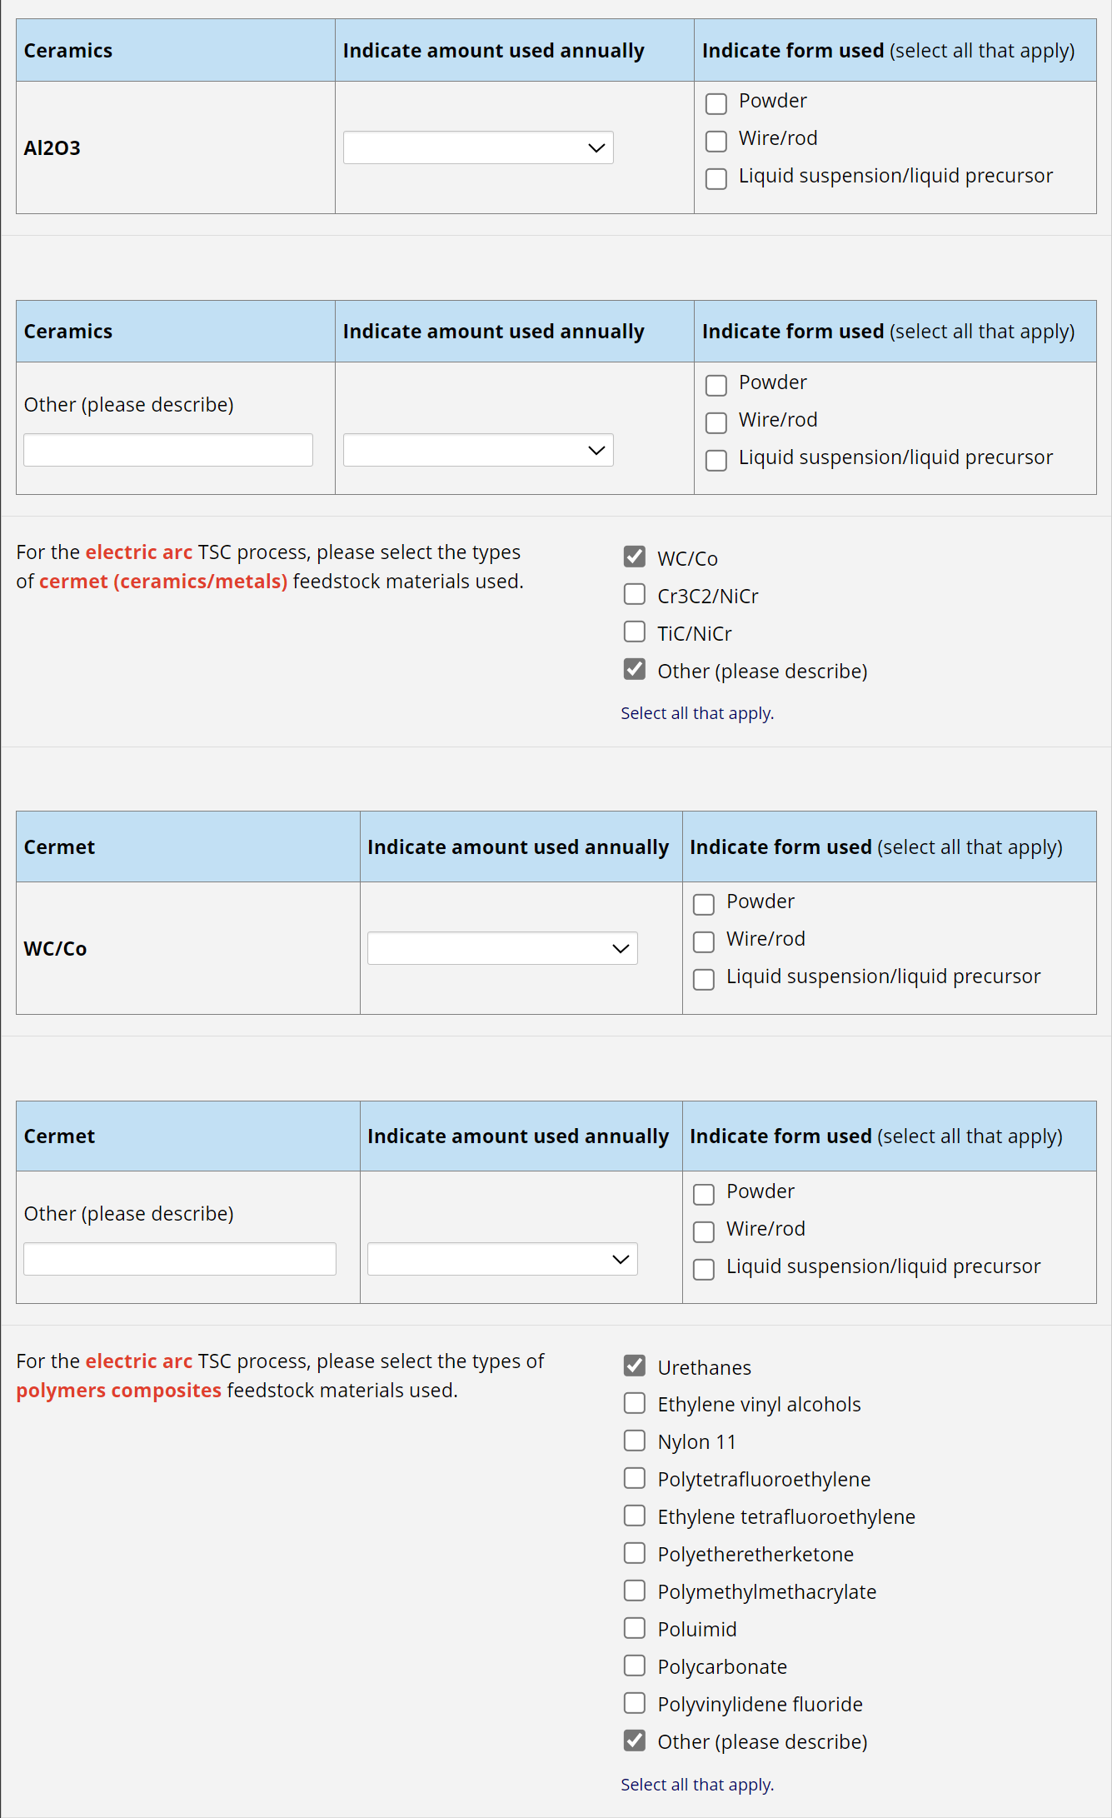
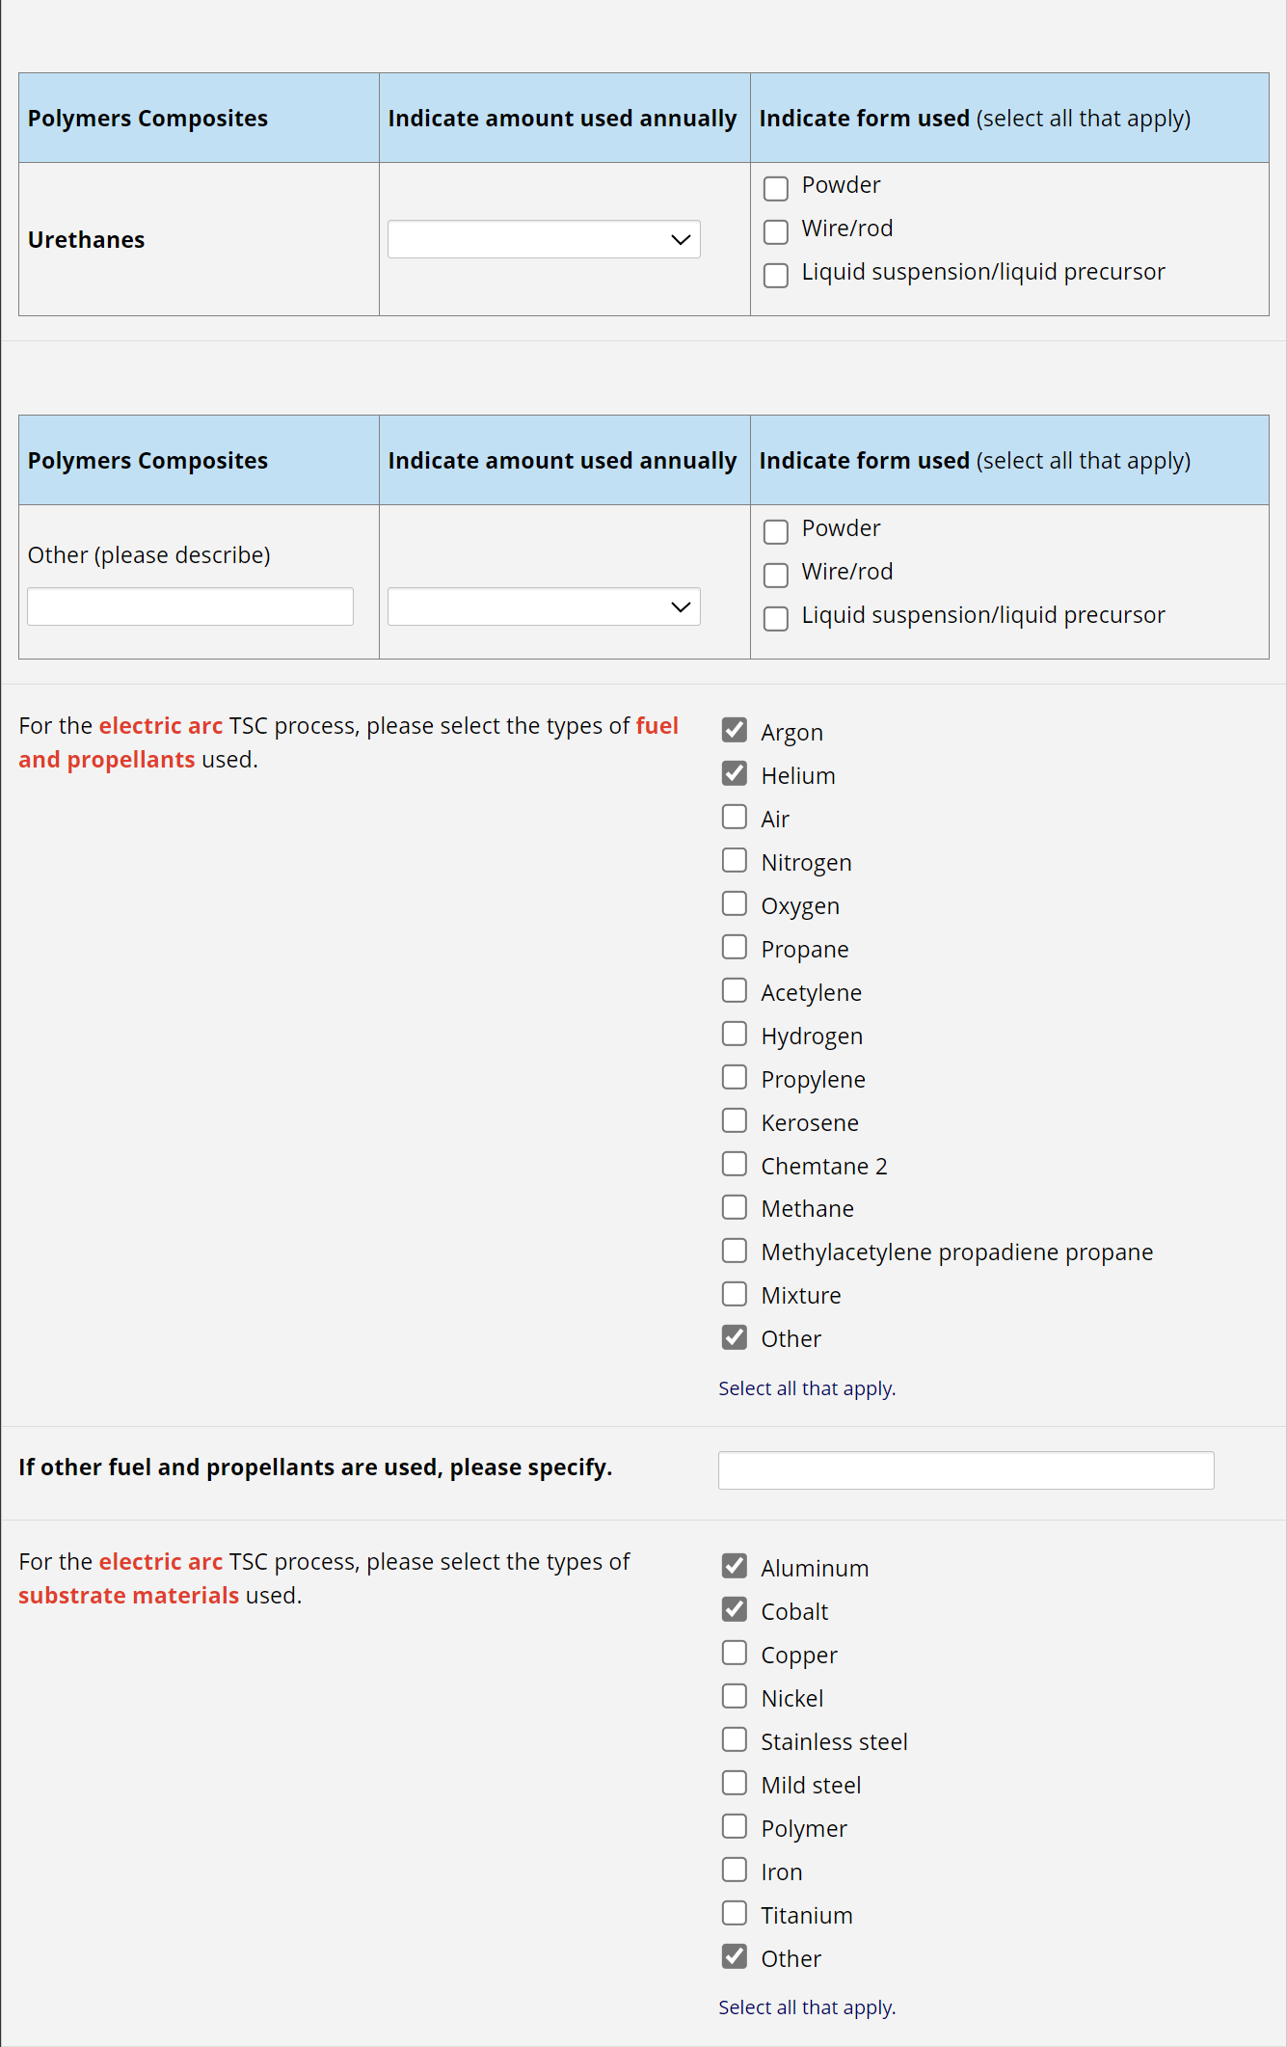
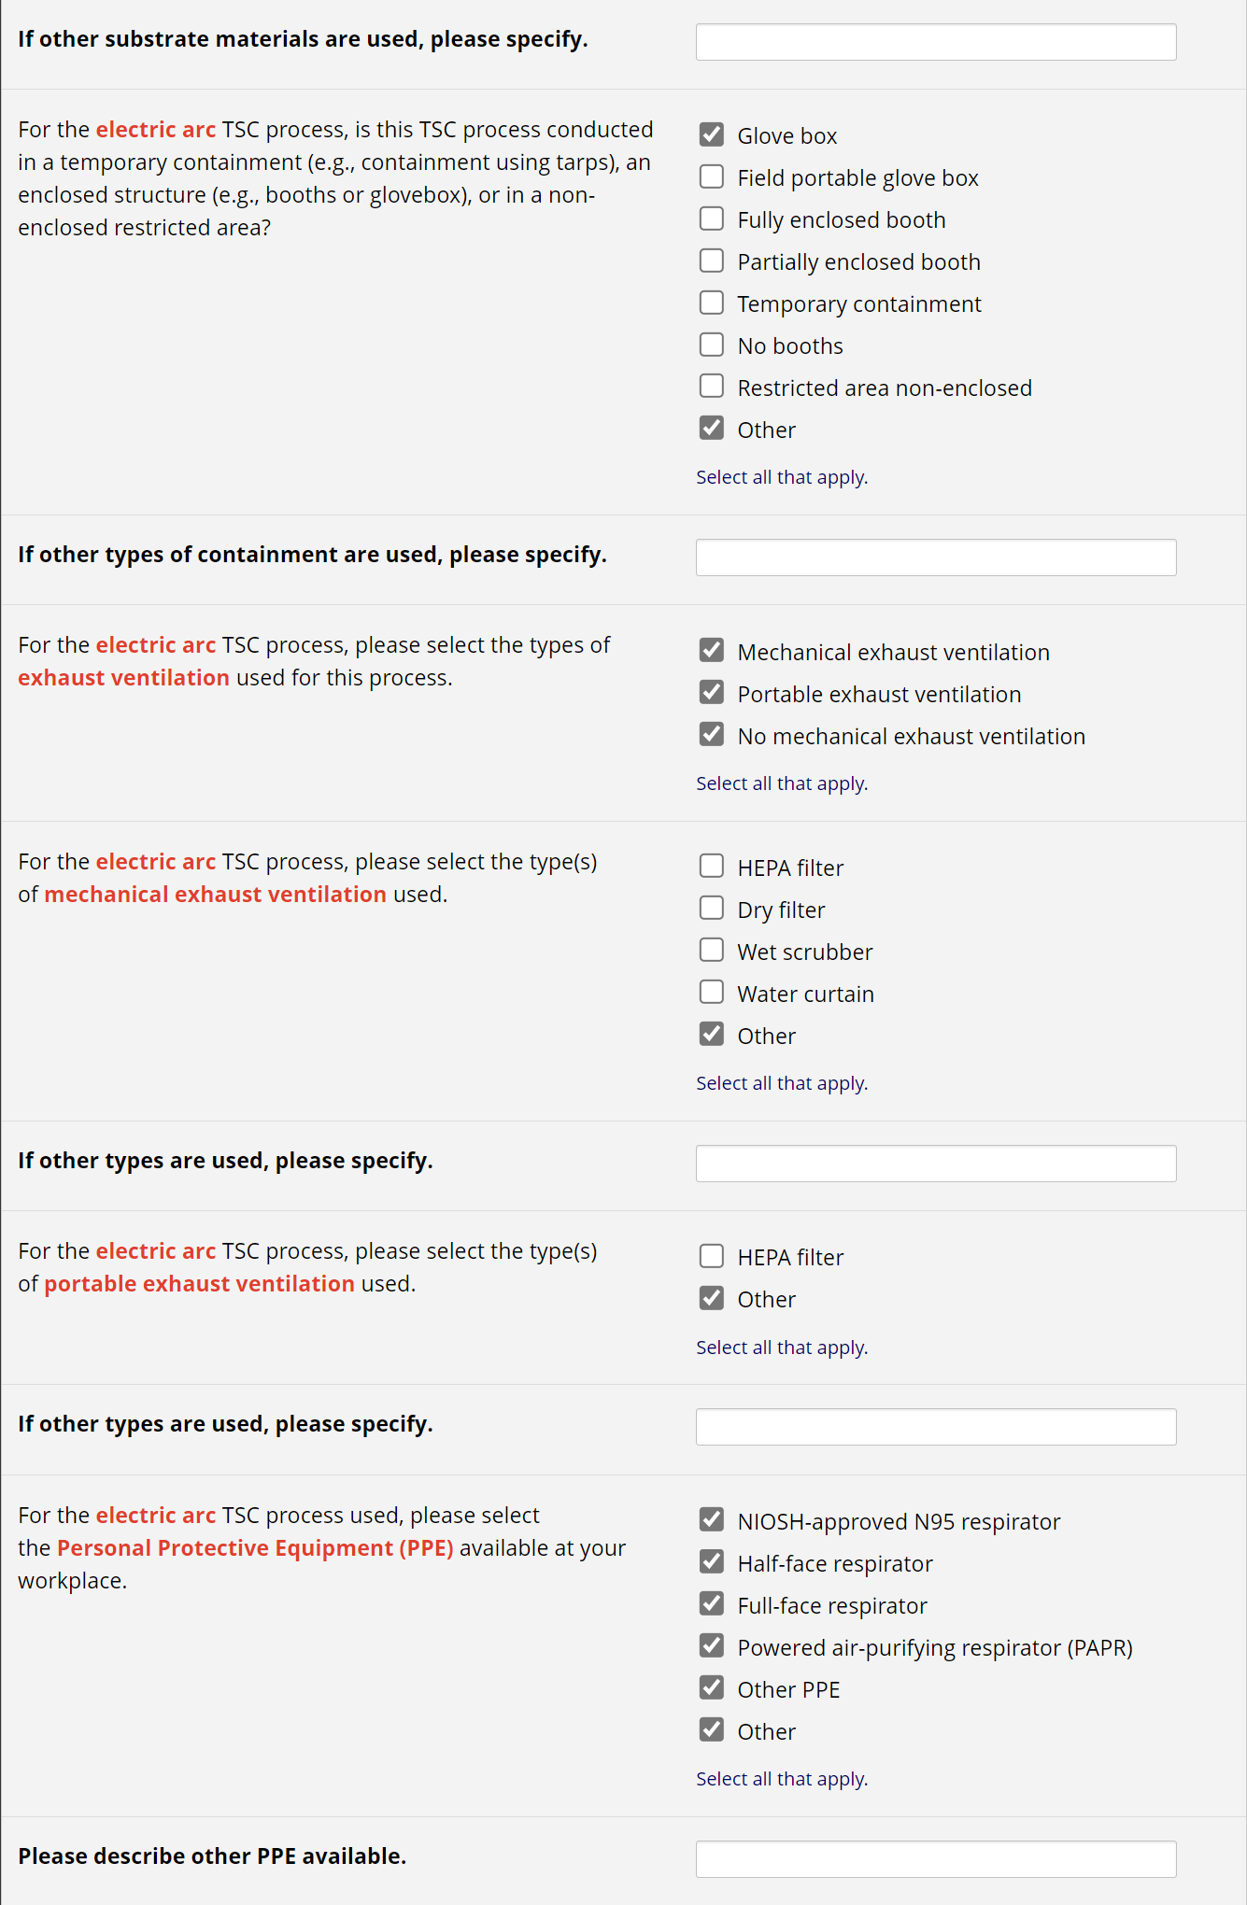

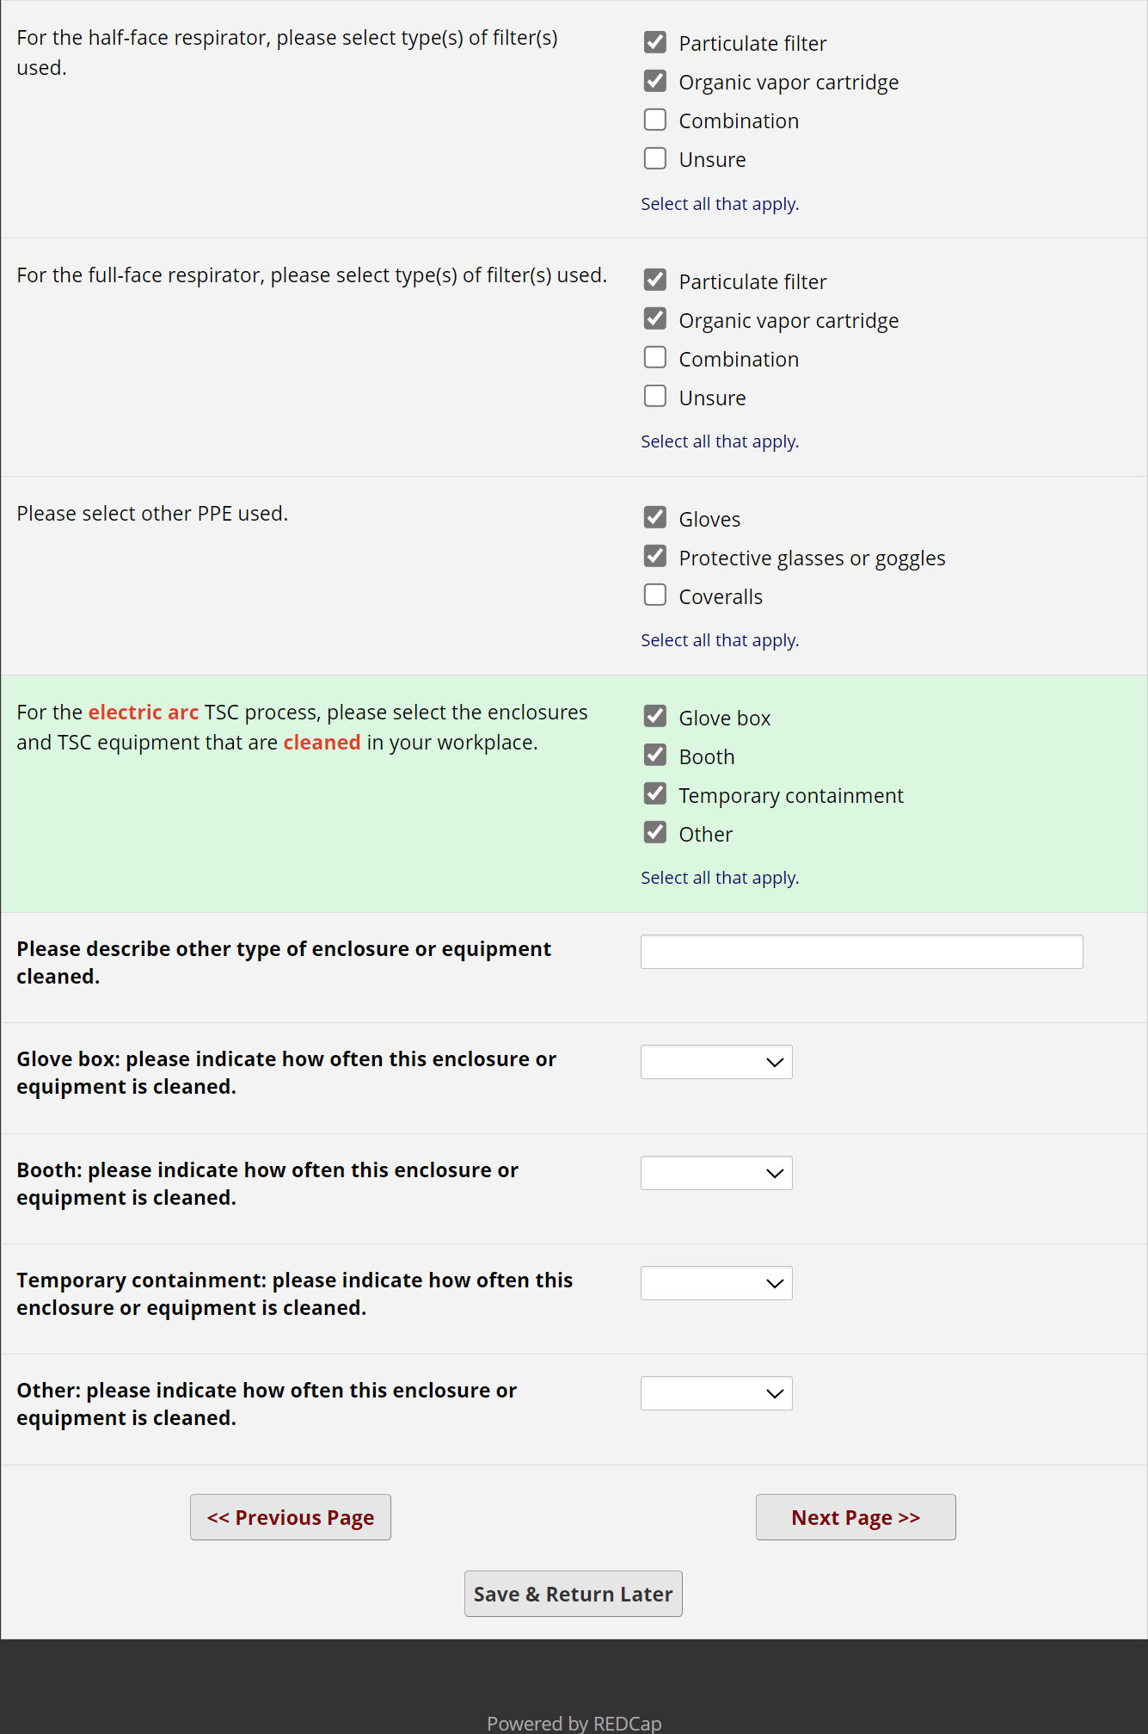

[After completing the group of questions above related to the electric arc TSC process, REDCap will move to the next question, asking if respondents use different type(s) of TSC processes]
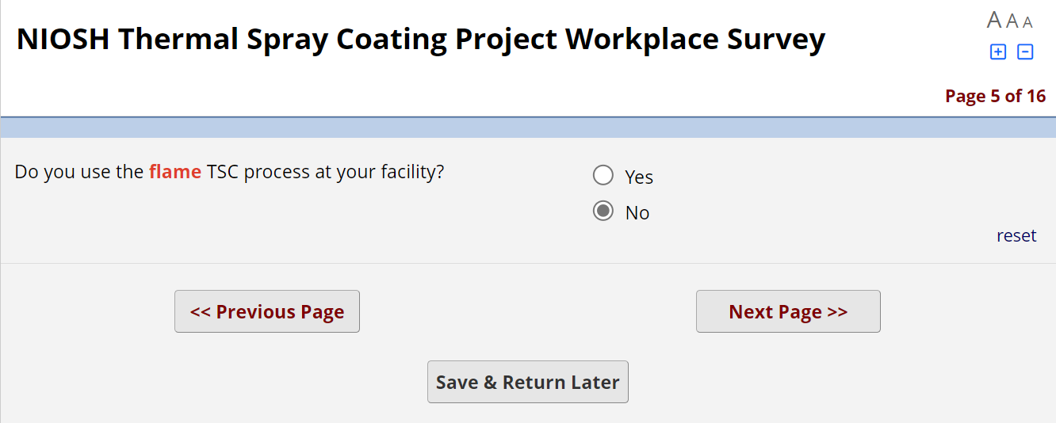
[If the answer is Yes, REDCap will trigger questions 13b – 13w above. If the answer is No, REDCap will move to the next question as follows]
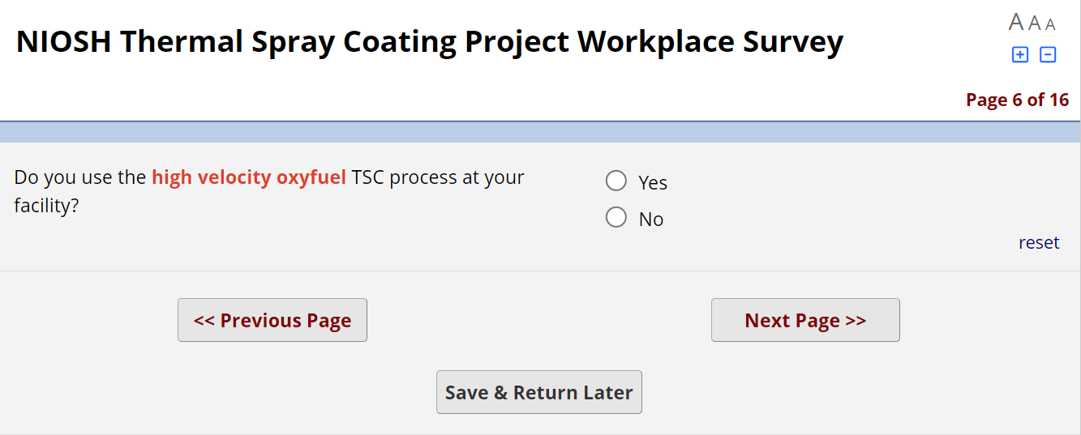
[If the answer is Yes, REDCap will trigger questions 13b – 13w above. If the answer is No, REDCap will move to the next question as follows]
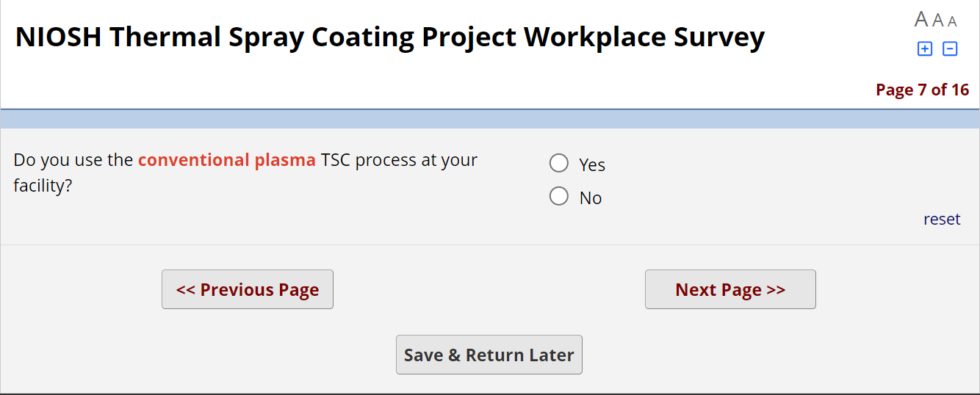
[If the answer is Yes, REDCap will trigger questions 13b – 13w above. If the answer is No, REDCap will move to the next question as follows]
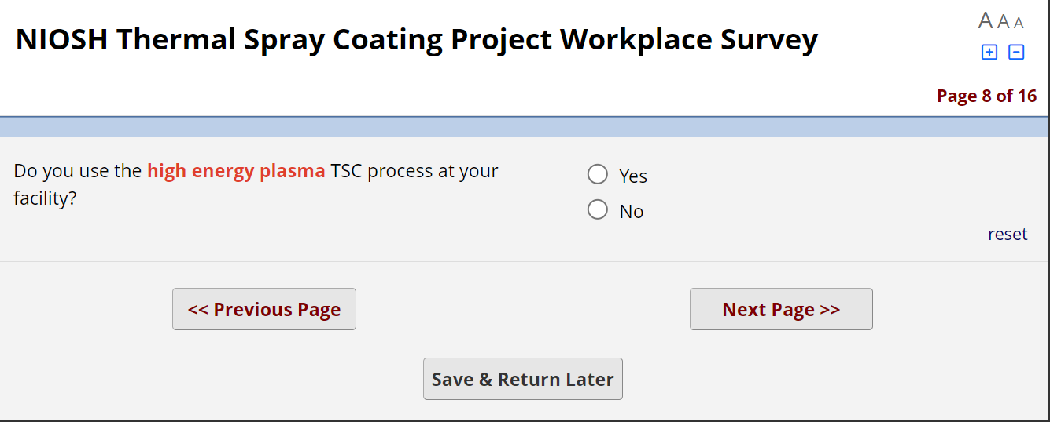
[If the answer is Yes, REDCap will trigger questions 13b – 13w above. If the answer is No, REDCap will move to the next question as follows]

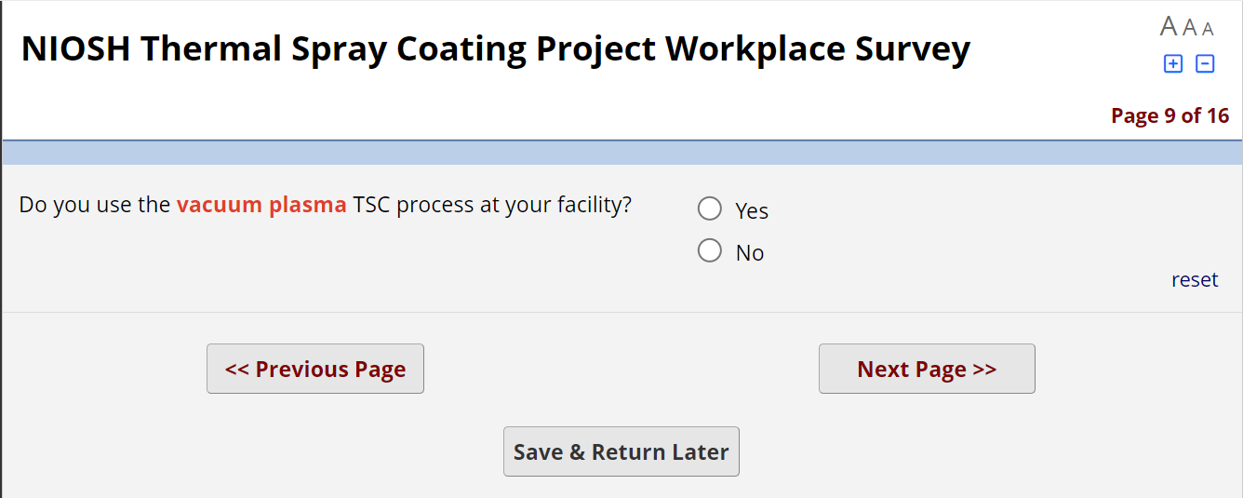
[If the answer is Yes, REDCap will trigger questions 13b – 13w above. If the answer is No, REDCap will move to the next question as follows]
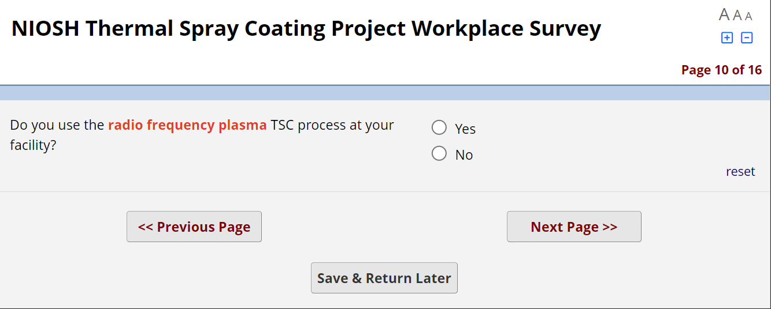
[If the answer is Yes, REDCap will trigger questions 13b – 13w above. If the answer is No, REDCap will move to the next question as follows]

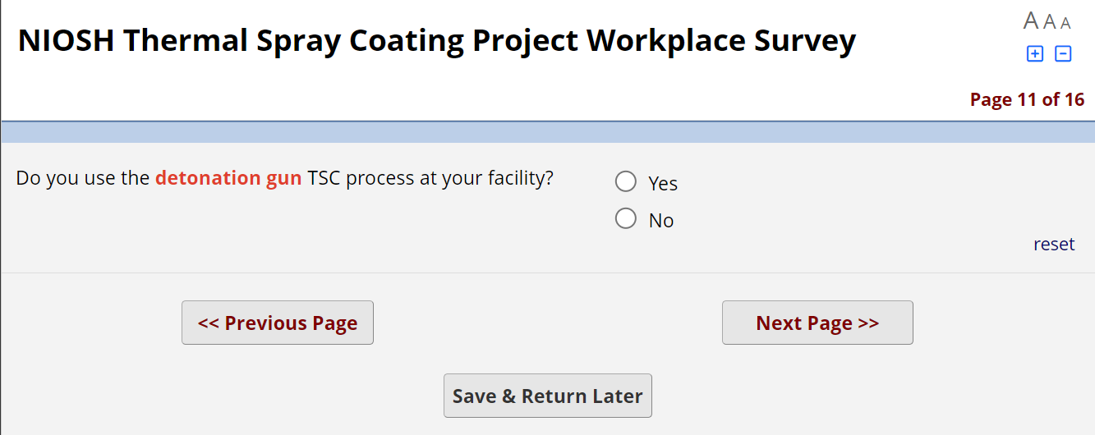
[If the answer is Yes, REDCap will trigger questions 13b – 13w above. If the answer is No, REDCap will move to the next question as follows]
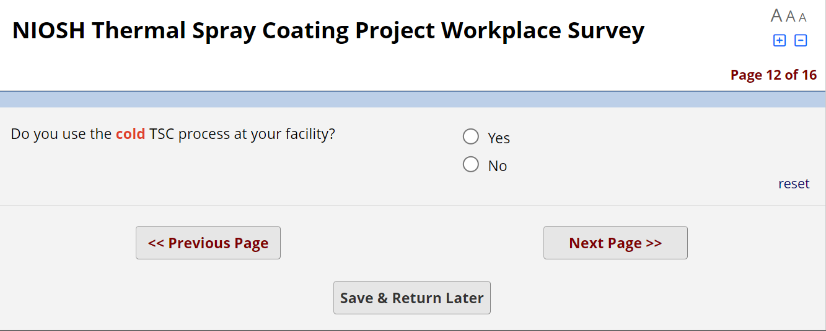
[If the answer is Yes, REDCap will trigger questions 13b – 13w above. If the answer is No, REDCap will move to the next question as follows]

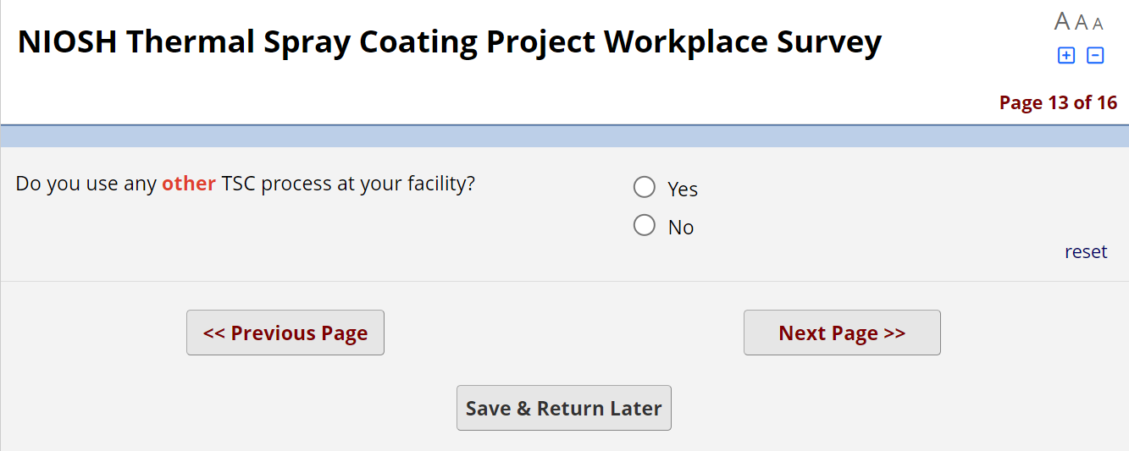
[If the answer is Yes, REDCap will trigger questions 13b – 13w above. If the answer is No, REDCap will move to the next question]

