Lock Performance Monitoring System (LPMS) Database to ENG forms 3102B, C and D
Arrival Screen (3102C or 3102D):
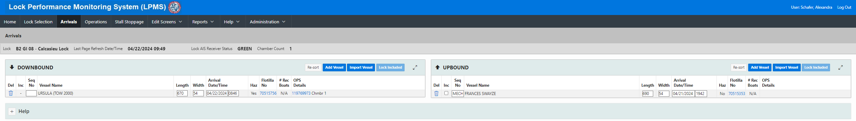
Flotilla and Commodity Information (3102C or 3102D):
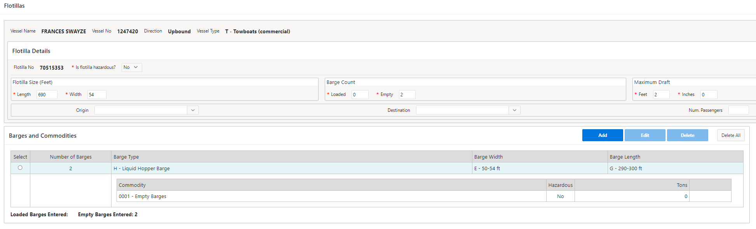
Lockage Times (3102B, internal USACE completed section):
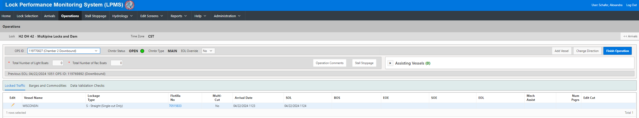
Stall Stoppage (3102 B):
