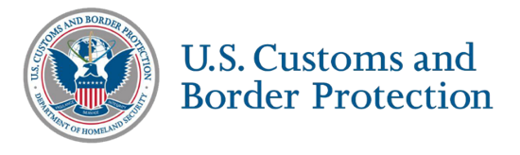

Foreign Mobile Enrollment Event Survey

Post-event survey
Thank you for participating in one of the Global Entry mobile enrollment events at the US Embassy and Consulate in either Italy or Switzerland with U.S. Customs and Border Protection (CBP). Please fill out this short survey about your experience at the event to inform future mobile enrollment events.

OMB control number 1651-0136
Expiration date 10/31/2027

*Required
Please do not add any personal information into the free text fields
- *How valuable was it to have a foreign mobile enrollment event? (scale 1-5, 1 being Not Valuable to Very Valuable)
  - Free response: Why did you answer this way?
- *Please rate your satisfaction with the following factors of this event (1-5, 1 being Not Satisfied to Very Satisfied)
  - Location
  - Staff friendliness
  - Efficiency
- *How likely are you to recommend the Global Entry program to your friends/family based on this event?? (scale 1-5, 1 being Very Unlikely to Very Likely)
- *Based on your foreign mobile enrollment event experience, you trust CBP is working in the best interest of Global Entry members. (scale 1-5, Strongly Disagree to Strongly Agree)
- *Has this event positively affected your perception of CBP?
- *How likely are you to travel to the US after this event? (scale 1-5, 1 being Very Unlikely to Very Likely)
- *Country (Italy or Switzerland)
  - *If neither, which country did you travel from for this event? (free response)
- *How did you hear about this event?
  - CBP communications
  - At the airport
  - Work
  - Friend/family
  - Other
- Please add any other information about your personal experience at the event. (free response)

Thank you for your feedback!

PRA Statement
An agency may not conduct or sponsor an information collection and a person is not required to respond to this information unless it displays a current valid OMB control number and an expiration date. The control number for this collection is 1651-0136. The estimated average time to complete this survey is 5 minutes. If you have any comments regarding the burden estimate you can write to U.S. Customs and Border Protection, Global Entry, Ronald Reagan Building, 1300 Pennsylvania Avenue, NW Washington, DC 20004. Expiration Date: 10/31/2027

