EDCS SSA-3369 Form updates to EDCS screens
  - SSA-3369 form
  - R56.0

Contents
Background 3
SSA-3369 Layout and Navigation 3
3369 Left Navigation- used for all EDCS 3369 pages 3
EDCS Frame 3
This screenshot shows the layout of all EDCS pages. 3
SSA-3369 EDCS Screenshots 4
SSA-3369 Section 1/2 – ID/Work History 4
SSA-3369 Section 2 – Work History 5
SSA-3369 Section 3 – Remarks 7
SSA-3369 Section 4 – Who Is Completing this Report 7

Background
The Electronic Disability Case Processing System (EDCS) is a mature software application that has been in production for over 20 years. Due to the age of the application, any updates triggered by the SSA-3369 form will follow the existing design approach in EDCS. This will help ensure easy adoption of new or updated content while limiting the need for separate training on the implemented features.

SSA-3369 Layout and Navigation

3369 Left Navigation- used for all EDCS 3369 pages

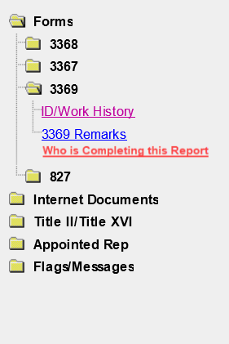

EDCS Frame

This screenshot shows the layout of all EDCS pages.
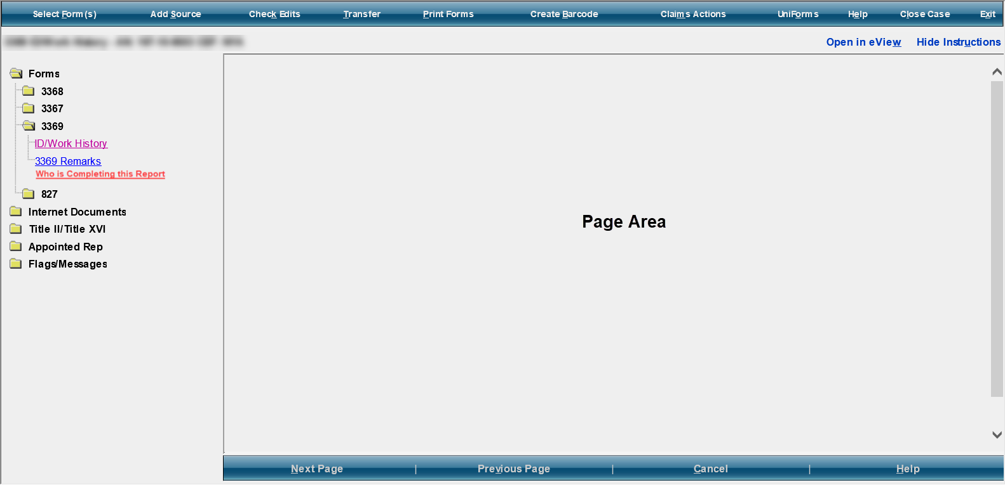

Things to note:

The left-hand navigation tree displays links to each of the SSA-3369 page screens.

Individual page screens display in the Page Area

Next/Previous buttons display at the bottom of the frame.

SSA-3369 EDCS Screenshots

SSA-3369 Section 1/2 – ID/Work History
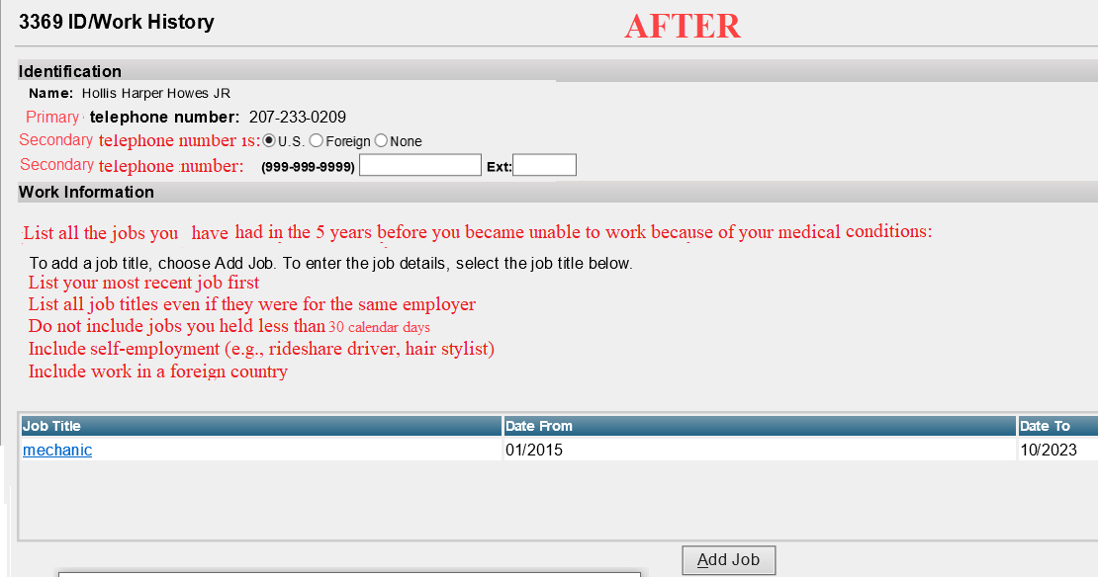

SSA-3369 Section 2 – Work History

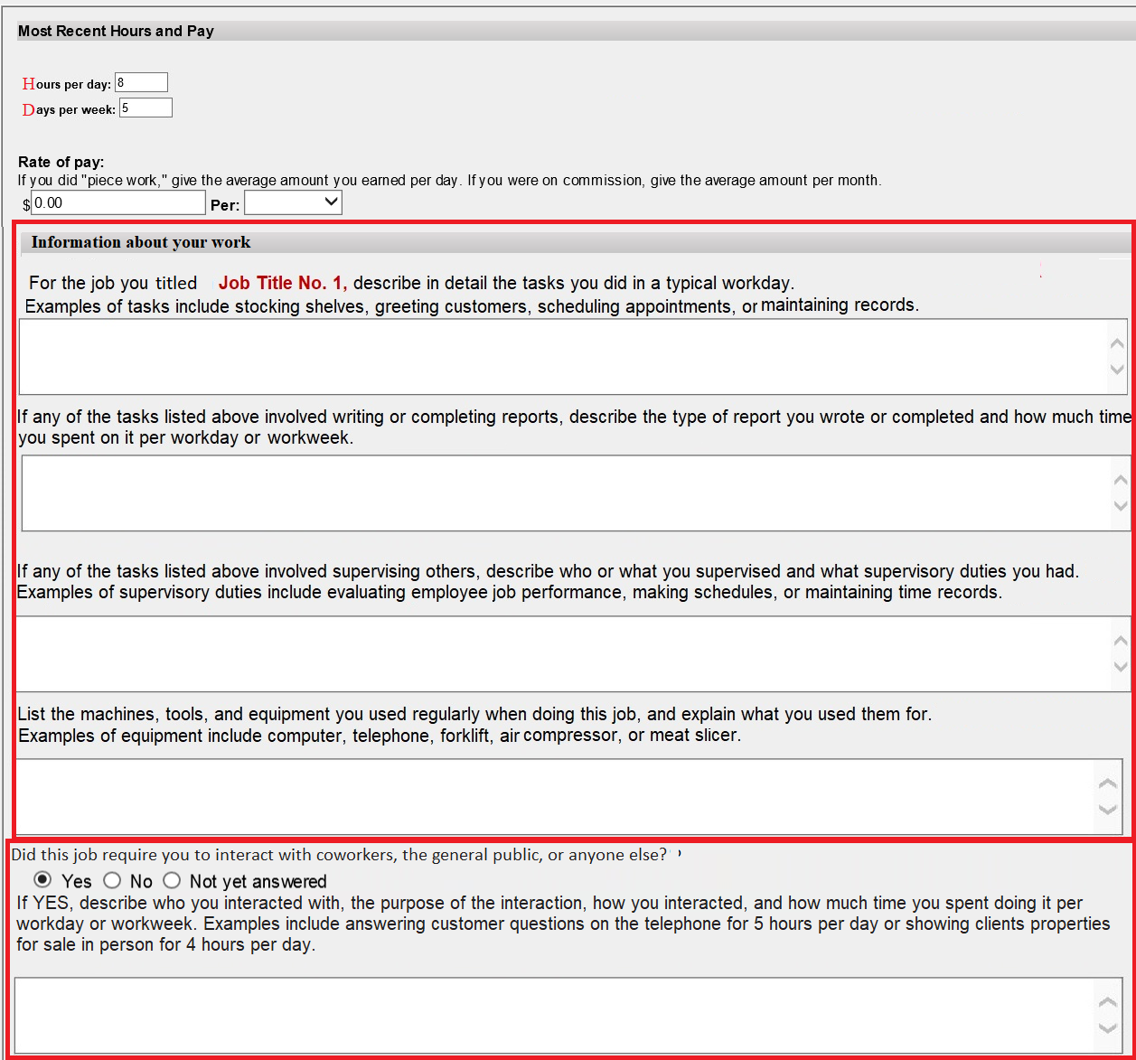
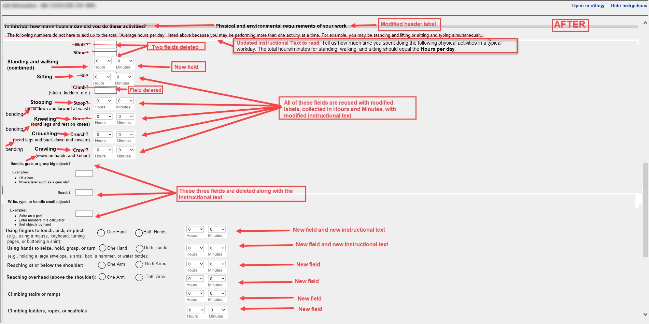
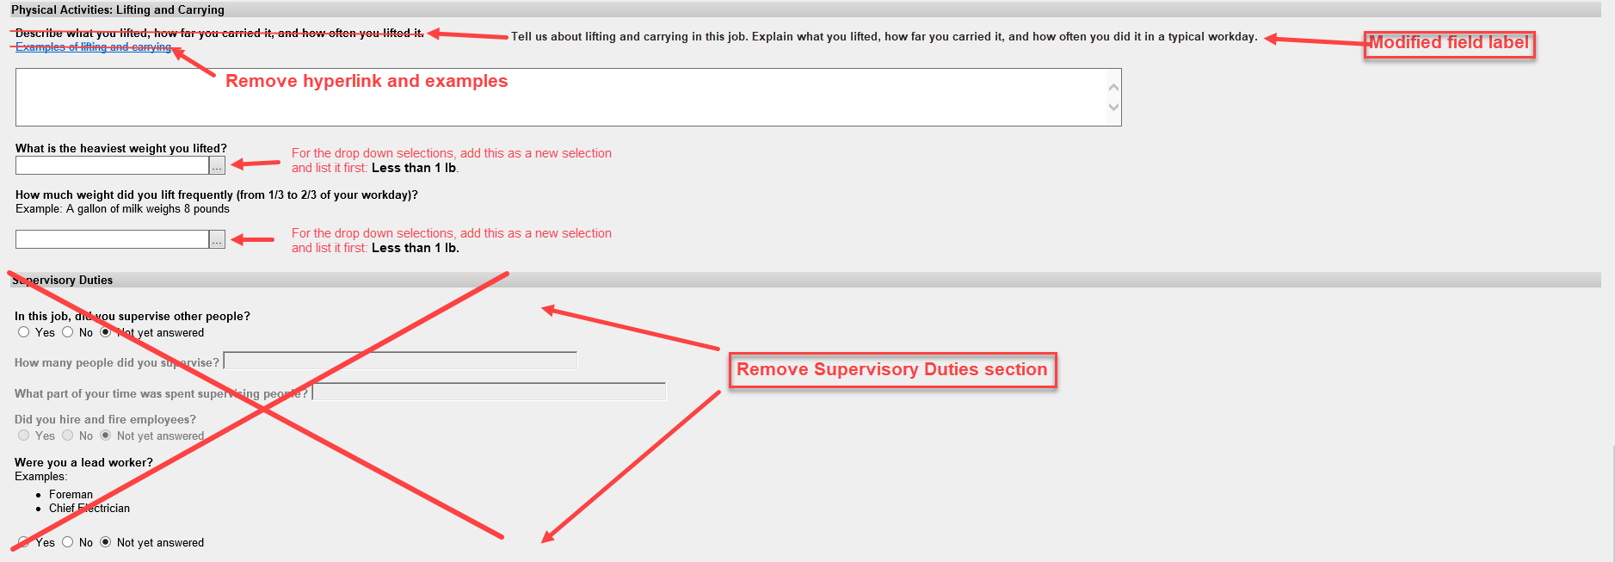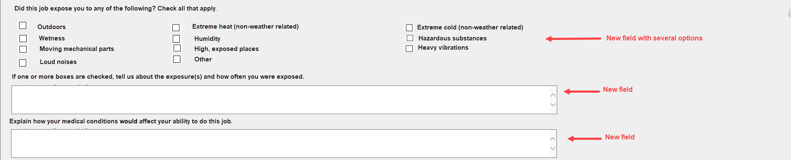

SSA-3369 Section 3 – Remarks
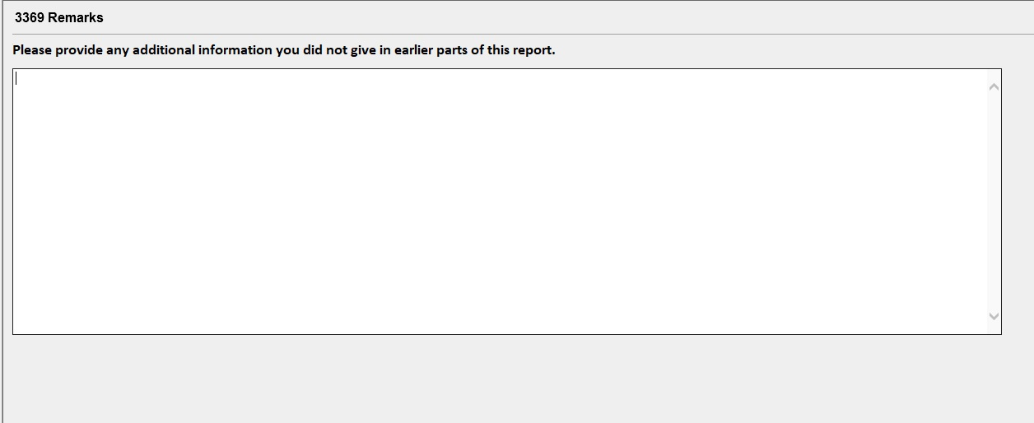

SSA-3369 Section 4 – Who Is Completing this Report
