Figure 1 – Current Screen

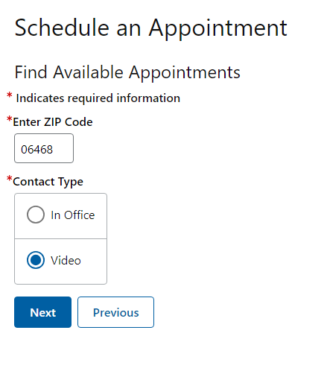

Figure 2 – Current Screen

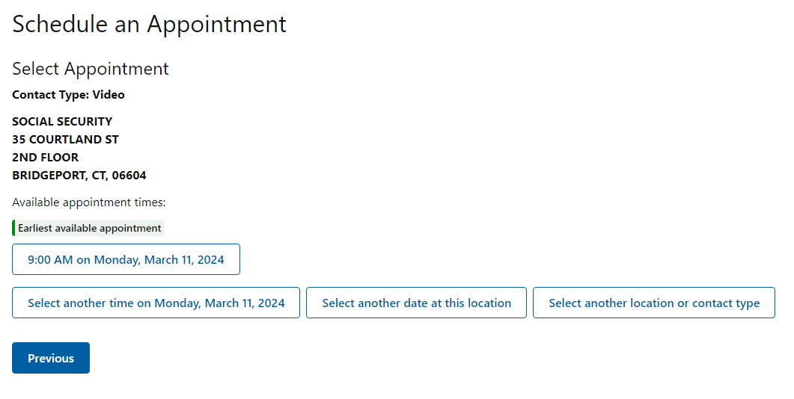

Figure 3 – Current Screen

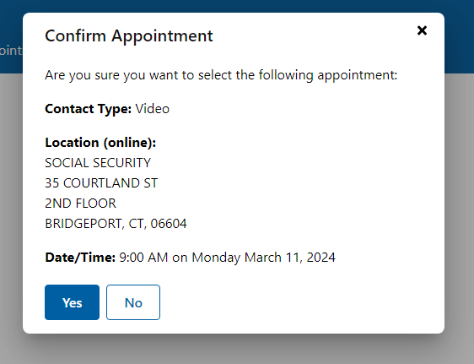

Figure 4 – Current Screen

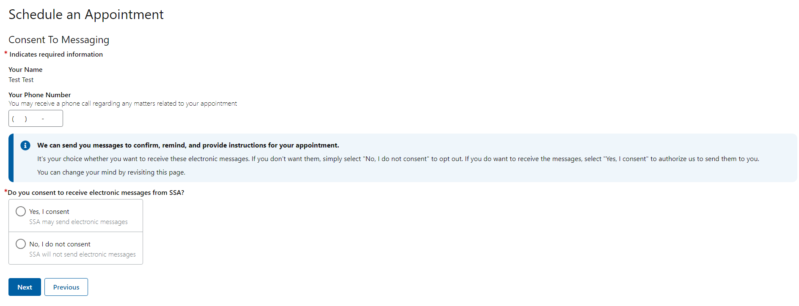

Figure 5 – Current Screen



