DATE: March 26, 2024

TO: Dan Cline, OMB Desk Officer

FROM: Joella Roland, HRSA Information Collection Clearance Officer

Request: The Health Resources and Services Administration (HRSA requests approval for non-substantive changes to the Uniform Data System (UDS) collection (OMB 0915-0193 expiration date 04/30/2026).
Purpose: The purpose of this request is to make a change to the Appendix E: Other Data Elements Form to capture data on health center patients’ family planning needs. Collection of this information will help HRSA better understand the health needs of patients served by health centers. Additionally, data on patients screened for family planning needs, including contraceptive methods, will enhance UDS’ programmatic and analytical value. This memo will further explain the specific change and rationale.
Appendix E: Other Data Elements (ODE) Form requires modification to allow for the addition of a new data element. The new question on the ODE form collects information on the evolving landscape of health centers’ services and delivery systems and aligns with the way the UDS currently collects similar screening assessment measures.
Change: HRSA is proposing to update the UDS’ Appendix E to include a fourth question to capture the total number of patients screened for family planning needs. HRSA would like to ask health centers: How many health center patients were screened for family planning needs, including contraceptive methods, using a standardized screener during the calendar year?

What does this question provide that isn't already captured?
Currently, the UDS does not include a question around family planning needs screening. The UDS presently includes a metric to report patients and their visits specific to contraceptive management (ICD code Z30-) covering a range of services, including counseling, surveillance, instruction, and initial contraceptive method. This new indicator, potentially, when paired with the current contraceptive management indicator, will help BPHC understand how often health centers are providing voluntary family planning services to patients who are interested in talking about contraception at their visits.
Why is this question needed now rather than in the next revision of the package?
The timely addition of this data collection activity supports President Biden’s recent Executive Order on Accessing Affordable, High-Quality Contraception and Family Planning Services, issued on June 23, 2023. The Executive Order is a call to action for the United States Department of Health and Human Services to bolster contraceptive access, promote research for data analysis, and ensure access to family planning services at HRSA-funded Health Centers. Additionally, by incorporating this new question into the instrument now, HRSA will be able to ascertain preliminary health center feedback on implementation while an electronic-clinical quality measure related to contraceptive access is undergoing testing and validation before its proposed 2025 use in clinical settings across the country.
Time Sensitivity: The data collection updates to the UDS instrument must be completed in a timely manner for health centers to fulfill Health Center Program requirements. Approval of these changes is needed by April 30, 2024, in order to implement the changes in HRSA’s data collection system and to provide adequate information on UDS reporting guidance to health centers, partners, and key stakeholders to submit their performance year 2024 data.

Burden: This non-substantive change is expected to minimally impact burden for those health centers who respond to the new question. Stakeholders have also shared that systems are in place to report this information, which will improve data quality, improve transparency, and better measure program services and outcomes, as well as support broad reaching, integrated primary health care priorities. The overall scope of change in data collected for the 2024 UDS is minimal. Stakeholders have also shared that there are systems in place to report this information. Health Center Program awardees that receive grants under multiple program funding authorities will not be required to complete the Other Data Elements Form as part of their separate grant reports.
PROPOSED CLARIFICATIONS AND NON-SUBSTANTIVE CHANGES FOR UNIFORM DATA SYSTEM FORMS:
Appendix E: Other Data Elements (ODE) Form
- Additional Question Added
One new question is being added to Appendix E: Other Data Elements Form, to capture the total number of health center patients screened for family planning needs using a standardized screener.

Rationale: This question will enhance the delivery of women’s health services and voluntary family planning and related services, which is a required primary health service under section 330(b)(1)(A) of the Public Health Service Act.

Attachments:

- Excerpt of Appendix E:
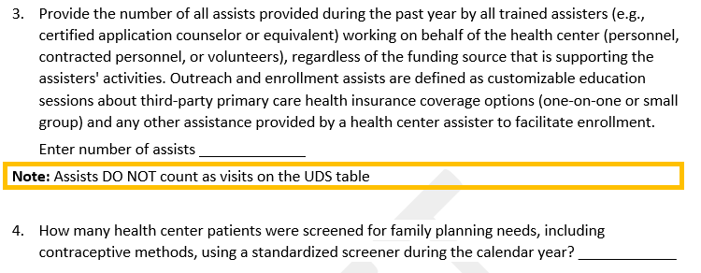
- Track Changes Version of Appendix E:
- Copy of the Current UDS Instrument (2023 UDS Manual):

