DAMAGE INFORMATION
Paperwork Burden Disclosure Notice
Public reporting burden for this data collection is estimated to average 75 minutes per response. The burden estimate includes the time for reviewing instructions, searching existing data sources, gathering and maintaining the data needed, and completing and submitting this form. This collection of information is required to obtain or retain benefits. You are not required to respond to this collection of information unless a valid OMB control number is displayed in the upper right corner of this form. Send comments regarding the accuracy of the burden estimate and any suggestions for reducing the burden to: Information Collections Management, Department of Homeland Security, Federal Emergency Management Agency, 500 C Street, SW., Washington, DC 20472, Paperwork Reduction Project (1660-0017) NOTE: Do not send your completed form to this address.
Privacy Act Statement
The collection of this information is authorized by the Robert T. Stafford Disaster Relief and Emergency Assistance Act, §§ 402-403, 406-407, 417, 423, 427, 428, 502, and 705; 42 U.S.C. 5170a-b, 5172-73, 5184, 5189a, 5189e, 5189f, 5192, 5205; 44 C.F.R. § 206 Subpart G; and 2 C.F.R. § 200. This information is being collected to provide assistance to eligible jurisdictions and organizations to facilitate the response to and recovery from a Presidentially declared disaster or emergency, or to provide assistance for hazard mitigation measures during the recovery process. The disclosure of information on this form is voluntary; however, failure to provide the requested information may delay or prevent the agency from receiving funds from FEMA’s Public Assistance Program.
Purpose and Applicability
FEMA, Recipients, or Applicants complete this form during a site inspection to record detailed incident-related damage descriptions with dimensions. FEMA and the Recipient use this form to validate damage, scopes of work, and estimates. For more information, please see Chapter 5 Damage and Impact Information in the Public Assistance Program and Policy Guide or contact the State, local, Tribal, or Territorial emergency management office for additional information.
Recipients and Applicants should use PA Grants Portal to submit all documentation and information to FEMA. Questions are displayed in an intuitive manner to show the information and documentation needed based on answers provided. All signatures are official and legally binding.
The following information is needed to complete this form:
- Damaged components
- Description and dimensions of the damage
- Cause of damage
Section I – Declaration and Applicant Information
Declaration #  [system generated] |  |  | Legal Name of Applicant: [system generated] |  |  |  |  |  |  | FEMA PA ID: [system generated]
Section II – Site Information
Facility Type(s)  [system generated] | Facility Name(s)  [system generated] |  |  |  |  | Site/Campus Name(s) [system generated] |  |  |  |  | Location(s)  [system generated]
Is the facility currently inundated with flood waters or are other factors preventing inspection to determine visible damage?
☐ No
☐ Yes. Please describe why it is inaccessible:

Who will provide the damage inspection for this location?
☐ Applicant. Please provide estimated date of submittal to FEMA: (MM/DD/YYYY)
☐ Recipient. Please provide estimated date of submittal to FEMA: (MM/DD/YYYY)
☐ FEMA providing virtual assistance via phone or video conference with Applicant on-site. What date(s) and time(s) are preferable to conduct the site inspection?
☐ FEMA on-site with Applicant. What date(s) and time(s) are preferable to conduct the site inspection? Please provide point-of-contact and any additional information for the day of the inspection:
Section III – Facility Damage
Please select the peril(s) which caused the damage. Please select all that apply.
☐ Earthquake  ☐ In-plane damage  ☐ Reinforcement failure  ☐ Short-column damage  ☐ Soft-story damage  ☐ Surface rupture  ☐ Explosion  ☐ Fire  ☐ Flame damage or combustion  ☐ Smoke and particulate matter  ☐ Soil hardening  ☐ Thermal exposure  ☐ Flooding |  |  |  |  |  | ☐ Landslide  ☐ Mudslide  ☐ Severe storm  ☐ Lightning  ☐ Hail  ☐ High winds  ☐ Wind-blown debris  ☐ Wind-driven rain  ☐ Sewer backup  ☐ Snow or ice  ☐ Tsunami or tidal wave  ☐ Volcanic eruption  ☐ Wind  ☐ Other. Please describe:
Parks or Recreational Facilities
Please describe the facility and how it was damaged:
Damaged Components (with common material types). Please select all that apply.
☐ Athletic court  ☐ Asphalt  ☐ Concrete  ☐ Composite  ☐ Other. Please describe:  ☐ Athletic field surface  ☐ Artificial  ☐ Grass  ☐ Other. Please describe:  ☐ Bleacher  ☐ Fence |  |  |  |  |  | ☐ Lighting  ☐ Loss of fill  ☐ Dirt  ☐ Gravel  ☐ Rock  ☐ Sand  ☐ Other. Please describe:  ☐ Playground surface  ☐ Power source and its electrical distribution and control system.  ☐ Running track  ☐ Other. Please describe:
Detention basin, Sediment or debris basin, and Stormwater retention
Please describe the facility and how it was damaged:
What is the quantity of material deposited by the incident? Please include quantity: and metric:
☐ Actual ☐ Estimate
Damaged Components (with common material types). Please select all that apply.
☐ Armor  ☐ Rip-rap  ☐ Rock armor  ☐ Shot rock  ☐ Other. Please describe:  ☐ Control gate  ☐ Embankment  ☐ Dirt  ☐ Gravel  ☐ Sand  ☐ Rock  ☐ Other. Please describe: |  |  |  |  |  | ☐ Grate  ☐ Lining  ☐ Pipe  ☐ Storm drain  ☐ Weir  ☐ Other. Please describe:
Beaches, Dune
Please describe the facility and how it was damaged:
☐erm, Levee, Sand Revetment, Seawall
Please describe the facility and how it was damaged:
Damaged Components (with common material types). Please select all that apply.
☐ Armor  ☐ Rip-rap  ☐ Rock armor  ☐ Shot rock  ☐ Other. Please describe:  ☐ Control gate  ☐ Core  ☐ Concrete  ☐ Earth  ☐ Metal  ☐ Plastic  ☐ Other. Please describe:  ☐ Embankment  ☐ Dirt  ☐ Gravel  ☐ Sand  ☐ Rock  ☐ Other. Please describe: |  |  |  |  |  | ☐ Foundation  ☐ Rock  ☐ Soil  ☐ Other. Please describe:  ☐ Lining  ☐ Loss of fill  ☐ Dirt  ☐ Gravel  ☐ Rock  ☐ Sand  ☐ Other. Please describe:  ☐ Pile  ☐ Rebar  ☐ Vegetative cover  ☐ Weir  ☐ Other. Please describe:
Bridge
Please describe the facility and how it was damaged:
Number of lanes:
Damaged Components (with common material types). Please select all that apply.
☐ Abutment  ☐ Approaches  ☐ Armor  ☐ Rip-rap  ☐ Rock armor  ☐ Shot rock  ☐ Other. Please describe:  ☐ Cross frame  ☐ Loss of fill  ☐ Dirt  ☐ Gravel  ☐ Rock  ☐ Sand  ☐ Other. Please describe:  ☐ Barrier  ☐ Deck  ☐ Foundation  ☐ Guardrail  ☐ Girder |  |  |  |  |  | ☐ Lighting  ☐ Substructure  ☐ Abutment  ☐ Foundation  ☐ Pier  ☐ Surface  ☐ Asphalt  ☐ Concrete  ☐ Composite  ☐ Chip & seal  ☐ Dirt  ☐ Gravel  ☐ Other. Please describe:  ☐ Traffic signal  ☐ Wingwall  ☐ Concrete  ☐ Rock  ☐ Other. Please describe:  ☐ Other. Please describe:
Building
Please describe the facility and how it was damaged:
Please provide the estimated damaged square footage: sq. ft. Please describe area:
Where is the damage to the building?  ☐ Exterior  ☐ Interior |  |  |  |  | ☐ Basement  ☐ Other. Please describe:
Damaged Components (with common material types). Please select all that apply.
☐ Bathroom components, please list and describe damage:  ☐ Ceiling  ☐ Acoustical drop ceiling  ☐ Blanket ceiling  ☐ Ceiling tiles  ☐ Drywall/sheet rock  ☐ Insulation  ☐ Plaster and lathe ceiling  ☐ Unfinished ceiling  ☐ Other. Please describe:  ☐ Electrical components, please list and describe damage:  ☐ Elevator. Please describe:  ☐ Fire Protection, please list and describe damage:  ☐ Doors  ☐ Hollow core  ☐ Metal  ☐ Flat panel  ☐ Raised panel  ☐ Overhead  ☐ Painted  ☐ Pre-finished  ☐ Solid core  ☐ Steel  ☐ Stained  ☐ Wood  ☐ Flat panel  ☐ Raised panel  ☐ Flooring  ☐ Carpet  ☐ Ceramic  ☐ Composition type (VCT)  ☐ Painted Concrete  ☐ Vinyl  ☐ Wood  ☐ Other. Please describe:  ☐ Foundation (spread footing, piles, etc.)  ☐ HVAC  ☐ Air conditioning unit  ☐ Air handler  ☐ Condenser  ☐ Diffuser  ☐ Duct work insulation  ☐ Duct work rigid  ☐ Fan coil unit  ☐ Furnace  ☐ Gas  ☐ Electric  ☐ Heat Pump  ☐ Other. Please describe: |  |  |  |  |  | ☐ Kitchen components, please list and describe damage:  ☐ Lighting  ☐ Emergency Lighting  ☐ Ceiling  ☐ Recessed  ☐ Other. Please describe:  ☐ Roofing  ☐ Roof accessories  ☐ Ridge  ☐ Continuous shingled ridge vent  ☐ Metal  ☐ Shingled  ☐ Weather barrier type  ☐ Asphalt felt 15#  ☐ Asphalt felt 30#  ☐ Other. Please describe:  ☐ Roof covering type.  ☐ Asphalt  ☐ 3-Tab  ☐ Multilayer  ☐ Built-up (multi-ply)  ☐ EPDM (ethylene propylene deine terpolymer) single ply  ☐ Fluid applied roofing  ☐ Metal  ☐ Corrugated  ☐ Ribbed  ☐ Standing seam  ☐ Other. Please describe:  ☐ PVC (polyvinyl chloride) single ply  ☐ SBS modified (multi-ply)  ☐ TPO (thermoplastic polyolefin) single ply  ☐ Other. Please describe:  ☐ Roof type  ☐ Gable  ☐ Number of Gable:  ☐ Hip  ☐ Number of Hip:  ☐ Other. Please describe:  ☐ Skylights  ☐ Fiberglass panels  ☐ Fixed dome type  ☐ Operable type  ☐ Septic components, please list and describe damage:  ☐ Structural element (column, beam, etc.)  ☐ Walls  ☐ Blanket wall insulation  ☐ Concrete masonry unit (CMU)  ☐ Drywall  ☐ External siding  ☐ Painted drywall  ☐ Paneling  ☐ Plaster  ☐ Plaster and lathe wall  ☐ Vinyl wall cover  ☐ Wainscoting  ☐ Other. Please describe:  ☐ Windows  ☐ Awning  ☐ Casement  ☐ Double hung  ☐ Fixed  ☐ Louver  ☐ Single hung  ☐ Sliding  ☐ Storm shutters  ☐ Other. Please describe:  ☐ Other. Please describe:
Cemetery
Please describe the facility and how it was damaged:
Damaged Components (with common material types). Please select all that apply.
☐ Casket  ☐ Grave marker  ☐ Loss of fill  ☐ Dirt  ☐ Gravel  ☐ Rock  ☐ Sand  ☐ Other. Please describe: |  |  |  |  |  | ☐ Other. Please describe:
Communications System
Please describe the facility and how it was damaged:
Damaged Components (with common material types). Please select all that apply.
☐ Antenna  ☐ Cable  ☐ Conduit  ☐ Electrical panel  ☐ Electrical wire  ☐ Guy wire  ☐ Insulator  ☐ Lines  ☐ Mast |  |  |  |  |  | ☐ Network tower  ☐ Pole  ☐ Sensor  ☐ Software/processor  ☐ Supervisory control and data acquisition (SCADA)  ☐ Terminal  ☐ Transformer  ☐ Vault/handhole  ☐ Other. Please describe:
Contents
Please upload a list of damaged contents and describe how the contents were damaged:
Culvert, Ditch
Please describe the facility and how it was damaged:
Culvert type:  ☐ Arch  ☐ Box/Rectangle (single or multiple)  ☐ Bridge culvert  ☐ Circular  ☐ Flat  ☐ Horizontal ellipse |  |  |  |  |  |  | ☐ Metal box  ☐ Pipe (single or multiple)  ☐ Pipe arch (single or multiple)  ☐ Vertical ellipse  ☐ Other. Please describe:
Damaged Components (with common material types). Please select all that apply.
☐ Armor  ☐ Rip-rap  ☐ Rock armor  ☐ Shot rock  ☐ Other. Please describe:  ☐ Culvert pipe  ☐ Aluminum  ☐ Concrete  ☐ Corrugated metal  ☐ High-density polyethylene  ☐ Polyvinyl chloride  ☐ Steel  ☐ Other. Please describe:  ☐ Headwall  ☐ Concrete  ☐ Rock  ☐ Other. Please describe:  ☐ Inlet  ☐ Dirt  ☐ Gravel  ☐ Rock  ☐ Sand  ☐ Other. Please describe: |  |  |  |  |  | ☐ Loss of fill  ☐ Dirt  ☐ Gravel  ☐ Rock  ☐ Sand  ☐ Other. Please describe:  ☐ Retaining Wall  ☐ Concrete  ☐ Rock  ☐ Other. Please describe:  ☐ Wingwall  ☐ Concrete  ☐ Rock  ☐ Other. Please describe:  ☐ Other. Please describe:
Dam
Please describe the facility and how it was damaged:
What is the dam type?
☐ Arch  ☐ Buttress  ☐ Concrete  ☐ Earth/rock embankments  ☐ Gravity  ☐ Masonry |  |  |  |  |  |  | ☐ Multi-arch  ☐ Rockfill  ☐ Stone  ☐ Timber crib  ☐ Other. Please describe:
Does the facility have a spillway?  ☐ No  ☐ Yes. What is the spillway type?  ☐ Controlled  ☐ Chute  ☐ Ogee  ☐ Shaft  ☐ Side channel |  |  |  |  | ☐ Siphon  ☐ Uncontrolled  ☐ Other. Please describe:
Damaged Components (with common material types). Please select all that apply.
☐ Abutment  ☐ Armor  ☐ Rip-rap  ☐ Rock armor  ☐ Shot rock  ☐ Other. Please describe:  ☐ Control gate  ☐ Core  ☐ Concrete  ☐ Earth  ☐ Metal  ☐ Plastic  ☐ Other. Please describe:  ☐ Electrical panel  ☐ Electrical wire  ☐ Foundation  ☐ Rock  ☐ Soil  ☐ Other. Please describe: |  |  |  |  |  | ☐ Lining  ☐ Outlet gate  ☐ Bascule  ☐ Drum  ☐ Flag  ☐ Needle  ☐ Roller  ☐ Slide/sluice gate  ☐ Vertical lift  ☐ Other. Please describe:  ☐ Overflow structure (Spillway)  ☐ Sensor  ☐ Supervisory control and data acquisition (SCADA)  ☐ Weir  ☐ Other. Please describe:
Dock, Harbor, Pier, or Port
Please describe the facility and how it was damaged:
What was the type of inspection completed?
☐ Above water
☐ Under water
☐ Structural integrity of piles
☐ Structural integrity of abutments
☐ Structural integrity of revetments
☐ In-situ borings
Damaged Components (with common material types). Please select all that apply.
☐ Abutment  ☐ Anchor  ☐ Boat ramp  ☐ Dock  ☐ Electrical power source and its distribution and control system, including grounding  ☐ Fender system |  |  |  |  |  | ☐ Frame and deck  ☐ Gangway  ☐ Light poles and fixture  ☐ Mooring device  ☐ Platform  ☐ Revetment or other marine structure  ☐ Other. Please describe:
Drainage channel, Canal, Aqueduct
Please describe the facility and how it was damaged:
☐hat is the shape of the channel?  ☐ Rectangular  ☐ Trapezoidal  ☐ V-ditch  ☐ Other. Please describe: |  |  |  |  |  |  | What are the dimensions of the top of the channel or waterway?  Average Width: feet  Average Depth: feet  Length: feet
What is the quantity of material deposited by the incident? Please include units: and metric:
☐ Actual ☐ Estimate
Damaged Components (with common material types). Please select all that apply.
☐ Armor  ☐ Rip-rap  ☐ Rock armor  ☐ Shot rock  ☐ Other. Please describe:  ☐ Control gate  ☐ Embankment  ☐ Dirt  ☐ Gravel  ☐ Sand  ☐ Rock  ☐ Other. Please describe: |  |  |  |  |  |  | ☐ Hydraulic structure  ☐ Lining  ☐ Vegetative Cover  ☐ Weir  ☐ Other. Please describe:
Equipment, Supplies, or Vehicle
Please upload a list of damaged equipment, supplies, and vehicles and describe how they were damaged:
Lift station, Pumping station
Please describe the facility and how it was damaged:
What is the capacity of the pumping facility? |  | How many generators are associated with the facility? |  |  |  |  |  |  | How many pumps are associated with the facility?
Damaged Components (with common material types). Please select all that apply.
☐ Electrical panel  ☐ Electrical cables  ☐ Emergency motor/generator set  ☐ Holding tank  ☐ Pipe |  |  |  |  |  | ☐ Pump  ☐ Sensor  ☐ Supervisory control and data acquisition (SCADA)  ☐ Transfer switch  ☐ Other. Please describe:
Low-water Crossing
Please describe the facility and how it was damaged:
Number of lanes:
Damaged Components (with common material types). Please select all that apply.
☐ Armor  ☐ Rip-rap  ☐ Rock armor  ☐ Shot rock  ☐ Other. Please describe:  ☐ Base  ☐ Dirt  ☐ Gravel  ☐ Sand  ☐ Other. Please describe:  ☐ Embankment  ☐ Dirt  ☐ Gravel  ☐ Rock  ☐ Sand  ☐ Other. Please describe:  ☐ Guardrail  ☐ Headwall  ☐ Concrete  ☐ Rock  ☐ Other. Please describe:  ☐ Loss of fill  ☐ Dirt  ☐ Gravel  ☐ Rock  ☐ Sand  ☐ Other. Please describe: |  |  |  |  |  | ☐ Retaining Wall  ☐ Concrete  ☐ Rock  ☐ Other. Please describe:  ☐ Subbase  ☐ Asphalt  ☐ Concrete  ☐ Composite  ☐ Chip & seal  ☐ Dirt  ☐ Gravel  ☐ Other. Please describe:  ☒ Surface  ☐ Asphalt  ☐ Concrete  ☐ Composite  ☐ Chip & seal  ☐ Dirt  ☐ Gravel  ☐ Other. Please describe:  ☐ Wingwall  ☐ Concrete  ☐ Rock  ☐ Other. Please describe:  ☐ Other. Please describe:

Natural gas transmission and distribution

Please describe the facility and how it was damaged:

Damaged Components (with common material types). Please select all that apply.
☐ Compressor station  ☐ Electrical control panel  ☐ Electrical cables  ☐ Pipe |  |  |  |  |  | ☐ Sensor  ☐ Supervisory control and data acquisition (SCADA)  ☐ Tank  ☐ Other. Please describe:

Power plant, Power transmission and distribution system, Substation, Wind turbine

Please describe the facility and how it was damaged:

Damaged Components (with common material types). Please select all that apply.
☐ Cable  ☐ Conductor  ☐ Conduit  ☐ Cooling tower  ☐ Crossarm  ☐ Electrical panel  ☐ Electrical wire  ☐ Insulator  ☐ Line |  |  |  |  |  | ☐ Pole  ☐ Riser  ☐ Sensor  ☐ Supervisory control and data acquisition (SCADA)  ☐ Transformer  ☐ Tower  ☐ Turbine  ☐ Other. Please describe:

Railway, Subway

Please describe the facility and how it was damaged:

Damaged Components (with common material types)
☐ Electrical panel  ☐ Electrical wire  ☐ Elevator  ☐ Escalator  ☐ Insulator |  |  |  |  |  | ☐ Lighting  ☐ Signal  ☐ Switch  ☐ Train track  ☐ Other. Please describe:

Reservoir
Please describe the facility and how it was damaged:
What is the type of reservoir?
☐ Dry
☐ Off stream
☐ On stream
Does the facility have a spillway?
☐ No
☐ Yes. What is the spillway type?
☐ Controlled
☐ Chute
☐ Ogee
☐ Shaft
☐ Side channel
☐ Siphon
☐ Uncontrolled
☐ Other. Please describe:

Damaged Components (with common material types). Please select all that apply.
☐ Abutments  ☐ Armor  ☐ Rip-rap  ☐ Rock armor  ☐ Shot rock  ☐ Other. Please describe:  ☐ Control gate  ☐ Core  ☐ Concrete  ☐ Earth  ☐ Metal  ☐ Plastic  ☐ Other. Please describe:  ☐ Electrical panel |  |  |  |  |  | ☐ Electrical cables  ☐ Electrical distribution and control systems  ☐ Emergency motor/generator set and transfer switch  ☐ Foundation  ☐ Rock  ☐ Soil  ☐ Other. Please describe:  ☐ Lining  ☐ Outlet gate. Please describe:  ☐ Overflow structure (Spillway)  ☐ Sensor  ☐ Supervisory control and data acquisition (SCADA)  ☐ Vegetative cover  ☐ Weir  ☐ Other. Please describe:

Road, Airport Runway/Taxiway, Parking, Sidewalk
Please describe the facility and how it was damaged:
Number of lanes:
Damaged Components (with common mat☐rial types). Please select all that apply.  ☐ Surface  ☐ Asphalt  ☐ Concrete  ☐ Composite  ☐ Chip & seal  ☐ Dirt  ☐ Gravel  ☐ Other. Please describe:  ☐ Base  ☐ Dirt  ☐ Gravel  ☐ Sand  ☐ Other. Please describe:  ☐ Subbase  ☐ Asphalt  ☐ Concrete  ☐ Composite  ☐ Chip & seal  ☐ Dirt  ☐ Gravel  ☐ Other. Please describe:  ☐ Curb  ☐ Asphalt  ☐ Concrete  ☐ Other. Please describe:  ☐ Ditch  ☐ Dirt  ☐ Gravel  ☐ Other. Please describe: |  |  |  |  |  |  | ☐ Embankment  ☐ Dirt  ☐ Gravel  ☐ Sand  ☐ Rock  ☐ Other. Please describe:  ☐ Guardrail  ☐ Lighting  ☐ Median  ☐ Shoulder  ☐ Asphalt  ☐ Concrete  ☐ Composite  ☐ Chip & seal  ☐ Dirt  ☐ Gravel  ☐ Other. Please describe:  ☐ Sidewalk/Path  ☐ Asphalt  ☐ Concrete  ☐ Composite  ☐ Chip & seal  ☐ Dirt  ☐ Gravel  ☐ Other. Please describe:  ☐ Traffic barrier  ☐ Traffic signal  ☐ Other. Please describe:

Water/ Wastewater

Please describe the facility and how it was damaged:

Damaged Components (with common material types). Please select all that apply.
☐ Aeration tank  ☐ Chlorination system  ☐ Clarifier  ☐ Effluent outflow  ☐ Electrical panel |  |  |  | ☐ Electrical cable  ☐ Electrical motor/generator set and transfer switch  ☐ Filter  ☐ Gauge  ☐ Generator  ☐ Intake system  ☐ Pipes |  |  |  | ☐ Power source and its distribution and control systems  ☐ Primary Sedimentation  ☐ Pump  ☐ Sensor  ☐ Supervisory Control and Data Acquisition (SCADA)  ☐ Tank  ☐ Other. Please describe:

Other

Please describe the facility and how it was damaged:

Please list the damaged component(s) :

Section IV– Component Damage Description and Dimensions

Complete this section for each damaged component.
Component: [system generated] |  |  |  |  |  | Component location: [system generated]
Incident Peril(s): [system generated]
Cause of facility/component damage: [system generated]
Manufacturer’s name plate data:
Type, style, model:
Material:
Quantity: Unit of measure:
Dimensions: Length: Width: Height:
Make, model, year |  |  |  |  |  |  | Capacity, size, horsepower
Additional information:

Section V– Sketch of Site/Facility/Damage/Dimensions
Use this section to capture sketches, diagrams, or other graphics of damage to the facility and its components.
Aqueduct, Canal, Drainage channel
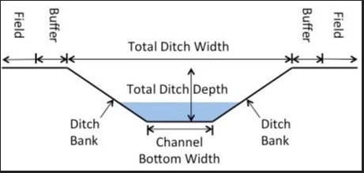
Athletic court, Athletic field, Golf course, Tennis court, Playground
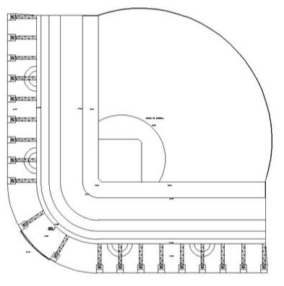
Basin (Debris, Detention, Sediment, Stormwater Retention and Detention)
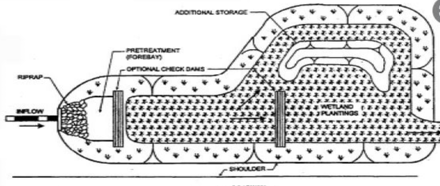

Beach, Dune
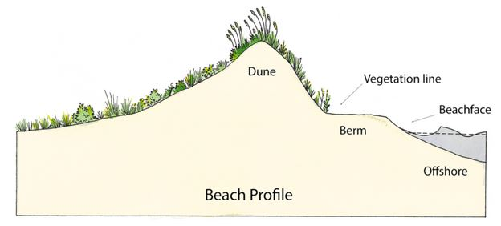
Berm, Levee, Sand Revetment, Seawall
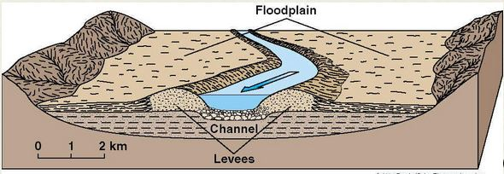
Boardwalk, Trail
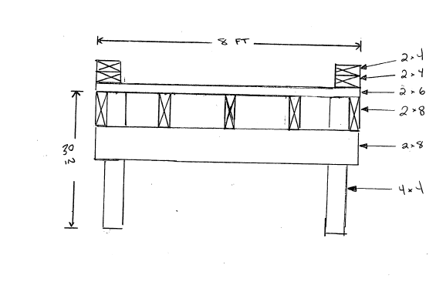
Bridge
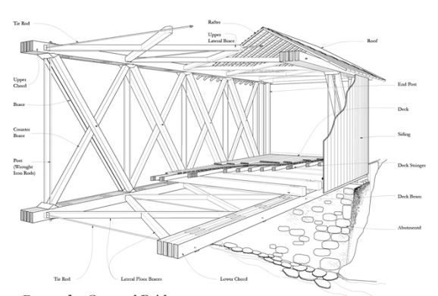

Building
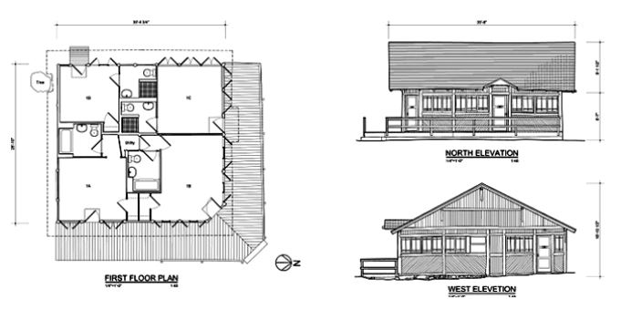
Cemetery
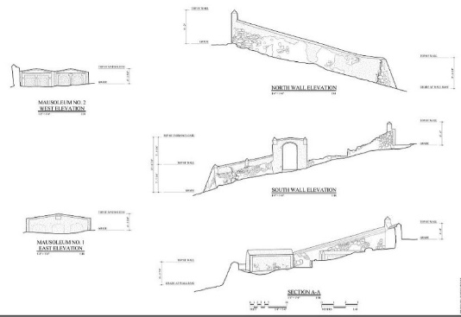
Communications System
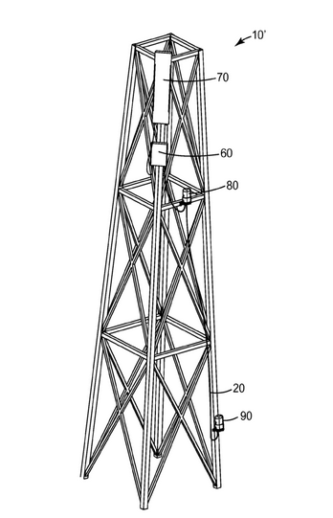
Contents
N/A
Culvert, Ditch
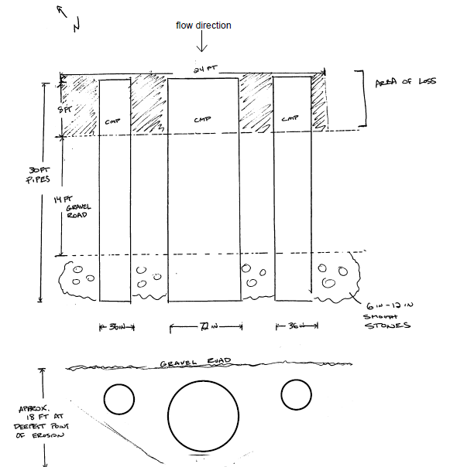
Dam
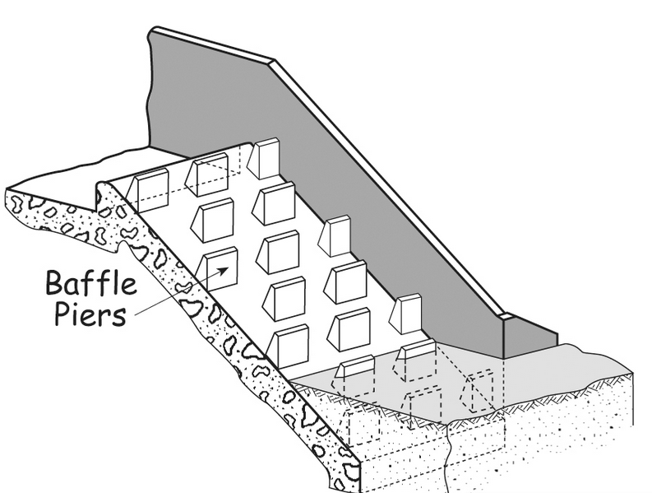
Dock, Harbor, Pier, or Port
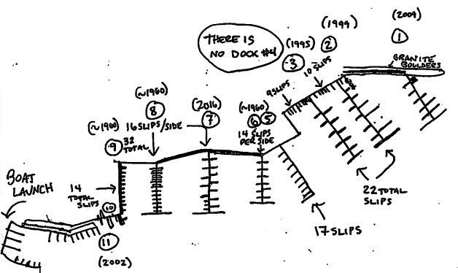
Equipment and Vehicles
N/A
Fish hatchery, Zoo
N/A
Lift station, Pumping station
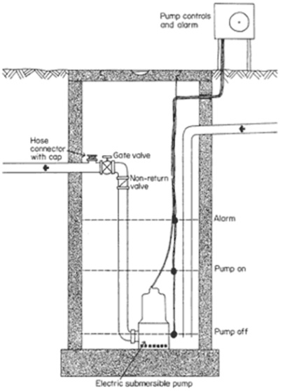
Natural gas transmission and distribution
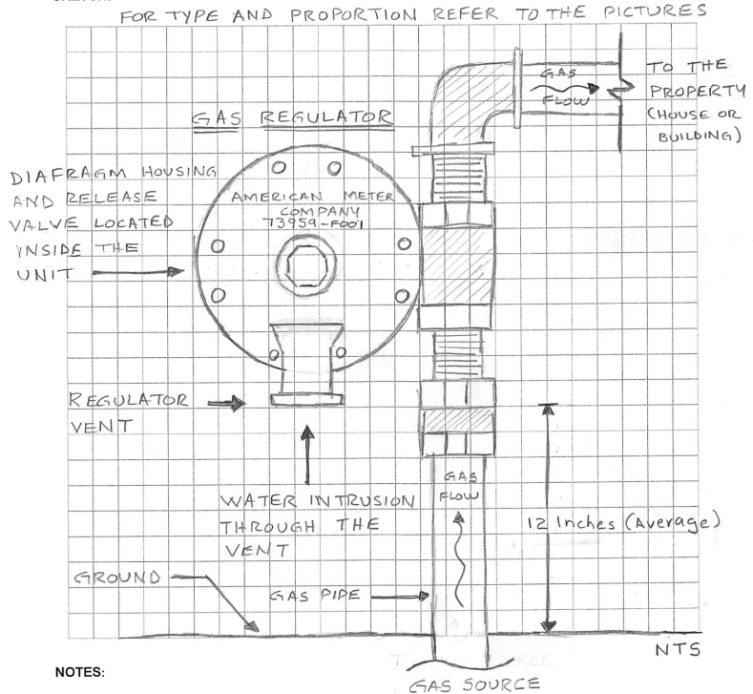

Power plant, Power transmission and distribution system, Substation, Wind turbine
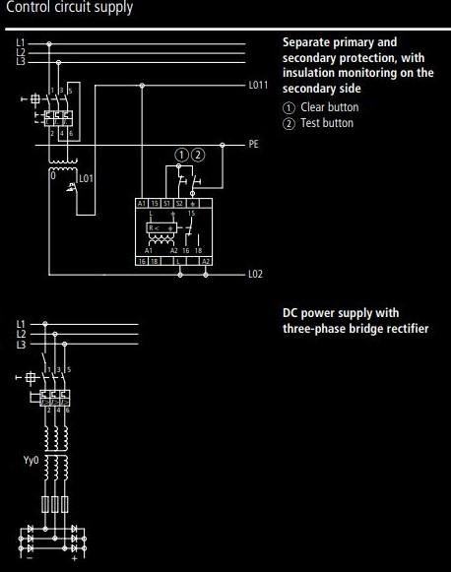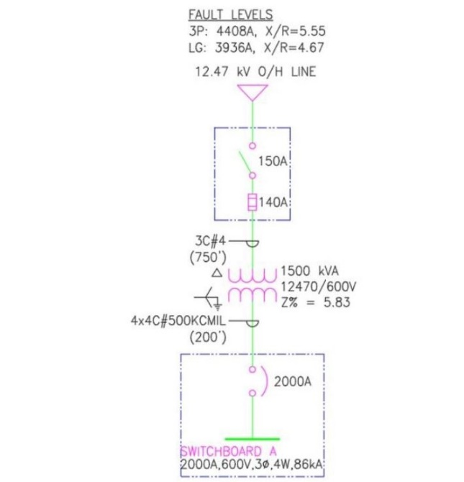
Railway, Subway
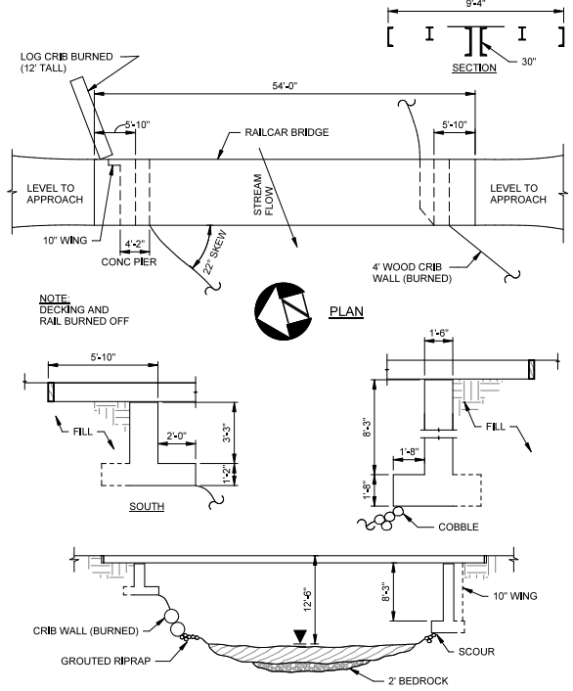

Reservoir
N/A
Road (Airport runway/taxiway, Parking, Road, Runway, Sidewalk)
Swimming pool
N/A
Water /Wastewater
N/A
Water control facilities
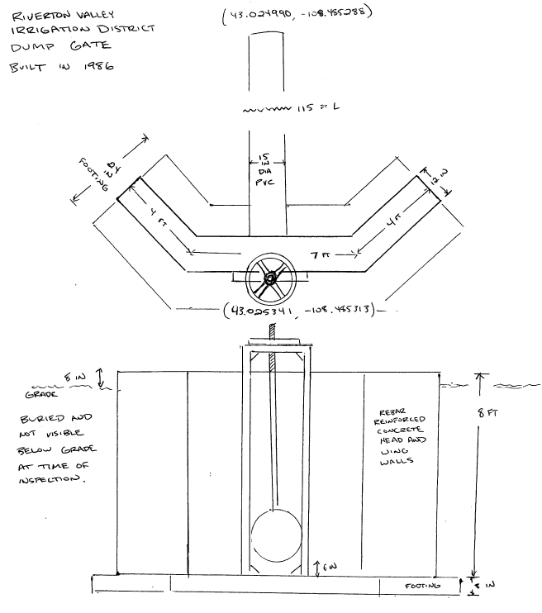

Sketch
Notes and comments:

Section VI – Photographs
Please provide photos of the damage to the facility and components. Please upload as many photos as needed to fully show the extent of the damage.
File name:
Damage description:
Photo number: [system generated]
Sub-site identifier:

Due to the historic nature of the facility, please provide contextual photos of the facility and surroundings: Please upload as many photos as needed to fully show the contextual area, all sides of the exterior (North, South, East, West), and historic aspects of the facility.
File name:
Photo description:
Photo number: [system generated]
Sub-site identifier:
Total number of photos: [system calculated]
Section VII– Applicant Review
Applicant personnel that submitted the damage information | Title [system generated] | Signature [system generated] | Date submitted [system automated]
Applicant personnel that attended the inspection | Title [system generated] | Signature [system generated] | Date submitted [system automated]
Do you concur with the damage reported?
☐ No. Please provide reason for non-concurrence:
☐ Yes
Section VIII – Recipient Recommendation
Do you concur with the damage reported?
☐ No. Please provide reason for non-concurrence:
☐ Yes
Recipient’s Authorized Representative [system generated] | Title [system generated] | Signature [system generated] | Date submitted [system automated]

Functionality: Generate declaration # from the Request for Public Assistance. Generate Legal Name of Applicant, and FEMA PA ID from the Organizational Profile.
Functionality: Generate the Facility Type, Facility Name, Site/Campus Name, and Location form the Impact List. For Simple Approach Only: Generate Facility Type from the Impact List. Facility Name and Site/Campus Name are optional.
(Help Text) See the Site Inspections and Obtaining Damage Information section in the Public Assistance Program and Policy Guide (PAPPG) for more information. Functionality: Generate this section only if “Work has started and is approximately % complete” or “Work has not started” is selected on the Impact List. If the work is completed, the responsibility for completing defaults to the Applicant.
Functionality: Insert calendar and time options (similar to websites that allow appointment scheduling based on availability). Allow for schedule changes. If rescheduled, show number of times rescheduled. Notify the PDTFL to route the Damage Information Form to the appropriate site inspector.
Functionality: Insert calendar and time options (similar to websites that allow appointment scheduling based on availability). Allow for schedule changes. If rescheduled, show number of times rescheduled. Notify the PDTFL to route the Damage Information Form to the appropriate site inspector.
(Help text) For example, the facility address may be the front door, but the damage location may be at a different location within the building grounds, or the meeting point may be different than the main facility address. Please provide point of contact information.
Functionality: Generate only if “Earthquake”, “Tsunami”, or “Volcanic eruption” were selected on the Incident Information form.
(Help text) When load-bearing walls are not designed to resist lateral force imposed by earthquakes. These common walls are typically made of masonry and are not reinforced. Shear failure is observed by the developments of diagonal cracking during earthquakes. When there are wall openings, cracks generally start from four corners of the opening. If the earthquake shaking is severe enough, the in-plane cracking may develop into an out-of-plane collapse.
(Help text) Damage may be caused simply by inadequate reinforcement. The absence of adequate structural reinforcement often leads to non-ductile structural failures. A structure is prone to significant failure in the absence of strength or the ability to deform (change in shape or form under stress or strain). Ductility in a building is commonly achieved by using detailed reinforcement in locations where the failure potential is high, such as beam-column connections, allowing for safe lateral deformation without collapse.
(Help text) Deformed columns caused by the Short Columns Effect when a less than the typical column height in a structure is present. Uneven ground level, intermediate floor levels, and infill wall openings are typical reasons for their presence. Short columns are stiffer when compared to tall columns, and therefore more brittle. They attract large seismic forces, leading to severe damage and failure if they are not designed and/or reinforced appropriately.
(Help text) Damage due to soft-story levels of a building where that level has noticeable stiffness/strength reduction in comparison to floors above or below. They can be present in mixed-use buildings that incorporate large open spaces. Examples include buildings with lower levels used as parking garages and commercial spaces for other uses. Due to their weak lateral load resistance, they often lead to collapse during an earthquake due to their low lateral strength, acting as a soft/weak story, unless they are anchored or strengthened to provide the necessary lateral resistance. Buildings built on stilts attached to the foundation are particularly vulnerable. This form of construction is widely used on sloped ground or to provide ventilation or protection from storm surge.
(Help text) By push and pull the ground, and earthquake can lead to ground displacement and tearing of a surface. The surface rupture can cause other hazards, as well as damage to roads and buildings.
Functionality: Generate if “Flood”, “Hurricane”, “Severe storm”, “Tropical depression”, and “Tropical storm” were selected under “Incident Type” in the Incident Information form.
Functionality: Generate if “Fire”, “Flood”, “Hurricane”, “Landslide”, “Severe storm”, “Tropical depression”, “Tropical storm events”, and “Volcanic eruption” were selected under “Incident Type” in the Incident Information form.
Functionality: Generate if “Fire”, “Flood”, “Hurricane”, “Mudslide”, “Severe storm”, “Tropical depression”, and “Tropical storm” were selected under “Incident Type” in the Incident Information form.
Functionality: Generate if “Hurricane”, “Severe storm”, “Straight-line winds”, “Tropical depression”, “Tropical storm events”, “Tornado”, and “Winter storm” were selected under “Incident Type” in the Incident Information form.
Functionality: Generate if “Snowstorm” or “Winter storm” were selected under “Incident Type” in the Incident Information form.
Functionality: Generate if “Tidal wave” or “Tsunami” were selected under “Incident Type” in the Incident Information form
Functionality: Generate if “Volcanic eruption” was selected under “Incident Type” in the Incident Information form.
Functionality: Trigger if “Parks or Recreational Facilities” was selected in Impact List Addendum. (More info) For example, Athletic court or field, Boardwalk, Dock, Fish hatchery, Gymnasium, Museum, Pavilion, Pier, Swimming pool, Trail, or Zoo.
Functionality: Trigger if “Detention basin,” “Sediment or debris basin,” or “Stormwater retention” were selected in the Impact List Addendum.
Functionality: Please include the metric used for quantity (e.g., each, weight, volume, area, etc.)
Functionality: Trigger if “Beaches” or “Dune” were selected in the Impact List Addendum.
Functionality: Trigger if "Berm,” “Levee,” “Sand Revetment,” or “Seawall” were selected in the Impact List Addendum.
Functionality: Trigger if “Bridge” was selected in the Impact List Addendum.
(Help text) Information should include bridge type (e.g., foot, highway, railway, aqueduct bridge) and bridge material (e.g., timber, mason, steel, and bridge type based on super structure e.g., arch, bean, girder, truss, suspension, etc.)
Functionality: Trigger if “Building” was selected in the Impact List Addendum.
(Help text) Information should include the number of stories, rooms, basement, parking levels, etc.
(Help text) For multi-storied buildings provide total estimated square footage. Functionality: Allow for multiple entries.
(Help text) Description can include floor number or area such as library, auditorium, or cafeteria.
Functionality: If “Exterior” is selected, do not populate interior damaged components (Bathroom, Ceiling, Elevator, or Kitchen Components).
(Help text) See Roof Pitch Chart and Roof Types and Materials for additional information.
Functionality: Trigger if “Cemetery” was selected on the Impact List Addendum.
Functionality: Trigger if “Communication Facility” or “Communication Tower” were selected on the Impact List Addendum.
Functionality: Trigger if “Contents” was selected on the Impact List Addendum.
Functionality: Trigger if “Culvert” or “Ditch” were selected on the Impact List Addendum.
(Help text) Information should include size of the culvert.
Functionality: Trigger if "Dam” was selected on the Impact List Addendum.
Functionality: Trigger if “Dock,” “Port or Harbor”, or “Pier” were selected on the Impact List Addendum.
Functionality: Trigger if “Aqueduct”, “Canal”, or “Drainage Channel”, were selected in Impact List.
Functionality: Please include the metric used for quantity (e.g., each, weight, volume, area, etc.)
Functionality: Any selection triggers Section V – Component Damage Description per component.
Functionality: Trigger if "Equipment”, “Supplies” or “Vehicles” were selected on the Impact List Addendum.
(Help Text) Please include the serial number or Vehicle Identification Number (VIN) and, if available, the odometer reading.
Functionality: Trigger if “Lift station” or “Pumping station” were selected on the Impact List Addendum.
Functionality: Trigger if “Low-water crossing” was selected on the Impact List Addendum.
Functionality: Trigger if “Natural gas transmission and distribution” were selected on the Impact List Addendum.
Functionality: Trigger if “Power plant”, “Power transmission and distribution system”, “Substation” or “Wind turbine” were selected on the Impact List Addendum.
Functionality: Trigger if “Transportation Facilities” was selected on the Impact List Addendum.
Functionality: Trigger if “Reservoir” was selected on the Impact List Addendum.
Functionality: Trigger if “Road”, “Airport runway”, “Airport hangar” “Airport runway / taxiway”, “Parking”, or “Sidewalk” were selected on Impact List Addendum.
Functionality: Trigger if “Wastewater collection system,” “Wastewater treatment plant,” “Water distribution system,” or “Water treatment plant” were selected on the Impact List Addendum.
Functionality: Generate if “Other Damaged Infrastructure” is selected on the Impact List Addendum.
Functionality: Generate this section for each component selected in Section V.
Functionality: Generate from “Components (with common material types)” from Section V.
(Help text) Please list the specific location of the component in relation to the overall facility, such as a room or area of the facility, or item specific GPS coordinates. GPS coordinates should be latitude and longitude values in decimal degrees formatted to the sixth decimal place (e.g., 38.885431, -77.018781)
(Help text) Please specify how the component was damaged (e.g., a second story window was damaged by winds and water seepage from rain; ground level flooring was damaged by 3 feet of flood waters which stood for two days before receding; flood debris damaged wire fence on park grounds, high winds damaged flashing metal, etc.) Please include available information on the direction of the wind or how water intrusion occurred.
Functionality: Generate from Section V – Facility Damage.
(Help text) For example, motor, motor control center, panel, control panel, switchgear.
Functionality: Trigger if “Equipment” was selected on the Impact List Addendum.
Functionality: Generate materials selected from Section V. For the components that have no materials identified in Section V, allow user entries.
(Help text) Please see the Calculation and Conversions spreadsheet for assistance calculating quantities of materials and converting units.
(Help text) Please see the Distance Calculator for assistance with calculating road dimensions.
Functionality: Trigger if “Vehicle” was selected on the Impact List Addendum.
Functionality: Trigger if “Equipment” or “Vehicle” was selected Impact List Addendum.
(Help text) Use this page to capture sketches, diagrams, or other graphics of damage to the facility and its components. Functionality: Only for work to be completed. Allow for download/upload of template sketch sheet; if possible, develop functionality to allow for sketching in system.
Functionality: Sketch shown if “Canal”, “Drainage Channel”, or “Aqueduct” was selected the Impact List Addendum.
Functionality: Sketch shown if “Athletic court”, “Athletic field”, “Golf course”, or “Playground” were selected on the Impact List Addendum.
Functionality: Sketch shown if Basin if “Sediment or Debris Basin”, “Detention Basin”, or “Stormwater Retention”, were selected in the Impact List Addendum.
Functionality: Sketch shown if “Beach” or “Dune” were selected on the Impact List.
Functionality: Sketch shown if " Berm”, “Levee”, “Sand Revetment”, or “Seawall” were selected on the Impact List Addendum.
Functionality: Sketch shown if "Boardwalk” or “Trail” was selected on the Impact List Addendum.
Functionality: Sketch shown if “Bridge” was selected on the Impact List Addendum.
Functionality: Sketch shown if “Building”, “Airport hangar” or “Airport terminal” was selected on the Impact List Addendum.
Functionality: Sketch shown if “Cemetery” was selected on Impact List Addendum.
Functionality: Sketch shown if “Communication facility” was selected on Impact List Addendum.
Functionality: Sketch shown if “Contents” was selected on Impact List Addendum.
Functionality: Sketch shown if “Culvert” or “Ditch” was selected on Impact List Addendum.
Functionality: Sketch shown if "Dam” was selected on Impact List Addendum.
Functionality: Sketch shown if “Dock”, “Port or Harbor” or “Pier” was selected on Impact List Addendum.
Functionality: Sketch shown if "Equipment” or “Vehicles” was selected on Impact List Addendum.
Functionality: Sketch shown if “Fish hatchery” or “Zoo” was selected on the Impact List Addendum.
Functionality: Sketch shown if “Lift station” or “Pumping station” was selected on the Impact List Addendum.
Functionality: Sketch shown if “Natural gas transmission and distribution system” was selected on the Impact List Addendum.
Functionality: Sketch shown if “Power plant”, or “Power transmission and distribution system”, “Substation” or “Wind turbine” was selected on the Impact List Addendum.
Functionality: Sketch shown if “Transportation Facilities” was selected on Impact List Addendum.
Functionality: Sketch shown if “Reservoir” was selected on the Impact List Addendum.
Functionality: Sketch shown if “Road”, “Airport runway / taxiway”, “Parking”, or “Sidewalk” was selected on Impact List Addendum.
Functionality: Sketch shown if “Swimming Pool” was selected on the Impact List Addendum.
Functionality: Sketch shown if “Wastewater collection system” or “Wastewater treatment plant” was selected on the Impact List Addendum.
Functionality: Sketch shown if “Water distribution system”, “Water treatment plant, or “Water control facilities” was selected on the Impact List Addendum.
Functionality: Uploaded photos create a photo sheet based on the file and the fields provided; photos should be managed through a photo document library. Allow for multiple entries. (Help Text): Photos communicate contextual information for staff involved in award development and reporting. Tips for taking good photos: Take several wide-view photos of the entire facility from multiple angles. For example, photograph road damage from both ends of the road. Look beyond the damaged element and consider the surrounding area. Wide shots of the area or facility are important for context for the up-close pictures of damaged components. This context is helpful to assess both damage and scope considerations. Show context when photographing structures that may be historic (For example: If a damaged culvert is within a stone structure, include the whole structure in the photo, not just the inside of the dented culvert). Take photos of Staging and Access Areas. Take zoomed-out photos to capture the area surrounding the facility (this assists with environmental reviews). Take wide-view photo of each component, capturing the entire component. Take close-up photos of each damaged component to show details. Include an item to indicate size, such as a traffic cone, tape measure, or pen. Capture distinctive, stationary features to indicate position, such as flags, signs, cones, desks, or trees. When taking multiple photos, ensure reference items help a reader “stitch together” the scene. When taking photos inside structures, take photos in a panoramic style. Ensure lighting and perspective allows a viewer to clearly see damage. Document all angles (north, south, east, west) and include GPS coordinates and perspective (e.g., facing East, from the West) on each photo. Label photos by the name of facility and component; include the name and description of what is in the photo; include annotations in the photo to highlight the damage (arrows, circles, etc.). Ensure that any site identifier is consistently used in submitting component information and photographs from the inspection.
(Help text) Include the disaster number, facility name, and sub-site identifier as appropriate. Please ensure that use of any site numbering or naming convention is consistent.
(Help text) Please provide context or describe what the photo is showing.
Functionality: Automated.
( Help text) Please list the specific building, room, or other sub-site identifier where the picture was taken of the facility. Ensure that use of any site identifier is consistent when submitting component information and photographs for the facility.
Functionality: Only show if “Yes” was answered to the question(s) “On or adjacent to a facility constructed 45 or more years ago; a facility listed on a local, state, or national register; or facility that is locally registered landmark?” on the Impact List. (Help text) If the appropriate photographs are taken, the Historic Specialist may not have to go on a site visit to view the resource, thereby speeding the review process. Clear and accurate photographs of the exterior of a historic facility and the damage is part of the consultation process with the State Historic Preservation Office.
(Help text) Include the disaster number, facility name, and sub-site identifier as appropriate. Please ensure that use of any site numbering or naming convention is consistent.
(Help text) Include the disaster number, facility name, and sub-site identifier as appropriate. Please ensure that use of any site numbering or naming convention is consistent.
Functionality: Automated.
Functionality: Calculate.
(Help text) The questions in the section are asked of the Applicant Authorized Representative.
Functionality: Allow Applicants to select name from the Additional Users section in the Organization Profile and allow for manual entry. Manual entered names will populate the Additional Users section in the Organization Profile. Allow for multiple entries. (More info): Add staff and technical experts not listed in the Applicant Contact Information- Additional User(s) section of the Organization Profile, especially for Applicant conducted inspections.
Functionality: Automated.
Functionality: Automated.
Functionality: Only ask if a FEMA employee or contractor is selected as the Inspector in the “Submitting Inspector” question in Section IV.
Functionality: Automated.

