Table of Contents
General Comments for Gransolutions to incorporate into OLDC: 2
SF 424 MODEL PLAN 3
SECTION 1 – Program Components 3
SECTION 2 – Heating Assistance 5
SECTION 3 – Cooling Assistance 5
SECTION 4 – Crisis Assistance 5
SECTION 5 – Weatherization 6
SECTION 6 – Outreach 6
SECTION 7 – Coordination 7
SECTION 8 – Agency Designation 7
SECTION 9 – Energy Suppliers 7
SECTION 10 – Program, Fiscal Monitoring and Audit 7
SECTION 11 – Timely and Meaningful Public Participation 8
SECTION 12 – Fair Hearing 8
SECTION 13 – Reduction of Home Energy Needs 8
SECTION 14 – Leveraging Incentive Program 8
SECTION 15 – Training 8
SECTION 16 – Performance Goals and Measures 8
SECTION 17 – Program Integrity 9
Section 18 – Certification Regarding Debarment, Suspension, and Other Responsibility Matters 9
Section 19 – Certification Regarding Drug-Free Workplace Requirements 9
Section 20 – Certification Regarding Lobbying 9
Section 21 – New Change Assurances to Section 21 9
Section 22 – Attachments 9

General Comments for Gransolutions to incorporate into OLDC:
1. Model Plan must be 508 Compliant to assist grant recipients with public posting for public hearing purposes.
2. Grant Recipients have also requested the ability to download the Model Plan from OLDC in Microsoft Word to demonstrate track changes and share with state level partners and for sharing with their legal reviewers.
3. Change “grantee” to “grant recipient” throughout report. Total count of change:
-“grantee”=27
-“grantees” =10
-“grantee’s” =8

4. Throughout the report there are multiple questions with only one opportunity to explain why “yes” is checked at the bottom. Please modify so that if “yes” is checked, there is a box to provide the policy explanation within that specific area (e.g., after the additional eligibility requirements question, the assets test questions, the set of questions about renters, and the set of questions about priority in eligibility) instead of just one explanation for all areas at the bottom. Screenshot from Section 2 below for reference:
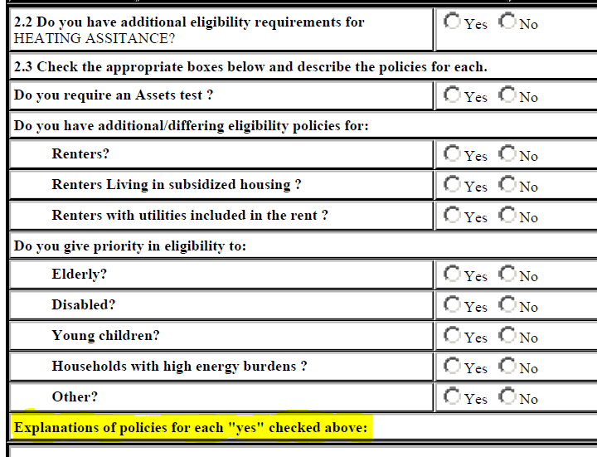
5. Under question 1.2, if there is a percentage added to a column, then that section of the plan will be required to complete. But if it is “zero”, then that section of the plan should gray out and cannot be completed. A statement in that section should state “Section 1, question 1.2 indicated 0% of funds being used towards these activities. Please modify question 1.2 if you would like to complete this section”. The sections this pertains to is:
- Section 2, Heating
- Section 3, Cooling
- Section 4, Summer Crisis Assistance
- Section 4, Winter Crisis Assistance
- Section 4, Year Round Assistance
- Section 5, Weatherization
- Section 13, Assurance 16

SF 424 MODEL PLAN
- 4a: Change from Federal Entity Identifier to “Unique Entity Identifier (UEI)”.
- 7b&c: Remove, UEI is requested in 4a
- 7f: add after current language “(person will be listed on Notice of Funding Awards and on the U.S. Department of Health and Human Services’ LIHEAP contact list webpage)”
  - Remove Prefix, Suffix, Middle Name and Organizational Affiliation
- 8a: Remove the “a” after 8 “Type of Applicant”
- Add 8a Is the applicant a Tribal Consortium
  - Add 8b If yes please attach at least one the following documentation:
  - 1) Current State-Tribe Agreement between their state and the Consortium, signed by the State Chief Executive Officer (such as a Governor or the delegate) and the Consortium President;
  - 2) Consortium letter listing the Tribes and signed by the elected Tribal Chief or President of each Tribe in the Consortium and signed by the Consortium President;
  - 3) A current resolution letter from each tribe in the Consortium, signed by the elected Tribal Chief or President of that Tribe. Each resolution letter needs to state that the Consortium has the Tribes’ permission to apply for, and administer, LIHEAP on their behalf; needs to designate a time period for the permission or until rescinded or revoked.
- 8b: Remove, not utilized
- 9: Remove, Name of Federal Agency, not used
- 13. – Change to “CONGRESSIONAL DISTRICTS OF APPLICANT”
  - Eliminate 13a and b. – Already answered in #7; and Eliminate “Attach an additional list of Program/Project Congressional Districts if needed.
- 15 a and b: Remove
- 17. – At the end of question change “explanation“ to If Yes, explain”

SECTION 1 – Program Components
Introduction: remove reference to grant recipient filing abbreviated plan. LIHEAP does not use abbreviated plans any longer.
- 1.1 Crisis assistance: Create one question for “Summer crisis assistance”, one question for “Winter crisis assistance” and one for “year round assistance”. We are receiving increase data request to understand the type of crisis programs provided.
- 1.2
  - Add a data entry column and provide the breakdown of funding from the previous year’s plan. This information is useful for the data dashboard.
  - Add language for “Tribal grant recipients: direct-grant tribes, tribal organizations or territories with allotments of $20,000 or less may use for planning and administration up to 20% of the funds payable. Grant recipients that are direct-grant tribes, tribal organizations or territories with allotments over $20,000 may use for planning and administration purposes up to 20% of the first $20,000 (or $4,000) plus 10% of the funds payable that exceeds $20,000. Any administrative costs in excess of these limits must be paid from non-Federal sources.
  - Change “Crisis Assistance” to “Summer crisis assistance”, one question for “Winter crisis assistance” and one for “year round assistance”.
- 1.4:
  - Remove Other and entire column. All allowable options are listed, other is not applicable
  - Insert “at least” before the word “one” in two places in this question. The edited question would be, “Do you consider households categorically eligible if at least one household member receives at least one of the following categories of benefits in the left column below?”
- 1.4a- Add a text box “Provide your definition of categorical eligibility. Please explain how households are categorically eligible (i.e. do all household members need to receive the benefits or just one member, is there a data exchange in place?) and how categorical eligibility streamlines the LIHEAP application process. This will ensure grant recipients understand categorical eligibility and answer the question appropriately
- If 1.4 is answered no, do not allow the table to be completed. Caused data inconsistencies in the data dashboard and requires manual review.
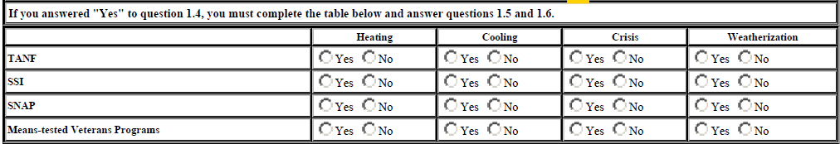
- 1.7:
  - Hyperlink the word “nominal” to a description of the word: Nominal benefits are LIHEAP payments over $20 made to SNAP households with an energy burden that allow the household to claim the SNAP "heating/cooling standard utility allowance" (SUA).
- 1.8 Add “Other - Describe” Grant recipients indicated there are exceptions and this box will allow those exceptions to be described and understood more clearly.
- 1.9 Remove SNAP and WIC as they cannot be counted as income.
- Add: 1.10 Do you have an online application process (Yes/No)
- Add 1.10a If yes, describe the type of online application (Select all boxes that apply)
  - A PDF version of the application is available online and can be downloaded, filled out and mailed in for processing.
  - A state-wide online application that allows a customer to complete data entry and submit an application electronically for processing
  - One or more locally available online applications that allows a customer to complete data entry and submit an application electronically for processing
  - Online application that is also mobile friendly
  - Other, please describe
  - If any of the above boxes are checked, please include a link here:
- Add 1.10b Can all program components be applied for online (Yes/No). If no, explain which components can and cannot be applied for online. –
- 1.11 Do you have a process for conducting and completing applications by phone (Yes/No)
- 1.12 Do you or any of your subrecipients require in person appointments in order to apply (Yes/No) If yes, please provide more information
- 1.13 How can applicants submit documentation for verification? Select all that apply (in-person, mail, email, portal application, other-describe)

SECTION 2 – Heating Assistance
- 2.2 – Correct the spelling of assistance
- 2.3 – Change “Elderly” to “Older Adults” (60 years or older)
- 2.3 – Change “Disabled” to “Individuals with a disability”
- 2.4 – Add space between “to” and “vulnerable”
- 2.6 – Add the following sentence, “Please note: the maximum and minimum benefits must be shown in the payment matrix”.

SECTION 3 – Cooling Assistance
- 3.3 – Change “Elderly” to “Older Adults”
- 3.3 – Change “Disabled” to “Individuals with a disability”
- 3.4 – Add space between “to” and “vulnerable”
- 3.6 – Add the following sentence, “Please note: the maximum and minimum benefits must be shown in the payment matrix”.

SECTION 4 – Crisis Assistance
- 4.2 Add to narrative, “If you administer multiple crisis assistance programs (winter, summer, and/or year-round), Include all program definitions.
- 4.6 – 4.7 and 4.10 – 4.13 Modify so that it is no longer “yes or no” but mirrors question 4.15 so they can select which program the response is applicable. If the component is not selected under 1.2, the boxes will be grayed out so they cannot select that option. Modify the instructions for the section to be “Check appropriate boxes below to indicate type(s) of assistance provided”

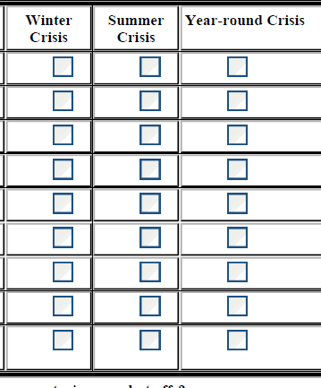

- 4.6 remove all CAPS from Crisis Assistance
- 4.7 Change “Elderly” to “Older Adults”
- 4.7 Change “Disabled” to “Individuals with a disability”
- 4.8 Modify “Fast Track” to: “Benefit Fast Track, no separate amount of crisis funds is issued. Rather benefits are issued to crisis customers within crisis response time frames”
- 4.9 Add a box next to the question, “amount to resolve crisis, up to a maximum amount”
- 4.11 change Physically Disabled to “Individuals with a disability”
- 4.18 – Add question that says: Do you intend to utilize LIHEAP crisis funds to address disaster related crisis situations? “Yes” or “No” if yes, describe Add hover over box that states “OCS' block grant funding has built in flexibility to support grant recipients in disaster response. Please visit https://ocs-emergency-assistance-hhs-acf.hub.arcgis.com/ for additional information” (508 compliant hyperlink)

SECTION 5 – Weatherization
- 5.3 – Modify to “If yes, name the agency and attach a copy of the Internal Agreement or Contract.”
- 5.8 – Change “Elderly” to “Older Adults”
- 5.8 – Change “Disabled” to “Individuals with a Disability”
- 5.9 – add a 5.9a replace with current 5.10 “If yes, what is the maximum”
- 5.10 Change to Do you use an Average Cost per Unit (ACPU).
  - 5.10a If so, what is the ACPU amount?
- 5.11 – This section needs two boxes for roof top solar and community solar projects.

SECTION 6 – Outreach
- 6.1 – This section needs to include other outreach including web posting, email, texting, events, and social media.

SECTION 7 – Coordination
- 7.1 This section needs to include data entry field next to the first two boxes.
- Joint application for multiple programs (indicate programs included:____)
- Intake referrals to/from other programs (indicate programs:____)

SECTION 8 – Agency Designation
- 8.1 –
  - Add Economic Development Agency
  - Change Welfare to “State Department of Welfare (administers TANF, SNAP, and/or Medicaid)”
  - Eliminate space between “Energy” and “/” and Environment
- New Attachment: Include current list of subrecipient name, main office address (do not list P.O. Box), phone number, county(s) served, Congressional District, and UEI number. Used for Near hotline and OCS Service Provider Tool and clearinghouse
- Add 8.10: If an agency is no longer providing LIHEAP, are you aware of prior-year LIHEAP funds being mismanaged or misspent? Yes or No
- 8.10a If yes, please explain.
- 8.10b Were other federal programs impacted such as CSBG, SSBG, Head Start, TANF, and Dept. of Energy Weatherization funding, etc.? Yes or No
- 8.10c If yes, please explain.
  - Questions added due to previous situations and questions needing a response to these specific items.

SECTION 9 – Energy Suppliers
- Add option at the end of the section to attach a copy of the vendor agreement.

SECTION 10 – Program, Fiscal Monitoring and Audit
- 10.1 – Revise the question as, “how do you ensure proper fiscal accounting and tracking of funds?” Add the following instructional sentence, be specific about tracking of grant award, tracking of expenditures, tracking vendor (benefit) refunds, fiscal reporting process, and fiscal software system being used. Clarification for grant recipients
- 10.1a New Question: Provide your definitions of the following:
  - Obligation (insert explanation box)
  - Expenditures (insert explanation box)
  - Expenditure timeframe (insert explanation box)
  - Administrative costs (insert explanation box)
- 10.2a- Add question: If yes, describe your auditor selection process.
- 10.3 Change wording to: “Describe any audit findings of the grant recipient (i.e. State/Tribe/Territory) rising to the level of material weakness or reportable condition cited in the single audits, inspector general reviews, or other government agency reviews from the most recently audited fiscal year.
- 10.5 – Change question to “Describe your monitoring process for compliance at each level below
  - Change “Grantee recipient employees” check box to state:
    - Grant recipients have a policy in place for appropriate separation of duties and internal controls
    - Other, describe
- 10.7 - Rewrite the question as, "Describe how you select local agencies for monitoring reviews. Attach a risk assessment if subrecipients are utilized.
- 10.8 - Add boxes, "Annually", bi-annually". Please attach a monitoring schedule if one has been developed.
- 10.9 and 10.10 – Remove
- 10.11 - Revise the question to, "How many local agencies are currently on corrective action plans
- 10.12 - Remove

SECTION 11 – Timely and Meaningful Public Participation
- 11.1 - Add explanation that Tribes do not need to hold a public hearing but must ensure participation through other means.
- 11.2 Remove. Removing because question is duplicative of 11.6
- 11.3 - Insert an option to add rows for additional dates and locations that they held public hearings on the proposed use and distribution of their LIHEAP funds
- 11.6 - Revise the question as follows: "What changes did you make to your LIHEAP plan as a result of public participation and solicitation of input?"

SECTION 12 – Fair Hearing
- 12.4 Change question: Describe your fair hearing procedures for households whose applications are denied and/or not acted upon in a timely manner.
- 12.5 Remove
- 12.6 Remove

SECTION 13 – Reduction of Home Energy Needs
- 13.3 - Add the following instructional sentence, “Impact can be measured in many different ways by using: logic model, data tracking system, process evaluation, impact evaluation, number of households served vs applied, and performance management, etc."
- 13.4 – Add a space between “of” and “direct”
- 13.5 Remove

SECTION 14 – Leveraging Incentive Program
- 14.3 – Add a space between “of” and “45”

SECTION 15 – Training
- 15.1a-c Change question to be consistent with each entity type (grant recipient, local agency, vendor)
  - Formal training provided virtually, on-site, and/or formal training conference
    - Annually
    - Biannually
    - As needed
    - Other, describe

SECTION 16 – Performance Goals and Measures
- No changes

SECTION 17 – Program Integrity
- 17.1. - Add posted in local administering agencies offices.
- 17.4 – Change “aliens” to “qualified non-citizens” in intro text. The second option in the question is phrased as “legal residence” but it needs to be changed to “U.S. Citizen or Qualified Non-Citizen”. The second box option should read “Client’s submission of certain Social Security Administration cards is accepted as proof of U.S. Citizen or Qualified Non-Citizen.”
- 17.4 - Rewrite the question, as "what are your procedures for ensuring LIHEAP recipients are U.S. citizens or qualified non-citizens who are eligible to receive LIHEAP benefits?
- 17.6 - Should also include how electronic files are protected in a secure location.

Section 18 – Certification Regarding Debarment, Suspension, and Other Responsibility Matters
- No changes

Section 19 – Certification Regarding Drug-Free Workplace Requirements
- 19.1 Place of Performance: Add instructional sentence that this must be physical address. No PO Boxes allowed.

Section 20 – Certification Regarding Lobbying
- No changes

Section 21 – New Change Assurances to Section 21
- 21.1 - Add the following acknowledgment statement and a check box, “By checking this box, the prospective primary participant is agreeing to the Assurances set out above."

Section 22 – Attachments
- Add optional attachment section for the following items: Policy Manual; Subrecipient Contract; Model Plan Participation Notes for Tribes

