Appendix D.1 Data Collection Pre-Notification Communication

Nursing Home Administrator Letter
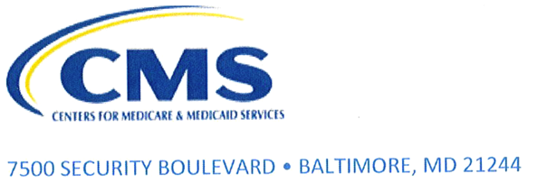
OMB number: 0938-1424
Expiration Date: xx/xx/20xx

[FACILITY ADDRESS] XXXXX xx, 20xx
Dear [NURSING HOME ADMINISTRATOR NAME],
The Centers for Medicare & Medicaid Services (CMS) is conducting a brief telephone survey about quality improvement assistance provided by the CMS-funded Quality Innovation Network-Quality Improvement Organization (QIN-QIO) contractors to nursing homes. By design, the survey is being directed to both nursing homes which received this technical assistance paid by CMS and nursing homes who did not receive this assistance. The survey will be conducted among facilities that serve Medicare beneficiaries as part of CMS’ efforts to improve the quality of care for beneficiaries. CMS has partnered with Booz Allen Hamilton to conduct this survey to learn about your facility’s quality improvement activities.
Within two weeks, you will be contacted to conduct the survey or to schedule a time to complete it. This survey should take no more than 20 minutes.
For this survey, we seek to talk with the person who is most knowledgeable about your facility’s participation in programs or other resources used to ensure high-quality healthcare services over the last 12 months. If your nursing home is part of a corporate chain, we would like to interview someone who works at [FACILITY NAME], rather than someone at corporate headquarters who is responsible for healthcare quality for several facilities. If you feel that someone other than yourself is more qualified to complete the survey, for example the Director of Nursing, please use the email address or toll-free number below to leave that person’s contact information.
We hope [FACILITY NAME] will participate in the survey and provide information that will help CMS improve its programs. Participation is voluntary, but please know that your facility was carefully chosen to represent nursing homes with similar characteristics. We will be collecting responses from many facilities and reporting only the aggregate results; your name and your organization will never be associated with the findings. What you say for the survey will be held securely and will not in any way affect your facility’s relationship with CMS. Your responses will in no way be used to evaluate your facility or be used by CMS outside improvements to the CMS quality improvement program. Your feedback will be key to understanding what needs to be improved by the QIN-QIO program in the provision of assistance to nursing homes. CMS will utilize this feedback in the development of future QIN-QIO requirements, as well as provide current feedback and direction to the QIN-QIOs to improve delivery of their services to nursing homes now.
Prior to completing the survey, it may be helpful for you to review your facility’s processes and protocols for quality improvement of healthcare services.
Please contact us at CMS.LTC_QIsurvey@bah.com or 877-215-6663 if you would like to schedule a time to take the survey, suggest that we contact another person at your facility, or if you have any questions or concerns. Self-scheduling is also available at [THG application program link]. For verification that this is not a phishing attempt, you may visit https://qioprogram.org/survey (a CMS resource) for a verifying statement of the survey activity. Thank you in advance for your participation in this important effort.
If you are having difficulty scheduling or have another question for CMS, please contact my CMS lead staff person for this survey activity, Jeff Mokry at jeff.mokry@cms.hhs.gov.
Sincerely,
[SIGNATURE]
Anita Monteiro, MBA, MSHCA, MA, BSN
Director, Quality Improvement and Innovation Group
CMS Center for Clinical Standards and Quality
7500 Security Boulevard, Baltimore, MD 21244
Anita.monteiro@cms.hhs.gov

