SUPPORTING STATEMENT - PART A
Decision Review Request: Labor Market Information Report-Veteran Readiness and Employment – OMB#2900-10290

- This is a New Collection.
- No comments were received during the 60-Day comment period.

1. Need for the Information Collection

The Department of Veterans Affairs (VA) through its Veterans Benefits Administration (VBA) administers an integrated program of benefits and services, established by law, for Veterans, service personnel, and their dependents and/or beneficiaries. Additionally, title 38 of the United States Code (U.S.C.) section 501(a) provides VA the authority to collect this information. 38 U.S.C 3116 and 3117 authorizes the VA to provide employment services.

The VA Veteran Readiness and Employment (VR&E) program refers Chapter 31 program participants to the American Job Centers staff including Disabled Veterans’ Outreach Program (DVOP) specialists to assist with individualized career services.
This form is required for the American Job Center staff to provide individualized labor market information. The information collected will include specific occupational trends, required qualifications, skills, physical requirements, salaries in the career market and educational requirements. This information will be used to conduct an evaluation to assist the Veteran in the development of a suitable Individual Written Rehabilitation Plan (IWRP).

2. Use of the Information

VA Form 28-10290 will be used to collect information on individualized labor market information to include specific occupational trends, required qualifications, skillsets, salaries, physical and educational requirements for the Veteran’s identified occupational career path. The information collected will be used to conduct an evaluation to assist the Veteran in selecting a suitable vocational goal that is consistent with his or her abilities, aptitudes, interests and does not aggravate his or her disability(ies). Vocational planning is a critical element in selecting a suitable vocational goal for the purpose of the development of a rehabilitation plan for a Veteran within the Veteran Readiness and Employment (VR&E) program. The foundation of a successful rehabilitation program is a well-developed plan of action. Comprehensive labor market information is the first step in developing a successful rehabilitation plan for each Veteran. The VR&E staff subsequently, will use the information on this form to ensure a suitable vocational goal is identified as part of the Veteran’s rehabilitation plan to assist him or her in obtaining and maintaining suitable employment. This form will be obtained through electronic methods to include VA.gov or by the referring Vocational Rehabilitation Counselor. Upon compilation of the data, the form will be electronically submitted to the appropriate VR&E staff.

3. Use of Information Technology

VA Form 28-10290 is available on the One-VA website in a fillable electronic format. VBA is currently hosting this form on a secure server and does not currently have the technology in place to allow for the complete electronic submission of the form. Validation edits are performed to assure data integrity. There currently is no utility process in place that will allow the data submitted on the form to be incorporated with an existing centralized legacy database.

4. Non-duplication

Currently there are no standardized forms that capture this information. Program reviews were conducted to identify potential areas of duplication; however, none were found to exist. There is no known Department or Agency which maintains the necessary information, nor is it available from other sources within our department. The information obtained through this collection is unique and is not already available for use or adaptation from another cleared source.

5. Burden on Small Businesses

The collection of information does not involve small businesses or entities. This information collection does not impose a significant economic impact on a substantial number of small businesses or entities.

6. Less Frequent Collection

This form is necessary to gather information to determine the most suitable vocational goal for the Veteran and the development of the IWRP. Without this information it would make it difficult for VR&E to ensure program participants receive required labor market information to develop Individualized Written Rehabilitation Plans that are compatible with the current and future Labor Markets. The IWRP must be suitable for program participants; and are compatible with the current and future labor markets to ensure the successful completion of their rehabilitation program and job placement.

7. Paperwork Reduction Act Guidelines
This collection of information does not require collection to be conducted in a manner inconsistent with the guidelines delineated in 5 CFR 1320.5(d)(2).

8. Consultation and Public Comments

Part A: PUBLIC NOTICE
A 60-Day Federal Register Notice (FRN) for the collection published on Wednesday, January 24, 2024. The 60-Day FRN citation is 89 FRN 4659. No comments were received during the 60-Day Comment Period.
A 30-Day Federal Register Notice for the collection published on Monday, April 8, 2024. The 30-Day FRN citation is 89 FRN 24572.

9. Gifts or Payment

No payments or gifts are being offered to respondents as an incentive to participate in the collection.

10. Confidentiality

The records are maintained in the appropriate Privacy Act System of Records identified as “Compensation, Pension, Education, and Veteran Readiness and Employment Records-VA (58VA21/22/28),” published at 74 FR 29275 on June 19, 2009, and last amended at 87 FR 8740 (February 16, 2022). This statement is located on the bottom of the VAF 28-10290.

11. Sensitive Questions

No questions considered sensitive are being asked in this collection.

12. Respondent Burden and its Labor Costs
Part A: ESTIMATION OF RESPONDENT BURDEN
a. Number of Respondents is estimated at 66,344 per year.
b. Frequency of Response is once.
c. Annual burden hours are 16,586 hours.

d. The estimated completion time for each form is 15 minutes.
e. The respondent population for VAF 28-10290 is composed of American Job Center staff who are providing employment service information. Therefore, VBA used general wage data to estimate the respondents’ costs associated with completing the information collection.
The Bureau of Labor Statistics (BLS) gathers information on full-time wage and salary workers. According to the latest available BLS data, the mean hourly wage is $29.76 based on the BLS wage code – “00-0000 All Occupations.” This information was taken from the following website: https://www.bls.gov/oes/current/oes_nat.htm.
Legally, respondents may not pay a person or business for assistance in completing the information collection. Therefore, there are no expected overhead costs for completing the information collection. VBA estimates the total cost to all respondents to be $493,599.36 (16,586 burden hours x $29.76 per hour).

13. Respondent Costs Other Than Burden Hour Costs

This submission does not involve any recordkeeping costs.

14. Cost to the Federal Government

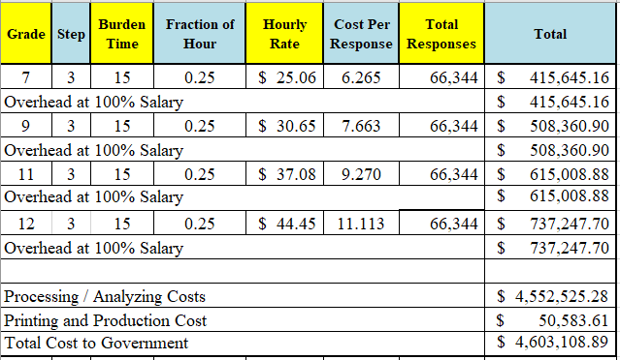
Overhead costs are 100% of salary and are the same as the wage listed above and the amounts are included in the total.

Printing and production costs approximates the cost of printing this information collection per year. (Processing/Analyzing Cost total divided by $90).

Note: The hourly wage information above is based on the hourly 2024 General Schedule (Base) Pay (SALARY TABLE 2024-GS (opm.gov). This rate does not include any locality adjustment as applicable.

The processing time estimates above are based on the actual amount of time employees of each grade level spend to process to completion a claim received on this form. The within-grade step (3) of each employee represents the average experience of employees within each grade.

15. Reasons for Change in Burden

N/A

16. Publication of Results

The information collection is not for publication or tabulation use.

17. Non-Display of OMB Expiration Date

We are not seeking approval to omit the expiration date for OMB approval.

18. Exceptions to “Certification for Paperwork Reduction Submissions”

This submission does not contain any exceptions to the certification statement.

