Table of Contents
EVALUATION SURVEYS 2
1. Welcome Page & Participation Decision – Parent Surveys 2
2. Parent Survey –Survey Questions 3

EVALUATION SURVEYS
- Welcome Page & Participation Decision – Parent Survey
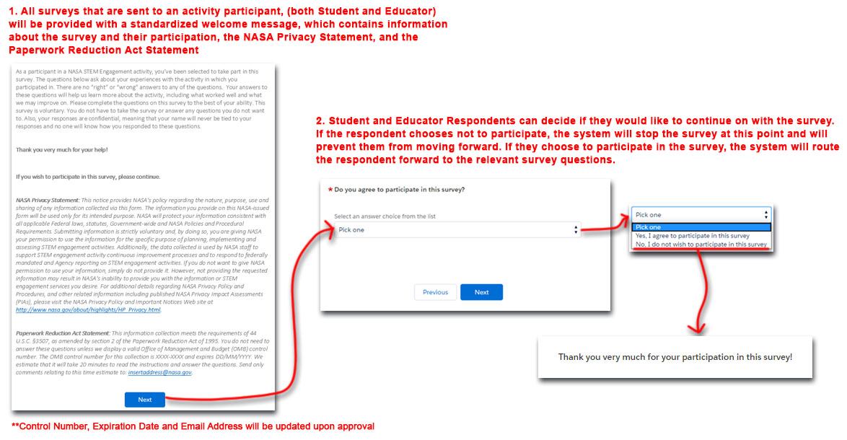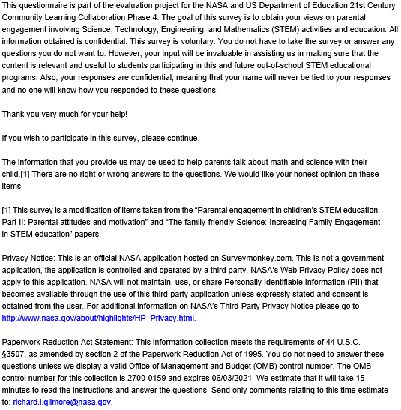
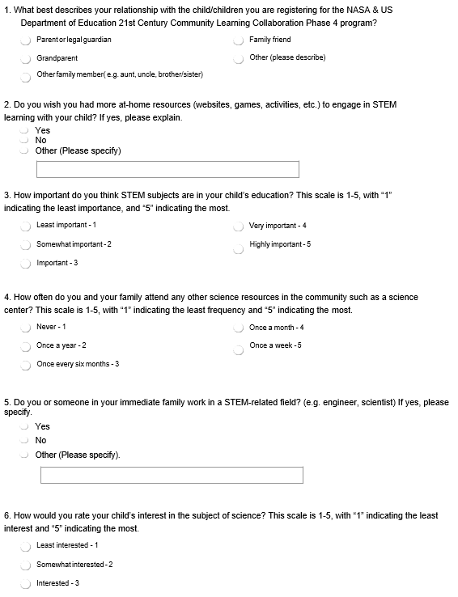
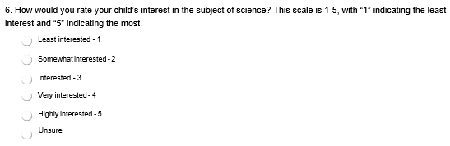
- Parent Survey –Survey Questions
