Table of Contents
EVALUATION SURVEYS 2
1. Welcome Page and Instructions 2
2. Pre-Training (Facilitator Confidence) Survey – Survey Questions 3

EVALUATION SURVEYS
- Welcome Page and Instructions
1. Educators and Facilitators will be provided the welcome page and instructions
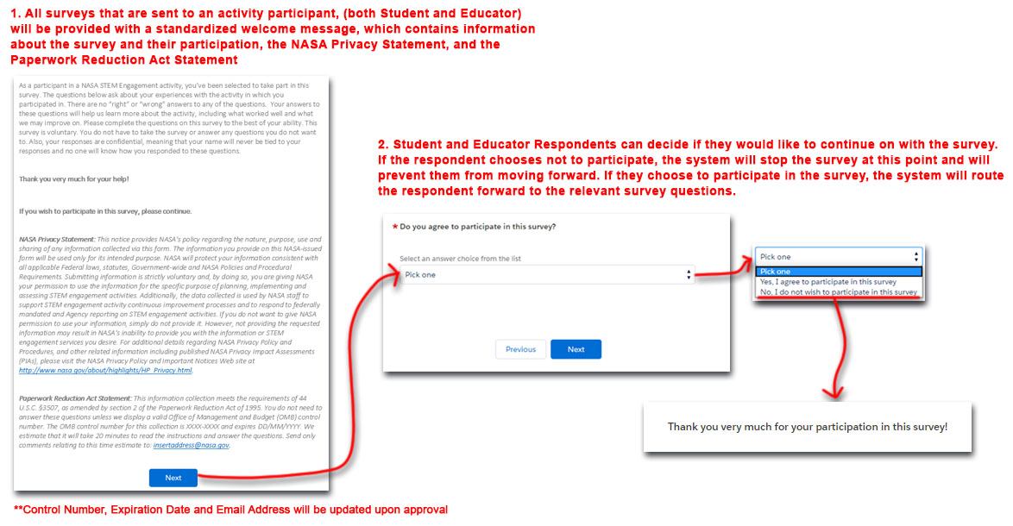
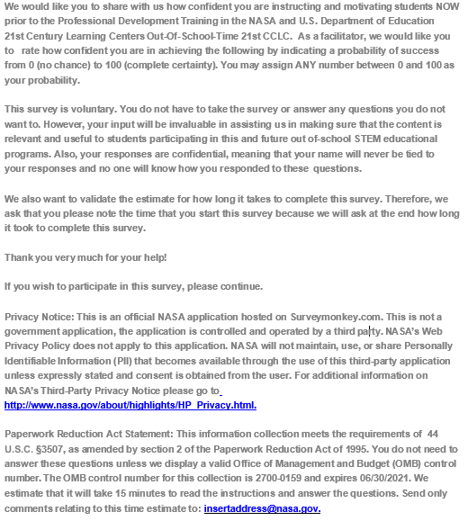

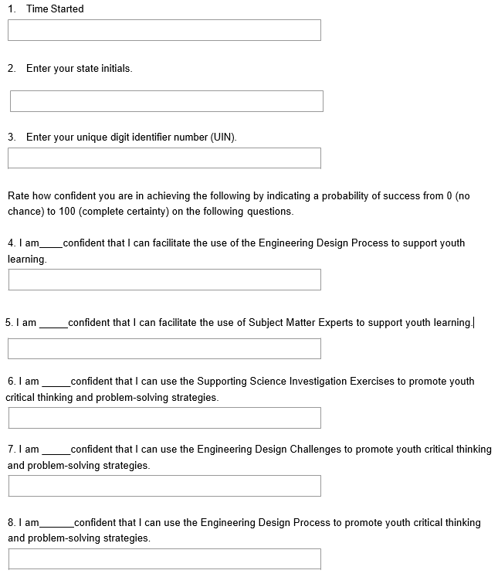
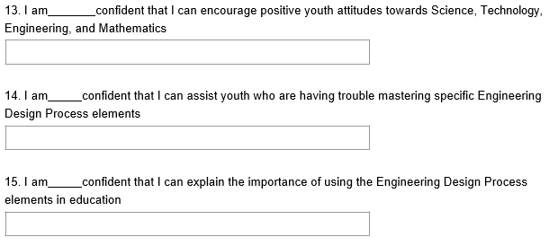
- Pre-Training (Facilitator Confidence) Survey – Survey Questions
