Table of Contents
EVALUATION SURVEYS 2
1. Standard Welcome Page & Participation Decision – ALL Surveys 2
2. Internship Applicants and Awardees Longitudinal Survey – Survey Questions 3

EVALUATION SURVEYS
- Standard Welcome Page & Participation Decision – ALL Surveys
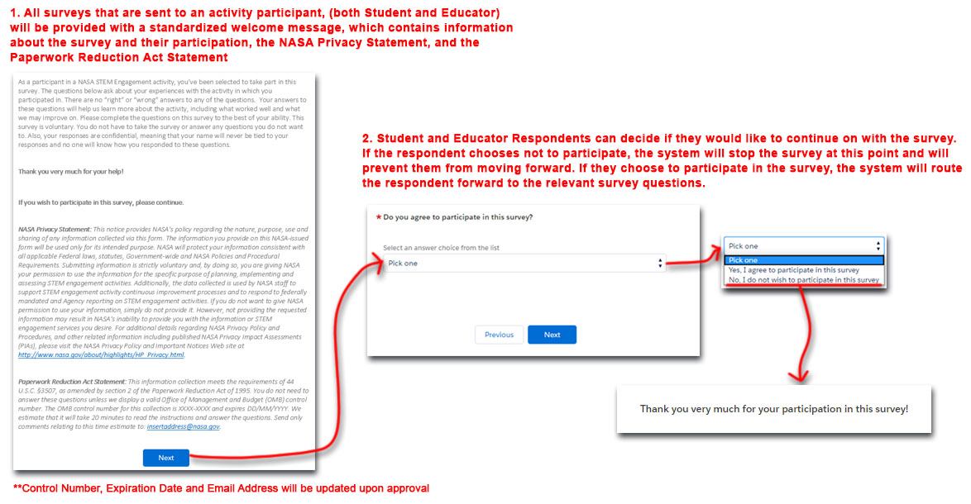
- Internship Applicants and Awardees Longitudinal Survey – Survey Questions
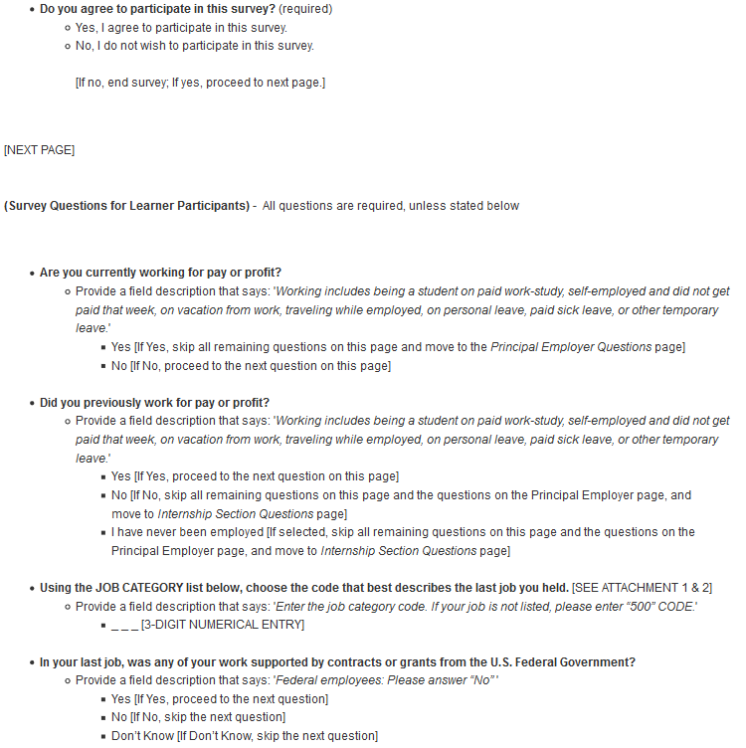

Attachment 1 Attachment 2
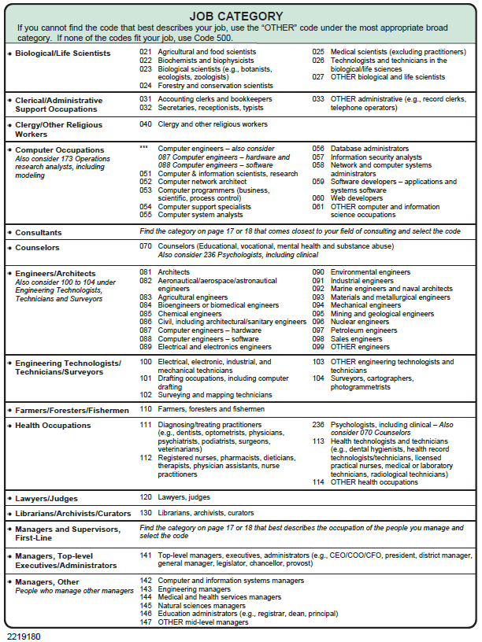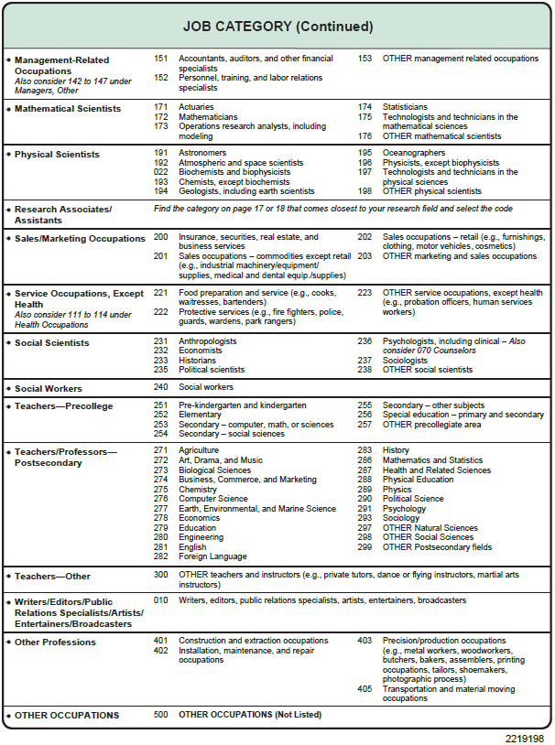

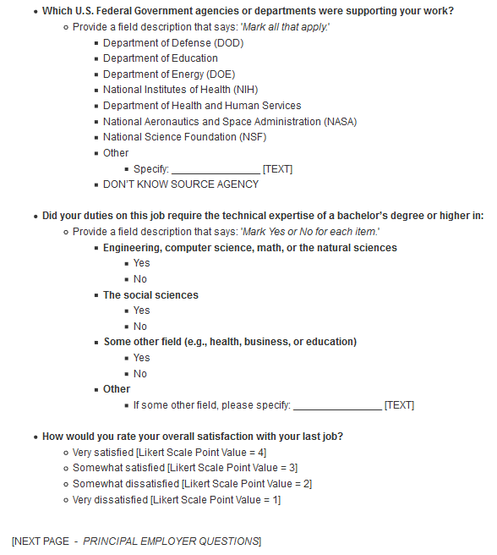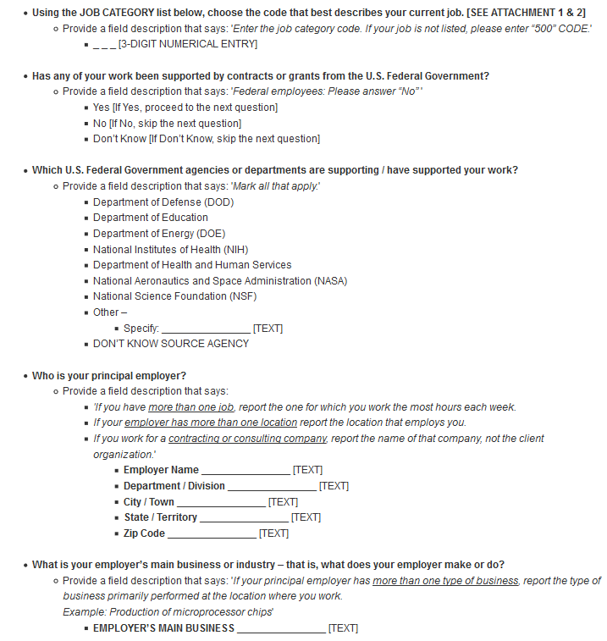

Attachment 1 Attachment 2

