Screenshots of the Federal Service Desk
Customer Satisfaction Survey

Survey Flow Chart
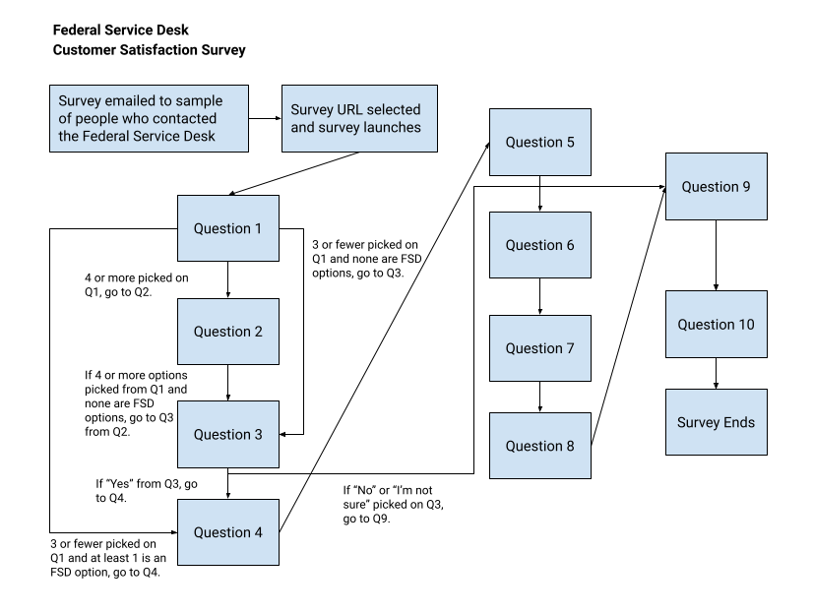

Question 1

- When you need help with SAM.gov, how do you find an answer? Select all that apply. (Answer order is randomized.)
  - Search FSD.gov
  - Use the chat on FSD.gov
  - Submit a web form on FSD.gov
  - Call the FSD help desk phone number
  - Look for help on SAM.gov
  - Ask a colleague
  - Search the internet
  - Something else

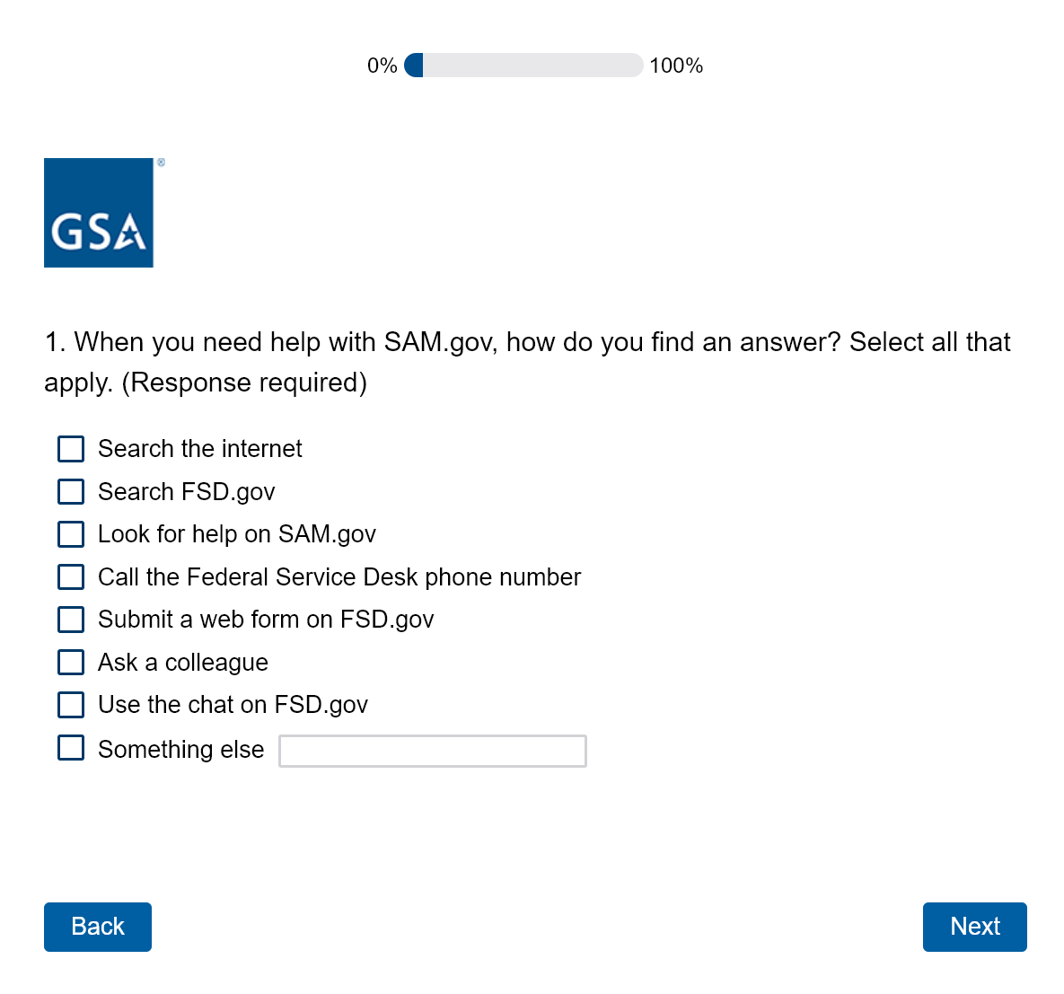

Question 2

- Of the options you chose, select your top three preferred ways to find answers.
(Choices are carried forward from the prior question. If they pick three or fewer, they skip question 2.)
  - Multi-select
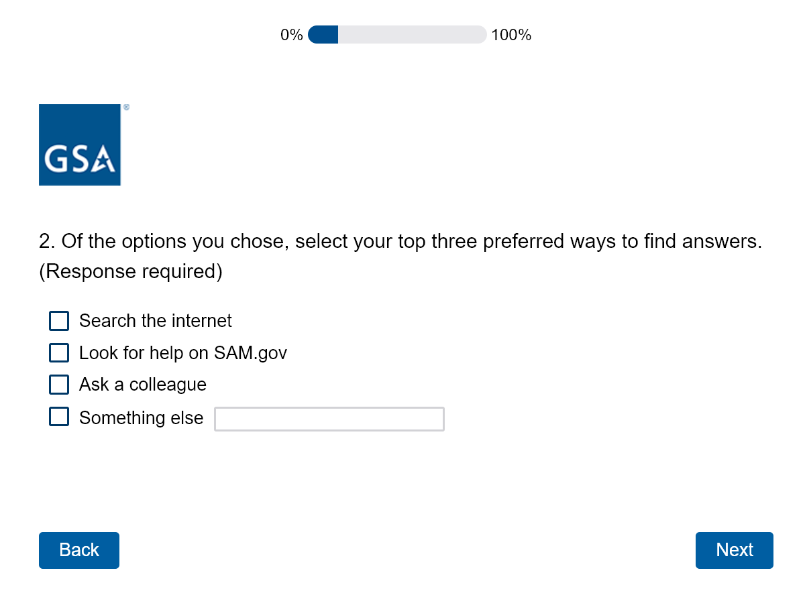

Question 3

- Have you used FSD.gov to get help with a question about SAM.gov?
(If they pick at least one of the FSD options on question 1, they skip question 3. If they select “No” or “I’m not sure,” they skip to question 9.)
  - Yes
  - No
  - I’m not sure
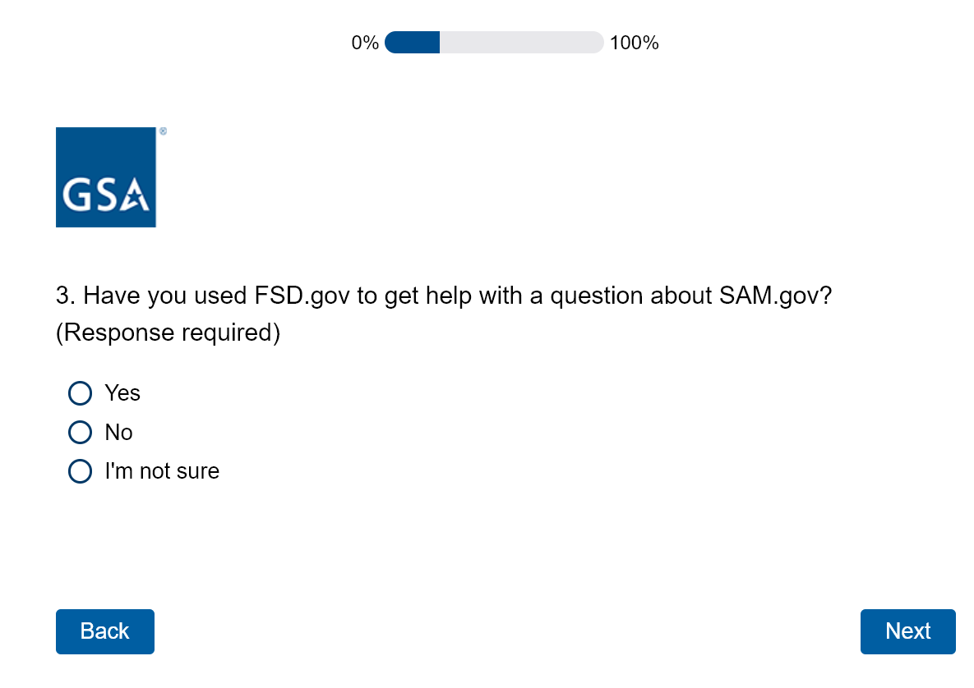

Question 4

- How would you rate your overall satisfaction with the support you received at FSD.gov?
  - Likert scale
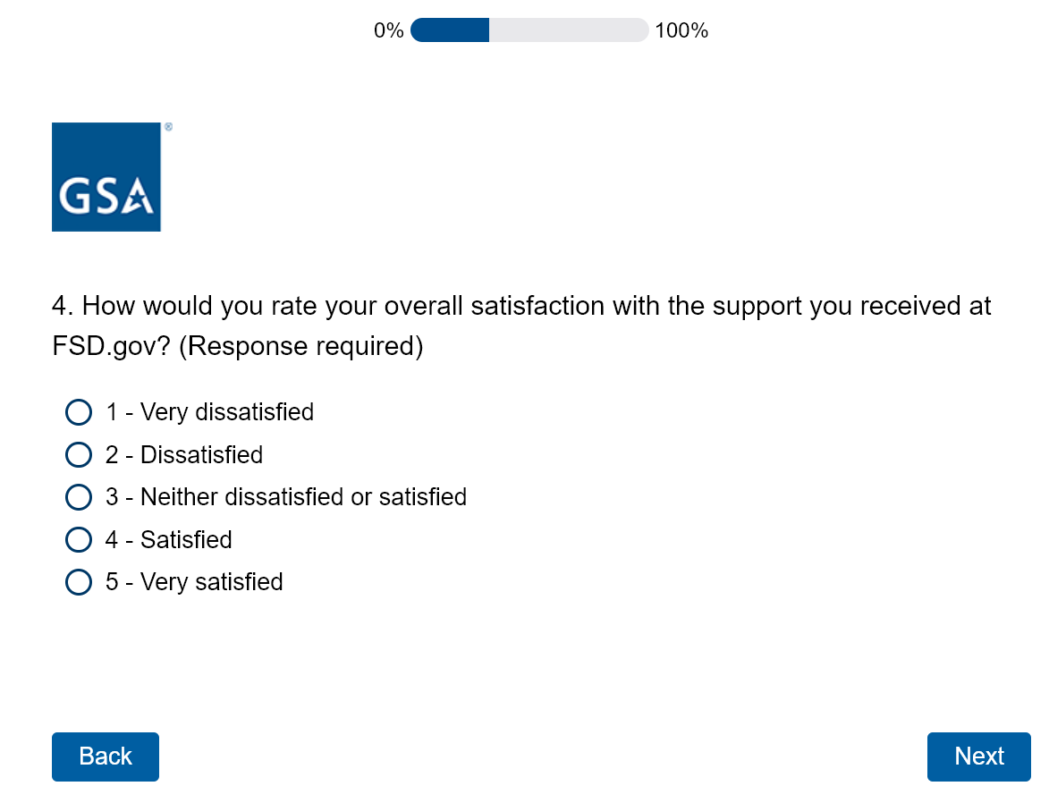
How much do you agree or disagree with the following statements:

Question 5
- When I need help with SAM.gov, the Federal Service Desk is where I start.
  - Likert scale

Question 6
- I get helpful information when I use the Federal Service Desk.
  - Likert scale
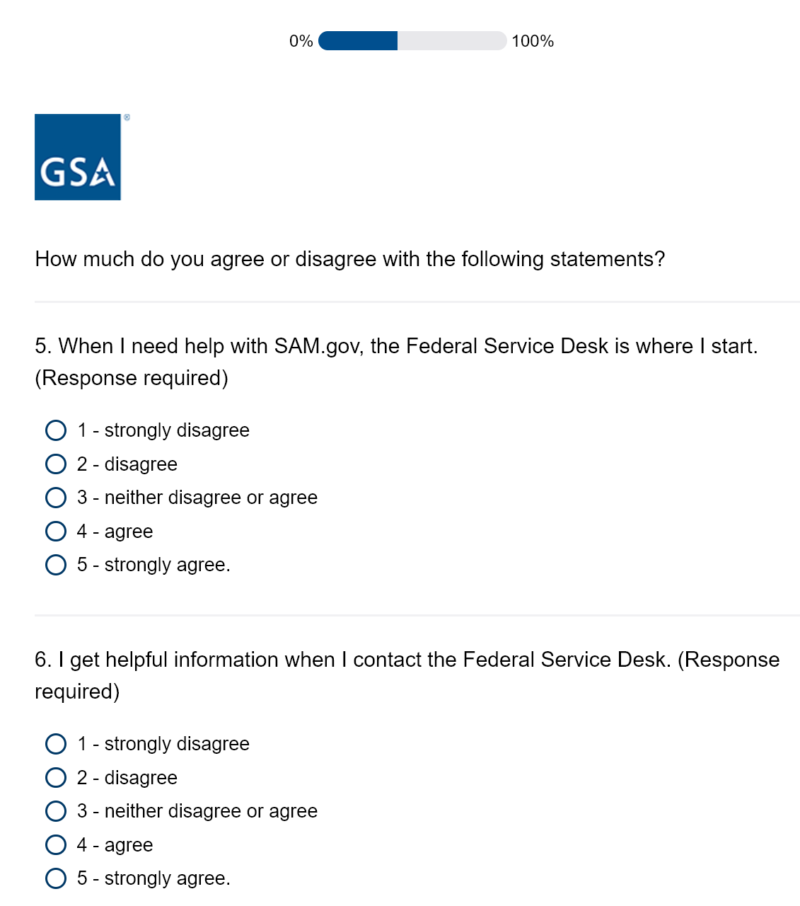

Question 7

- It takes too long to get help from the Federal Service Desk.
  - Likert scale

Question 8

- Finding answers to my questions about SAM.gov is difficult.
  - Likert scale

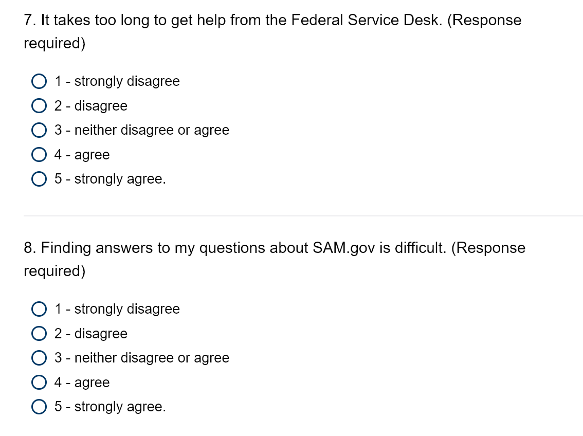

Question 9

- What works well when you get help with SAM.gov?
  - Open feedback
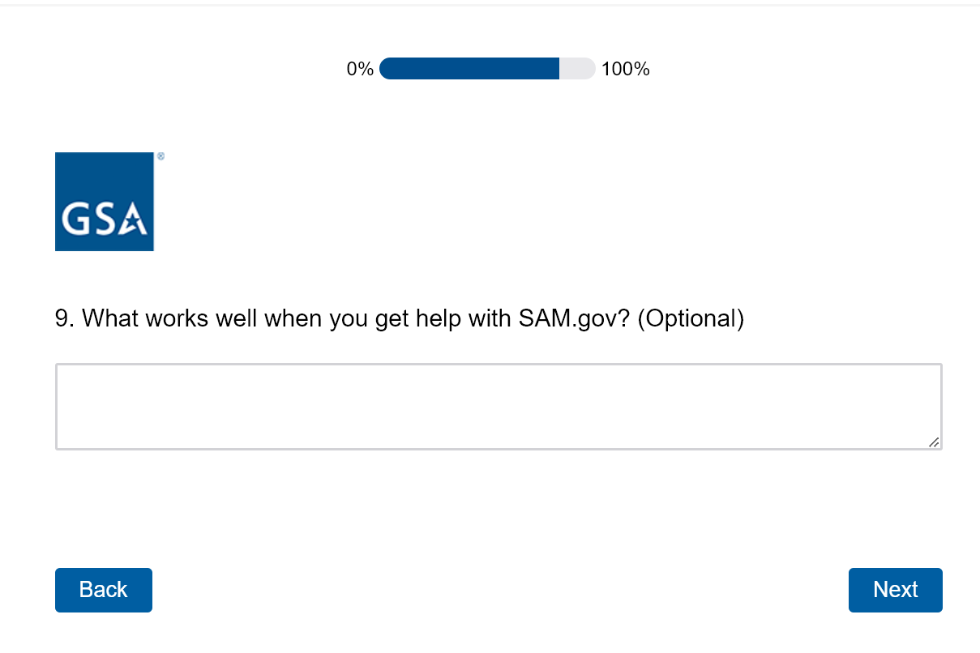

Question 10

- How can we support you better when you get help with SAM.gov?
  - Open feedback
