Request for Approval under the “Generic Clearance for the Collection of Routine Customer Feedback” (OMB Control Number: 3090-0297)
(Req-)

Title: Voluntary Customer Satisfaction Survey for Customers of the USAGov Telephone Government Information Service Who Speak to an Information Specialist

Upon completion of conversation with an Information Specialist (aka Agent), customers may receive an SMS (text) message to their mobile phone. The message contains a weblink to a webform. Participants submit responses using the webform. The survey is optional.

POC: david.kaufmann@gsa.gov

ENGLISH VERSION

Paperwork Reduction Act Statement:
OMB No: 3090-0297
Expires 06/30/2025

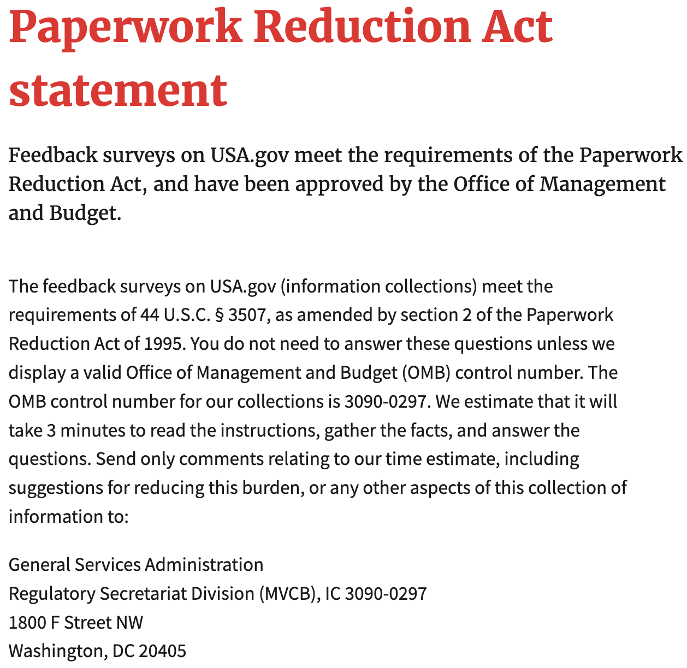

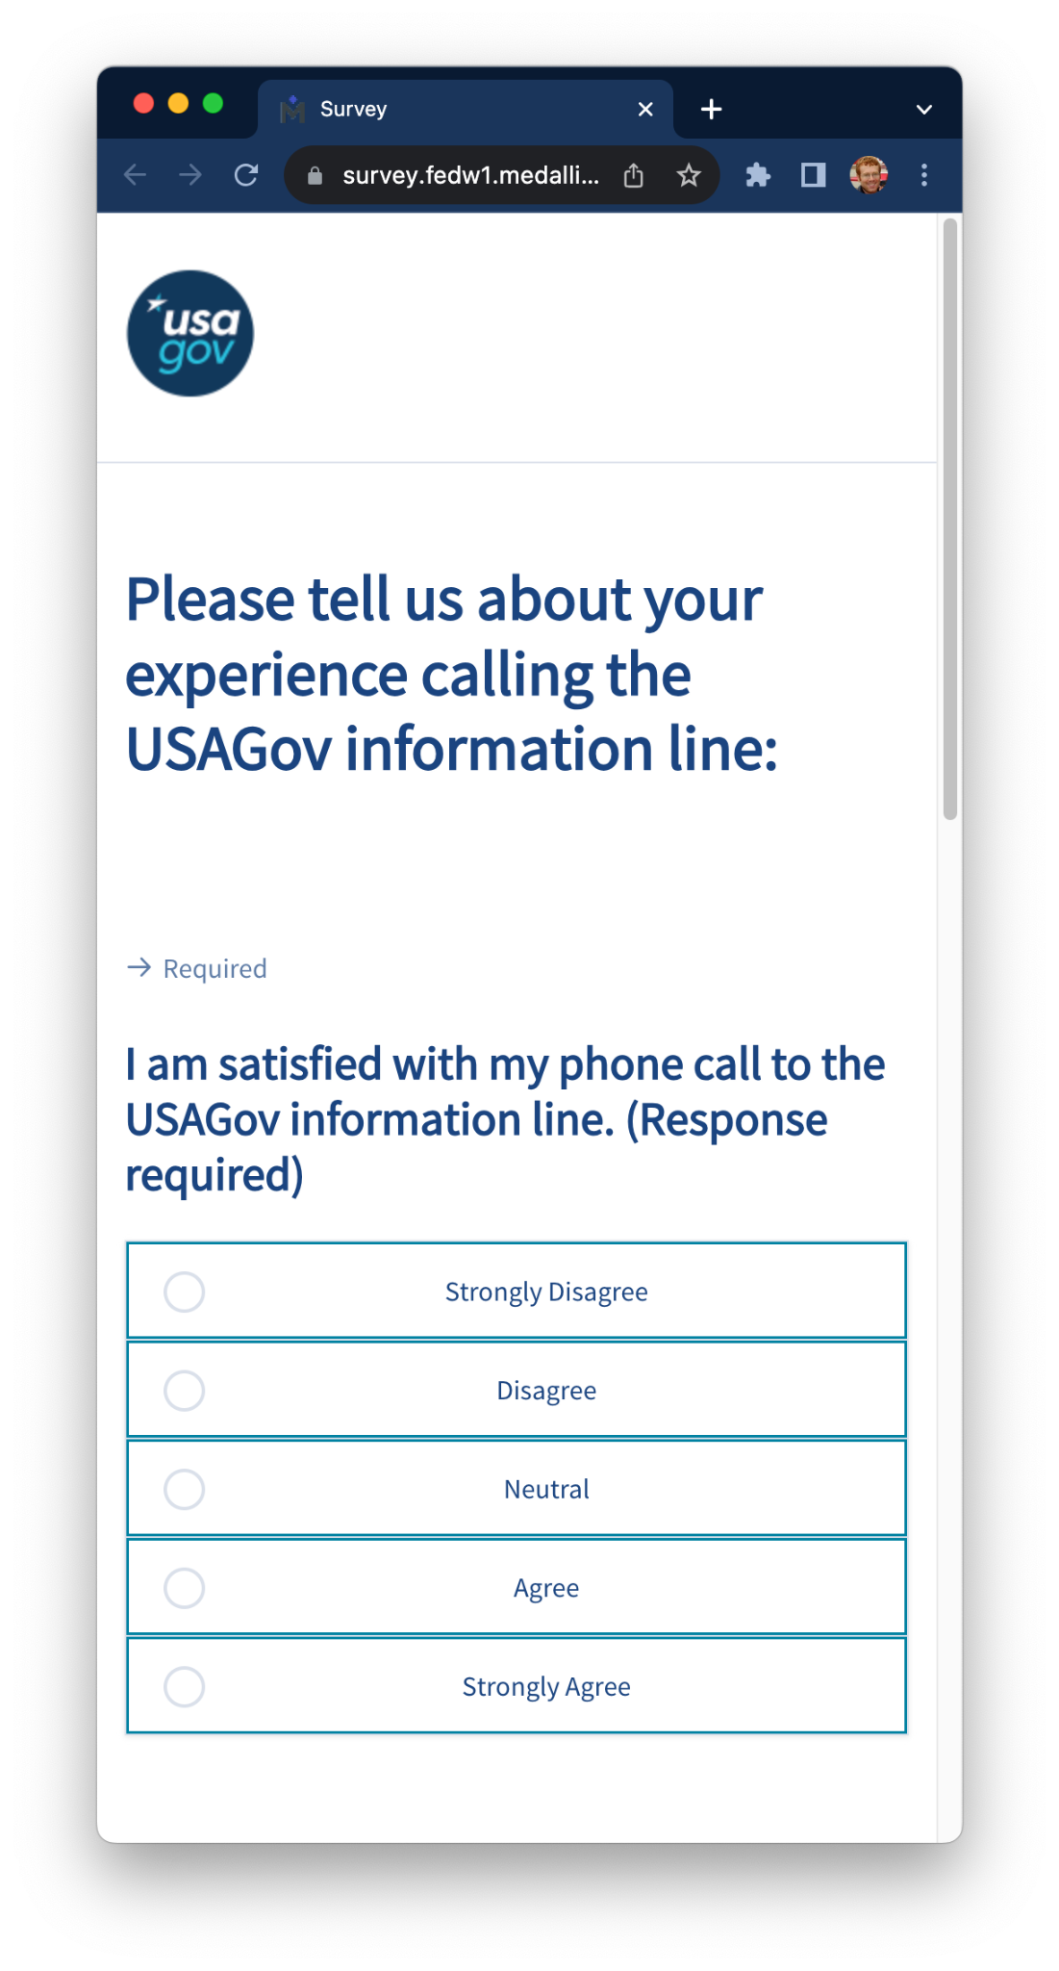
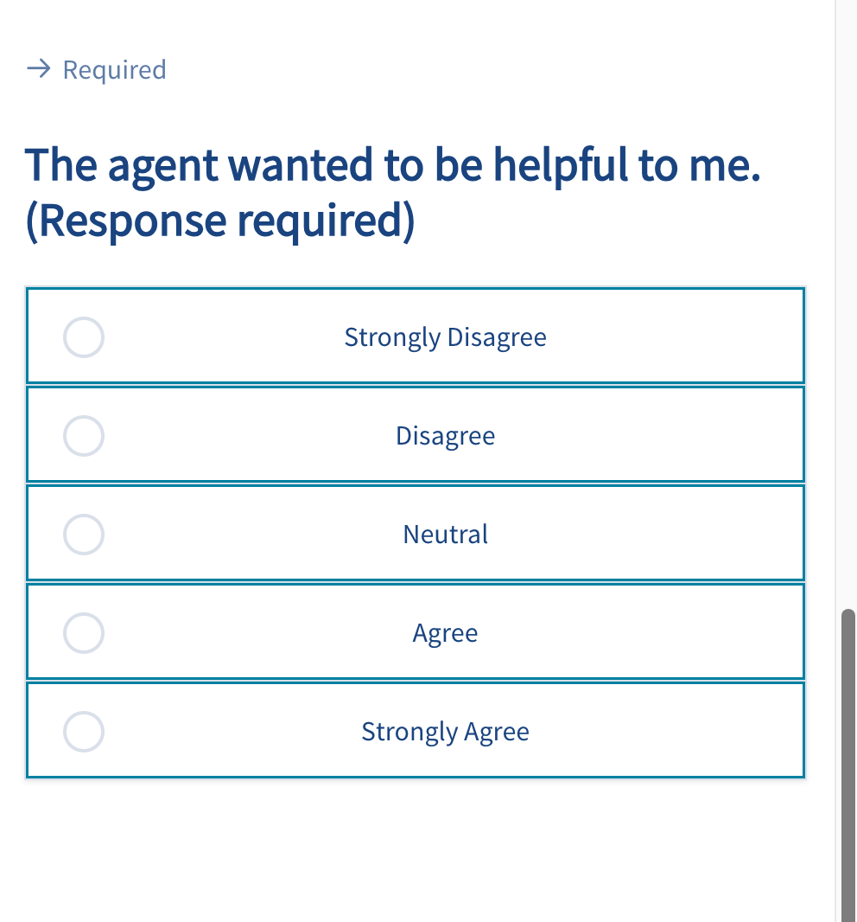
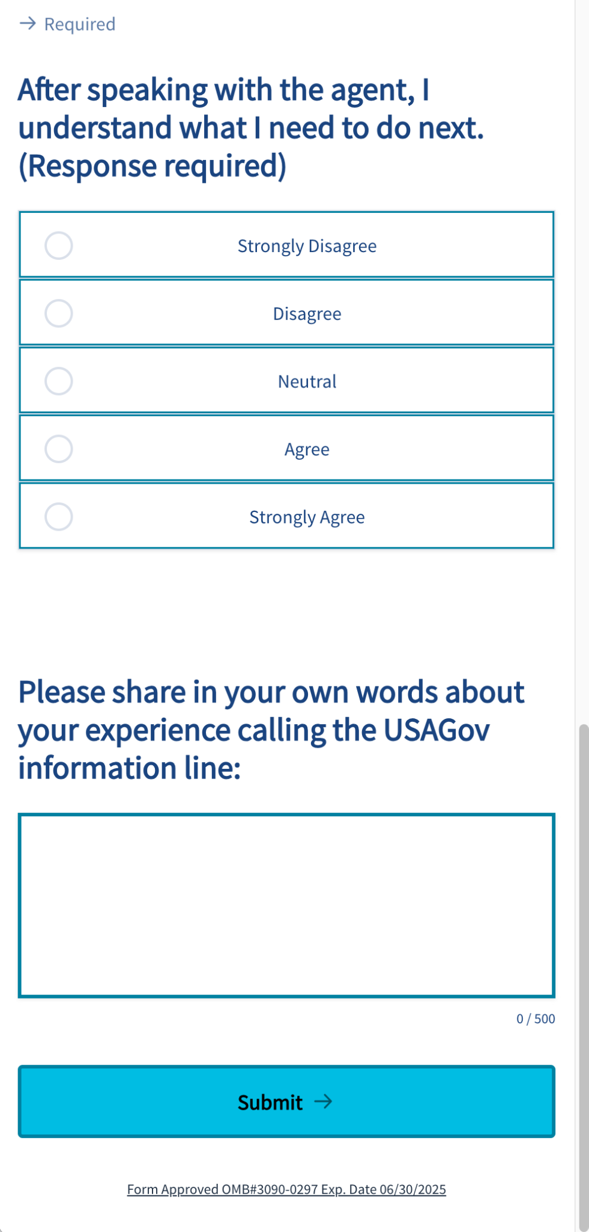

SPANISH VERSION

Paperwork Reduction Act Statement:
OMB No: 3090-0297
Expires 06/30/2025

