This set of screenshots captures the Renewal of Broadcast Station License flow in the LMS application.
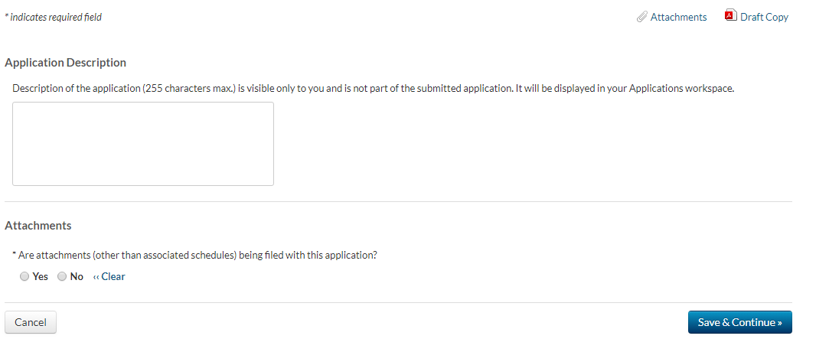

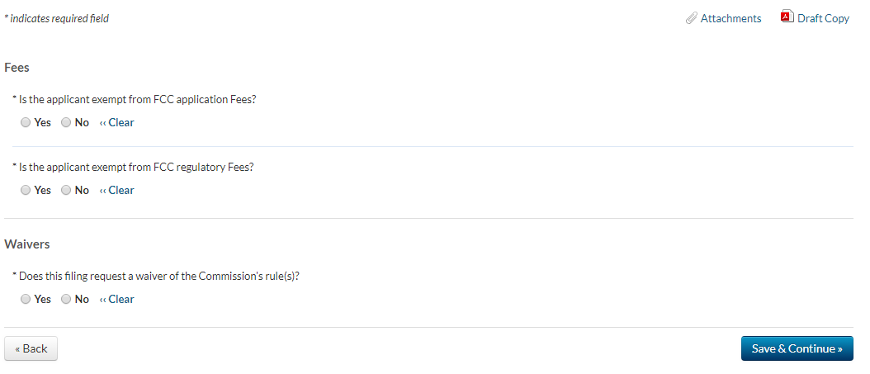

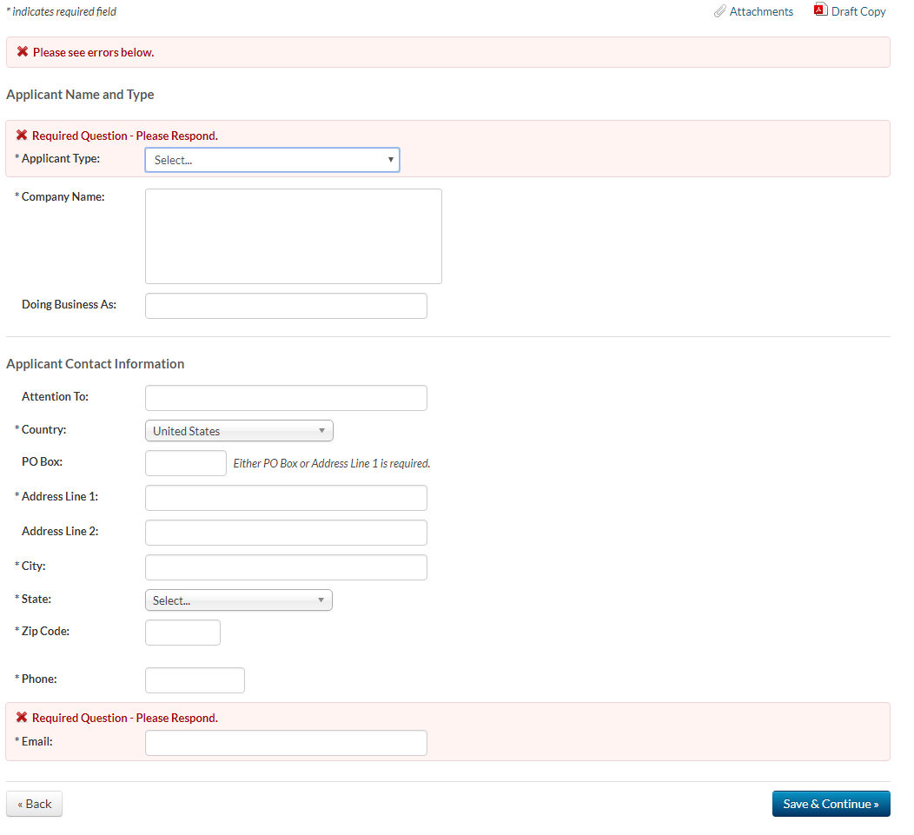

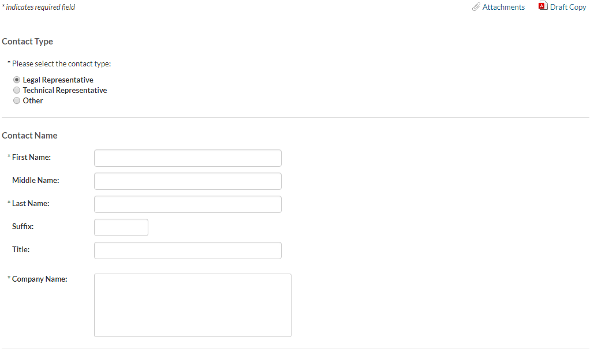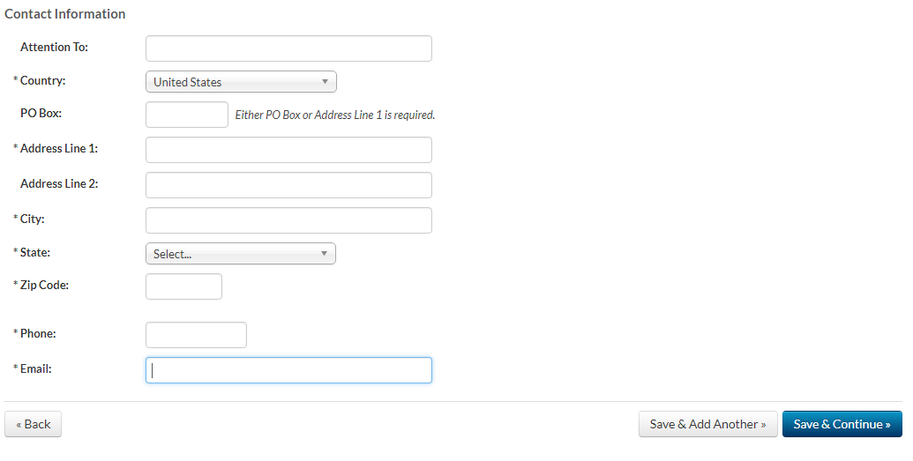

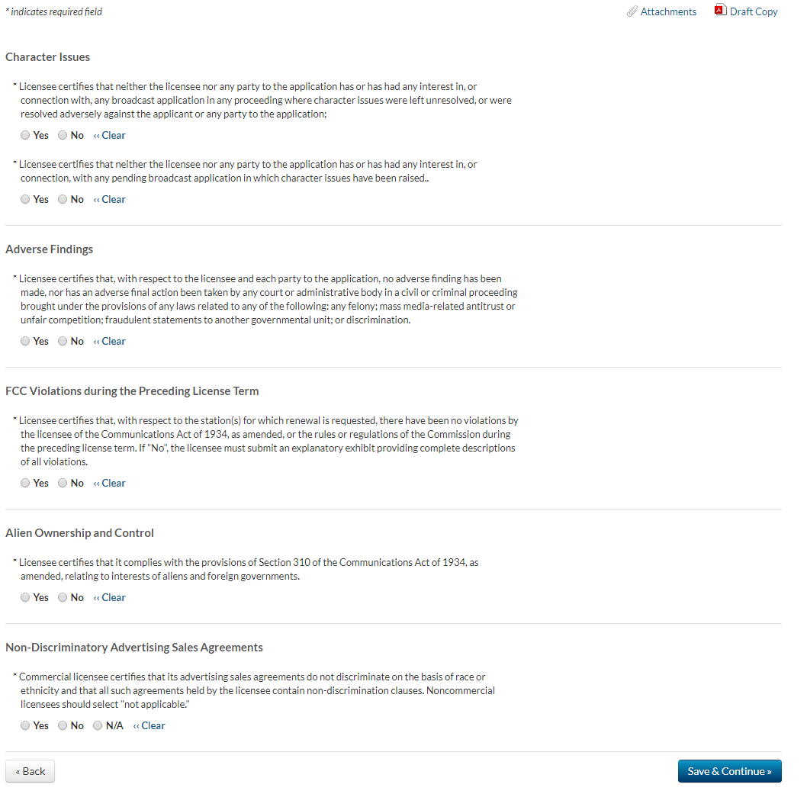
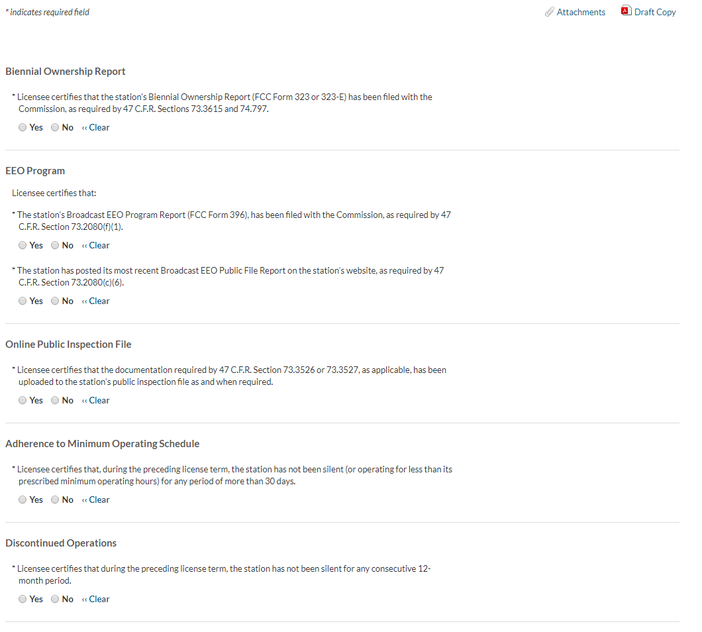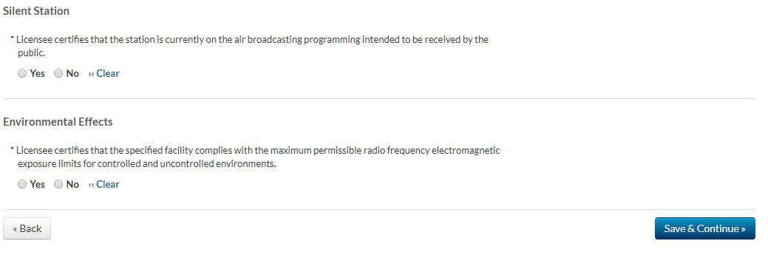

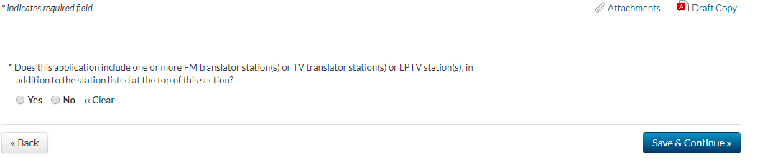

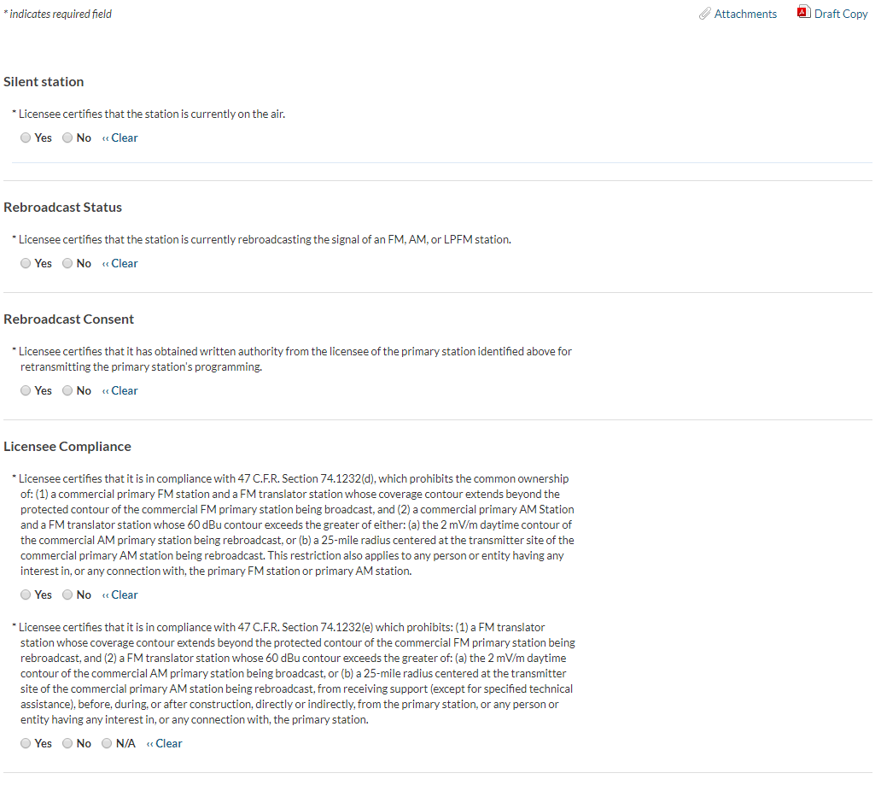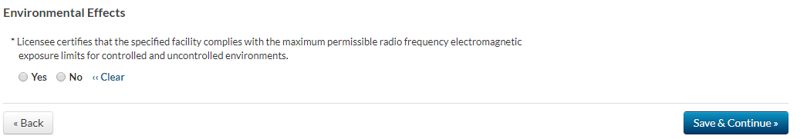
Section: DTV/Class A Certification
Biennial Ownership Report. Licensee certifies that the station's Biennial Ownership Report (FCC Form 323 or 323-E) has been filed with the Commission, as required by 47 CFR Section 73.3615.
Yes/No. If no, require exhibit.
EEO Program. Licensee certifies that
- The station’s Broadcast EEO Program Report (FCC Form 396), has been filed with the Commission as required by 47 CFR Section 73.2080(f)(1).
Yes/No. If no, require exhibit.
Specify FCC Form 396 File Number:

- The station has posted its most recent Broadcast EEO Public File Report on the station’s website, as required by 47 CFR Section 73.2080(c)(6).
Yes/No/Not Applicable. If no, require exhibit.
Online Public Inspection File. Licensee certifies that the documentation required by 47 CFR Sections 73.3526 or 73.3527, as applicable, has been uploaded to the station’s public inspection file when required.
Yes/No. If no, require exhibit.
Children’s Programming Commercial Limitations. For the period of time covered by this application, the licensee certifies that it has complied with the limits on commercial matter as set forth in 47 CFR Section 73.670 and the Commission’s commercial limit policies related to host-selling and program-length commercials.
Yes/No. If no, submit as an Exhibit a statement of explanation.
Children’s Television Programming Reports. For the period of time covered by this application, the licensee certifies that it has filed with the Commission, and incorporates by reference, the Children's Television Programming Reports (FCC Form 2100, Schedule H), as described in 47 CFR Section 73.3526, containing all required information.
Yes/No. If no, submit as an Exhibit a statement of explanation.
Core Programing Processing Guidelines. For the period of time covered by this application, the licensee certifies that the station has complied with the Core Programming criteria and Core Programming Processing Guidelines, as required by the Commission’s rules that were in effect at the time the Core Program was aired.
Yes/No. If no, submit as an Exhibit a statement of explanation.
E/I Symbol. The licensee certifies that, as required by 47 CFR Section 73.671(c)(5), it identifies each Core Program using the E/I symbol throughout the airing of each program.
Yes/No. If no, submit as an Exhibit a statement of explanation.
Notifying Publishers of Program Guides. The licensee certifies that it provides information identifying each Core Program aired on its station to publishers of program guides, as required by 47 CFR Section 73.673.
Yes/No. If no, submit as an Exhibit a statement of explanation.
Publicizing Children’s Reports. The licensee certifies that prior to January 20, 2020, it publicized the existence and location of the station's Children's Television Programming Reports (FCC Form 2100, Schedule H) as required by 47 CFR Section 73.3526(e)(11)(iii).
Yes/No. If no, submit as an Exhibit a statement of explanation.
Children’s Programming Disclosures and Other Efforts. The licensee may include as an exhibit an explanation of any violations of the Commission’s children’s television programing rules and any other comments or information it wants the Commission to consider in evaluating compliance with the Children's Television Act. Attach Exhibit (Optional)
Continued Class A Eligibility (Class A Only). Licensee certifies that its station does, and will continue to, broadcast: (a) a minimum of 18 hours per day; and (b) an average of at least 3 hours per week of programming each quarter produced within the market area served by the station, or by a group of commonly controlled low power or Class A stations whose predicted Grade B contours are contiguous. See 47 CFR Section 73.6001.
Yes/No. If no, submit as an Exhibit a statement of explanation.

Discontinued Operations. Licensee certifies that during the preceding license term, the station has not been silent for any consecutive 12-month period.
Yes/No. If no, submit as an Exhibit a statement of explanation.
Silent Stations. Licensee certifies that the station is currently on the air broadcasting programming intended to be received by the public.
Yes/No. If no, submit as an Exhibit a statement of explanation.
Environmental Effects. Licensee certifies that the specified facility complies with the maximum permissible radio frequency electromagnetic exposure limits for controlled and uncontrolled environments.
Yes/No. If no, submit as an Exhibit a statement of explanation.
Adherence to Minimum Operating Schedule. Licensee certifies that during the preceding license term the station has not been silent (or operating for less than its prescribed minimum operating hours) for any period of more than 30 days.
Yes/No. If no, submit as an Exhibit a statement of explanation.
Adherence to Operating Parameters. Licensee certifies that during the preceding license term, the station has operated pursuant to authorized operating parameters, either pursuant to the terms of its license, special temporary authority, or as otherwise permitted under the Commission’s rules.
Yes/No. If no, submit as an Exhibit a statement of explanation.

Section: Other Broadcast Certifications
Does this application include one or more FM translator station(s) or TV translator station(s) or LPTV station(s), in addition to the station listed at the top of this section?
Yes/No. [If yes, ask for call sign, facility identifier, and community of license, permit multiple entries.]
Call Sign | Facility Identifier | Community of license (City/State)

Section: TV Translators and Low Power TV Licensees
Silent Station: Licensee certifies the station is currently on the air broadcasting programming intended to be received by the public.
Yes/No. If no, submit as an Exhibit a statement of explanation.

Rebroadcast Status. Licensee certifies that the station is currently rebroadcasting the signal of a full power TV, Class A TV, or LPTV station.
Yes/No/Not Applicable. If yes, identify the station being broadcast.
Call Sign | Facility Identifier | Community of license (City/State)

Rebroadcast Consent. Licensee certifies that it has obtained written authority from the licensee of the primary station identified above for retransmitting the primary station's programming.
Yes/No/Not Applicable. If no, submit as an Exhibit a statement of explanation.
EEO Program Report (For LPTV Applicants Only). Licensee certifies that it has filed with the Commission the station's Broadcast EEO Program Report (FCC Form 396), and has posted the most recent Public File Report on the station's website (if it has one), as required by 47 CFR Sections 73.2080(f)(1) and 73.2080(c)(6).
Yes/No. If no, require exhibit.
Specify FCC Form 396 File Number:
Environmental Effects. Licensee certifies that the specified facility complies with the maximum permissible radio frequency electromagnetic exposure limits for controlled and uncontrolled environments.
Yes/No. If no, submit as an Exhibit a statement of explanation.
Biennial Ownership Report (LPTV stations only). Licensee certifies that the station's Biennial Ownership Report (FCC Form 323 or 323-E) has been filed with the Commission, as required by 47 CFR Section 74.797
Yes/No. If no, submit as an Exhibit a statement of explanation.
Discontinued Operations. Licensee certifies that during the preceding license term the station has not been silent for any consecutive 12-month period.
Yes/No. If no, submit as an Exhibit a statement of explanation.
Adherence to Minimum Operating Schedule. Licensee certifies that during the preceding license term the station has not been silent (or operating for less than its prescribed minimum operating hours) for any period of more than 30 days.
Yes/No. If no, submit as an Exhibit a statement of explanation.
Adherence to Operating Parameters. Licensee certifies that during the preceding license term the station has operated pursuant to its authorized operating parameters, either pursuant to the terms of its license, special temporary authority, or as otherwise permitted under the Commission’s rules.
Yes/No. If no, submit as an Exhibit a statement of explanation.

