October 27, 2023

MEMORANDUM FOR : Reviewer of 1220-0045

FROM : Tiffany Pinkney, Chief
Division of Collection and Review
Office of Safety and Health Statistics
Office of Compensation and Working Conditions
Bureau of Labor Statistics

SUBJECT : Nonsubstantive change request for the Reference Year (RY)
2023 Survey of Occupational Injuries and Illnesses

The Bureau of Labor Statistics (BLS) seeks approval for nonsubstantive updates to screens in the BLS Internet Data Collection Facility (IDCF) for the upcoming collection of the reference year (RY) 2023 Survey of Occupational Injuries and Illnesses (SOII).

Background
In 2016, OSHA passed a new rule that required employers in designated industries to annually report information from their OSHA form 300A (Summary of Work-Related Injuries and Illnesses) using OSHA’s Injury Tracking Application (API) starting in 2017. OSHA’s ITA collection overlapped with the BLS SOII collection and resulted in duplicative reporting burden for respondents required to report to both agencies. The Office of Management and Budget (OMB) directed BLS and OSHA to work together to find a way to mitigate this duplicative reporting burden. The BLS and OSHA coordinated to implement an Application Programming Interface (API) to import into the SOII IDCF data that a respondent previously reported to the OSHA ITA. This API has reduced reporting burden for thousands of respondents annually that have been able to import their summary data from OSHA ITA when reporting for the BLS SOII.

In 2023, OSHA revised their rule to require respondents in designated industries to also report case details for injuries and illnesses from their OSHA form 300 (Log of Work-Related Injuries and Illnesses) and OSHA form 301 (Injury and Illness Incident Report). To further mitigate additional reporting burden from this revised rule, the BLS is coordinating again with OSHA to implement a new API that will allow respondents who have already reported to OSHA ITA to import both their summary data that they have been required to report since 2017 and case details being added to OSHA ITA reporting starting in January 2024. The BLS is implementing changes to screens in its SOII IDCF application to support this new import of case details.

Nonsubstantive updates to screens in the BLS SOII IDCF include new and revised messaging to aid SOII respondents in importing details for their injury and illness cases that they are newly required to report to OSHA ITA. These nonsubstantive updates to SOII IDCF include:

- New pop-up messaging is added to the screen on which a respondent is asked to enter their OSHA ID that is used to match the SOII establishment to import data reported to OSHA ITA. The following two new messages are being added to inform respondents when (a) a match is found in OSHA ITA and data are imported or (b) when technical difficulties occur and data could not be imported.

- New pop-up messaging (Match Found):

- New pop-up messaging (Technical Difficulty):

- The existing Tooltip that aids respondents in identifying their OSHA ID (assigned when reporting to OSHA ITA) is updated minimally to reflect this may now be a 6- or 7-digit number; previously OSHA IDs were limited to 6-digits but have been expanded by OSHA.

- Instructions in Section 3 (Cases with Days Away From Work, Job Transfer, or Restriction) are updated to instruct respondents reporting 8 or fewer cases to review the case details imported from OSHA ITA and to enter information not imported from OSHA (i.e., OSHA excluded some case information in their collection and BLS collects some elements not included in OSHA collection, that respondents must add).

- Instructions in Section 3 (Cases with Days Away From Work, Job Transfer, or Restriction) are updated for respondents reporting 9 or more cases. To reduce reporting burden for respondents with higher number of cases, BLS subsamples cases and instructs the respondent to report details for 8 specified cases from their case log. Instructions on this screen are updated to instruct the respondent to review their data imported from OSHA ITA and to enter information not imported from OSHA (i.e., OSHA excluded collection of some case information in their collection and BLS collects some elements not included in OSHA collection, that respondents must add). The Selected Case numbers displayed on the screen are also updated to reflect the case numbers the respondent reported to OSHA ITA. This will allow the respondent to easily identify cases from their logs to verify imported data and to add details not collected by OSHA.

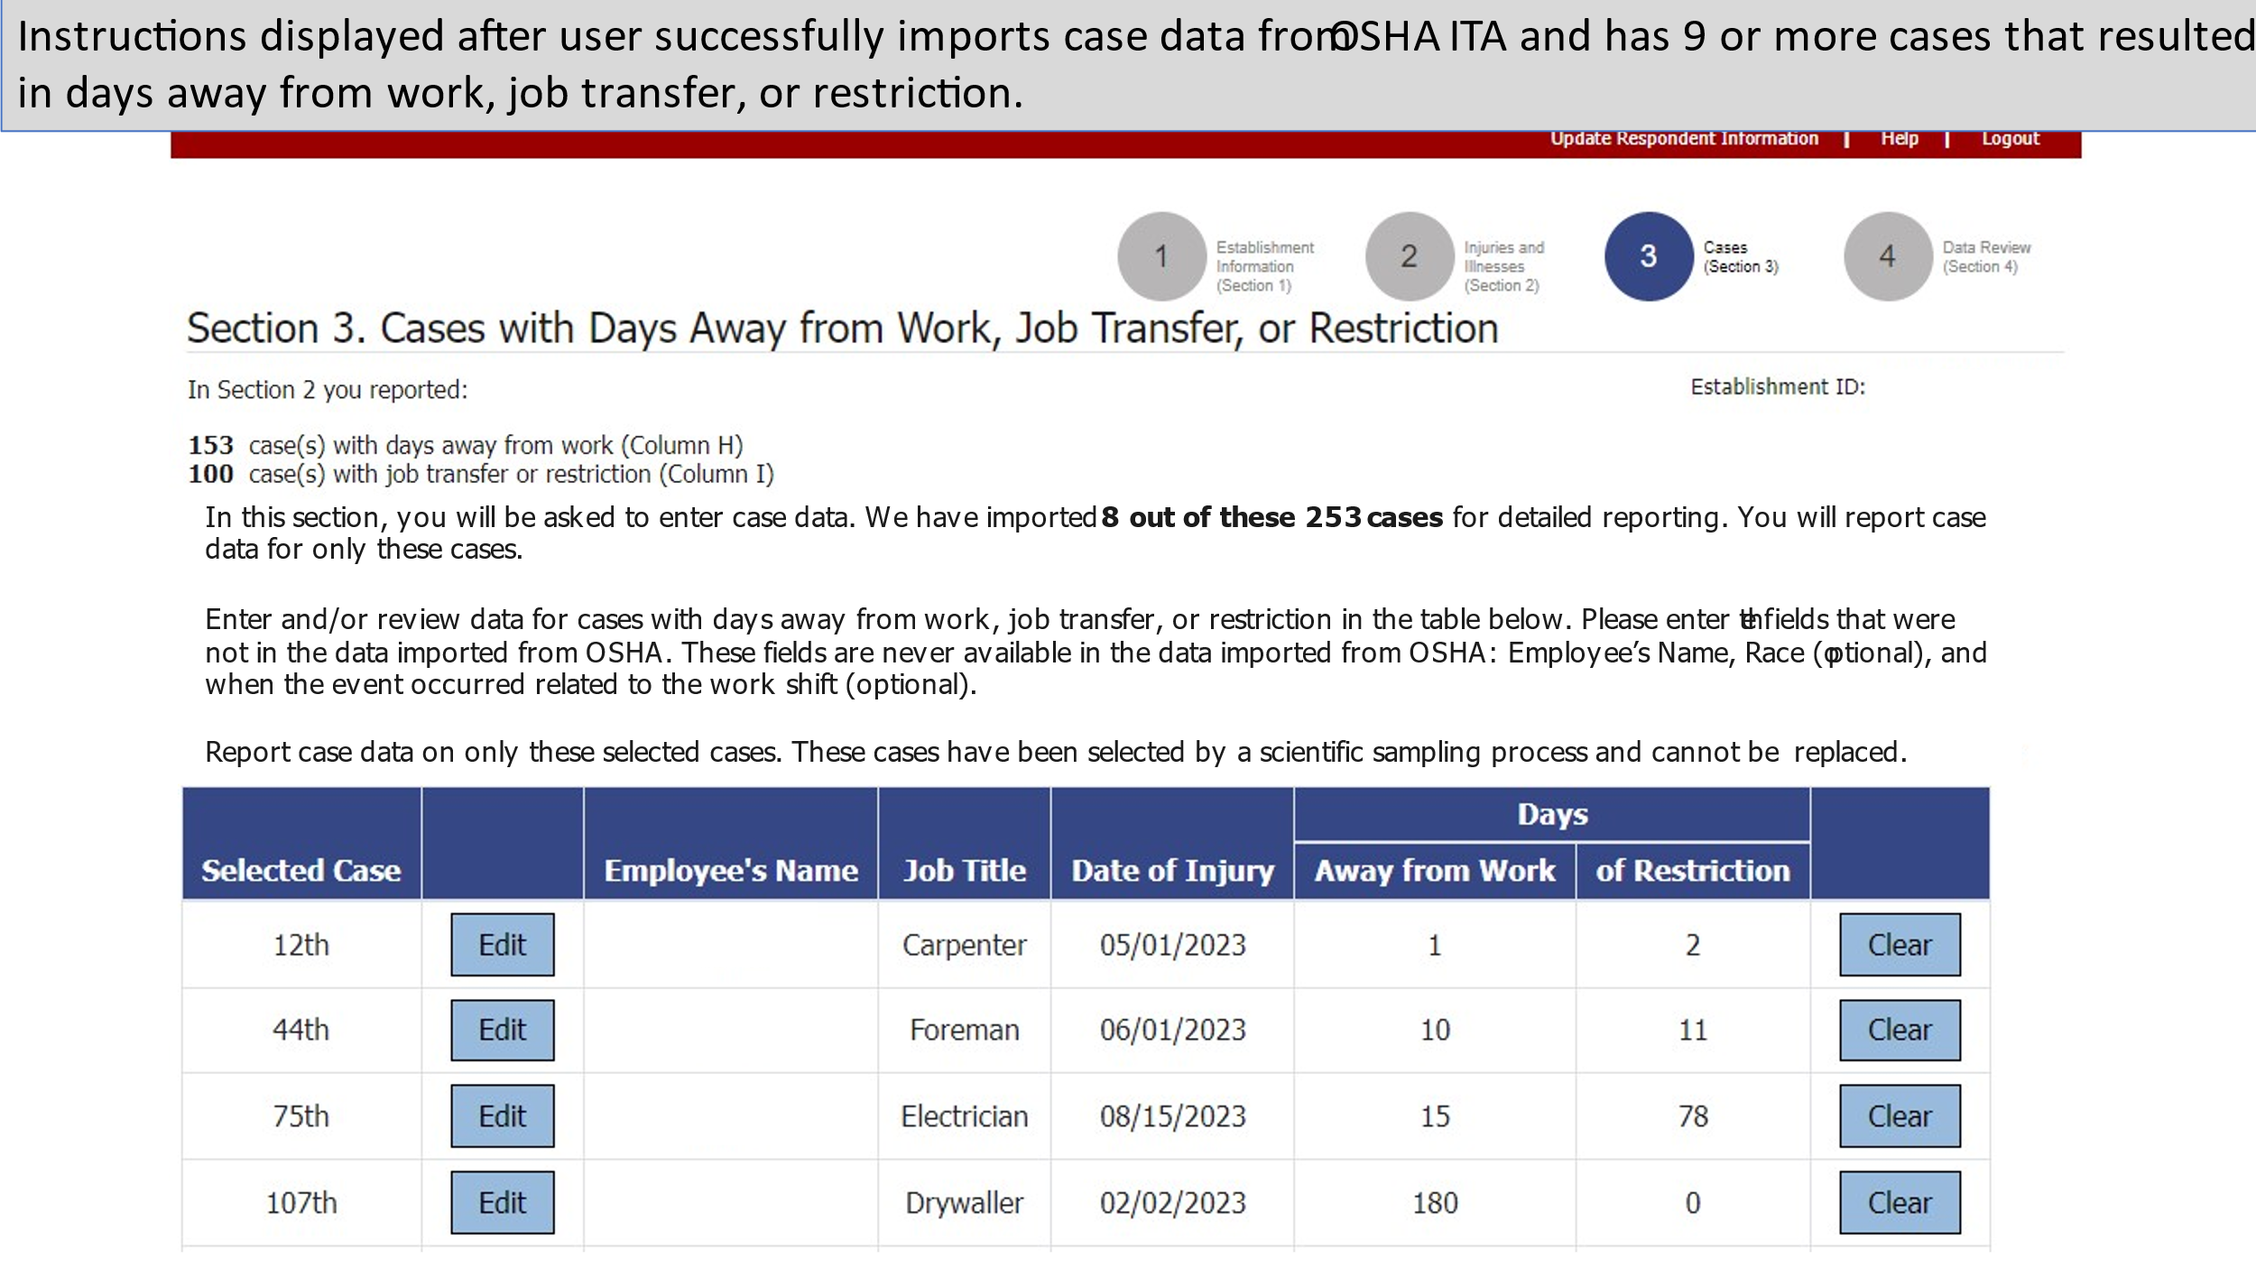

- A new soft edit message is being added and will appear in Section 4 (Data Review) to request the respondent add Employee Name to cases imported from OSHA ITA. This element is not being collected by OSHA but is important for BLS data quality processes. The soft edit will read: “Please enter employee names in Section 3.”

- Instructions are updated on the Help Page explaining how to determine the annual average number of employees.

- Instructions are updated on the Help Page explaining how to determine the total hours worked by all employees.

These updates reflect OSHA’s revised rule requiring respondents to report case details annually to OSHA ITA. These updates to the BLS SOII IDCF application are intended to reduce reporting burden for respondents required to report to both OSHA and BLS by providing the opportunity to import the case details from OSHA ITA when reporting for the BLS SOII. Although reporting burden will be reduced, we are unable to quantify this reduction until these data have been collected and we know the number of cases that have been imported with this new process. If you have any questions about this request, please contact Tiffany Pinkney by telephone at 202-691-6218 or by e-mail at pinkney.tiffany@bls.gov.

