NATIONAL CENTER FOR EDUCATION STATISTICS
NATIONAL ASSESSMENT OF EDUCATIONAL PROGRESS

National Assessment of Educational Progress (NAEP) 2024

Appendix I

Content of Assessment Management System (AMS)

OMB# 1850-0928 v.31



August 2023
Appendices that are marked “Approved v.30” were previously approved in Amendment #2 (OMB# 1850-0928 v.30), in August 2023. Screens that are marked “NEW” are new to this Amendment #3 submission for the 2024 NAEP administration. Appendix I2 (HSTS AMS screens) have been merged into this Appendix I document and are now in Appendix I15.
There is a possibility that some of the screens in this document will require small technical revisions after the 30D inspection period is complete but before OMB approval. Final drafts of all approved documents are always available on reginfo.gov.
Table of Contents
Assessment Management System (AMS) 3
Appendix I1: Login Screen, English and Spanish Puerto Rico 4
Appendix I2: School Summary Page, English and Spanish Puerto Rico (Approved v.30) 5
Appendix I3: Manage Questionnaires, English and Spanish Puerto Rico (NEW) 9
Appendix I4: Add New Students, English and Spanish Puerto Rico (NEW) 18
Appendix I5: Instructions for Preparing and Importing a Student Excel File (Approved v.30) 25
Appendix I6: Internet Connectivity Survey, English and Spanish Puerto Rico (NEW) 30
Appendix I7: Schedule Assessment Planning Meetings, English and Spanish Puerto Rico (NEW) 37
Appendix I8: Assessment Logistics, English and Spanish Puerto Rico (NEW) 40
Appendix I9: Support Assessment Activities, English and Spanish Puerto Rico (NEW) 49
Appendix I10: Parent/Guardian Notification, English and Spanish Puerto Rico (NEW) 58
Appendix I11: Provide Student Information, English and Spanish Puerto Rico (NEW) 63
Appendix I12: Technical Logistics Prototype Images and Rules, English and Spanish Puerto Rico (NEW) 76
Appendix I13: Best Practices Guide (NEW) 103
Appendix I14: Request Help, English and Spanish Puerto Rico (NEW) 109
Appendix I15: High School Transcript Study (HSTS) Assessment Management System (AMS) Screens (Approved v.30) 112
Appendix I16: AMS Tutorials, English and Spanish Puerto Rico (NEW) 146
Appendix I16-a: Assessment Logistics AMS Tutorial 147
Appendix I16-b: Manage Questionnaires AMS Tutorial 151
Appendix I16-c: Notify Parents/Guardians AMS Tutorial 154
Appendix I16-d: Provide Student Information AMS Tutorial 157
Appendix I16-e: Technical Logistics AMS Tutorial 160
Appendix I17: School Surveys, English and Spanish Puerto Rico (NEW) 165
Appendix I17-a: Observers Feedback Form 166
Appendix I17-b: SC Preassessment Feedback Form 169
Appendix I17-c: SC Assessment Day Feedback Form 175
Appendix I17-d: TC Preassessment Feedback Form 178
Appendix I17-e: TC Assessment Feedback Form 185
Appendix I18: Automated Questionnaire Emails (NEW) 190
Appendix I19: School-Based Equipment Staff Questions, English and Spanish Puerto Rico (NEW) 205

Assessment Management System (AMS)

Paperwork Reduction Act (PRA) Statement

National Center for Education Statistics (NCES) conducts the National Assessment of Educational Progress to evaluate federally supported education programs. All of the information you provide may be used only for statistical purposes and may not be disclosed, or used, in identifiable form for any other purpose except as required by law (20 U.S.C. §9573 and 6 U.S.C. §151). By law, every NCES employee as well as every NCES agent, such as contractors and NAEP coordinators, has taken an oath and is subject to a jail term of up to 5 years, a fine of $250,000, or both if he or she willfully discloses ANY identifiable information about you. Electronic submission of your information will be monitored for viruses, malware, and other threats by Federal employees and contractors in accordance with the Cybersecurity Enhancement Act of 2015.

NCES estimates the time required to complete this information collection to average 270 minutes for schools that do not submit student sample information or 390 minutes for schools that submit student sample information manually, plus an additional 10 minutes for each student identified as SD or EL, plus an additional 25 minutes to complete technical activities, plus an additional 60 minutes for schools participating in High School Transcript Study (HSTS) and an additional 150 minutes for schools submitting HSTS materials electronically, including the time to review instructions, search existing data resources, gather the data needed, and complete and review the information collection. This voluntary information collection was reviewed and approved by OMB (Control No. 1850-0928). If you have any comments concerning the accuracy of the time estimate, suggestions for improving this collection, or any comments or concerns regarding the status of your individual submission, please write to: National Assessment of Educational Progress (NAEP), National Center for Education Statistics (NCES), Potomac Center Plaza, 550 12th St., SW, 4th floor, Washington, DC 20202, or send an email to: nces.information.collections@ed.gov.

When you have finished or if you need to stop before finishing, please LOG OUT of the survey system by clicking "Save and exit" and CLOSE ALL browser windows or screens to keep your responses secure. For example, if you used Chrome or Safari to open the survey, make sure no Chrome or Safari windows or screens are open after you end the survey. Not closing all browsers may allow someone else to see your responses.

OMB No. 1850-0928 APPROVAL EXPIRES 4/30/2026

Appendix I1: Login Screen, English and Spanish Puerto Rico

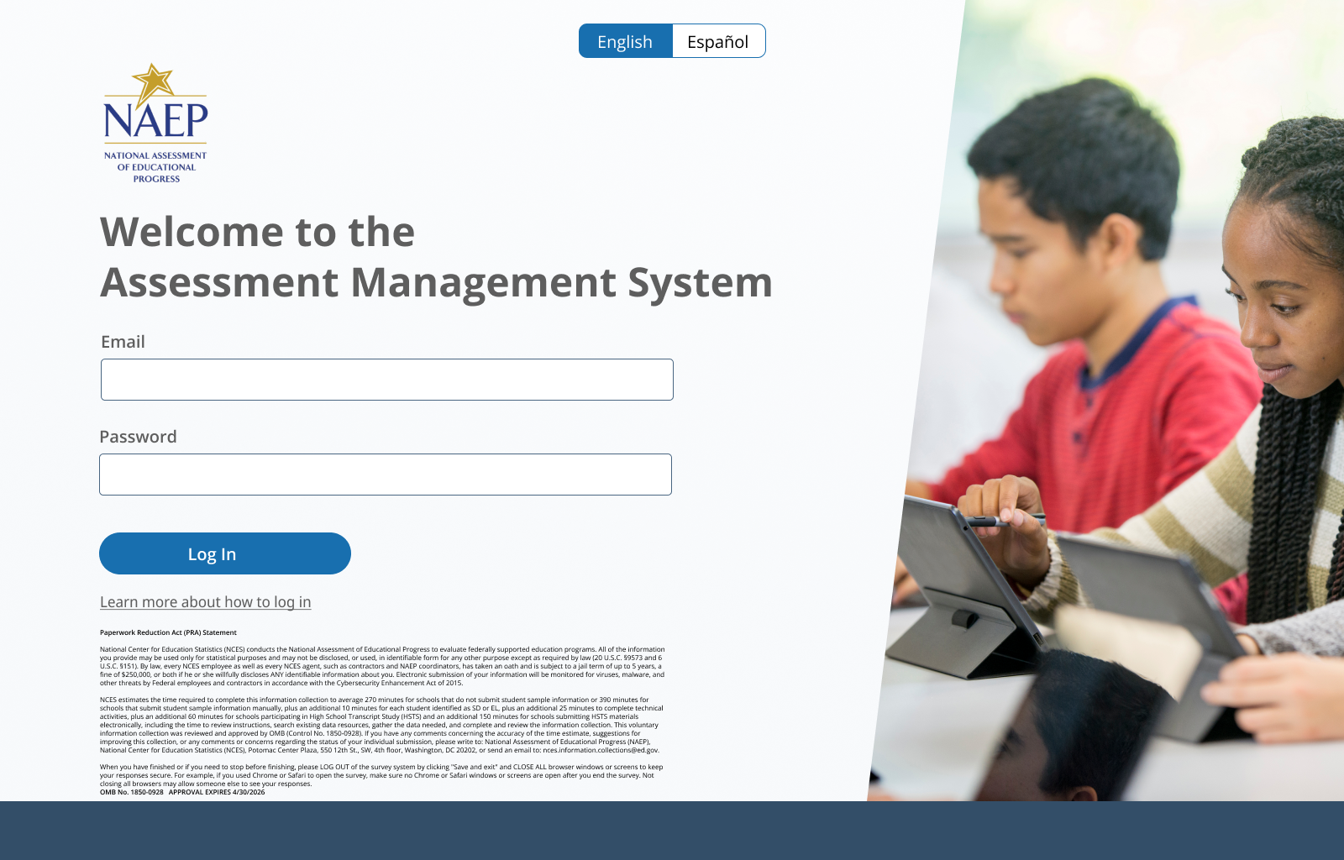
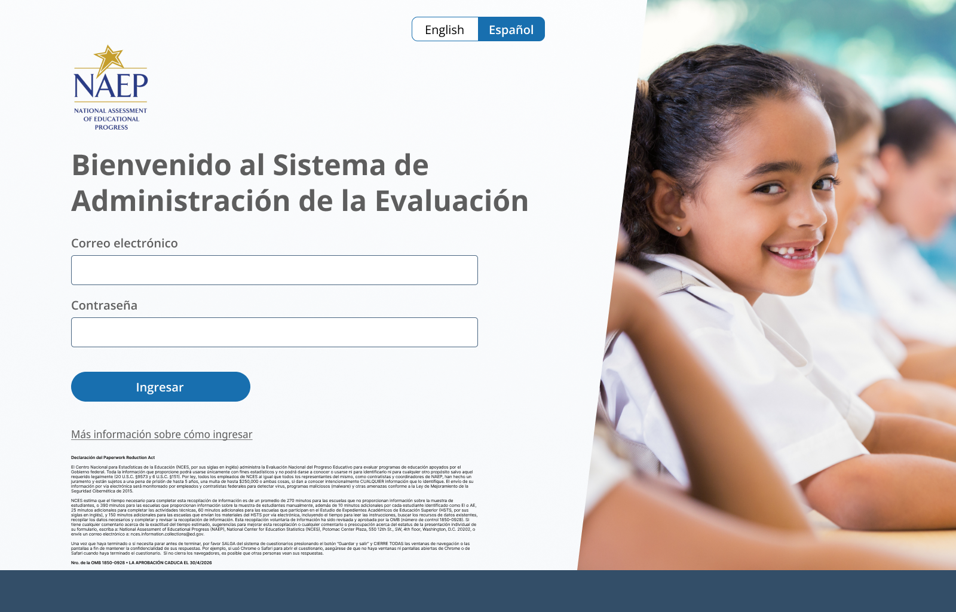

Appendix I2: School Summary Page, English and Spanish Puerto Rico (Approved v.30)

School Summary Page – Provide School Characteristics
The school summary page – provide school characteristics section organizes all information that the school should review and provide as they begin assessment activities. Schools will use the provide school characteristics section to confirm their address, provide enrollment numbers and important dates, and update student attendance.
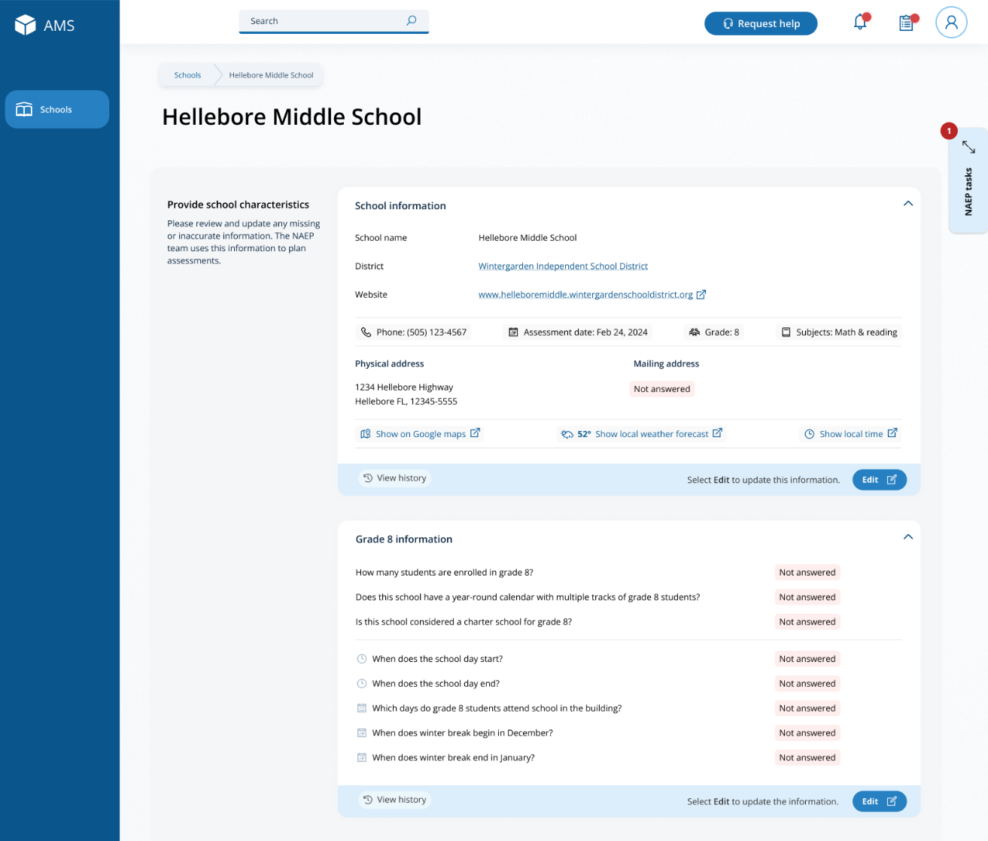

School Summary Page – Manage Team
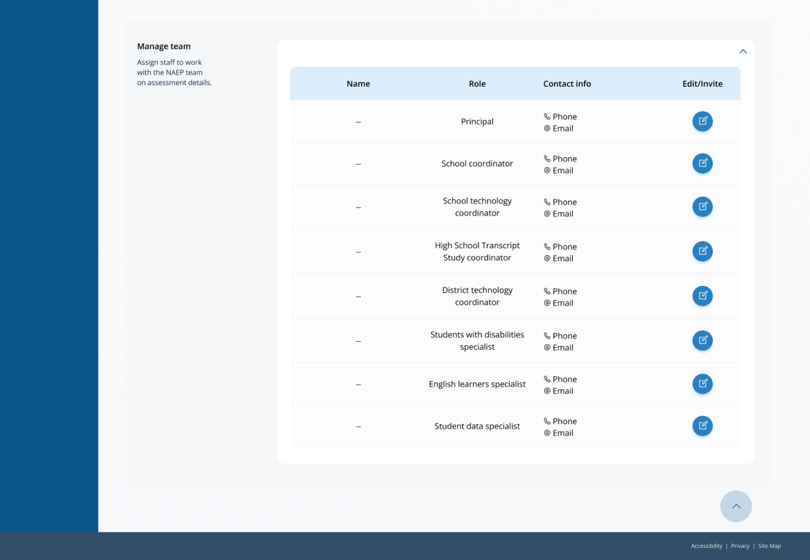
The manage teams section serves two purposes. The first is to invite school users to register for the system. The second is to monitor and edit the school team, as needed.

School Summary Page – Provide School Characteristics (Puerto Rico)
The school summary page – provide school characteristics section organizes all information that the school should review and provide as they begin assessment activities. Schools will use the provide school characteristics section to confirm their address, provide enrollment numbers and important dates, and update student attendance.
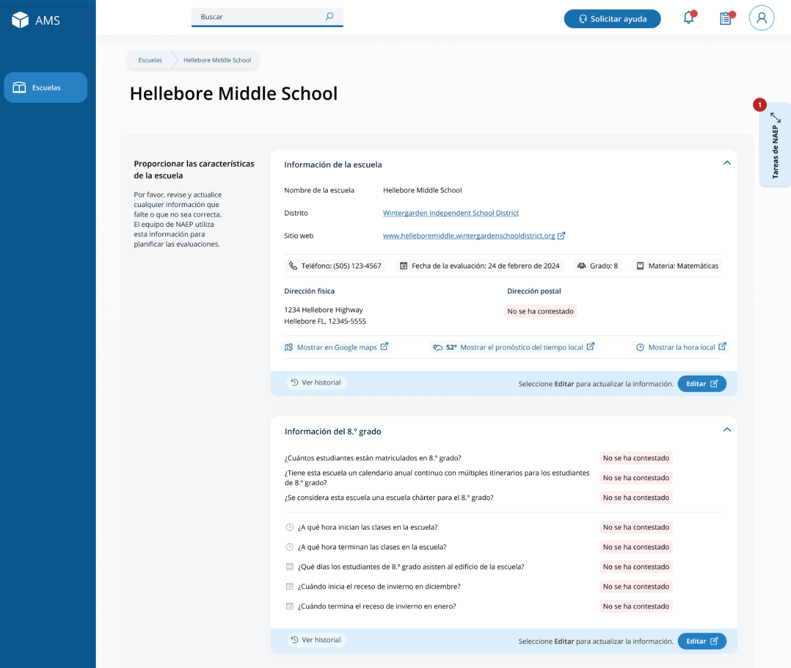

School Summary Page – Manage Team
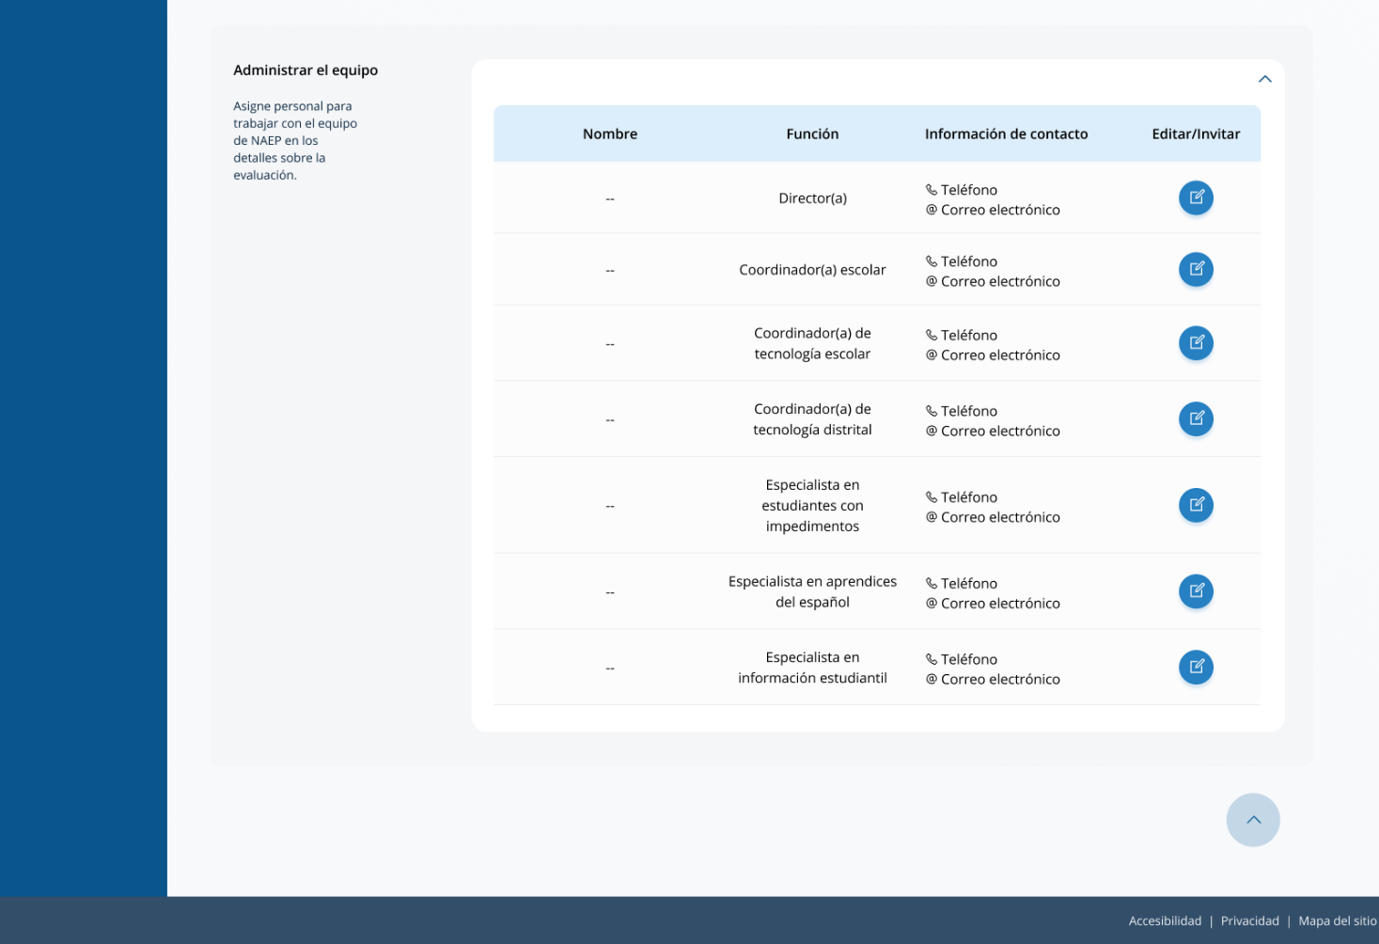
The manage teams section serves two purposes. The first is to invite school users to register for the system. The second is to monitor and edit the school team, as needed.

Appendix I3: Manage Questionnaires, English and Spanish Puerto Rico (NEW)

Manage Questionnaires
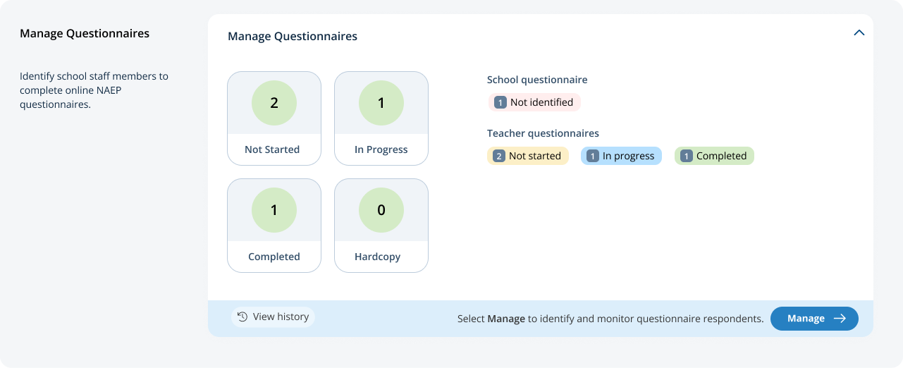
From the school summary page, schools will access and update this section by selecting Manage.

After selecting Manage on this page, schools will identify teacher and school questionnaire respondents to complete questionnaires. There are only teacher questionnaires for grades 4 and 8 schools. Schools will be able to monitor the completion status of each questionnaire respondent and send the questionnaire links and password emails.
Schools will also match students with their teachers. In schools that have students identified as American Indian/Alaska Native, the students have to be matched with both their math and reading teachers.
In the how to use this page, the following directions are provided to users:
- Single edits: Select the edit button to edit information.
- Multiple student edits: Select the boxes to edit multiple students, then use Category and Change menus to make changes.
- Export: Use the button to export the teacher or student information.

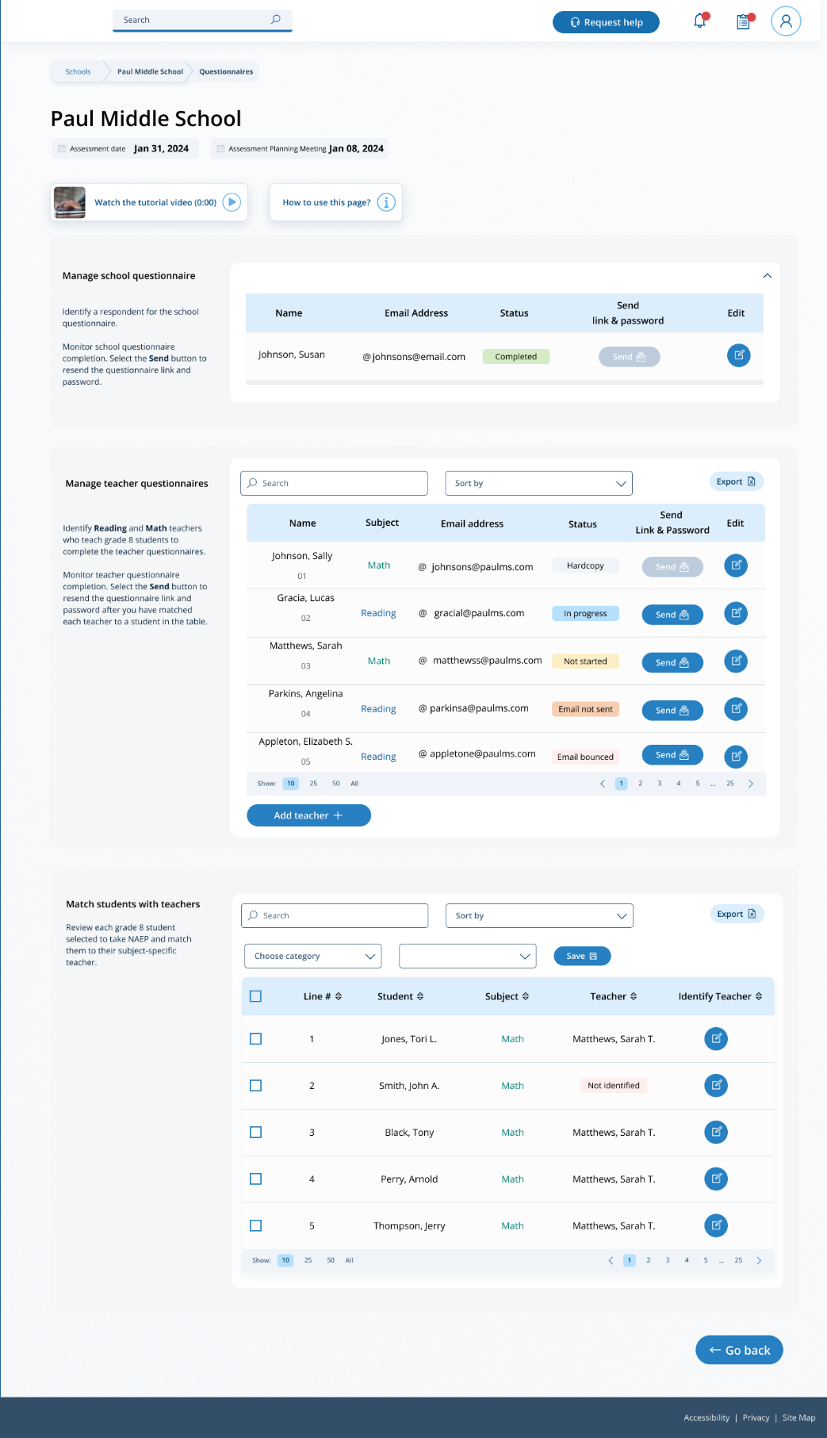

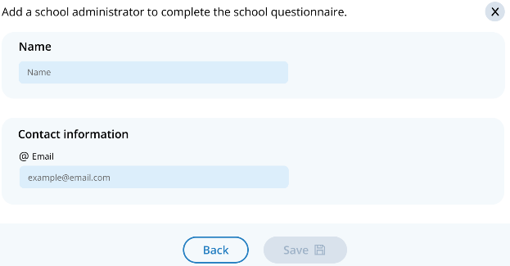
Add a questionnaire respondent
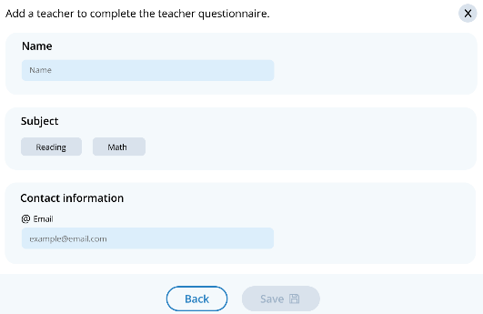

Edit a teacher questionnaire respondent
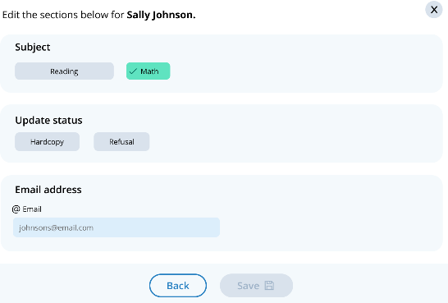

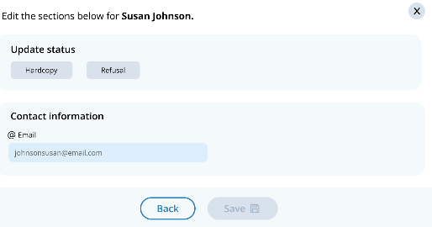
Edit a school questionnaire respondent

Match students with teachers
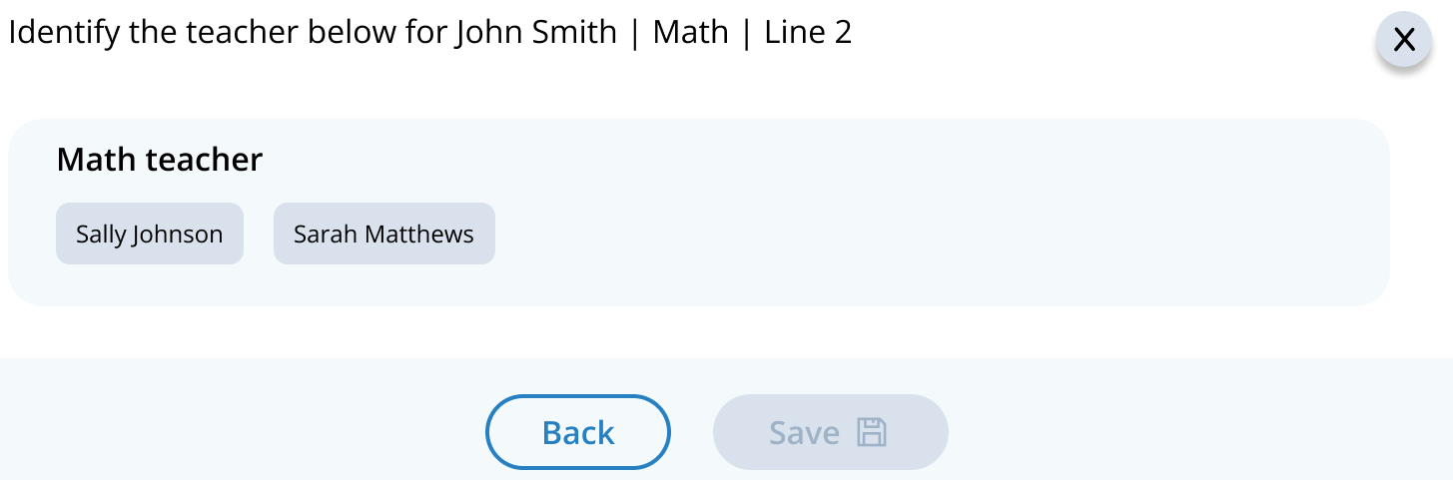

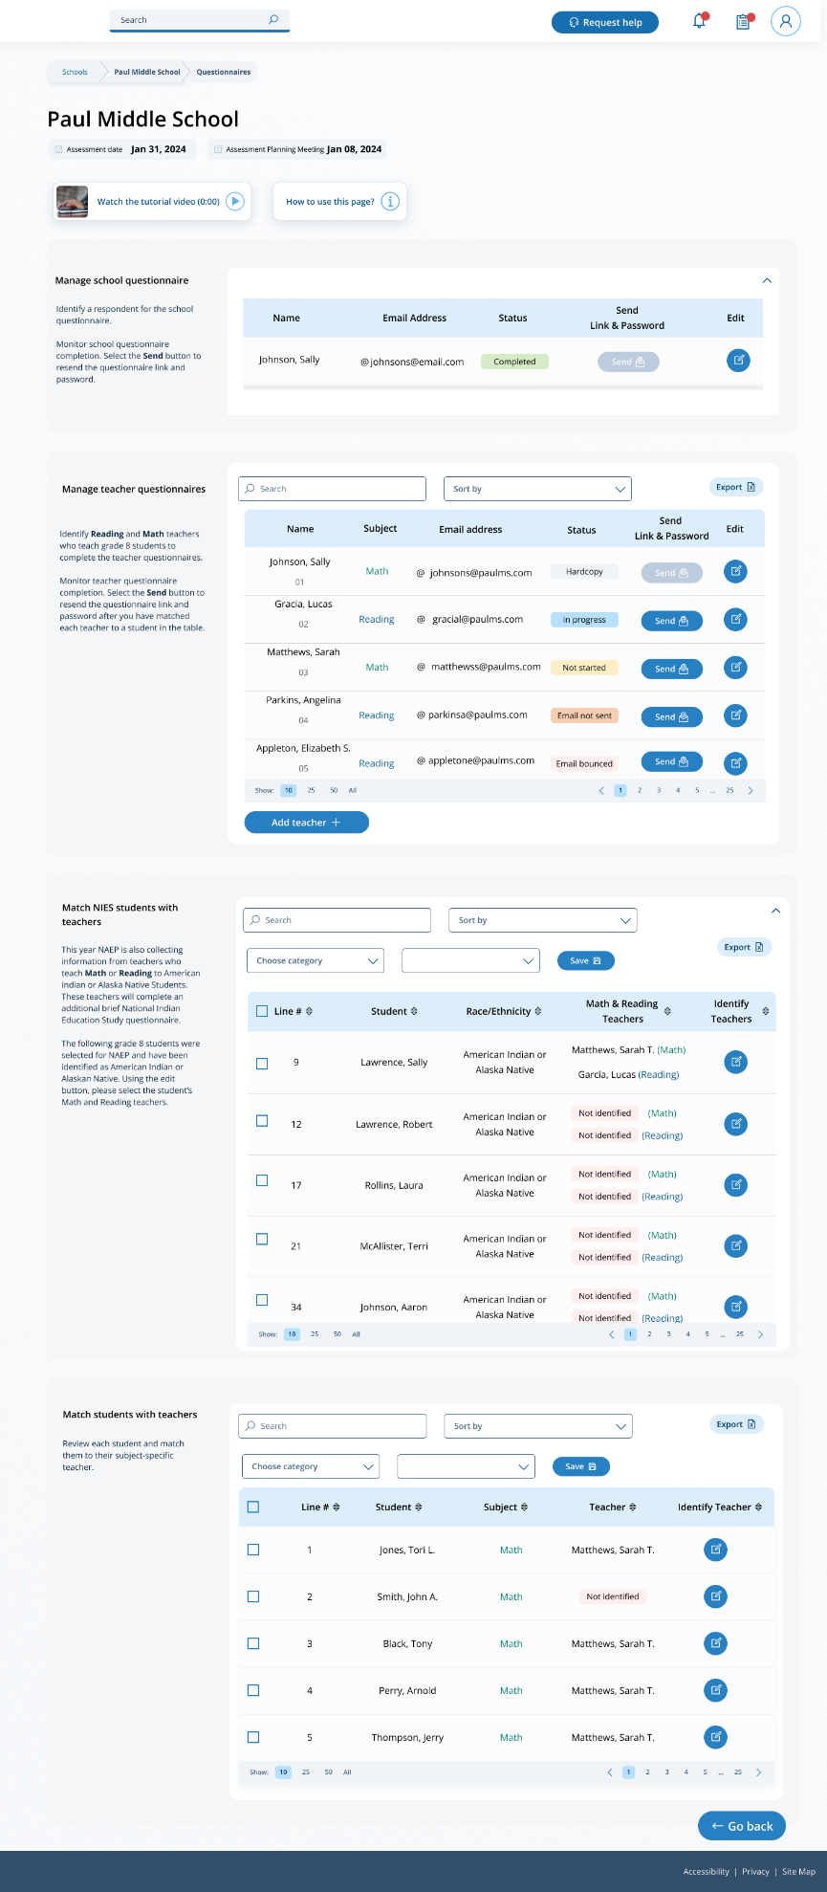

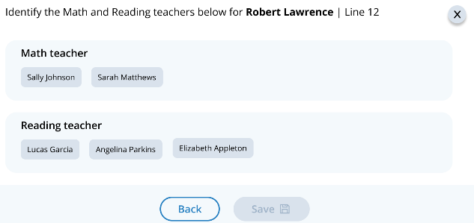
Match NIES students with teachers

Manage Questionnaires
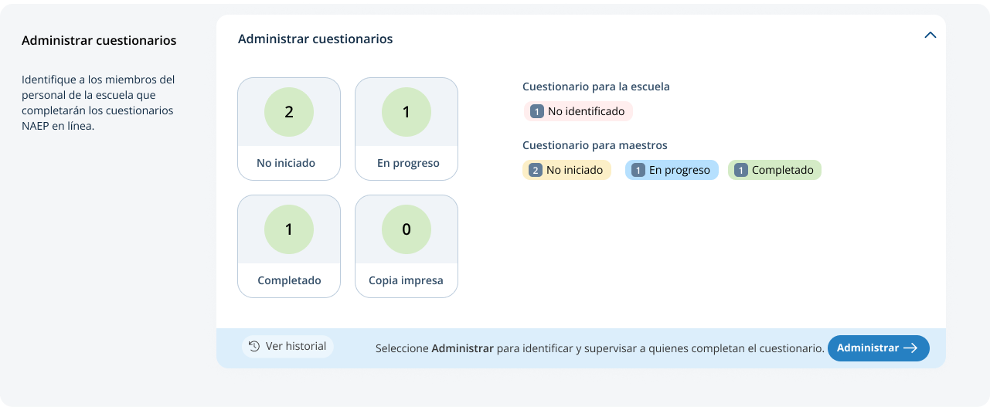
From the school summary page, schools will access and update this section by selecting Manage.

After selecting Manage on this page, schools will identify teacher and school questionnaire respondents to complete questionnaires. There are only teacher questionnaires for grades 4 and 8 schools. Schools will be able to monitor the completion status of each questionnaire respondent and send the questionnaire links and password emails.
Schools will also match students with their teachers. In schools that have students identified as American Indian/Alaska Native, the students have to be matched with both their math and reading teachers.
In the how to use this page, the following directions are provided to users:
- Single edits: Seleccione el botón de editar para editar la información.
- Multiple student edits: Seleccione las casillas para editar la información de varios estudiantes y luego utilice los menús de Categoría y Cambiar a para hacer los cambios.
- Export: Utilice el botón para exportar la información de los maestros o de los estudiantes.

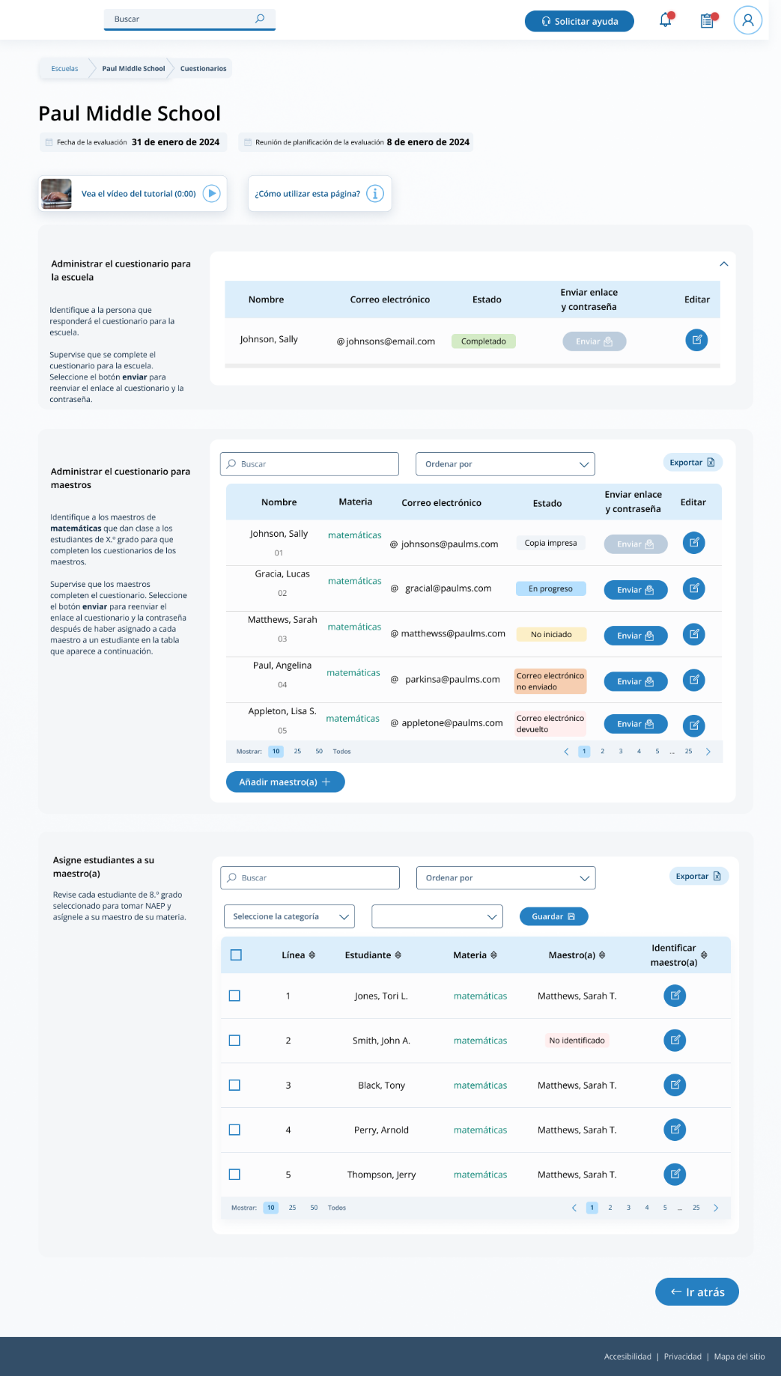

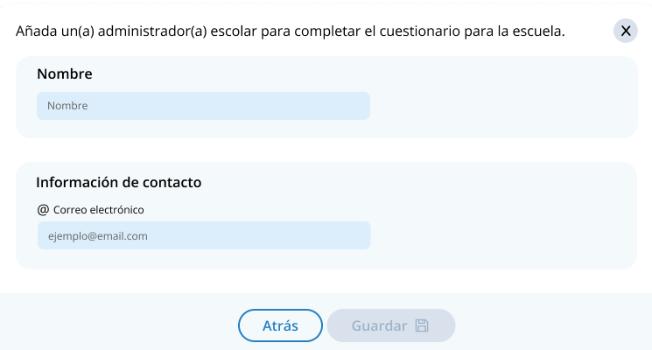
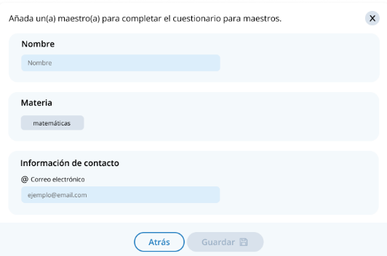
Add a questionnaire respondent

Edit a teacher questionnaire respondent
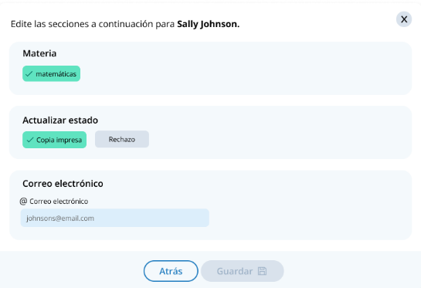

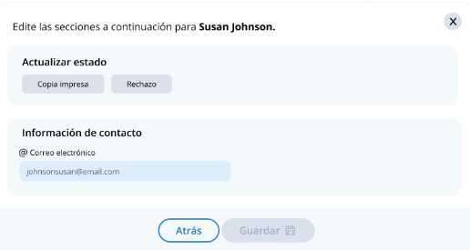
Edit a school questionnaire respondent

Match students with teachers
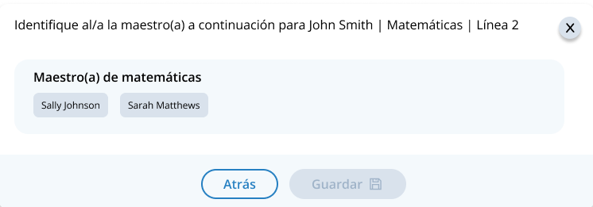

Appendix I4: Add New Students, English and Spanish Puerto Rico (NEW)

Add New Students - English
Schools will select the Add New Students tab in January on the Provide Student Information section.
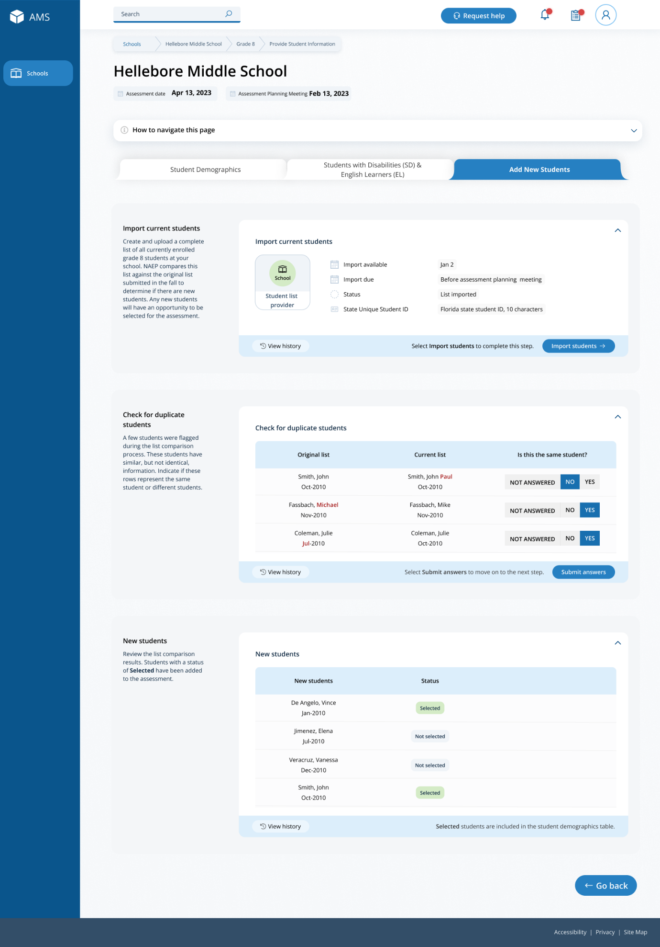

In this section, schools will import a list of currently enrolled students in the selected grade. The list should contain the following for each student:
- State Unique Student ID (optional, but recommended)
- First name
- Middle name (optional)
- Last name
- Month of birth
- Year of birth
The system will compare this new list against the list originally submitted in the fall. The goal is to identify any new students who have enrolled since the fall. New students will have an opportunity to be selected for the assessment.
If any students have similar, but not identical information, they will be flagged for a duplicate check. Schools will indicate if the records from the original and current lists represent the same student or different students.
After the new list has been imported and compared against the original list, any newly selected students will appear in a table on the page. New students who have been selected for the assessment will have a status of “Selected”.

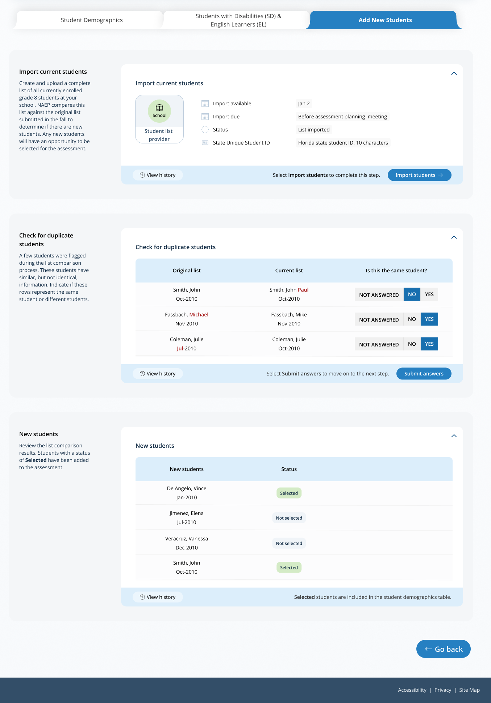

Add New Students – Spanish
Schools will select the Add New Students tab in January on the Provide Student Information section.
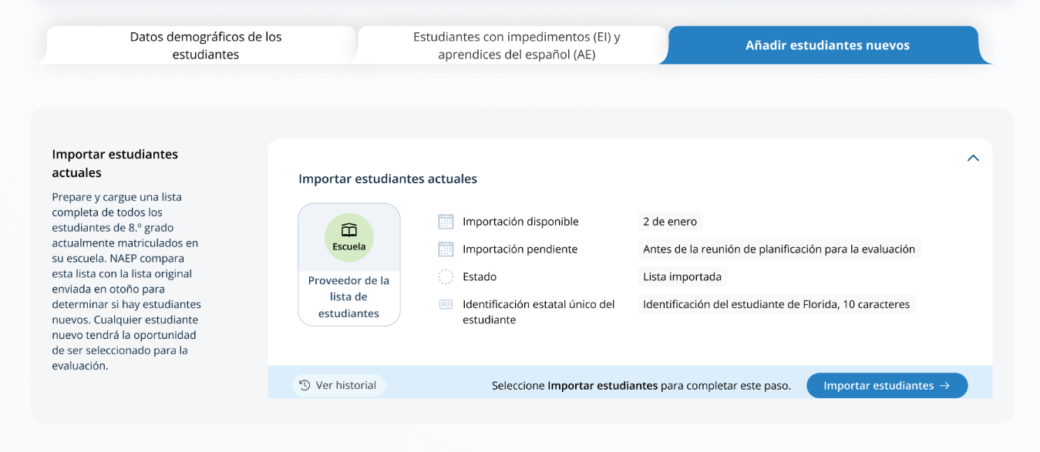

In this section, schools will import a list of currently enrolled students in the selected grade. The list should contain the following for each student:
- Identificación única estatal del estudiante (opcional, pero recomendada)
- Nombre
- Segundo nombre (opcional)
- Apellido
- Mes de nacimiento
- Año de nacimiento
The system will compare this new list against the list originally submitted in the fall. The goal is to identify any new students who have enrolled since the fall. New students will have an opportunity to be selected for the assessment.
If any students have similar, but not identical information, they will be flagged for a duplicate check. Schools will indicate if the records from the original and current lists represent the same student or different students.
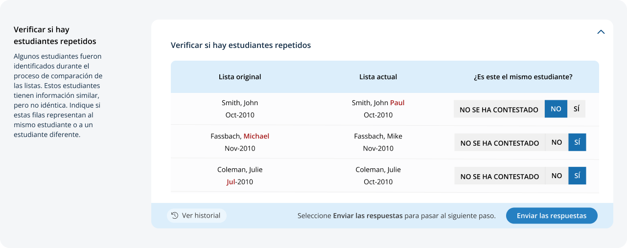
After the new list has been imported and compared against the original list, any newly selected students will appear in a table on the page. New students who have been selected for the assessment will have a status of “Seleccionado”.
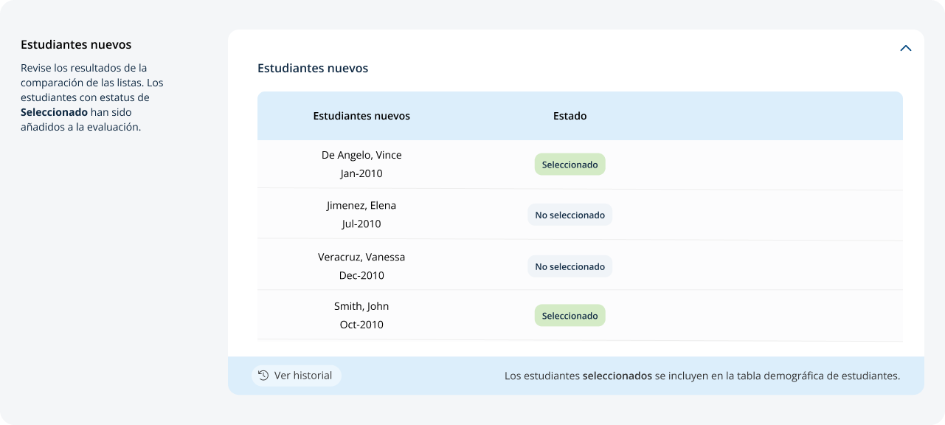

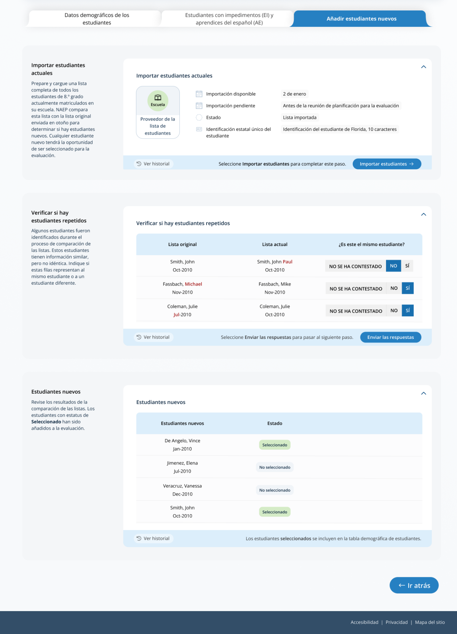

Appendix I5: Instructions for Preparing and Importing a Student Excel File (Approved v.30)

Requirements
NAEP needs a complete Excel file of students enrolled during the 2023–2024 school year for the selected grade(s) at your school. Schools selected for multiple grades should create separate files for each grade. NAEP uses this student list to draw a random sample of students to participate in the assessment. Include all students in the selected grade, even students who are typically excluded from other testing programs, such as students with IEPs (SD) and English Learners (EL), and students participating in virtual/remote learning.
NAEP recommends using a Student List Template, which is available on the Assessment Management System website. If you create your own Excel file, use the same or similar header names. If you cannot submit your student data in an Excel file, contact the NAEP help desk at 1-800-283-6237 or naephelp@westat.com.
The Excel file must contain the following information for each student:
Excel Header Name | Format | Notes
State unique Student ID | Numeric | If available, do not use Social Security Numbers
First name | Text | Recommendation: If possible, include first and last names in separate columns. NAEP accepts names stored in a single column, which requires answering questions to determine how names are ordered/formatted.
Last name | Text
Middle name or initial optional | Text
Grade in School | 4, 8, 12 | Include all students in the selected grade
Homeroom/other locator optional | Text or Numeric | Optional, include if available
Month of Birth | Numeric | Recommendation: If possible, include month and year of birth in separate columns. NAEP accepts birthdates in a single column too. Expected birth years for NAEP: grade 4 2010–2014, grade 8 2006–2010, and grade 12 2002–2007.
Year of Birth | Numeric
Gender | School-defined code | Map school-defined codes to NAEP definitions. See pages 2-4.
Race/Ethnicity | School-defined code | Map school-defined codes to NAEP definitions. See pages 2-4.
Economically Disadvantaged | School-defined code | Map school-defined codes to NAEP definitions. See pages 2-4.
Students with Disabilities (SD) | School-defined code | Map school-defined codes to NAEP definitions. See pages 2-4.
English Learner (EL) | School-defined code | Map school-defined codes to NAEP definitions. See pages 2-4.
On-Break Indicator for year-round schools | School-defined code | Only required for year-round schools
ZIP Code | Numeric | 5 or 9 digit format

NAEP Codes and Definitions
You will need to map your file’s school-defined codes to NAEP’s definitions for the following variables: Gender, Race/Ethnicity, Economically Disadvantaged, Students with Disabilities (SD), English Learner (EL). See NAEP definitions below.

Gender
Map your school’s codes to the following categories.
- Male
- Female
- Nonbinary: A student who does not identify exclusively as male or female.

Race/Ethnicity
NAEP offers three student list templates to accommodate different race/ethnicity formats.
Race/ethnicity in one column – Use when all race/ethnicity information is included in a single column.
Race/ethnicity in two columns – Use when ethnicity (Hispanic, of any race) is included in a single column. Other race information is included in a separate column.
Race/ethnicity in six columns – Use when each of the six categories below have a dedicated column: Hispanic (of any race), White (not Hispanic), Black or African American (not Hispanic), Asian (not Hispanic), American Indian or Alaska Native (not Hispanic), and Native Hawaiian or Pacific Islander (not Hispanic). Responses from these six categories will determine the Two or More Races, not Hispanic category.
NAEP accepts race/ethnicity information in other formats. The formats above are the most common.

Map your school’s codes to the following categories.
- Hispanic, of any race: A person of Mexican, Puerto Rican, Cuban, Central or South American, or other Spanish (but not Portuguese) culture of origin, regardless of race
- White, not Hispanic: A person having origins in any of the original peoples of Europe (except Spain), North Africa, or the Middle East
- Black or African American, not Hispanic: A person having origins in any of the Black peoples of Africa
- Asian, not Hispanic: A person having origins in any of the original peoples of the Far East, Southeast Asia, the Indian Subcontinent, including, for example, Cambodia, China, Japan, India, Korea, Malaysia, Pakistan, the Philippine Islands, Thailand, and Vietnam
- American Indian or Alaska Native, not Hispanic: A person having origins in any of the original peoples of North and South America (including Central America), and who maintains tribal affiliation or community attachment
- Native Hawaiian or Pacific Islander, not Hispanic: A person having origins in any of the original people of Hawaii, Guam, Samoa, or other Pacific Islands
- Two or More Races, not Hispanic: A person who identifies with two or more of the non-Hispanic categories above.
- Information unavailable at this time: If you currently do not have this information for one or more students, bank cells or an indicator such as “N/A” (Not Available) in the cell(s) can be mapped to this code to notify your NAEP representative of the need to collect the data at a later date.
- School does not collect this information: Available to nonpublic schools only. When used, this code must be applied to all students.

Economically Disadvantaged
Map your school’s codes to the following categories.
- Yes, economically disadvantaged
- No, not economically disadvantaged
- Information unavailable at this time: If you currently do not have this information for one or more students, blank cells or an indicator such as “N/A” (Not Available) in the cell(s) can be mapped to this code to notify your NAEP representative of the need to collect the data at a later date.

SPECIAL INSTRUCTIONS FOR CEP SCHOOLS: If your school participates in the Community Eligibility Provision (CEP), please use the following codes for students.

CEP Direct Only
In CEP schools in our state, economically disadvantaged students are those who are directly certified through participation in assistance programs, such as the Supplemental Nutrition Assistance Program (SNAP) and the Temporary Assistance for Needy Families (TANF).
Use the following codes for NAEP:
- Yes, economically disadvantaged
- No, not economically disadvantaged
- Information unavailable at this time

CEP Direct Certification Plus
In CEP schools in our state, economically disadvantaged students are identified in two ways: a) directly certified through participation in assistance programs, such as the Supplemental Nutrition Assistance Program (SNAP) and the Temporary Assistance for Needy Families (TANF); b) through a household income survey.
Use the following codes for NAEP:
- Yes, economically disadvantaged
- No, not economically disadvantaged
- Information unavailable at this time

CEP All
In our state, all students in CEP schools are considered economically disadvantaged. Please use the code Yes, economically disadvantaged for all students.

Students with Disabilities (SD)
Map your school’s codes to the following categories.
- Yes, IEP: Student has a formal Individualized Education Plan (IEP), the student’s IEP is in progress, or the student has an equivalent classification for private schools. If some students have both an IEP and a 504 Plan, code these students as “Yes, IEP.”
- No, not SD: Student does not have an IEP. If students have a 504 Plan without an IEP, code these students as “No, not SD.”
- Information unavailable at this time: If you currently do not have this information for one or more students, blank cells or an indicator such as “N/A” (Not Available) in the cell(s) can be mapped to this code to notify your NAEP representative of the need to collect the data at a later date.

English Learner (EL)
Map your school’s codes to the following categories.
- Yes, EL
- No, Not EL
- No, Formerly EL: If a student who has achieved full English proficiency, is monitored, and is included in EL subgroup for accountability reporting for 2 years (or 4 years depending on state policy) after exiting. Public schools, contact your NAEP State Coordinator if you have any questions about using this code.
- Information unavailable at this time: If you currently do not have this information for one or more students, blank cells or an indicator such as “N/A” (Not Available) in the cell(s) can be mapped to this code to notify your NAEP representative of the need to collect the data at a later date.

On-Break Indicator
For year-round schools only: Include students who will be on break/vacation on the scheduled assessment day along with all of the other students enrolled in the sampled grade. The Student List Template contains an “On Break” column for identifying students who will be on break/vacation by filling in “Yes.” If you are not using the template, create and provide data for an “On Break” column in your file.

Instructions for importing the student list
See the steps below for importing the student list.

Step 1: Prepare the Excel file and a legend
The legend should explain the file’s codes. The following NAEP variables involve school-defined codes:
- Gender
- Race/Ethnicity
- Economically Disadvantaged
- Students with Disabilities (SD)
- English Learner (EL)
In the example below, a school uses five different codes for the Students with Disabilities variable. The legend explains how to “map” school codes to NAEP definitions.
School codes for Students with Disabilities
IEP
IEP + 504
504
No
Blank (no data in cell)

NAEP Definitions
Legend
IEP =
IEP + 504 =
504 =
No =

Blank =
Yes, IEP
No, not SD
Information unavailable
Yes, IEP
Information unavailable
Yes, IEP
No, not SD
No, not SD

Step 2: Check your file, then upload
Prevent upload failures by resolving these common problems first.
- Student records should be in one worksheet. Delete all other worksheets.
- File should include all currently enrolled students in the selected grade. Delete any students that are not in the selected grade.
- Include all required NAEP variables (see page 1 for full list). The following cannot be blank for any students: first name, last name, birth month/year, grade, and gender. Blanks for other variables are acceptable, you will add missing information later.
- Check for duplicate students. Delete any duplicate student rows.
- Header row for each required variable must be in row 1.
- Blank rows should begin after the last student record. Delete blank rows between students.
- Remove password protection. NAEP cannot process protected files.
Go to the Import Student List section on your school’s AMS page. Select Upload file.

Step 3: Map file contents
Use the completed legend for this step. The legend explains how to map each variable.
- Map your file’s column headings to NAEP variables. This step is done automatically if you use NAEP’s Excel template or the same variable/header row names.
  - The field names used by your database system may not have the same names as the NAEP variable. In this case, match the names of your columns to the names of the NAEP variables.
- Map your school’s codes to NAEP definitions. In the repeated example below, the school code “IEP” is mapped to NAEP’s definition “Yes, IEP”, and so on.
School codes for Students with Disabilities
IEP
IEP + 504
504
No
Blank (no data in cell)

NAEP Definitions
Legend
IEP =
IEP + 504 =
504 =
No =

Blank =
Yes, IEP
No, not SD
Information unavailable
Yes, IEP
Information unavailable
Yes, IEP
No, not SD
No, not SD

Step 4: Check warnings
Information from the student list runs through a series of checks.
- Review warnings. NAEP compares the student list against two databases: previous NAEP assessments and Common of Core Data. Common Core of Data (CCD) is the Department of Education’s primary database on public elementary and secondary education in the United States. These comparisons generate warnings to ensure demographics in the student list are accurate. Warnings serve as prompts to review and confirm existing information, and do not always require changes to the student list. There are additional warnings that identify missing information and possible mapping problems.
- Resolve warnings. Some warnings are resolved by adding missing information or editing existing information. Others require a review of how file contents are mapped, and possible changes if the mapping is incorrect.

Step 5: Confirm file
Review student counts and percentages for each variable in your file. This summary serves as a final check before submitting the file. Make sure these counts and percentages are representative of students in the selected grade at your school.

Appendix I6: Internet Connectivity Survey, English and Spanish Puerto Rico (NEW)

Introduction
Thank you for supporting the National Assessment of Educational Progress (NAEP).
[Insert short video of the assessment]
NAEP is gathering information in the Internet Connectivity Survey to help meet the goal of connecting NAEP devices to school-provided Internet to conduct the assessments. Using the school’s Internet will allow the assessment and student responses to be streamed in real time. The information you provide in the survey will help determine if this is feasible for your school.
In January, NAEP field staff will ask your school’s on-site technology coordinator to confirm your survey responses and safelisting of NAEP URLS and internet bandwidth by running the NAEP Diagnostic Tool. The on-site technology coordinator will also discuss how the school’s Wi-Fi credentials will be provided to the NAEP team to ensure a successful assessment.
Best Practice: When possible, setting up a dedicated Wi-Fi network for the NAEP team to use on assessment day will reduce the burden on school(s), ensure the best student experience, and provide the ideal connection method for the assessment administration. The dedicated Wi-Fi network should meet NAEP’s technical requirements.
Please contact the NAEP Help Desk at naephelp@westat.com or 1-800-283-6237 if you have any questions.

Confirm Bandwidth Requirements and Wi-Fi Connection
The 2024 NAEP assessment will require a stable, uninterrupted wireless internet connection of XX mbps download and XX mbps upload or greater across 6 hours for 28 devices in the designated testing location(s). Review the Technical Requirements Fact Sheet for more information.
[Insert a link to the technical requirements fact sheet]
- Does the school have a Wi-Fi network that meets or exceeds these bandwidth requirements?
- Yes
- No
- Do not know

Network Information
- Who manages the school’s Wi-Fi network?
- District: The network connection line is managed and configured by the district and is available across all schools.
- School: The network connection line is managed and configured by the school.
- Other
If other, please specify [Text box]
- Would your school or district be willing to set up a dedicated guest Wi-Fi network to be used specifically for the NAEP assessments?
- Yes
- No
- What is the name of the Wi-Fi connection that will support NAEP requirements on the day of the assessment?
[Text box]

Safelist Requirements
The NAEP team needs access to specific URLs during the assessment. Safelisting (sometimes referred to as whitelisting or allowlisting) these URLs is critical to ensuring that your district’s and/or school’s web filtering does not impede the assessment. Please safelist the URLs in the link below.
[Add a link to the URLs]

NAEP Network Diagnostic Tool
Please use the Network Diagnostic Tool to confirm the safelisting of the URLs. If the safelist check does not pass, you may need to work with your network IT staff for any technology support to safelist the URLs. The NAEP Diagnostic Tool also confirms the bandwidth requirements. It can be run as often as needed; however, it must be run by the on-site technology coordinator in January in the designated testing location on the assigned Wi-Fi network once the assessment location is confirmed and the week before the scheduled assessment date. Please run the test during school hours.

[Add a link to network diagnostic tool]

- Were there any issues with safelisting the URLs using the Network Diagnostic Tool in the link above?
- Yes
- No
If 5 = Yes,
Please explain. [Text box]

Security Requirements
Please indicate if the district or school requires any of the following to connect external NAEP-provided devices to the Wi-Fi network.
- The district or school needs to know the MAC addresses of the NAEP-provided devices.
- Connecting to the Wi-Fi network requires multi-factor authentication to log on.
- The Wi-Fi network requires a different username and password for each device.
- The district or school requires security software to be installed on the external NAEP-provided devices to access the Wi-Fi network.
- The district or school restricts external devices from connecting to the Wi-Fi network.

Internet Connectivity Decision
Based on the answers provided above, the external NAEP-provided devices can connect to the school’s Wi-Fi network and the NAEP assessment will be conducted using the School Wi-Fi Mode if all other checks pass prior to the scheduled assessment date.
OR
Based on the answers provided above, the external NAEP-provided devices cannot connect to the school’s Wi-Fi network and the NAEP assessment will be conducted in the NAEP Private Network Mode.

Survey Respondent Information
- Which of the following designations best describes your role? (Please select one)
- Designated on-site technology coordinator for NAEP
- Designated district technology director for NAEP
- Please provide the names, titles, and contact information of all individuals that you had to contact to complete this survey.
[Insert text fields]

Thank you
Thank you for completing this survey. In January, NAEP field staff will confirm your survey responses with your school’s designated on-site technology coordinator. During that time, NAEP field staff will also confirm with the on-site technology coordinator that the NAEP Diagnostic Tool to test the internet speed and safelisted URLs was run in the designated assessment location, on the assigned network, and explain how the Wi-Fi credentials will be provided to the NAEP team to ensure a successful assessment.

Introducción
Gracias por su apoyo a la Evaluación Nacional del Progreso Educativo (NAEP, por sus siglas en inglés).
[Insert short video of the assessment]
NAEP está recopilando información en la Encuesta sobre la conectividad a Internet para ayudar a cumplir el objetivo de conectar los dispositivos de NAEP al Internet proporcionado por la escuela para administrar las evaluaciones. El uso del Internet de la escuela permitirá transmitir la evaluación y las respuestas de los estudiantes en tiempo real. La información que proporcione en la encuesta ayudará a determinar si esto es posible para su escuela.
En enero, el personal de campo de NAEP le solicitará al/a la coordinador(a) de tecnología interno(a) de su escuela que confirme sus respuestas a la encuesta y que confirme los requisitos de lista segura de los URL de NAEP y ancho de banda de Internet ejecutando la Herramienta de diagnóstico de NAEP. El(la) coordinador(a) de tecnología interno(a) también explicará cómo se proporcionarán las credenciales de WiFi de la escuela al equipo de NAEP para garantizar el éxito de la evaluación.
Prácticas recomendadas: Cuando sea posible, configurar una red WiFi dedicada para que el equipo de NAEP la utilice el día de la evaluación reducirá la carga de la(s) escuela(s), garantizará la mejor experiencia de los estudiantes y proporcionará el método de conexión ideal para la administración de la evaluación. La red WiFi dedicada debe cumplir los requisitos técnicos de NAEP.
Si tiene alguna pregunta, comuníquese con el Centro de Ayuda de NAEP (Help Desk) escribiendo a naephelp@westat.com o llamando al 1-800-283-6237.

Confirme los requisitos de ancho de banda y de conexión WiFi
La evaluación de NAEP de 2024 requerirá una conexión inalámbrica a Internet estable e ininterrumpida de XX mbps de descarga y XX mbps de carga, o superior, durante 3 horas para 28 dispositivos en el lugar(es) designado(s) para la evaluación. Consulte la Hoja informativa sobre requisitos técnicos para más información.
[Insert a link to the technical requirements fact sheet].
- ¿Dispone la escuela de una red WiFi que cumple o supera estos requisitos de ancho de banda?
- Sí
- No
- No lo sé

Información sobre la red
- ¿Quién administra la red WiFi de la escuela?
- Distrito: La conexión a la red es administrada y configurada por el distrito y está disponible en todas las escuelas.
- Escuela: La conexión a la red es administrada y configurada por la escuela.
- Otro
Si seleccionó otro, especifique [Text box]
- ¿Estaría dispuesta(o) su escuela o distrito a configurar una red WiFi dedicada para invitados que se utilizará específicamente para las evaluaciones de NAEP?
- Sí
- No
- ¿Cómo se llama la conexión WiFi que cumplirá con los requisitos de NAEP el día de la evaluación?
[Text box]

Requisitos de la lista segura
El equipo de NAEP necesita acceder a URL específicos durante la evaluación. La inclusión de estos URL en una lista segura (a veces denominada lista blanca o lista de permisos) es fundamental para garantizar que el filtrado de contenido web de su distrito o escuela no impida la evaluación. Incluya los URL que aparecen en el enlace a continuación en la lista segura.
[Add a link to the URLs].

Herramienta de diagnóstico de la red de NAEP
Utilice la Herramienta de diagnóstico de la red para confirmar la inclusión de los URL en la lista segura. Si la verificación de la lista segura falla, es posible que deba trabajar con su personal de tecnología de la red para obtener asistencia técnica para incluir los URL a la lista segura. La Herramienta de diagnóstico de la red de NAEP también confirma los requisitos de ancho de banda. La herramienta puede ejecutarse tantas veces como sea necesario; sin embargo, debe ejecutarse por el(la) coordinador(a) de tecnología interno(a) en enero en el lugar designado para la evaluación y usando la red WiFi designada una vez que se confirme el lugar para la evaluación y una semana antes de la fecha programada para la evaluación. Realice la prueba durante el horario escolar.

[Add a link to network diagnostic tool]

- ¿Hubo algún problema con la Herramienta de diagnóstico de la red en el enlace anterior?
- Sí
- No
Si 5 = Sí,
Por favor, explique. [Text box]

Requisitos de seguridad
Indique si el distrito o la escuela requiere alguno de los siguientes criterios para conectar los dispositivos externos proporcionados por NAEP a la red WiFi.
- El distrito o la escuela necesita conocer las direcciones MAC de los dispositivos proporcionados por NAEP.
- La conexión a la red WiFi requiere autenticación multifactor para ingresar.
- La red WiFi requiere un nombre de usuario y una contraseña diferentes para cada dispositivo.
- El distrito o la escuela requiere que se instale software de seguridad en los dispositivos externos proporcionados por NAEP para acceder a la red WiFi.
- El distrito o la escuela restringe la conexión de dispositivos externos a la red WiFi.
Decisión sobre la conectividad a Internet
Según las respuestas anteriores, los dispositivos externos proporcionados por NAEP pueden conectarse a la red WiFi de la escuela y la evaluación de NAEP se llevará a cabo utilizando el modo WiFi de la escuela si todas las demás verificaciones se aprueban antes de la fecha programada para la evaluación.
O
Según las respuestas anteriores, los dispositivos externos proporcionados por NAEP no pueden conectarse a la red WiFi de la escuela y la evaluación de NAEP se realizará en el modo de red privada de NAEP.

Información sobre el(la) encuestado(a)
- ¿Cuál de las siguientes denominaciones describe mejor su función? (Seleccione una)
- Coordinador(a) de tecnología interno(a) designado(a) para NAEP
- Director(a) de tecnología distrital designado(a) para NAEP
- Proporcione los nombres, cargos e información de contacto de todas las personas con las que haya tenido que ponerse en contacto para completar esta encuesta.
[Insert text fields]

Gracias
Gracias por completar esta encuesta. En enero, el personal de campo de NAEP confirmará las respuestas de su encuesta con el(la) coordinador(a) de tecnología interno(a) designado(a) para su escuela. Durante ese tiempo, el personal de campo de NAEP también confirmará con el(la) coordinador(a) de tecnología interno(a) que la Herramienta de diagnóstico de NAEP para probar la velocidad de Internet y la lista segura de los URL se ejecutaron en el lugar designado para la evaluación, usando la red designada, y explicará cómo se proporcionarán las credenciales del WiFi al equipo de NAEP para garantizar una evaluación exitosa.

Appendix I7: Schedule Assessment Planning Meetings, English and Spanish Puerto Rico (NEW)

Schedule Assessment Planning Meetings
From the school summary page, school coordinators and on-site technology coordinators are able to schedule the assessment planning meeting with their NAEP representative by selecting the schedule assessment planning meeting button to their corresponding meeting.
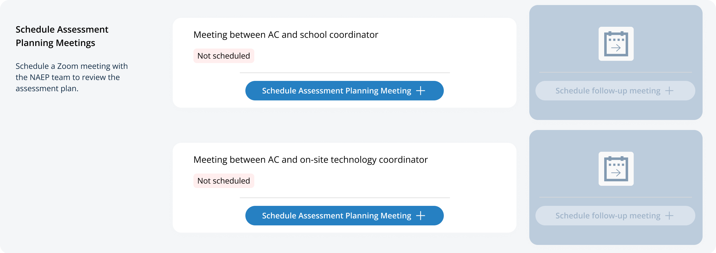
On the modal pop-up, the school coordinators and on-site technology coordinators will be able to select a date and time that their NAEP representative is available and schedule the assessment planning meeting to review and confirm school information prior to assessment day.
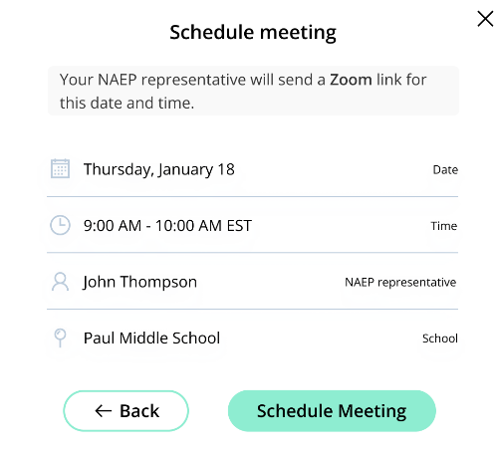
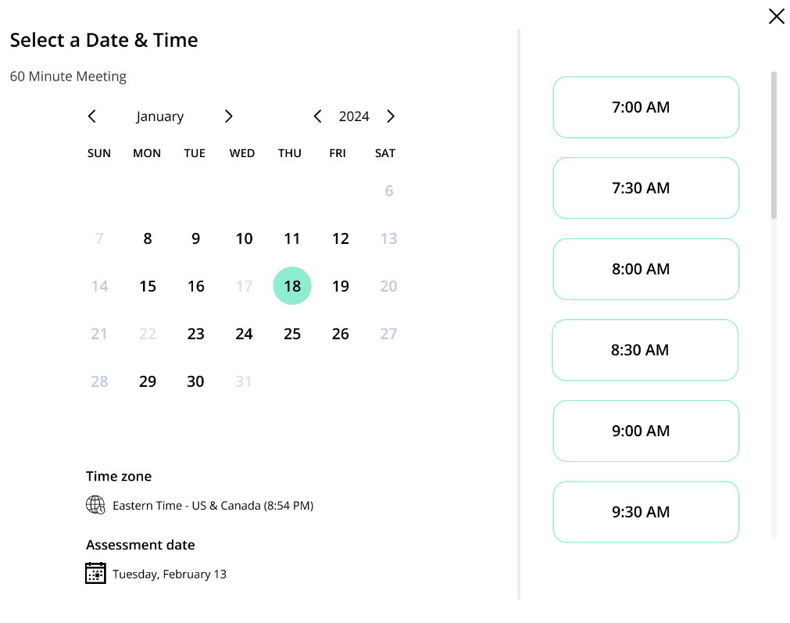

Schedule Assessment Planning Meetings
From the school summary page, school coordinators and on-site technology coordinators are able to schedule the assessment planning meeting with their NAEP representative by selecting the schedule assessment planning meeting button to their corresponding meeting.
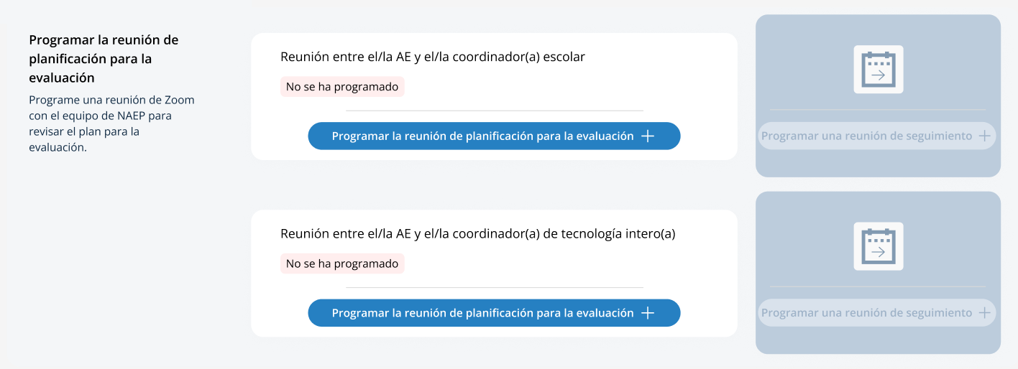
On the modal pop-up, the school coordinators and on-site technology coordinators will be able to select a date and time that their NAEP representative is available and schedule the assessment planning meeting to review and confirm school information prior to assessment day.
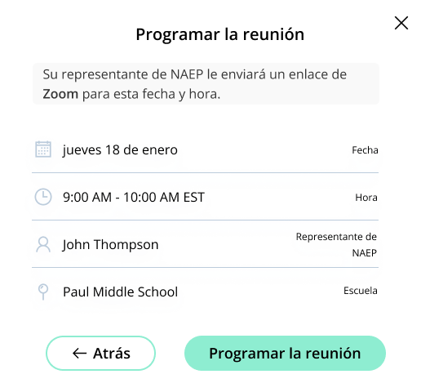
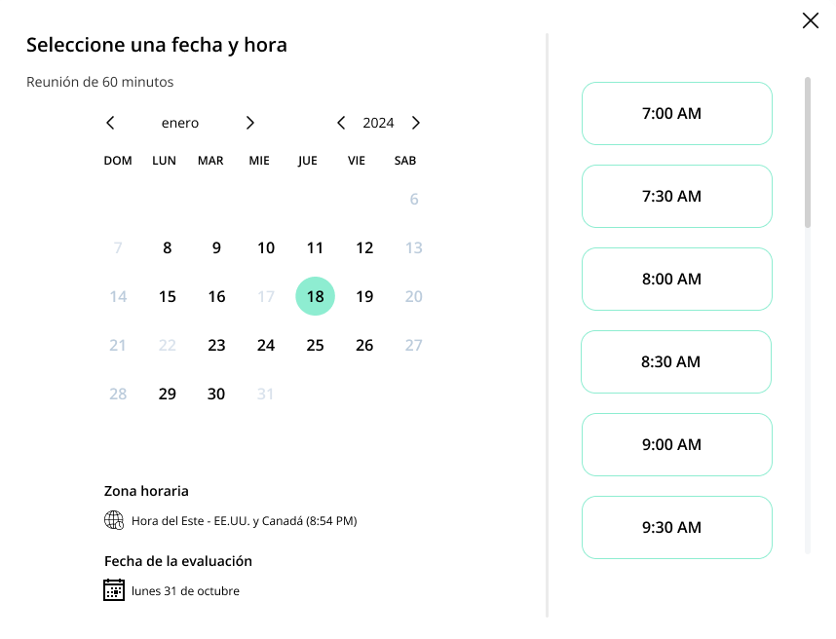

Appendix I8: Assessment Logistics, English and Spanish Puerto Rico (NEW)

Assessment Logistics
From the school summary page, schools will access the assessment logistics section by selecting the Manage button.
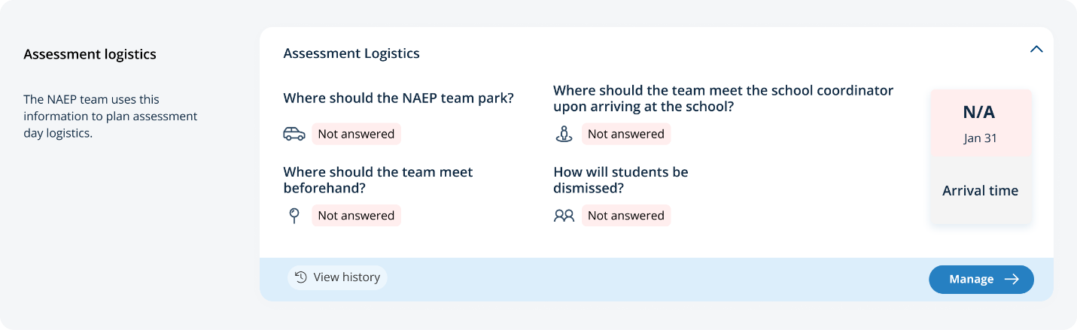
On this page, schools will provide details about logistical information for assessment day. This includes selecting a location and start time for each group, providing details about arriving at the school and checking in, emergency protocols, and dismissal options.
In the how to use this page, the following directions will be provided to users:
- Editing tiles: Select the edit button to edit information.
- Editing tables: Select the edit button to edit information.
- Export: Use the button to export the student information.
In the schedule groups section, schools will receive a warning if there is not three hours between the start of the first group and second group:

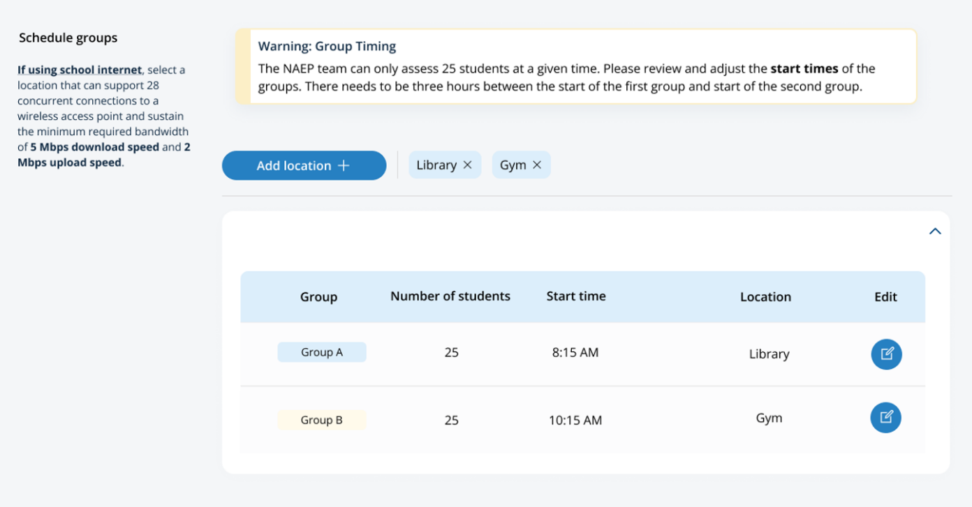

In the after the assessment section, schools can select from the following options for distributing certificates of community service and student dismissal:
- Certificates of community service
  - The NAEP team should give the certificates to students after the assessment.
  - The NAEP team should give the certificates to me.
  - We will not offer certificates of community service to students.
- Dismissal options
  - Option 1: Dismiss as a group once the last student has finished (students with extended time or late arrivals will be dismissed later, if needed).
  - Option 2: Dismiss students as they finish but no earlier than 70 minutes after students begin the assessment.
  - Option 3 (grade 12 only): (For schools using flexible start times) Dismiss students individually as they finish.
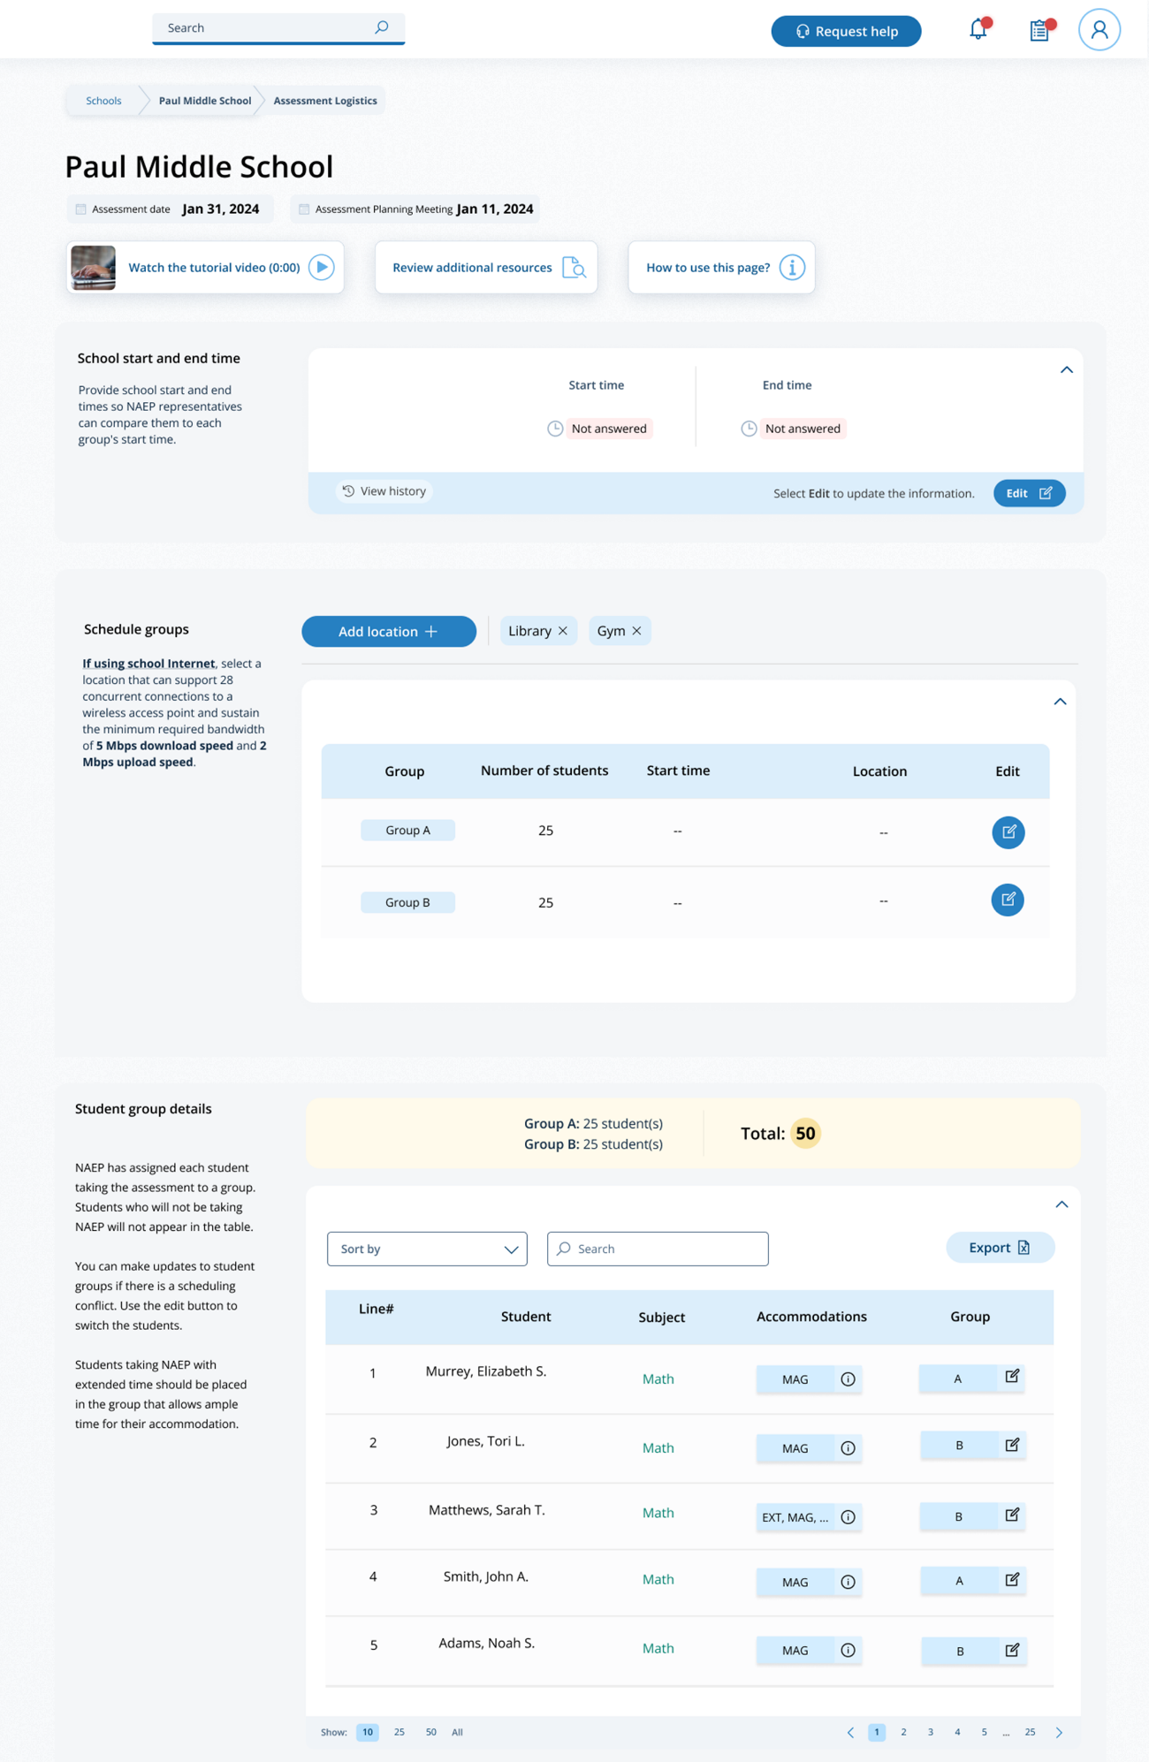

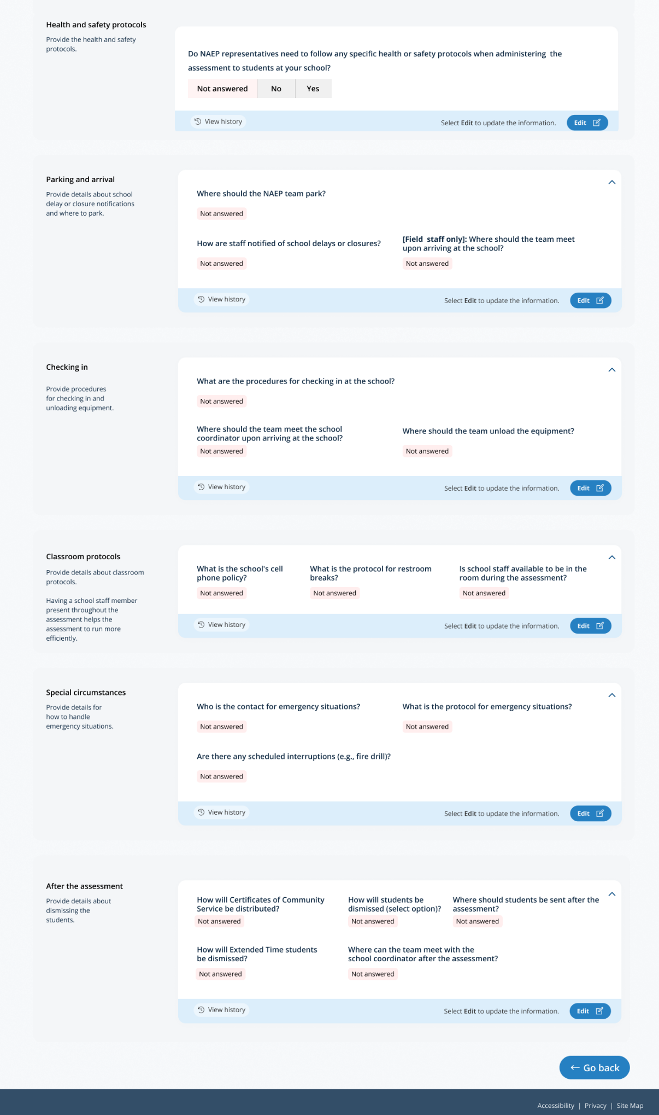

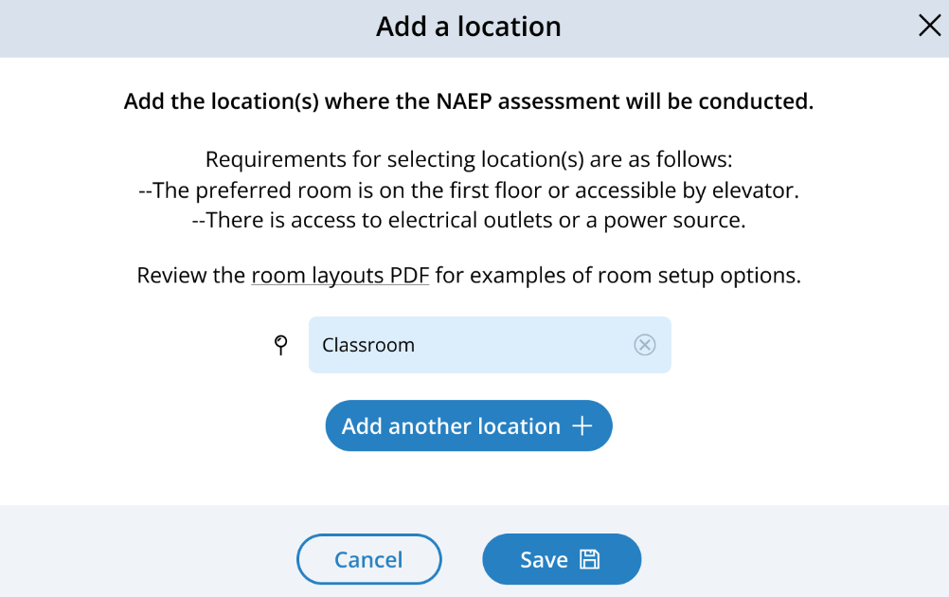
Add location pop-up:

Schedule groups pop-up:
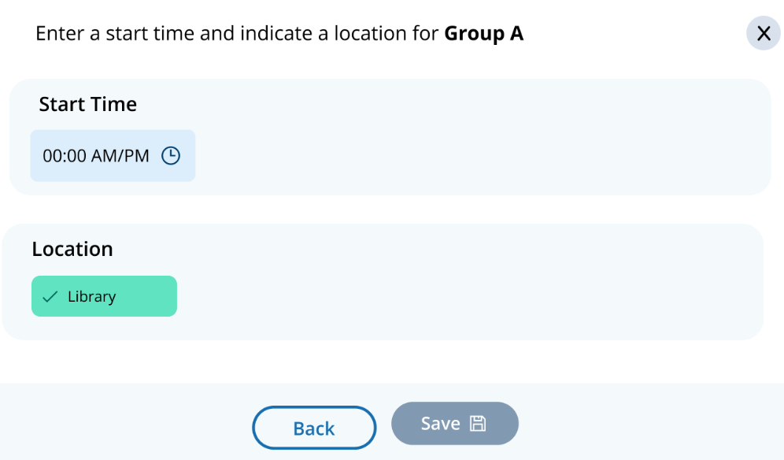

Student group details pop-up:
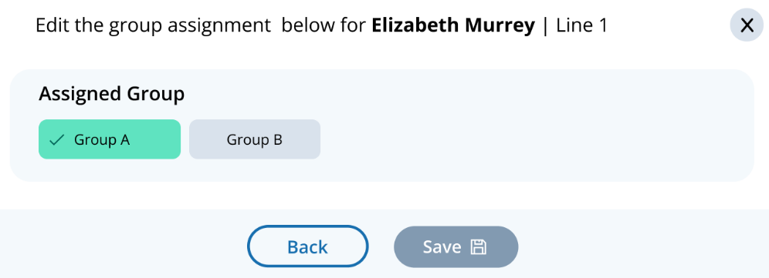

Assessment Logistics
From the school summary page, schools will access the assessment logistics section by selecting the Manage button.
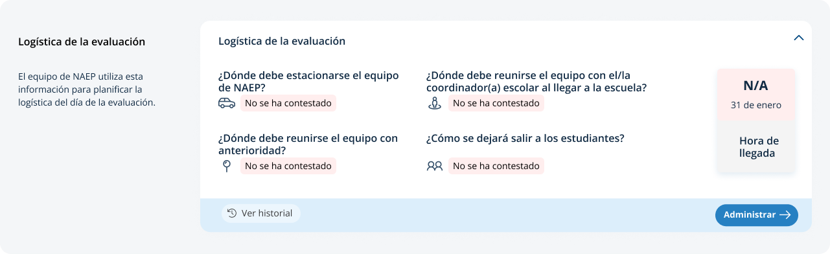
On this page, schools will provide details about logistical information for assessment day. This includes selecting a location and start time for each group, providing details about arriving at the school and checking in, emergency protocols, and dismissal options.
In the how to use this page, the following directions will be provided to users:
- Editing tiles: Seleccione el botón de editar para editar la información.
- Editing tables: Seleccione el botón de editar para editar la información.
- Export: Utilice el botón para exportar la información del estudiante.
In the schedule groups section, schools will receive a warning if there is not three hours between the start of the first group and second group:
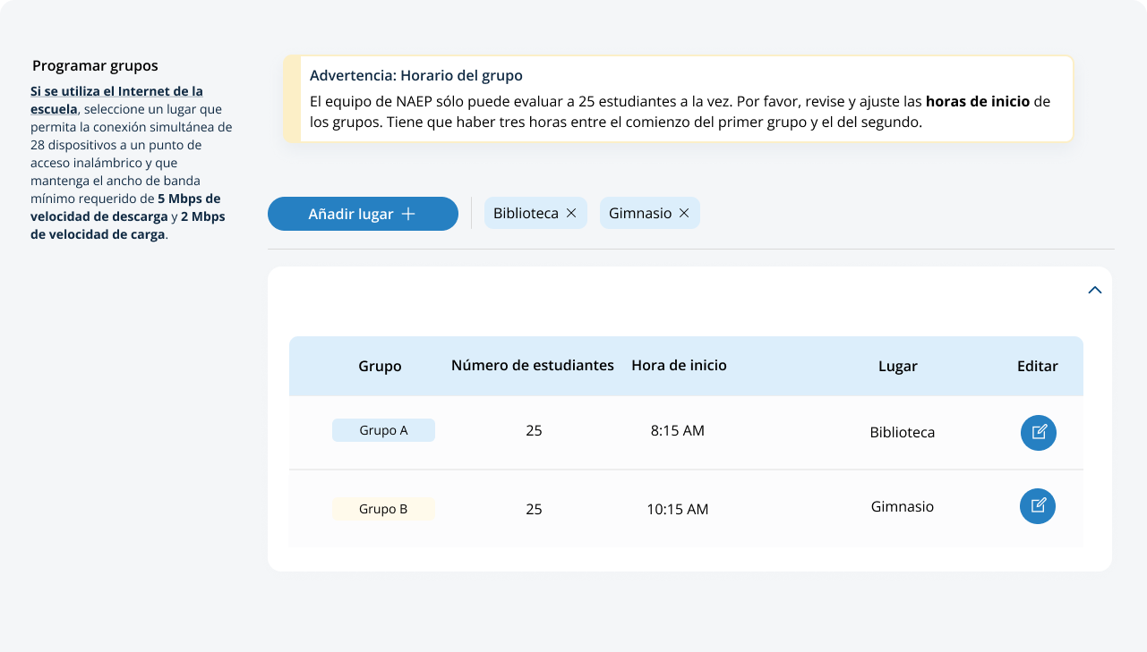
In the after the assessment section, schools can select from the following options for distributing certificates of community service and student dismissal:
- Certificates of community service
  - El equipo de NAEP debe entregar los certificados a los estudiantes después de la evaluación.
  - El equipo de NAEP debe entregarme los certificados a mí.
  - No ofreceremos certificados de servicio comunitario a los estudiantes.
- Dismissal options
  - Opción 1: Dejar salir al grupo una vez que el último estudiante haya terminado (a los estudiantes con tiempo extendido o que lleguen tarde se les dejará salir más tarde, de ser necesario).
  - Opción 2: Dejar salir a los estudiantes a medida que terminan pero no antes de 70 minutos después de que los estudiantes comiencen la evaluación.
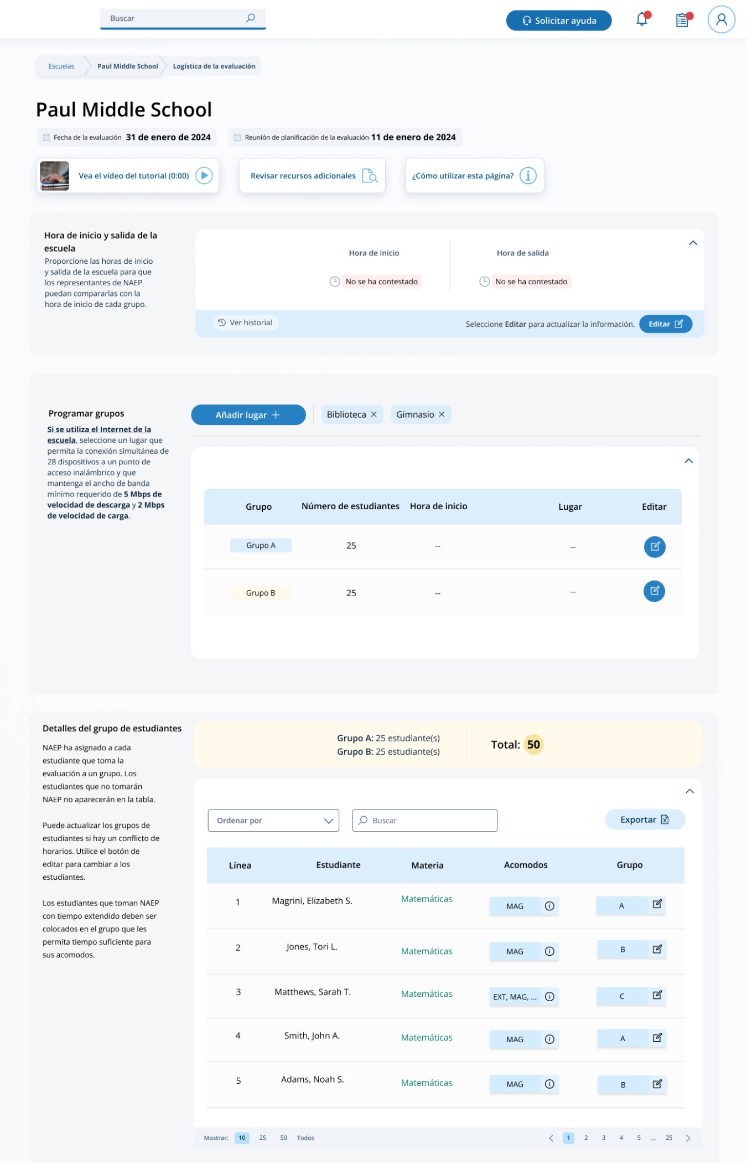

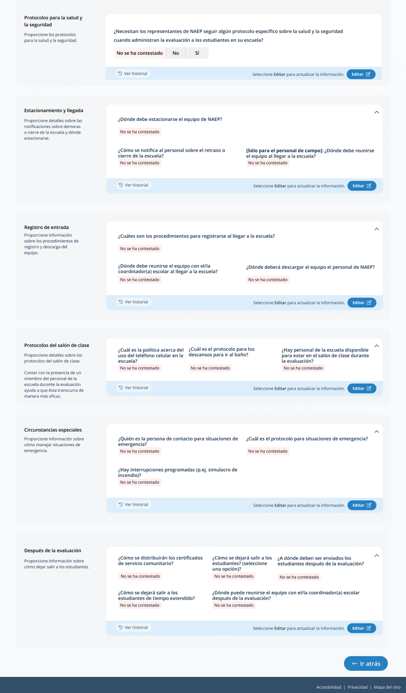

Add location pop-up:
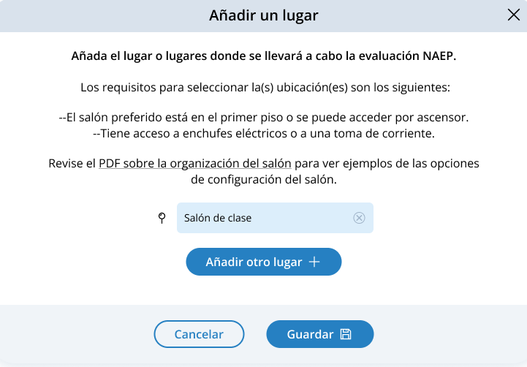

Schedule groups pop-up:
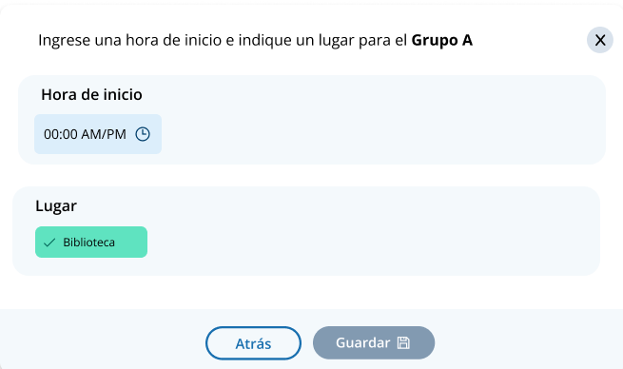

Student group details pop-up:
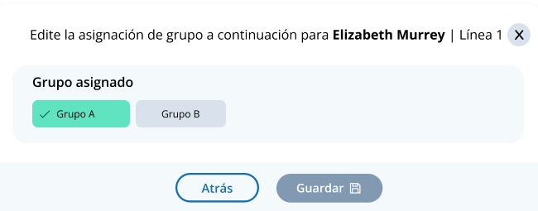

Appendix I9: Support Assessment Activities, English and Spanish Puerto Rico (NEW)

Support Assessment Activities
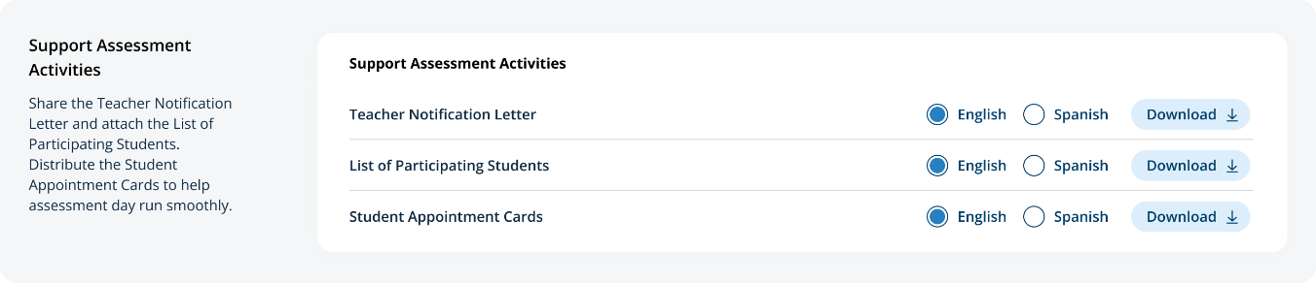
From this section, schools can download documents such as the Teacher Notification Letter, List of Participating Students, and Student Appointment Cards to help support assessment activities.

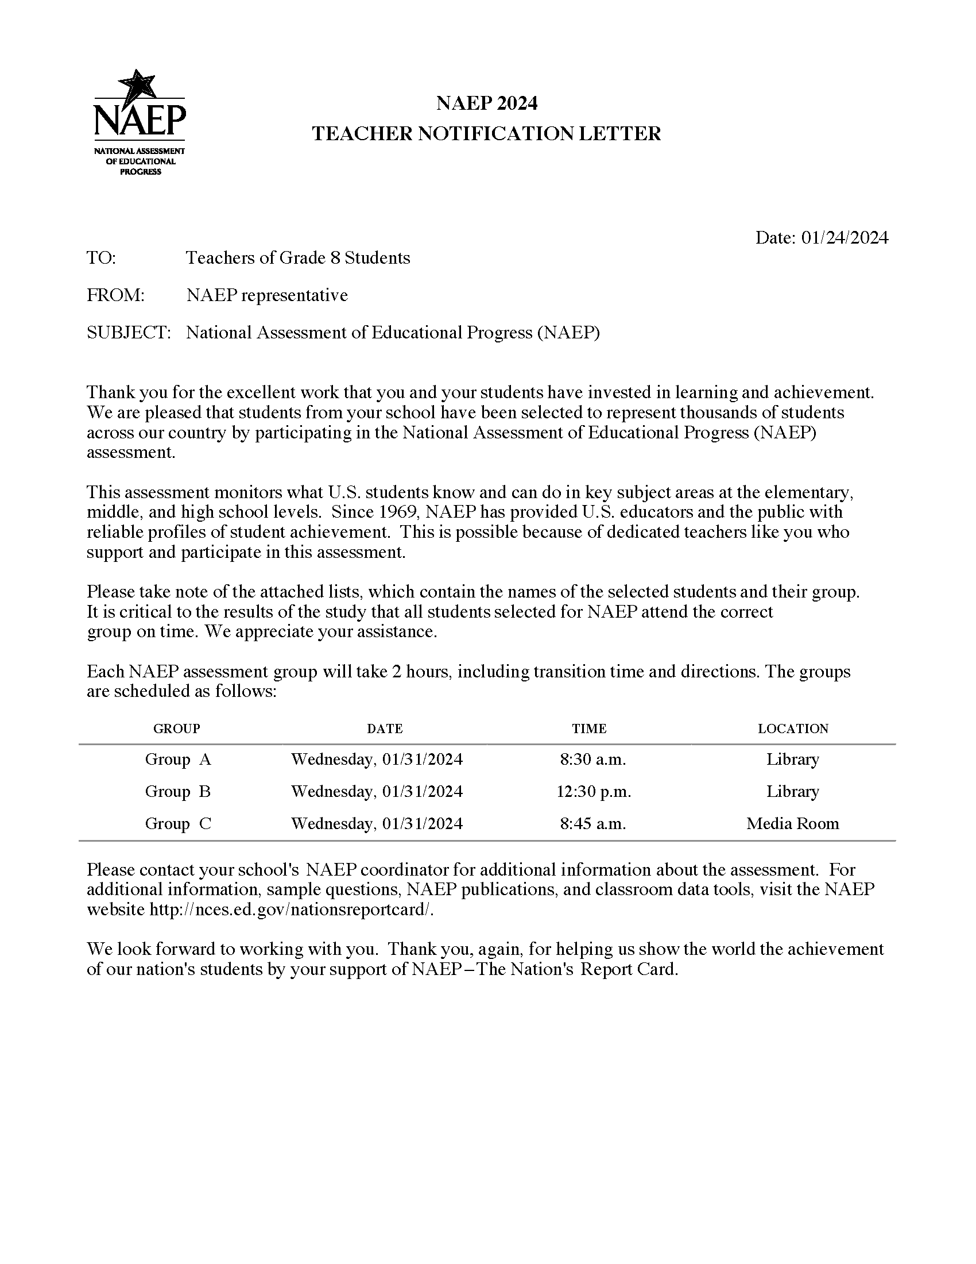Teacher Notification Letter

List of Participating Students
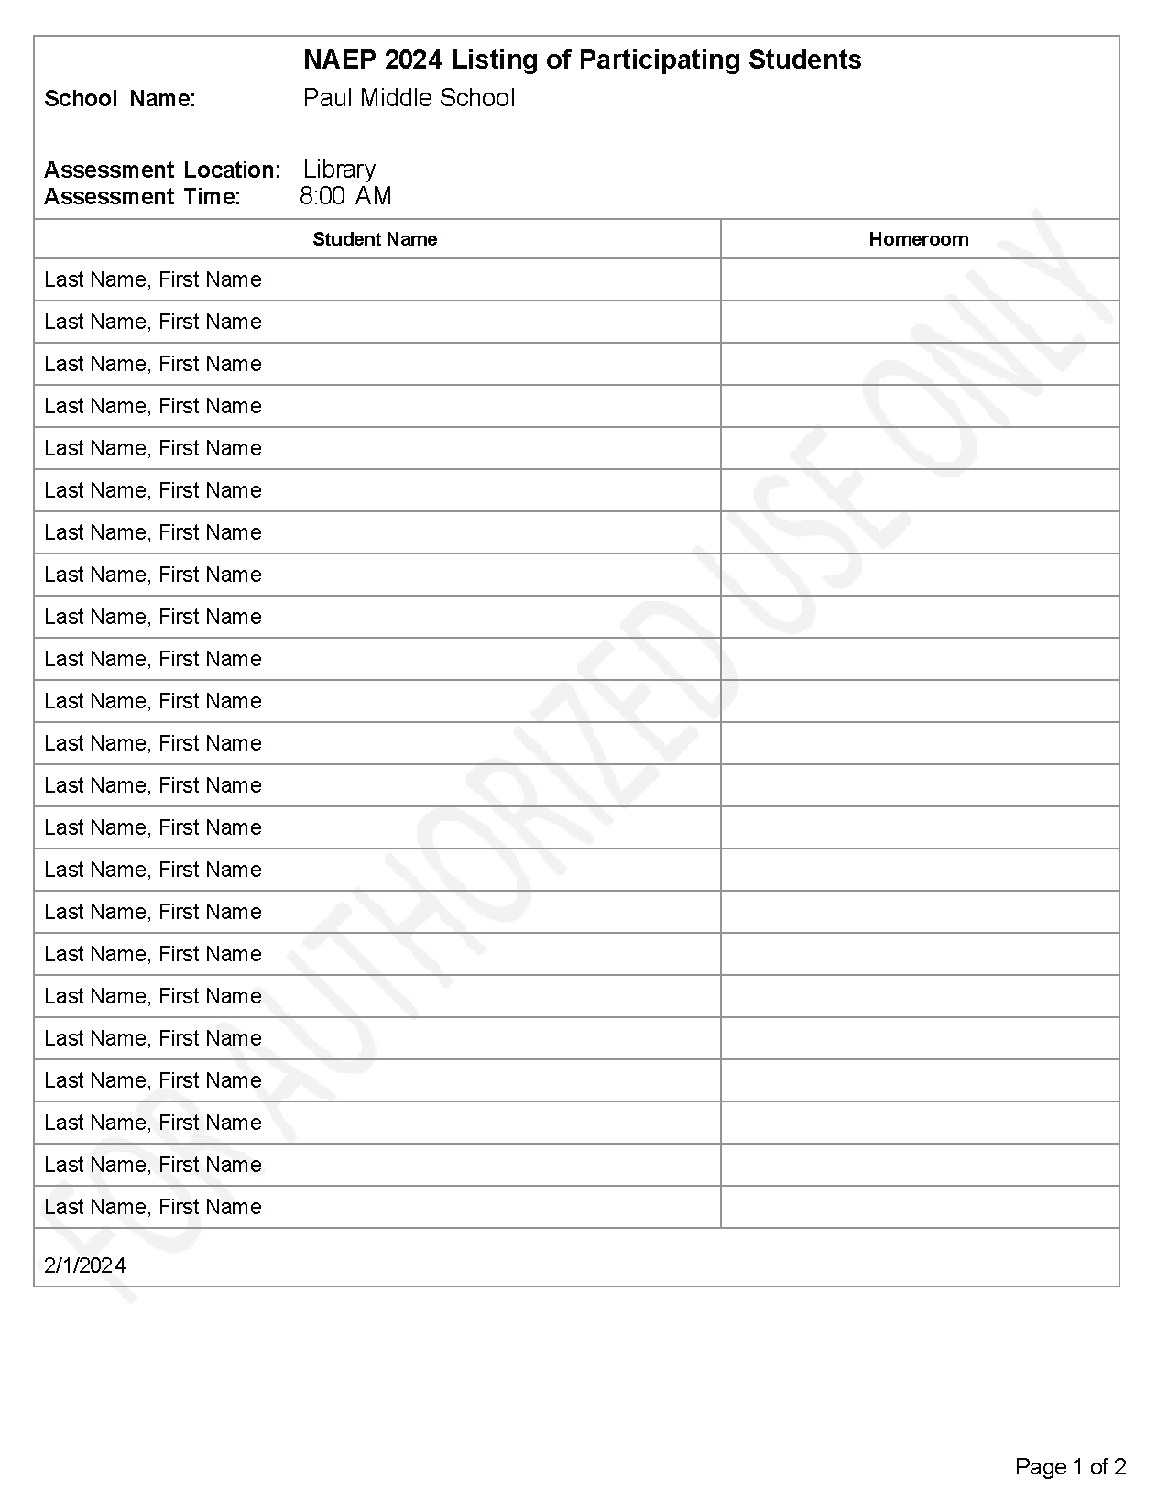

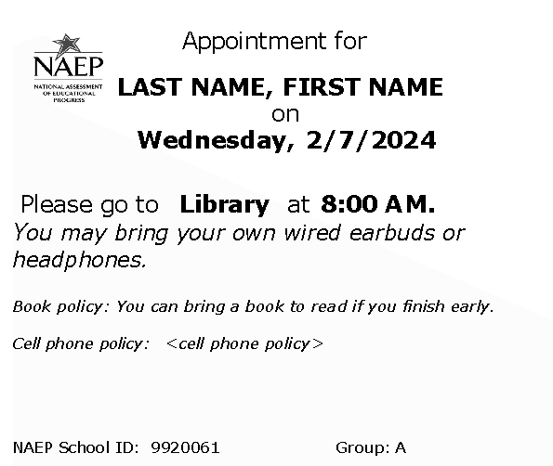
Student Appointment Cards

Support Assessment Activities
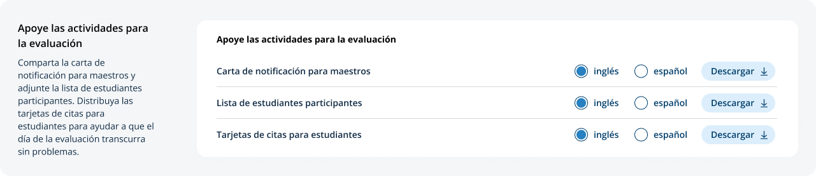
From this section, schools can download documents such as the Teacher Notification Letter, List of Participating Students, and Student Appointment Cards to help support assessment activities.

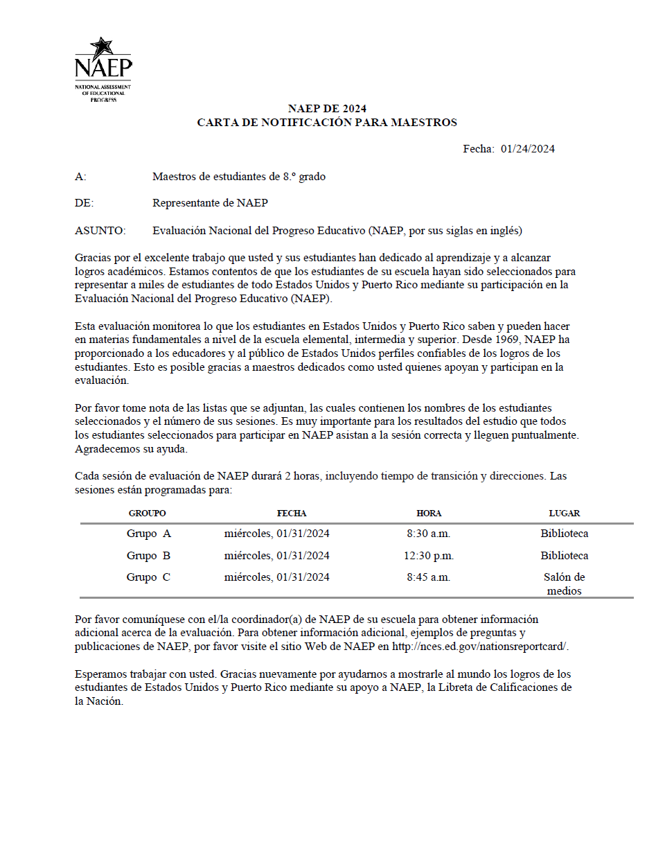
Teacher Notification Letter

List of Participating Students
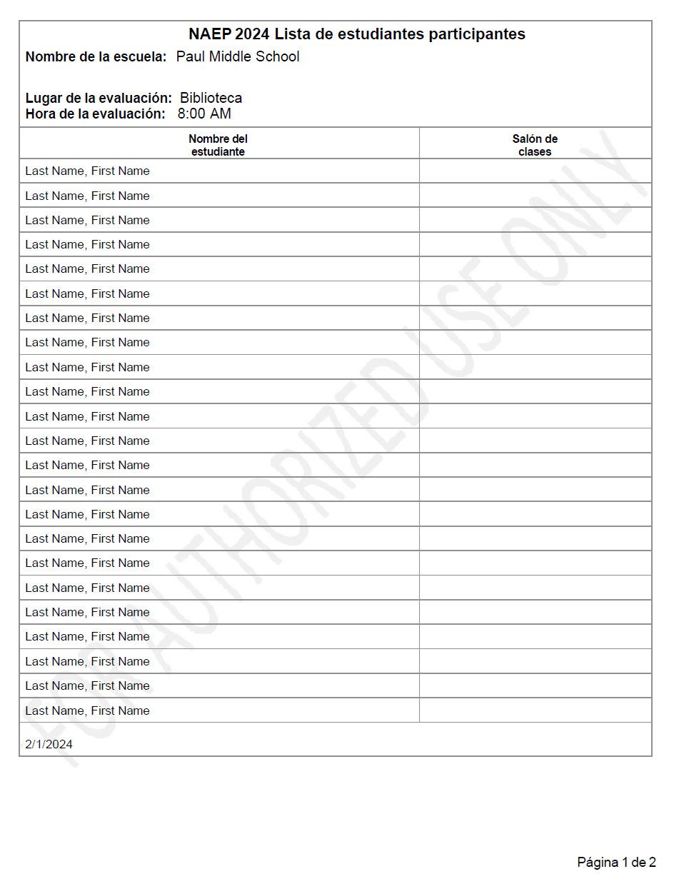

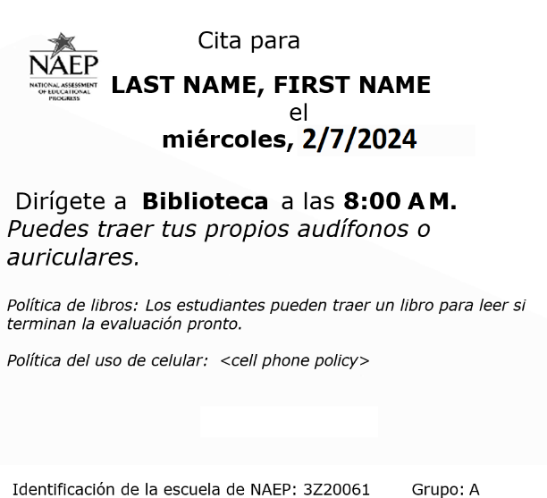
Student Appointment Cards

Appendix I10: Parent/Guardian Notification, English and Spanish Puerto Rico (NEW)

Parent/Guardian Notification
From the school summary page, schools will access and update this section by selecting Manage.
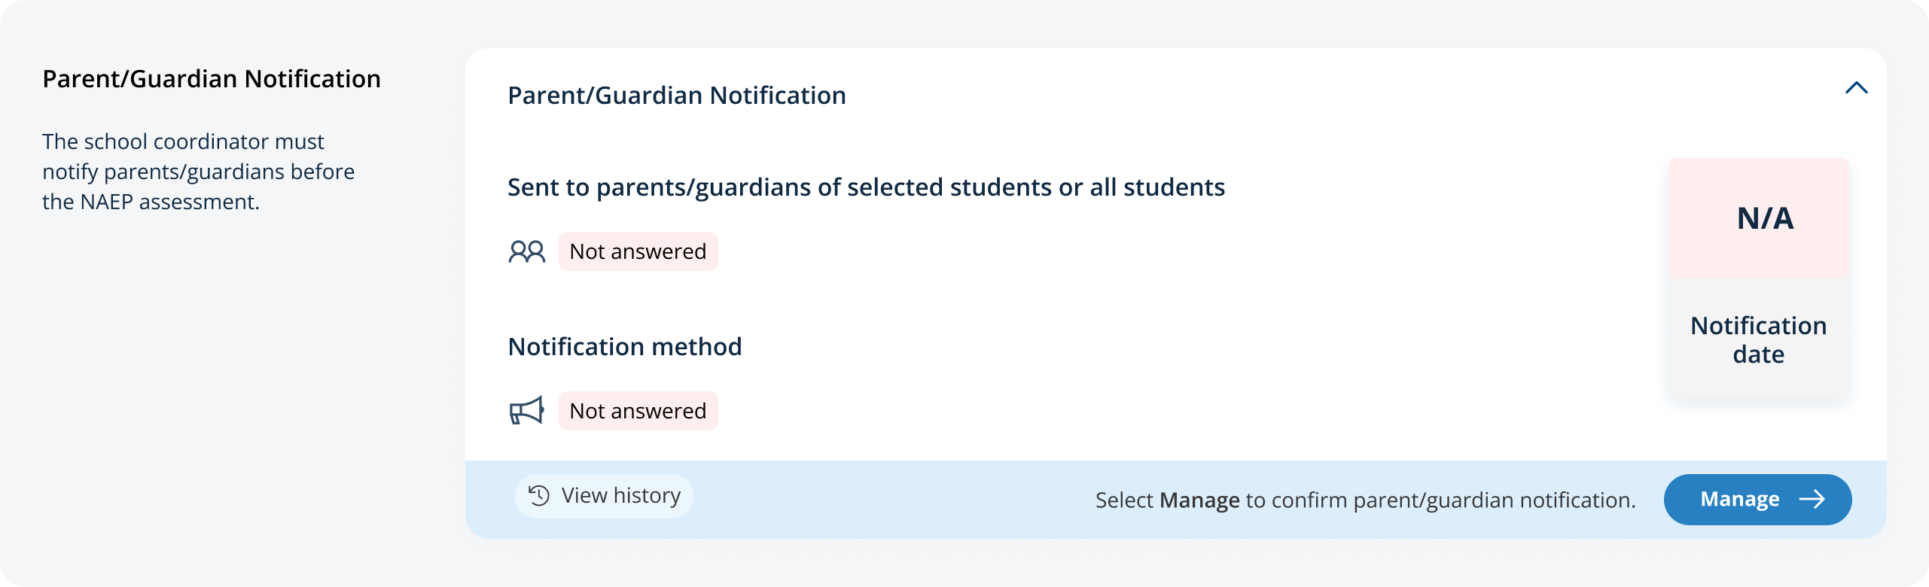
After selecting Manage on this page, schools will indicate how they notified parents and guardians, who was notified, and what date they were notified prior to the assessment. Schools will then download a PDF of the parent notification letter to distribute to parents and guardians. Schools are also able to download a translation notice to provide to parents or guardians as needed.
In the how to use this page, the following direction will be provided to users:
- Select the edit button to edit information.
In the parent/guardian notification details section, schools can select from the following options for “Parent/guardians were notified by” and “Parent/guardians who received the letter:”
- Parent/guardians were notified by
  - Mailed letter
  - Emailed letter
  - Letter sent home with students
  - Posted notice in newsletter
  - Other
- Parent/guardians who receive the letter
  - Parent/guardians of sampled students only
  - Parent/guardians of all grade <X> students
- Contact information to include in the letter
  - School coordinator’s contact information
  - Principal’s contact information
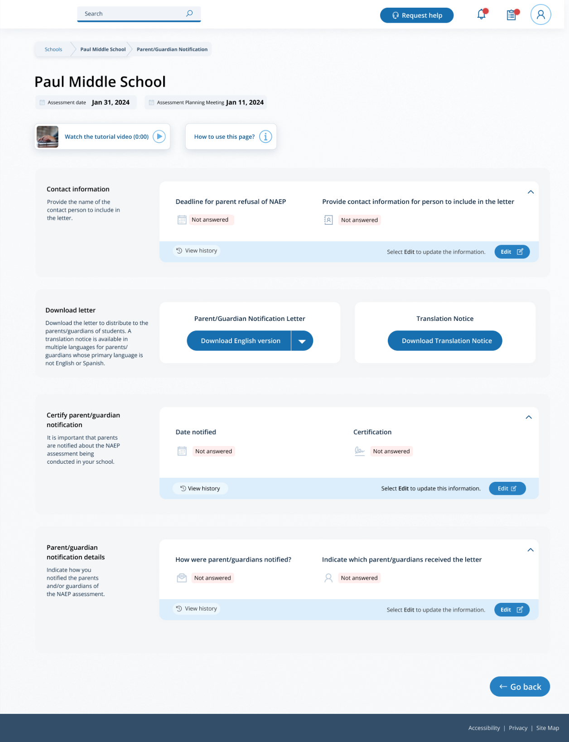

Parent/Guardian Notification
From the school summary page, schools will access and update this section by selecting Manage.
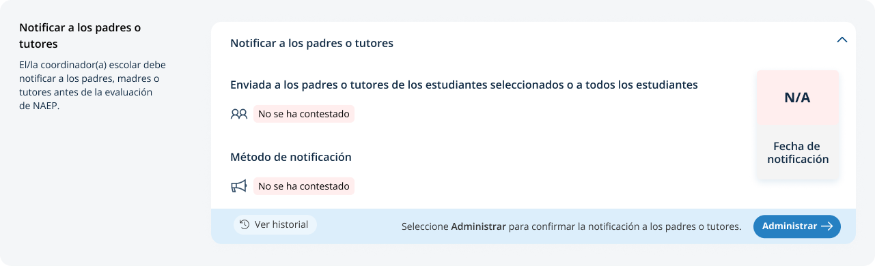
After selecting Manage on this page, schools will indicate how they notified parents and guardians, who was notified, and what date they were notified prior to the assessment. Schools will then download a PDF of the parent notification letter to distribute to parents and guardians. Schools are also able to download a translation notice to provide to parents or guardians as needed.
In the how to use this page, the following direction will be provided to users:
- Seleccione el botón de editar para editar la información.
In the parent/guardian notification details section, schools can select from the following options for “Parent/guardians were notified by” and “Parent/guardians who received the letter:”
- Los padres o tutores fueron notificados por
  - Carta enviada por correo postal
  - Carta enviada por correo electrónico
  - Carta enviada a casa con los estudiantes
  - Anuncio en el boletín informativo
  - Otro
- Los padres o tutores que recibieron la carta
  - Sólo los padres o tutores de los estudiantes de la muestra
  - Todos los padres o tutores de los estudiantes de grado X
- Información de contacto para incluir en la carta
  - Información de contacto del/de la coordinador(a) escolar
  - Información de contacto del/de la directora(a)
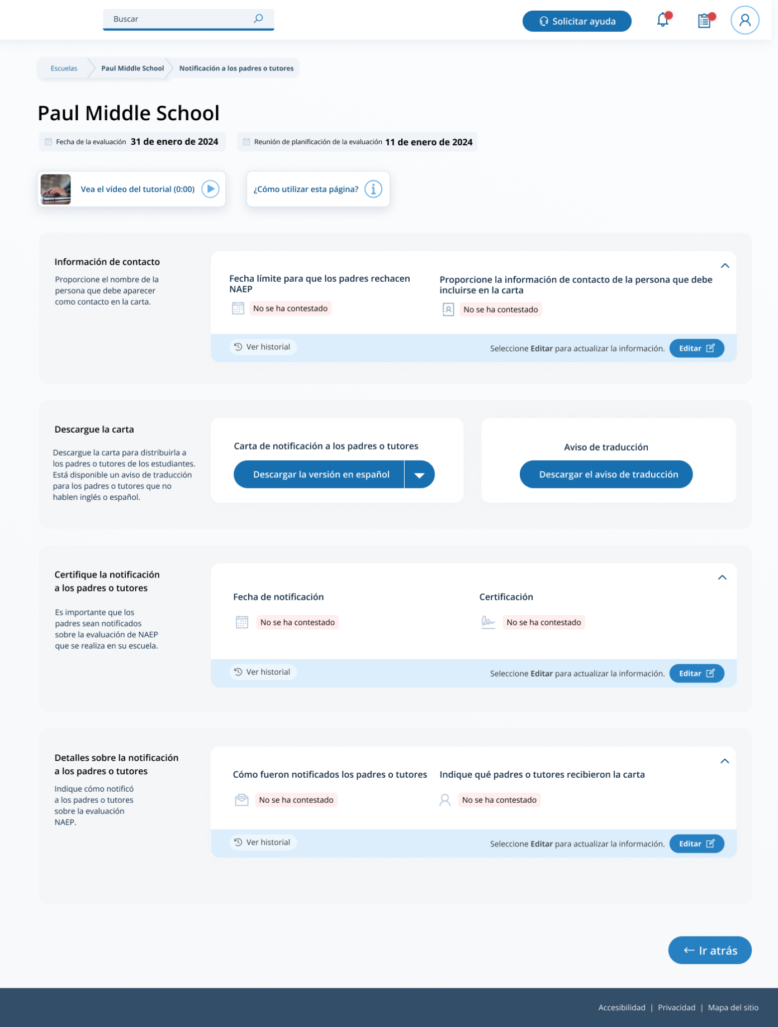

Appendix I11: Provide Student Information, English and Spanish Puerto Rico (NEW)

Provide Student Information
From the school summary page, schools will access this section to provide student information by selecting the Manage button, as shown below (bottom-right).
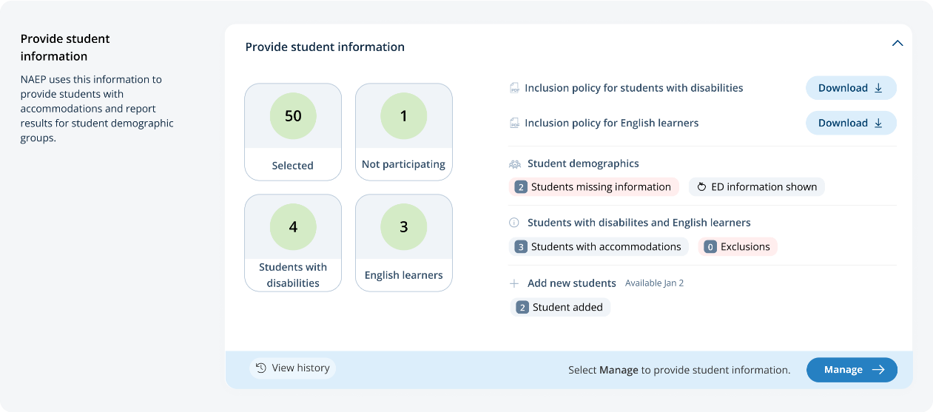

Student Demographic Information
On this page, schools will need to review both the student demographic information and students with disabilities and English learners tabs.
On the student demographic information tab, schools will review student demographic data and update any inaccurate information or provide missing information. This is where schools will identify students with a Section 504 Plan who require accommodations.
In the how to use this page, the following directions will be provided to users:
- Single student edits: Select the edit icon to edit an information for a single student.
- Multiple student edits: Select the boxes to edit multiple students, then use Category and Change menus to make changes.
- Export: Use the button to export the student information.
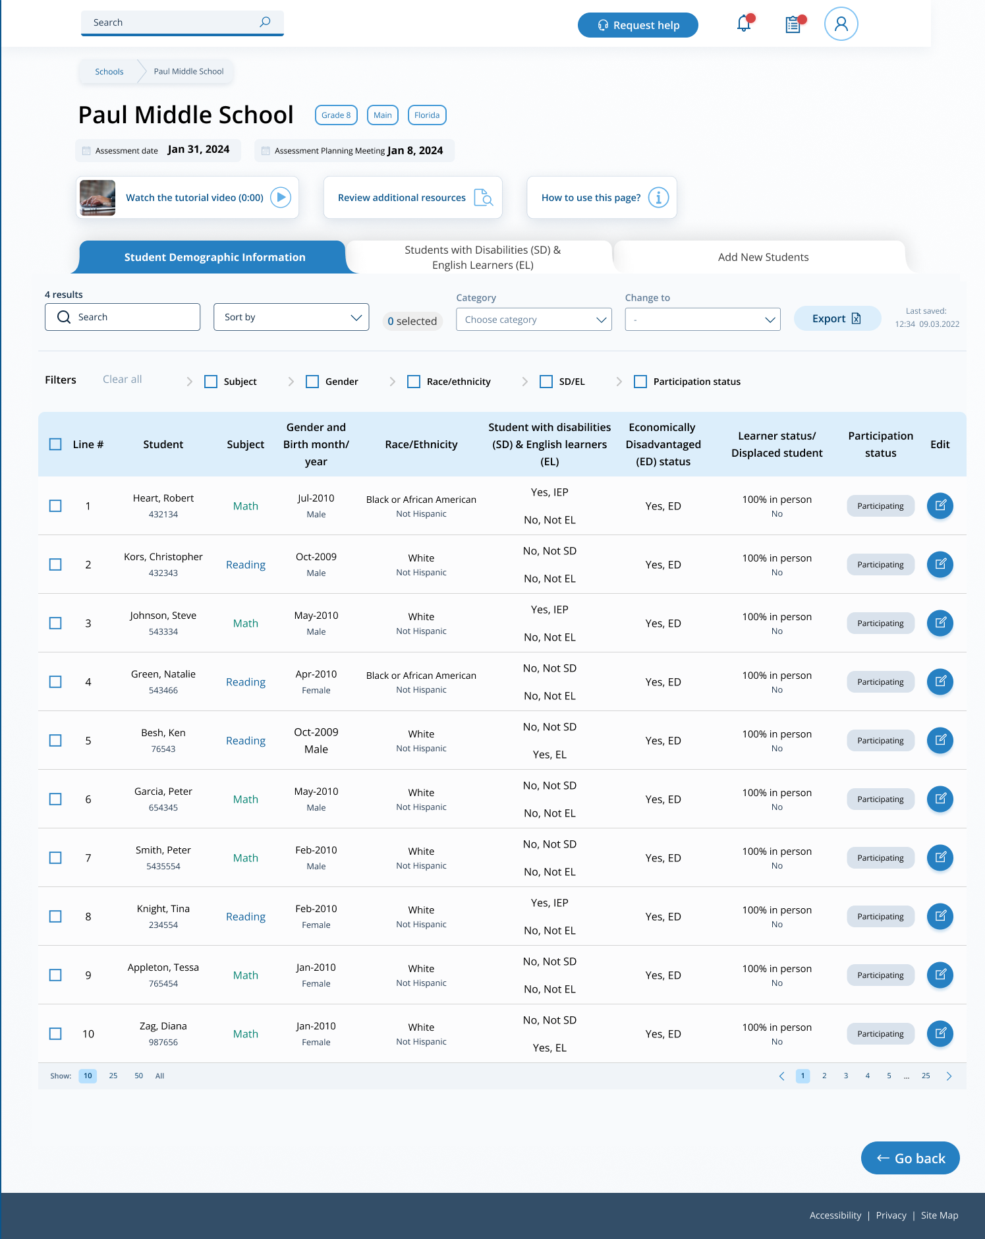
From the table, schools can make single edits or multiple edits. To make multiple student edits, schools select the number of students from the left-hand column, then use the Category and Change to drop-down menus to apply the changes.
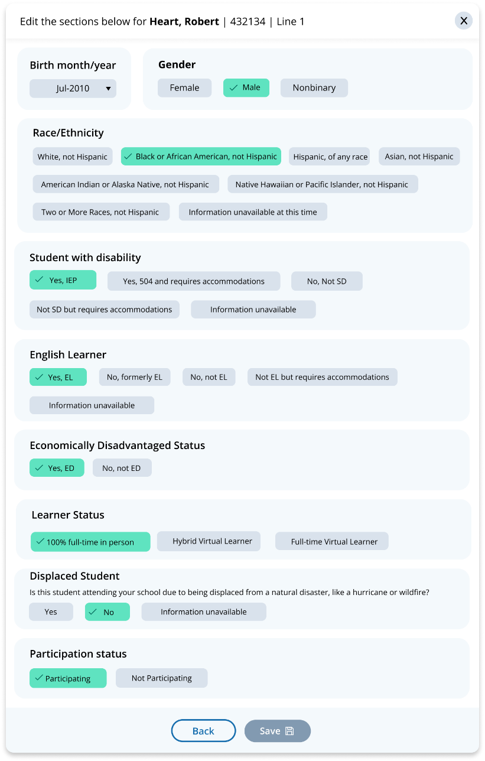
A single student edit is from the following pop-up:

Not participating options are as follows:
- Not enrolled at the school
- Enrolled but never attends campus
- Student listed in error
- Attends all classes full-time virtually
- Parent refusal
- Student refusal
- School refusal
- Students who are SD only: Meets (or met) participation for alternative state assessment
- Students who are EL only: Enrolled in U.S. schools for less than 1 year prior to the NAEP assessment

Student with a disability and English learners
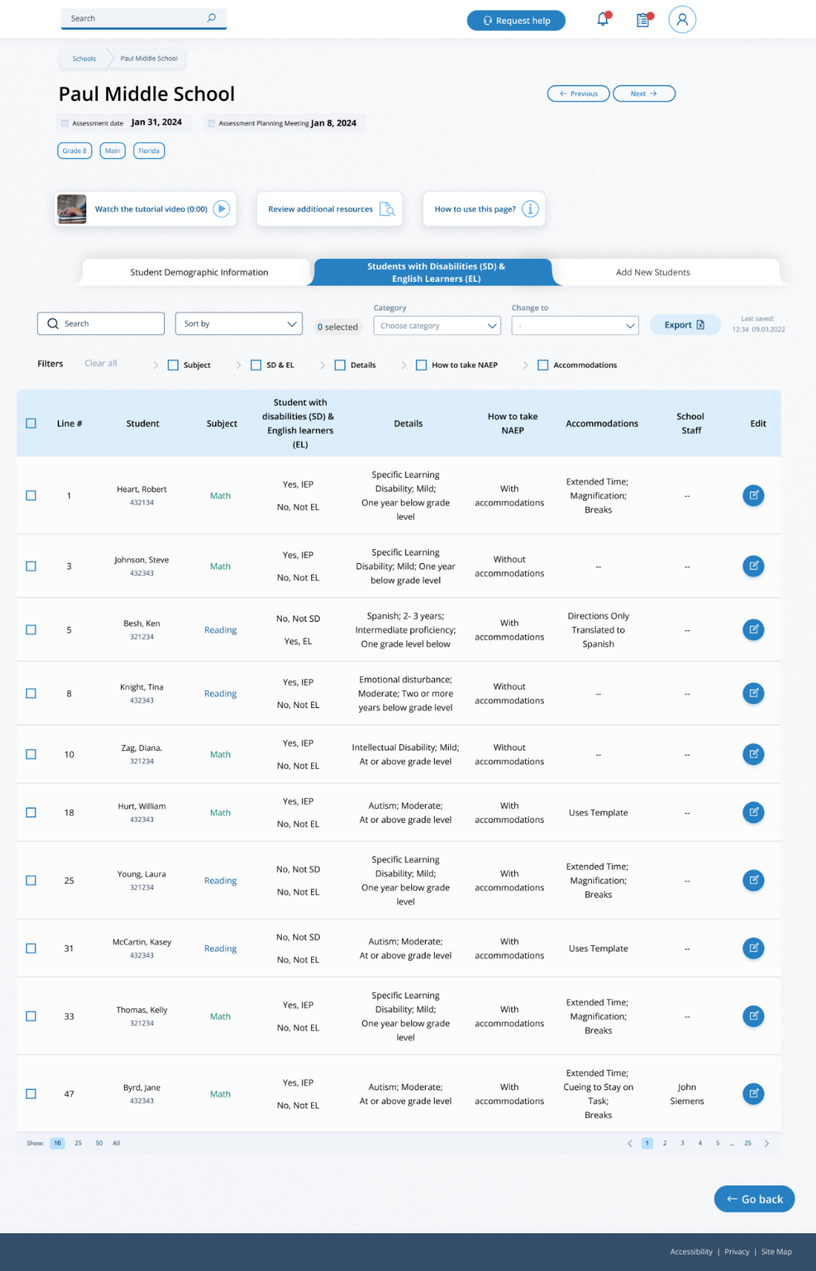
From this table, schools will provide information for students identified as students with disabilities and/or English learners. Schools will also select NAEP-provided accommodations, if needed by the student.

From the table, schools can make single edits or multiple edits. To make multiple edits, schools select the number of students from the left-hand column, then use the Category and Change to drop-down menus to apply the changes.
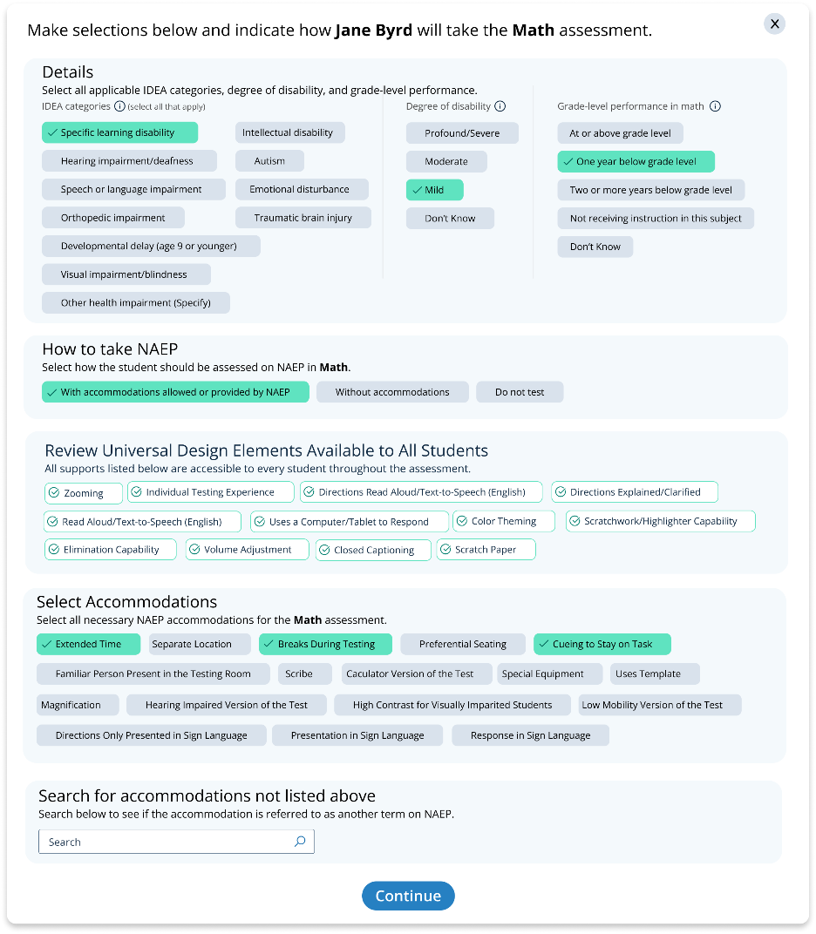
Schools edit a single student from the following pop-up:

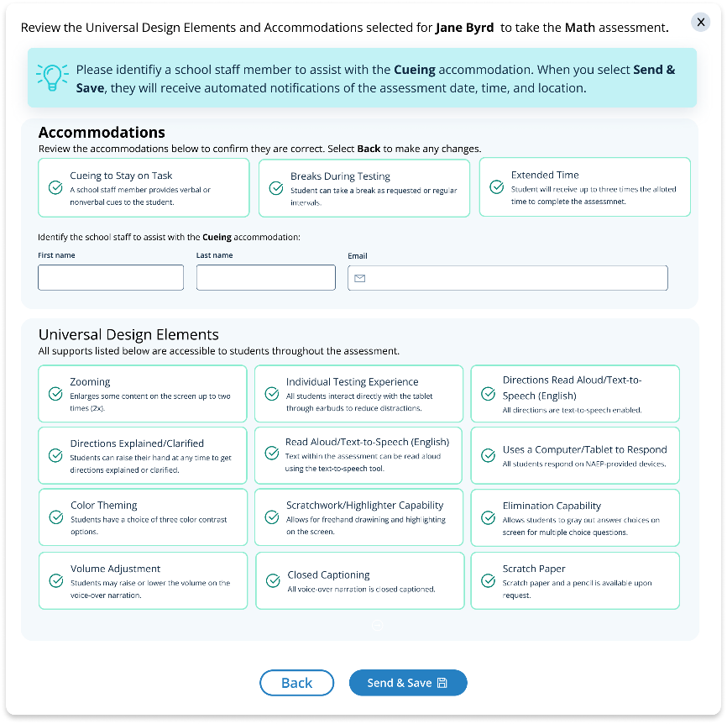

Review NIES Students
This tab will only appear for mainland, operational assessments at Grade 4 and Grade 8 schools, if there are students identified as American Indian or Alaska Native. From this table, schools will confirm students are correctly identified as American Indian or Alaska Native and can make updates to a student’s race/ethnicity if incorrectly identified.
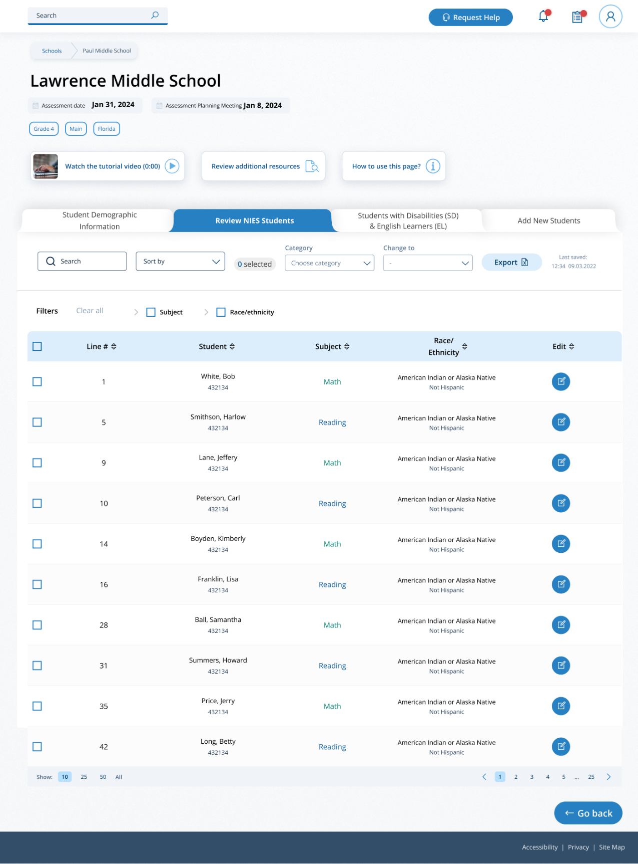
From the table, schools can make single edits or multiple edits. To make multiple edits, schools select the number of students from the left-hand column, then use the Category and Change to drop-down menus to apply the changes.
Schools edit a single student from the following pop-up:
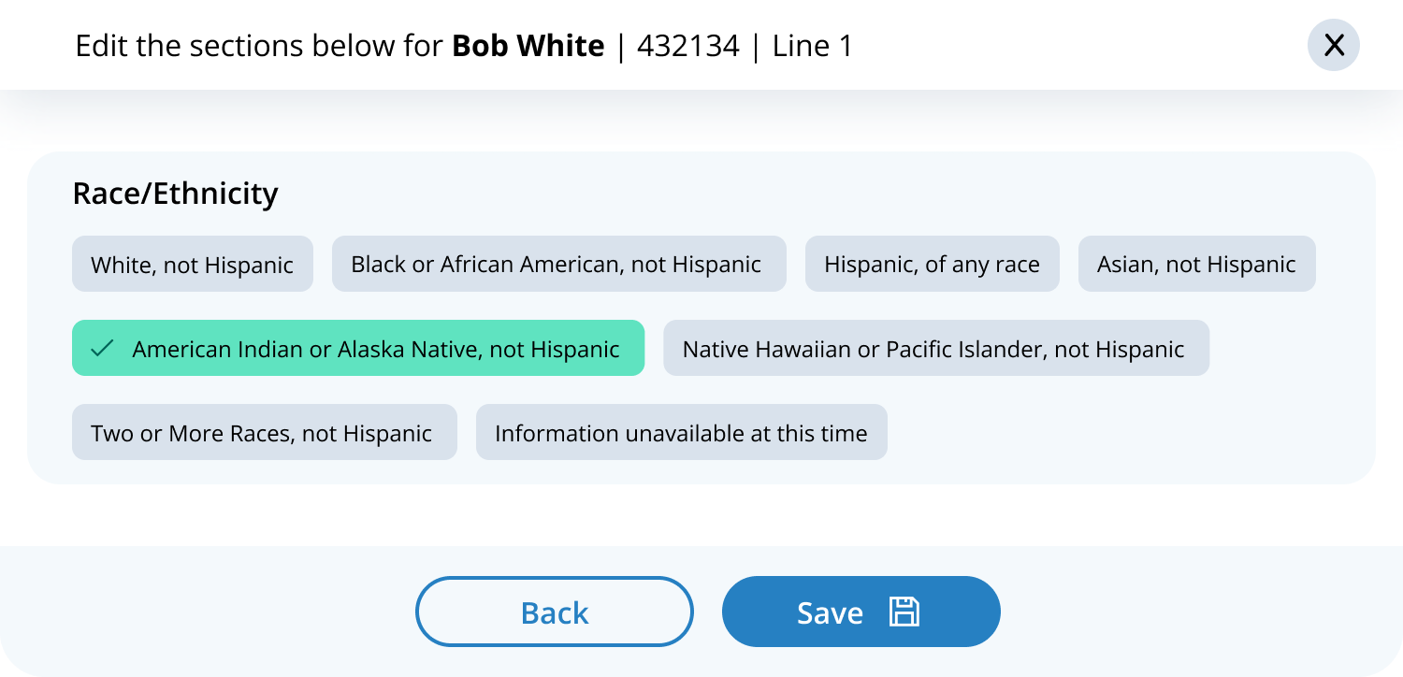

Provide Student Information
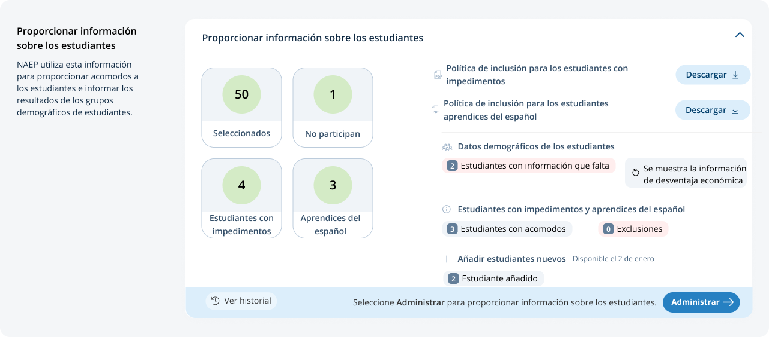From the school summary page, schools will access this section to provide student information by selecting the Manage button, as shown below (bottom-right).

Student Demographic Information
On this page, schools will need to review both the student demographic information and students with disabilities and Spanish learners tabs.
On the student demographic information tab, schools will review student demographic data and update any inaccurate information or provide missing information. This is where schools will identify students with a Section 504 Plan who requires accommodations.
In the how to use this page, the following directions will be provided to users:
- Single student edits: Seleccione el icono de editar para editar la información de un solo estudiante.
- Multiple student edits: Seleccione las casillas para editar la información de varios estudiantes y luego utilice los menús de Categoría y Cambiar a para hacer los cambios.
- Export: Utilice el botón para exportar la información de los estudiantes.
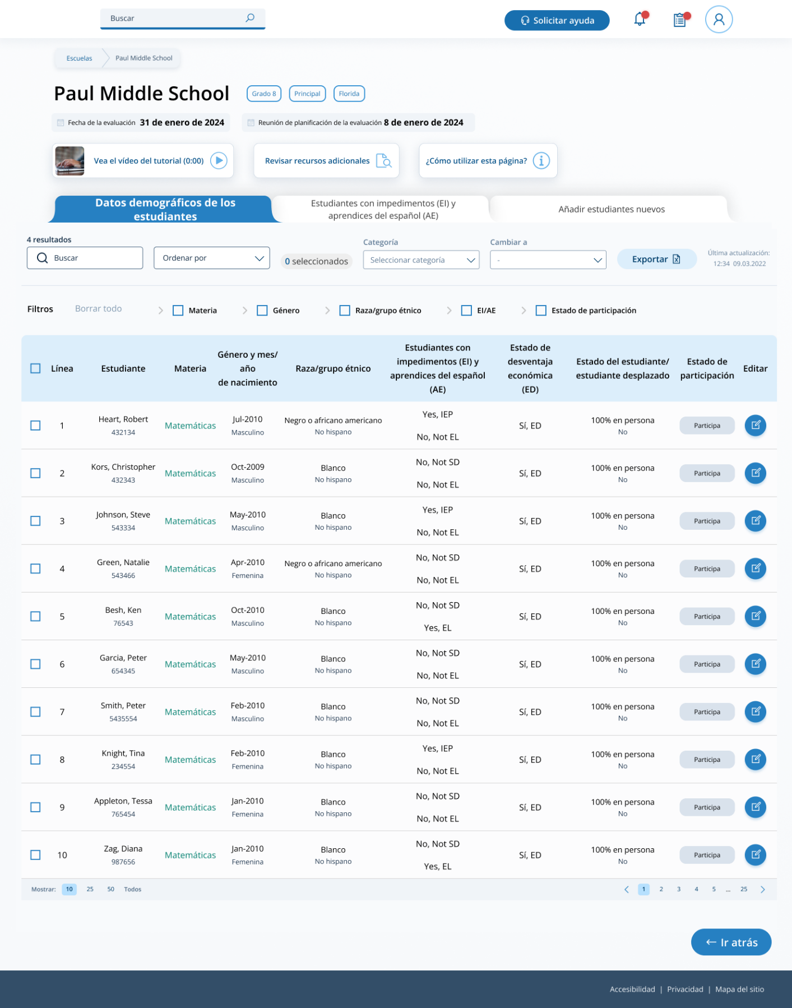
From the table, schools can make single edits or multiple edits. To make multiple student edits, schools select the number of students from the left-hand column, then use the Category and Change to drop-down menus to apply the changes.
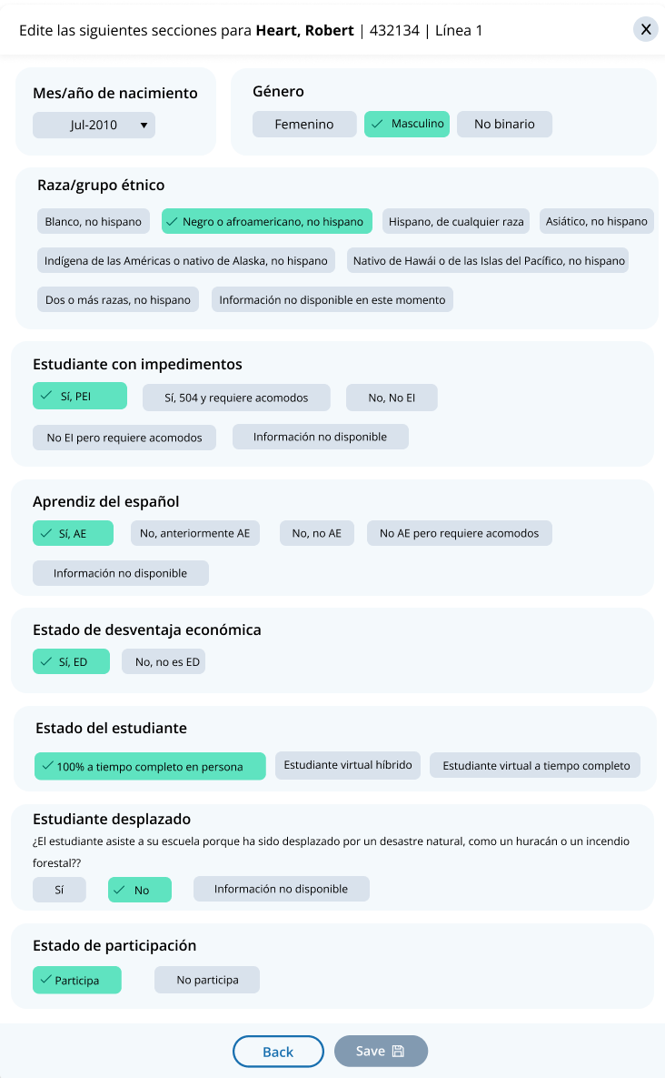
A single student edit is from the following pop-up:

Not participating options are as follows:
- No está matriculado en la escuela
- Está matriculado pero nunca asiste a las instalaciones
- Estudiante incluido en la lista por error
- Asiste a todas las clases a tiempo completo de forma virtual
- Rechazo de los padres
- Rechazo del estudiante
- Rechazo de la escuela
- Estudiantes que sólo son EI: Cumple (o cumplió) con la participación para la evaluación estatal alterna
- Estudiantes que sólo son AE: Estuvo matriculado en las escuelas de Puerto Rico durante menos de un año antes de la evaluación NAEP

Student with a disability and Spanish learners
From this table, schools will provide information for students identified as students with disabilities and/or Spanish learners. Schools will also select NAEP-provided accommodations, if needed by the student.
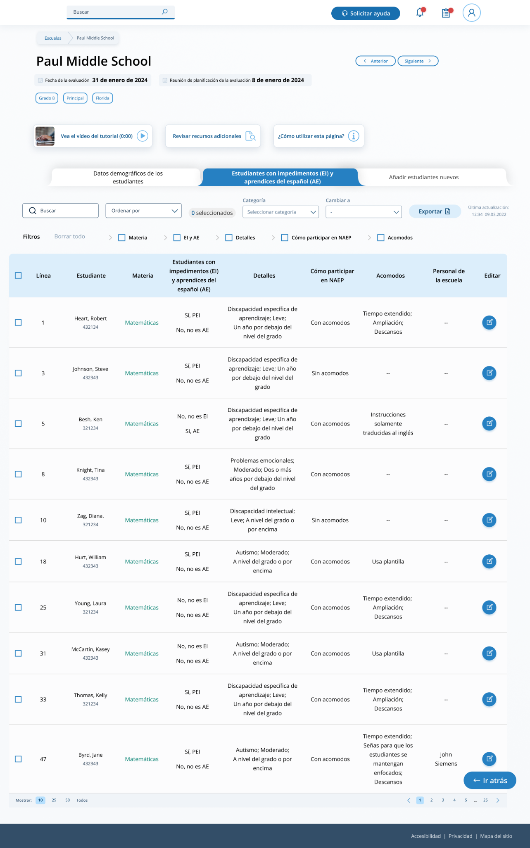
From the table, schools can make single edits or multiple edits. To make multiple edits, schools select the number of students from the left-hand column, then use the Category and Change to drop-down menus to apply the changes.
Schools edit a single student from the following pop-ups:
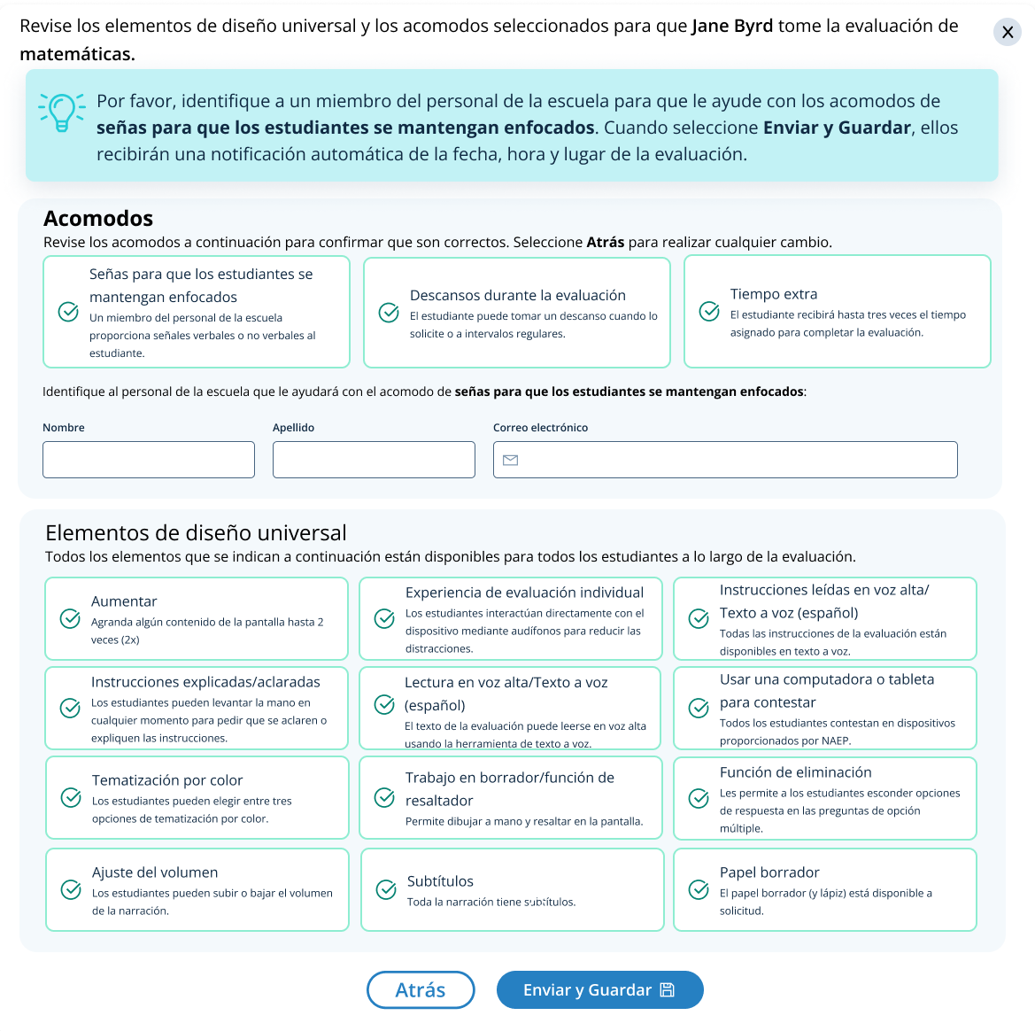
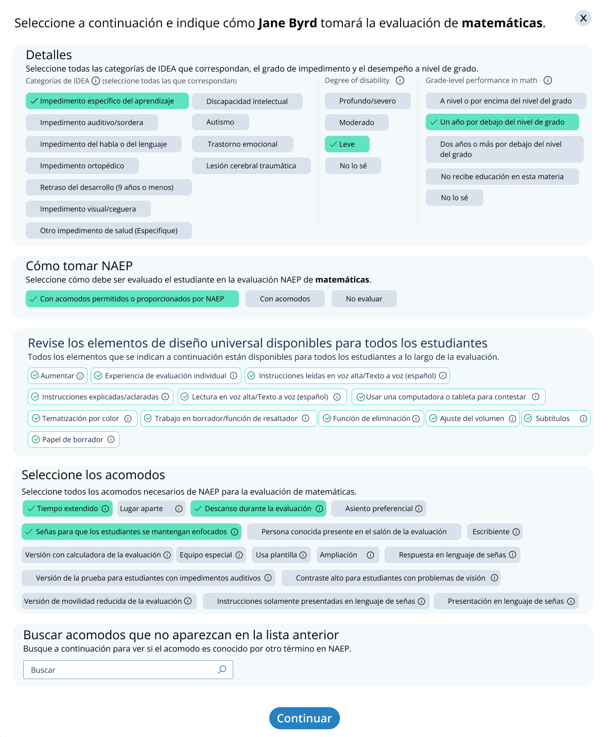

Appendix I12: Technical Logistics Prototype Images and Rules, English and Spanish Puerto Rico (NEW)

NOTE: The Puerto Rico Technical Logistics Prototype Images and Rules screens have not yet been updated to match the English Technical Logistics Prototype Images and Rules screens in time for inclusion for the 30D public comment period. There is a possibility that this screen and others may require slight technical revisions after the 30D inspection period is complete but before OMB approval. Final drafts of all approved documents are always available on reginfo.gov.

Technical Logistics Prototype Images and Rules

On-site technology coordinators complete the Technical Logistics section only when responses from the Internet Connectivity Survey indicate external NAEP-provided devices can connect to the school’s Wi-Fi network.

Activity 1: Initial Wi-Fi Check

Introduction
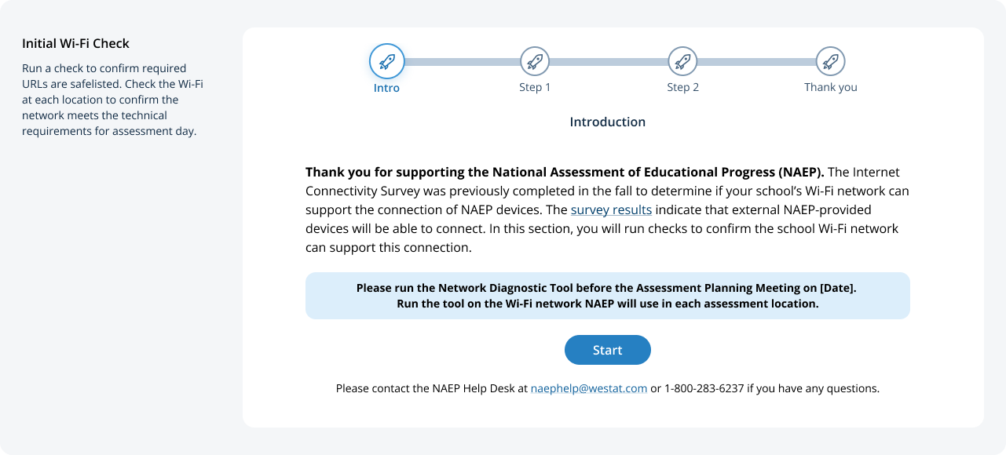
The Start button becomes active after the school coordinator selects assessment locations in the Assessment Logistics section. The button is turned off with a message underneath until that event takes place.
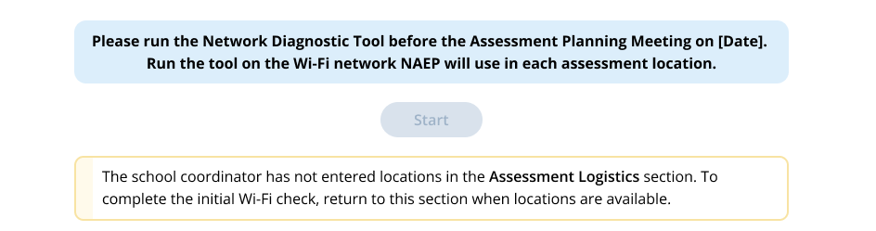

Step 1
The technology coordinator runs the Network Diagnostic Tool in each assessment location.
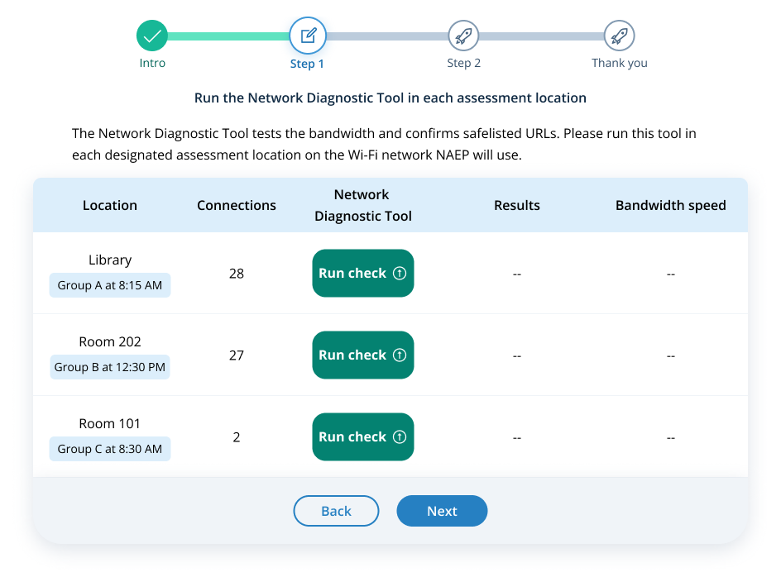
If the coordinator selects the Next button without running the check for each location, they will see a corrective action message. The coordinator cannot go to the next step until they run a check at each location.
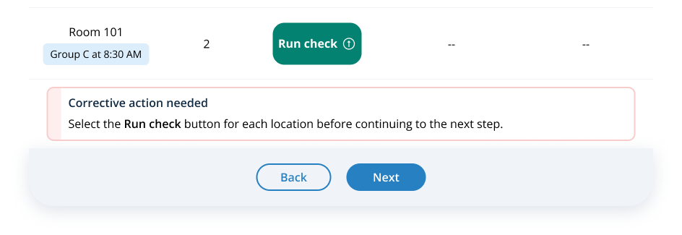

Running the Network Diagnostic Tool
A modal popup appears when the coordinator selects the Run check button for a location.
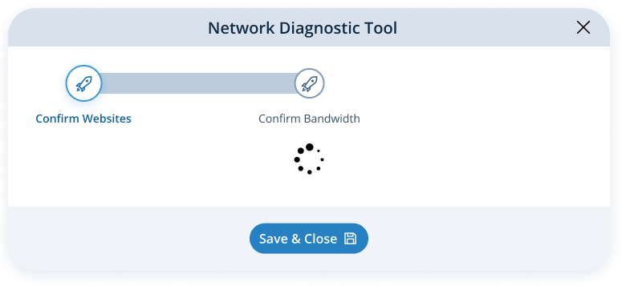
When the safelist check fails, the modal changes.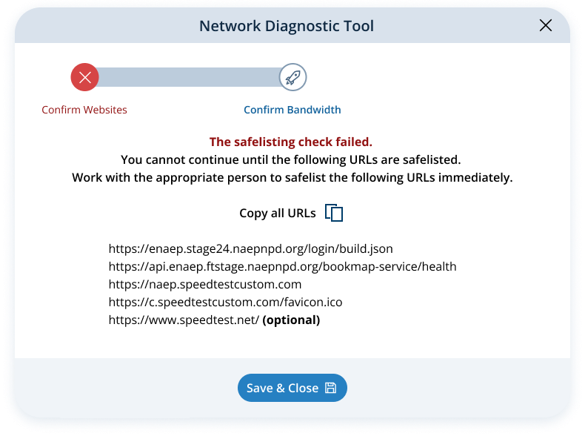

The table reflects a safelist failure for each location. The coordinator cannot go to the next step until the safelist check passes.
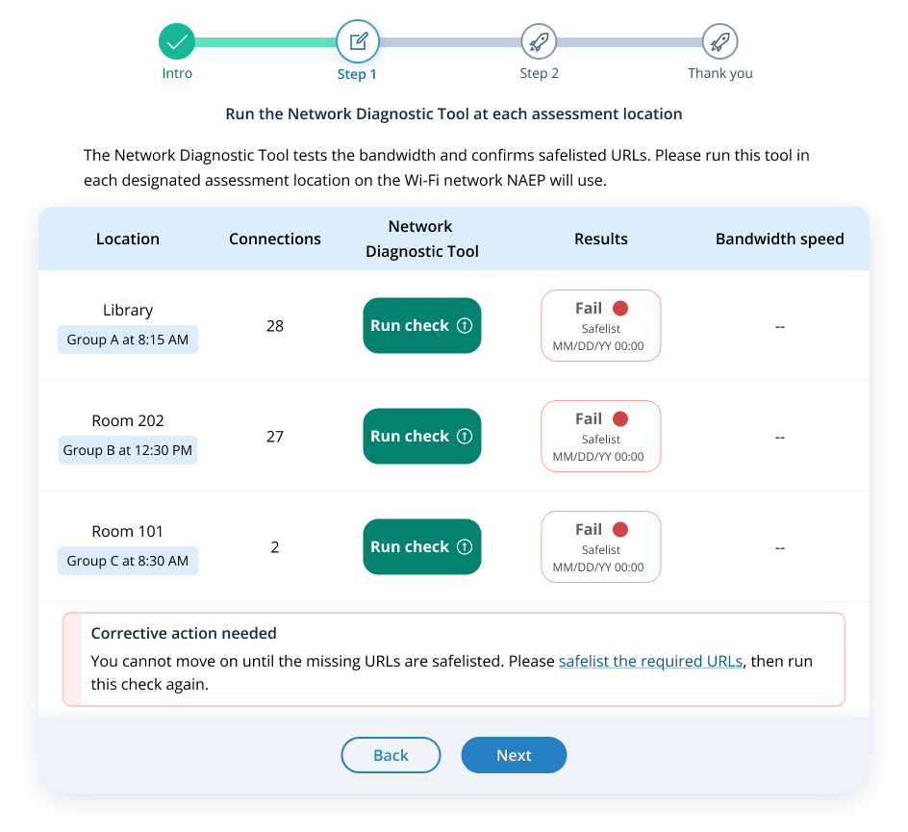
The corrective action hyperlink opens instructions for safelisting URLs.
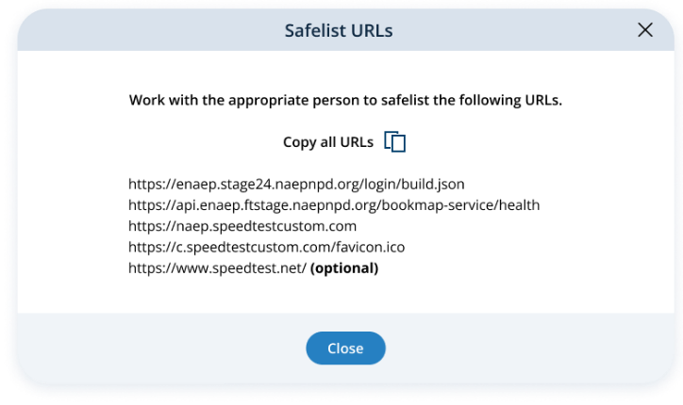

When the bandwidth check fails, the modal changes.
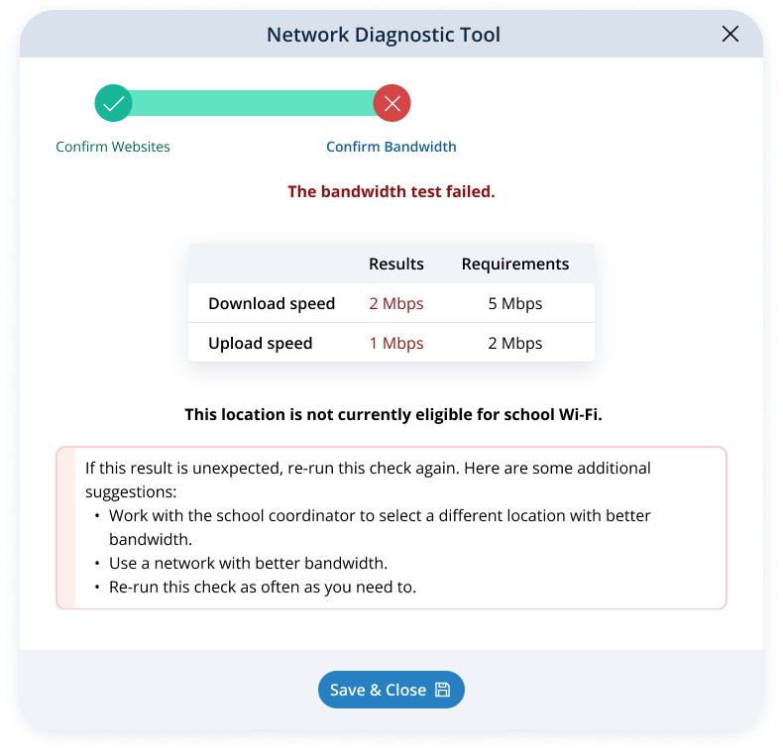

When both checks pass, the modal changes.
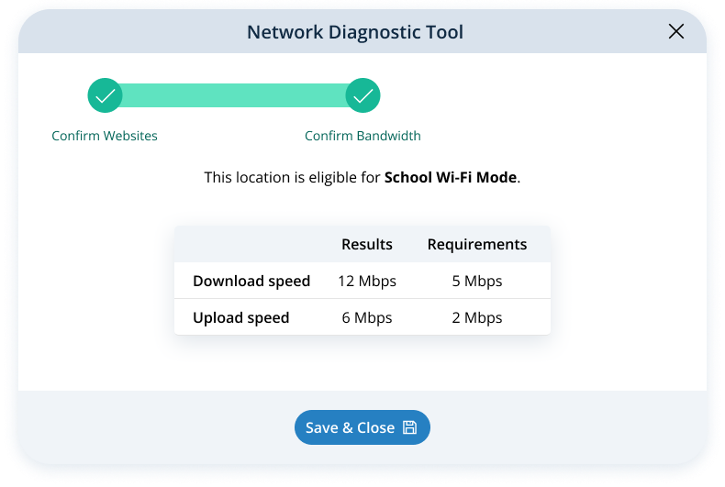

Bandwidth pass/fail results are shown in the table.

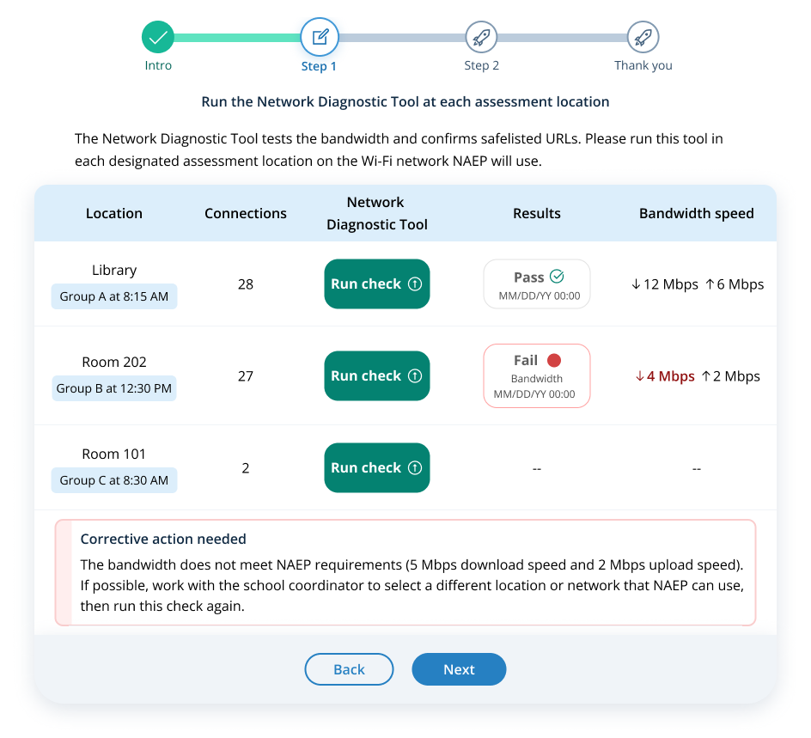

The coordinator can move on to step 2 when there’s a result for each location.
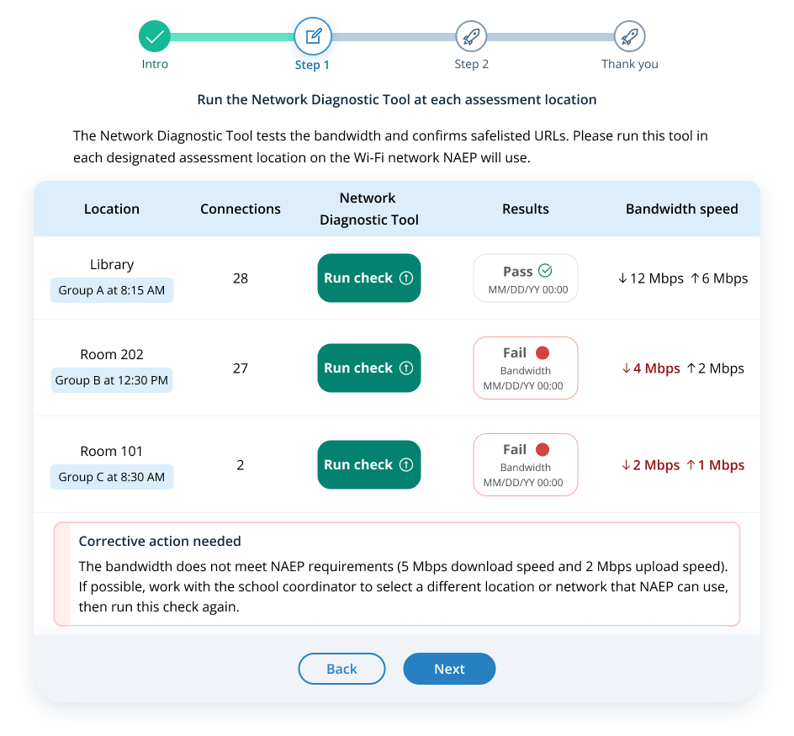

Step 2
The technology coordinator confirms the Wireless Access Points can support all connections in step 2.
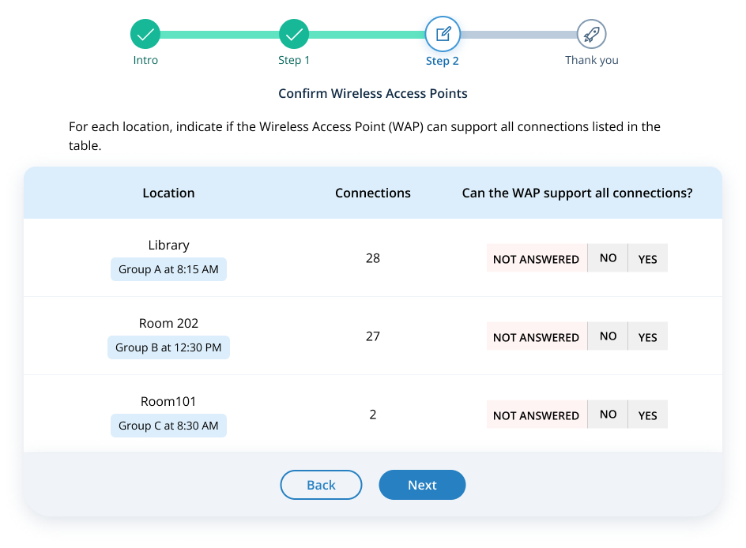

If the coordinator selects the Next button without answering the question for each location, they will see a corrective action message. The coordinator cannot go to the next step until they answer the question for each location.
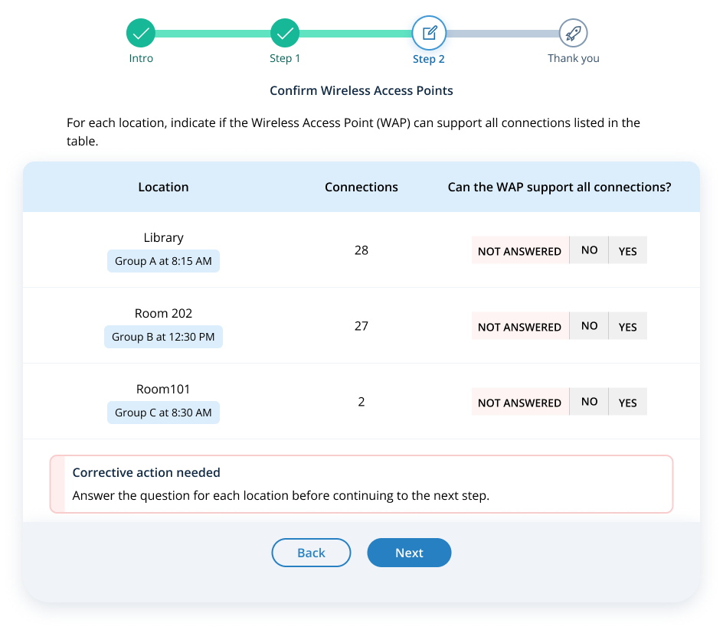

If the coordinator selects No for any location, they will see a suggested action message. Locations with an answer of No will not be eligible for school Wi-Fi mode.
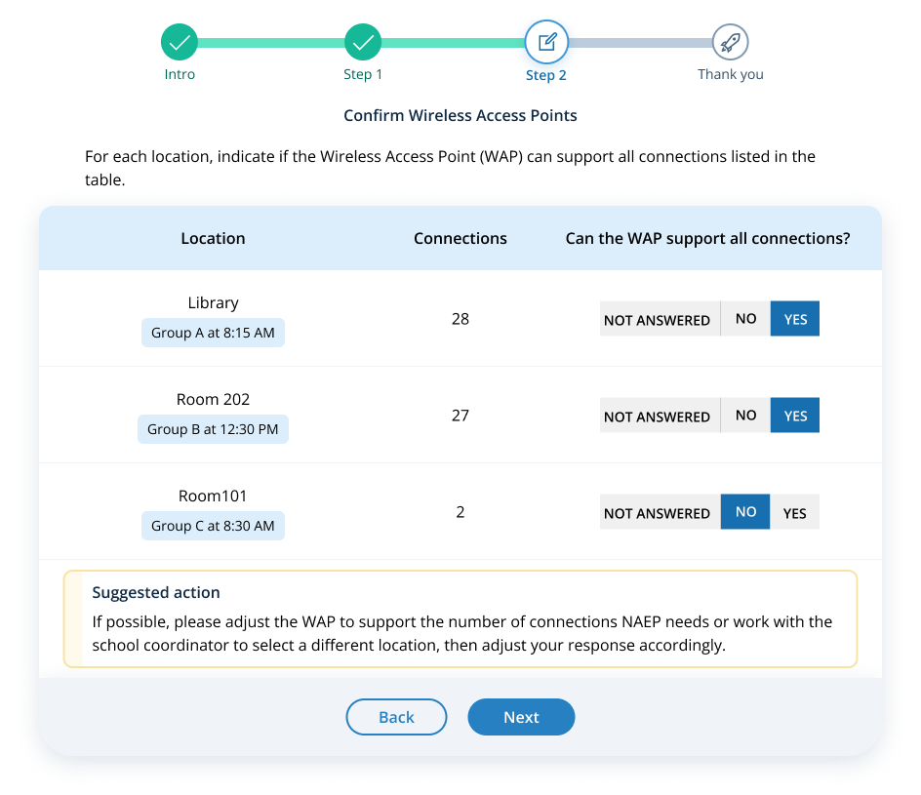

Step 3
The technology coordinator reviews the results of the initial check in Step 3.
- Locations that pass all initial checks are “Eligible for school Wi-Fi”, and are included in the Final Wi-Fi check.
- Locations that fail the initial bandwidth test are “Not eligible for school Wi-Fi”, but are included in the Final Wi-Fi check.
- Locations that cannot support all Wireless Access Points are “Not eligible for school Wi-Fi”, and are excluded from the Final Wi-Fi check.
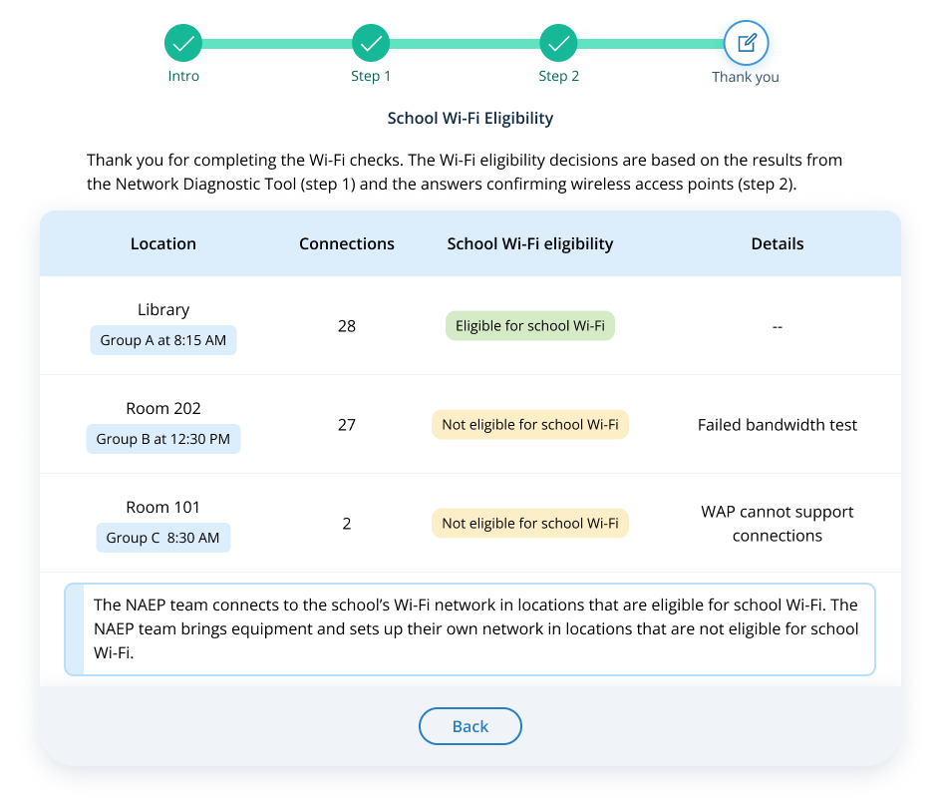

Activity 2: Network Connectivity Types and Wi-Fi Details
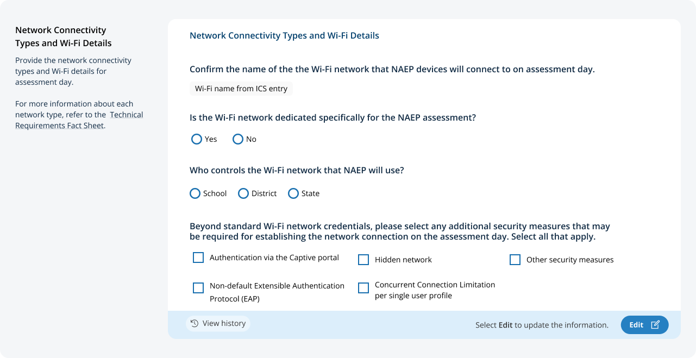
The coordinator will select the Edit button to provide Network Connectivity Types and Details. If they select the checkbox for Authentication via the Captive portal, two extra fields will appear.
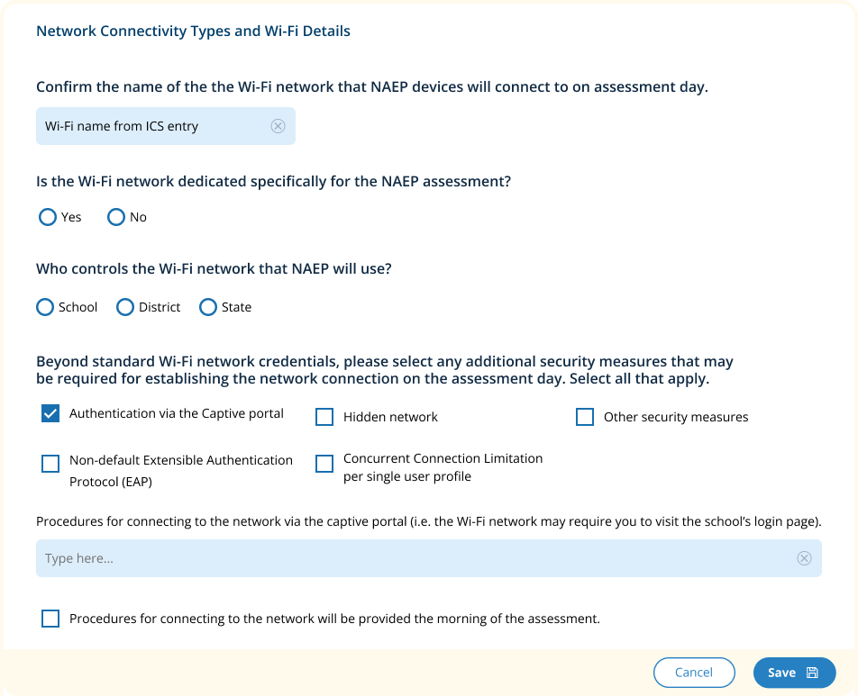

If they select the checkbox for Hidden Network, two extra fields will appear.
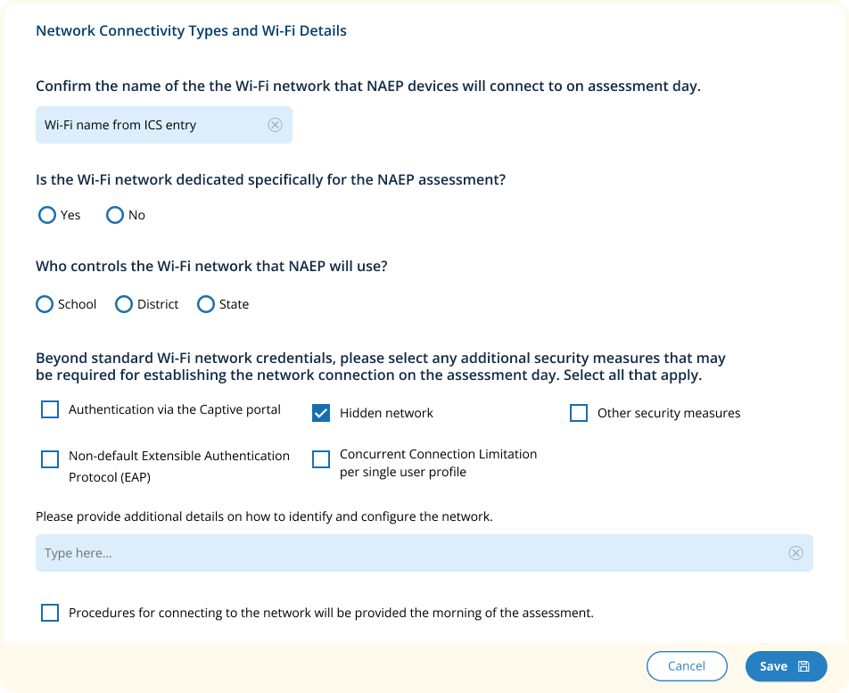

If they select the checkbox for Other security measures, two extra fields will appear.
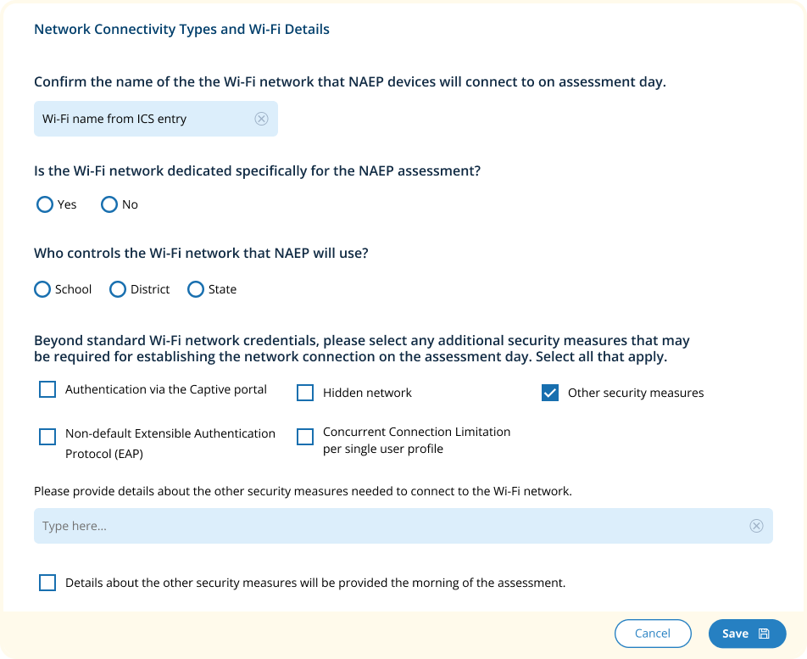

If they select the checkbox for Non-default Extensible Authentication Protocol (EAP), two extra fields will appear.
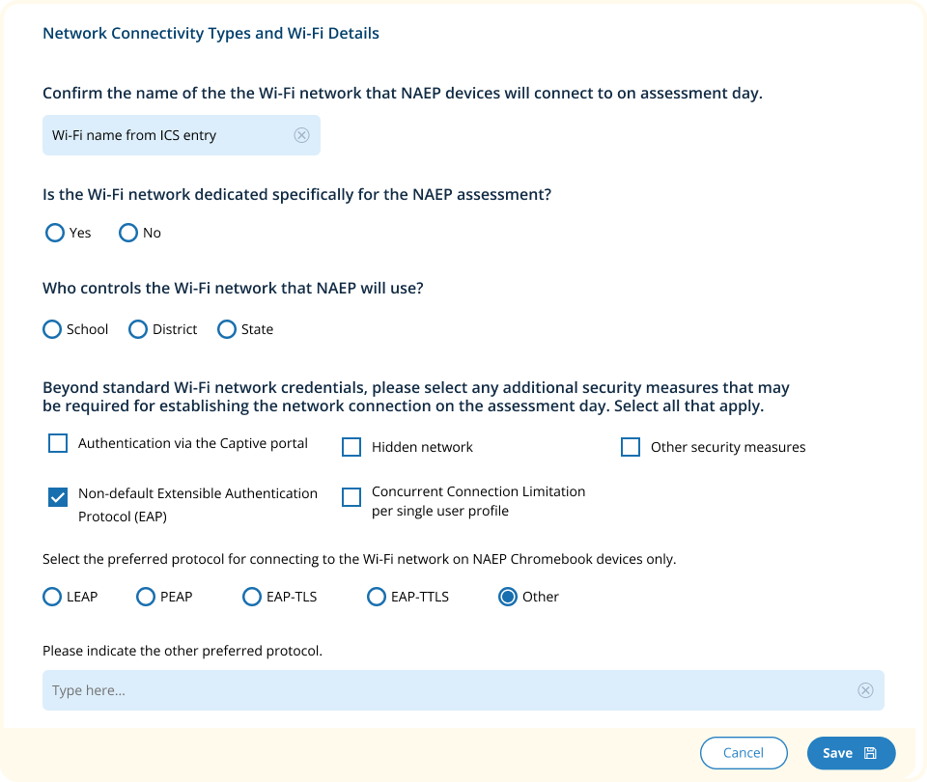

If they select the checkbox for Concurrent Connection Limitation per single user profile, one extra field will appear.
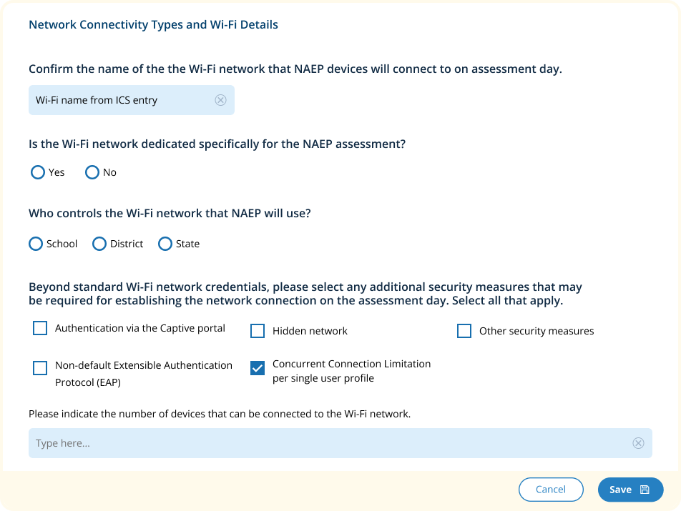

Activity 3: Meeting the NAEP Team on assessment day

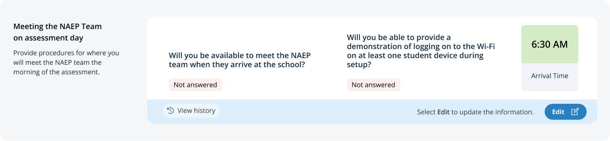

The coordinator will select the Edit button to answer questions about assessment day availability. If they select no for either question, extra fields will appear.
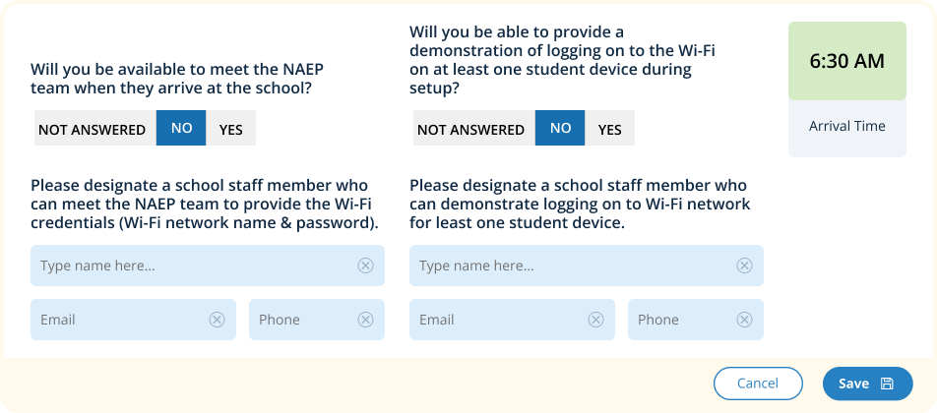

Activity 4: Final Wi-Fi Check

Introduction
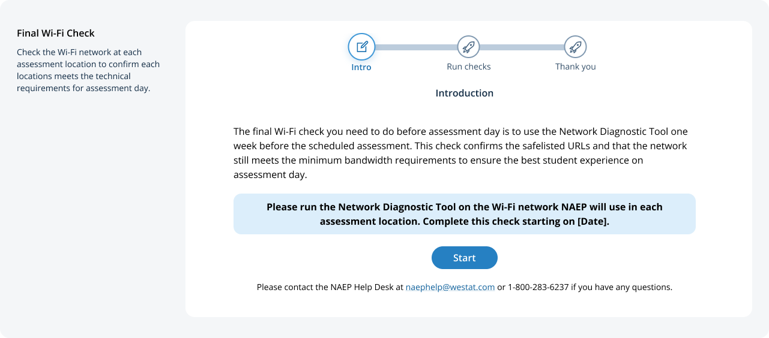
The Start button becomes active 7 days before the scheduled assessment date. The button is turned off with a message underneath until that time.
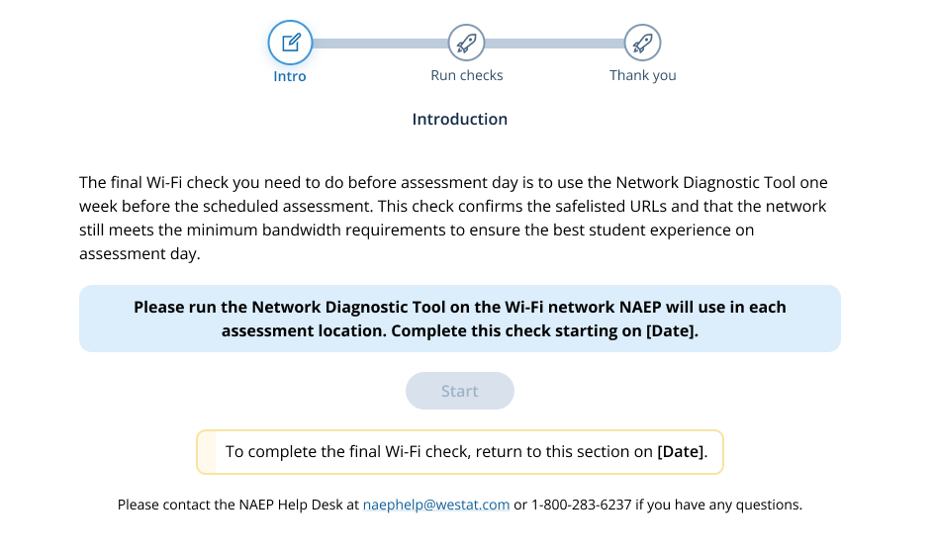

Run checks
The technology coordinator runs the Network Diagnostic Tool in each assessment location identified as “Eligible for school Wi-Fi” or “Not eligible for school Wi-Fi: Failed bandwidth test”. The Run check button is not available for any locations identified as “Not eligible for school Wi-Fi: WAP cannot support connections.”
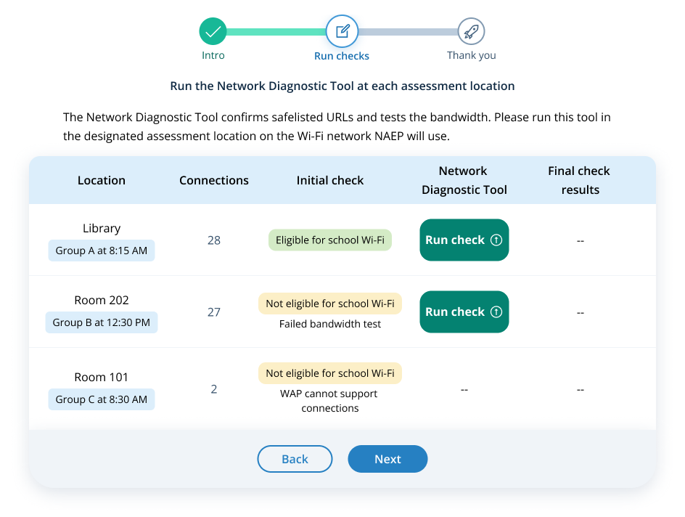

If the coordinator selects the Next button without running the check for each location, they will see a corrective action message. The coordinator cannot go to the next step until they run a check at each location.
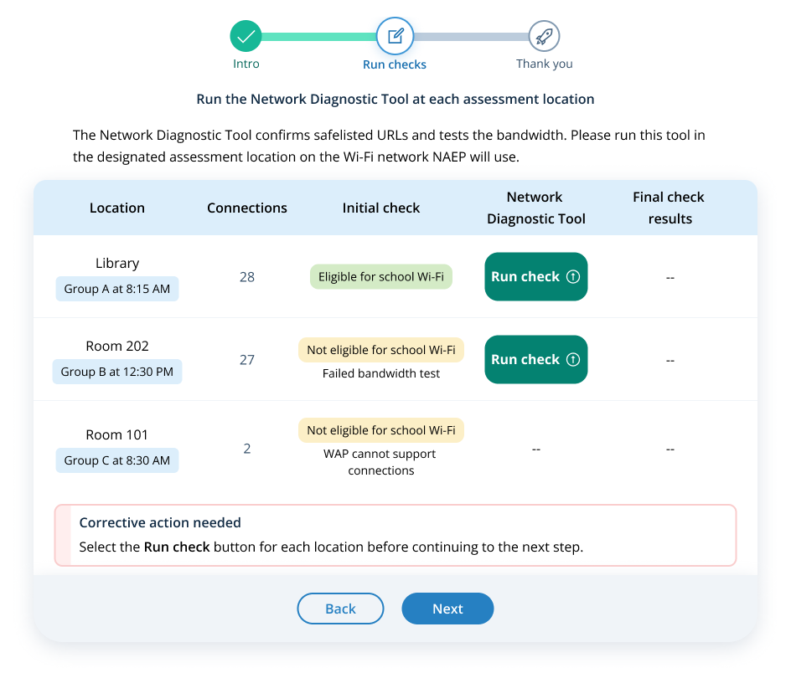
The results show in the table.
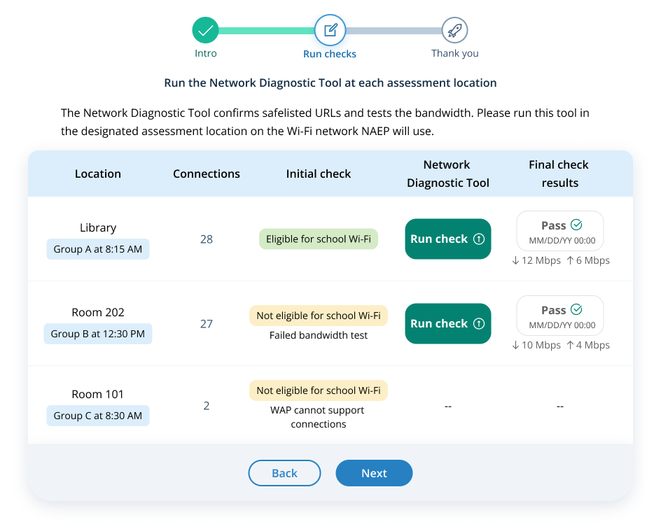

Thank you
The technology coordinator sees the results from the Initial check and the Final check on the thank you screen.
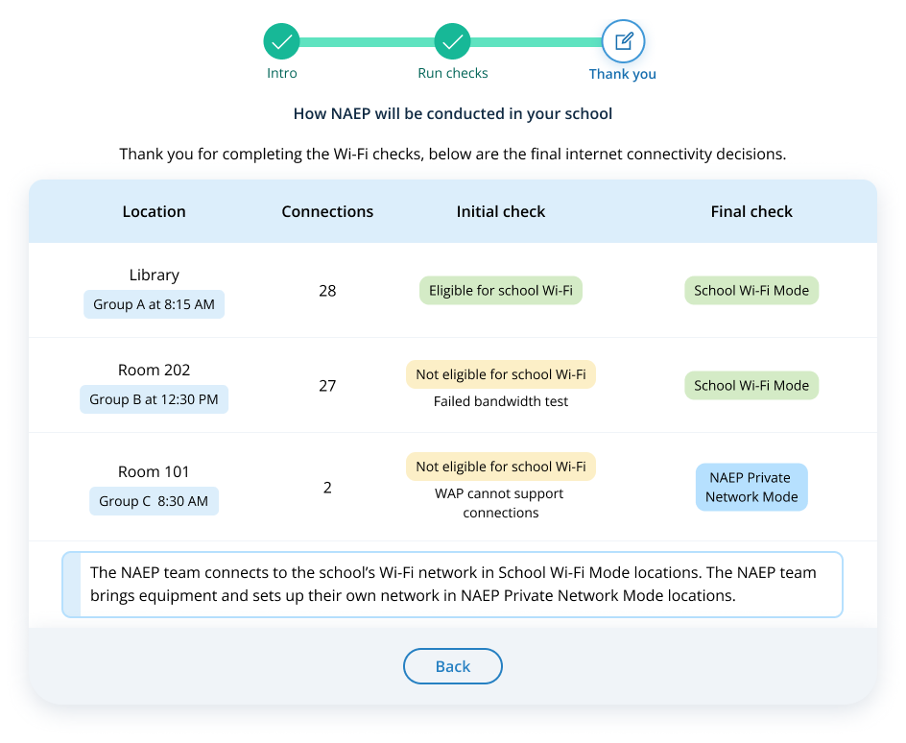

NOTE: The following Puerto Rico Technical Logistics Prototype Images and Rules screens have not yet been updated to match the English Technical Logistics Prototype Images and Rules screens to include in this update.

Technical Logistics
From the school summary page, schools will access this section, where they can provide and confirm Technical Logistics by selecting the Manage button.
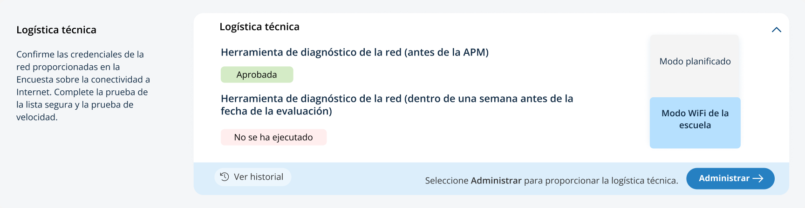
After selecting the Manage button on this page, schools will confirm responses from the Internet Connectivity Survey, answer additional questions to select the network type to conduct the assessment on, confirm the location meeting technical requirements, and run the network diagnostic tool.
In the how to use this page, the following directions will be provided to users:
- Editing tiles: Seleccione el botón de editar para editar la información.
- Editing tables: Seleccione el botón de editar para editar la información.

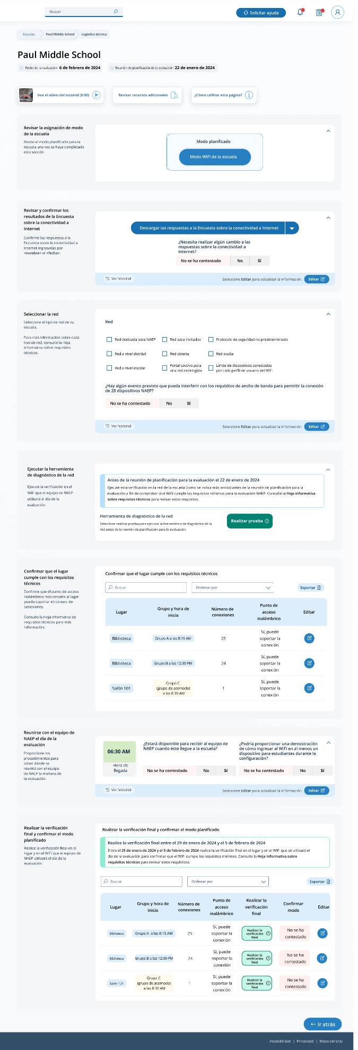

Pop-up for confirm location meets technical requirements:


Appendix I13: Best Practices Guide (NEW)

Best Practices
From the school summary page, grade 12 schools will access the Best Practices Guide section by selecting the Review button.
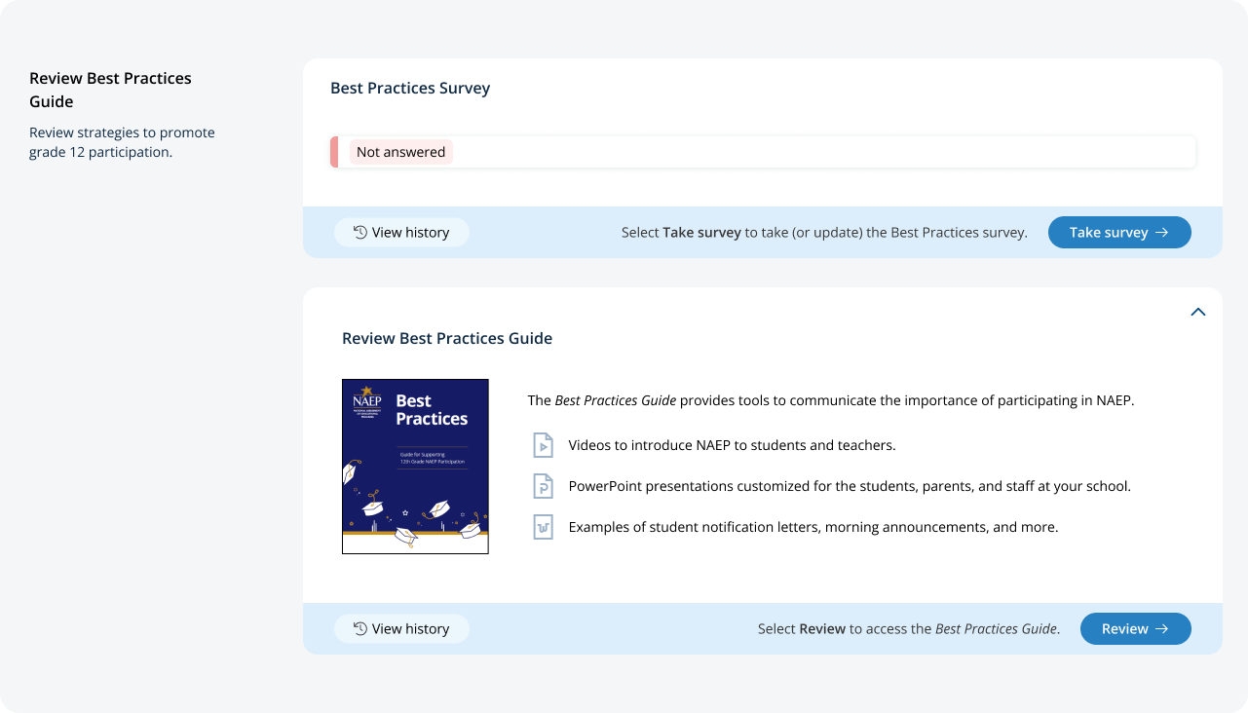
On this page, schools will watch a video that explains the purpose of the Best Practices Guide for Supporting Twelfth-Grade NAEP Participation. Schools will also be able to download a PDF version of the guide.

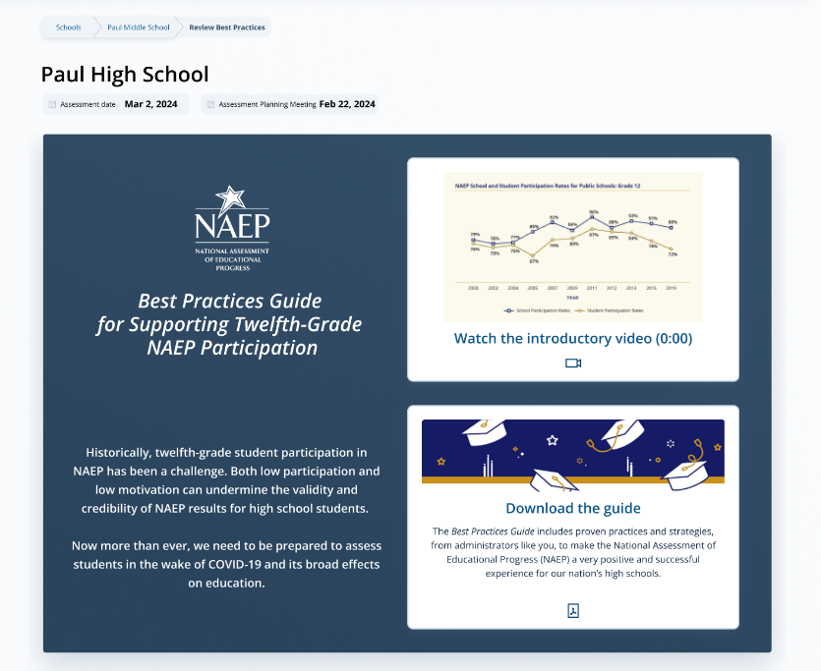
Schools can also access individual links and templates/materials referenced within the guide. Materials are organized by target audience.
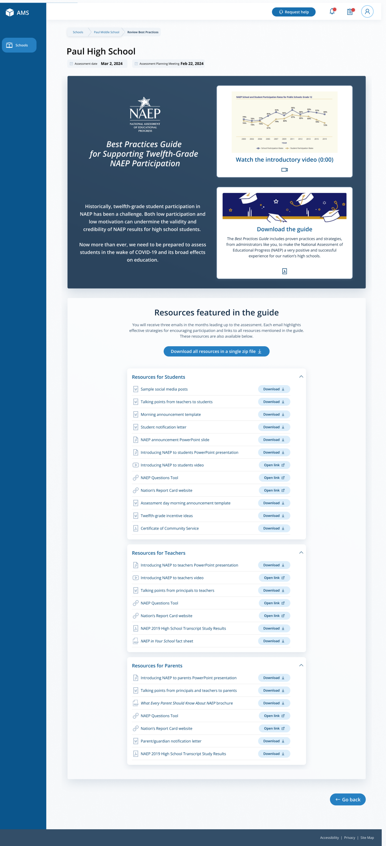
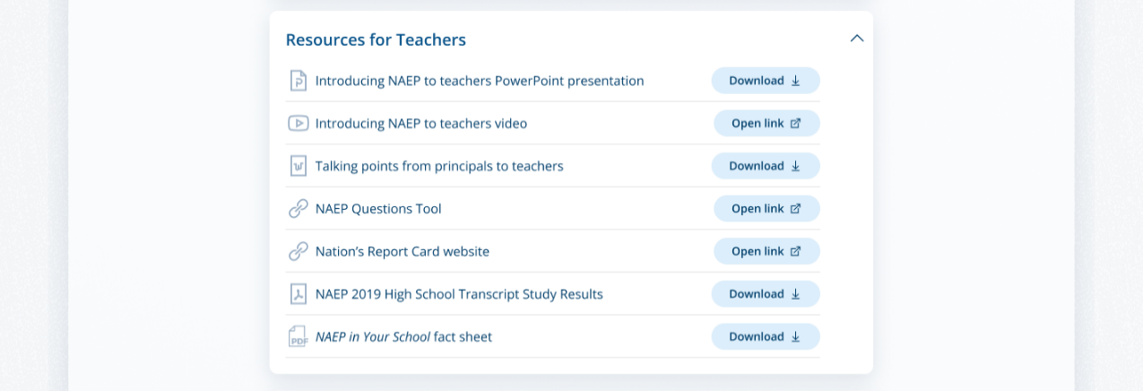

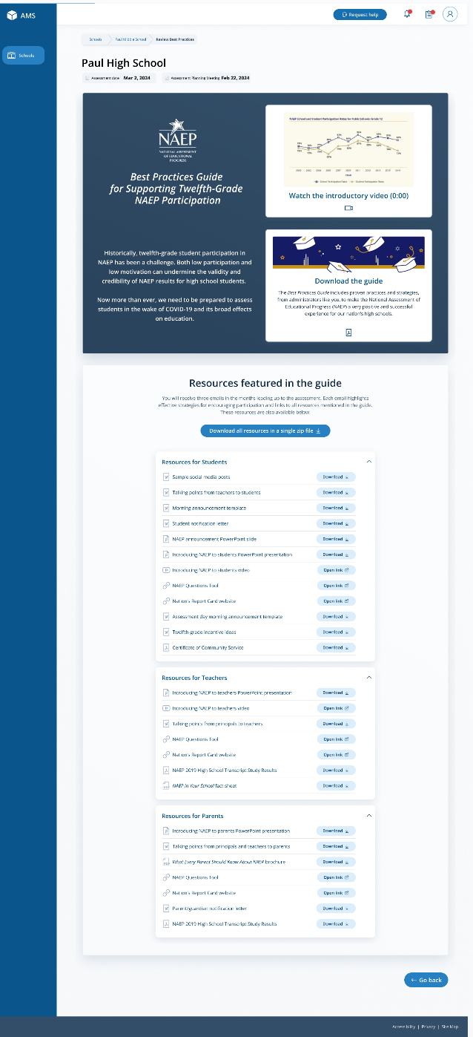

On assessment, a Best Practices Survey will become available schools. School will access this survey via the Take Survey button.
The survey asks the following questions:
- Did your school hold meetings with students, teachers, or parents? Did your school share PowerPoint presentations?
- Did your school share NAEP videos? Did your school share NAEP online resources?
- Did your school use talking points or sample announcements? Did your school use social media posts?
- Did your school offer incentives to encourage participation? Did your school use any other strategies to encourage participation?

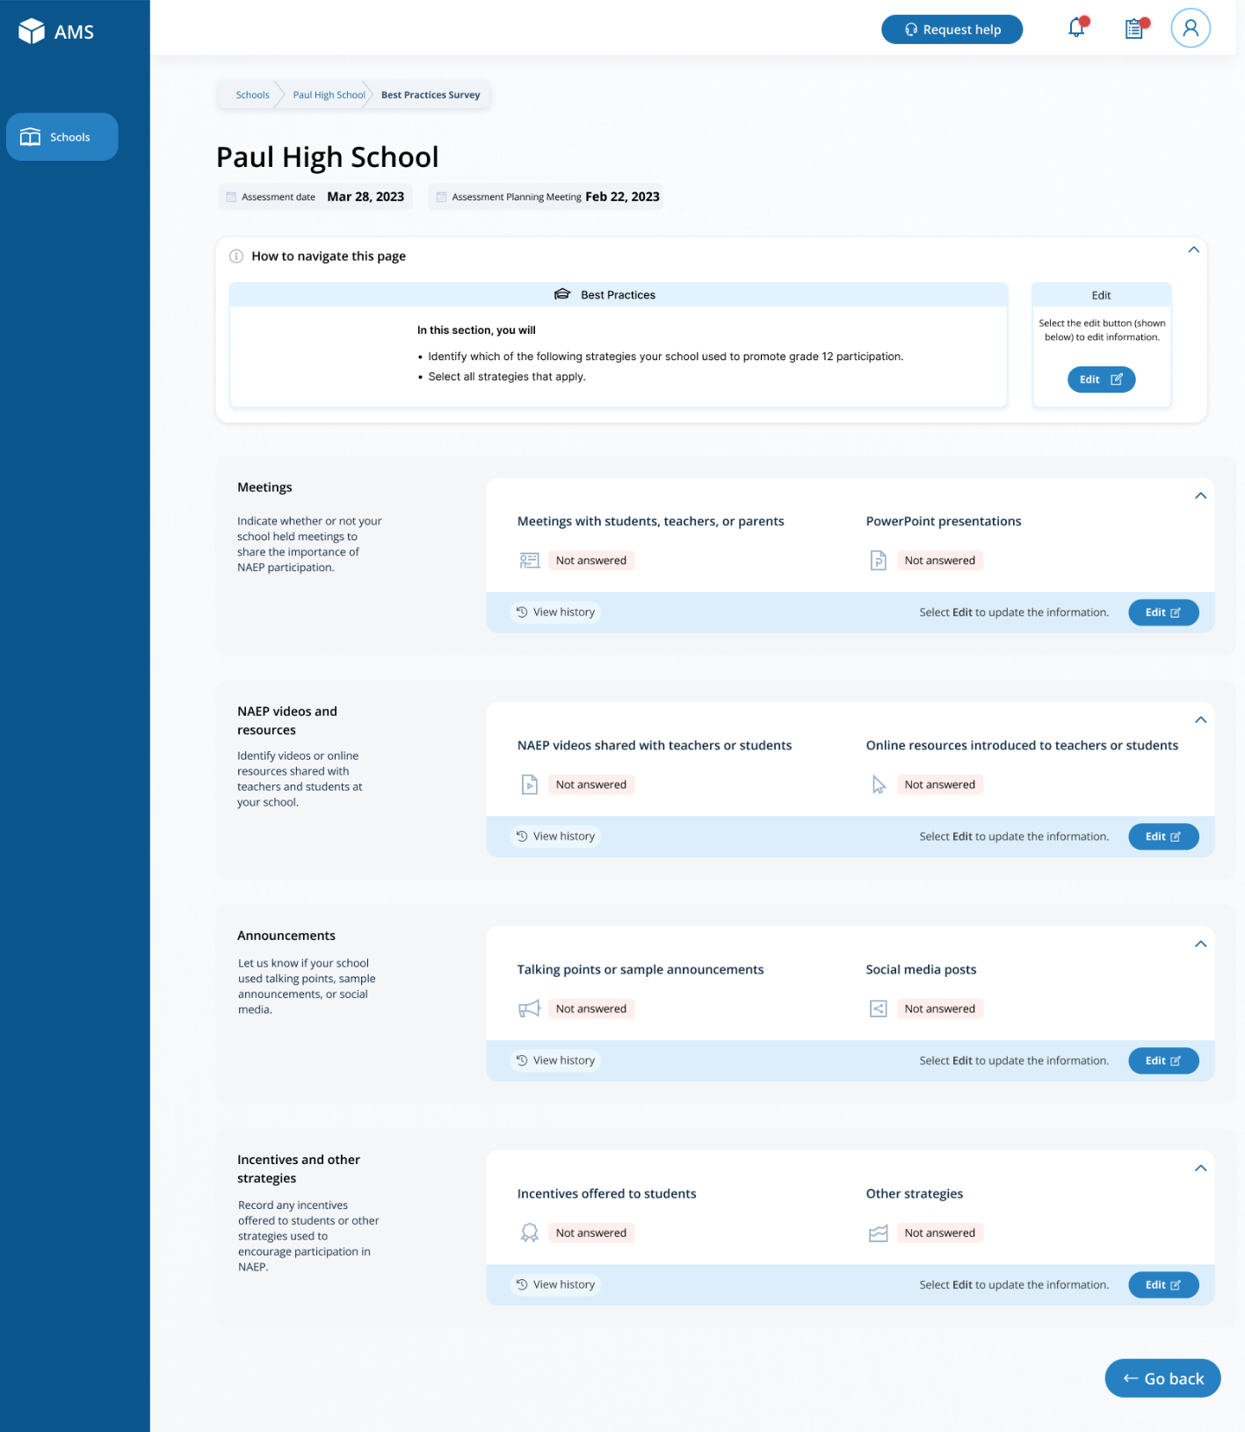

Appendix I14: Request Help, English and Spanish Puerto Rico (NEW)

Request Help - English
From this section, schools can view the contact information for the NAEP help desk.
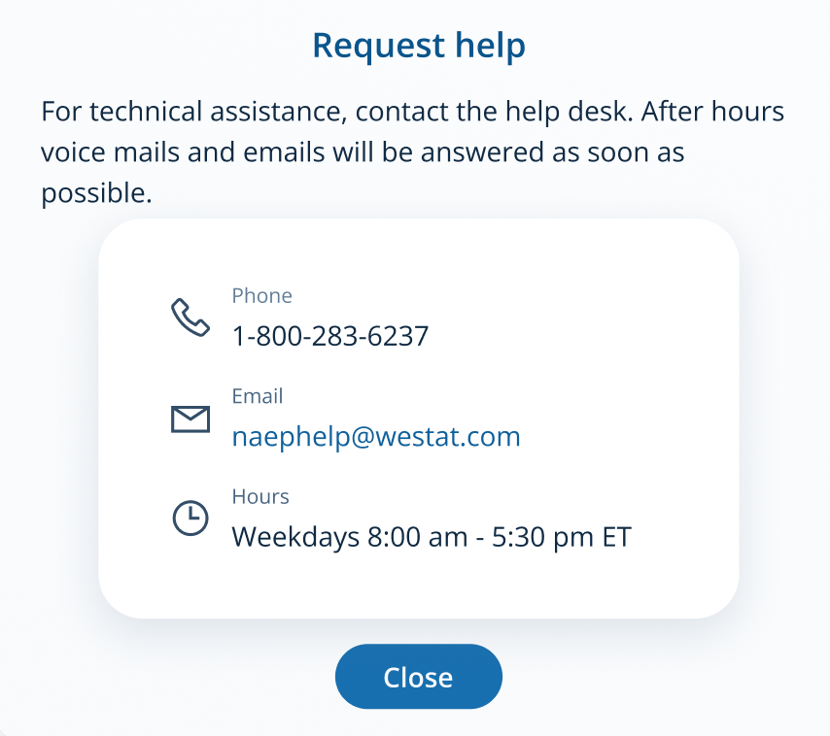

Request Help – Spanish
From this section, schools can view the contact information for the NAEP help desk.
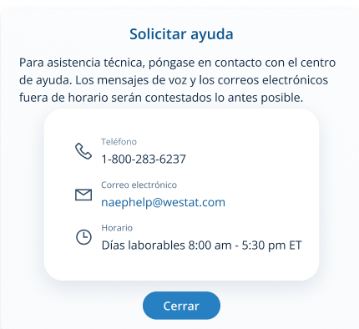

Appendix I15: High School Transcript Study (HSTS) Assessment Management System (AMS) Screens (Approved v.30)

High School Transcript Study (HSTS)
  - Assessment Management System Pages
Description of the HSTS Website: The NAEP State and TUDA Coordinators will set designations in fall 2023 to decide if schools or districts are responsible for providing information and materials for the study. The data collected for the study includes course catalogs, a transcript information survey, and student transcripts. The HSTS pages serve as the primary resource and action center throughout the data collection period. NAEP State and TUDA coordinators will contact schools in fall 2023 to provide information about the study and instructions for accessing the HSTS pages on the AMS website, as well as to request the designation of a dedicated school or district HSTS coordinator. The content of the HSTS pages for schools and districts are included in this document.
Notes on the organization of this document
- Red text indicates descriptive notes.
- Colored notes with figure numbers within the webpage screenshots are for reference during review.
- All documents that can be downloaded and the scripts for videos on the website are submitted separately.
The webpages shown below would be shown to a school or district designated to provide all data for the High School Transcript Study (HSTS). The pages on the actual website will be customized based what data the schools and districts need to provide, so some tasks will not be visible for schools/districts if their state or TUDA district is providing the data on their behalf.
Contents
HSTS Tile on School/District Summary Page 104
HSTS Main Page 105
Navigation Tile 106
Learn about the High School Transcript Study Tile 107
Submit Course Catalogs Tile 108
Complete the Transcript Information Survey Tile 109
Submit Student Transcripts Tile 110
Submit Course Catalogs Page 112
Upload Pop-Up 115
Enter a Link Pop-Up 116
Request a Prepaid Mailing Envelope Pop-Up 117
No Course Catalog Available Pop-Up 118
Transcript Information Survey 119
Submit Student Transcript Page for School: Electronic Upload 125
Step 1 125
Step 2 127
Step 3 127
Step 3 Upload Pop-Up 128
Step 4 129
Submit Student Transcripts Page: Prepare for in Person Visit 130
Prepare for In-Person Visit Step 1 and 2 131
Prepare for In-Person Visit Step 3 and 4 132
Submit Student Transcript Page for District: Electronic Upload 133
Step 1 and 2 134
Step 3 135

HSTS Tile on School/District Summary Page
Schools access the HSTS tile on the School Summary Page and districts access the tile from the District Summary Page. School and district HSTS coordinators will enter this section to provide data for the High School Transcript Study by selecting the “Go to HSTS” button, as shown below (bottom-right). This tile is identical for schools and districts.
Figure 1: Screenshot of HSTS tile on School or District Summary Page
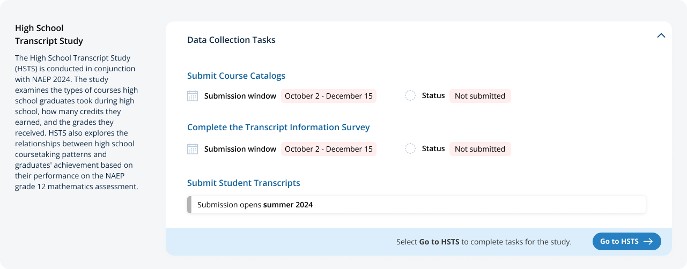

HSTS Main Page
Schools/Districts will arrive at the HSTS main page from selecting “Go to HSTS” on the HSTS Tile. On this page they can learn more about HSTS, submit course catalogs, complete the transcript information survey, and submit student transcripts.
Figure 2 shows School View of the page. Figure 3 shows the entire page for districts. The following pages include descriptions of each tile on the page HSTS Main Page with larger screenshots for better readability (figures 4 – 12 below). Notes have been added with figure numbers of the corresponding enlarged screenshots below.
Figure 2: Screenshot of HSTS Main Page for Schools Figure 3: Screenshot of HSTS Main Page for Districts
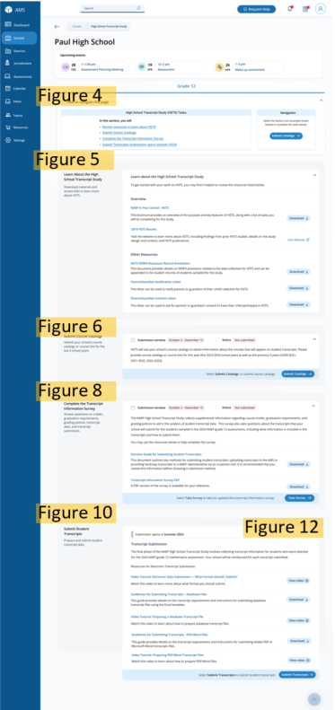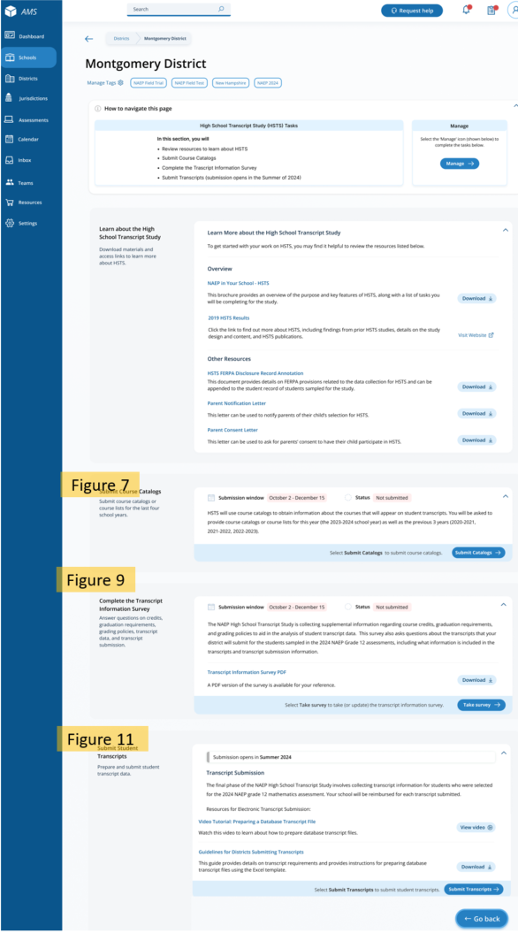

HSTS Main Page: Navigation Tile
At the top of the page, there is a list of tasks and instructions for navigating the page. The list will be customized for the tasks the school/district is designated to provide. This section is identical for schools and districts.
Figure 4: Screenshot of HSTS Main Page Navigation
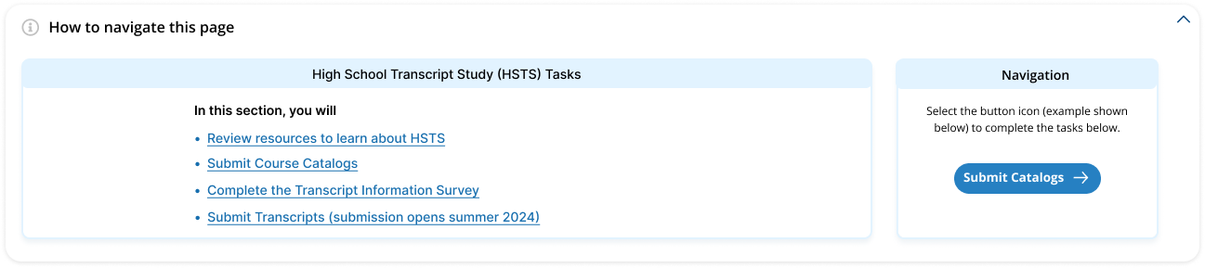

HSTS Main Page: Learn about the High School Transcript Study Tile
The next section “Learn about the High School Transcript Study” has a list of resources to download and links to the NAEP HSTS website for more information. Parent/Guardian Letters will also be posted in this section if requested. This tile is identical for schools and districts.
Links/Downloads on this page (see Documents submitted separately):
- NAEP in Your School – HSTS
- 2019 HSTS Results (Link to external webpage: https://nces.ed.gov/nationsreportcard/hsts/)
- HSTS FERPA Disclosure Record Annotation
- Parent/Guardian Notification Letter
- Parent/Guardian Consent Letter
Figure 5: Screenshot of HSTS Main Page, Learn About HSTS Tile
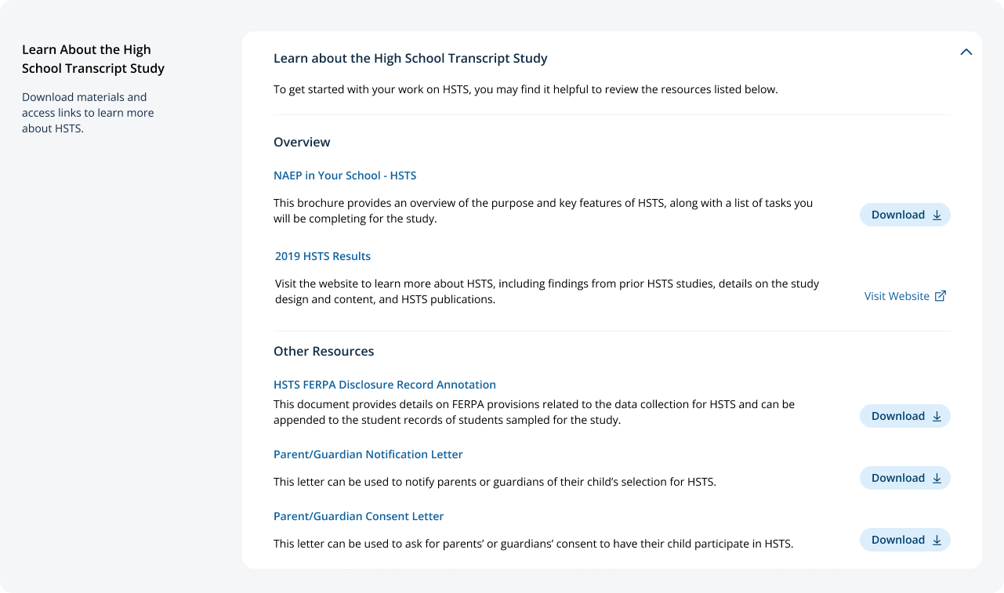

HSTS Main Page: Submit Course Catalogs Tile
In the next tile, “Submit Course Catalogs,” Schools or districts will select the “Submit Catalogs” button in the bottom-right corner to view the submit course catalogs page. The text on this tile is slightly different for school and district users, see Figure 6 and 7 below.
Figure 6: Screenshot of Submit Course Catalogs Tile, School Version
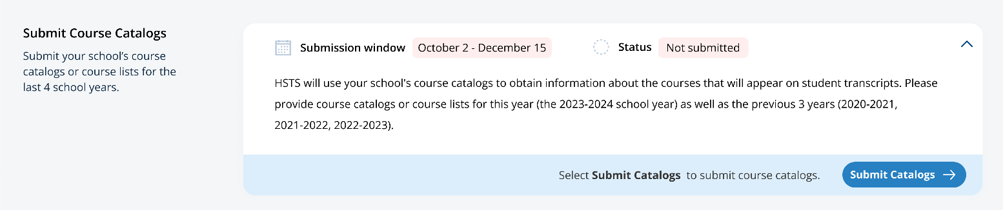

Figure 7: Screenshot of Submit Course Catalogs Tile, District Version
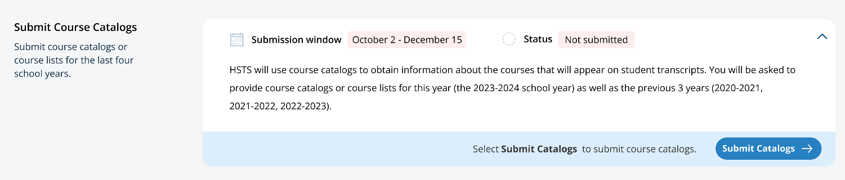

HSTS Main Page: Complete the Transcript Information Survey Tile
The “Complete the Transcript Information Survey” tile contains a description of the task and downloadable resources for completing the survey. Users can access the survey by clicking the “Take Survey” bottom in the bottom-right of the tile. The school and district versions of this tile are shown in figure 8 and 9 respectively.
Links/Downloads on this page (see Documents submitted separately):
- Decision Guide for Submitting Student Transcripts
- Transcript Information Survey PDF
Figure 8: Screenshot of Complete Transcript Information Survey Tile School Version
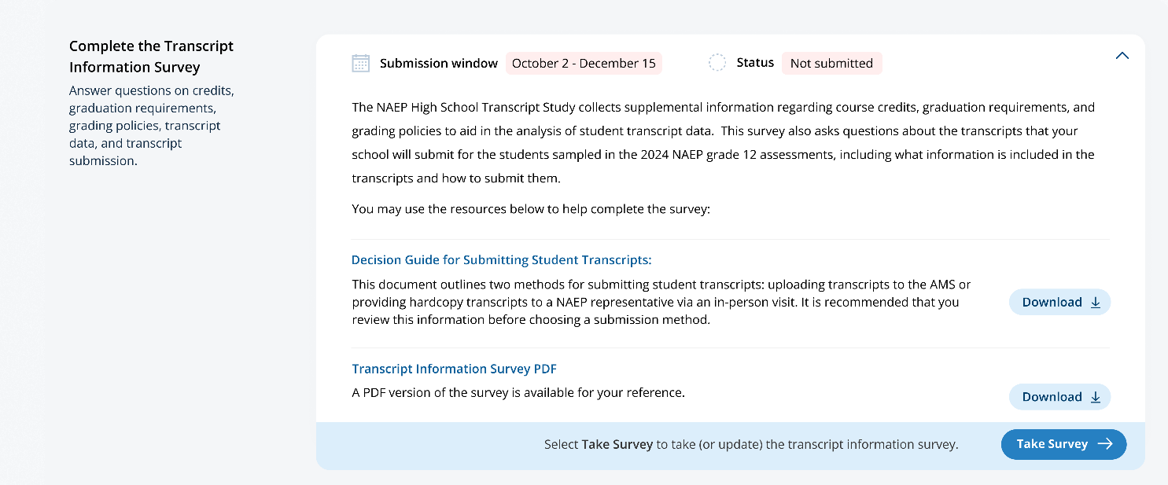

Figure 9: Screenshot of Complete Transcript Information Survey Tile, District Version
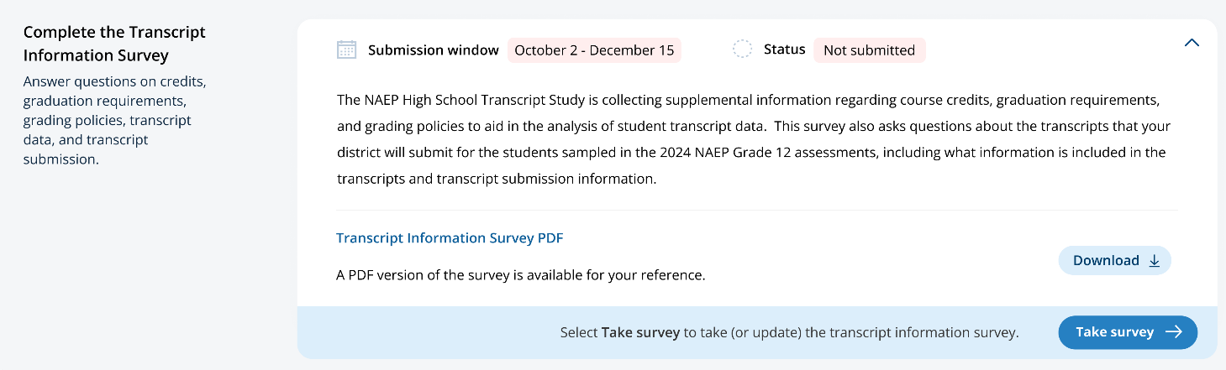

HSTS Main Page: Submit Student Transcripts Tile
The last section on the HSTS main Page is the “Submit Student Transcript” tile. Schools and districts can download resources and watch instructional videos about submit transcripts in this tile. When the transcript submission window opens, schools and districts can select “Submit Transcripts” in the bottom-right to view the submit transcripts page. The school and district versions of the page are shown below in Figure 10 and Figure 11 respectively. Figure 12 shows the view of the top section of the tile when the submission window opens.
Links/Downloads on this page (see Documents submitted separately):
- Video Tutorial: Electronic Data Submission – What Format Should I Submit
- Guidelines for Submitting Transcripts – Database Files
- Video Tutorial: Preparing a Database Transcript File
- Guidelines for Submitting Transcripts - PDF/Word Files
- Video Tutorial: Preparing PDF/Word Transcript Files
- Guidelines for Districts Submitting Transcripts
Figure 10: Screenshot of Submit Student Transcripts Tile, School Version
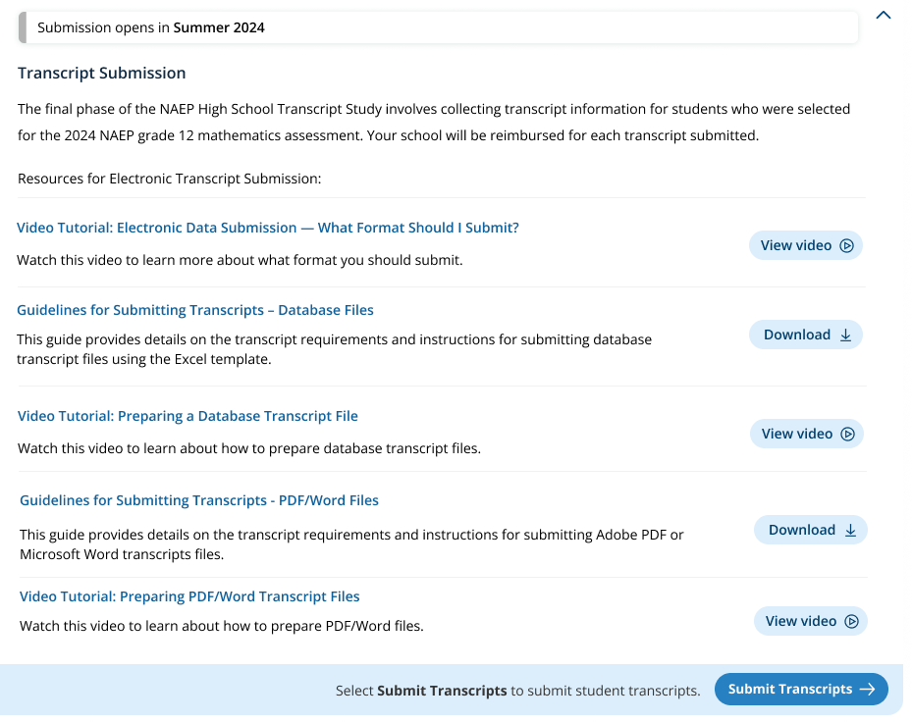

Figure 11: Screenshot of Submit Student Transcripts Tile, District Version
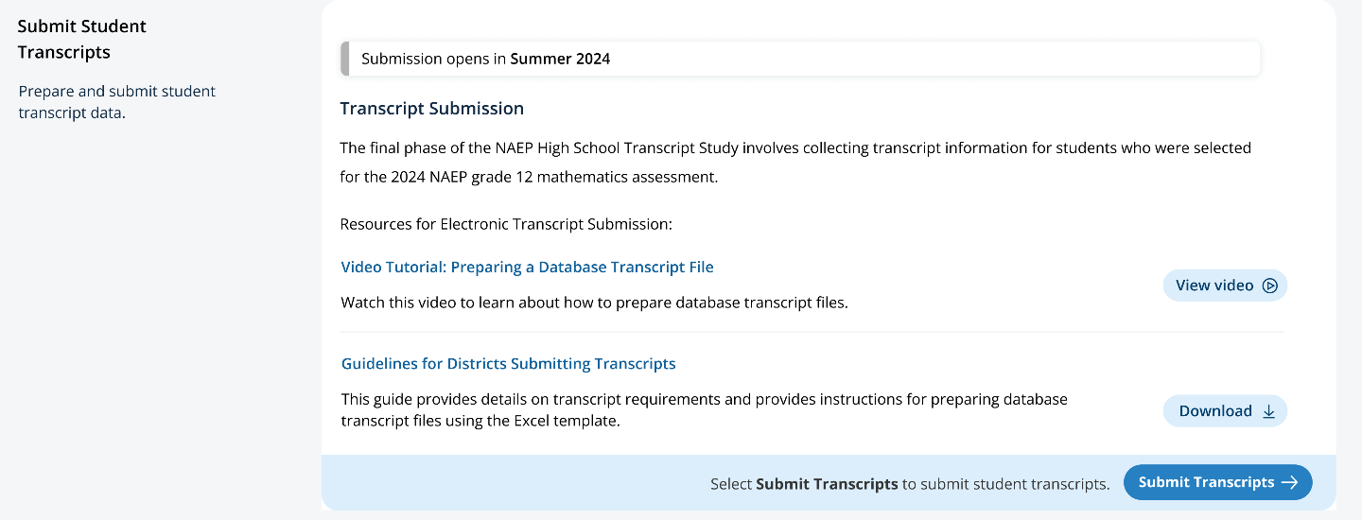

After submission opens, the submission window and status will be shown at the top of the tile for schools and districts.
Figure 12: Screenshot of Top of Transcript Submission Tile, Alternate View

Submit Course Catalogs Page
Schools and districts will access the Submit Course Catalog page by selecting “Submit Catalogs” on the HSTS Main Page Submit Catalog tile.
On the top of the page, details are provided about the requested course catalogs or lists.
The middle section of the page allows schools and districts to select the year of the catalog they are submitting in the tabs, and then select the method for that catalog. The methods available are, 1) to upload course catalogs, 2) to enter a link to a web catalog, or 3) to request a pre-paid envelope to send hardcopy catalogs. The year 2023-2024 has all options available, but the prior 3 years have only the upload and link option available.
The bottom of the page has a submission history which will show what catalogs a school submits.
Figure 13 shows the version for schools, and Figure 14 shows the version for districts. The instruction text is slightly different in the district version. Notes have been added to these views to identify the figure numbers of the pop-up windows accessible from selecting each of the submission options.

Figure 13: Screenshot of Submit Course Catalogs Page School Version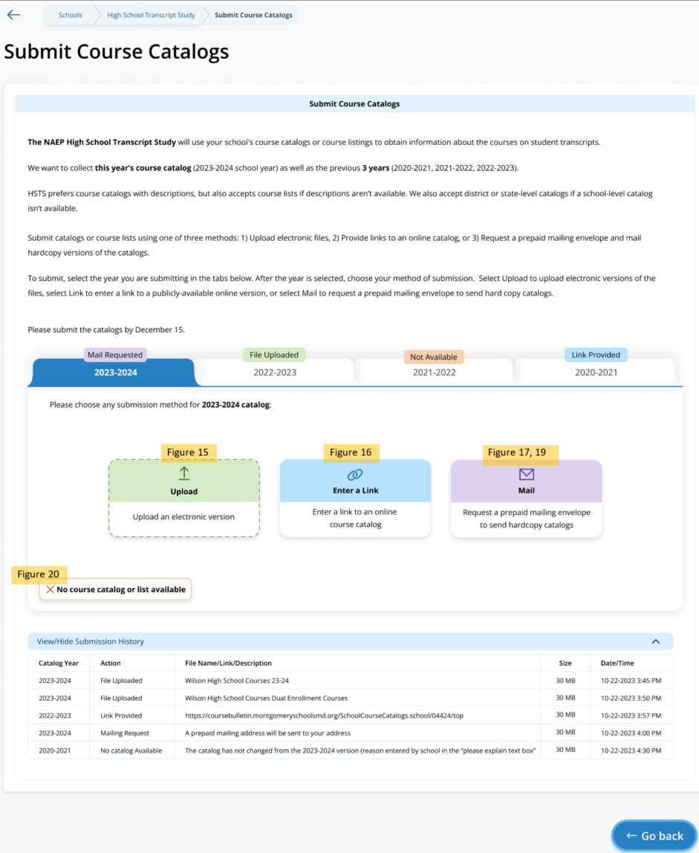
Figure 14: Submit Course Catalogs Page District Version
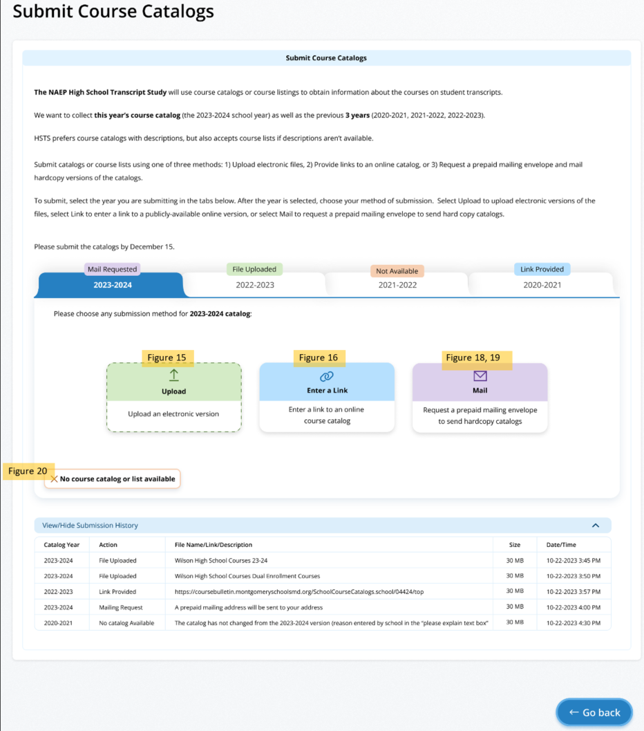

Submit Course Catalogs Page: Upload Pop-Up
This Upload pop-up window allows the school/district to drag and drop, or browse to select the file to upload. Then the school/district will indicate the type of catalog (school, district, or state level), and answer if the catalog includes all courses offered to students in grades 9-12. A text box will appear if the school/district selects ‘No’ to the second question. To submit, the school/district can then select “Submit” at the bottom of the window.
Figure 15: Screenshot of Submit Course Catalog Upload Pop-Up
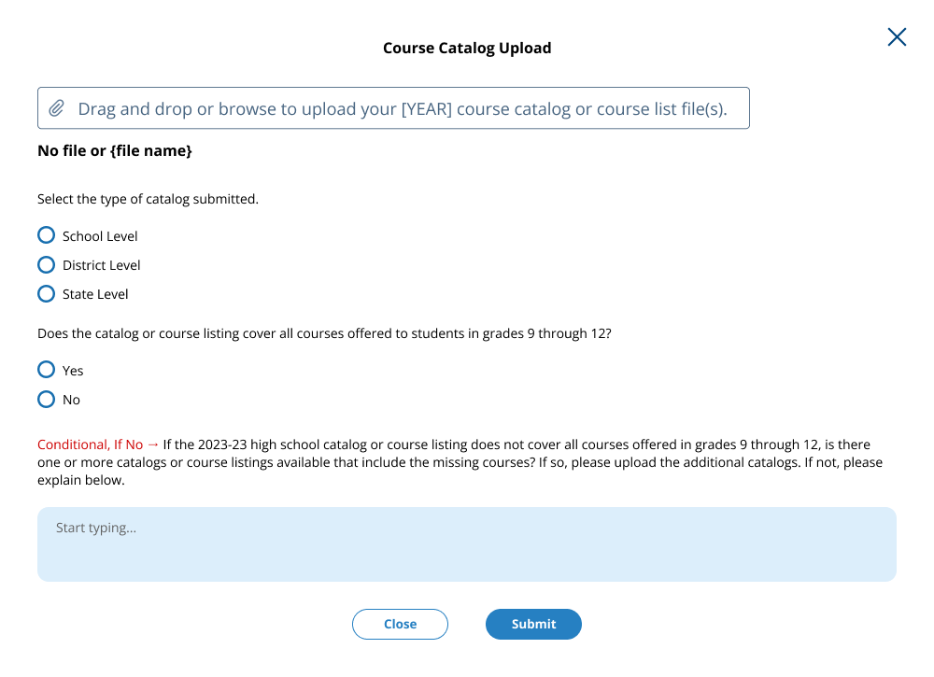

Submit Course Catalogs Page: Enter a Link Pop-Up
In this window, a school or district can enter a link to a publicly available catalog. Then the school/district will indicate the type of catalog (school, district, or state level), and answer if the catalog includes all courses offered to students in grades 9-12. A text box will appear if the school/district selects ‘No’ to the second question. To submit, the user can select “Submit” at the bottom of the window.
Figure 16: Screenshot of Submit Course Catalogs, Enter a Link Pop-up
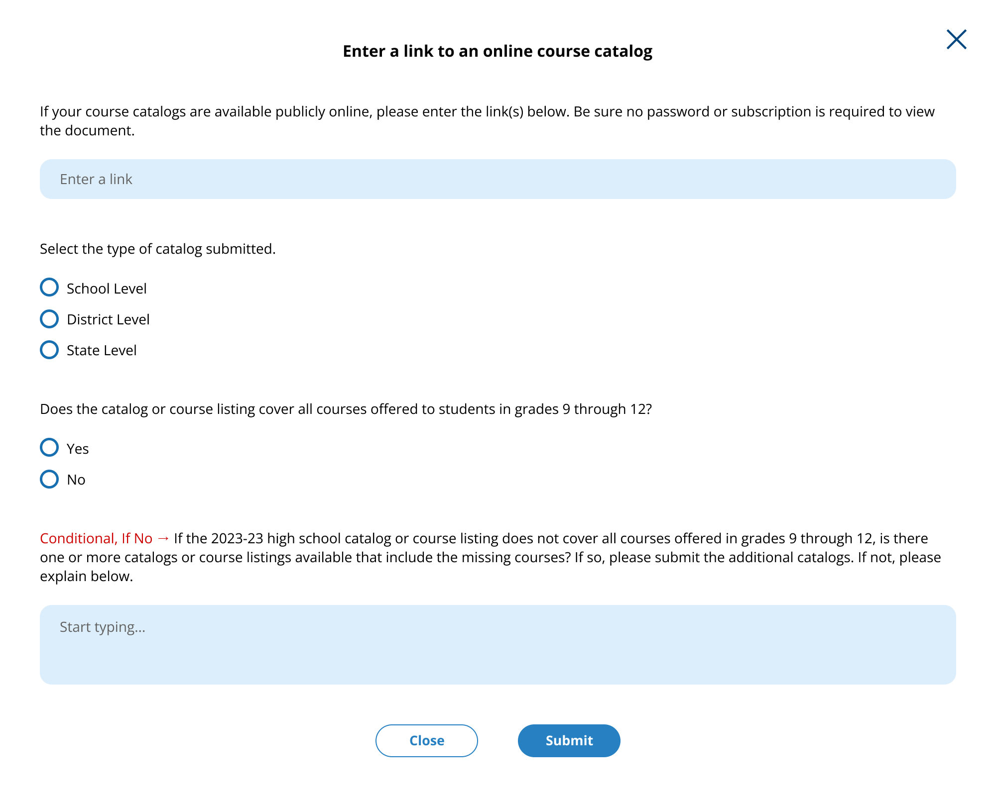

Submit Course Catalogs Page: Request a Prepaid Mailing Envelope Pop-Up
This pop-up window allows schools and districts to update the address information if needed for the pre-paid mailing envelope. The school/district can also indicate what years they plan to send in the envelope. When they submit, the school will see a confirmation message in another pop-up.
Figure 17: Screenshot of Submit Course Catalog Request Mail Pop-Up, School Version
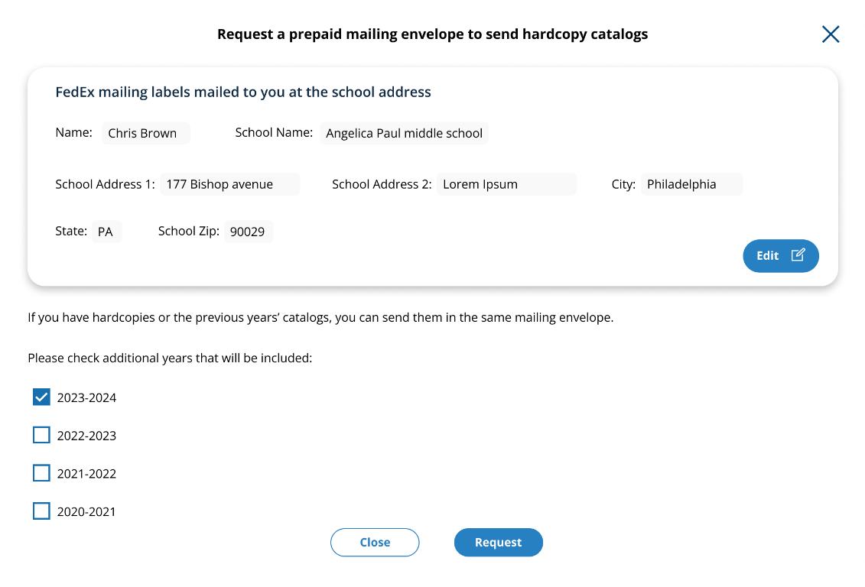
Figure 18: Screenshot of Submit Course Catalog Request Mail Pop-Up, District Version
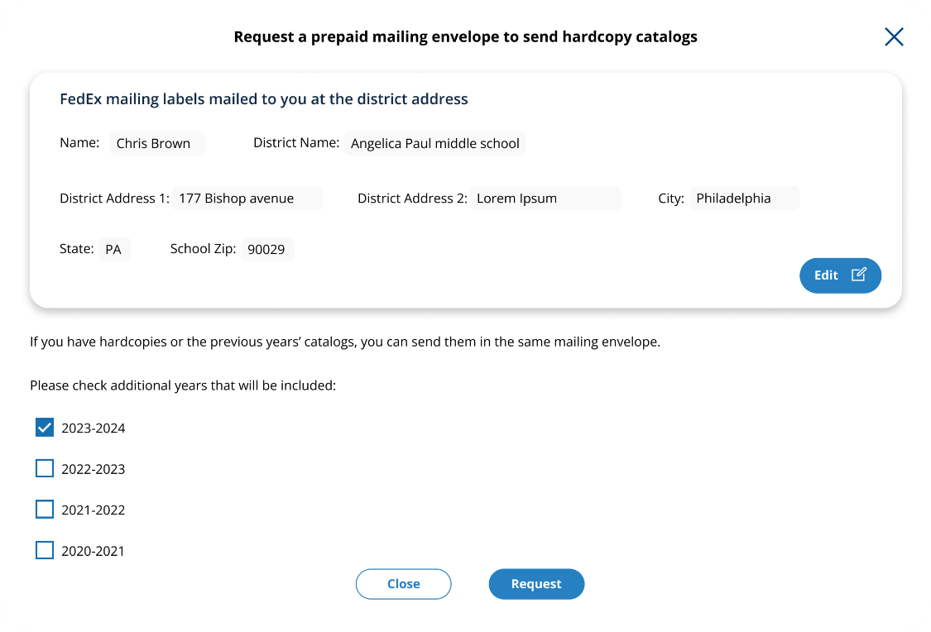

Figure 19: Screenshot of Submit Course Catalog Request Mailing Thank You Message
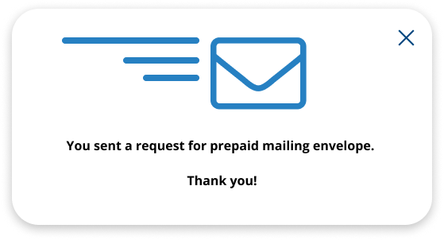

Submit Course Catalogs: No Course Catalog Available Pop-Up
This pop up window allows schools or districts to note if they do not have a course catalog or list available and give an explanation in the provided text box.
Figure 20: Screenshot of Submit Course Catalogs, No Catalog Available Window
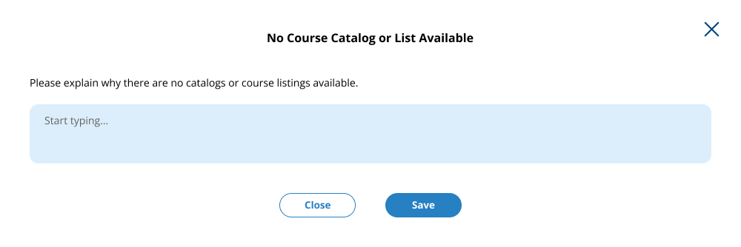

Transcript Information Survey
Schools and districts access these pages with the survey by selecting “Take Survey” on the Transcript Information Survey Tile on the HSTS Home Page. The text for this survey is located in the resources section of this document. Figures 21 – Figure 26 below shows how this survey will be formatted in the AMS. The users can navigate through the survey using the “Next” button at the bottom of the page. There is also a tracker at the top of the page to show their progress through the sections. The survey is identical for school and district users.
Figure 21: Screenshot of Transcript Information Survey, Part 1
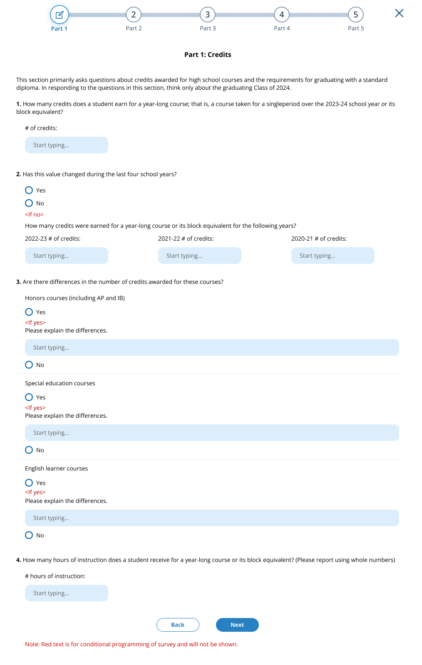
Figure 22: Screenshot of Transcript Information Survey, Part 2
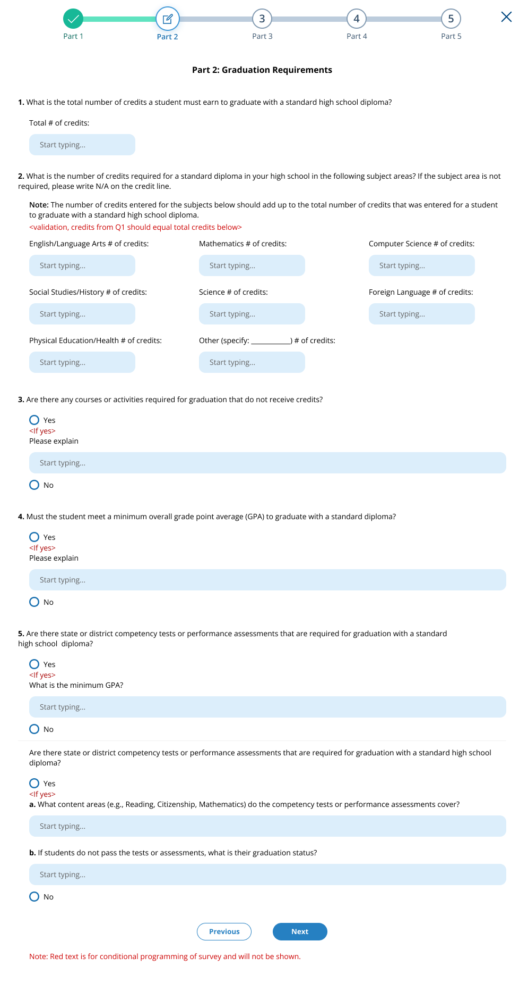
Figure 23: Screenshot of Transcript Information Survey, Part 3
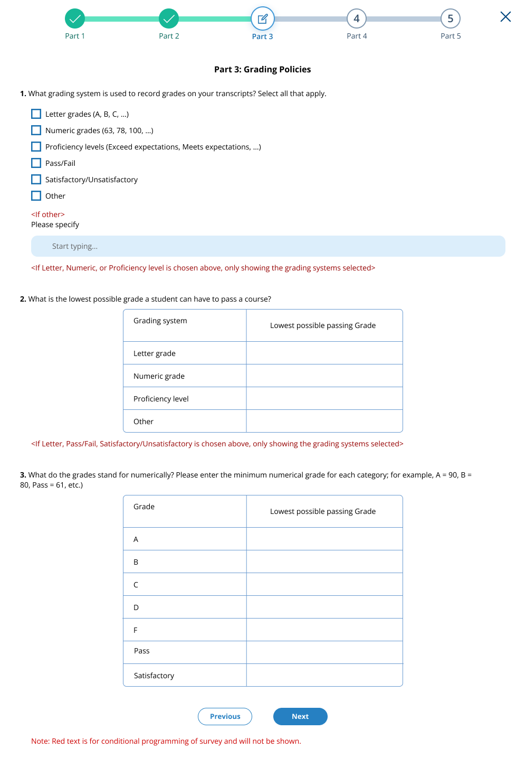
Figure 24: Screenshot of Transcript Information Survey, Part 4
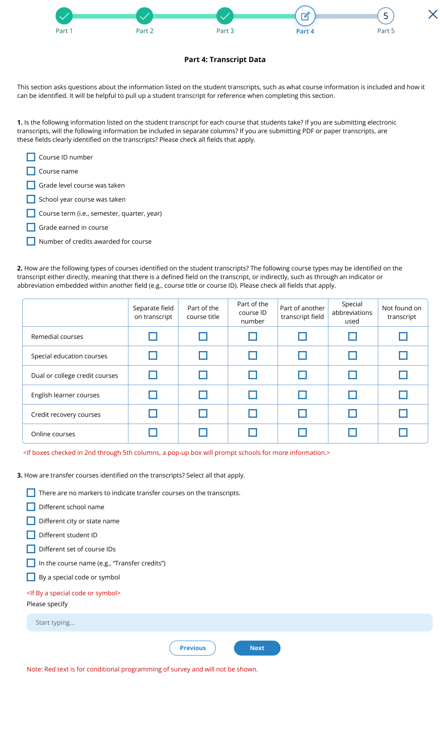
Figure 25: Screenshot of Transcript Information Survey, Part 5
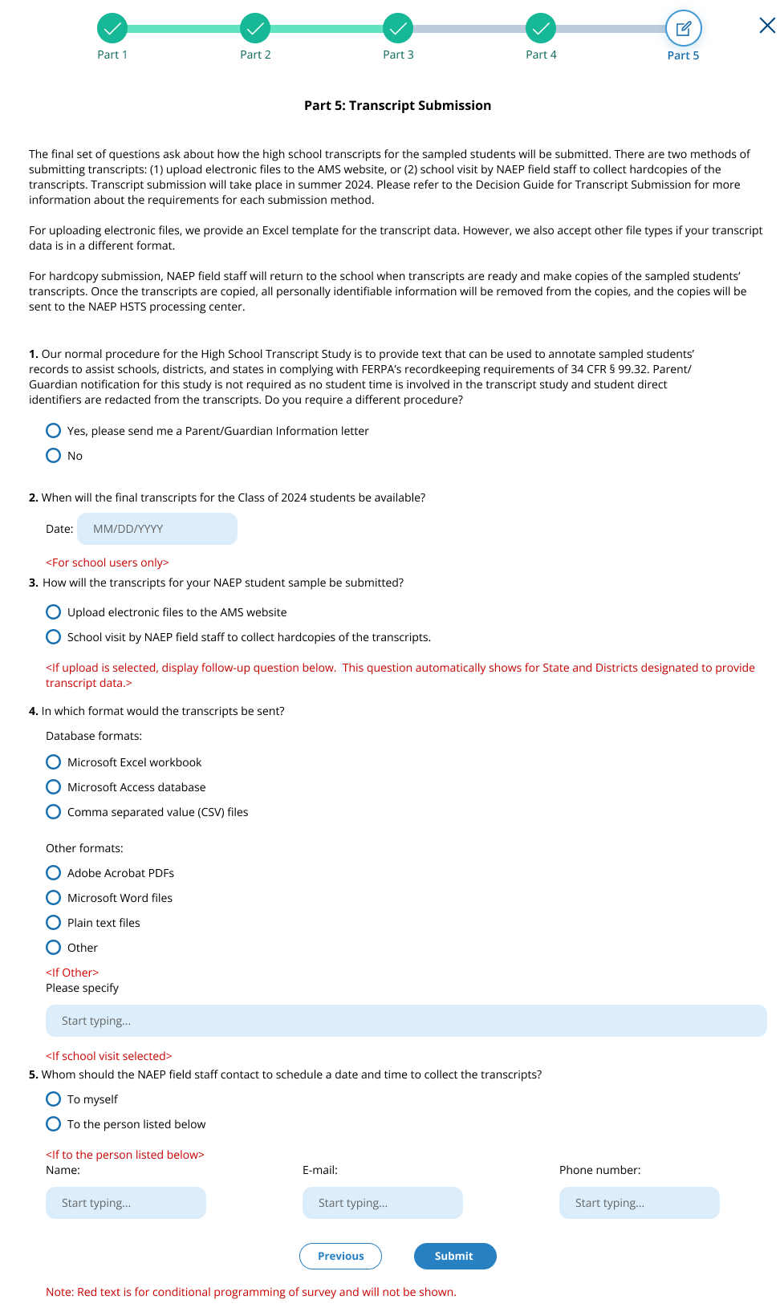
Figure 26: Screenshot of Transcript Information Survey, Thank You
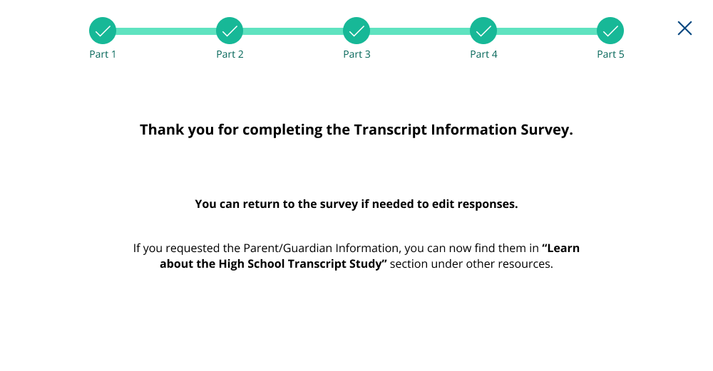

Submit Student Transcript Page for School: Electronic Upload
This page is shown to schools designated to submit transcripts, who have selected the electronic submission method in the Transcript Information Survey. Below is the view of the entire page, followed by separate screenshots of each section with explanation of the tasks to complete on each tile. Notes have been added with figure numbers of the corresponding enlarged screenshots below.
Figure 27: Screenshot of Submit Student Transcripts Page, Electronic Upload
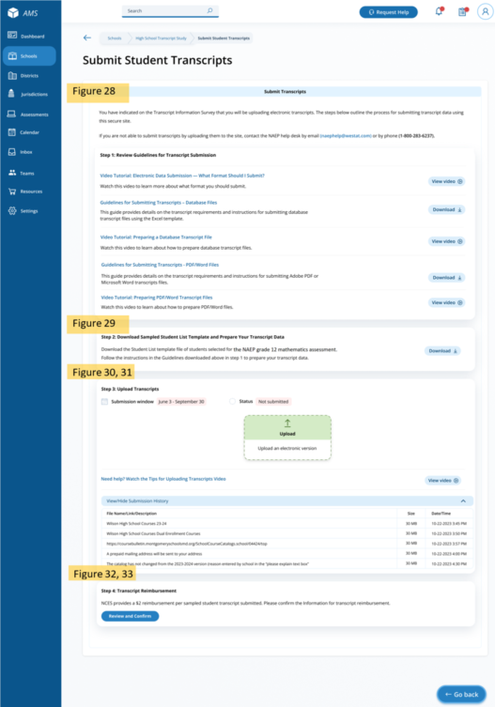

Submit Student Transcripts Page: Step 1
At the top of the Submit Student Transcript page for electronic upload is text introducing the school to the task of uploading catalogs. In the step 1 tile, Guidelines for submitting transcripts, as well as instructional videos are available for schools to download or view.
Links/Downloads on this page (see Documents submitted separately):
- Video Tutorial: Electronic Data Submission – What Format Should I Submit?
- Guidelines for Submitting Transcripts – Database Files
- Video Tutorial: Preparing a Database Transcript File
- Guidelines for Submitting Transcripts - PDF/Word Files
- Video Tutorial: Preparing PDF/Word Transcript Files
Figure 28: Screenshot of Submit Student Transcripts Page, Step 1
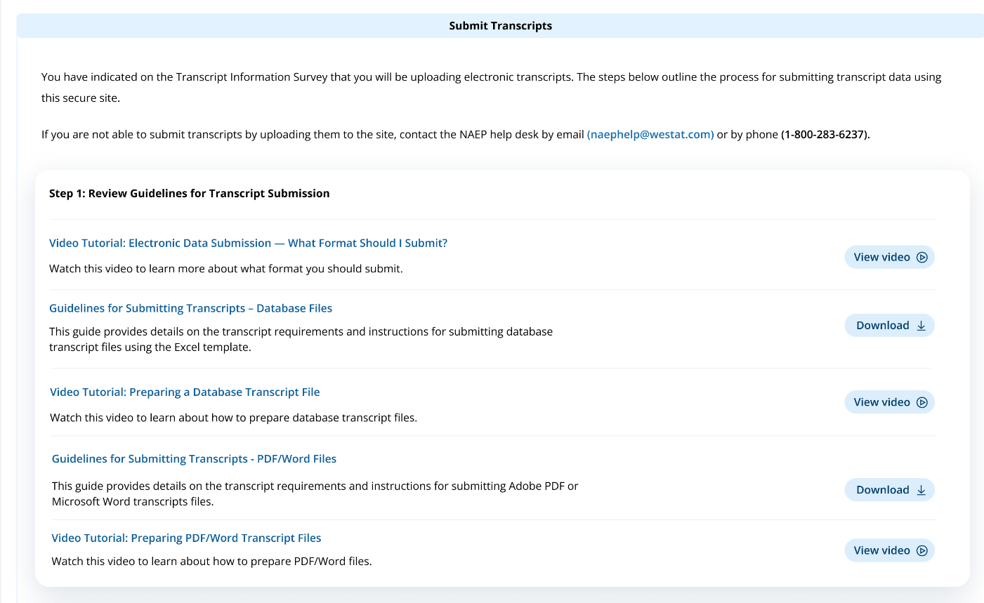

Submit Student Transcripts Page: Step 2
On the step 2 tile, schools/districts can download the Sampled Student List Template, which contains the list of students selected for the study.
Links/Downloads on this page (see Documents submitted separately):
- Student List Template
Figure 29: Screenshot of Submit Student Transcripts Page, Step 2
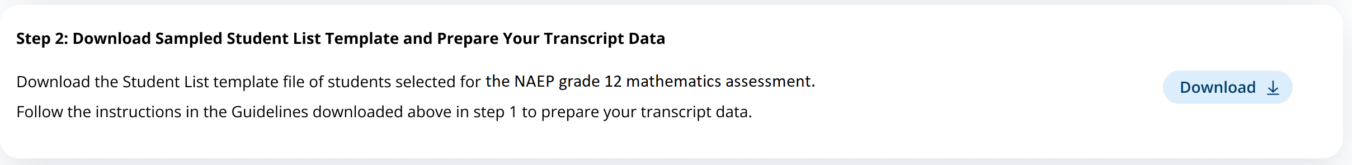

Submit Student Transcripts Page: Step 3
The step 3 tile shows the submission window and status for transcripts, and contains an upload button for when schools/districts are ready to submit their transcripts. When they select “Upload”, a pop up window will appear (see figure 31 below) where schools/districts can select the files to upload.
Links/Downloads on this page (see Documents submitted separately):
- Tips for Uploading Transcripts Video
Figure 30: Screenshot of Submit Student Transcript Page, Step 3
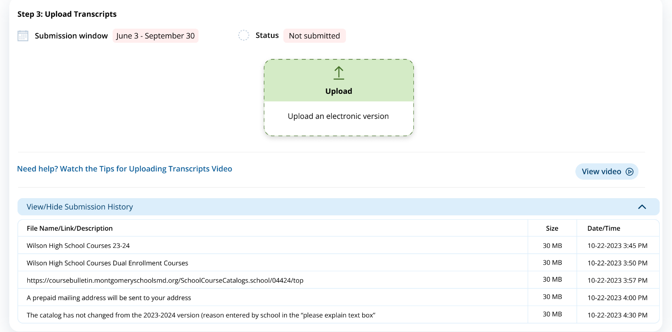

Submit Student Transcripts Page: Step 3 Upload Pop-Up Window
Using this upload pop-up window, schools/districts can drag and drop or browse for the transcript files they will submit. There is a list of items to review before submitting the files, as well as two text boxes. The first text box asks schools or districts to indicate if any transcripts from the list were not provided. The second text box gives space for a school/district to make any additional comments about their file.
Figure 31: Screenshot of Transcript Upload Pop-Up
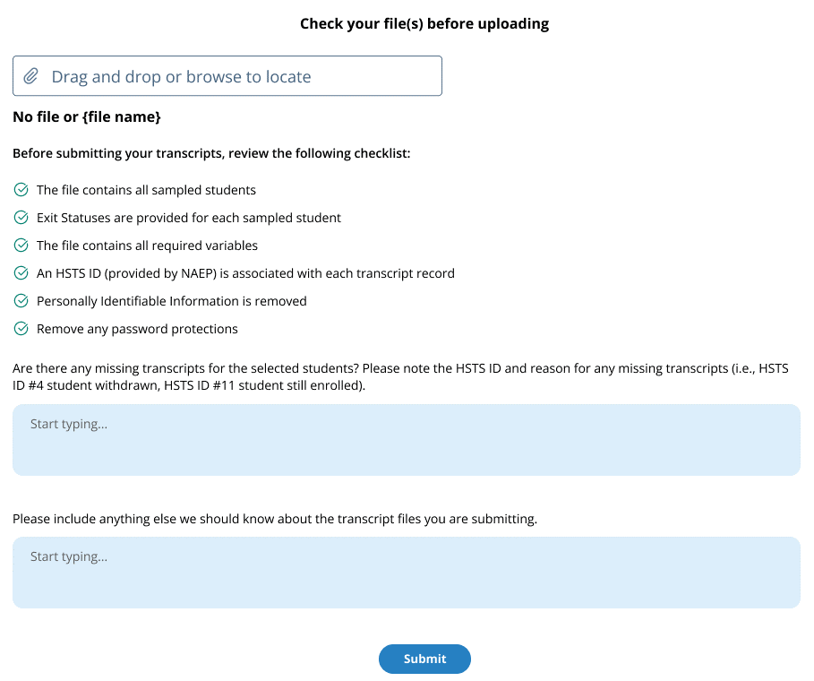

Submit Student Transcripts Page: Step 4
The last tile (figure 32) on the submit student transcript page contains a button “Review and Confirm.” When a school selects this button they will see a pop up with the option to edit the necessary information needed to send a reimbursement check. The pop-up window is shown in figure 33 below.
Figure 32: Screenshot of Transcript Submission Page, Step 4
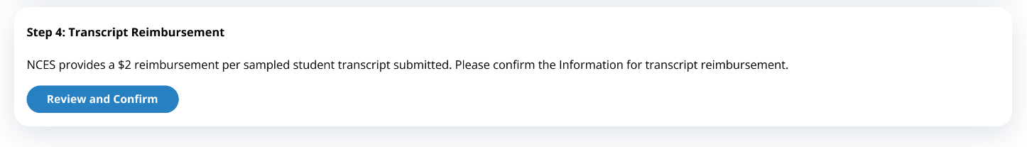
Figure 33: Screenshot of Transcript Reimbursement Pop-Up Window
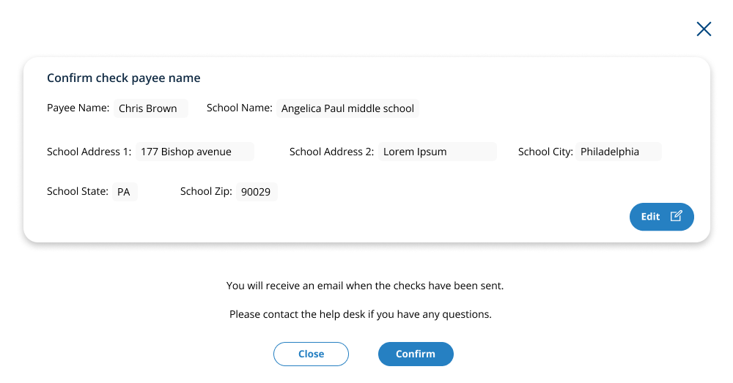

Submit Student Transcripts Page: Prepare for in Person Visit
This page will be displayed to schools if they choose the in person visit for collection of their students’ transcripts in the Transcript Information Survey. Below is the view of the entire page, followed by separate screenshots of each section with explanation of the tasks to complete on each tile. Notes have been added with figure numbers of the corresponding enlarged screenshots below.
Figure 34: Screenshot of Submit Student Transcripts In-Person Visit Page
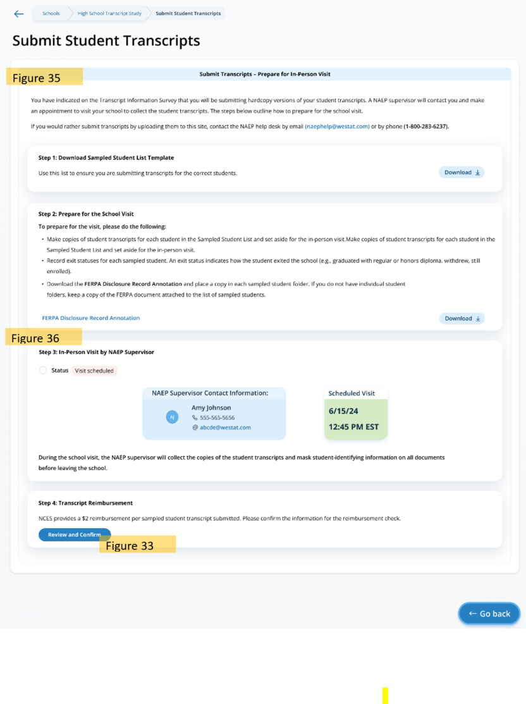

Submit Student Transcripts Page: Prepare for In-Person Visit Step 1 and 2
On the step 2 tile, schools/districts can select “Download” to download the Sampled Student List Template, which contains the list of students selected for the study. In step 2, schools are given guidance on how to prepare for their visit. They can also download the FERPA Disclosure Record Annotation from this tile.
Links/Downloads on this page (see Documents submitted separately):
- Student List Template
- FERPA Disclosure Record Annotation
Figure 35: Screenshot of Submit Student Transcript Page for In Person Visit, Step 1 and 2
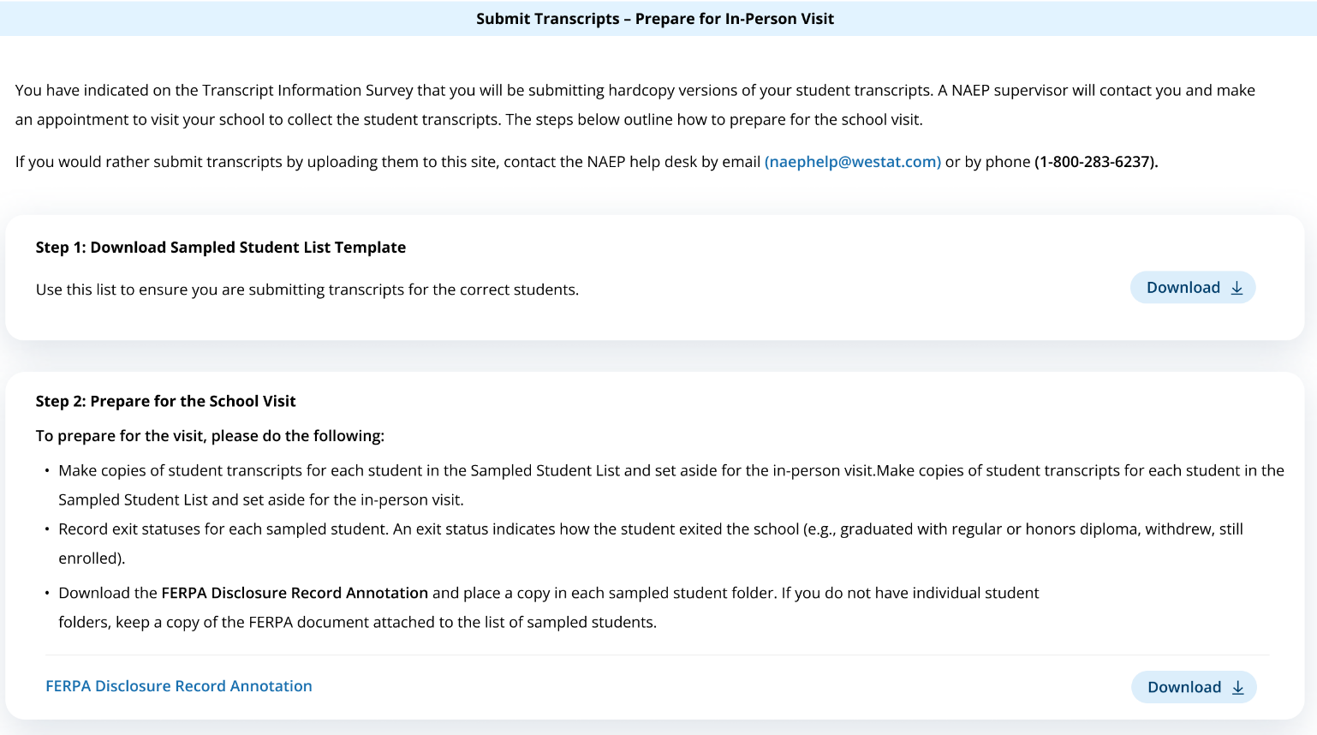

Submit Student Transcripts Page: Prepare for In-Person Visit Step 3 and 4
In step 3, schools can view the status of their submission, the contact information for the NAEP Supervisor that will be visiting the school, and the scheduled date and time for the meeting.
In step 4, schools can select “Review and Confirm” to confirm the information needed for the reimbursement check (see figure 33 above).
Figure 36: Screenshot of Submit Student Transcript Page, In Person Visit, Step 3 and 4
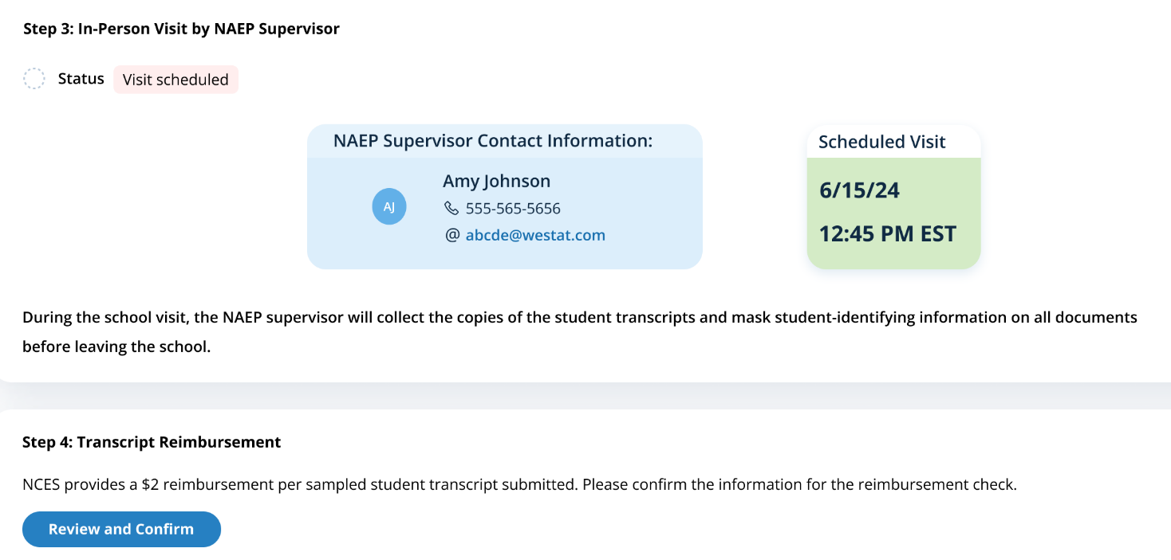

Submit Student Transcript Page for District: Electronic Upload
This page is shown to districts designated to submit transcripts. Below is the view of the entire page, followed by separate screenshots of each section with explanation of the tasks to complete on each tile. Notes have been added with figure numbers of the corresponding enlarged screenshots below.
Figure 37: Screenshot of Submit Student Transcript Page: District Version
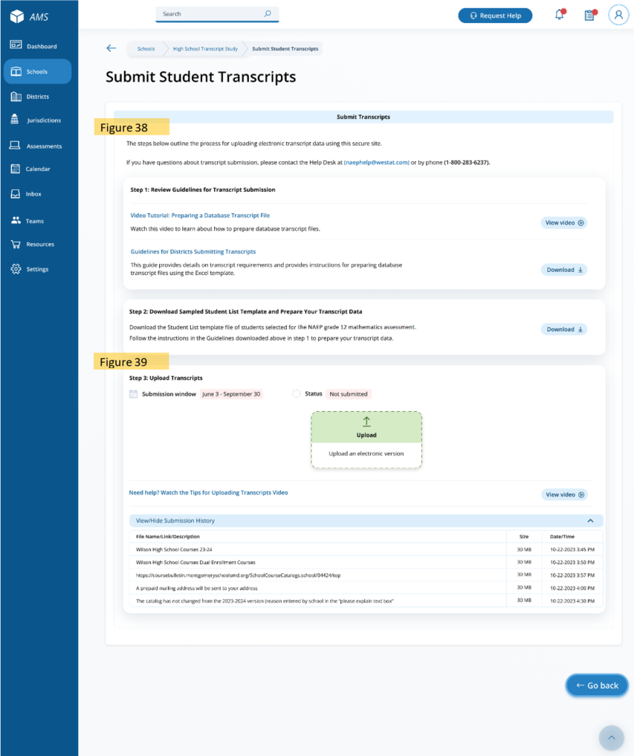

Submit Student Transcripts Page for Districts: Step 1 and 2
In Step 1 districts can select “View video” to watch a tutorial on preparing a database transcript file, and download the Guidelines for Districts Submitting Transcripts.
On the step 2 tile, districts can download the Sampled Student List Template, which contains the list of students selected for the study, by selecting “Download.”
Links/Downloads on this page (see Documents submitted separately):
- Video Tutorial: Preparing a Database Transcript File
- Guidelines for Districts Submitting Transcripts
- Student List Template
Figure 38: Screenshot of Submit Student Transcripts Page for Districts, Step 1 and 2
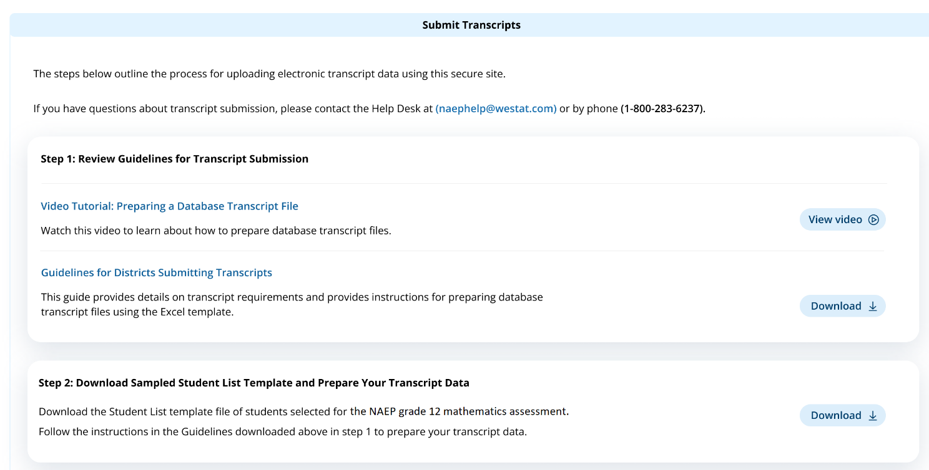

Submit Student Transcripts Page for Districts: Step 3
The step 3 tile shows the submission window and status for transcripts, and contains an upload button for when districts are ready to submit their transcripts. When they select “Upload”, a pop up window will appear (see figure 31 above) where districts can select the files to upload. A video with instructions on how to upload transcripts is also available for districts by selecting “View video.” At the bottom of the tile, districts can view what files were successfully submitted in the Submission History section.
Links/Downloads on this page (see Documents submitted separately):
- Tips for Uploading Transcripts Video
Figure 39: Screenshot of Submit Student Transcripts Page for Districts, Step 3
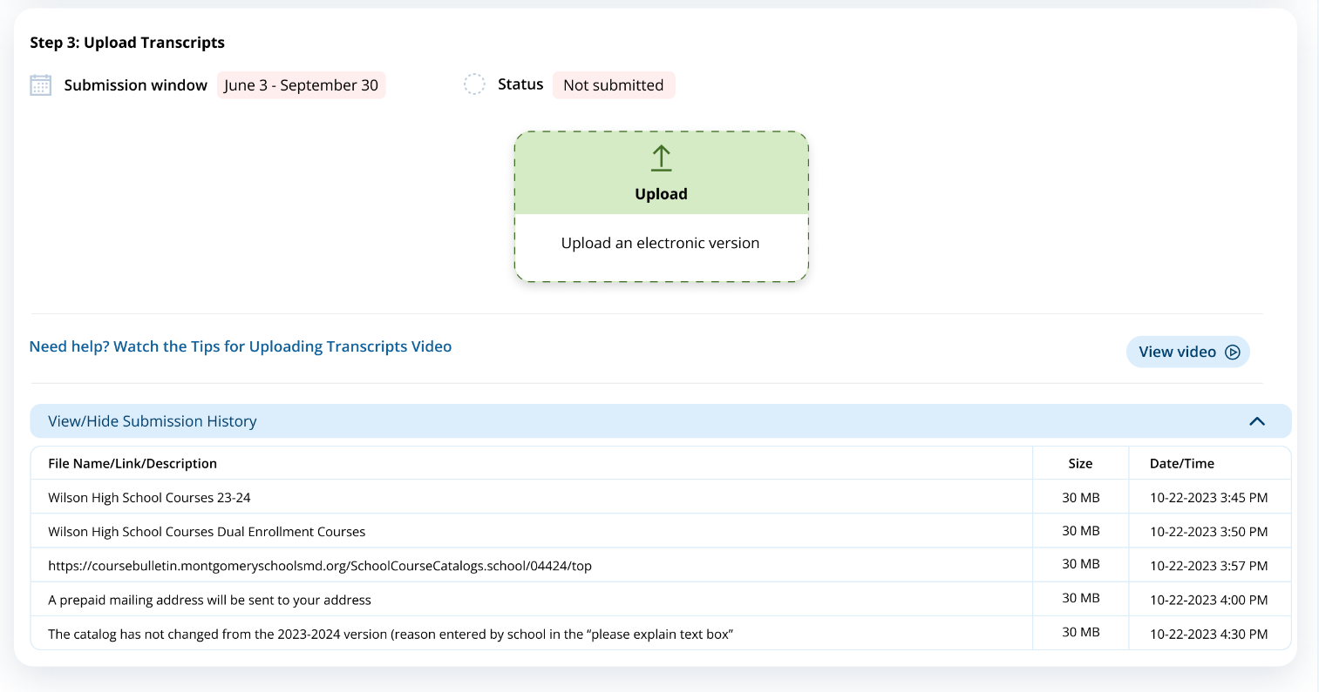

Appendix I16: AMS Tutorials, English and Spanish Puerto Rico (NEW)

Appendix I16-a: Assessment Logistics AMS Tutorial

AMS Tutorial
Assessment Logistics

Screen # | Screen content | Audio script | Media/images
 | Assessment Logistics Section | [Voiceover]: The Assessment Logistics section is where you will provide all the logistical information needed for assessment day. This section contains details on arriving at the school, classroom procedures during the assessment, and procedures for ending the assessment. Additionally, you will enter the start time and location for each assessment group. | Show image of the assessment logistics section
 | Assessment Logistics Section | [Voiceover]: You will edit information in one of two ways in this section. The first is editing the specific tiles by selecting the edit button, answering the questions or updating previously entered responses, and then selecting save.  The second is editing information in the schedule groups and student group details table. To edit the tables, you will select edit, next to the row that needs information entered or updated. When you select edit, a pop-up will display for you to enter information or make updates. Then you will select save. | Show image of the assessment logistics section
 | Start and end time | [Voiceover]: In the first tile, you will enter the school’s start and end time. This will be necessary to help with scheduling the group start times to make sure the last scheduled group ends before the end of the school day. | Show image of start time and end time tile
 | Schedule group; add location | [Voiceover]: Next you’ll indicate a location and start time for each group in the schedule groups tile. First, you will have to add a location by selecting the add location button. Here you will enter each location that the assessments will take place.  Once you have entered all the locations, you will select the location and start time for each group in the table. There should be at least three hours between the start of the first group and the start of the second group. This allows the students enough time to complete the assessment and the NAEP team to setup for the second group. | Show image of schedule group tile
 | Student group details | [Voiceover]: The Student group details table allows you to update the student’s group if there is a scheduling conflict.  There cannot be more than 25 students scheduled per group since the NAEP team only has enough equipment to assess 25 students. | Show image of student group details tile
 | Assessment Logistics Section | [Voiceover]: The next six tiles are where you will enter logistical information for the NAEP team. This includes information about arriving at the school, emergency procedures, and dismissal options.  The more detailed the responses, the better prepared the NAEP team will be before arriving at your school for assessment day. | Show image of the assessment logistics section
 | Assessment Logistics Section | [Voiceover]: If you have any questions about completing your tasks within the Assessment Logistics section of the AMS, please contact your NAEP representative or the NAEP Help Desk. | Show image of the assessment logistics section

AMS Tutorial – Puerto Rico
Assessment Logistics

Screen # | Screen content | Audio script | Media/images
 | Sección de la logística de la evaluación | [Voiceover]: La sección de la logística de la evaluación es donde usted proporcionará toda la información logística necesaria para el día de la evaluación. Esta sección contiene detalles sobre la llegada a la escuela, los procedimientos en el salón de clase durante la evaluación y los procedimientos para finalizar la evaluación. Además, ingresará la hora y el lugar de inicio de cada grupo de evaluación. | Assessment Logistics Section
 | Sección de la logística de la evaluación | [Voiceover]: Editará la información de una de dos maneras en esta sección. La primera es editar las fichas específicas seleccionando el botón Editar, respondiendo a las preguntas o actualizando las respuestas ingresadas previamente y luego seleccionando guardar.  La segunda es editar la información en los programas de los grupos y la tabla de detalles del grupo de estudiantes. Para editar las tablas, seleccionará editar en la fila que necesita ingresar o actualizar la información. Cuando seleccione editar, aparecerá una ventana emergente para que ingrese información o realice actualizaciones. Luego seleccionará guardar. | Assessment Logistics Section
 | Hora de inicio y de salida | [Voiceover]: En la primera ficha, ingresará la hora de inicio y de salida de la escuela. Esto será necesario para ayudar a programar las horas de inicio del grupo para asegurarse de que el último grupo programado finalice antes del final del día escolar. | Assessment Logistics Section
 | Programar grupos; añadir lugar | Luego, indicará un lugar y hora de inicio para cada grupo en la ficha de programar grupos. Primero, deberá añadir un lugar seleccionando el botón Añadir lugar. Aquí ingresará cada lugar en el que se realizarán las evaluaciones.  Una vez que haya ingresado todos los lugares, seleccionará el lugar y la hora de inicio para cada grupo en la tabla. Debe haber al menos tres horas entre el inicio del primer grupo y el inicio del segundo grupo. Esto permite que los estudiantes tengan tiempo suficiente para completar la evaluación y que el equipo de NAEP se prepare para el segundo grupo. | Assessment Logistics Section
 | Detalles del grupo de estudiantes | [Voiceover]: La tabla de detalles del grupo de estudiantes le permite actualizar el grupo de estudiantes si hay un conflicto de programación.  No puede haber más de 25 estudiantes programados por grupo ya que el equipo de NAEP solo tiene equipo suficiente para evaluar a 25 estudiantes. | Assessment Logistics Section
 | Sección de la logística de la evaluación | [Voiceover]: Las siguientes seis fichas son aquellas en donde ingresará la información logística para el equipo de NAEP. Esto incluye información sobre cómo llegar a la escuela, procedimientos de emergencia y opciones para dejar salir a los estudiantes.  Cuan más detalladas sean las respuestas, mejor preparado estará el equipo de NAEP antes de llegar a su escuela para el día de la evaluación. | Assessment Logistics Section
 | Sección de la logística de la evaluación | [Voiceover]: Si tiene alguna pregunta sobre cómo completar sus tareas en la sección de la logística de la evaluación del AMS, comuníquese con su representante de NAEP o con el centro de ayuda de NAEP. | Assessment Logistics Section

Appendix I16-b: Manage Questionnaires AMS Tutorial

AMS Tutorial
Manage Questionnaires

Screen # | Screen content | Audio script | Media/images
 | Manage Questionnaires section | [Voiceover]: NAEP school and teacher questionnaires are administered online. The Manage Questionnaires section is where you will provide the names and email addresses of questionnaire recipients, send the questionnaire link and password emails, and monitor the completion of questionnaires. Finally, this is where you will match students with their teachers. | Show image of manage questionnaires section
 | Manage Questionnaires section | [Voiceover]: To edit the tables, you will select edit next to the row that needs information entered or updated. When you select edit, a pop-up will display for you to enter information or make updates. Then you will select save. | Show image of manage questionnaires section
 | School questionnaire | [Voiceover]: In the first table, identify a respondent for the school questionnaire. This is usually the school principal, but you can designate a school administrator at the school, if needed.  From this table, you will also send the questionnaire link and password emails and monitor the status of questionnaire completion. | Show image of school questionnaire table
 | Manage Questionnaires section | [Voiceover]: The reminder of this tutorial goes over teacher questionnaires which is only applicable for grade 4 and grade 8 schools. | Show image of teacher questionnaire table
 | Teacher questionnaire  Add teacher | [Voiceover]: In the next table, identify respondents to complete the teacher questionnaires. You will need to add teachers that teach the selected students in the grade your school was selected for NAEP. To add a teacher, select the add teacher button and enter the required information.  From this table, you will also send the questionnaire link and password emails and monitor the status of questionnaire completion. | Show image of teacher questionnaire table
 | Match teacher with student | [Voiceover]: The final task is to match each student selected for NAEP with their teacher in the match students with teachers table.  If the student’s teacher does not appear as an option, you must add the teacher in the previous table. Then return to this table to match the student with their teacher. | Show image of match students with teachers table
 | Manage Questionnaires section | [Voiceover]: If you have any questions about completing your tasks within the Manage Questionnaires section of the AMS, please contact your NAEP representative or the NAEP Help Desk. | Show image of manage questionnaires section

AMS Tutorial – Puerto Rico
Manage Questionnaires

Screen # | Screen content | Audio script | Media/images
 | Sección Administrar Cuestionarios | [Voiceover]: Los cuestionarios de NAEP para las escuelas y para los maestros se administran en línea. La sección Administrar cuestionarios es donde usted proporcionará los nombres y las direcciones de correo electrónico de quienes completarán el cuestionario, enviará los correos electrónicos con el enlace al cuestionario y las contraseñas y supervisará que se completen los cuestionarios. Finalmente, aquí es donde asignará los estudiantes a sus maestros. | Show image of manage questionnaires section
 | Sección Administrar Cuestionarios | [Voiceover]: Para editar las tablas, seleccionará editar en la fila que necesita ingresar o actualizar información. Cuando seleccione editar, aparecerá una ventana emergente para que ingrese información o realice actualizaciones. Luego seleccionará guardar. | Show image of manage questionnaires section
 | Cuestionario para la escuela | [Voiceover]: En la primera tabla, identifique a la persona que completará el cuestionario de la escuela. Normalmente se trata del o de la directora de la escuela, pero puede designar a un o una administradora de la escuela, de ser necesario.  Desde esta tabla, también enviará los correos electrónicos con el enlace al cuestionario y las contraseñas y supervisará el estado del cuestionario. | Show image of school questionnaire table
 | Sección Administrar Cuestionarios | [Voiceover]: El recordatorio de este tutorial repasa los cuestionarios para los maestros, que solo se aplica a las escuelas de 4 y 8 grados. | Show image of teacher questionnaire table
 | Cuestionario para maestros  Añadir maestro(a) | [Voiceover]: En la siguiente tabla, identifique a quienes completarán los cuestionarios para maestros. Deberá añadir maestros que enseñen a los estudiantes en el grado para el que se seleccionó su escuela para NAEP. Para añadir un maestro, seleccione el botón añadir maestro e ingrese la información requerida.  Desde esta tabla, también enviará los correos electrónicos con el enlace al cuestionario y las contraseñas y supervisará el estado del cuestionario. | Show image of teacher questionnaire table
 | Asignar maestros a estudiantes | [Voiceover]: La tarea final es asignar a cada estudiante seleccionado para NAEP a su maestro en la tabla de asignar estudiantes a su maestro.  Si el maestro del estudiante no aparece como opción, debe añadirlo en la tabla anterior. Luego regrese a esta tabla para asignar al estudiante a su maestro. | Show image of match students with teachers table
 | Sección Administrar Cuestionarios | [Voiceover]: Si tiene alguna pregunta sobre cómo completar sus tareas en la sección Administrar cuestionarios, comuníquese con su representante de NAEP o con el centro de ayuda de NAEP. | Show image of manage questionnaires section

Appendix I16-c: Notify Parents/Guardians AMS Tutorial

AMS Tutorial
Notify Parents/Guardians

Screen # | Screen content | Audio script | Media/images
 | Notify Parent/Guardian page | [Voiceover]: The Notify Parent/Guardian section is where you will confirm that parents or guardians have been notified of NAEP. All parents or guardians must be notified in writing before the NAEP team can conduct the assessment. This can be through letter, email, or notice in the school newsletter. It is important that you send Parent/Guardian notifications and document the completion of this task in this section of the Assessment Management System. | Show image of notify Parent/Guardian page
 | Notify Parent/Guardian page | [Voiceover]: To edit information in this section, you will edit specific tiles by selecting the edit button, answering the questions or updating previously entered responses, and then selecting save. | Show image of notify Parent/Guardian page
 | Contact information section | [Voiceover]: The first tile, contact information, is where you will enter a deadline for when parents or guardians need to inform you that their child will not be participating in NAEP and indicate who parents or guardians should contact with questions about the NAEP assessment. | Show image of contact information
 | Download letters section | [Voiceover]: This next tile, download letter tile, is where you will download the Parent/Guardian letter and the translation notice (if needed). | Show image of download letter
 | Certify parent/guardian section | [Voiceover]: In the next tile, certify parent/guardian notification, you will enter the date the parent/guardian notification letters will be distributed and certify that you will distribute them on the date indicated. | Show image of certify parent/guardian notification details
 | Notify parent/guardian details section | [Voiceover]: Finally in the last tile, parent/guardian notification details, you will indicate how you notified parents/guardians about the NAEP assessment and who received the letter. | Show image of certify parent/guardian notification details
 | Notify Parent/Guardian page | [Voiceover]: If you have any questions about completing your tasks within the Notify Parents/Guardians section of the AMS, please contact your NAEP representative or the NAEP Help Desk. | Show image of notify Parent/Guardian page

AMS Tutorial – Puerto Rico
Notify Parents/Guardians

Screen # | Screen content | Audio script | Media/images
 | Página Notificar a los padres o tutores | [Voz en off]: La sección Notificar a los padres o tutores es donde confirmará que los padres o tutores han sido notificados sobre NAEP. Se les debe notificar por escrito a todos los padres o tutores antes de que el equipo de NAEP pueda llevar a cabo la evaluación. Esto puede hacerse a través de una carta, correo electrónico, o anuncio en el boletín escolar. Es importante que envíe notificaciones a los padres o tutores y documente la finalización de esta tarea en esta sección del Sistema de Administración de la Evaluación. | Show image of notify Parent/Guardian page
 | Página Notificar a los padres o tutores | [Voz en off]: Para editar la información en esta sección, editará fichas específicas seleccionando el botón editar, respondiendo a las preguntas o actualizando las respuestas ingresadas anteriormente, y luego seleccionando guardar. | Show image of notify Parent/Guardian page
 | Sección de Información de contacto | [Voz en off]: La primera ficha de información de contacto, es donde ingresará una fecha límite para cuando los padres o tutores deben informarle que su hijo o hija no participará en NAEP e indicar a quién deben contactar los padres o tutores si tienen preguntas sobre la evaluación de NAEP. | Show image of contact information
 | Sección de Descargue la carta | [Voz en off]: Esta siguiente ficha, Descargue la carta, es donde descargará la carta de notificación a los padres o tutores y el aviso de traducción (si es necesario). | Show image of download letter
 | Sección Certifique la notificación a los padres o tutores | [Voz en off]: En la siguiente ficha, Certifique la notificación a los padres o tutores, ingresará la fecha en que se distribuyeron las cartas de notificación a los padres o tutores para certificar que serán distribuidas en la fecha indicada. | Show image of certify parent/guardian notification details
 | Sección Detalles sobre la notificación a los padres o tutores | [Voz en off]: Finalmente, en la última ficha, Detalles sobre la notificación a los padres o tutores, indicará cómo notificó a los padres o tutores sobre la evaluación de NAEP y quién recibió la carta. | Show image of certify parent/guardian notification details
 | Página Notificar a los Padres/Tutores | [Voz en off]: Si tiene alguna pregunta sobre cómo completar sus tareas en la sección Notificar a los padres o tutores del AMS, comuníquese con su representante de NAEP o con el centro de ayuda. | Show image of notify Parent/Guardian page

Appendix I16-d: Provide Student Information AMS Tutorial

AMS Tutorial
Provide Student Information

Screen # | Screen content | Audio script | Media/images
1. | Provide Student Information Section | [Voiceover]: In this section, you will review the list of students selected for NAEP to ensure it is accurate and complete, and update any missing or incomplete information. You will update students with a Section 504 that require accommodations. Finally, you will review the list of students identified as Students with Disabilities (SD) and/or English Learners (EL) and provide information on what accommodations (if any) these students require for NAEP. | Show image of provide student information section
2. | Provide Student Information Section | [Voiceover]: There are up to four tabs which you will need to review and may need to update or enter missing information. The tabs can include student demographic information, review NIES students, and students with disabilities (SD) and English learners (EL), and Add New Students.  You will only have to access the review NIES students tab if your school has been selected for Grade 4 or Grade 8 Math and Reading, and there are students identified as American/Indian or Alaska Native. | Show image of student demographic information
3. | Provide Student Information Section | [Voiceover]: To review for missing data in the tabs, you can use the filters or review for the exclamation indicator in any column with missing data. | Show image of student demographic information
4. | Provide Student Information Section | [Voiceover]: To edit the data for a single student in the first three tabs, select the Edit button on the student’s row. This will open a pop-up, where you can update data or add missing data for the student. Once all updates have been made for the selected student, you will select the Save button to apply the selected edits to the student. | Show image of student demographic information and edit pop-up
5. | Provide Student Information Section | [Voiceover]: You can also bulk edit information for multiple students who need the same edits made or enter missing information.  To do this, select the checkboxes next to all the students requiring that edit. Then, from the choose category dropdown, select the appropriate category being edited. Next, select the appropriate change to dropdown menu option. Select Save to apply the edit to all the students. | Show student demographic information
6. | Provide Student Information Section | [Voiceover]: The Add New Students activity will open on January 2nd. Students who have enrolled since the fall of 2023 will have an opportunity to be selected for the assessment. Follow the instructions on this page to identify any new students in the selected grade. Please complete this activity before the scheduled assessment planning meeting with your assessment coordinator. | Show image of add new students section
7. | Provide Student Information Section | [Voiceover]: If you have any questions about completing your tasks within the Provide Information section of the AMS, please contact your NAEP representative or the NAEP Help Desk. | Show image of student demographic information

AMS Tutorial – Puerto Rico
Provide Student Information

Screen # | Screen content | Audio script | Media/images
1. | Sección Proporcionar información de los estudiantes | [Voiceover]: En esta sección revisará la lista de los estudiantes seleccionados para NAEP para asegurarse de que sea precisa y completa, y actualizará toda información que falte o esté incompleta. Actualizará la información de los estudiantes con un plan de la sección 504 que requieren acomodos. Finalmente, revisará la lista de estudiantes identificados como Estudiantes con impedimentos (EI) o Estudiantes aprendices del español (AE) y proporcionará información sobre qué acomodos (si corresponde) requieren estos estudiantes para NAEP. | Show image of provide student information section
2. | Sección Proporcionar información de los estudiantes | [Voiceover]: Hay hasta tres pestañas que necesitará revisar y puede que tenga que actualizar o proporcionar información que falte sobre el estudiante. Las pestañas incluyen datos demográficos de los estudiantes, estudiantes con impedimentos (EI) y aprendices del español (AE) y añadir estudiantes nuevos. | Show image of student demographic information
3. | Sección Proporcionar información de los estudiantes | [Voiceover]: Para revisar los datos que faltan en las pestañas, puede usar los filtros o revisar el indicador de exclamación en las columnas en las que faltan datos. | Show image of student demographic information
4. | Sección Proporcionar información de los estudiantes | [Voiceover]: Para editar los datos de un solo estudiante, seleccione el botón Editar en la fila del estudiante y se abrirá una ventana emergente, donde puede actualizar los datos o añadir datos que faltan para el estudiante. Una vez que se hayan realizado todas las actualizaciones para el estudiante seleccionado, seleccionará el botón Guardar para aplicar las ediciones seleccionadas al estudiante. | Show image of student demographic information and edit pop-up.
5. | Sección Proporcionar información de los estudiantes | [Voiceover]: También puede editar al mismo tiempo la información de varios estudiantes que necesitan las mismas ediciones o para ingresar información que falte.  Para hacer esto, seleccione las casillas de verificación junto a todos los estudiantes que necesitan esa edición. Luego, desde el menú desplegable de seleccionar categoría, seleccione la categoría apropiada que se está editando. Luego, seleccione el cambio apropiado en la opción del menú desplegable. Seleccione Guardar para aplicar la edición a todos los estudiantes. | student demographic information
6. | Sección Proporcionar información de los estudiantes | [Voiceover]: La actividad para añadir nuevos estudiantes estará disponible a partir del 2 de enero. Los estudiantes que se hayan matriculado desde otoño de 2023 tendrán la oportunidad de ser seleccionados para la evaluación. Siga las instrucciones en esta página para identificar a cualquier estudiante nuevo en el grado seleccionado. Por favor complete esta actividad antes de la reunión de planificación para la evaluación programada con su coordinador o coordinatora de evaluación. | Show image of add new students section
7. | Sección Proporcionar información de los estudiantes | [Voiceover]: Si tiene alguna pregunta sobre cómo completar sus tareas en la sección proporcionar información del AMS, comuníquese con su representante de NAEP o con el centro de ayuda. | Show image of student demographic information

Appendix I16-e: Technical Logistics AMS Tutorial

AMS Tutorial
Technical Logistics

Screen # | Screen content | Audio script | Media/images
 | [1] Technical Logistics tile | [Voiceover]: The Technical Logistics section is where you will respond to questions about your school’s Wi-Fi capabilities and work with your NAEP representative to prepare for assessment day.  You will review the responses from the Internet Connectivity Survey and update any information as necessary. You will also identify the network type the NAEP team will use on the assessment day and run the network diagnostic tool to confirm the Wi-Fi can support the NAEP assessment. | Show image of technical logistics tile
 | [1] Review and confirm Internet Connectivity Survey Results tile  [2] Provide the technical details tile | [Voiceover]: To view and edit information on the tiles, select the blue Edit button on bottom right corner of the tile.  To edit the information in the Provide the technical details table, select the blue edit button in the last column of each row. | Show image of technical logistics tile
 | [1] Highlight Review the school’s mode assignment tile and Review and confirm Internet Connectivity Survey Results tile  [2] Highlight planned mode  [3] Highlight Review and confirm ICS Results tile | [Voiceover]: The first tile displays the school’s planned mode based on the results of the Internet Connectivity Survey responses provided in the fall.  The second tile is for you to review the responses to the Internet Connectivity Survey and make updates, if necessary. | Show image of review the school’s mode assignment tile
 | [1] Select Network tile and Highlight Edit button | [Voiceover]: When specifying the network the NAEP team will use, you will select the school’s network type and provide the network name. In some cases, additional information or procedures will need to be provided in order to successfully complete the Select Network tile. | Show image of Select Network tile
 | [1] Run Network Diagnostic Tool tile and Highlight Run check button | [Voiceover]: It is essential that running the Network Diagnostic Tool be completed prior to the scheduled Assessment Planning Meeting so you can discuss the results with your NAEP representative. | Show image of Run Network Diagnostic Tool tile
 | [1] Provide the technical details tile  [2] Highlight the wireless access point  [3] Highlight the location  [4] Highlight the group | [Voiceover]: Next, you will indicate if the wireless access point for the locations selected by the school coordinator can support the connection of the devices. | Show image of provide the technical details tile
 | [1] Meeting the NAEP Team on assessment day tile  [2] Highlight Arrival time and location to meet, Wi-Fi credentials response, and, demonstration response  [3] Highlight Edit button | [Voiceover]: Finally on the meeting the NAEP team on assessment day tile, you will provide specifics on meeting the NAEP team on the morning of the scheduled assessment and providing the necessary Wi-Fi credentials. | Show image of meeting the NAEP Team on assessment day tile
 | Run Network Diagnostic Tool tile and Highlight Run check button | [Voiceover]: Within one week of the assessment date, you will need to return to this section to perform the final check. It is important you perform this final check so the NAEP team can prepare accordingly for conducting the assessment in your school. | Show image of technical logistics tile
 | [1] Return to Technical Logistics tile | [Voiceover]: If you have any questions about completing your tasks within the technical logistics section of the AMS, please contact your NAEP representative or the NAEP Help Desk. | Show image of Technical Logistics tile

AMS Tutorial – Puerto Rico
Technical Logistics

Screen # | Screen content | Audio script | Media/images
1. | [1] Ficha de la Logística Técnica | [Voiceover]: La sección de la logística técnica es donde responderá a las preguntas sobre las capacidades de Wi-Fi de su escuela y trabajará con su representante de NAEP para prepararse para el día de la evaluación.  Revisará las respuestas de la Encuesta sobre la conectividad a Internet y actualizará toda información según sea necesario. También identificará el tipo de red que utilizará el equipo de NAEP el día de la evaluación y ejecutará la herramienta de diagnóstico de la red para confirmar que el Wi-Fi es compatible con la configuración de la evaluación de NAEP. | Show image of technical logistics tile
2. | [1] Revise y confirme la ficha Resultados de la encuesta sobre la conectividad a Internet  [2] Proporcione la ficha de detalles técnicos | [Voiceover]: Para ver y editar información en las fichas, seleccione el botón azul Editar en la esquina inferior derecha de la ficha.  Para editar la información en la tabla Proporcionar los detalles técnicos, seleccione el botón azul editar en la última columna de cada fila. | Show image of technical logistics tile
3. | [1] Resalte la ficha Revisar la asignación de modo de la escuela y la ficha Revisar y confirmar los Resultados de la encuesta sobre la conectividad a Internet  [2] Resalte el modo planificado  [3] Resalte la ficha Revisar y confirmar los Resultados de ICS | [Voiceover]: La primera ficha muestra el modo planificado de la escuela en función de los resultados de las respuestas a la Encuesta sobre la conectividad a Internet que se proporcionaron en otoño.  La segunda ficha es para que revise las respuestas a la Encuesta sobre la conectividad a Internet y realice actualizaciones, si es necesario. | Show image of review the school’s mode assignment tile
4. | [1] Seleccione la ficha Red y resalte el botón Editar | [Voiceover]: Al especificar la red que utilizará el equipo de NAEP, seleccionará el tipo de red de la escuela y proporcionará el nombre de la red. En algunos casos, será necesario proporcionar información o procedimientos adicionales para completar con éxito la ficha Seleccionar la red. | Show image of elect Network tile
5. | [1] Ejecute la ficha Herramienta de Diagnóstico de la Red y resalte el botón Ejecutar verificación | [Voiceover]: Es fundamental que la Herramienta de Diagnóstico de la Red se ejecute antes de la reunión de planificación para la evaluación para que pueda analizar los resultados con su representante de NAEP. | Show image of Run Network Diagnostic Tool tile
6. | [1] Proporcione la ficha de detalles técnicos  [2] Resalte el punto de acceso inalámbrico  [3] Resalte el destino  [4] Resalte el grupo | [Voiceover]: Luego, indicará si el punto de acceso inalámbrico para los lugares seleccionados por el coordinador de la escuela son compatibles con la conexión de los dispositivos. | Show image of provide the technical details tile
7. | [1] Ficha de la reunión con el equipo de NAEP el día de la evaluación  [2] Resalte la hora de llegada y el destino para reunirse, la respuesta de las credenciales de Wi-Fi y la respuesta de demostración  [3] Resalte el botón Editar | [Voiceover]: Finalmente, en la ficha de la reunión con el equipo de NAEP el día de la evaluación, usted proporcionará detalles sobre la reunión con el equipo de NAEP en la mañana de la evaluación programada y proporcionará las credenciales necesarias para el Wi-Fi. | Show image of meeting the NAEP Team on assessment day tile
8. | Ejecute la ficha Herramienta de Diagnóstico de la Red y resalte el botón Ejecutar verificación | [Voiceover]: Una semana antes de la fecha de la evaluación, deberá volver a esta sección para realizar la verificación final. Es importante que realice esta verificación final para que el equipo de NAEP pueda prepararse adecuadamente para llevar a cabo la evaluación en su escuela. | Show image of technical logistics tile
9. | [1] Regrese a la ficha de la logística técnica | [Voiceover] Si tiene alguna pregunta sobre cómo completar sus tareas en la sección de la logística de la evaluación del AMS, comuníquese con su representante de NAEP o con el centro de ayuda. | Show image of technical logistics tile

Appendix I17: School Surveys, English and Spanish Puerto Rico (NEW)

Appendix I17-a: Observers Feedback Form

Observers Feedback Form
- How satisfied were you with the overall NAEP testing day experience?
- Completely satisfied
- Somewhat satisfied
- Somewhat unsatisfied
- Completely unsatisfied

[Display if Q1 = Somewhat unsatisfied or Completely unsatisfied] Why were you unsatisfied with the NAEP testing day experience that you observed? Please select all that apply.
- NAEP staff performance
- Assessment and preparations took too much time
- Difficulties implementing accommodations
- Difficulties with equipment setup
- Difficulties with device connection to school Internet
- Other (please specify) _________________

- Please give the NAEP assessment team an overall rating:
- Very good
- Good
- Fair
- Poor
- Not enough information to rate
- Did anything happen on assessment day that requires immediate attention from a supervisor of the NAEP team?
- Yes (please explain)
- No
[Display if Q3 = “Yes”]: Please describe the situation.

Formulario de comentarios para los observadores
- ¿Qué tan satisfecho(a) estuvo con la experiencia general del día de la prueba NAEP?
- Completamente satisfecho(a)
- Algo satisfecho(a)
- Algo insatisfecho(a)
- Completamente insatisfecho(a)
[Display if Q1 = Algo insatisfecho(a) or Completamente insatisfecho(a)] ¿Por qué quedó insatisfecho(a) con la experiencia del día de la prueba NAEP que observó? Seleccione todas las opciones que correspondan.
- Desempeño del personal de NAEP
- La evaluación y los preparativos tomaron demasiado tiempo
- Dificultades para aplicar los acomodos
- Dificultades con la configuración del equipo
- Dificultades con la conexión de dispositivos al Internet de la escuela
- Otro (especifique) _________________
- Por favor, dé al equipo de evaluación de NAEP una calificación general:
- Muy buena
- Buena
- Regular
- Deficiente
- No hay suficiente información para calificar
- ¿Sucedió algo el día de la evaluación que necesitó la atención inmediata de un supervisor del equipo de NAEP?
- Sí (explique)
- No
[Display if Q3 = Sí] Describa la situación.

Appendix I17-b: SC Preassessment Feedback Form

NAEP 2024 Assessment Planning Feedback (School Coordinator)

Part 1: Contacts with your NAEP Representative

- Think about all the activities that took place during the NAEP assessment planning phase. Please give the NAEP representative an overall rating:
- Very good
- Good
- Fair
- Poor
- Not enough information to rate

- How satisfied were you with how the Assessment Planning Meeting went?
- Very satisfied
- Somewhat satisfied
- Somewhat unsatisfied (please explain)
- Very unsatisfied (please explain)

[Display if Q2 = “Somewhat unsatisfied” or “Very unsatisfied”]: What could have been done to improve your satisfaction with the Assessment Planning Meeting?

- How confident do you feel that NAEP assessment day in your school will go smoothly?

- Completely confident
- Mostly confident
- Not very confident (please explain)
- Not at all confident (please explain)

[Display if Q3 = “Not very confident” or “Not at all confident”]: What concerns do you have about assessment day? Please select all that apply.
- Disruption to the school day
- Not enough school staff
- Other reason (specify)

Part 2: Using the Assessment Management System

- How easy was navigating the Assessment Management System?
- Very easy
- Somewhat easy
- Somewhat difficult (please explain)
- Very difficult (please explain)

[If Q4 = “Somewhat difficult” or “Very difficult” display Q7] What made navigating the Assessment Management System difficult?

- How easy was it updating or providing missing student information in the Assessment Management System?
- Very easy
- Somewhat easy
- Somewhat difficult (please explain)
- Very difficult (please explain)

[Display if Q5 = “Somewhat difficult” or “Very difficult”]: What made updating student information or providing missing student information in the Assessment Management System difficult?

- How easy was it to match students with teachers in the Manage Questionnaire section?
- Very easy
- Somewhat easy
- Somewhat difficult (please explain)
- Very difficult (please explain)
- Did not have to complete this task

[Display if Q6 = “Somewhat difficult” or “Very difficult”]: What made matching students to teachers difficult?

- How easy was it completing any part of the Add New Students task?
- Very easy
- Somewhat easy
- Somewhat difficult (please explain)
- Very difficult (please explain)
- Did not complete any Add New Students tasks
[If Q7 = “Somewhat difficult” or “Very difficult” display Q13] What part of the Add New Students task was difficult?

- How long did it take to complete your assessment planning activities?
- Completely satisfied
- Less than 30 minutes
- 30–45 minutes
- 45–60 minutes
- More than 60 minutes
- Please provide any suggestions for improving the Assessment Management System.

Opinión del/de la coordinador(a) escolar sobre la planificación para la evaluación de NAEP 2024

Parte 1: Contactos con su representante de NAEP

- Piense en todas las actividades que tuvieron lugar durante la fase de planificación para la evaluación de NAEP. Califique al/a la representante de NAEP en términos generales:
- Muy bueno
- Bueno
- Regular
- Pobre
- No hay suficiente información para calificar

- ¿Cuán satisfecho(a) está con respecto a cómo se desarrolló la reunión de planificación para la evaluación?
- Muy satisfecho(a)
- Algo satisfecho(a)
- Algo insatisfecho(a) (explique)
- Muy insatisfecho(a) (explique)

[Display if Q2 = “Algo insatisfecho(a)” or “Muy insatisfecho(a)”] ¿Qué se pudo haber hecho para mejorar su satisfacción con la reunión de planificación de la evaluación?

- ¿Cuánta confianza tiene en que el día de la evaluación de NAEP en su escuela se desarrollará sin problemas?
- Completamente confiado(a)
- Mayormente confiado(a)
- No muy confiado(a) (explique)
- No tengo ninguna confianza (explique)

[Display if Q3 = "No muy confiado(a)" or "No tengo ninguna confianza"] ¿Qué preocupaciones tiene sobre el día de la evaluación? Seleccione todas las opciones que correspondan.
- Interrupción del día de clases
- No hay suficiente personal escolar
- Otra razón (especifique)

Parte 2: Utilización del Sistema de Administración de la Evaluación

- ¿Cuán fácil fue navegar el Sistema de Administración de la Evaluación?
- Muy fácil
- Algo fácil
- Algo difícil (explique)
- Muy difícil (explique)

[Display if Q4 = "algo difícil" or "muy difícil"] ¿Qué ha dificultado la navegación por el Sistema de Administración de la Evaluación?

- ¿Cuán fácil fue actualizar o proporcionar la información que faltaba de los estudiantes en el Sistema de Administración de la Evaluación?
- Muy fácil
- Algo fácil
- Algo difícil (explique)
- Muy difícil (explique)

[Display if Q5 = "Algo difícil" or "Muy difícil"] ¿Qué ha dificultado la actualización de la información de los estudiantes o el suministro de la información que faltaba en el Sistema de Administración de la Evaluación?

- ¿Cuán fácil fue asignar estudiantes a maestros en la sección Administrar cuestionarios?
- Muy fácil
- Algo fácil
- Algo difícil (explique)
- Muy difícil (explique)
- No tuve que completar esta tarea

[Display if Q6 = “Algo difícil” or “Muy difícil”] ¿Qué dificultó el asignar estudiantes a maestros?

- ¿Cuán fácil fue completar la tarea de Añadir estudiantes nuevos?

- Muy fácil
- Algo fácil
- Algo difícil (por favor, explique)
- Muy difícil (por favor, explique)
- No tuve que completar las tareas de Añadir estudiantes nuevos

[Display if Q7 = “Algo difícil” or “Muy difícil”] ¿Qué parte de la tarea de Añadir estudiantes nuevos fue difícil?

- ¿Cuánto tiempo le tomó completar sus actividades de planificación para la evaluación?
- Menos de 30 minutos
- 30-45 minutos
- 45-60 minutos
- Más de 60 minutos

- Por favor, proporcione cualquier sugerencia para mejorar el Sistema de Administración de la Evaluación.

Appendix I17-c: SC Assessment Day Feedback Form

NAEP 2024 Assessment Day Feedback Form (School Coordinator)
- How satisfied were you with the overall NAEP testing day experience?
- Completely satisfied
- Somewhat satisfied
- Somewhat unsatisfied
- Completely unsatisfied
[Display if Q1 = “Somewhat unsatisfied” or “Completely unsatisfied”] Why are you unsatisfied with your overall NAEP testing day experience? Please select all that apply.
- NAEP staff performance
- Assessment and preparations took too much time
- School was selected for NAEP before
- Difficulties implementing accommodations
- Difficulties with space for the assessment
- Difficulties with equipment setup
- Difficulty with device connection to school Internet
- Other (please specify) _________________
[Display if Other (please specify) is selected]: Please describe other difficulties or experiences:

- Think about the contacts you have had with NAEP staff and the activities that took place on assessment day. Please give the NAEP assessment team an overall rating:
- Very good
- Good
- Fair
- Poor
- Not enough information to rate
- Please provide any additional information you would like to share regarding the NAEP assessment at your school.

- Did anything happen on assessment day that requires immediate attention from a supervisor of the NAEP team?
- Yes (please explain)
- No
[Display if Q4 = “Yes”]: Please describe the situation.

Opinión del/de la coordinador(a) escolar sobre el día de la evaluación de NAEP 2024
- ¿Cuán satisfecho(a) está con respecto al día de la evaluación de NAEP en términos generales?
- Completamente satisfecho(a)
- Algo satisfecho(a)
- Algo insatisfecho(a)
- Completamente insatisfecho(a)
[Display if Q1 = "Algo insatisfecho(a)" or "Completamente insatisfecho(a)"] ¿Por qué está insatisfecho(a) con respecto al día de la evaluación de NAEP en términos generales? Por favor, seleccione todo lo que corresponda.
- Rendimiento del personal de NAEP
- La evaluación y los preparativos tomaron demasiado tiempo
- La escuela fue seleccionada para NAEP anteriormente
- Dificultades para aplicar los acomodos
- Dificultades con el espacio para la evaluación
- Dificultades con la configuración del equipo
- Dificultad con la conexión de dispositivos al Internet de la escuela
- Otro (especifique) _________________
[Display if Otro (especifique) is selected] Por favor, describa otras dificultades o experiencias:

- Piense en los contactos que ha tenido con el personal de NAEP y en las actividades que tuvieron lugar el día de la evaluación. Califique al equipo de evaluación de NAEP en términos general:
- Muy bueno
- Bueno
- Regular
- Pobre
- No hay suficiente información para calificar

- Por favor, proporcione cualquier información adicional que desee compartir relacionada con la evaluación de NAEP en su escuela.

- ¿Ocurrió algo el día de la evaluación que requiriera la atención inmediata de un(a) supervisor(a) del equipo de NAEP

  - Sí (explique)
  - No

[Display if Q4 = “Yes”] Describa la situación.

Appendix I17-d: TC Preassessment Feedback Form

NAEP 2024 Assessment Planning Feedback (On-Site Technology Coordinator)

Part 1: Contacts with your NAEP Representative

- Think about all the activities that took place during the NAEP assessment planning phase. Please give the NAEP representative an overall rating:
- Very good
- Good
- Fair
- Poor
- Not enough information to rate

- How satisfied were you with how the Assessment Planning Meeting went?
- Very satisfied
- Somewhat satisfied
- Somewhat unsatisfied (please explain)
- Very unsatisfied (please explain)

[If Q2 = “Somewhat unsatisfied” or “Very unsatisfied” display Q3] What could have been done to improve your satisfaction with the Assessment Planning Meeting?

- How confident do you feel that NAEP assessment day in your school will go smoothly?
- Completely confident
- Mostly confident
- Not very confident (please explain)
- Not at all confident (please explain)

[Display if Q3 = “Not very confident” or “Not at all confident”]: What concerns do you have about assessment day? Please select all that apply.
- Setting up the school network for connection to NAEP devices
- Using the school network to conduct the NAEP assessment
- Disruption to the school day
- Not enough school staff
- Other reason (specify)

Part 2: Using the Assessment Management System

- How easy was navigating the Assessment Management System?
- Very easy
- Somewhat easy
- Somewhat difficult (please explain)
- Very difficult (please explain)

[Display if Q4 = “Somewhat difficult” or “Very difficult”] What made navigating the Assessment Management System difficult?

- When reviewing the responses from the Internet Connectivity Survey completed in the fall, did you have to update any responses due to changes to school or district procedures?
- Yes, I needed to make updates (please explain)
- No, I did not need to make any updates

[Display if Q5 = “Yes, I needed to make updates”]: Which sections did you update? (select all that apply)
- Confirm bandwidth requirements and connection
- Network information
- Safelist requirements and Wi-Fi credentials
- Security requirements

- How easy was it to run the Network Diagnostic Tool on the Wi-Fi and in the planned assessment location for assessment day?
- Very easy
- Somewhat easy
- Somewhat difficult (please explain)
- Very difficult (please explain)

[Display if Q6 = “Somewhat difficult” or “Very difficult”]: What made running the Network Diagnostic Tool difficult?

- After running the Network Diagnostic Tool, did you have to work with the school coordinator to update the assessment location to be closer to the school’s Wireless Access Point?
- Yes (please explain)
- No

[Display if Q7 = “Yes”]: Please explain how it was to work with the school coordinator to update the assessment location and any difficulties you may have experienced.

- Was there any information related to preparing the school network that should have been included or enhanced in the Assessment Managment System that would have helped with preparing the Wi-Fi for assessment day?

- How long did it take to complete your assessment planning activities?

- Less than 30 minutes
- 30–45 minutes
- 45–60 minutes
- More than 60 minutes
- Please provide any suggestions for improving the Assessment Management System.

Opinión del/de la coordinador(a) de tecnología interno(a) sobre la planificación para la evaluación de NAEP 2024

Parte 1: Contactos con su representante de NAEP

- Piense en todas las actividades que tuvieron lugar durante la fase de planificación para la evaluación de NAEP. Califique al/a la representante de NAEP en términos generales:
- Muy bueno
- Bueno
- Regular
- Pobre
- No hay suficiente información para calificar

- ¿Cuán satisfecho(a) está con respecto a cómo se desarrolló la reunión de planificación para la evaluación?
- Muy satisfecho(a)
- Algo satisfecho(a)
- Algo insatisfecho(a) (explique)
- Muy insatisfecho(a) (explique)

[Display if Q2 = “Algo insatisfecho(a)” or “Muy insatisfecho(a)”] ¿Qué se pudo haber hecho para mejorar su satisfacción con la reunión de planificación de la evaluación?

- ¿Cuánta confianza tiene en que el día de la evaluación de NAEP en su escuela se desarrollará sin problemas?
- Completamente confiado(a)
- Mayormente confiado(a)
- No muy confiado(a) (explique)
- No tengo ninguna confianza (explique)

[Display if Q3 = "No muy confiado(a)" or "No tengo ninguna confianza"] ¿Qué preocupaciones tiene sobre el día de la evaluación? Seleccione todas las opciones que correspondan
- La configuración de la red de la escuela para conectar los dispositivos de NAEP
- El utilizar la red de la escuela para realizar la evaluación NAEP
- Interrupción del día de clases
- No hay suficiente personal escolar
- Otra razón (especifique)

Parte 2: Utilización del Sistema de Administración de la Evaluación

- ¿Cuán fácil fue navegar el Sistema de Administración de la Evaluación?
- Muy fácil
- Algo fácil
- Algo difícil (explique)
- Muy difícil (explique)

[Display if Q4 = "Algo difícil (explique)" or "Muy difícil (explique)" ¿Qué ha dificultado la navegación por el Sistema de Administración de la Evaluación?

- Al revisar las respuestas de la Encuesta sobre la conectividad a Internet completada en otoño, ¿tuvo que actualizar alguna respuesta debido a cambios en los procedimientos de su escuela o distrito?
- Sí, tuve que hacer actualizaciones (explique)
- No, no tuve que hacer actualizaciones

[Display if Q5 = "Sí, tuve que hacer actualizaciones (explique)"] ¿Qué secciones actualizó? (seleccione todas las opciones que correspondan)
  - Confirmar los requisitos de ancho de banda y conexión
  - Información sobre la red
  - Los requisitos de la lista segura y las credenciales del WiFi
  - Los requisitos de seguridad

- ¿Cuán fácil fue usar la Herramienta de diagnóstico de la red en el WiFi y en el lugar de la evaluación previsto para el día de la evaluación?
- Muy fácil
- Algo fácil
- Algo difícil (explique)
- Muy difícil (explique)

[If Q10 = “Algo difícil (explique)” or “Muy difícil (explique)”] ¿Qué dificultó el uso de la Herramienta de diagnóstico de la red?

- Después de usar la Herramienta de diagnóstico de la red, ¿tuvo que trabajar con el(la) coordinador(a) escolar para actualizar el lugar de la evaluación para que estuviera más cerca del Punto de Acceso Inalámbrico de la escuela?

- Sí (explique)
- No

[Display if Q7 = “Sí (explique)”] Explique cómo fue trabajar con el(la) coordinador(a) escolar para actualizar el lugar de la evaluación y cualquier dificultad que haya podido experimentar.

- ¿Hubo alguna información relacionada con la preparación de la red de la escuela que debería haberse incluido o mejorado en el Sistema de Administración de la Evaluación para ayudar a preparar el WiFi para el día de la evaluación?

- ¿ Cuánto tiempo le tomó completar sus actividades de planificación para la evaluación?
- Menos de 30 minutos
- 30-45 minutos
- 45-60 minutos
- Más de 60 minutos

- Por favor, proporcione cualquier sugerencia para mejorar el Sistema de Administración de la Evaluación.

Appendix I17-e: TC Assessment Feedback Form

NAEP 2024 Assessment Day Feedback Form (On-site Technology Coordinator)
Please answer the following questions based on your experience completing tasks at the school to prepare for and support NAEP 2024.

- How satisfied were you with the overall NAEP testing day experience?
- Completely satisfied
- Somewhat satisfied
- Somewhat unsatisfied
- Completely unsatisfied
Display if Q1 = “Somewhat unsatisfied” or “Completely unsatisfied”]: Why are you unsatisfied with your overall NAEP testing day experience? Please select all that apply.
- Challenges with completing the Network Diagnostic Tool
- Challenges with providing the Wi-Fi credentials to NAEP staff
- Difficulties with safelisting URLs on assessment day
- Difficulties with equipment setup
- Other (please specify) _________________
[If Other (please specify)]: Please describe other difficulties or experiences:

- Were there any issues connecting to the school’s Internet on assessment day?
- Yes (please explain
- No
- Don’t know

[Display if Q3 = “Yes”]: If you selected “Yes,” please explain.

- Overall, how easy or difficult was it to support the technical requirements to administer the NAEP assessments in your school?
- Very easy
- Somewhat easy
- Somewhat difficult (please explain)
- Very difficult (please explain)

[Display if Q4 = “Somewhat difficult” or “Very difficult”] If you selected “Somewhat difficult” or “Very difficult,” please explain.

- Were there any technical issues or other problems on the day of the assessment that you would like to inform NAEP about?
- Yes (please explain)
- No
- Don’t know

[Display if Q5 = “Yes”]: If you selected “Yes,” please explain.

- Is there anything NAEP can do to help improve the technical preparation process for future NAEP assessments?

Opinión del/de la coordinador(a) de tecnología interno(a) sobre el día de la evaluación de NAEP 2024

Por favor, responda a las siguientes preguntas según su experiencia al completar las tareas en su escuela para preparar y apoyar a NAEP 2024.

- ¿ Cuán satisfecho(a) está con respecto al día de la evaluación de NAEP en términos generales?
  - Completamente satisfecho(a)
  - Algo satisfecho(a)
  - Algo insatisfecho(a)
  - Completamente insatisfecho(a)

- [Display if Q1 = "Algo insatisfecho(a)" or "Completamente insatisfecho(a)"] ¿Por qué está insatisfecho(a) con respecto al día de la evaluación de NAEP en términos generales? Por favor, seleccione todo lo que corresponda.

- Dificultades al completar la Herramienta de diagnóstico de la red
- Dificultades para proporcionar las credenciales del WiFi al personal de NAEP
- Dificultades con la inclusión de URL en la lista segura el día de la evaluación.
- Dificultades con la configuración de los equipos
- Otro (especifique) _________________
[Display if “Otro (especifique)”] Por favor, describa otras dificultades o experiencias:

- ¿Hubo algún problema para conectarse al Internet de la escuela el día de la evaluación?
  - Sí (explique)
  - No
  - No lo sé

[Display if Q3 = “Sí (explique)”] Si seleccionó "Sí", explique.

- En general, ¿cuán fácil o difícil fue lograr que los requisitos técnicos para administrar las evaluaciones de NAEP se cumplieran en su escuela?
  - Muy fácil
  - Algo fácil
  - Algo difícil (explique)
  - Muy difícil (explique)

[Display if Q4 = “Algo difícil (explique)” or “Muy difícil (explique)”]
Si seleccionó "Algo difícil" o "Muy difícil", explique.

- ¿Hubo algún problema técnico o de otro tipo el día de la evaluación sobre el que le gustaría informar a NAEP?
  - Sí (explique)
  - No
  - No lo sé

[Display if Q5 = “Sí (explique)”] Si seleccionó "Sí", explique.

- ¿Hay algo que NAEP pueda hacer para ayudar a mejorar el proceso de preparación técnica para futuras evaluaciones de NAEP?

Appendix I18: Automated Questionnaire Emails (NEW)

Automated Questionnaire Emails

NAEP 2024

Table of Contents
Welcome Email with Verification Link (SQ version) 2
Email with NAEPQ URL (SQ version) 3
Email with NAEPQ Password (SQ version) 4
Welcome Email with Verification Link (TQ version) 5
Email with NAEPQ URL (TQ version) 6
Email with NAEPQ Password (TQ version) 7

Welcome Email with Verification Link (SQ version)

To: NAEP SQ Respondent
Subject: NAEP School Questionnaire


Support Educational Progress!
Complete the NAEP Questionnaire

Dear [SQ Respondent Name],

The National Assessment of Educational Progress (NAEP) is the only ongoing assessment of what our nation's students know and can do in a variety of subjects. Grade [4/8/12] students at [school name] will take [mathematics and reading and/or science] assessments on [assessment date].

In addition to conducting assessments, NAEP gathers information on school policies and characteristics by using a school questionnaire. [School coordinator name] has identified you as the respondent. Your responses will provide important information for educators, policymakers, and researchers to better understand the context in which students learn. This enhanced understanding can help improve education in our nation's classrooms.



Please select the link below or copy/paste into your browser to receive your questionnaire link and password in two additional emails.

https://ams-qa.wesdemo.com/Registration/NAEPQEmailVerification.aspx?qid=F8FA0D7A-C9E5-49A0-9384-F00F7CA1379F

Visit https://nces.ed.gov/nationsreportcard/experience/survey_questionnaires.aspx to explore how your responses contribute to NAEP’s ability to report on what our nation’s students know and can do.

Email with NAEPQ URL (SQ version)

To: NAEP SQ Respondent
Subject: NAEP School Questionnaire – Link
NAEP School Questionnaire
Custom link enclosed

Dear [SQ Respondent Name],

Thank you for supporting the National Assessment of Educational Progress (NAEP).

- Select the questionnaire link below or copy/paste into your browser.
- See separate email for password, the subject is NAEP School Questionnaire – Password.
- Grade [4/8/12] students at [school name] will take the assessment on [assessment date]. Please complete the questionnaire before this date. It takes approximately [Grade 4/8/12 =30, Grade 4/8 with NIES =110] minutes to complete, and does not have to be completed in one visit.

https://naepq-test.naepnpd.org/login/b5dc4cc8

For technical assistance, contact the NAEP help desk at 1-800-283-NAEP (6237) or naephelp@westat.com.

Visit https://nces.ed.gov/nationsreportcard/experience/survey_questionnaires.aspx to explore how your responses contribute to NAEP’s ability to report on what our nation’s students know and can do.

Email with NAEPQ Password (SQ version)

To: NAEP SQ Respondent
Subject: NAEP School Questionnaire – Password

NAEP School Questionnaire
Password

Dear [SQ Respondent Name],

Thank you for supporting the National Assessment of Educational Progress (NAEP).

You should have a separate email with the NAEP School Questionnaire link for [school name]. The password is available below.

[PASSWORD]

For technical assistance, contact the NAEP help desk at 1-800-283-NAEP (6237) or naephelp@westat.com.

Visit https://nces.ed.gov/nationsreportcard/experience/survey_questionnaires.aspx to explore how your responses contribute to NAEP’s ability to report on what our nation’s students know and can do.

Welcome Email with Verification Link (TQ version)

To: NAEP TQ Respondent

Subject: NAEP Teacher Questionnaire

Support Educational Progress!
Complete the NAEP Questionnaire

Dear [TQ Respondent Name],

The National Assessment of Educational Progress (NAEP) is the only ongoing assessment of what our nation’s students know and can do in a variety of subjects. [Grade] [4/8] students at [school name] will take [mathematics and reading, and/or science] assessments on [assessment date].

In addition to conducting assessments, NAEP uses a teacher questionnaire to gather information concerning years of teaching experience, frequency of assignments, use of teaching materials, and availability and use of computers. [School coordinator name] has identified you as a respondent. Your responses will provide important information for educators, policymakers, and researchers to better understand the context in which students learn. This enhanced understanding can help improve education in our nation's classrooms.

Please select the link below or copy/paste into your browser to receive your questionnaire link and password in two additional emails.

https://ams-qa.wesdemo.com/Registration/NAEPQEmailVerification.aspx?qid=F8FA0D7A-C9E5-49A0-9384-F00F7CA1379F

Visit https://nces.ed.gov/nationsreportcard/experience/survey_questionnaires.aspx to explore how your responses contribute to NAEP’s ability to report on what our nation’s students know and can do.

Email with NAEPQ URL (TQ version)

To: NAEP TQ Respondent
Subject: NAEP Teacher Questionnaire – Link
NAEP Teacher Questionnaire
Custom link enclosed

Dear [TQ Respondent Name],

Thank you for supporting the National Assessment of Educational Progress (NAEP).

- Select the questionnaire link below or copy/paste into your browser.
- See separate email for password, the subject is NAEP Teacher Questionnaire – Password.
- [Grade] [4/8] students at [school name] will take the assessment on [assessment date]. Please complete the questionnaire before this date. It takes approximately [grade 4=30, grade 4 with NIES=50, grade 8=20/30/40, grade 8 with NIES=40/50/60] minutes to complete, and does not have to be completed in one visit.

https://naepq-test.naepnpd.org/login/b5dc4cc8

For technical assistance, contact the NAEP help desk at 1-800-283-NAEP (6237) or naephelp@westat.com.

Visit https://nces.ed.gov/nationsreportcard/experience/survey_questionnaires.aspx to explore how your responses contribute to NAEP’s ability to report on what our nation’s students know and can do.

Email with NAEPQ Password (TQ version)

To: NAEP TQ Respondent
Subject: NAEP Teacher Questionnaire – Password

NAEP Teacher Questionnaire
Password

Dear [TQ Respondent Name],

Thank you for supporting the National Assessment of Educational Progress (NAEP).

You should have a separate email with the NAEP Teacher Questionnaire link for [school name]. The password is available below.

[PASSWORD]

For technical assistance, contact the NAEP help desk at 1-800-283-NAEP (6237) or naephelp@westat.com.

Visit https://nces.ed.gov/nationsreportcard/experience/survey_questionnaires.aspx to explore how your responses contribute to NAEP’s ability to report on what our nation’s students know and can do.

Automated Questionnaire Emails – PR

NAEP 2024

Table of Contents
Welcome Email with Verification Link (SQ version) 2
Email with NAEPQ URL (SQ version) 3
Email with NAEPQ Password (SQ version) 4
Welcome Email with Verification Link (TQ version) 5
Email with NAEPQ URL (TQ version) 6
Email with NAEPQ Password (TQ version) 7

Welcome Email with Verification Link (SQ version)

To: NAEP SQ Respondent
Subject: Cuestionario escolar de NAEP

Apoye el progreso educativo!
Complete el cuestionario de NAEP

Estimado(a) [SQ Respondent Name],

La Evaluación Nacional del Progreso Educativo (NAEP, por sus siglas en inglés) es la única evaluación continua de lo que los estudiantes de nuestra nación saben y pueden hacer en diferentes materias. Los estudiantes de [4/8] grado de [school name] tomarán las evaluaciones de matemáticas el [assessment date].

Además de realizar evaluaciones, NAEP recoge información sobre las políticas y características de las escuelas mediante un cuestionario escolar. [School coordinator name] lo(la) ha identificado a usted como encuestador(a). Sus respuestas proporcionarán información importante para que los educadores, legisladores e investigadores comprendan mejor el contexto en el que aprenden los estudiantes. Esta comprensión puede ayudar a mejorar la educación en los salones de clase de nuestro país.

Seleccione el siguiente enlace para recibir el enlace del cuestionario y la contraseña en dos correos electrónicos adicionales.

https://ams-qa.wesdemo.com/Registration/NAEPQEmailVerification.aspx?qid=F8FA0D7A-C9E5-49A0-9384-F00F7CA1379F

Visite https://nces.ed.gov/nationsreportcard/experience/survey_questionnaires.aspx para explorar cómo sus respuestas contribuyen a la capacidad de NAEP para informar sobre lo que los estudiantes de nuestra nación saben y pueden hacer.

Email with NAEPQ URL (SQ version)

To: NAEP SQ Respondent
Subject: Cuestionario escolar de NAEP - Enlace
Cuestionario escolar de NAEP
Enlace personalizado adjunto

Estimado(a) [SQ Respondent Name],

Gracias por apoyar la Evaluación Nacional del Progreso Educativo (NAEP, por sus siglas en inglés).

- Seleccione el enlace del cuestionario que aparece a continuación o copie/pegue en su navegador.
- Vea el correo electrónico separado para la contraseña, el asunto es Cuestionario escolar de NAEP - Contraseña.
- Los estudiantes de [4/8] grado de [school name] realizarán la evaluación el [assessment date]. Por favor, complete el cuestionario antes de esta fecha. Se tarda aproximadamente 30 minutos en completarlo y no es necesario hacerlo en una sola visita.

https://naepq-test.naepnpd.org/login/b5dc4cc8

Para obtener asistencia técnica, comuníquese con la oficina de ayuda de NAEP llamando al 1-800-283-NAEP (6237) o escribiendo a naephelp@westat.com.

Visite https://nces.ed.gov/nationsreportcard/experience/survey_questionnaires.aspx para explorar cómo sus respuestas contribuyen a la capacidad de NAEP para informar sobre lo que los estudiantes de nuestra nación saben y pueden hacer.

Email with NAEPQ Password (SQ version)

To: NAEP SQ Respondent
Subject: Cuestionario escolar de NAEP - Contraseña

Cuestionario escolar de NAEP
Contraseña

Estimado(a) [SQ Respondent Name],

Gracias por apoyar la Evaluación Nacional del Progreso Educativo (NAEP, por sus siglas en inglés).

Debió recibir un correo electrónico separado con el enlace del Cuestionario escolar de NAEP para [school name]. La contraseña está disponible abajo.

[CONTRASEÑA]

Para obtener asistencia técnica, comuníquese con la oficina de ayuda de NAEP llamando al 1-800-283-NAEP (6237) o escribiendo a naephelp@westat.com.

Visite https://nces.ed.gov/nationsreportcard/experience/survey_questionnaires.aspx para explorar cómo sus respuestas contribuyen a la capacidad de NAEP para informar sobre lo que los estudiantes de nuestra nación saben y pueden hacer.

Welcome Email with Verification Link (TQ version)

To: NAEP TQ Respondent
Subject: Cuestionario para maestros de NAEP

Apoye el progreso educativo!
Complete el cuestionario de NAEP
Estimado(a) [TQ Respondent Name],

La Evaluación Nacional del Progreso Educativo (NAEP, por sus siglas en inglés) es la única evaluación continua de lo que los estudiantes de nuestra nación saben y pueden hacer en diferentes materias. Los estudiantes de [4/8] grado de [school name] realizarán las evaluaciones de matemáticas el [assessment date].

Además de llevar a cabo las evaluaciones, NAEP utiliza un cuestionario para los maestros con el fin de recopilar información sobre los años de experiencia docente, la frecuencia de las tareas, el uso de materiales didácticos y la disponibilidad y el uso de computadoras. [School coordinator name] lo(la) ha identificado como encuestado. Sus respuestas proporcionarán información importante para que los educadores, legisladores y los investigadores comprendan mejor el contexto en el que aprenden los estudiantes. Esta comprensión puede ayudar a mejorar la educación en los salones de clase de nuestro país.

Seleccione el siguiente enlace o copie/pegue en su navegador para recibir el enlace del cuestionario y la contraseña en dos correos electrónicos adicionales.

https://ams-qa.wesdemo.com/Registration/NAEPQEmailVerification.aspx?qid=F8FA0D7A-C9E5-49A0-9384-F00F7CA1379F

Visite https://nces.ed.gov/nationsreportcard/experience/survey_questionnaires.aspx para explorar cómo sus respuestas contribuyen a la capacidad de NAEP para informar sobre lo que los estudiantes de nuestra nación saben y pueden hacer.

Email with NAEPQ URL (TQ version)

To: NAEP TQ Respondent
Subject: Cuestionario para maestros de NAEP - Enlace
Cuestionario para maestros de NAEP
Enlace personalizado adjunto

Estimado(a) [Nombre del demandado TQ],

Gracias por apoyar la Evaluación Nacional del Progreso Educativo (NAEP, por sus siglas en inglés).

- Seleccione el enlace del cuestionario que aparece a continuación o copie/pegue en su navegador.
- Vea el correo electrónico separado para la contraseña, el asunto es Cuestionario para maestros de NAEP - Contraseña.
- Los estudiantes de [4/8] grado de [school name] realizarán la evaluación el [assessment date]. Por favor, complete el cuestionario antes de esta fecha. Se tarda aproximadamente [grado 4=35, grado 8=25] minutos en completarlo, y no es necesario hacerlo en una sola visita.

https://naepq-test.naepnpd.org/login/b5dc4cc8

Para obtener asistencia técnica, comuníquese con la oficina de ayuda de NAEP llamando al 1-800-283-NAEP (6237) o escribiendo a naephelp@westat.com.

Visite https://nces.ed.gov/nationsreportcard/experience/survey_questionnaires.aspx para explorar cómo sus respuestas contribuyen a la capacidad de NAEP para informar sobre lo que los estudiantes de nuestra nación saben y pueden hacer.

Email with NAEPQ Password (TQ version)

To: NAEP TQ Respondent
Reglas: Password email sends after the school coordinator selects “send” in the AMS.
Subject: Cuestionario para maestros de NAEP - Contraseña

Cuestionario para maestros de NAEP
Contraseña

Estimado(a) [TQ Respondent Name],

Gracias por apoyar la Evaluación Nacional del Progreso Educativo (NAEP, por sus siglas en inglés).

Debió recibir un correo electrónico por separado con el enlace del Cuestionario para maestros de NAEP para [school name]. La contraseña está disponible abajo.

[CONTRASEÑA]

Para obtener asistencia técnica, comuníquese con la oficina de ayuda de NAEP llamando al 1-800-283-NAEP (6237) o escribiendo a naephelp@westat.com.

Visite https://nces.ed.gov/nationsreportcard/experience/survey_questionnaires.aspx para explorar cómo sus respuestas contribuyen a la capacidad de NAEP para informar sobre lo que los estudiantes de nuestra nación saben y pueden hacer.

Appendix I19: School-Based Equipment Staff Questions, English and Spanish Puerto Rico (NEW)

School-Based Equipment Staff Questions
Respondent: The designated district technology directors will receive and respond to this survey. When these individuals log into the Assessment Management System (AMS) they will have a list of their schools. They have the capability to select the full list or individual schools to respond as appropriate.

Distribution: This survey will be distributed via the AMS after schools complete the 2024 operational assessment; all district technology directors will receive the survey.

Description of Survey:
NAEP is focused on being innovative in how to best assess students and reduce burden on schools. The information from this survey will inform the feasibility of using school-based equipment to deliver the NAEP assessment in the future.

Device Ownership
- Which of the following equipment models is used in your school(s) to provide students technology access? (e.g., laptops, desktop computers, tablets) (check all that apply)

 | One to one | One to more than one | Technology Center | Bring your own device (BYOD) | School does not provide devices
Grade 4
Grade 8
Grade 12

- Does your school require students to bring personal headphones to school for academic use or for state testing?
- Yes (Please explain) (fillable field)
- No (Please explain) (fillable field)
- Other (fillable field):

Device Management
- What type of student devices and operating systems (OS) does your school support? (percentage)
 | Chromebook ChromeOS | Microsoft Windows  (Laptops, tablets, desktops) | MacOS (Laptops, desktops) | iPad  iOS | Android Tablet  Android OS | Other (fillable)
Grade 4
Grade 8
Grade 12

- Are all your student devices managed (controlled by an organized process) at the school, district, or state level?
- Yes
  - School
  - District
  - State
- No
  - Approximate percentage of managed devices (fillable field):
  - Approximate percentage of unmanaged devices (fillable field):
- Comments (fillable field)

- How does your school, district, or state manage student devices? (check all that apply)
- School-owned devices:
  - Chromebooks
    - Google Admin console
    - Google Workspace for Education
    - Other, please specify (fillable field):
  - Microsoft Windows devices
    - Microsoft Intune for Education service:
    - Other, please specify (fillable field):
  - Apple Devices (e.g. Mac, iPad, iMac)
    - Mobile Device Management (MDM) tool for Apple devices
      - Jamf:
      - Kandji:
      - Other:
    - Other, please specify (fillable field):
  - Other (please specify):

- Bring your own devices (BYOD)
  - Does not manage centrally
  - Chromebooks
    - Google Admin console
    - Google Workspace for Education
    - Other, please specify (fillable field):
  - Microsoft Windows devices
    - Microsoft Intune for Education service
    - Other, please specify (fillable field):
  - Apple Devices (e.g. Mac, iPad, iMac)
    - Mobile Device Management (MDM) tool for Apple devices
      - Jamf:
      - Kandji:
      - Other:
    - Other, please specify (fillable field):
  - Other (please specify):

- How are applications distributed to student devices? (check all that apply)
- Chromebooks
  - All applications are managed via Google Admin console
  - Faculty or students can install apps as a part of a classroom curriculum
  - Applications are installed individually from the Chrome web store
  - Applications are installed individually from credible sources (e.g., websites from organizations such as Pearson, Cambium)
  - Other, please specify (fillable field):
- Microsoft Windows devices
  - All applications are distributed remotely via a central management tool.
  - Preferred distribution format (if known)
    - MSI
    - MSIX
    - Other, please specify (fillable field):
  - Installed individually from Windows Store
  - Installed individually from credible sources (e.g., websites from organizations such as Pearson, Cambium)
  - Other, please specify (fillable field):
- Apple Devices (e.g Mac, iPad, iMac)
  - All applications are distributed via Mobile Device Management (MDM) tool for Apple devices.
  - Installed individually from Apple store on student device.
  - Other, please specify (fillable field):
- Other (please specify):

- Who is responsible for installing applications on student devices? (check all that apply)
- School technology coordinator
- District technology coordinator
- Other, please specify (fillable field):
- Comments (fillable field)

- How are major state assessment apps configured on student devices to provide a secure/lockdown testing/assessment environment?
- Chromebooks
  - via Google Admin console kiosk mode option
  - Other, please specify (fillable field):
- Windows
  - via Microsoft tool "Take a Test in kiosk mode"
  - Installed app controls the secure environment without additional configurations required.
  - Installed app controls the secure environment with additional manual configurations.
  - Other, please specify (fillable field):
- Apple Devices (e.g Mac, iPad, iMac)
  - Installed app controls the secure environment without additional configurations required.
  - Installed app controls the secure environment with additional manual configurations.
  - Other, please specify (fillable field):
- Other (please specify):

Device and Security Policies
- What is the replace (refresh) student device policy at your school/district/state?
- Every year
- Every 2 years
- Every 3 years
- Every 4 years
- Other, please specify (fillable field):
- Comments (fillable field)

- What is the operating system (OS) upgrade policy at your school/district/state?
- Every major OS release
- On a set schedule (e.g., at the start of each semester) (please specify):
- On a delayed schedule (e.g., one week after a major release) (please specify):

- Do your security policies allow the NAEP assessment application to be downloaded on student devices?
- Yes
- No (Please explain)

- Do school/district/state policies allow any of the following activities on the student devices?
 | Yes | No
a. Installing applications to access the local user’s file system
b. Downloading applications from websites other than Microsoft and Chrome application stores
c. Downloading and installing executable files from credible sources if they are safelisted/whitelisted
d. Downloading and installing any executable files from credible sources regardless of safelist status

Device Specification

- What is the screen resolution on the type of student devices used by students in your school? (check all that apply)
- 1224x768
- 1366x768
- 1920x1080
- 1920x1200
- Other (fillable field):

- What is the screen size on the type of devices used by students in your school? (check all that apply)
- 11.6”
- 12.2”
- 13.5”
- 14.0”
- 15.6”
- Other (fillable field):

- Do student devices have touch capabilities?
  - Yes
  - No

- [Display if Q15=Yes] If student devices have touch capabilities, is a stylus provided? (check all that apply)
- Yes, students are provided styluses for use with student devices
- No, students use their own stylus for use with student devices
- No, styluses are not provided

Preguntas para el personal sobre el equipo de la escuela
Encuestado: Los directores de tecnología distritales designados recibirán y responderán a esta encuesta. Cuando estas personas ingresen al Sistema de Administración de la Evaluación (AMS, por sus siglas en inglés) tendrán una lista de sus escuelas. Para responder, ellos pueden seleccionar la lista completa o escuelas individuales, según corresponda.

Distribución: Esta encuesta se enviará a través del AMS después de que las escuelas completen la evaluación operativa de 2024. Todos los directores de tecnología distritales recibirán la encuesta.

Descripción de la encuesta:
El enfoque de NAEP es innovar a fin de evaluar a los estudiantes de la mejor manera y reducir la carga de las escuelas. La información derivada de esta encuesta orientará la viabilidad de usar equipos de la escuela para administrar la evaluación de NAEP en el futuro.

Propiedad de los dispositivos
- ¿Cuáles de los siguientes modelos de equipos se emplean en su(s) escuela(s) para darles a los estudiantes acceso a la tecnología? (P. ej., computadoras portátiles, computadoras de escritorio, tabletas) (Seleccione todos los que apliquen)

 | Individual | Uno para más de uno | Centro de tecnología | Trae tu propio dispositivo (BYOD) | La escuela no proporciona dispositivos
4.° grado
8.° grado

- ¿Su escuela exige que los estudiantes lleven sus propios audífonos a la escuela para uso académico o para pruebas estatales?
- Sí (por favor explique) (Campo para rellenar)
- No (por favor explique) (Campo para rellenar)
- Otro (campo para rellenar)

Gestión de los dispositivos
- ¿Qué tipo de dispositivos para estudiantes y qué sistemas operativos (SO) emplea su escuela? (Porcentaje)
 | Chromebook ChromeOS | Microsoft Windows  (Computadoras portátiles, tabletas, computadoras de escritorio) | MacOS (Computadoras portátiles, computadoras de escritorio) | iPad  iOS | Tableta de Android  SO de Android | Otro (campo para rellenar)
4.° grado
8.° grado

4. ¿Todos sus dispositivos para estudiantes son gestionados (controlados mediante un proceso organizado) a nivel escolar, distrital o estatal?
- Sí
  - Escolar
  - Distrital
  - Estatal
- No
  - Porcentaje aproximado de dispositivos gestionados (campo para rellenar):
  - Porcentaje aproximado de dispositivos no gestionados (campo para rellenar):
- Comentarios (campo para rellenar)

5. ¿Cómo gestiona su escuela, distrito o estado los dispositivos para estudiantes? (Seleccione todos los que apliquen)
- Dispositivos de propiedad de la escuela:
  - Chromebooks
    - Consola de administración Google Admin
    - Google Workspace for Education
    - Otro, por favor especifique (campo para rellenar):
  - Dispositivos de Microsoft Windows
    - Servicio de Microsoft Intune para la Educación:
    - Otro, por favor especifique (campo para rellenar):
  - Dispositivos de Apple (p. ej., Mac, iPad, iMac)
    - Herramienta Mobile Device Management (MDM, por sus siglas en inglés) para dispositivos de Apple
      - Jamf:
      - Kandji:
      - Otro (por favor especifique) (Campo para rellenar):
  - Otro (por favor especifique):

- Trae tu propio dispositivo (BYOD)
  - No son gestionados a nivel central
  - Chromebooks
    - Consola de administración Google Admin
    - Google Workspace for Education
    - Otro, por favor especifique (campo para rellenar):
  - Dispositivos de Microsoft Windows
    - Servicio de Microsoft Intune para la Educación
    - Otro, por favor especifique (campo para rellenar):
  - Dispositivos de Apple (p. ej., Mac, iPad, iMac)
    - Herramienta Mobile Device Management (MDM) para dispositivos de Apple
      - Jamf:
      - Kandji:
      - Otro (por favor especifique) (Campo para rellenar):
  - Otro (por favor especifique):

6. ¿Cómo se les distribuyen las aplicaciones a los estudiantes?
- Chromebooks
  - Todas las aplicaciones se gestionan mediante la consola de administración Google Admin
  - El personal docente o los estudiantes pueden instalar aplicaciones como parte del currículo del salón de clases
  - Las aplicaciones se instalan individualmente a través de la tienda virtual Chrome Web Store
  - Las aplicaciones se instalan individualmente a través de fuentes confiables (p. ej., sitios web de organizaciones como Pearson, Cambium).
  - Otro, por favor especifique (campo para rellenar):
- Dispositivos de Microsoft Windows
  - Todas las aplicaciones se distribuyen de manera virtual a través de una herramienta de gestión central
  - Formato preferido de distribución (si lo conoce)
    - MSI
    - MSIX
    - Otro, por favor especifique (campo para rellenar):
  - Se instala individualmente a través de la tienda virtual Windows Store
  - Se instala individualmente a través de fuentes confiables (p. ej., sitios web de organizaciones como Pearson, Cambium)
  - Otro, por favor especifique (campo para rellenar):
- Dispositivos de Apple (p. ej., Mac, iPad, iMac)
  - Todas las aplicaciones se distribuyen a través de la herramienta Mobile Device Management (MDM) para dispositivos de Apple.
  - Se instala individualmente a través de la tienda virtual de Apple en el dispositivo para el estudiante.
  - Otro (por favor especifique) (Campo para rellenar):
- Otro (por favor especifique):

7. ¿Quién es la persona encargada de instalar las aplicaciones en los dispositivos para estudiantes? (Seleccione todos los que apliquen)
- Coordinador(a) de tecnología escolar
- Coordinador(a) de tecnología distrital
- Otro, por favor especifique (campo para rellenar):
- Comentarios (campo para rellenar)

8. ¿Cómo se configuran las aplicaciones de las principales evaluaciones estatales en los dispositivos para estudiantes a fin de proporcionarles un entorno de evaluación(prueba) seguro(restringido)?
- Chromebooks
  - A través de una opción de modo quiosco en la consola Google Admin
  - Otro, por favor especifique (campo para rellenar):
- Windows
  - A través de la herramienta de Microsoft “Tomar una prueba en modo quiosco”
  - La aplicación instalada controla el entorno seguro sin que se requieran configuraciones adicionales
  - La aplicación instalada controla el entorno seguro empleando configuraciones manuales adicionales
  - Otro, por favor especifique (campo para rellenar):
- Dispositivos de Apple (p. ej., Mac, iPad, iMac)
  - La aplicación instalada controla el entorno seguro sin que se requieran configuraciones adicionales
  - La aplicación instalada controla el entorno seguro empleando configuraciones manuales adicionales
  - Otro, por favor especifique (campo para rellenar):
- Otro (por favor especifique):

Políticas del dispositivo y de seguridad
9. ¿Cuál es la política para el reemplazo (actualización) de los dispositivos para estudiantes en su escuela/distrito/estado?
- Cada año
- Cada 2 años
- Cada 3 años
- Cada 4 años
- Otro, por favor especifique (campo para rellenar):
Comentarios (campo para rellenar)
10. ¿Cuál es la política de actualización del sistema operativo (SO) en su escuela/distrito/estado?
- Cada vez que se lanza una mayor actualización del SO
- En un horario fijo (p. ej., al inicio de cada semestre) (Por favor especifique):
- En un horario retrasado (p. ej., una semana después de que se lanza una mayor actualización) (Por favor especifique):

11. ¿Sus políticas de seguridad permiten que se descargue la aplicación de evaluación de NAEP en los dispositivos para estudiantes?
- Sí
- No (por favor explique)

12. ¿Las políticas de la escuela/distrito/estado permiten alguna de las siguientes actividades en los dispositivos para estudiantes?
 | Sí | No
a. Instalar aplicaciones para acceder al sistema de archivos del usuario local
b. Descargar aplicaciones de páginas diferentes a las tiendas de aplicaciones de Microsoft y Chrome
c. Descargar e instalar archivos ejecutables de fuentes confiables siempre y cuando figuren en una lista segura/lista blanca
d. Descargar e instalar cualquier archivo ejecutable de fuentes confiables independientemente de si figura o no en una lista segura

Especificaciones de los dispositivos
13.
13. ¿Cuál es la resolución de la pantalla en el tipo de dispositivos para estudiantes que usan los estudiantes de su escuela? (Seleccione todos los que apliquen)
- 1224x768
- 1366x768
- 1920x1080
- 1920x1200
- Otro (campo para rellenar):

14. ¿Cuál es el tamaño de la pantalla en el tipo de dispositivos para estudiantes que tiene su escuela? (Seleccione todos los que apliquen)
- 11.6”
- 12.2”
- 13.5”
- 14.0”
- 15.6”
- Otro (campo para rellenar):

15. ¿Los dispositivos para estudiantes tienen funciones táctiles?
  - Sí
  - No

16. Si los dispositivos para estudiantes tienen funciones táctiles, ¿se les proporciona un lápiz óptico? (Seleccione todos los que apliquen)
  - Sí, a los estudiantes se les proporcionan lápices ópticos para usarlos con los dispositivos para estudiantes
  - No, los estudiantes son responsables por sus propios lápices ópticos
  - No, no se proporcionan lápices ópticos

One to One-Individual students are given a device to use for school purposes
One to more than one-Devices are shared by multiple students (e.g., mobile classroom)
Technology Center-Fixed space where students go to use a device (e.g., computer lab)
BYOD-Students can bring their own device and have school software installed
Individual: A cada estudiante se le proporciona un dispositivo para propósitos escolares.
Uno para más de uno: Varios estudiantes comparten los dispositivos (p. ej., salón móvil).
Centro de tecnología: Un espacio fijo a donde los estudiantes van para usar un dispositivo (p. ej., un laboratorio de computación).
Trae tu propio dispositivo (BYOD, por sus siglas en inglés): Los estudiantes pueden traer su propio dispositivo e instalar el software de la escuela.

