Spring-Summer Bird and Egg Harvest,
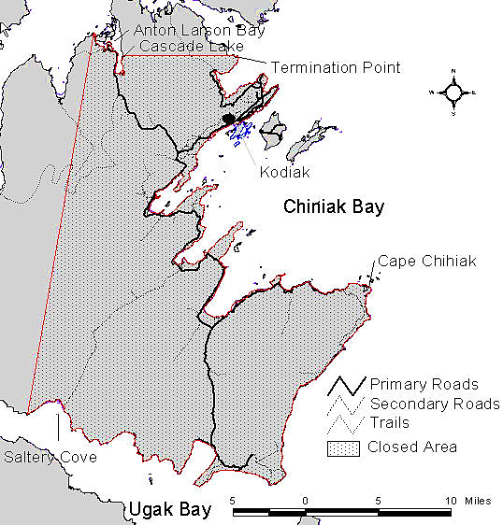
Kodiak Roaded Area

Season: Seabirds 2 Apr–30 Jun, 31 Jul–31 Aug (closed 1–30 Jul). Other birds 2 Apr–20 Jun, 22 Jul–31 Aug (closed 21 Jun–21 Jul).

Eligibility: Permanent residents of Kodiak Archipelago communities and Alaska residents in possession of a harvest invitation letter issued by a Kodiak tribe.

Harvesters are required to carry:
All bird hunters 16 years or older are required to carry a current State of Alaska hunting license and waterfowl stamp. Disabled veterans, people 60 years or older, and people that qualify for a low income hunting license are exempted from the state waterfowl stamp requirement. The state hunting license and waterfowl stamp are not required for harvest of eggs. The federal duck stamp is not required for this harvest of birds and eggs.
A Kodiak roaded area permit is required for harvest of birds and eggs on all land and water within 500 feet from the water’s edge (including exposed tidelands) east of a line extending from Crag Point in the north to the west end of Saltery Cove in the south and all lands and water south of a line extending from Termination Point along the north side of Cascade Lake extending to Anton Larsen Bay. Permits are available at the Sun'aq Tribe of Kodiak (bring proof of eligibility). A registration is not required for harvest in other Kodiak areas and offshore islands.

Species opened for harvest: In Kodiak areas outside the above-described roaded area, birds and eggs from dozens of species are opened to harvest as listed at http://www.alaskamigratorybirds.com/index.php/regulations-by-region/species-open-to-harvest. Bird species not specifically opened to harvest are closed. In the Kodiak roaded area, harvest of birds and eggs of Emperor Goose, Aleutian Tern, Arctic Tern, and Mew Gull are closed.

Required harvest monitoring: At the end of the season (early Sep), harvesters are required to report their bird and egg harvest via the harvest calendar (provided with permit) or mail survey.

Questions?
● Sun'aq Tribe of Kodiak: | (907) 486-4449. 312 W Marine Way, Kodiak
● USFWS-AMBCC Program: | 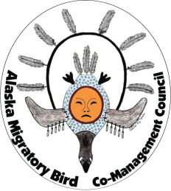  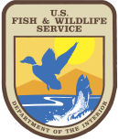  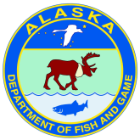  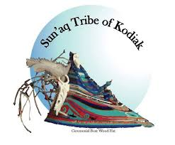  (907) 786-3887. Anchorage
● Alaska Migratory Bird Co-Management Council (AMBCC) website:
https://www.fws.gov/alaska/pages/co-management
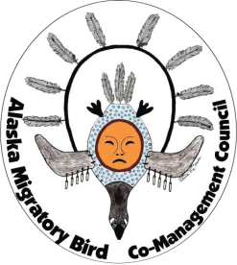
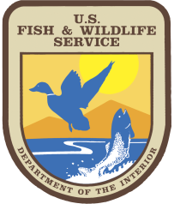

- Native Village of Eyak: phone 907-424-7738; 110 Nicholoff Way, Cordova.
- U.S. Forest Service: phone 907-424-7661; 612 2nd Street, Cordova.
- USFWS-AMBCC Program: phone 907-786-3499, Anchorage.

For more information:

