Child Aggregate Screens – Add Event - Create New Event/Edit Event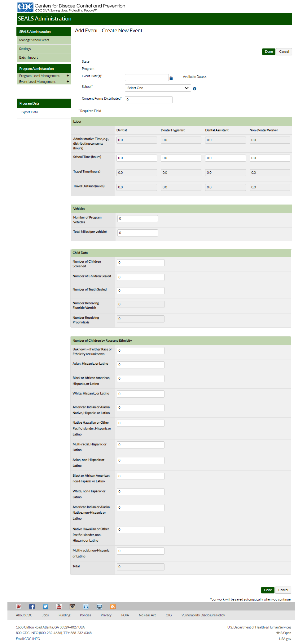
Child Detail Screens
SEALS Event Data - Create Child Record/ Edit Event for Screening and Preventive Services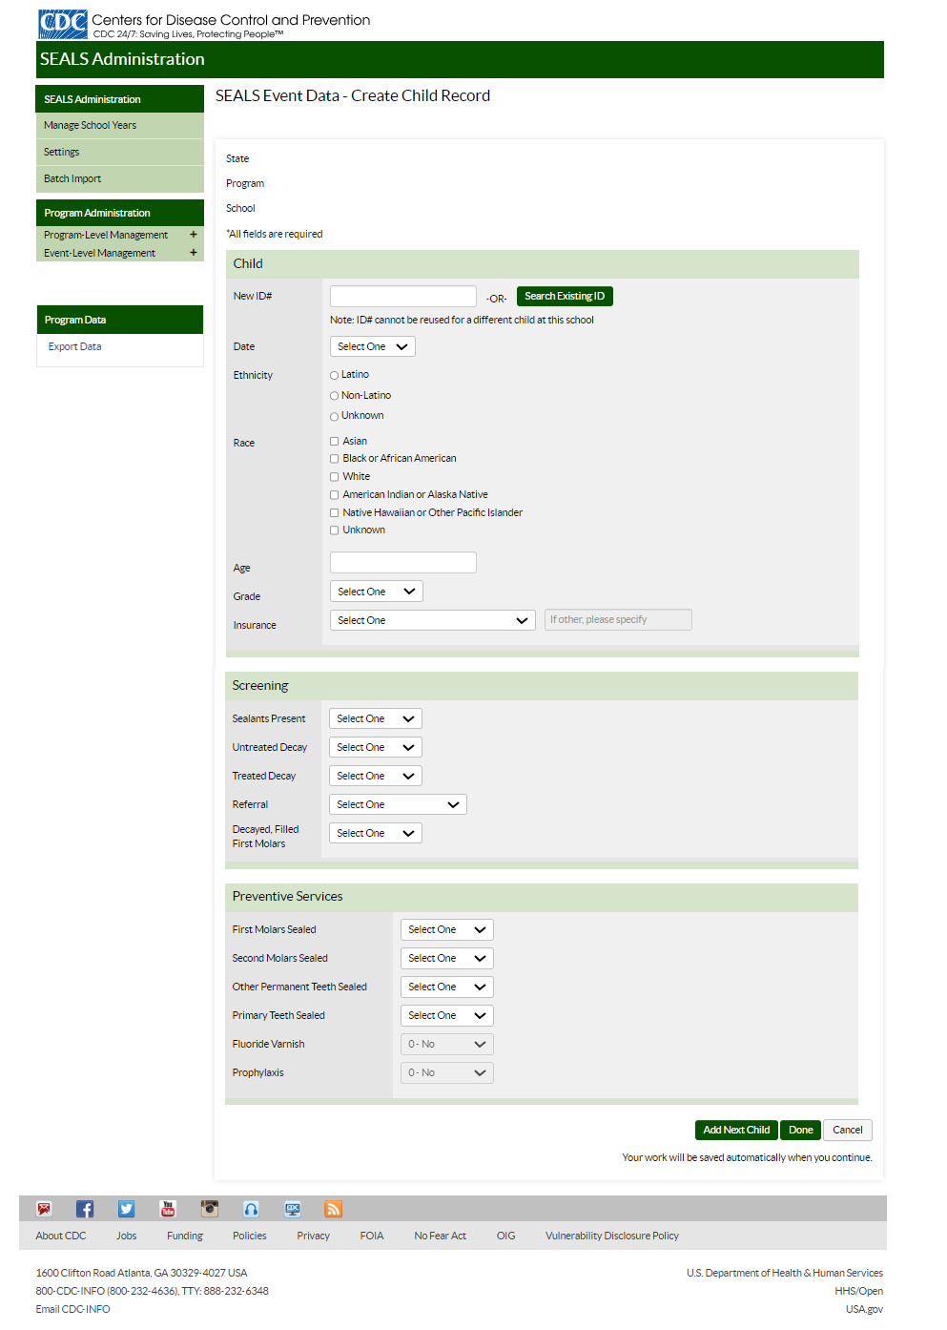
SEALS Event Data - Create Child Record Details for Screening, Preventive Services, and Retention Check
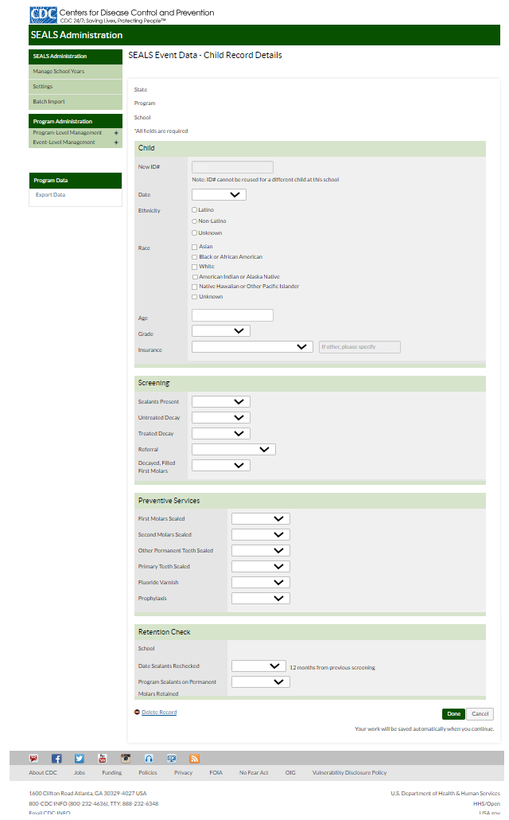

SEALS Event Data – Add Event - Create New Event/Edit Event – Event Details for the Required Assignment of the Child Detail Data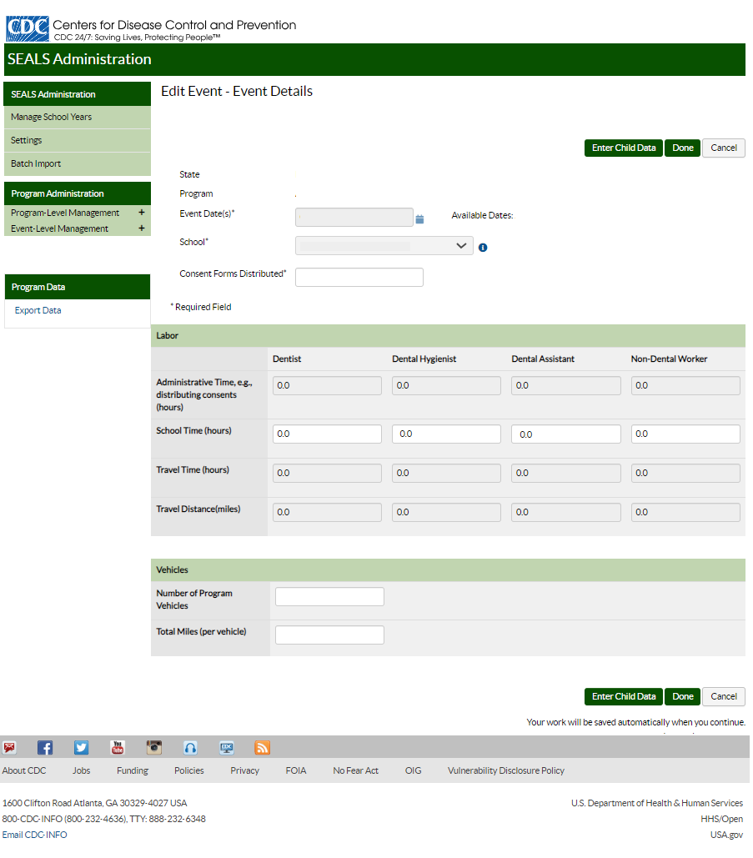
State and Program Administrator Screens
Add User - Create New User
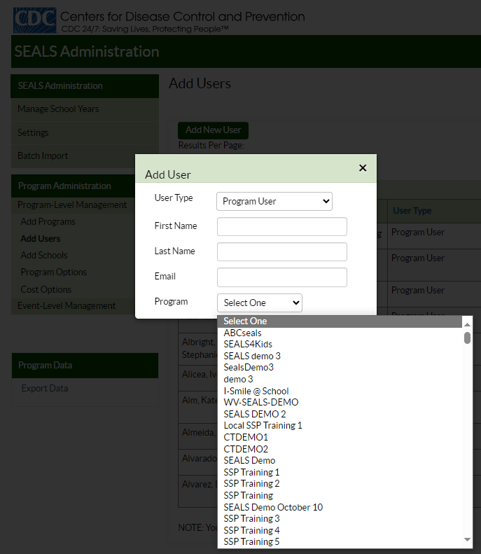

Add Program - Create New Program
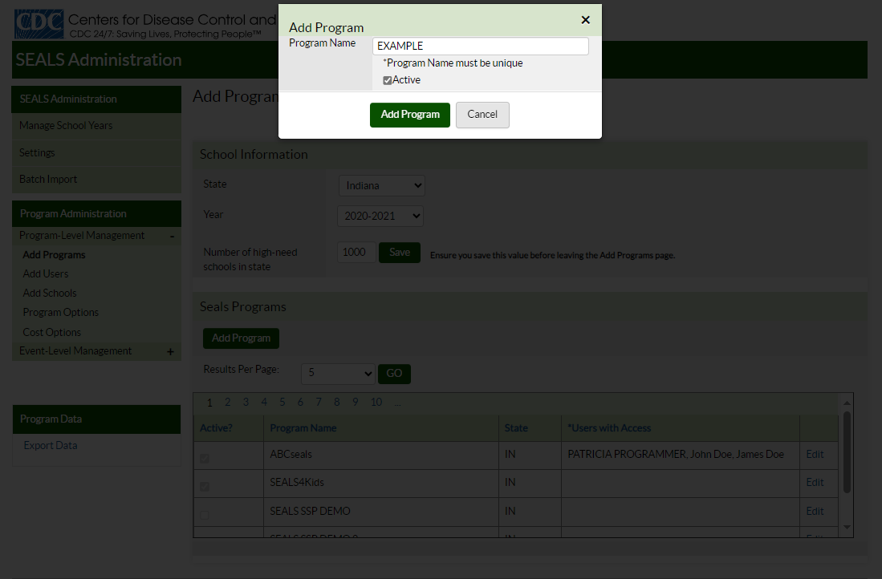

Add School - Create New School

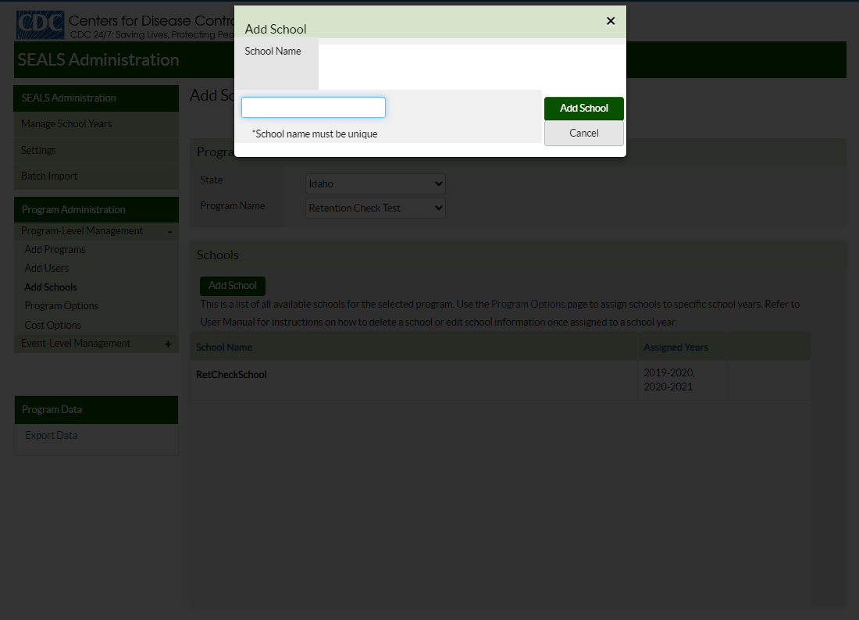

Program Options
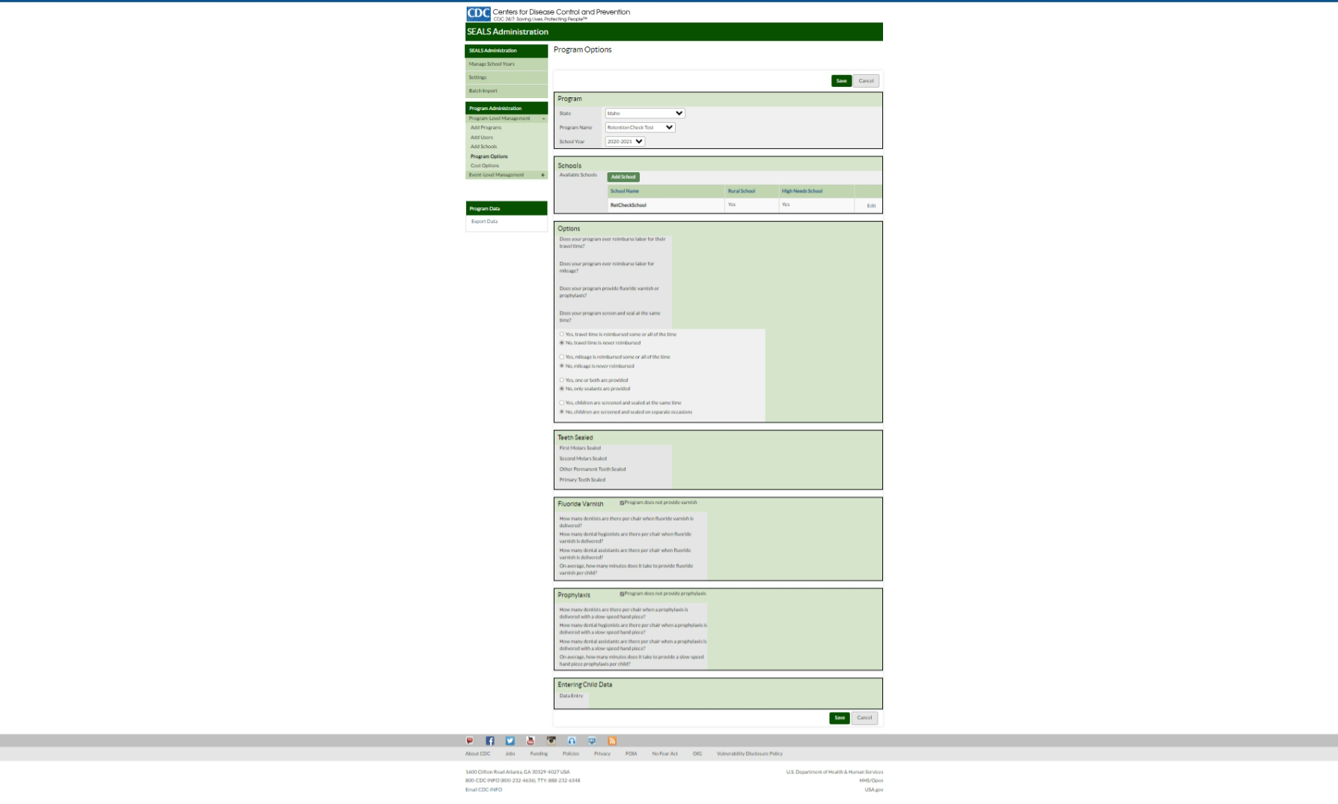

Cost Options
