ATTACHMENT: DATA COLLECTION FORM PART B
SAMPLE PHOTOS

Anterior teeth

Permanent molars
1st molar  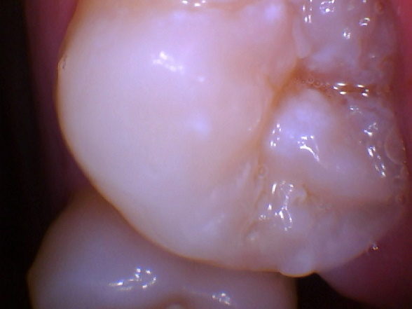 | 2nd molar  