BRAIN Meeting Communications
Email:
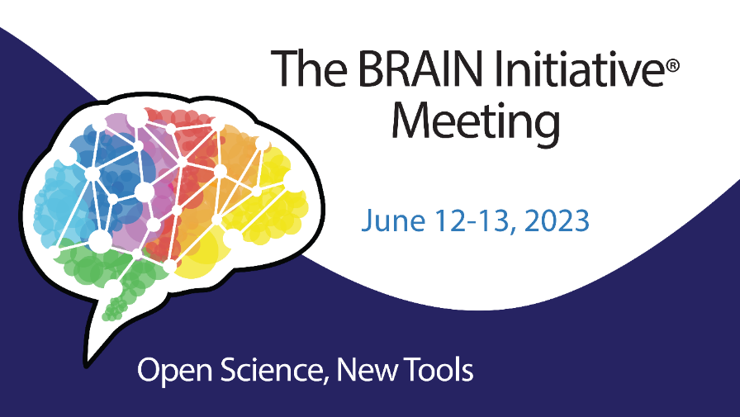
Dear BRAIN Community,

Please SAVE the DATE for The 9th Annual BRAIN Initiative Meeting: Open Science, New Tools on Monday, June 12 – Tuesday, June 13, 2023. We remain committed to expanding our BRAIN community in an inclusive manner, and everyone interested in BRAIN and neuroscience research is welcome. This forum will provide space to discuss exciting scientific developments and potential new directions and identify areas for collaboration and research coordination.

We are optimistic we will run a hybrid event with in-person sessions and networking. In the coming months, we will share more information with you, including the in-person and virtual locations and an associated hotel room block. And we will also watch pandemic developments closely as the virus continues to affect communities across the globe.

We look forward to your participation,

The 2023 Program Committee

Dear BRAIN Community,

The website for the 9th Annual BRAIN Initiative Meeting: Open Science, New Tools is now available! The BRAIN Initiative Meeting, which will be held on Monday, June 12 – Tuesday, June 13, 2023, aims to build a dynamic and collaborative research community through your attendance and symposia submissions.
Bookmark the website today, and we’ll let you know as soon as registration opens.

What will you find now?
- Background information on the meeting
- A preliminary agenda
- Abstract submission instructions and deadlines for symposia, trainee highlight awards, and general abstracts

What’s to come? Stay tuned for the registration and abstract submission system to open in the coming weeks. In the meantime, if you’re interested in submitting an abstract, we welcome you to prepare it in advance, and we’ll notify you of the submission process when it’s available.

This is a public event, so please feel free to share the news with your networks. And if you’re spreading the word through social media, use #studyBRAIN.

If you have any questions about the content or programming of the 9th Annual BRAIN Initiative Meeting, please contact BRAINInitiativeConferences@mail.nih.gov.

If you have any questions regarding the website, please contact BRAIN@infinityconferences.com.

Thank you,

The Program Committee

Blogs
Save the Date for the 9th Annual BRAIN Initiative Meeting
The BRAIN Initiative will host its 9th Annual BRAIN Initiative Meeting as a hybrid event on June 12-13, 2023 in Bethesda, MD and online.
Join us on June 12-13, 2023 for the 9th Annual BRAIN Initiative Meeting and be a part of a growing, dynamic, and collaborative BRAIN research community.
Visit the website today
!
What will you find now?
- Background information on the meeting
- A preliminary agenda
- Abstract submission instructions and deadlines
- for symposia, trainee highlight awards, and general abstracts
What’s to come? Stay tuned for the registration and abstract submission system to open in the coming weeks. In the meantime, if you’re interested in submitting an abstract, we welcome you to prepare it in advance, and we’ll notify you of the submission process when it’s available.
This is a public event, so please share the news with your networks. And if you’re spreading the news through social media, use the hashtag #studyBRAIN.
If you have any questions about the content or programming of the 9th Annual BRAIN Initiative Meeting, please contact: BRAINInitiativeConferences@mail.nih.gov
.
If you have any logistics or technical questions regarding the website, please contact: BRAIN@infinityconferences.com
.
We hope to see you in June—either virtually or in person!

Register today for the 9th Annual BRAIN Initiative Meeting
Registration is now open for the 9th Annual BRAIN Initiative Meeting which will take place June 12-13, 2023 in Bethesda, MD and online.
Registration is now open
for the 9th Annual BRAIN Initiative Meeting: Open Science, New Tools. Join us on Monday, June 12 and Tuesday, June 13 and submit your scientific proposals today!
Register and submit proposals here
!
Plenary sessions will feature talks from Nita Farahany, J.D., Ph.D., Vanessa Ruta, Ph.D., and Sameer Sheth, M.D., Ph.D. In addition, you won’t want to miss networking opportunities, attendee-generated symposia, scientific posters, exhibits, and more during this hybrid event.
During registration, attendees may submit proposals for symposium sessions, abstracts for Trainee Highlight Award consideration, and the general poster session.
Key Dates to Consider:
Tuesday, March 7: Symposia Submission Deadline Extension
Friday, March 17: Trainee Highlight Award Abstract Deadline
Monday, May 8: General Abstract Submission Deadline
This is a public event, so please share the news with your networks. And if you’re spreading the news through social media, use the hashtag #studyBRAIN.
If you have any questions about the content or programming of the 9th Annual BRAIN Initiative Meeting, please contact: BRAINInitiativeConferences@mail.nih.gov
.
If you have any logistics or technical questions regarding registration and/or the workshop, please contact: BRAIN@infinityconferences.com
.
We look forward to seeing you in person or online!

Websites
https://brainmeeting.swoogo.com/2023
https://braininitiative.nih.gov/News-Events/event/9th-annual-brain-initiative-meeting
https://www.braininitiative.org/events/pimeeting/
Social Media
Save the date for the 9th Annual BRAIN Initiative Meeting! The event will be held June 12-13, 2023. The registration site and agenda will be posted soon: https://braininitiative.nih.gov/News-Events/event/9th-annual-brain-initiative-meeting. #studyBRAIN
The BRAIN Initiative Meeting website is now live! Learn more about the meeting and agenda: https://brainmeeting.swoogo.com/2023/home. #studyBRAIN
ATTN: Symposia abstract submissions for the 9th Annual #BRAINInitiative Meeting are now being accepted. Submit by March 7th! https://brainmeeting.swoogo.com/2023/submissions#symposium #studyBRAIN

