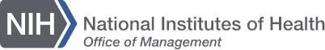
National Institutes of Health Library / Translations Office

To Our Valued Customer,

The translation you requested has been completed and is attached to this message along with its certification of accuracy.

The translations you requested have been completed and are ready for pick-up at the reception desk of the Translations Office in the NIH Library (Bldg. 10 / Room 1L21).
Please review your documents and feel free to contact me should you have any questions.

I would highly appreciate if you could complete the quality survey, which will be used for administrative purposes and will help us to serve you better in the future.

Cordially,

[Staff member’s name]

