NAPIS Log In Screen:
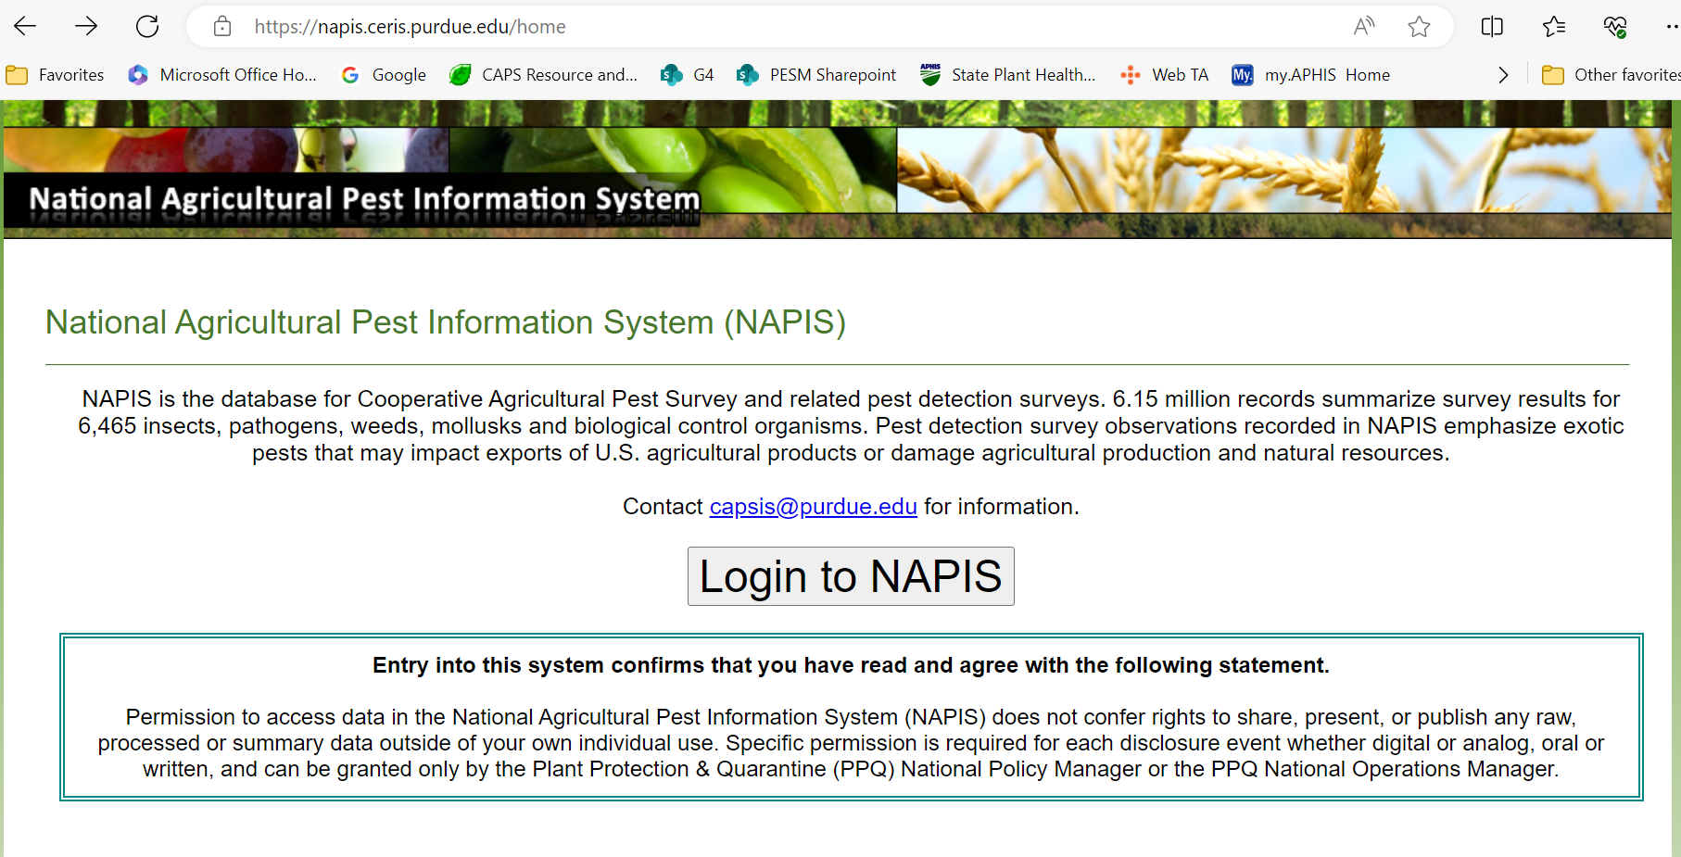

Landing Page:
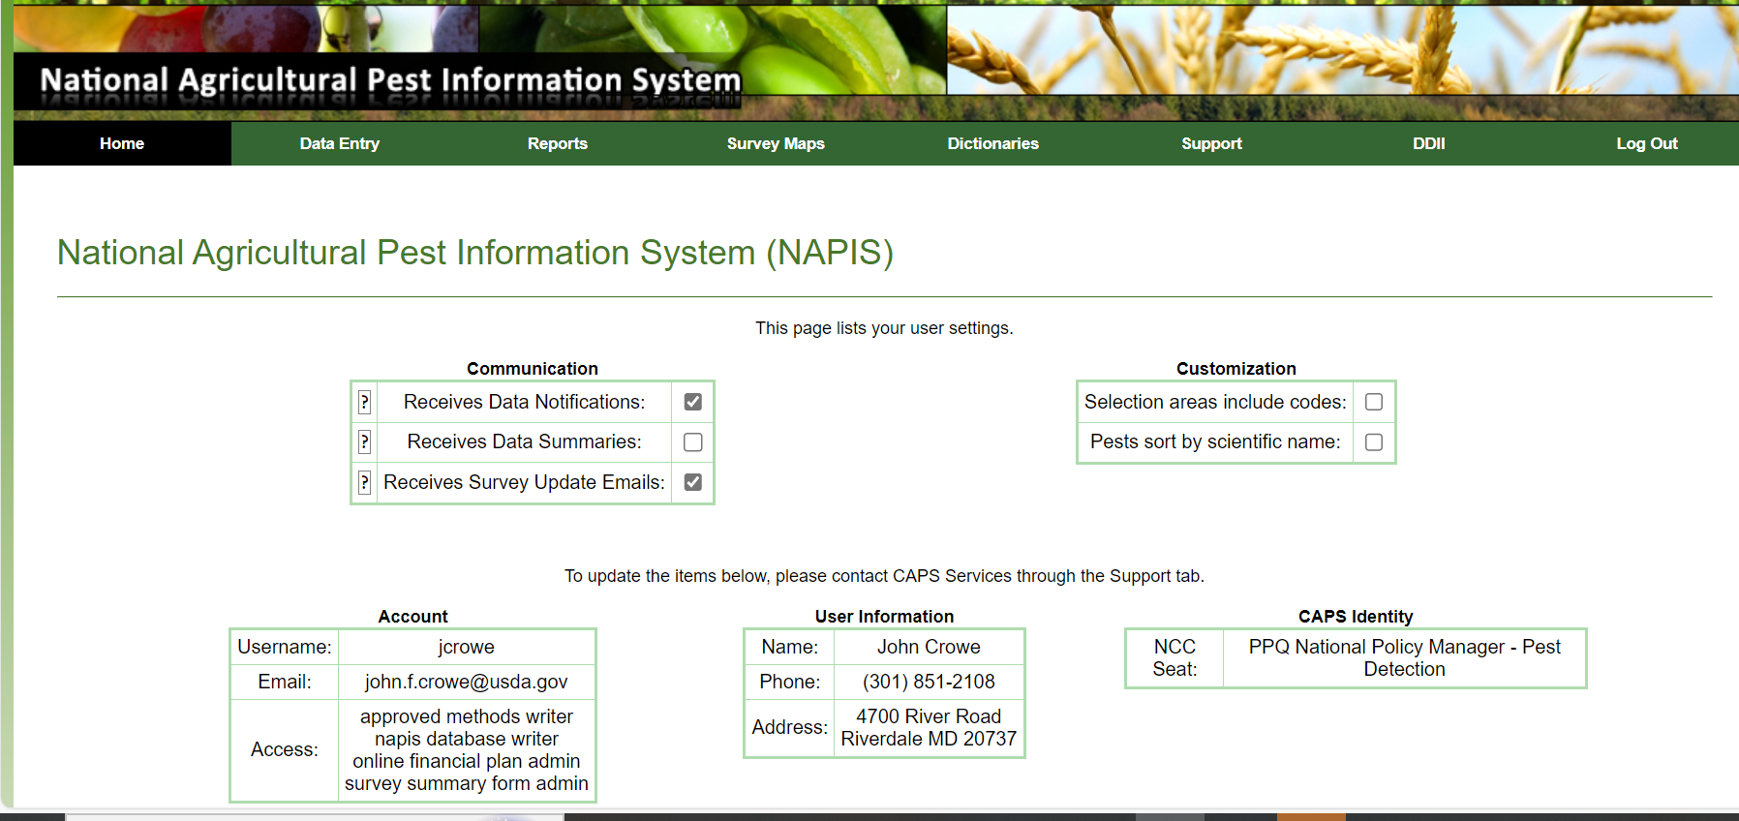

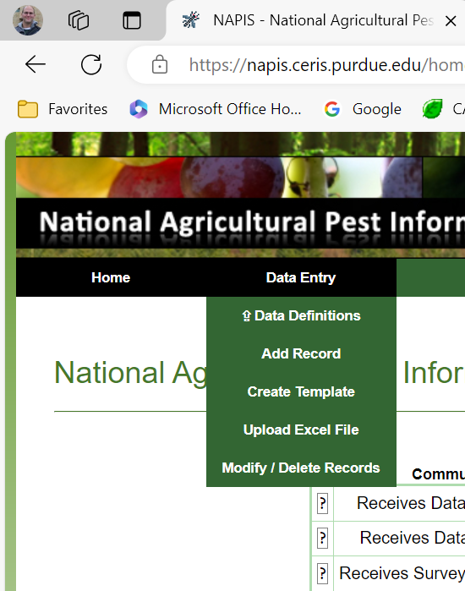

Single entry and template development record example:
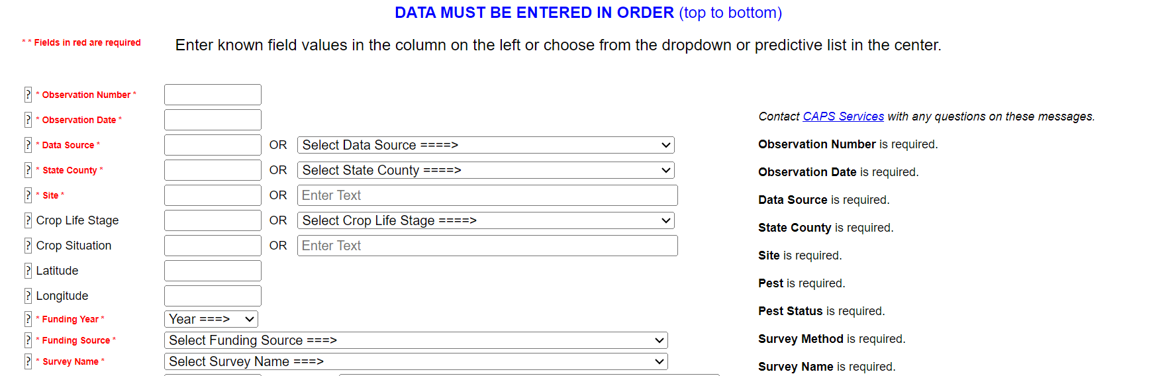
Definitions are available for user and there are standard templates for bulk upload already available. This would be for the rare instances.

Users are able to run reports with the following fields on an adhoc basis, additional reports can be requested for any field:

