APPENDIX E.1

Draft 2023 SDR Survey Mailing Materials

Contents
Contact Mailing Material Overview 4
Phase: Starting 8
Week 1: Initial Invitation 8
Week 1: Initial Invitation for Cooperative Non-Retirees 9
Week 1: Initial Invitation for Cooperative Retirees 10
Week 1: Initial Invitation for Nonresponding Retirees 11
Week 1: Initial Invitation for Non-Retiree Refusals 12
Week 1: Initial Invitation for Retiree Refusals 13
Week 1: Initial Invitation for New Cohort 14
Week 1: Infocard for New Cohort Initial Invitation 15
Week 1: Initial Invitation for Hostile Refusals 18
Week 3: First Follow Up Letter 19
Week 3: First Follow up Letter for Retirees 20
Week 3: First Follow up Letter with Incentive 21
Week 3: First Follow up Letter with Incentive for Retirees 22
Week 3: First Follow-up Letter with Incentive for New Cohort 23
Stage: Interim 24
Week 7: Reminder Letter 24
Week 7: Reminder Letter for Prior Incentive Sent 26
Week 7: Reminder Letter with Prepaid Incentive 27
Week 7: Reminder Letter with Postpaid Incentive 29
Week 9: SAQ Cover Letter 30
Week 9: SAQ Cover Letter for those previously offered a prepaid incentive 31
Week 9: SAQ Cover Letter for those previously offered a post-paid incentive 32
Week 10: Thank you postcard 33
Stage: Late-Stage 34
Week 13: Infocard Letter 34
Week 13: Letter with Incentive 35
Week 16: 2nd SAQ Cover Letter 36
Week 16: 2nd SAQ Cover Letter for those previously offered the post-paid incentive 37
Stage: Last Chance 38
Week 19: Reminder Letter with Token Incentive 38
Week 22: CIO Offer Letter 39
Stage: Final Request 40
Week 25: Final Request Letter 40
Stage: Ad Hoc 41
As Needed: SAQ Request Letter 41
As needed: Newly Located SAQ Cover Letter 42

Contact Mailing Material Overview
The 2023 Survey of Doctorate Recipients (SDR) contact mailing materials are consistent with materials utilized in past cycles. Over the 6-month field period, various mailing materials will be sent as a part of the data collection outreach protocol implemented across four phases – Starting, Interim, Late-Stage, and Last Chance. As shown in Figure E.1, most postal letters sent as a part of the 2023 SDR data collection protocol will be paired with a parallel email message.

Figure E.1 2023 SDR Main Data Collection Contacting Protocol by Data Collection Phases
Phase | Week | Contact Description | Incentive
Starting | 1 | Initial invitation (M&E)
Starting | 2
Starting | 3 | Follow-up contact (M&E) | Offered to past respondents who only complete with an incentive and new cohort sample members who did not complete SED
Starting | 4 | Telephone prompting
Starting | 5 | Telephone prompting
Starting | 6 | Telephone prompting
Interim | 7 | Reminder contact (M&E) | Offered to select continuing and new cohort sample members who have not yet responded
Interim | 8
Interim | 9 | Questionnaire mailing #1
Interim | 10 | Reminder postcard
Interim | 11
Interim | 12
Late-Stage | 13 | Infocard mailing | Offered to select sample members who have not yet responded
Late-Stage | 14 | Telephone prompting
Late-Stage | 15 | Reminder email
Late-Stage | 16 | Questionnaire mailing #2
Late-Stage | 17 | Reminder Postcard
Late-Stage | 18
Last Chance | 19 | Reminder w/token (M&E)
Last Chance | 20 | Telephone prompting
Last Chance | 21 | Telephone prompting
Last Chance | 22 | CIO offer USPS letter
Last Chance | 23 | CIO offer by email
Last Chance | 24 | CIO offer by telephone
Final Request | 25 | Final request contact (M&E)
Final Request | 26 | Final telephone prompt
CIO = Critical Item Only version of the survey.
M&E = parallel contact of email and USPS letter mailing.

Letters will be tailored based on past response history and other attributes such as whether the case is a part of the new cohort sample, is living outside the U.S., or has reported being retired in the prior survey cycle. All letters will be printed on the 2023 SDR letterhead where the back page provides the basic elements of informed consent (see the next two pages for the letterhead front and back page).

The 2023 SDR initial draft mailing materials are presented after the letterhead example.

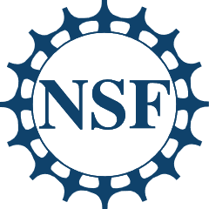
2023 Survey of Doctorate Recipients

You are uniquely qualified to contribute to this survey and cannot be replaced by anyone else.

Frequently Asked Questions

What is the Survey of Doctorate Recipients (SDR)?
Since the 1970s, the SDR has been the most important source of information on the education and training, work experience, and career development of science, engineering, and health (SEH) doctorate holders trained in the U.S. The SDR is sponsored by the National Center for Science and Engineering Statistics within the National Science Foundation and the National Institutes of Health.

How is the information used?
The SDR provides data useful for policymakers, academic organizations, and governmental agencies. This unique data supports understanding about the educational and occupational achievements and career movements of U.S.-trained doctoral scientists and engineers in the U.S. and around the world.

Who should participate?
You have been randomly selected to represent the population of doctorate holders trained in SEH fields at U.S. academic institutions for the 2023 Survey of Doctorate Recipients. The SDR is not an employer-based survey; the SDR seeks to represent doctorate-degree holders whether they are working, retired, seeking work, or in some other situation. Your survey participation and honest responses help make the SDR data series more complete, accurate, and reliable. While we hope that you will agree to fully participate in the SDR, it is a voluntary survey, and you are not required to answer any questions.

Will my information be kept confidential?
All information you provide will be kept strictly confidential and safeguarded in accordance with the Privacy Act of 1974 and the Confidential Information Protection and Statistical Efficiency Act of 2018. Per the Federal Cybersecurity Enhancement Act of 2015, your data are protected from cybersecurity risks through screening of the Federal systems that transmit your data. Your responses are used for research purposes only. Information that personally identifies you is separated from your survey responses. Published reports show only summary information.

How long will this survey take?
The average time to complete the survey is 22 minutes. Depending on your circumstances, it might be a little shorter or longer.

Who can I contact for more information?
The 2023 SDR data collection activities are contracted to NORC at the University of Chicago, an objective, nonpartisan research organization. If you have questions about taking the survey, you can reach out to SDR@norc.org or call toll-free 1-800-685-1663. If you have questions about your rights as a study participant, you may call the NORC Institutional Review Board Administrator, toll-free within the U.S., at 1-866-309-0542.

Phase: Starting

Week 1: Initial Invitation
For continuing cohort sample members who did not refuse the 2021 SDR and were not retirees.

[DATE], 2023

Dr. [FIRST NAME] [MIDDLE INITIAL] [LAST NAME]
[ORGNAME]
[STREET ADDRESS 1]
[STREET ADDRESS 2]
[CITY], [STATE] [ZIP CODE]

Dear Dr. [LAST NAME],

You are invited to complete the Survey of Doctorate Recipients (SDR) sponsored by the National Science Foundation and the National Institutes of Health. Since 1973, the SDR studies the experiences of doctorate degree holders and is the only source of data on the careers of science, engineering, and health doctorate holders from U.S. academic institutions.

To complete the SDR online, open the survey link on a computer or any mobile device and enter your unique personal identification number (PIN):

SDR survey link: | https://NSFsdr.org
PIN: | [pin]

You were randomly selected for the SDR based on your doctorate award. We cannot substitute you for anyone else. By participating in this research, you will help ensure the validity and accuracy of the survey data. SDR results provide crucial information about the educational and career outcomes of the most highly educated segment of our population.

The information you provide will be collected by NORC at the University of Chicago, the survey contractor conducting the SDR on our behalf. Your responses are confidential and will only be used for statistical purposes. If you have any questions regarding the survey, please review the information on the back of this letter or contact NORC by emailing SDR@norc.org, calling 1-800-685-1663 (toll-free in the U.S. and Canada) or 312-871-4272, or visiting https://NSFsdr.org. NORC staff are available from 9 a.m. to 9 p.m. (Central Time) to assist you.

Thank you in advance for contributing to the SDR.

Sincerely,

Emilda B. Rivers, Director
National Center for Science and Engineering Statistics
National Science Foundation

P.S. To ensure this message reaches you, we are also sending this survey invitation to the email address NORC has on record for you.

Week 1: Initial Invitation for Cooperative Non-Retirees
For continuing cohort sample members who responded in 2021 SDR and were not retirees

[DATE], 2023

Dr. [FIRST NAME] [MIDDLE INITIAL] [LAST NAME]
[ORGNAME]
[STREET ADDRESS 1]
[STREET ADDRESS 2]
[CITY], [STATE] [ZIP CODE]

Dear Dr. [LAST NAME],

You are invited to complete the Survey of Doctorate Recipients (SDR) sponsored by the National Science Foundation and the National Institutes of Health. Thank you for your past contribution to this unique study of doctorate holders. Since 1973, the SDR studies the experiences of doctorate degree holders and is the only source of data on the careers of science, engineering, and health doctorate holders from U.S. academic institutions.

To complete the SDR online, open the survey link on a computer or any mobile device and enter your unique personal identification number (PIN):

SDR survey link: | https://NSFsdr.org
PIN: | [pin]

Your continued participation in this research will help ensure the validity and accuracy of the survey data. SDR results provide crucial information about the educational and career outcomes of the most highly educated segment of our population.

The information you provide will be collected by NORC at the University of Chicago, the survey contractor conducting the SDR on our behalf. Your responses are confidential and will only be used for statistical purposes. If you have any questions regarding the survey, please review the information on the back of this letter or contact NORC by emailing SDR@norc.org, calling 1-800-685-1663 (toll-free in the U.S. and Canada) or 312-871-4272, or visiting https://NSFsdr.org. NORC staff are available from 9 a.m. to 9 p.m. (Central Time) to assist you.

Thank you for your continued contribution to the SDR.

Sincerely,

Emilda B. Rivers, Director
National Center for Science and Engineering Statistics
National Science Foundation

P.S. To ensure this message reaches you, we are also sending this survey invitation to the email address NORC has on record for you.

Week 1: Initial Invitation for Cooperative Retirees
For continuing cohort sample members who responded in 2021 SDR and were retirees

[DATE], 2023

Dr. [FIRST NAME] [MIDDLE INITIAL] [LAST NAME]
[ORGNAME]
[STREET ADDRESS 1]
[STREET ADDRESS 2]
[CITY], [STATE] [ZIP CODE]

Dear Dr. [LAST NAME],

You are invited to complete the Survey of Doctorate Recipients (SDR) sponsored by the National Science Foundation and the National Institutes of Health. Thank you for your past contribution to this unique study of doctorate holders. Since 1973, the SDR studies the experiences of doctorate degree holders and is the only source of data on the careers of science, engineering, and health doctorate holders from U.S. academic institutions.

To complete the SDR online, open the survey link on a computer or any mobile device and enter your unique personal identification number (PIN):

SDR survey link: | https://NSFsdr.org
PIN: | [pin]

As someone who reported being retired in the SDR in the past, we are particularly looking forward to your continued participation in this research effort. The 2023 SDR features new questions specifically designed to capture the distinct and important experiences of doctorates who are partially, fully, or formerly retired. Your response to these new questions will help ensure the validity and accuracy of the results.

The information you provide will be collected by NORC at the University of Chicago, the survey contractor conducting the SDR on our behalf. Your responses are confidential and will only be used for statistical purposes. If you have any questions regarding the survey, please review the information on the back of this letter or contact NORC by emailing SDR@norc.org, calling 1-800-685-1663 (toll-free in the U.S. and Canada) or 312-871-4272, or visiting https://NSFsdr.org. NORC staff are available from 9 a.m. to 9 p.m. (Central Time) to assist you.

Thank you for your continued contribution to the SDR.

Sincerely,

Emilda B. Rivers, Director
National Center for Science and Engineering Statistics
National Science Foundation

P.S. To ensure this message reaches you, we are also sending this survey invitation to the email address NORC has on record for you.

Week 1: Initial Invitation for Nonresponding Retirees
For continuing cohort sample members who were non-refusing nonrespondents in 2021 SDR who were past retirees

[DATE], 2023

Dr. [FIRST NAME] [MIDDLE INITIAL] [LAST NAME]
[ORGNAME]
[STREET ADDRESS 1]
[STREET ADDRESS 2]
[CITY], [STATE] [ZIP CODE]

Dear Dr. [LAST NAME],

You are invited to complete the Survey of Doctorate Recipients (SDR) sponsored by the National Science Foundation and the National Institutes of Health. Since 1973, the SDR studies the experiences of doctorate degree holders and is the only source of data on the careers of science, engineering, and health doctorate holders from U.S. academic institutions. You were randomly selected for the SDR based on your doctorate award. We cannot substitute you for anyone else.

To complete the SDR online, open the survey link on a computer or any mobile device and enter your unique personal identification number (PIN):

SDR survey link: | https://NSFsdr.org
PIN: | [pin]

As someone who reported being retired in the SDR in the past, we are particularly hoping you will choose to participate in this research effort. The 2023 SDR features new questions specifically designed to capture the distinct and important experiences of doctorates who are partially, fully, or formerly retired. Your response to these new questions will help ensure the validity and accuracy of the results.

The information you provide will be collected by NORC at the University of Chicago, the survey contractor conducting the SDR on our behalf. Your responses are confidential and will only be used for statistical purposes. If you have any questions regarding the survey, please review the information on the back of this letter or contact NORC by emailing SDR@norc.org, calling 1-800-685-1663 (toll-free in the U.S. and Canada) or 312-871-4272, or visiting https://NSFsdr.org. NORC staff are available from 9 a.m. to 9 p.m. (Central Time) to assist you.

Thank you in advance for contributing to the SDR.

Sincerely,

Emilda B. Rivers, Director
National Center for Science and Engineering Statistics
National Science Foundation

P.S. To ensure this message reaches you, we are also sending this survey invitation to the email address NORC has on record for you.

Week 1: Initial Invitation for Non-Retiree Refusals
For continuing sample members who were 2021 SDR refusals and not past retirees

[DATE], 2023

Dr. [FIRST NAME] [MIDDLE INITIAL] [LAST NAME]
[ORGNAME]
[STREET ADDRESS 1]
[STREET ADDRESS 2]
[CITY], [STATE] [ZIP CODE]

Dear Dr. [LAST NAME],

You are invited to complete the Survey of Doctorate Recipients (SDR) sponsored by the National Science Foundation and the National Institutes of Health. Since 1973, the SDR studies the experiences of doctorate degree holders and is the only source of data on the careers of science, engineering, and health doctorate holders from U.S. academic institutions.

To complete the SDR online, open the survey link on a computer or any mobile device and enter your unique personal identification number (PIN):

SDR survey link: | https://NSFsdr.org
PIN: | [pin]

We understand you did not want to participate in the past, but we cannot substitute you for anyone else. If you chose to participate in this research, you will help ensure the validity and accuracy of the survey data. SDR results provide crucial information about the educational and career outcomes of the most highly educated segment of our population.

The information you provide will be collected by NORC at the University of Chicago, the survey contractor conducting the SDR on our behalf. Your responses are confidential and will only be used for statistical purposes. If you have any questions regarding the survey, please review the information on the back of this letter or contact NORC by emailing SDR@norc.org, calling 1-800-685-1663 (toll-free in the U.S. and Canada) or 312-871-4272, or visiting https://NSFsdr.org. NORC staff are available from 9 a.m. to 9 p.m. (Central Time) to assist you.

Thank you in advance for your consideration.

Sincerely,

Emilda B. Rivers, Director
National Center for Science and Engineering Statistics
National Science Foundation

P.S. To ensure this message reaches you, we are also sending this survey invitation to the email address NORC has on record for you.

Week 1: Initial Invitation for Retiree Refusals
For continuing sample members who were 2021 SDR refusals and past retirees

[DATE], 2023

Dr. [FIRST NAME] [MIDDLE INITIAL] [LAST NAME]
[ORGNAME]
[STREET ADDRESS 1]
[STREET ADDRESS 2]
[CITY], [STATE] [ZIP CODE]

Dear Dr. [LAST NAME],

You are invited to complete the Survey of Doctorate Recipients (SDR) sponsored by the National Science Foundation and the National Institutes of Health. Since 1973, the SDR studies the experiences of doctorate degree holders and is the only source of data on the careers of science, engineering, and health doctorate holders from U.S. academic institutions.

To complete the SDR online, open the survey link on a computer or any mobile device and enter your unique personal identification number (PIN):

SDR survey link: | https://NSFsdr.org
PIN: | [pin]

We understand you did not want to participate in the past, but as someone who previously reported being retired in the SDR, we are particularly hoping you will now choose to complete the survey. The 2023 SDR which features new questions specifically designed to capture the distinct and important experiences of doctorates who are partially, fully, or formerly retired. Your response to these new questions would help ensure the validity and accuracy of the results.

The information you provide will be collected by NORC at the University of Chicago, the survey contractor conducting the SDR on our behalf. Your responses are confidential and will only be used for statistical purposes. If you have any questions regarding the survey, please review the information on the back of this letter or contact NORC by emailing SDR@norc.org, calling 1-800-685-1663 (toll-free in the U.S. and Canada) or 312-871-4272, or visiting https://NSFsdr.org. NORC staff are available from 9 a.m. to 9 p.m. (Central Time) to assist you.

Thank you in advance for your consideration.

Sincerely,

Emilda B. Rivers, Director
National Center for Science and Engineering Statistics
National Science Foundation

P.S. To ensure this message reaches you, we are also sending this survey invitation to the email address NORC has on record for you.

Week 1: Initial Invitation for New Cohort
For new cohort sample members; the letter mailing will include an infocard

[DATE], 2023

Dr. [FIRST NAME] [MIDDLE INITIAL] [LAST NAME]
[ORGNAME]
[STREET ADDRESS 1]
[STREET ADDRESS 2]
[CITY], [STATE] [ZIP CODE]

Dear Dr. [LAST NAME],

You are invited to complete the Survey of Doctorate Recipients (SDR) sponsored by the National Science Foundation and the National Institutes of Health. Since 1973, the SDR studies the experiences of doctorate degree holders and is the only source of data on the careers of science, engineering, and health doctorate holders from U.S. academic institutions.

To complete the SDR online, open the survey link on a computer or any mobile device and enter your unique personal identification number (PIN):

SDR survey link: | https://NSFsdr.org
PIN: | [pin]

You were randomly selected for the SDR to represent a crucial segment of the population of individuals earning a doctorate in the U.S. By participating in this research, you will help ensure the validity and accuracy of the survey data. SDR results provide crucial information about the educational and career outcomes of the most highly educated segment of our population. To thank you for your consideration, you will find a card enclosed that provides more information about the SDR with an attached bookmark.

The information you provide will be collected by NORC at the University of Chicago, the survey contractor conducting the SDR on our behalf. Your responses are confidential and will only be used for statistical purposes. If you have any questions regarding the survey, please review the information on the back of this letter or contact NORC by emailing SDR@norc.org, calling 1-800-685-1663 (toll-free in the U.S. and Canada) or 312-871-4272, or visiting https://NSFsdr.org. NORC staff are available from 9 a.m. to 9 p.m. (Central Time) to assist you.

Thank you in advance for contributing to the SDR.

Sincerely,

Emilda B. Rivers, Director
National Center for Science and Engineering Statistics
National Science Foundation

P.S. To ensure this message reaches you, we are also sending this survey invitation to the email address NORC has on record for you.

Enclosure

Week 1: Infocard for New Cohort Initial Invitation

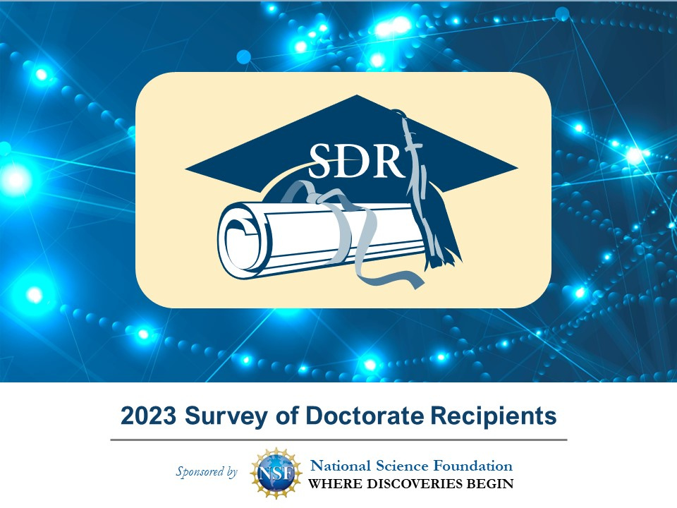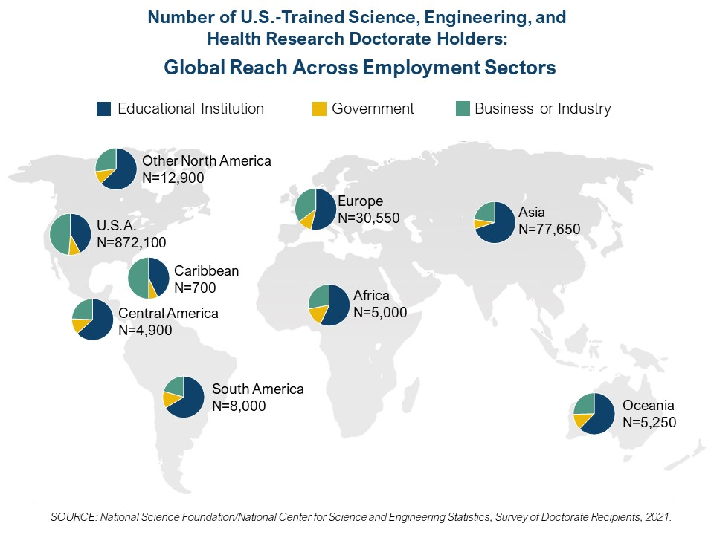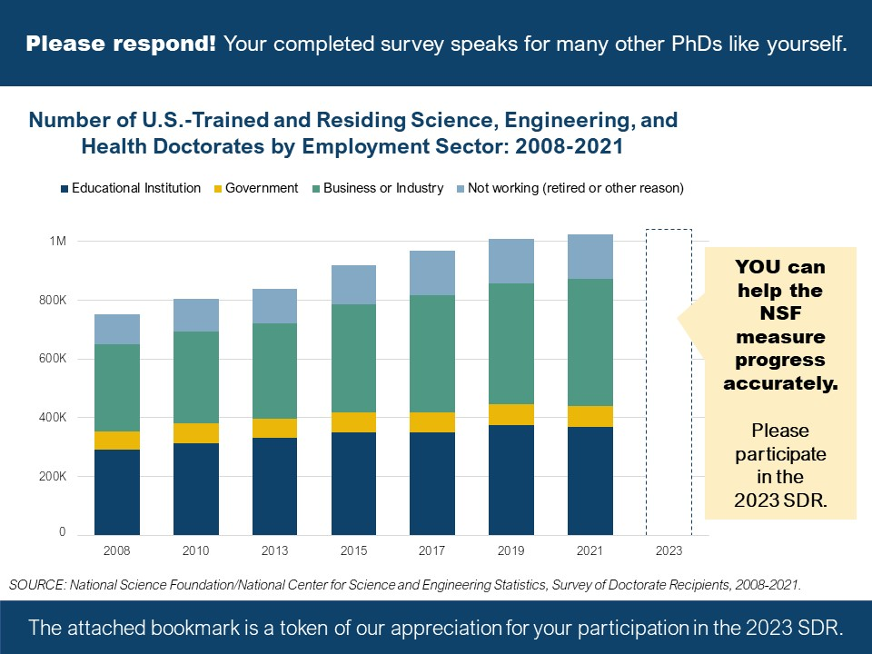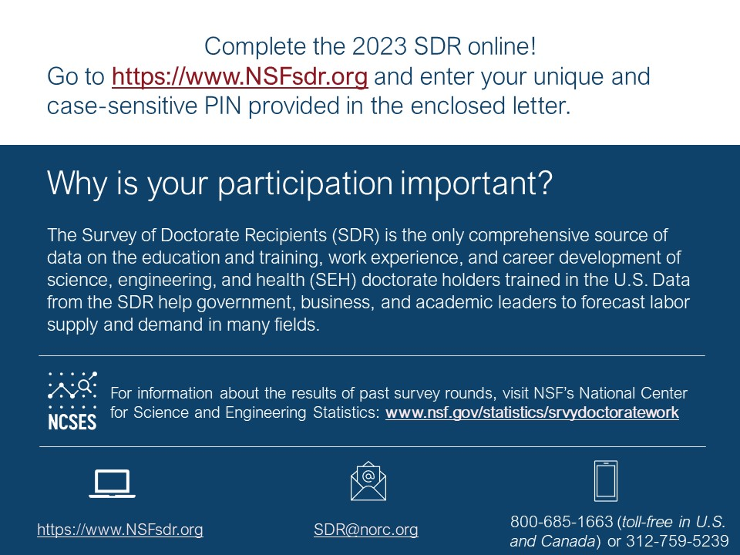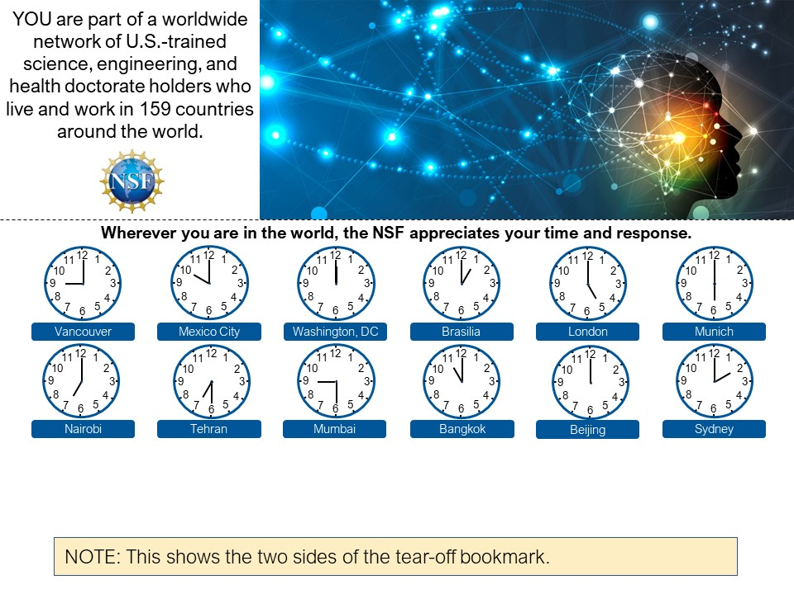

Week 1: Initial Invitation for Hostile Refusals
For continuing sample members who were hostile refusals in the 2021 SDR; this will include an SAQ and these sample members receive no further contacts

[DATE], 2023

Dr. [FIRST NAME] [MIDDLE INITIAL] [LAST NAME]
[ORGNAME]
[STREET ADDRESS 1]
[STREET ADDRESS 2]
[CITY], [STATE] [ZIP CODE]

Dear Dr. [LAST NAME],

We are writing to notify you that data collection for the 2023 Survey of Doctorate Recipients (SDR), sponsored by the National Science Foundation and the National Institutes of Health, has begun. Since 1973, the SDR studies the experiences of doctorate degree holders and is the only source of data on the careers of science, engineering, and health doctorate holders from U.S. academic institutions.

We understand that you have indicated in the past you do not want to participate in the study. However, you were randomly selected for the SDR based on your doctorate award. We cannot substitute you for anyone else. By participating in this research, you would help ensure the validity and accuracy of the survey data. SDR results provide crucial information about the educational and career outcomes of the most highly educated segment of our population.

We will not be contacting you again during this survey cycle. However, if you have changed your mind about participating, a 10-minute version of the survey is available online. To complete the SDR online, open the survey link on a computer or any mobile device and enter your unique personal identification number (PIN):

SDR survey link: | https://NSFsdr.org
PIN: | [pin]

We are also enclosing a questionnaire and return envelope in case you decide to participate in this unique study and would prefer to respond by mail. The information you provide will be collected by NORC at the University of Chicago, the survey contractor conducting the SDR on our behalf. Your responses are confidential and will only be used for statistical purposes. If you have any questions regarding the survey, please review the information on the back of this letter or contact NORC by emailing SDR@norc.org, calling 1-800-685-1663 (toll-free in the U.S. and Canada) or 312-871-4272, or visiting https://NSFsdr.org. NORC staff are available from 9 a.m. to 9 p.m. (Central Time) to assist you.

Thank you for your consideration.

Sincerely,

Emilda B. Rivers, Director
National Center for Science and Engineering Statistics
National Science Foundation
Enclosure

Week 3: First Follow Up Letter
First Follow up Letter for all non-retiree sample members (continuing and new cohort) except those who are eligible for an incentive; past refusal non-retirees will receive this letter in Week 4

[DATE], 2023

Dr. [FIRST NAME] [MIDDLE INITIAL] [LAST NAME]
[ORGNAME]
[STREET ADDRESS 1]
[STREET ADDRESS 2]
[CITY], [STATE] [ZIP CODE]

Dear Dr. [LAST NAME],

Please participate in the 2023 Survey of Doctorate Recipients (SDR), sponsored by the National Science Foundation and the National Institutes of Health. Your responses will help academic and governmental organizations with decision-making about personnel availability and funding needs for research and development. SDR data is also valuable for students who want to learn about the occupational potential of their graduate education.

To complete the SDR online, open the secure survey link on a computer or any mobile device and enter your unique personal identification number (PIN):

SDR survey link: | https://NSFsdr.org
PIN: | [pin]

Your participation makes the SDR information and statistics more complete and valid. Your response, regardless of your employment situation or residential location, is vital to the creation of an accurate picture of the doctorate population. The SDR seeks to measure the number of scientists and engineers who are working in or out of their field of study, seeking employment, or are retired. Because you were scientifically selected for the SDR, we cannot substitute any other person for you.

Your responses are confidential and will only be used for statistical purposes. If you have any questions regarding the survey, please contact the survey contractor, NORC at the University of Chicago, at SDR@norc.org or toll-free at 1-800-685-1663, where staff members are available from 9 a.m. to 9 p.m. (Central Time) to assist you; there is more information about the survey on the back of this letter. To ensure we reach you, we are also sending survey access information to the email address we have on record for you.

Thank you for your cooperation in this important effort.

Sincerely,

Emilda B. Rivers, Director
National Center for Science and Engineering Statistics
National Science Foundation

Week 3: First Follow up Letter for Retirees
For past retiree continuing cohort sample members except those who are eligible for an incentive; past refusal retirees will receive this letter in Week 4

[DATE], 2023

Dr. [FIRST NAME] [MIDDLE INITIAL] [LAST NAME]
[ORGNAME]
[STREET ADDRESS 1]
[STREET ADDRESS 2]
[CITY], [STATE] [ZIP CODE]

Dear Dr. [LAST NAME],

Please participate in the 2023 Survey of Doctorate Recipients (SDR), sponsored by the National Science Foundation and the National Institutes of Health. Your responses will help academic and governmental organizations with decision-making about personnel availability and funding needs for research and development. The SDR data is also valuable for students who want to learn about the occupational potential of their graduate education.

To complete the SDR online, open the secure survey link on a computer or any mobile device and enter your unique personal identification number (PIN):

SDR survey link: | https://NSFsdr.org
PIN: | [pin]

Your participation helps ensure that the SDR information and statistics are valid and complete. The 2023 SDR features new questions specifically designed to capture the distinct and important experiences of doctorates who are partially, fully, or formerly retired. Whether you are still retired or have returned to the workforce, your response to these new questions will help ensure the validity and accuracy of the results. Because you were scientifically selected for the SDR, we cannot substitute any other person for you.

Your responses are confidential and will only be used for statistical purposes. If you have any questions regarding the survey, please contact the survey contractor, NORC at the University of Chicago, at SDR@norc.org or toll-free at 1-800-685-1663, where staff members are available from 9 a.m. to 9 p.m. (Central Time) to assist you; there is more information about the survey on the back of this letter. To ensure we reach you, we are also sending survey access information to the email address we have on record for you.

Thank you for your cooperation in this important effort.

Sincerely,

Emilda B. Rivers, Director
National Center for Science and Engineering Statistics
National Science Foundation

Week 3: First Follow up Letter with Incentive
Offers a $30 prepaid incentive for continuing cohort sample members who are not retirees who only complete after receiving an incentive

[DATE], 2023

Dr. [FIRST NAME] [MIDDLE INITIAL] [LAST NAME]
[ORGNAME]
[STREET ADDRESS 1]
[STREET ADDRESS 2]
[CITY], [STATE] [ZIP CODE]

Dear Dr. [LAST NAME],

Please participate in the 2023 Survey of Doctorate Recipients (SDR), sponsored by the National Science Foundation and the National Institutes of Health. Your responses will help academic and governmental organizations with decision-making about personnel availability and funding needs for research and development. SDR data is also valuable for students who want to learn about the occupational potential of their graduate education.

Enclosed please find a $30 check offered in appreciation of your past participation and to thank you in advance for your participation in the 2023 SDR. Your participation makes the SDR information and statistics more complete and valid. Your response, regardless of your employment situation or residential location, is vital to the creation of an accurate picture of the doctorate population. The SDR seeks to measure the number of scientists and engineers who are working in or out of their field of study, seeking employment, or are retired.

To complete the SDR online, open the secure survey link on a computer or any mobile device and enter your unique personal identification number (PIN):

SDR survey link: | https://NSFsdr.org
PIN: | [pin]

Your responses are confidential and will only be used for statistical purposes. If you have any questions regarding the survey, please contact the survey contractor, NORC at the University of Chicago, at SDR@norc.org or toll-free at 1-800-685-1663, where staff members are available from 9 a.m. to 9 p.m. (Central Time) to assist you; there is more information about the survey on the back of this letter. To ensure we reach you, we are also sending survey access information to the email address we have on record for you.

Thank you for your cooperation in this important effort.

Sincerely,

Emilda B. Rivers, Director
National Center for Science and Engineering Statistics
National Science Foundation

Enclosure

Week 3: First Follow up Letter with Incentive for Retirees
Offers a $30 prepaid incentive for retiree continuing cohort sample members who only complete after receiving an incentive

[DATE], 2023

Dr. [FIRST NAME] [MIDDLE INITIAL] [LAST NAME]
[ORGNAME]
[STREET ADDRESS 1]
[STREET ADDRESS 2]
[CITY], [STATE] [ZIP CODE]

Dear Dr. [LAST NAME],

Please participate in the 2023 Survey of Doctorate Recipients (SDR), sponsored by the National Science Foundation and the National Institutes of Health. Your responses will help academic and governmental organizations with decision-making about personnel availability and funding needs for research and development. SDR data is also valuable for students who want to learn about the occupational potential of their graduate education.

Enclosed please find a $30 check offered in appreciation of your past participation and to thank you in advance for your participation in the 2023 SDR. The 2023 survey features new questions specifically designed to capture the distinct and important experiences of doctorates who are partially, fully, or formerly retired. Whether you are still retired or have returned to the workforce, your response to these new questions will help ensure the validity and accuracy of the results.

To complete the SDR online, open the secure survey link on a computer or any mobile device and enter your unique personal identification number (PIN):

SDR survey link: | https://NSFsdr.org
PIN: | [pin]

Your responses are confidential and will only be used for statistical purposes. If you have any questions regarding the survey, please contact the survey contractor, NORC at the University of Chicago, at SDR@norc.org or toll-free at 1-800-685-1663, where staff members are available from 9 a.m. to 9 p.m. (Central Time) to assist you; there is more information about the survey on the back of this letter. To ensure we reach you, we are also sending survey access information to the email address we have on record for you.

Thank you for your cooperation in this important effort.

Sincerely,

Emilda B. Rivers, Director
National Center for Science and Engineering Statistics
National Science Foundation

Enclosure

Week 3: First Follow-up Letter with Incentive for New Cohort
Offers a $30 prepaid incentive for reluctant new cohort sample members

[DATE], 2023

Dr. [FIRST NAME] [MIDDLE INITIAL] [LAST NAME]
[ORGNAME]
[STREET ADDRESS 1]
[STREET ADDRESS 2]
[CITY], [STATE] [ZIP CODE]

Dear Dr. [LAST NAME],

Please participate in the 2023 Survey of Doctorate Recipients (SDR), sponsored by the National Science Foundation and the National Institutes of Health. Your responses will help academic and governmental organizations with decision-making about personnel availability and funding needs for research and development. SDR data is also valuable for students who want to learn about the occupational potential of their graduate education.

Enclosed please find a $30 check offered in appreciation of your consideration and to thank you in advance for your participation in the 2023 SDR. Your participation makes the SDR information and statistics more complete and valid. Your response, regardless of your employment situation or residential location, is vital to the creation of an accurate picture of the doctorate population. The SDR seeks to measure the number of scientists and engineers who are working in or out of their field of study, seeking employment, or are retired. Because you were scientifically selected for the SDR, we cannot substitute any other person for you.

To complete the SDR online, open the secure survey link on a computer or any mobile device and enter your unique personal identification number (PIN):

SDR survey link: | https://NSFsdr.org
PIN: | [pin]

Your responses are confidential and will only be used for statistical purposes. If you have any questions regarding the survey, please contact the survey contractor, NORC at the University of Chicago, at SDR@norc.org or toll-free at 1-800-685-1663, where staff members are available from 9 a.m. to 9 p.m. (Central Time) to assist you; there is more information about the survey on the back of this letter. To ensure we reach you, we are also sending survey access information to the email address we have on record for you.

Thank you for your cooperation in this important effort.

Sincerely,

Emilda B. Rivers, Director
National Center for Science and Engineering Statistics
National Science Foundation

Enclosure

Stage: Interim

Week 7: Reminder Letter
For nonresponding sample members who were not past refusals, not receiving an accelerated SAQ, not already incentivized, and are not eligible for an incentive in week 7.

[DATE], 2023

Dr. [FIRST NAME] [MIDDLE INITIAL] [LAST NAME]
[ORGNAME]
[STREET ADDRESS 1]
[STREET ADDRESS 2]
[CITY], [STATE] [ZIP CODE]

Dear Dr. [LAST NAME],

Please participate in the 2023 Survey of Doctorate Recipients (SDR) to help us accurately report on the career outcomes of U.S.-trained doctorate recipients. To complete the SDR online, open the survey link on a computer or any mobile device and enter your unique personal identification number (PIN):

SDR survey link: | https://NSFsdr.org
PIN: | [pin]

You have been randomly selected to represent an important network of U.S.-trained science and engineering doctorate holders. Through the SDR, the National Science Foundation (NSF) endeavors to understand the wide variety of career pathways taken by this network of the most highly trained individuals in the U.S., whether it is working in the same field of doctoral study, obtaining additional training in another field, deciding to retire or leave the workforce, or training the next generation of scientists and engineers. By reporting your unique career outcomes in the 2023 SDR, you make the NSF’s reporting more inclusive and accurate.
Results from the 2021 SDR show there are over a million U.S.-trained doctorates working full- or part-time around the world (872,100 working in the U.S. and 145,250 working outside the U.S.).
Of those in the U.S., 72% worked in science or engineering occupations. Trend data from 2008 to 2021 SDR show an increase of U.S.-residing, U.S.-trained doctorates working in industry from 46% to 49% and a comparable decrease in employment in educational institutions from 45% to 42%.
To learn more visit: https://www.nsf.gov/statistics/srvydoctoratework/
Your responses are confidential and will only be used for statistical purposes. If you have any questions regarding the survey, please review the back of this letter or contact the survey contractor, NORC at the University of Chicago, at SDR@norc.org or toll-free at 1-800-685-1663, where staff members are available from 9 a.m. to 9 p.m. (Central Time) to assist you.

Your cooperation in this important effort is greatly appreciated.

Thank you for your consideration,

Emilda B. Rivers, Director
National Center for Science and Engineering Statistics
National Science Foundation

P.S. We are also sending survey access information to the email address we have on record for you. If you have already completed the 2023 SDR – thank you so much for your time.

Week 7: Reminder Letter for Prior Incentive Sent
For nonresponding sample members who were sent a prepaid incentive in week 3.

[DATE], 2023

Dr. [FIRST NAME] [MIDDLE INITIAL] [LAST NAME]
[ORGNAME]
[STREET ADDRESS 1]
[STREET ADDRESS 2]
[CITY], [STATE] [ZIP CODE]

Dear Dr. [LAST NAME],

I hope you received the $30 token of our appreciation recently mailed to you for the 2023 Survey of Doctorate Recipients (SDR). We are requesting your participation in this important study,
to help us accurately report on the career outcomes of U.S.-trained doctorate recipients.

To complete the SDR online, open the survey link on a computer or any mobile device and enter your unique personal identification number (PIN):

SDR survey link: | https://NSFsdr.org
PIN: | [pin]

You have been randomly selected to represent an important network of U.S.-trained science and engineering doctorate holders. Through the SDR, the National Science Foundation (NSF) endeavors to understand the wide variety of career pathways taken by this network of the most highly trained individuals in the U.S., whether it is working in the same field of doctoral study, obtaining additional training in another field, deciding to retire or leave the workforce, or training the next generation of scientists and engineers. By reporting your unique career outcomes in the 2023 SDR, you make the NSF’s reporting more inclusive and accurate.

Your responses are confidential and will only be used for statistical purposes. If you have any questions regarding the survey, please review the back of this letter or contact the survey contractor, NORC at the University of Chicago, at SDR@norc.org or toll-free at 1-800-685-1663, where staff members are available from 9 a.m. to 9 p.m. (Central Time) to assist you.

Your cooperation in this important effort is greatly appreciated.

Thank you for your consideration,

Emilda B. Rivers, Director
National Center for Science and Engineering Statistics
National Science Foundation

P.S. We are also sending survey access information to the email address we have on record for you. If you have already completed the 2023 SDR – thank you so much for your time.

Week 7: Reminder Letter with Prepaid Incentive
For nonresponding sample members who were not refusals, not receiving an accelerated SAQ, and are selected for an early incentive via prepaid check, including both new cohort and continuing cohort members.

[DATE], 2023

Dr. [FIRST NAME] [MIDDLE INITIAL] [LAST NAME]
[ORGNAME]
[STREET ADDRESS 1]
[STREET ADDRESS 2]
[CITY], [STATE] [ZIP CODE]

Dear Dr. [LAST NAME],

Please find a $30 token of our appreciation enclosed to thank you in advance for participating in the 2023 Survey of Doctorate Recipients (SDR). Your participation helps us to accurately report on the career outcomes of U.S.-trained doctorate recipients.

To complete the SDR online, open the survey link on a computer or any mobile device and enter your unique personal identification number (PIN):

SDR survey link: | https://NSFsdr.org
PIN: | [pin]

You have been randomly selected to represent an important network of U.S.-trained science and engineering doctorate holders. Through the SDR, the National Science Foundation (NSF) endeavors to understand the wide variety of career pathways taken by this network of the most highly trained individuals in the U.S., whether it is working in the same field of doctoral study, obtaining additional training in another field, deciding to retire or leave the workforce, or training the next generation of scientists and engineers. By reporting your unique career outcomes in the 2023 SDR, you make the NSF’s reporting more inclusive and accurate.

Your responses are confidential and will only be used for statistical purposes. If you have any questions regarding the survey, please review the back of this letter or contact the survey contractor, NORC at the University of Chicago, at SDR@norc.org or toll-free at 1-800-685-1663, where staff members are available from 9 a.m. to 9 p.m. (Central Time) to assist you.

Your cooperation in this important effort is greatly appreciated.

Thank you for your consideration,

Emilda B. Rivers, Director
National Center for Science and Engineering Statistics
National Science Foundation

Enclosure

P.S. We are also sending survey access information to the email address we have on record for you. If you have already completed the 2023 SDR – thank you so much for your time.

Week 7: Reminder Letter with Postpaid Incentive
For nonresponding sample members who were not refusals, not receiving an accelerated SAQ, and are selected for an early incentive via post-paid gift code, including both new cohort and continuing cohort members.

[DATE], 2023

Dr. [FIRST NAME] [MIDDLE INITIAL] [LAST NAME]
[ORGNAME]
[STREET ADDRESS 1]
[STREET ADDRESS 2]
[CITY], [STATE] [ZIP CODE]

Dear Dr. [LAST NAME],

Please participate in the 2023 Survey of Doctorate Recipients (SDR). To thank you for your time, you will receive a $30 VISA gift code immediately after completing the survey. Your participation helps us to accurately report on the career outcomes of U.S.-trained doctorate recipients.

To complete the SDR online, open the survey link on a computer or any mobile device and enter your unique personal identification number (PIN):

SDR survey link: | https://NSFsdr.org
PIN: | [pin]

You have been randomly selected to represent an important network of U.S.-trained science and engineering doctorate holders. Through the SDR, the National Science Foundation (NSF) endeavors to understand the wide variety of career pathways taken by this network of the most highly trained individuals in the U.S., whether it is working in the same field of doctoral study, obtaining additional training in another field, deciding to retire or leave the workforce, or training the next generation of scientists and engineers. By reporting your unique career outcomes in the 2023 SDR, you make the NSF’s reporting more inclusive and accurate.

Your responses are confidential and will only be used for statistical purposes. If you have any questions regarding the survey, please review the back of this letter or contact the survey contractor, NORC at the University of Chicago, at SDR@norc.org or toll-free at 1-800-685-1663, where staff members are available from 9 a.m. to 9 p.m. (Central Time) to assist you.

Your cooperation in this important effort is greatly appreciated.

Thank you for your consideration,

Emilda B. Rivers, Director
National Center for Science and Engineering Statistics
National Science Foundation

P.S. We are also sending survey access information to the email address we have on record for you. If you have already completed the 2023 SDR – thank you so much for your time.

Week 9: SAQ Cover Letter
For all nonresponding sample members except those who were sent an incentive in week 7; note that sample members in the accelerated paper protocol will receive this letter with SAQ in week 6.

[DATE], 2023

Dr. [FIRST NAME] [MIDDLE INITIAL] [LAST NAME]
[ORGNAME]
[STREET ADDRESS 1]
[STREET ADDRESS 2]
[CITY], [STATE] [ZIP CODE]

Dear Dr. [LAST NAME],

We are requesting your participation in the 2023 Survey of Doctorate Recipients, sponsored by the National Science Foundation and the National Institutes of Health. We hope you have received our prior requests to participate. Whether you are working in or out of your field of doctorate study, seeking employment, retired, or in some other situation, your response is vital and contributes to a more accurate understanding of U.S.-trained research doctorates.

For your convenience, we are offering three different ways to participate.

1. Paper: Please fill out the enclosed questionnaire and return it using the postage-paid envelope.
2. Phone: If you prefer a telephone interview, please call 1-800-685-1663. You can also schedule an appointment for a phone interview by going to [insert FlexBooker link].
3. Online: If you prefer to complete this survey online, open the survey link on a computer or any mobile device and enter your unique personal identification number (PIN):

SDR survey link: | https://NSFsdr.org
PIN: | [pin]

Your responses are confidential and will only be used for statistical purposes. If you have any questions regarding the survey, please see the back of this letter or contact the survey contractor, NORC at the University of Chicago, at SDR@norc.org or toll-free at 1-800-685-1663, where staff members are available from 9 a.m. to 9 p.m. (Central Time) to assist you. We are also sending survey access information to the email address we have on record for you.

Thank you for your help with this important effort. We look forward to your response.

Sincerely,

Emilda B. Rivers, Director
National Center for Science and Engineering Statistics
National Science Foundation

Enclosure

Week 9: SAQ Cover Letter for those previously offered a prepaid incentive
For all nonresponding sample members sent a prepaid incentive in week 7.

[DATE], 2023

Dr. [FIRST NAME] [MIDDLE INITIAL] [LAST NAME]
[ORGNAME]
[STREET ADDRESS 1]
[STREET ADDRESS 2]
[CITY], [STATE] [ZIP CODE]

Dear Dr. [LAST NAME],

I hope you received the $30 token of our appreciation recently mailed to you for the 2023 Survey of Doctorate Recipients (SDR). Please participate in the 2023 SDR, sponsored by the National Science Foundation and the National Institutes of Health. Whether you are working in or out of your field of doctorate study, seeking employment, retired, or in some other situation, your response is vital and contributes to a more accurate understanding of U.S.-trained research doctorates.

For your convenience, we are offering three different ways to participate.

1. Paper: Please fill out the enclosed questionnaire and return it using the postage-paid envelope.
2. Phone: If you prefer a telephone interview, please call 1-800-685-1663. You can also schedule an appointment for a phone interview by going to [insert FlexBooker link].
3. Online: If you prefer to complete this survey online, open the survey link on a computer or any mobile device and enter your unique personal identification number (PIN):

SDR survey link: | https://NSFsdr.org
PIN: | [pin]

Your responses are confidential and will only be used for statistical purposes. If you have any questions regarding the survey, please see the back of this letter or contact the survey contractor, NORC at the University of Chicago, at SDR@norc.org or toll-free at 1-800-685-1663, where staff members are available from 9 a.m. to 9 p.m. (Central Time) to assist you. We are also sending survey access information to the email address we have on record for you.

Thank you for your help with this important effort. We look forward to your response.

Sincerely,

Emilda B. Rivers, Director
National Center for Science and Engineering Statistics
National Science Foundation

Enclosure

Week 9: SAQ Cover Letter for those previously offered a post-paid incentive
For all nonresponding sample members sent a post-paid incentive in week 7.

[DATE], 2023

Dr. [FIRST NAME] [MIDDLE INITIAL] [LAST NAME]
[ORGNAME]
[STREET ADDRESS 1]
[STREET ADDRESS 2]
[CITY], [STATE] [ZIP CODE]

Dear Dr. [LAST NAME],

We are requesting your participation in the 2023 Survey of Doctorate Recipients, sponsored by the National Science Foundation and the National Institutes of Health. We hope you have received our prior requests to participate. Whether you are working in or out of your field of doctorate study, seeking employment, retired, or in some other situation, your response is vital and contributes to a more accurate understanding of U.S.-trained research doctorates.

Whichever way you choose to participate, you will receive a $30 VISA gift code after completing the survey to thank you for your time.

1. Paper: Please fill out the enclosed questionnaire and return it using the postage-paid envelope; we’ll send your gift code once your survey arrives.
2. Phone: If you prefer a telephone interview, please call 1-800-685-1663. You can also schedule an appointment for a phone interview by going to [insert FlexBooker link]. The interviewer will give you your gift code at the close of the survey.
3. Online: To complete this survey online and get your gift code immediately, open the survey link on a computer or any mobile device and enter your unique personal identification number (PIN):
SDR survey link: | https://NSFsdr.org
PIN: | [pin]

Your responses are confidential and will only be used for statistical purposes. If you have any questions regarding the survey, please see the back of this letter or contact the survey contractor, NORC at the University of Chicago, at SDR@norc.org or toll-free at 1-800-685-1663, where staff members are available from 9 a.m. to 9 p.m. (Central Time) to assist you. We are also sending survey access information to the email address we have on record for you.

Thank you for your help with this important effort. We look forward to your response.

Sincerely,

Emilda B. Rivers, Director
National Center for Science and Engineering Statistics
National Science Foundation
Enclosure

Week 10: Thank you postcard
For all sample members sent an SAQ mailing in week 9; note that sample members in the accelerated paper protocol will receive this postcard in week 7.

Last week you should have received a survey in the mail from NORC at the University of Chicago, who has been contracted to conduct a survey sponsored by the National Science Foundation and the National Institutes of Health.
Many thanks if you have already completed the survey, we look forward to receiving it shortly. If you have not completed the survey, we hope you will complete it as soon as you can. If you did not receive the materials, or if you would like to complete the survey online or over the telephone, please contact NORC via email at NSFstudy@norc.uchicago.edu or toll-free at 1-800-685-1663 between 9 a.m. and 9 p.m. (U.S. Central Time). Your participation is important for the success of this study.
With appreciation,
Emilda B. Rivers, Director
National Center for Science and Engineering Statistics
National Science Foundation

Stage: Late-Stage

Week 13: Infocard Letter
Week 13. For all sample members not eligible for a late incentive.

[DATE], 2023

Dr. [FIRST NAME] [MIDDLE INITIAL] [LAST NAME]
[ORGNAME]
[STREET ADDRESS 1]
[STREET ADDRESS 2]
[CITY], [STATE] [ZIP CODE]

Dear Dr. [LAST NAME],

We have been trying to reach you to participate in the 2023 Survey of Doctorate Recipients but have not yet received your survey response. To thank you for your consideration, you will find a card enclosed that provides more information about the SDR with an attached bookmark. The SDR is not an employer-based survey and seeks to represent doctorate-degree holders whether they are working, retired, seeking work, or in some other situation.

To complete the SDR online, open the survey link on a computer or any mobile device and enter your unique personal identification number (PIN):

SDR survey link: | https://NSFsdr.org
PIN: | [pin]

Your responses are confidential and will only be used for statistical purposes. If you have any questions regarding the survey, please see the back of this letter, review the enclosed infocard, or contact the survey contractor, NORC at the University of Chicago, at SDR@norc.org or toll-free at 1-800-685-1663, where staff members are available from 9 a.m. to 9 p.m. (Central Time) to assist you. We are also sending survey access information to the email address we have on record for you.

Thank you for your cooperation in this important effort. We look forward to receiving your response.

Sincerely,

Emilda B. Rivers, Director
National Center for Science and Engineering Statistics
National Science Foundation

Enclosure

Week 13: Letter with Incentive
For all sample members eligible for a late incentive.

[DATE], 2023

Dr. [FIRST NAME] [MIDDLE INITIAL] [LAST NAME]
[ORGNAME]
[STREET ADDRESS 1]
[STREET ADDRESS 2]
[CITY], [STATE] [ZIP CODE]

Dear Dr. [LAST NAME],

We have been trying to reach you to participate in the 2023 Survey of Doctorate Recipients but have not yet received your survey response. We have enclosed a $30 token of appreciation because your response is critical to the survey’s success. The SDR is not an employer-based survey and seeks to represent doctorate-degree holders whether they are working, retired, seeking work, or in some other situation.

To complete the SDR online, open the survey link on a computer or any mobile device and enter your unique personal identification number (PIN):

SDR survey link: | https://NSFsdr.org
PIN: | [pin]

Your responses are confidential and will only be used for statistical purposes. If you have any questions regarding the survey, please see the back of this letter, or contact the survey contractor, NORC at the University of Chicago, at SDR@norc.org or toll-free at 1-800-685-1663, where staff members are available from 9 a.m. to 9 p.m. (Central Time) to assist you. We are also sending survey access information to the email address we have on record for you.

Thank you for your cooperation in this important effort. We look forward to receiving your response.

Sincerely,

Emilda B. Rivers, Director
National Center for Science and Engineering Statistics
National Science Foundation

Enclosure

Week 16: 2nd SAQ Cover Letter
For all nonresponse sample members except past refusals and those offered the post-paid incentive.

[DATE], 2023

Dr. [FIRST NAME] [MIDDLE INITIAL] [LAST NAME]
[ORGNAME]
[STREET ADDRESS 1]
[STREET ADDRESS 2]
[CITY], [STATE] [ZIP CODE]

Dear Dr. [LAST NAME],

We are requesting your help in completing the 2023 Survey of Doctorate Recipients. Whether you are working in or out of your doctoral field of study, seeking employment, retired, or in some other situation, your response is vital. We can only learn about how the career patterns of doctorate recipients change over time from you.

If you have already completed the survey, we look forward to receiving it shortly. If not, we are offering three different ways to participate.

1. Paper: Please fill out the enclosed questionnaire and return it using the postage-paid envelope.
2. Phone: If you prefer a telephone interview, please call 1-800-685-1663. You can also schedule an appointment for a phone interview by going to [insert FlexBooker link].
3. Online: If you prefer to complete this survey online, open the survey link on a computer or any mobile device and enter your unique personal identification number (PIN):

SDR survey link: | https://NSFsdr.org
PIN: | [pin]

If you have any questions regarding the survey, please see the back of this letter or contact the survey contractor, NORC at the University of Chicago, at SDR@norc.org or toll-free at 1-800-685-1663, where staff members are available from 9 a.m. to 9 p.m. (Central Time) to assist you. Your responses are confidential and will only be used for statistical purposes. We are also sending survey access information to the email address we have on record for you.

Thank you for your help with this important effort. We look forward to your response.

Sincerely,

Emilda B. Rivers, Director
National Center for Science and Engineering Statistics
National Science Foundation

Enclosure

Week 16: 2nd SAQ Cover Letter for those previously offered the post-paid incentive
For all nonresponse sample members except past refusals and those offered the post-paid incentive.

[DATE], 2023

Dr. [FIRST NAME] [MIDDLE INITIAL] [LAST NAME]
[ORGNAME]
[STREET ADDRESS 1]
[STREET ADDRESS 2]
[CITY], [STATE] [ZIP CODE]

Dear Dr. [LAST NAME],

We are requesting your help in completing the 2023 Survey of Doctorate Recipients. Whether you are working in or out of your doctoral field of study, seeking employment, retired, or in some other situation, your response is vital. We can only learn about how the career patterns of doctorate recipients change over time from you.

If you have already completed the survey, we look forward to receiving it shortly. If not, after you complete the survey, you will receive a $30 VISA gift code to thank you for your time. We are offering three different ways to participate.

1. Paper: Please fill out the enclosed questionnaire and return it using the postage-paid envelope; we’ll send your gift code once your survey arrives.
2. Phone: If you prefer a telephone interview, please call 1-800-685-1663. You can also schedule an appointment for a phone interview by going to [insert FlexBooker link]. The interviewer will give you your gift code at the close of the survey.
3. Online: To complete this survey online and get your gift code immediately, open the survey link on a computer or any mobile device and enter your unique personal identification number (PIN):
SDR survey link: | https://NSFsdr.org
PIN: | [pin]

If you have any questions regarding the survey, please see the back of this letter or contact the survey contractor, NORC at the University of Chicago, at SDR@norc.org or toll-free at 1-800-685-1663, where staff members are available from 9 a.m. to 9 p.m. (Central Time) to assist you. Your responses are confidential and will only be used for statistical purposes. We are also sending survey access information to the email address we have on record for you.

Thank you for your help with this important effort. We look forward to your response.

Sincerely,

Emilda B. Rivers, Director
National Center for Science and Engineering Statistics
National Science Foundation

Enclosure

Stage: Last Chance

Week 19: Reminder Letter with Token Incentive
For all sample members.

[DATE], 2023

Dr. [FIRST NAME] [MIDDLE INITIAL] [LAST NAME]
[ORGNAME]
[STREET ADDRESS 1]
[STREET ADDRESS 2]
[CITY], [STATE] [ZIP CODE]

Dear Dr. [LAST NAME],

We would like your help in completing the 2023 Survey of Doctorate Recipients (SDR). While we have not yet received your completed survey, you still have time to respond. Your response, regardless of your employment situation or location, is vital to the creation of an accurate picture of the doctorate population. We want to learn how many doctorate holders are working in or out of their field of study, are employed, seeking employment, or are retired.

Enclosed please find a small token in appreciation of your consideration and to thank you in advance for your participation in the 2023 SDR. Your responses help academic and governmental organizations with decision-making, for instance, in the anticipation of personnel shortages and funding needs for research and development. The data from this survey is also valuable for students who want to learn about the occupational potential of their graduate education.

To complete the SDR online, open the survey link on a computer or any mobile device and enter your unique personal identification number (PIN):

SDR survey link: | https://NSFsdr.org
PIN: | [pin]

If you have any questions regarding the survey, please see the back of this letter or contact NORC at the University of Chicago, at SDR@norc.org or toll-free at 1-800-685-1663, where staff members are available from 9 a.m. to 9 p.m. (Central Time) to assist you. We are also sending survey access information to the email address we have on record for you. Your responses are confidential and will only be used for statistical purposes.

Thank you for your cooperation in this important effort.

Sincerely,

Emilda B. Rivers, Director
National Center for Science and Engineering Statistics
National Science Foundation

Enclosure

Week 22: CIO Offer Letter
For all sample members.

[DATE], 2023

Dr. [FIRST NAME] [MIDDLE INITIAL] [LAST NAME]
[ORGNAME]
[STREET ADDRESS 1]
[STREET ADDRESS 2]
[CITY], [STATE] [ZIP CODE]

Dear Dr. [LAST NAME],

The 2023 Survey of Doctorate Recipients (SDR) is scheduled to close soon. Because your response is critical to the study’s success, we are offering you a brief 10-minute version of the online survey. This is the fastest way you can help policy makers, researchers, and the public understand the impact of a doctorate education.

To complete the SDR online, open the survey link on a computer or any mobile device and enter your unique personal identification number (PIN):

SDR survey link: | https://NSFsdr.org
PIN: | [pin]

Because you were scientifically selected for the SDR, we cannot substitute any other person for you. We are counting on your help to ensure the highest quality data possible.

Your responses are confidential and will only be used for statistical purposes. If you have any questions regarding the survey, please see the back of this letter or contact the survey contractor, NORC at the University of Chicago, at SDR@norc.org or toll-free at 1-800-685-1663, where staff members are available from 9 a.m. to 9 p.m. (Central Time) to assist you. We are also sending survey access information to the email address we have on record for you.

Thank you for your contribution to this important effort.

Sincerely,

Emilda B. Rivers, Director
National Center for Science and Engineering Statistics
National Science Foundation

Stage: Final Request

Week 25: Final Request Letter
For all sample members.

[DATE], 2023

Dr. [FIRST NAME] [MIDDLE INITIAL] [LAST NAME]
[ORGNAME]
[STREET ADDRESS 1]
[STREET ADDRESS 2]
[CITY], [STATE] [ZIP CODE]

Dear Dr. [LAST NAME],

The 2023 Survey of Doctorate Recipients (SDR) is scheduled to close soon, and this is your last chance to respond. This study is conducted every two years and your response will help policy makers, researchers, and the public understand the impact of a doctorate education.

To complete the SDR online, open the survey link on a computer or any mobile device and enter your unique personal identification number (PIN):

SDR survey link: | https://NSFsdr.org
PIN: | [pin]

Because you were scientifically selected for the SDR, we cannot substitute any other person for you. We are counting on your help to ensure the highest quality data possible. If you have already completed the survey, thank you so much for your time. Otherwise, please complete the SDR by [Date], 2023.

Your responses are confidential and will only be used for statistical purposes. If you have any questions regarding the survey, please see the back of this letter or contact NORC at the University of Chicago, at SDR@norc.org or toll-free at 1-800-685-1663, where staff members are available from 9 a.m. to 9 p.m. (Central Time) to assist you. We are also sending survey access information to the email address we have on record for you.

Thank you for your contribution to this important effort. We look forward to receiving your completed survey.

Sincerely,

Emilda B. Rivers, Director
National Center for Science and Engineering Statistics
National Science Foundation

Stage: Ad Hoc

As Needed: SAQ Request Letter
For sample members who request we send them a paper SAQ.

[DATE], 2023

Dr. [FIRST NAME] [MIDDLE INITIAL] [LAST NAME]
[ORGNAME]
[STREET ADDRESS 1]
[STREET ADDRESS 2]
[CITY], [STATE] [ZIP CODE]

Dear Dr. [LAST NAME],

Thank you for contacting us about your participation in the Survey of Doctorate Recipients (SDR). Enclosed is a paper copy of the questionnaire. Please complete it at your earliest convenience and return it using the provided postage-paid envelope.

Alternatively, you can still complete the SDR online using the information shown below.

To complete the SDR online, open the survey link on a computer or any mobile device and enter your unique personal identification number (PIN):

SDR survey link: | https://NSFsdr.org
PIN: | [pin]

Your responses are confidential and will only be used for statistical purposes. If you have any questions regarding the survey, please see the back of this letter or contact the survey contractor, NORC at the University of Chicago, at SDR@norc.org or toll-free at 1-800-685-1663, where staff members are available from 9 a.m. to 9 p.m. (Central Time) to assist you.

Thank you for your contribution to this important effort. We look forward to your response.

Sincerely,

Emilda B. Rivers, Director
National Center for Science and Engineering Statistics
National Science Foundation

Enclosure

As needed: Newly Located SAQ Cover Letter
For sample members located after the first SAQ is mailed.

[DATE], 2023

Dr. [FIRST NAME] [MIDDLE INITIAL] [LAST NAME]
[ORGNAME]
[STREET ADDRESS 1]
[STREET ADDRESS 2]
[CITY], [STATE] [ZIP CODE]

Dear Dr. [LAST NAME],

You are invited to complete the Survey of Doctorate Recipients (SDR), sponsored by the National Science Foundation and the National Institutes of Health. The SDR has studied the experiences of doctorate degree holders since 1973 and is the only source of data on the careers of science, engineering, and health doctorate holders from U.S. academic institutions. This survey collects demographic, education, and career history information from individuals whether they are working, retired, or seeking work.

For your convenience, we are offering three different ways to participate.

1. Paper: Please fill out the enclosed questionnaire and return it using the postage-paid envelope.
2. Phone: If you prefer a telephone interview, please call 1-800-685-1663. You can also schedule an appointment for a phone interview by going to [insert FlexBooker link].
3. Online: If you prefer to complete this survey online, open the survey link on a computer or any mobile device and enter your unique personal identification number (PIN):

SDR survey link: | https://NSFsdr.org
PIN: | [pin]

Your responses are confidential and will only be used for statistical purposes. If you have any questions regarding the survey, please see the back of this letter or contact the survey contractor, NORC at the University of Chicago, at SDR@norc.org or toll-free at 1-800-685-1663, where staff members are available from 9 a.m. to 9 p.m. (Central Time) to assist you. We are also sending survey access information to the email address we have on record for you.

Thank you for your help with this important effort. We look forward to your response.

Sincerely,

Emilda B. Rivers, Director
National Center for Science and Engineering Statistics
National Science Foundation

Enclosure

