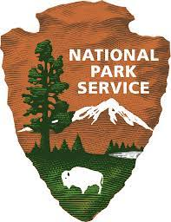
<NPS UNIT>
Wildlife-Vehicle Collision Survey
<Note to Reviewer: Species-Specific photos and graphics used as appropriate for the different Parks and species surveyed>
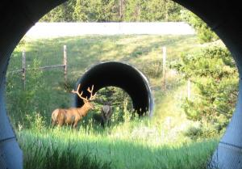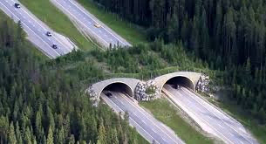

Paperwork Reduction Act Statement: The National Park Service is authorized by 54 U.S.C. 100070 to collect this information. This survey explores visitor opinions regarding reduction strategies for car and wildlife collisions in [NPS unit]. Your responses to this collection are completely voluntary and will remain anonymous. You can end the process at any time and will not be penalized in any way for choosing to do so. Data collected will only be reported in aggregates and no individually identifiable responses will be reported. A Federal agency may not conduct or sponsor, and you are not required to respond to, a collection of information unless it displays a currently valid OMB Control Number. Your response is not required to obtain or retain a benefit. OMB has approved this collection of information and assigned control number XXXX-XXXX. The expiration date is XX/XX/XXXX
Estimated Burden Statement: Public reporting for this collection of information is estimated to be about 15 minutes per survey. Send comments regarding this burden estimate or any other aspect of this collection of information, including suggestions for reducing this burden, to the Information Collection Clearance Officer, National Park Service, 13461 Sunrise Valley Dr. (MS-244), Reston, VA 20191.

BACKGROUND INFORMATION ABOUT THIS STUDY
Please read this page before you complete the survey.

This survey deals with the ways to reduce collisions between wildlife and cars in <NPS UNIT> through the installation of fences, bridges, and culverts. Each year, numerous species are killed in collisions with vehicles in the park. However, installation of fences in key crossing locations can keep animals off roads and can also direct animals to safer bridge or culvert crossing locations. We are interested in your opinions and thoughts on wildlife protection structures and their use in <NPS UNIT>.

While many species of animals are involved in vehicle collisions within <NPS UNIT>, this survey focuses on two species—elk and fox. <note to reviewer: elk and fox used for exposition> While some animals that are hit by vehicles might only be injured, nearly all eventually die from the accident—either immediately or afterward from injuries.

Q1-Q3: The questions in this section serve as an introduction to the survey. These questions gather background information on the respondent’s experiences with wildlife collisions. Further, these questions will also be used in conjunction with screening questions asked in the park(s) to allow for non-response bias analysis and corrections (e.g., individual fills out intercept survey and their spouse fills out the mail-back survey).
- Did you personally drive or ride in a personal vehicle on your recent trip to <NPS UNIT> (either your own or one owned by someone else)?
- No q Yes
- Have you personally ever been driving or riding in a vehicle that has been in a collision with wildlife?
- No q Yes

- Please check any of the following animals that you have personally hit with a vehicle or been in a vehicle that hit them.

- Deer q Elk
  - Raccoon q Bear
- Fox q Moose
- Skunk q Porcupine
- Coyote q Fox
q Other_________________________

Q4-Q5: Responses to these questions will provide experience and ranking information to allow bracketing of species-specific values beyond those addressed in the current survey.
- Please place a check next to each of the animal species you saw while on your recent trip to <PARK UNIT>. <Note to reviewer: species list will vary by park unit.>

Check if seen | Species | Rank preference to see
¨ | Grizzly | _____
¨ | Black Bear | _____
¨ | Moose | _____
¨ | Elk | _____
¨ | Mountain Lion | _____
¨ | Sheep | _____
¨ | Eagle | _____
¨ | Bison | _____
¨ | Wolf | _____
¨ | Wolverine | _____
¨ | Fox | _____
¨ | Coyote | _____
¨ | Skunk | _____
¨ | Porcupine | _____

- Now, please look at the list above and tell us which 3 species you most wanted to see on your <PARK UNIT> visit. (Place “1” next to the animal you most wanted to see, “2” next to the next most preferred animal, and “3” next to the third most preferred animal.)

WAYS THAT ROAD DESIGNERS TRY TO REDUCE THE NUMBER OF ANIMAL-VEHICLE COLLISIONS
Wildlife experts and road designers have found several methods that significantly reduce the number of wildlife-car collisions and that allow wildlife to safely get to the other side of the road. Below are three commonly used and effective methods.

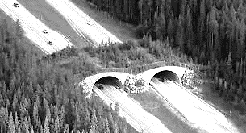
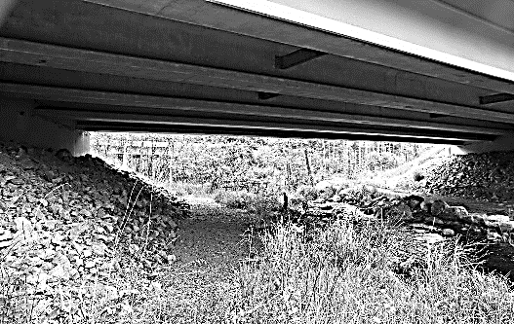
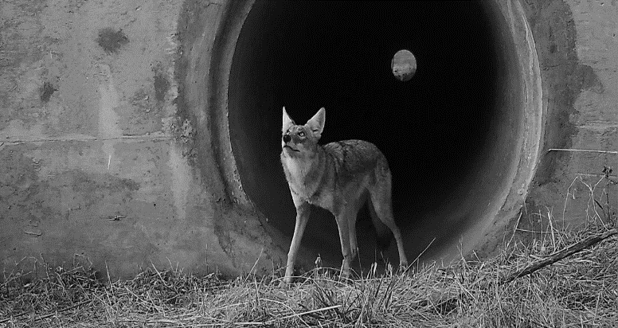
.
OVERPASSES
Wildlife overpasses, with fencing to direct wildlife to the overpass, can provide a crossing that includes natural vegetation and is inviting to elk, deer, and other animals
HYBRID UNDERPASSES
Wildlife hybrid underpasses with a “passage bench” on river or stream bridges can be simpler and less expensive to build, but still provide very useful routes for animals like foxes to avoid crossing busy roads when combined with fencing
FENCING & CULVERTS
Road fencing which guides small animals such as foxes and coyotes away from unsafe crossing locations and towards culverts can be cost-effective methods to reduce wildlife-vehicle collisions and provide passage across roadways.

Q6-Q8: The questions in this section introduce the respondents to the concept of wildlife road-crossing structures. These questions will inform and set the stage for the hypothetical animal protection programs and the discrete choice questions on animal valuation.
- Have you heard about any of these types of collision avoidance structures before reading this survey?
- No q Yes

- Have you personally seen any of these types of structures while driving?
q No q Yes

- Generally, are you in favor or opposed to use of these types of animal collision avoidance structures?
Strongly favor
Somewhat favor
Neither favor nor oppose
Somewhat oppose
Strongly oppose

A potential program to reduce wildlife-vehicle collisions in <PARK UNIT>

A possible program to build wildlife crossings in <PARK UNIT> could significantly reduce the number of vehicle-animal collisions. Such a program would use a combination of the structures described on the previous page placed at locations with the highest levels of collisions. Such a program would have both benefits and costs.
Depending on what type of structures were built, and where they were built, different combinations of reduced collisions could be expected. Large structures are primarily designed to prevent elk or deer collisions. Some smaller structures would benefit small mammals such as coyotes.
WILDLIFE BENEFITS OF THE PROGRAM
- Avoiding killing or injuring elk and foxes
- Provide safe connections and corridors for movement of wildlife populations between areas in the park and the region.
COSTS OF THE PROGRAM
- Depending on the location and types of mitigation structures used, the program could have substantial costs. One method for paying for roadway improvements in parks is to have a surcharge on entrance fees to the park.
The following questions ask you whether you would vote for a program to reduce elk and fox-vehicle collisions in <PARK UNIT>. The programs proposed use different combinations of animal road crossing types combined with fencing and would have different impacts on wildlife collisions. Also, the different programs would have different costs. We would like to know your opinions on such a program and how much you would value such a program.
For questions 9 and 10, please assume that the animal road fencing and crossing construction program would be undertaken by the park. The estimated cost is the increased entrance fees per park visit. Assume that park pass holders would be given the opportunity to make the same contribution to a wildlife protection fund when entering the park.
Q9-Q10: The two discrete choice questions are the core valuation questions in the survey and are needed to establish per-animal valuation. The questions will describe different costs and benefits associated with alternative plans to fund the animal protection programs in the park.
- Over the past 10 years, vehicles have collided with an estimated 200 elk and 50 foxes in <PARK UNIT>. Please ask yourself whether the reduced elk and fox collisions offered under Plan A (below) are worth the cost shown to your group in increased entrance fees to <PARK UNIT>. Current entrance fees to the park are <$X> for a private vehicle for a 7-day pass. Please check ONE box at the bottom of the table to indicate whether you prefer Plan A, or no expanded wildlife collision program.
Resources impacted by plans | PLAN A  Expanded Wildlife-vehicle collision reduction program | No collision reduction program
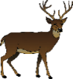  Change in <Park Unit>  Elk-vehicle collisions | 50% decrease in number of Elk collisions  (100 fewer elk killed) | No change
  Change in <Park Unit>  Fox-vehicle collisions | No change | No change
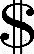  Cost to your group in increased park entrance fees DOLLARS PER TRIP | $5 | $0
I would vote for  (check only one ) | q | q

Now please consider a different choice…
We would now like to know how you would vote if you were presented with a completely different Plan. When making this choice, please imagine that the ONLY two options are Plan B and no expanded wildlife collision program.
- Over the past 10 years, vehicles have collided with an estimated 200 elk and 50 foxes in <NPS UNIT>. Please ask yourself whether the reduced elk and fox collisions offered under Plan B (below) are worth the cost shown to your group in increased entrance fees to <NPS UNIT>. Current entrance fees to the park are <$> for a private vehicle for a 7-day pass. Please check ONE box at the bottom of the table to indicate whether you prefer Plan B, or no expanded wildlife collision program.
Resources impacted by plans | PLAN B  Expanded Wildlife-vehicle collision reduction program | No collision reduction program
Change in <Park Unit>  Elk-vehicle collisions | 5% decrease in number of Elk collisions  (10 fewer elk killed) | No change
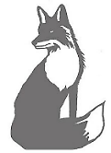  Change in <Park Unit>  Fox-vehicle collisions | 25% decrease in number of Fox collisions  (25 fewer foxes killed | No change
Cost to your group in increased park entrance fees DOLLARS PER TRIP | $10 | $0
I would vote for  (check only one ) | q | q

Q11: This question will be used to conduct sensitivity analysis of the discrete choice question responses to the respondent’s self-reported certainty.
- How certain do you feel about the choices you made above?

q Very certain q Somewhat certain q Not certain at all

Q12: These three statements are intended to help identify responses that have been based on rejecting the scenario presented rather than answering the questions based on an economic weighing of costs and benefits. If a person votes “NO” because they either believe it is the governments job alone to fund the program, or they do not believe the program, as presented, will work, then their responses should be further examined for potential exclusion from the analysis as “protest responses.”
12. If you voted for the No Collision Reduction Program in either of the previous choices, please rate how much you agree or disagree with the following statement. If not, skip to Q13. (Circle one)

 | Strongly  Agree | Agree | Neither Agree or Disagree | Disagree | Strongly Disagree
I voted for the NO COLLISION REDUCTION PLAN because I believe entrance fees are already too high. | 1 | 2 | 3 | 4 | 5
I believe it is the government’s responsibility to fund this program. | 1 | 2 | 3 | 4 | 5
I don’t believe the program would work. | 1 | 2 | 3 | 4 | 5

Q13: This question used to understand respondent motivations and help explain whether support for the collision reduction plan is more motivated by concern for the respondent and their family or by concern for animal welfare.

13. If you voted for PLAN A or PLAN B, please rate how much you agree or disagree with each of the following statements. (Circle one number for each statement.) If not, skip this question.

 | Strongly  Agree | Agree | Neither Agree or Disagree | Disagree | Strongly Disagree
I voted for Plan A or B mainly to protect myself or my family from animal collisions | 1 | 2 | 3 | 4 | 5
I voted for Plan A or B mainly to protect elk and foxes from vehicle collisions | 1 | 2 | 3 | 4 | 5

Q14: This question used to understand respondent motivations and opinions on both their answers to the previous discrete choice questions and animal welfare, in general. The responses to these questions may be used as covariates in Willingness-to-Pay (WTP) modeling to further explain motivations for WTP.

14. We are interested in learning how you feel about wildlife in general and protecting wildlife in particular. On a scale of 1 to 5, with 1 being “strongly agree” and 5 being “strongly disagree,” please indicate how you feel about each statement written below. (Circle one number for each statement.)

Statement | Strongly  Agree | Agree | Neither Agree or Disagree | Disagree | Strongly Disagree
I have a great deal of concern for protecting wildlife. | 1 | 2 | 3 | 4 | 5
Wildlife species must be beneficial to humans to deserve protection. | 1 | 2 | 3 | 4 | 5
It is important to protect rare plants and animals to maintain genetic diversity. | 1 | 2 | 3 | 4 | 5
I am concerned about animals getting hit by vehicles on roads. | 1 | 2 | 3 | 4 | 5

Q15-Q16: These questions present an alternative WTP question framework which will act as a cross-verification/calibration tool for the previous discrete choice valuation question results. The “Payment Card” question format has advantages as an alternative valuation method because the respondent data can be modeled in a variety of ways, from using simple averages to using more complex parametric survival models. While the resulting analysis provides a robust method for estimating respondent WTP. The proposed payment card addresses the above considerations by providing a range of 9 potential choices to select from, ranging from $0-$250 or more.

15. Rather than paying for wildlife fences and crossing structures with increased entrance fees, another possible method of financing the structures would be through voluntary donations to a wildlife crossing trust fund in <PARK UNIT>. If such a trust fund existed, what is the largest amount you be willing to give in a one-time donation to fund a program if the program was predicted to prevent 50 elk-vehicle collisions over time? (Circle the largest one-time donation you would be willing to make.)

$0  (No donation) | $2 | $5
$10 | $25 | $50
$75 | $150 | $250 or more

16. Now please consider a trust fund to pay for fencing and crossings designed to prevent fox-vehicle collisions. If such a trust fund existed, what is the largest amount you be willing to give in a one-time donation to fund a program if the program was predicted to prevent 20 fox-vehicle collisions over time? (Circle the largest one-time donation you would be willing to make.)

$0  (No donation) | $2 | $5
$10 | $25 | $50
$75 | $150 | $250 or more

In this last section, we would like to ask you some questions about your background that will help us compare your answers with those of other people.

Q17-Q23: Data from these questions will be used both as explanatory covariates in WTP modeling and as possible non-response bias tests when compared with screening question responses from park intercepts and non-respondents.

17. What is your gender?
¨ Male ¨ Female ¨ Transgender, non-binary, or another gender
¨ Prefer not to respond

18. What is your age? ________ years old
19. What is the highest degree or level of school you have completed?
¨ No high school diploma
¨ High school diploma or GED
¨ Some college credit or Associate’s degree (for example: AA)
¨ Bachelor’s degree (e.g. BA or BS)
¨ Some graduate school or professional school or degree

20. Which of the following categories best describes your household employment status? (Check all that apply)
¨ Employed full-time ¨ Employed part-time ¨ Retired
¨ Student ¨ Full-time homemaker ¨Unemployed
¨ Other

18. What is your race and/or ethnicity?
Select all that apply and enter additional details in the spaces below.
¨ American Indian or Alaska Native—Enter, for example, Navajo Nation, Blackfeet Tribe of the Blackfeet Indian Reservation of Montana, Native Village of Barrow Inupiat Traditional Government, Nome Eskimo Community, Aztec, Maya, etc.

¨ Asian—Provide details below.
- Chinese | - Asian Indian | - Filipino
- Vietnamese | - Korean | - Japanese
Enter, for example, Pakistani, Hmong, Afghan, etc.
¨ Black or African American—Provide details below.
- African American | - Jamaican | - Haitian
- Nigerian | - Ethiopian | - Somali
Enter, for example, Trinidadian and Tobagonian, Ghanaian, Congolese, etc.
¨ Hispanic or Latino—Provide details below.
- Mexican | - Puerto Rican | - Salvadoran
- Cuban | - Dominican | - Guatemalan
Enter, for example, Colombian, Honduran, Spaniard, etc.
¨ Middle Eastern or North African—Provide details below.
- Lebanese | - Iranian | - Egyptian
- Syrian | - Iraqi | - Israeli
Enter, for example, Moroccan, Yemeni, Kurdish, etc.

¨ Native Hawaiian or Pacific Islander—Provide details below.
- Native Hawaiian | - Samoan | - Chamorro
- Tongan | - Fijian | - Marshallese
Enter, for example, Chuukese, Palauan, Tahitian, etc.
¨ White—Provide details below.
- English | - German | - Irish
- Italian | - Polish | - Scottish
Enter, for example, French, Swedish, Norwegian, etc.

23. What was your total pre-tax household income, including all earners in your household, in 2021?
- Under $25,000
- $25,000 to $34,999
- $35,000 to $49,999
- $50,000 to $74,999
- $75,000 to $99,999
- $100,000 to $199,999
- $200,000 or more

THANK YOU FOR YOUR HELP!
Please return only this survey booklet in the
enclosed, postage-paid envelope

For questions, contact:
Chris Neher (406) 721-2265

