ATLAS Login

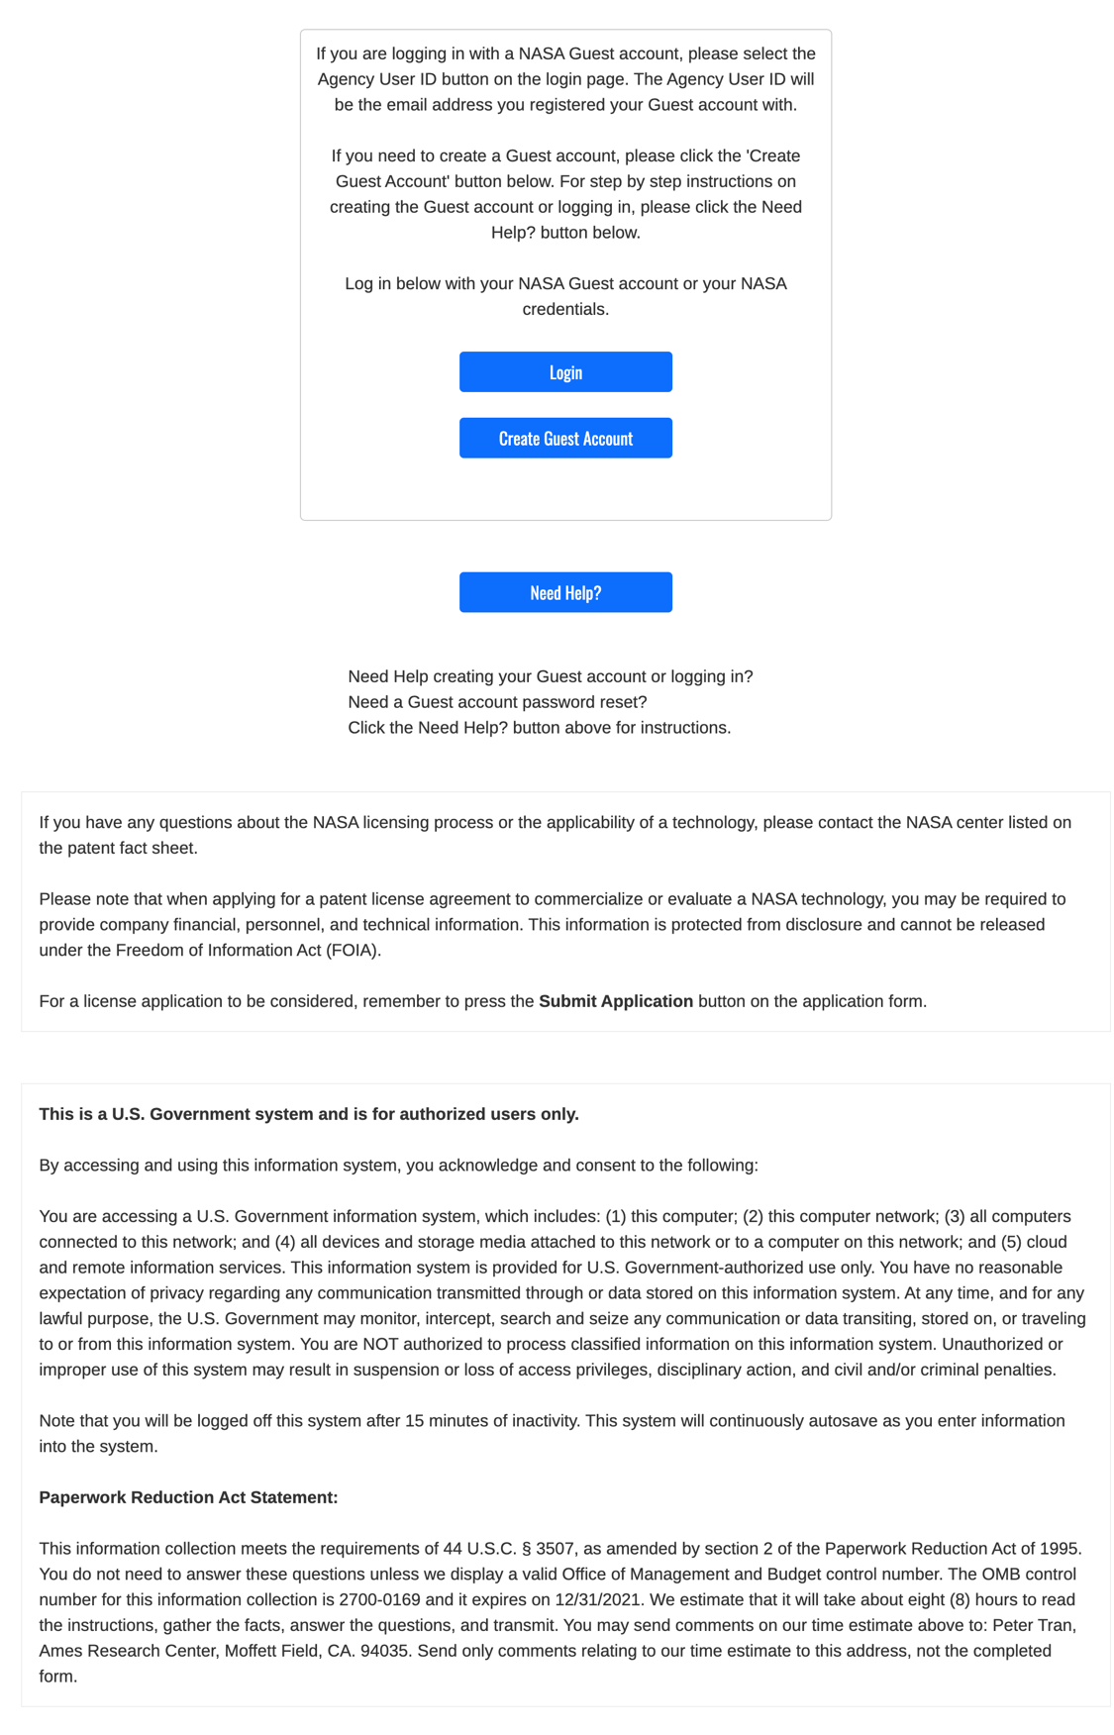

Universal License Application

Supplemental Commercial License Application

Supplemental Startup License Application

Supplemental Research License Application

