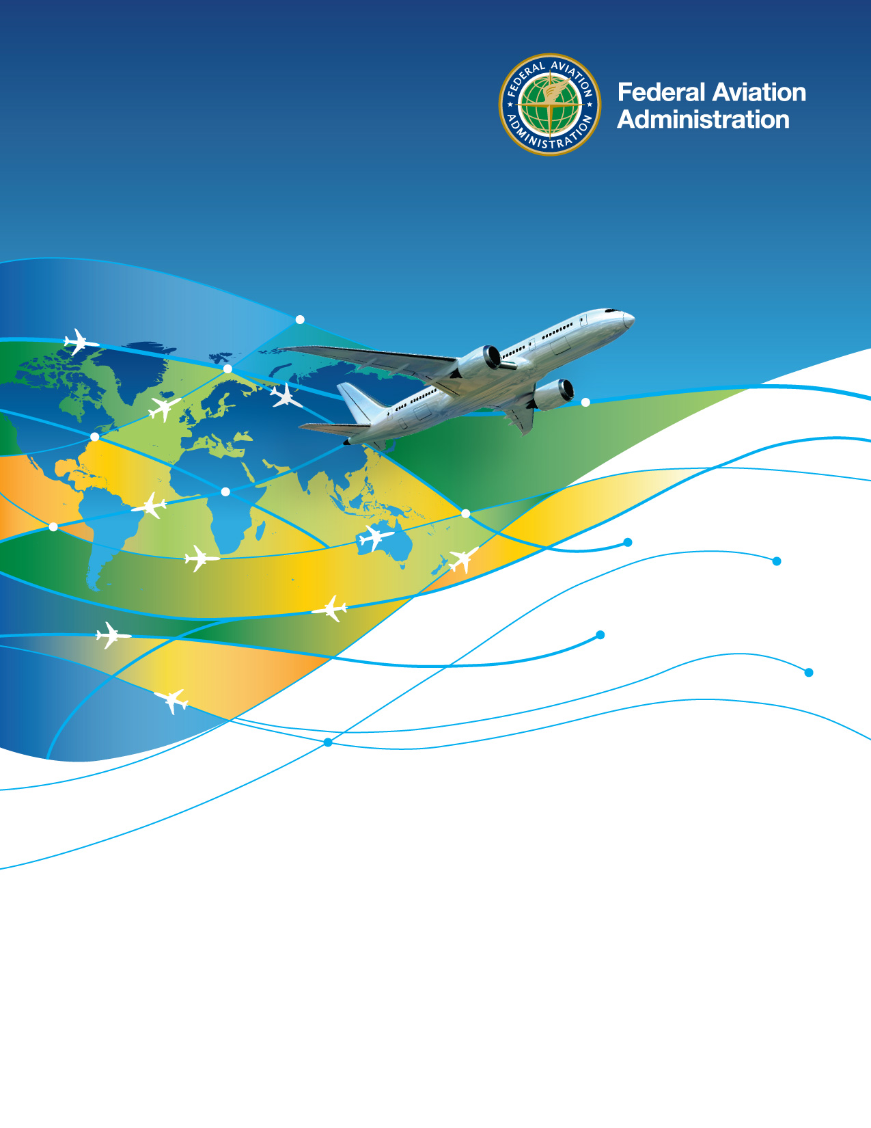

Office of International Affairs
Job Aid

Technical Assistance Requests

Sample Questions / Survey for the Intake of Technical Assistance Requests

- Date the technical assistance request was received by the FAA.
- Name of entity making the request for technical assistance.
- In which region dose the requesting entity reside? (Africa, Europe and Middle East; Asia-Pacific; Western Hemisphere; ICAO)
- What is the name of the point-of-contact for the technical assistance request?
- What is the email address of the point-of-contact for the technical assistance request?
- What is the phone number of the point-of-contact for the technical assistance request?
- Is the requesting entity the same as the technical assistance recipient? (Yes; No)
- Which country will host or receive the technical assistance?
- What is the name of the point-of-contact for the host or recipient country?
- What is the email address of the point-of-contact for the host or recipient country?
- What is the phone number of the point-of-contact for the host or recipient country?
- Describe the specific request being made of the FAA.
- Describe the reason(s) for the specific request. Explain what barrier the FAA may help the foreign entity overcome through technical assistance.
- If the request is for training, how many students are expected to participate?
- When does the request need to be fulfilled by?
- Attach any emails, records of conversation, or other files associated with the technical assistance request.
- Which FAA Line of Business or Staff Office has technical responsibility for supporting the specific request? (APL-11, APT, APX, APC, AEU, APC, AWH, AJV-I, AIR-40, AFS-50, AMA-800, Other)
- Which FAA Desk Officer is assigned responsibility for the host or recipient country?

