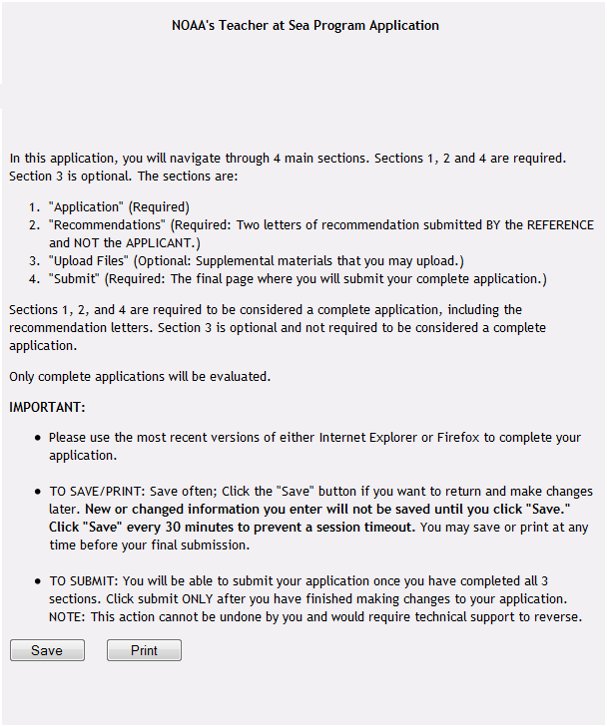

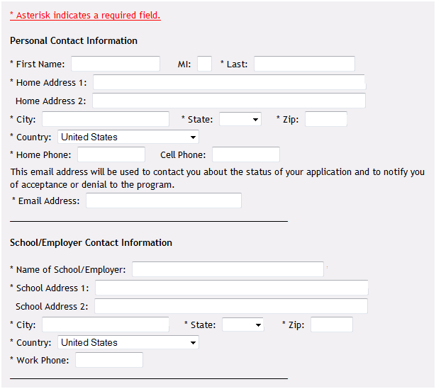

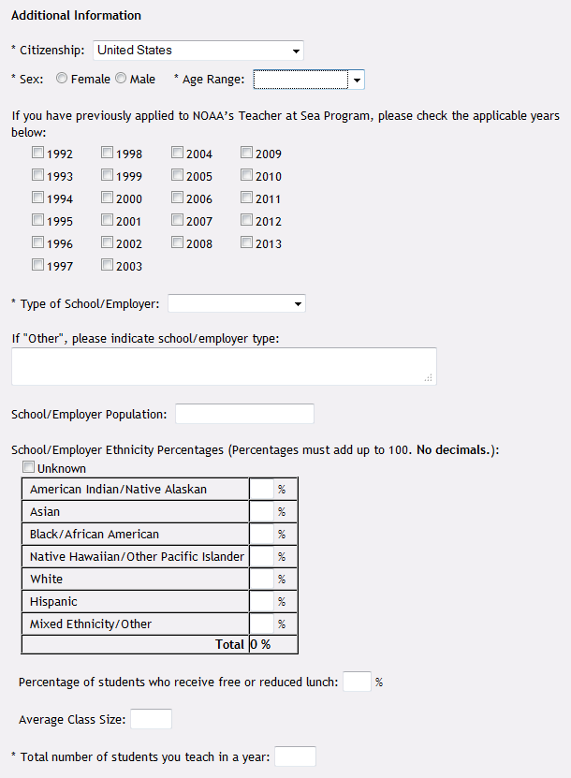
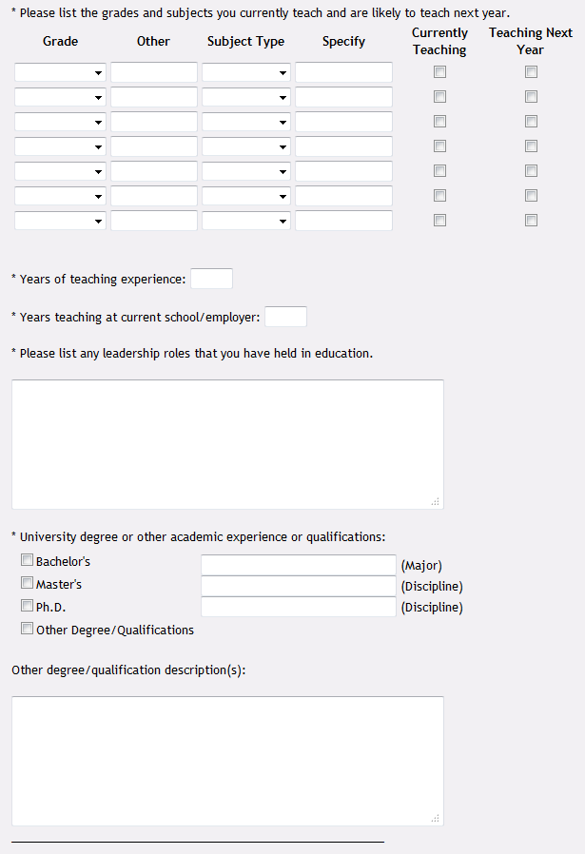
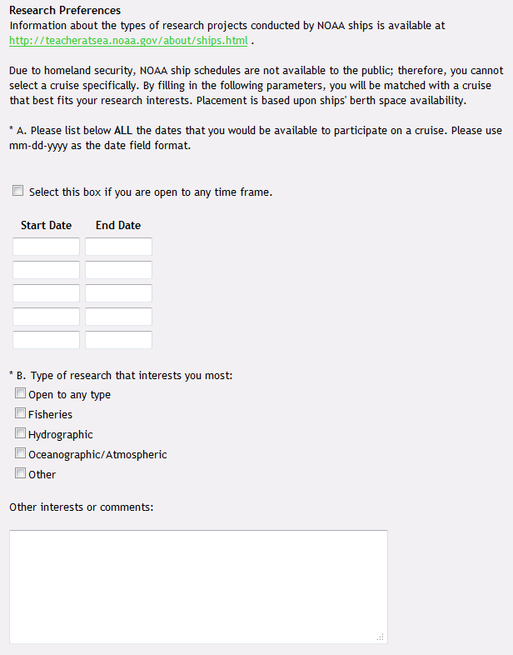

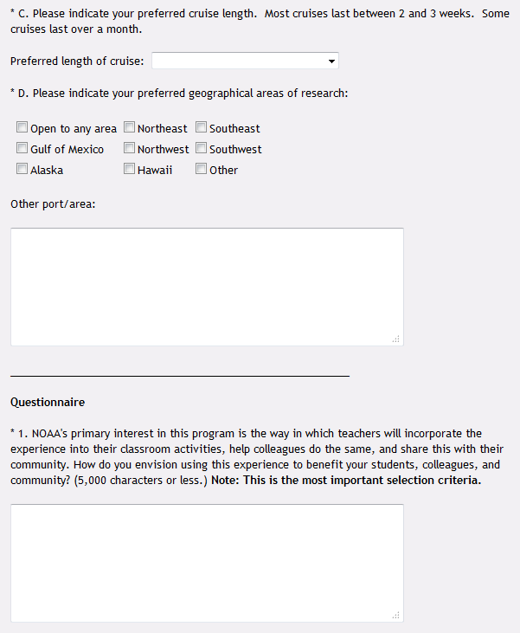

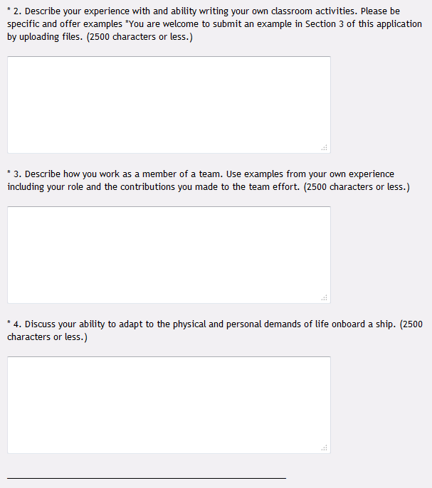

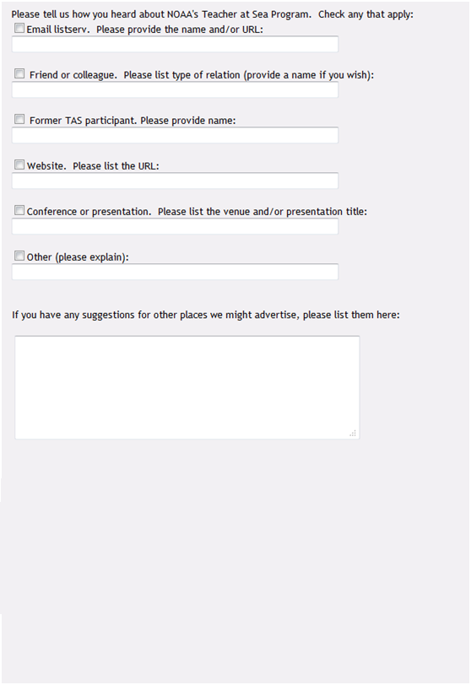

PAPERWORK REDUCTION ACT INFORMATION
NOAA conducts the Teacher at Sea Program in order to promote oceanographic and related education. Public reporting burden for this collection of information is estimated to average 75 minutes per response, including the time for reviewing instructions, searching existing data sources, gathering and maintaining the data needed, and completing and reviewing the collection of information. Send comments regarding this burden estimate or any other aspect of this collection of information, including suggestions for reducing this burden, to NOAA’s Teacher at Sea Program, 1315 East West Hwy, Division F, Room 14249, Silver Spring, MD 20910
Notwithstanding any other provision of the law, no person is required to respond to, nor shall any person be subject to a penalty for failure to comply with, a collection of information subject to the requirements of the Paperwork Reduction Act, unless that collection displays a currently valid OMB Control Number.

