CBER On-Line- Login Screen
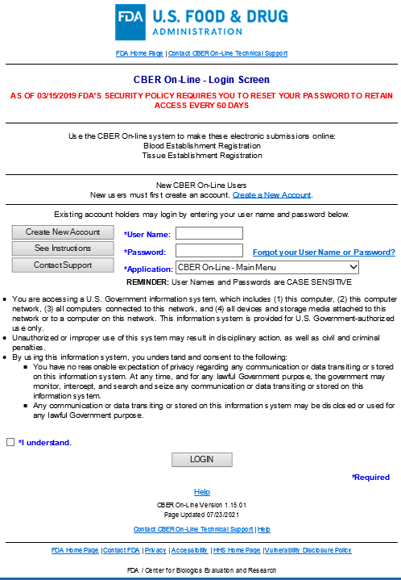

CBER On-Line Main Menu Screen

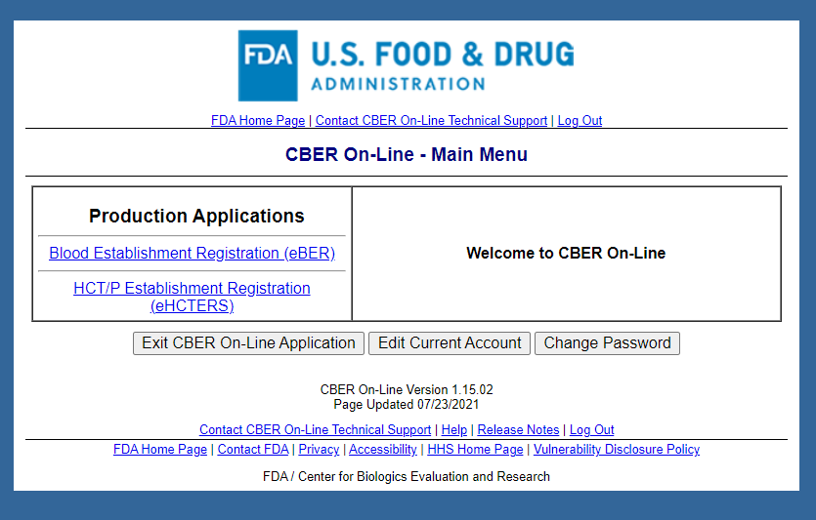

Note: After eHCTERS application is selected, the OMB control number and expiration date are displayed on all subsequent pages (see next page for an example).
Electronic Human Cells and Tissue Establishment Registration System (eHCTERS)
Activity Selection Screen (screenshot of the entire page)
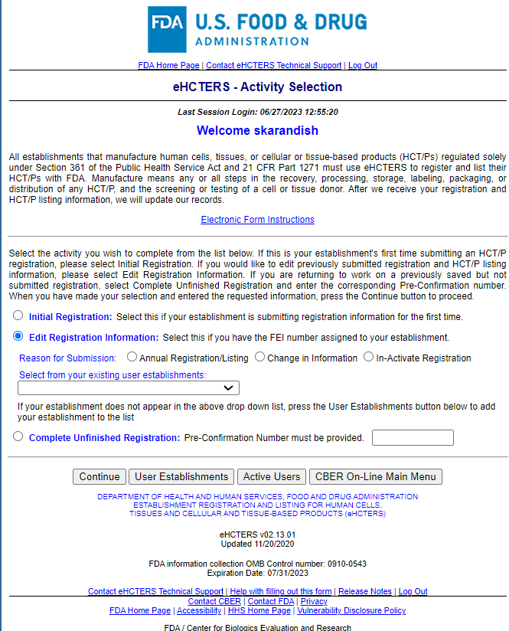
UserName
The text highlighted in yellow will be replaced with:
OMB Control Number 0910-0543; Expiration Date 07/31/2023
See OMB Burden Statement

The hyperlink will lead to this text:

OMB Burden Statement

Public reporting burden for this collection of information is estimated as follows:
The time required to complete registration and listing for existing establishments is estimated to average 30 minutes per response, for new establishments it is estimated to average 45 minutes per response, and updates to a list are estimated to average 30 minutes per response, including the time to review instructions, search existing data sources, gather and maintain the data needed and complete and review the collection of information.
Send comments regarding this burden estimate or any other aspects of this collection of information, including suggestions for reducing burden, to PRAStaff@fda.hhs.gov.
An agency may not conduct or sponsor, and a person is not required to respond to, a collection of information unless it displays a currently valid OMB control number.
User Establishments Screen

Active Users Screen
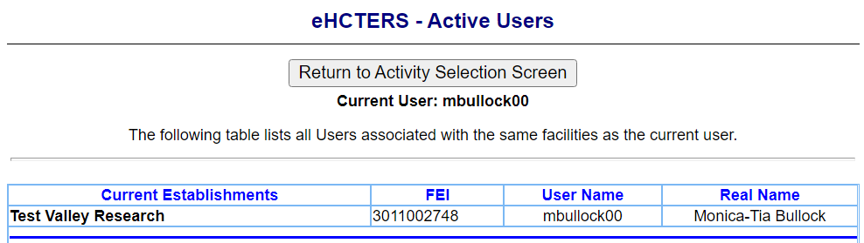

Submissions Pending Screen

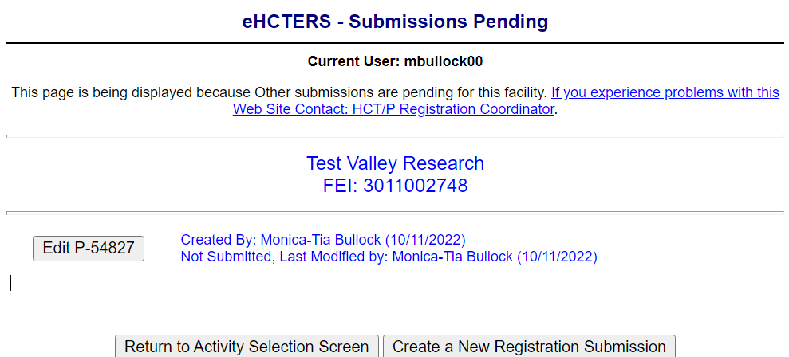

Initial Establishment Registration Information Screen

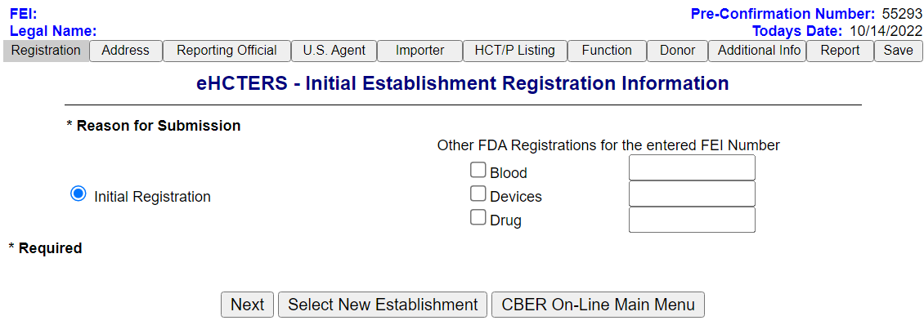

Edit Establishment Registration Information Screen

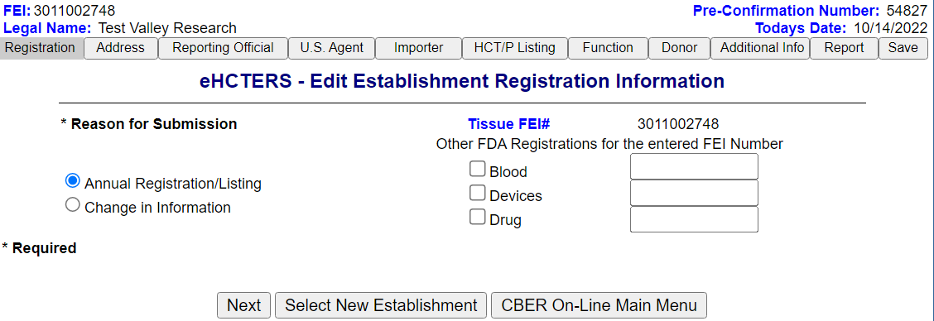

Establishment Registration Address Information Screen

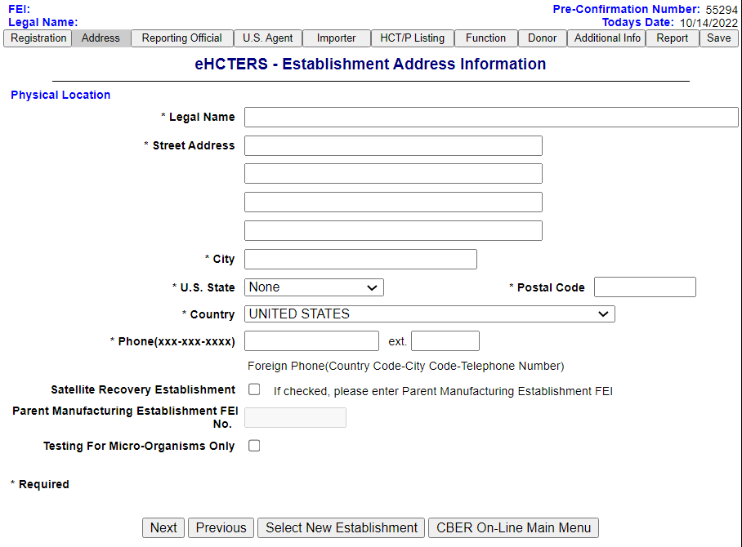

Possible Establishment Matches Found Screen

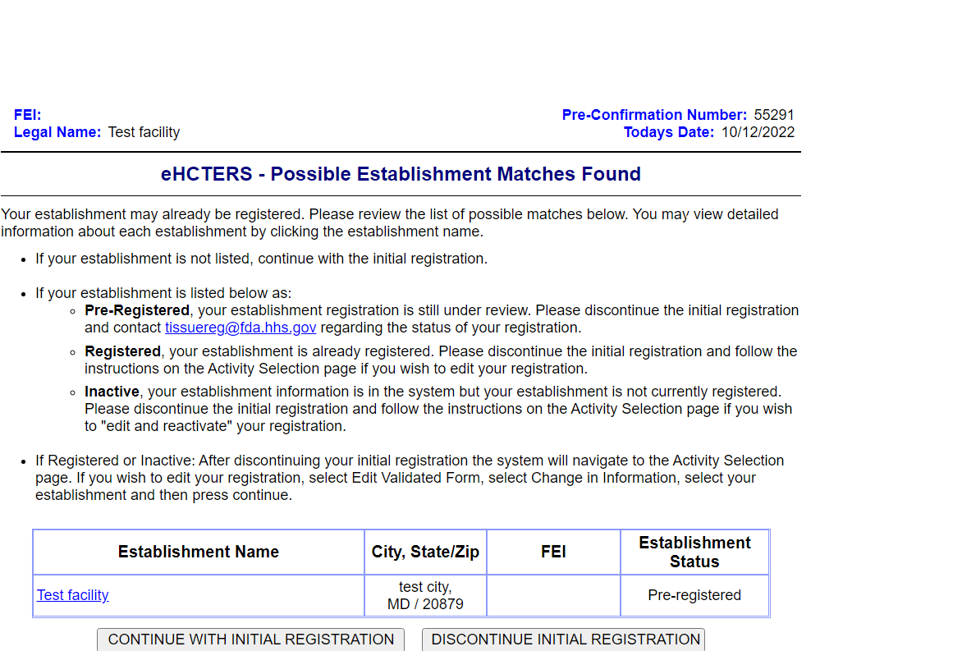

Establishment Reporting Official Information Screen

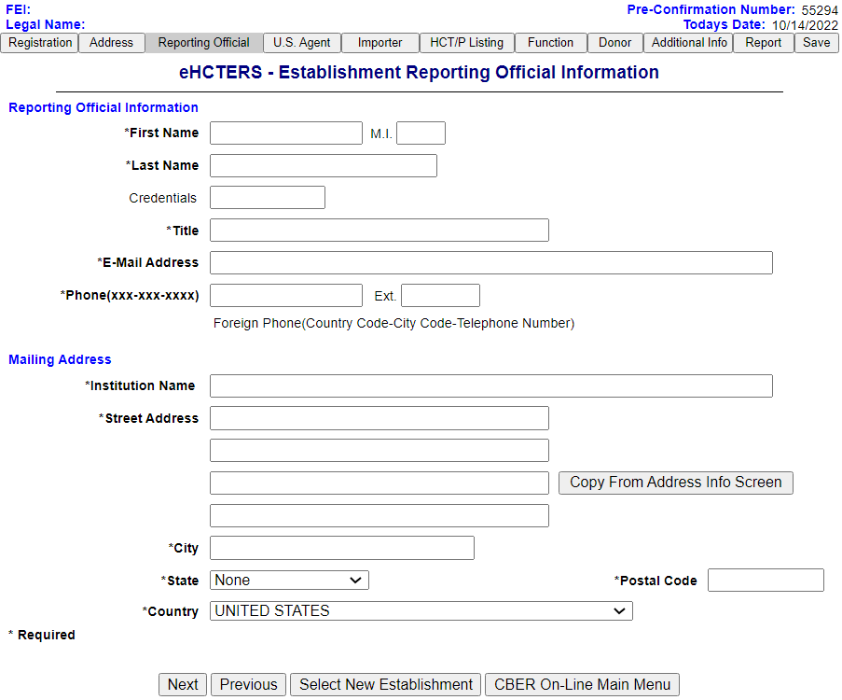

Establishment U.S. Agent Information Screen

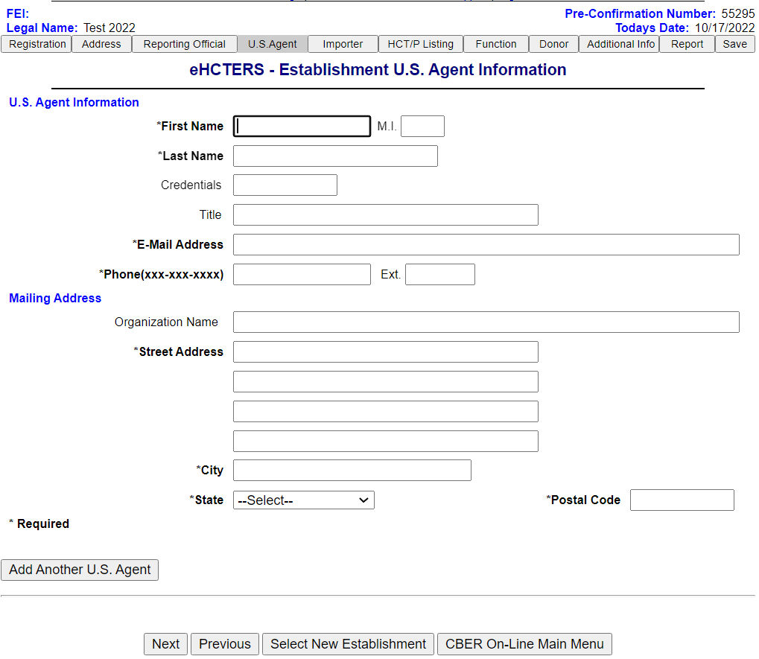

Establishment Importer Information Screen

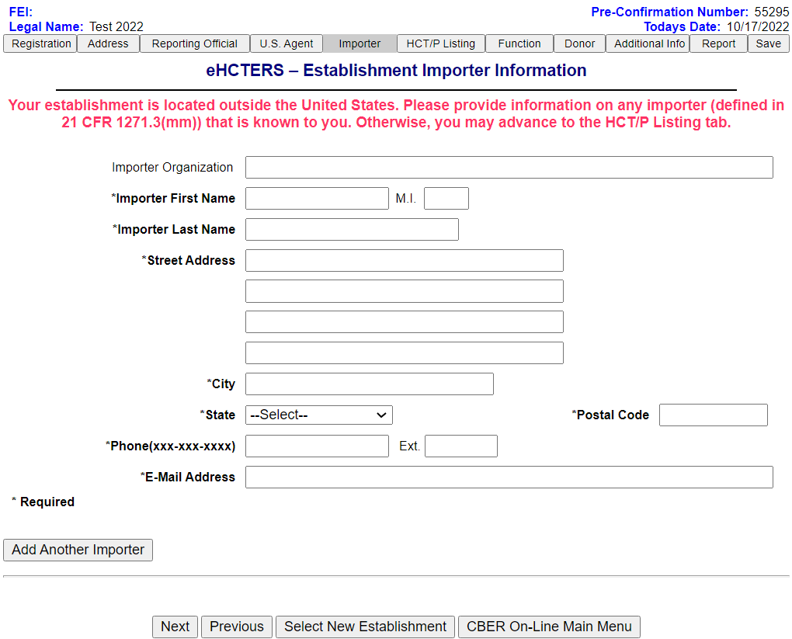

HCT/P Listing Information Screen

Function Information Screen

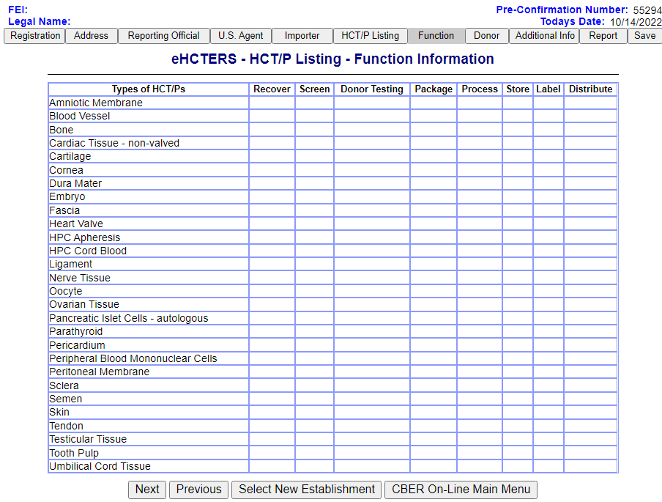

Donor Information Screen

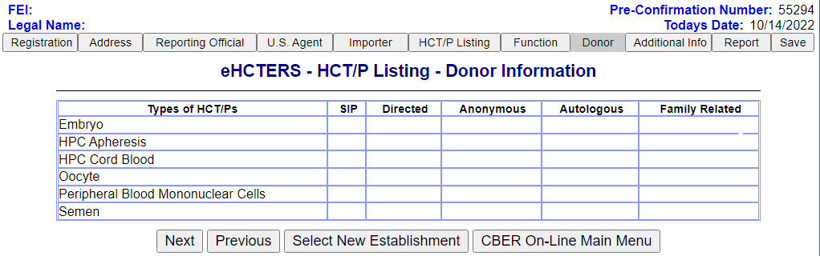

Additional Information to Complete HCT/P Information Listing Screen

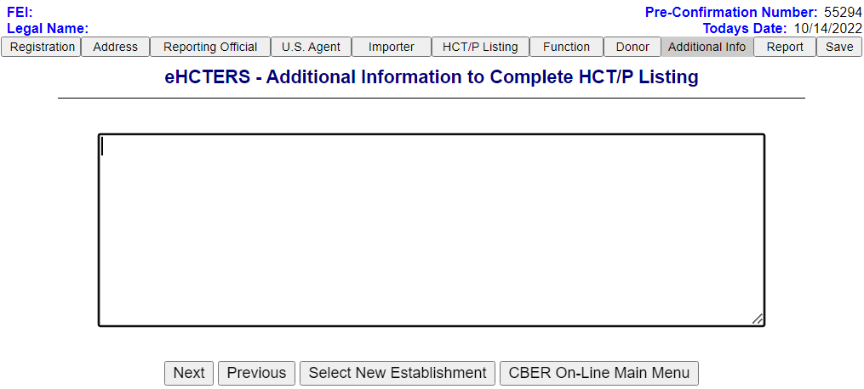

Reporting Official Signature Screen

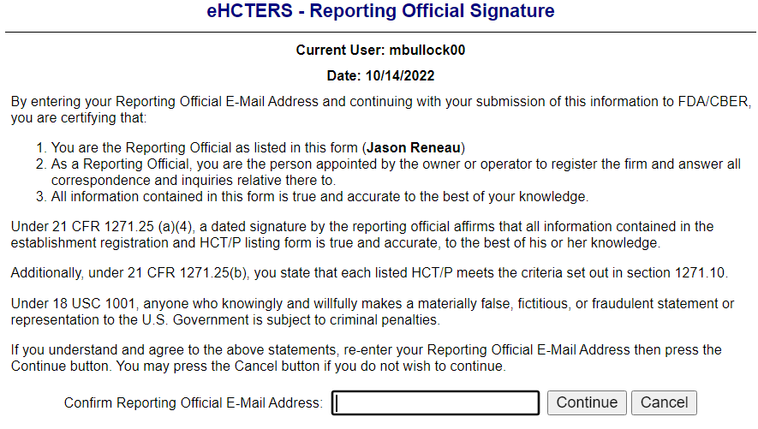

Submitted Establishment Registration Information Screen

Registration Summary Report Provided to the Establishments (Example-Page 1)
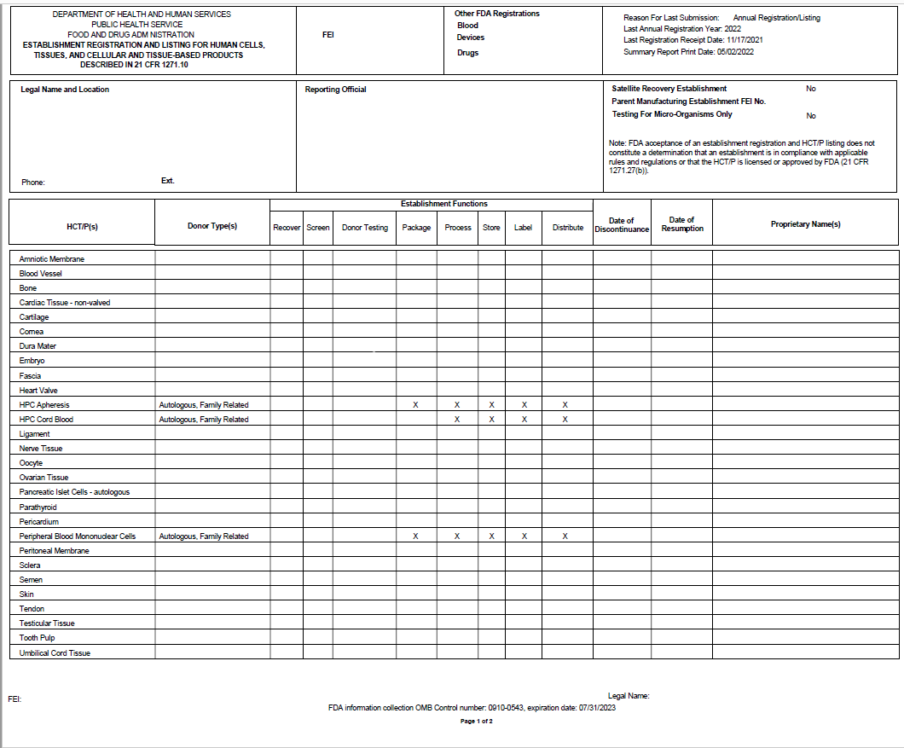

Registration Summary Report Provided to the Establishments (Example-Page 2)

