APPENDIX D

Proposed Changes
for the 2023 NSCG Questionnaire

Proposed Changes for the 2023 NSCG Questionnaire
The 2023 NSCG questionnaire will include the following revisions:

  - The items that were modified for the 2021 NSCG to understand the impact of the coronavirus pandemic on NSCG measures will be returned to their form in the 2019 NSCG, prior to the pandemic.
      - A3: Reasons for not working
      - A39: Reasons for working fewer than 35 hours
      - A40: Available job benefits
      - B3: Reasons for changing employer
      - C4: Conference attendance

  - Items that were added for the 2021 NSCG to understand how income and earnings were affected by the pandemic will be removed.
      - A31: Has salary been affected by the pandemic
      - A32: Did reported salary reflect effects of pandemic
      - A33: Has 2021 salary increased or decreased due to pandemic
      - A34: By how much did 2021 salary decrease
      - A35: By how much did 2021 salary increase
      - A45: Did 2020 earnings increase or decrease due to pandemic
      - A46: By how much did 2020 earnings decrease
      - A47: By how much did 2020 earnings increase

  - The question about telework opportunities that was added to the 2021 NSCG in light of the pandemic will be modified to collect information about remote work in general.

New item: Thinking of your principal job during the week of February 1, 2023, which of the following BEST describes whether you were allowed or required to telecommute or work remotely?
      - Telecommuting or working remotely did not make sense for my job
      - I was not allowed or required to telecommute or work remotely
      - I was required to telecommute or work remotely
      - I was allowed to telecommute or work remotely, and did skip to follow-up below
      - I was allowed to telecommute or work remotely, but did not

[If “d” above] How often did you typically telework or work remotely?
    - Occasionally, but not consistently
    - Consistently 1-2 days per week
    - Consistently 3-4 days per week
    - Consistently 5 or more days per week

  - The race item will be modified…
    - to collect subgroups within the categories of Asian and Native Hawaiian or other Pacific Islander,
    - to remove the write-in response for American Indian and Alaska Native tribal affiliations, and
    - to reorder the race categories to better align with other surveys, such as ACS.

From the 2021 NSCG questionnaire:
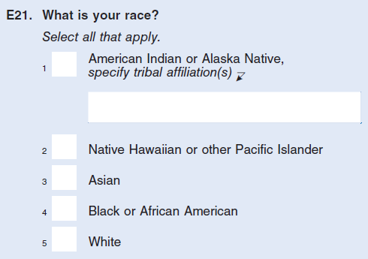

Proposed for the 2023 NSCG questionnaire:
What is your race?
Select all that apply.
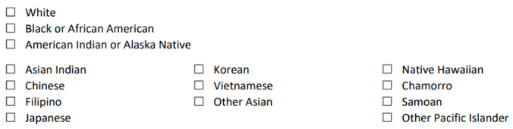

  - The sex item will be modified from one question into two to collect gender identity, as follows:

From the 2021 NSCG questionnaire:
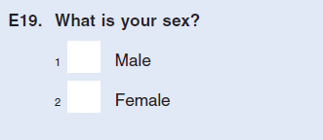
Proposed for the 2023 NSCG questionnaire:
Q1. What sex were you assigned at birth, on your original birth certificate?
- Female
- Male

Q2. How do you currently describe yourself?
Select all that apply.
- Female
- Male
- Transgender
- I use a different term [free-text]

  - Based on an evaluation and cognitive interviews conducted by Census Bureau methodologists, some NSCG questionnaire items will be revised to provide greater clarity to respondents to reduce burden and increase data quality.

  - The lists of job categories and fields of study will be updated to reflect the latest occupation taxonomy and field of degree taxonomy used by NCSES.

  - The item asking which mode (web, mail, phone) respondents would prefer to use to complete the NSCG in the future will be removed, as the preference for modes other than web has declined.

