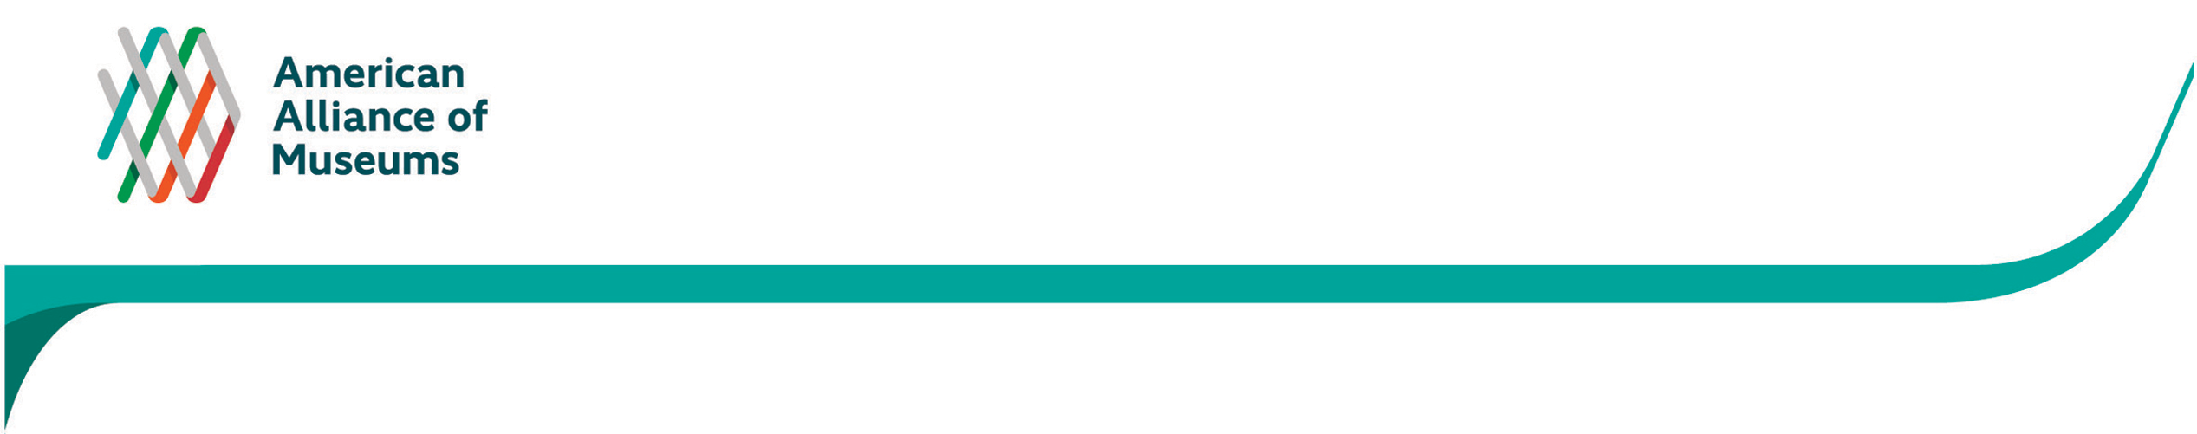
Dear _______________,
APPENDIX F
Email invitation to selected MAP Participants soliciting participation in telephone interview (sample)

Thank you for responding to the survey about what changes participation in MAP brought about at your institution. As part of this effort, representatives from Spotlight Impact, LLC—the firm AAM contracted to conduct the evaluation—will be conducting phone interviews with selected respondents.

We would like to invite you to take part in one of these conversations.

The purposes of the interview are to:
- learn more about the types and timing of changes you reported as resulting from participating in the Museum Assessment Program;
- understand how MAP contributed to your institution’s capacity-building efforts;
- listen to your opinions and ideas about the Museum Assessment Program from a field-wide service and program provider standpoint;
- determine how MAP could further support your institution.

We want to get your point of view for several reasons: 1) we believe your institution’s experience with MAP positively contributes to our understanding of the assessment process and its potential; 2) your institution demonstrates a unique or fundamental result from the MAP process we are interested in learning more about; and 3) you and your institution represent a segment of the museum field that we are interested in showcasing.

We believe that you are in an ideal position to help us understand the positive influence of the Museum Assessment Program, and can speak on the organization’s behalf from a broad viewpoint. If ultimately your schedule does not permit, or you feel another person is better suited to do the interview, please contact Angelina Ong to discuss.

On behalf of AAM and Museum Assessment Program team, thank you in advance for your time to do the interview.

Best,

Angelina Ong  Principal, Spotlight Impact, LLC  angie@spotlightimpact.com | Julie Hart  Senior Director, Museum Standards & Excellence  jhart@aam-us.org

