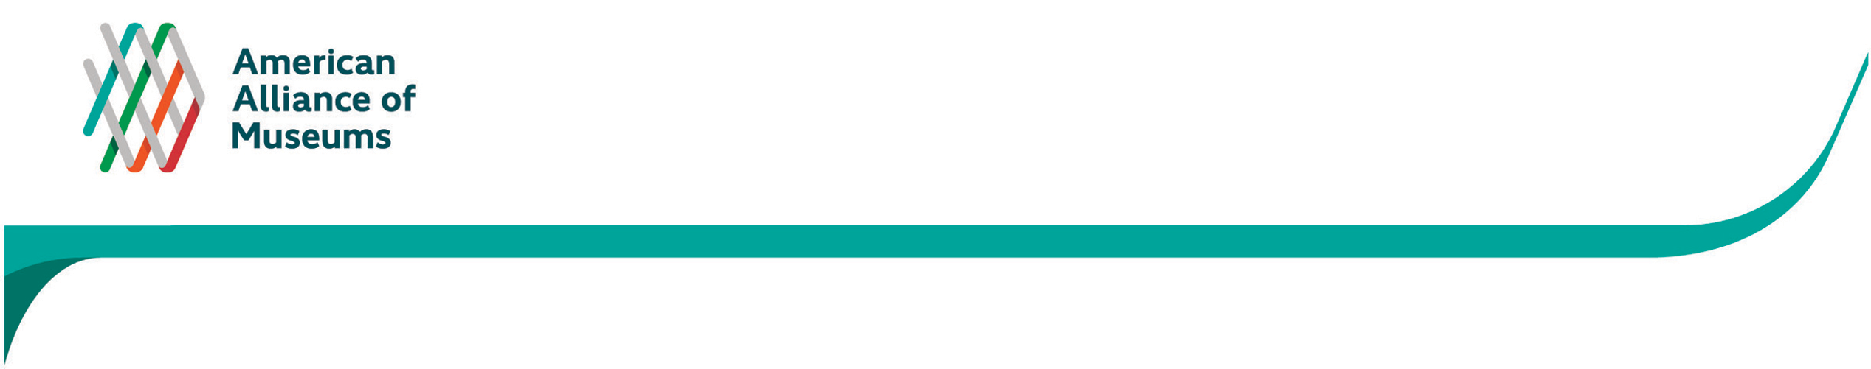
APPENDIX E
Online survey invitation emailed to MAP Participants (sample)
Dear _______________,

Your museum made an important commitment to excellence by participating in the Museum Assessment Program (MAP) at some point over the last seven years. I hope the process has produced lasting and noticeable changes on the museum’s professional growth and capacity and ask you to take part in a current survey we are conducting on this topic.

The American Association of Museums and its partner, the Institute of Museum and Library Services (IMLS) are doing a periodic assessment of MAP. As part of this endeavor, Spotlight Impact, LLC has been tasked with conducting a survey on how MAP has informed practices and influenced operations at participating institutions—from overall professionalization and capacity development to specific initiatives, plans and policies.

The only way we can ensure that MAP is relevant, beneficial, and worthy of continued support is to understand the types of changes it fostered within the institutions that have completed at least one assessment. Your feedback will help us serve the dozens of institutions currently participating, and the hundreds who will follow.

Please take about 20-30 minutes to answer questions about your museum’s participation in the program by [insert date]. This link will take you directly there: [INSERT LINK]

If someone else at your museum is better suited to complete the survey, please forward the link to them. Even if you were not at the museum when the assessment occurred you can still take the survey, as it looks at the after-effects.

Thank you in advance for your time and input.

Sincerely,

Laura L. Lott
President & CEO
American Alliance of Museums

