Under the Paperwork Reduction Act, a federal agency may not conduct or sponsor, and a person is not required to respond to collection of information subject to the requirements of the Paperwork Reduction Act unless that collection of information displays a current valid OMB Control number. The OMB Control Number for this information collection is 2127-NEW (expiration date: MM/DD/YYYY). The average amount of time to complete the form is 5 minutes. The purpose of this research study is to examine drivers’ interactions with advanced vehicle technologies and the relationships between attitudes, behaviors, and traffic safety. All responses to this collection of information are voluntary. If you have comments regarding this burden estimate or any other aspect of this collection of information, including suggestions for reducing this burden send them to Information Collection Clearance Officer, National Highway Traffic Safety Administration, 1200 New Jersey Ave, S.E., Washington, DC, 20590.

Usability Questionnaire

- Regarding the Adaptive Cruise Control system in the vehicle you just drove, please indicate the extent you agree or disagree with the following statements:
- This system’s capabilities meet my requirements.
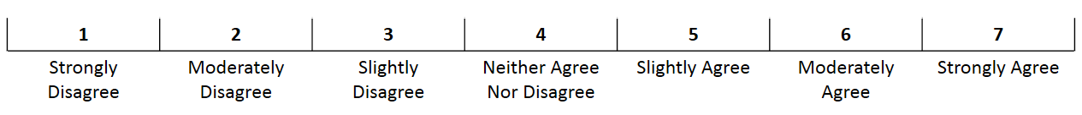
- Using this system is a frustrating experience.
- This system is easy to use.
- I have to spend too much time correcting things with this system.

- Regarding the Lane Centering system in the vehicle you just drove, please indicate the extent you agree or disagree with the following statements:
- This system’s capabilities meet my requirements.
- Using this system is a frustrating experience.
- This system is easy to use.
- I have to spend too much time correcting things with this system.

