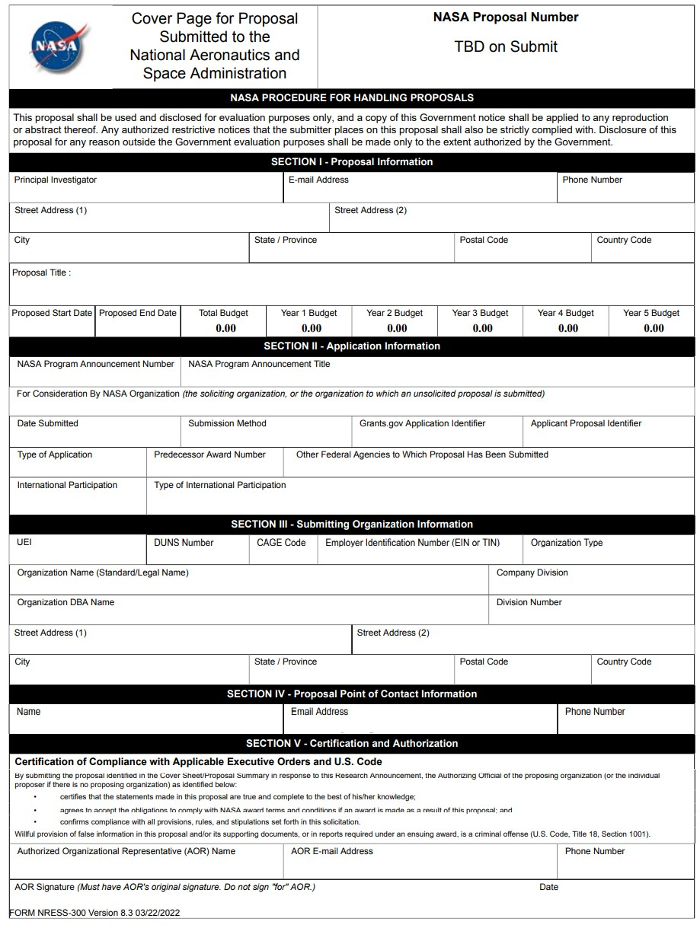

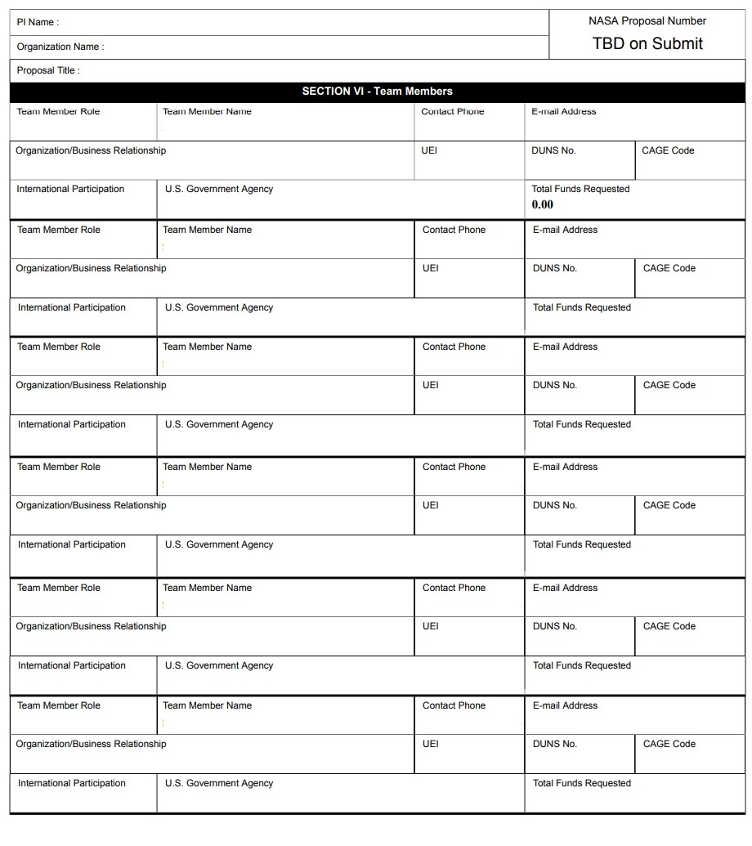

PI Name: |  | NASA Proposal Number TBD on Submit
Organization Name: |  | NASA Proposal Number TBD on Submit
Proposal Title:
 | SECTION VII – Project Summary

PI Name: |  |  |  | NASA Proposal Number TBD on Submit
Organization Name:
Proposal Title:
SECTION VIII – Other Project Information
Proprietary Information
Is proprietary/privileged information included in this application?
International Collaboration
Does this project involve activities outside the U.S. or partnership with International Collaborators?
Principal Investigator | Co-Investigator | Collaborator | Equipment |  | Facilities
Explanation:

NASA Civil Servant Project Personnel
Will NASA civil servant personnel work on this project?
Fiscal Year | Fiscal Year | Fiscal Year | Fiscal Year |  | Fiscal Year
Number of FTEs | Number of FTEs | Number of FTEs | Number of | FTEs | Number of FTEs

PI Name:

NASA Proposal Number

TBD on Submit

Organization Name:

Proposal Title:

SECTION VIII
–

Other Project Information

Environmental Impact

Does this project have an actua
l or potential impact on the environment?

Has an exemption been authorized or an environmental assessment (EA) or an
environmental impact statement (EIS) been performed?

Environmental Impact Explanation:

Exemption/EA/EIS Explanation:

PI Name: | NASA Proposal Number TBD on Submit
Organization Name: | NASA Proposal Number TBD on Submit
Proposal Title:
SECTION VIII – Other Project Information
Historical Site/Object Impact
Does this project have the potential to affect historic, archeological, or traditional cultural sites (such as Native American burial or ceremonial grounds) or historic objects (such as an historic aircraft or spacecraft)?

Explanation:

PI Name: |  | NASA Proposal Number TBD on Submit
Organization Name: |  | NASA Proposal Number TBD on Submit
Proposal Title:
 | SECTION IX – Program Specific Data

